**UCS2612 Machine Learning Laboratory**

**Assignment 2 : Handwritten Character Recognition using Neural Networks**

Name **: Anandh K**

Roll No **: 3122 21 5001 009**

**---------------------------------------------------------------------------------------------------------**

# Aim

To Develop a python program to recognize handwritten characters using Neural Network (NN) Model.

# Code

**Importing the Necessary Libraries For Single layer perceptron model , Multiple Layer Perceptron Model and CNN Using Keras**

from google.colab import drive

drive.mount('/content/drive')

import numpy as np import pandas as pd

import matplotlib.pyplot as plt

import os

from PIL import Image import cv2

from sklearn.model_selection import train_test_split from sklearn.preprocessing import LabelEncoder

from sklearn.metrics import accuracy_score from sklearn.linear_model import Perceptron

from sklearn.neural_network import MLPClassifier

import tensorflow as tf

**Loading the dataset and Pre-Processing the data (Image Enhancement techniques)**

# Image resize

1. **Normalization of image frequencies**

data_dir = "/content/drive/MyDrive/Image_dataset/Img"

x=[]

x1=[]

x2=[]

for image in os.listdir(data_dir):

image_path = os.path.join(data_dir, image)

img = Image.open(image_path).resize((100, 100)) img_array = np.array(img)

img_array1 = np.array(img).flatten() / 255.0 img_array2 = np.array(img).flatten() / 255.0 x.append(img_array)

x1.append(img_array1) x2.append(img_array2)

x = np.array(x) x1 = np.array(x1)

x2 = np.array(x1)

# Printing the Sample Images

print("the no of Images in dataset : ",len(x1))



plt.figure(figsize=(10, 10)) for i in range(min(25, len(x))):

plt.subplot(5, 5, i + 1) plt.imshow(x[i], cmap='gray') plt.axis('off')

plt.show()

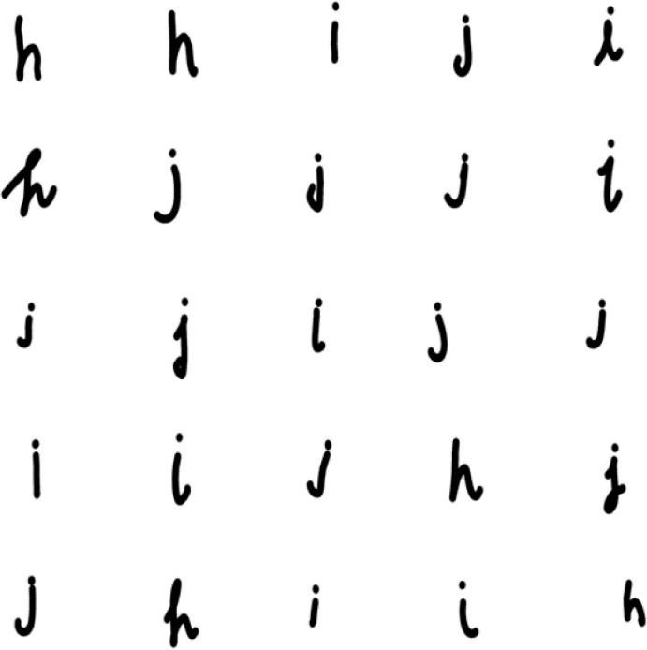

# Exploratory Data Analysis. Histogram For The Images

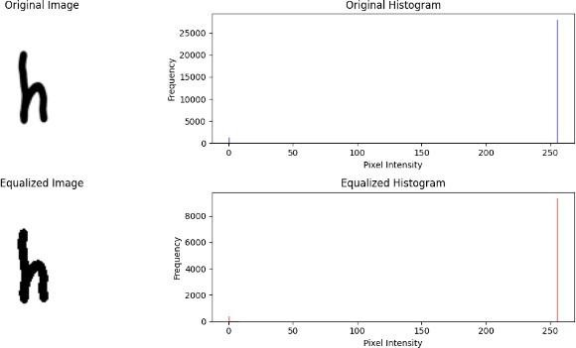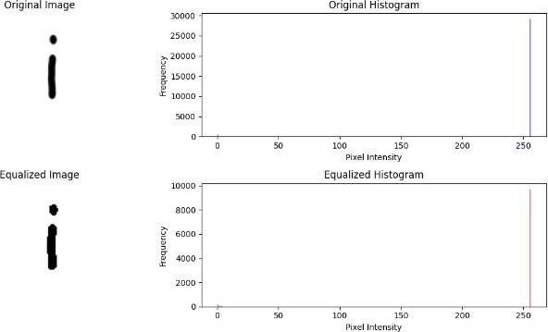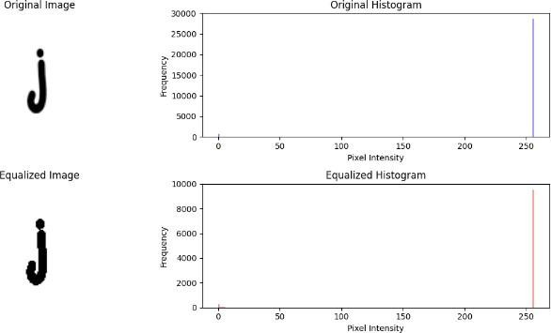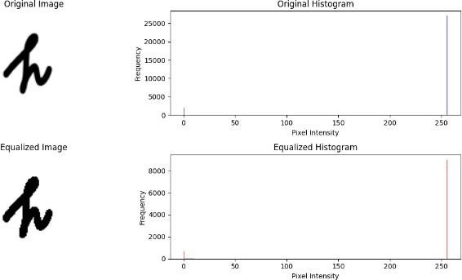

**Split the data into training, testing and validation sets**

y=pd.read_csv("/content/drive/MyDrive/english.csv")

len(y)

y

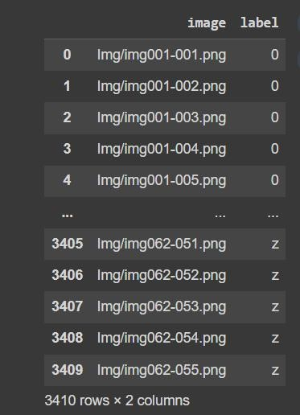

# CNN Model

x_train, x_test, y_train, y_test = train_test_split(x, y, test_size=0.3, random_state=42)

print("x_train Dataset shape:", x_train.shape) print("y_train shape:", len(y_train)) print("x_test shape:", x_test.shape)

print("y_test shape:", len(y_test))

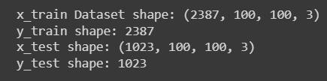

y_train_array = y_train.to_numpy() y_test_array = y_test.to_numpy()

y_train_indices = np.argmax(y_train_array, axis=1) y_test_indices = np.argmax(y_test_array, axis=1)

label_encoder = LabelEncoder()

y_train_encoded = label_encoder.fit_transform(y_train_indices) y_test_encoded = label_encoder.transform(y_test_indices)

model = tf.keras.Sequential([

tf.keras.layers.Conv2D(32, (3, 3), activation='relu',

input_shape=(100, 100, 3)),

tf.keras.layers.MaxPooling2D((2, 2)),

tf.keras.layers.Conv2D(64, (3, 3), activation='relu'),

tf.keras.layers.MaxPooling2D((2, 2)),

tf.keras.layers.Conv2D(128, (3, 3), activation='relu'),

tf.keras.layers.MaxPooling2D((2, 2)), tf.keras.layers.Flatten(), tf.keras.layers.Dense(256, activation='relu'), tf.keras.layers.Dropout(0.5), tf.keras.layers.Dense(128, activation='relu'), tf.keras.layers.Dropout(0.5), tf.keras.layers.Dense(62, activation='softmax')

])

model.compile(optimizer=tf.keras.optimizers.Adam(lr=.01), loss='sparse_categorical_crossentropy', metrics=['accuracy'])

history = model.fit(x_train, y_train_encoded, epochs=20, validation_data=(x_test, y_test_encoded))

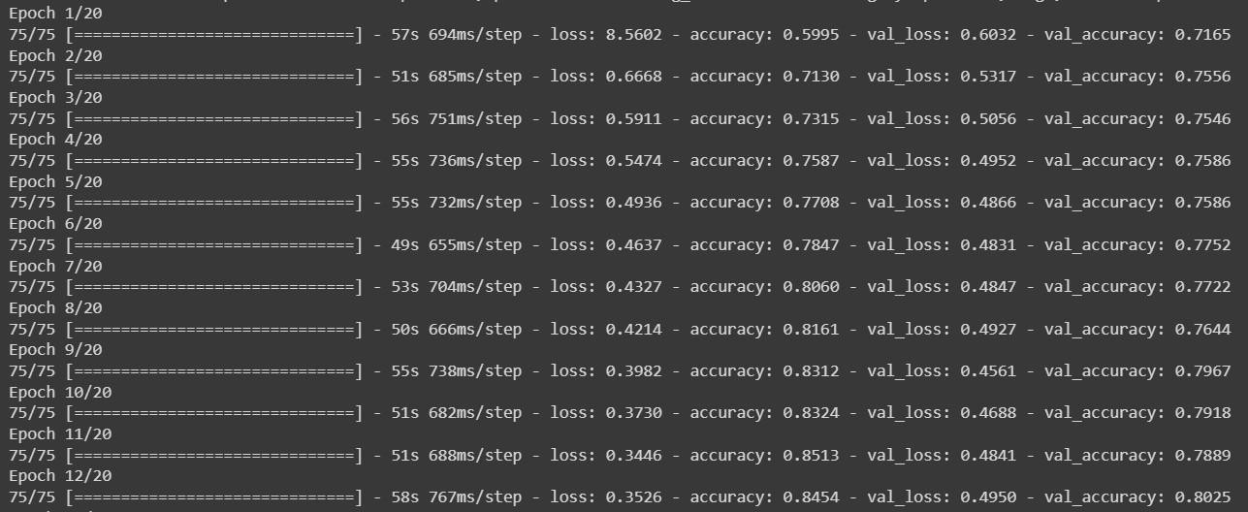

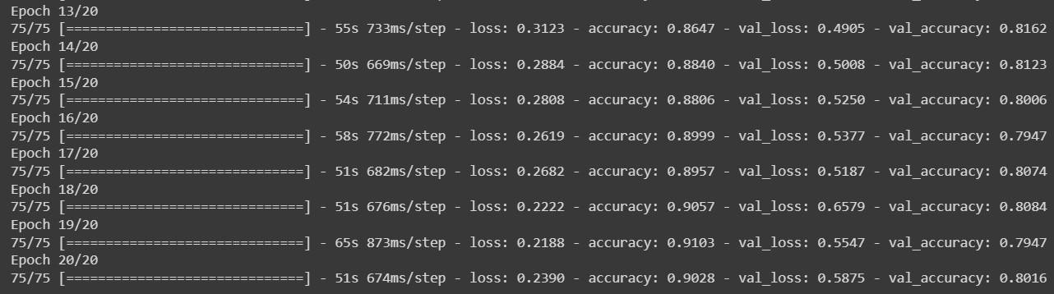

test_loss, test_accuracy = model.evaluate(x_test, y_test_encoded) print(f"testing Accuracy of Neural Network model using keras :

{test_accuracy}\n\n\n\n")

plt.plot(history.history['accuracy'], label='Training Accuracy') plt.plot(history.history['val_accuracy'], label='Validation Accuracy') plt.xlabel('Epoch')

plt.ylabel('Accuracy') plt.legend(loc='lower right')

plt.show()

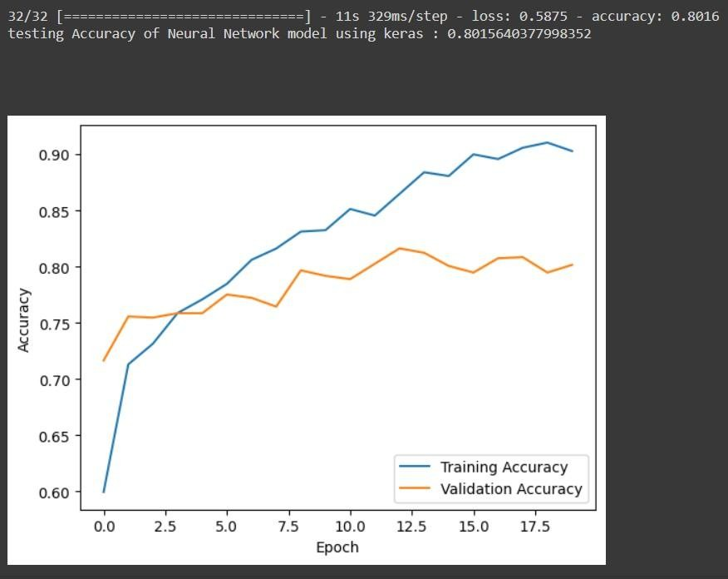

**Neural network model Using Single Layer perceptron model**

x_train, x_test, y_train, y_test = train_test_split(x1, y, test_size=0.3, random_state=42)

y_train_array = y_train.to_numpy() y_test_array = y_test.to_numpy()

y_train_indices = np.argmax(y_train_array, axis=1) y_test_indices = np.argmax(y_test_array, axis=1)

label_encoder = LabelEncoder()

y_train_encoded = label_encoder.fit_transform(y_train_indices) y_test_encoded = label_encoder.transform(y_test_indices)

perceptron_model = Perceptron(max_iter=20, eta0=0.01)

train_accuracies = [] val_accuracies = []

for epoch in range(20):

perceptron_model.partial_fit(x_train, y_train_encoded, classes=np.unique(y_train_encoded))

y_train_pred = perceptron_model.predict(x_train)

train_accuracy = accuracy_score(y_train_encoded, y_train_pred) train_accuracies.append(train_accuracy)

y_val_pred = perceptron_model.predict(x_test)

val_accuracy = accuracy_score(y_test_encoded, y_val_pred) val_accuracies.append(val_accuracy)

print(f"Epoch {epoch+1}/100 - Training Accuracy:

{train_accuracy:.4f}, Validation Accuracy: {val_accuracy:.4f}")

y_test_pred = perceptron_model.predict(x_test)

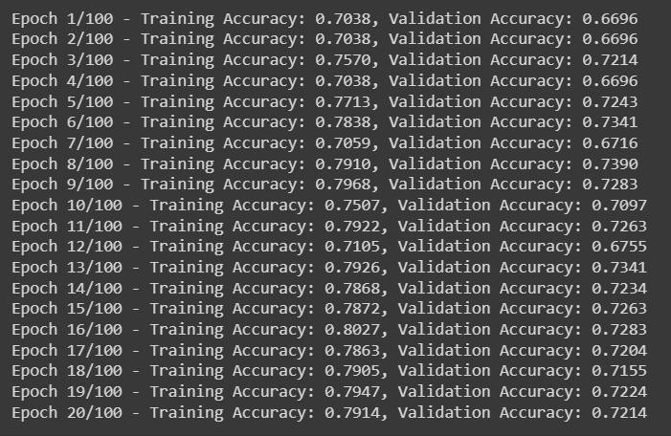

test_accuracy = accuracy_score(y_test_encoded, y_test_pred)

print(f"\n\n\nTesting Accuracy fo Single Layer perceptron model :

{test_accuracy}\n\n\n")

plt.plot(range(1, 21), train_accuracies, label='Training Accuracy') plt.plot(range(1, 21), val_accuracies, label='Validation Accuracy') plt.xlabel('Epoch')

plt.ylabel('Accuracy')

plt.legend(loc='lower right')

plt.title('Training and Validation Accuracy over Epochs') plt.show()

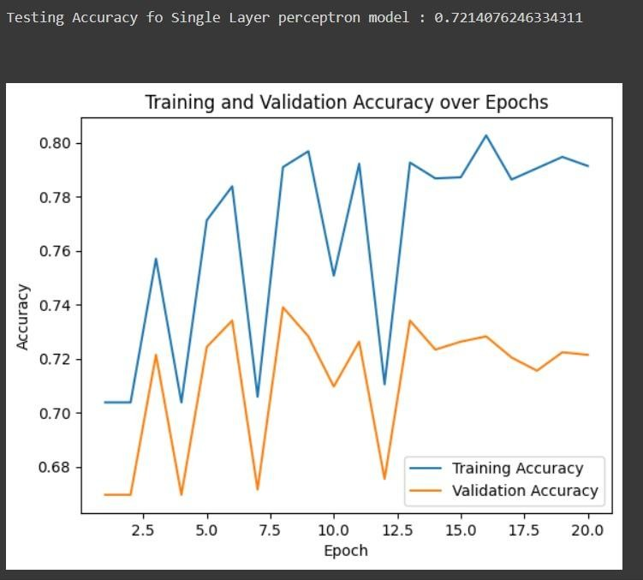

# Neural network model Using multiple Layer perceptron model

x_train, x_test, y_train, y_test = train_test_split(x2, y, test_size=0.3, random_state=42)

y_train_array = y_train.to_numpy() y_test_array = y_test.to_numpy()

y_train_indices = np.argmax(y_train_array, axis=1) y_test_indices = np.argmax(y_test_array, axis=1)

label_encoder = LabelEncoder()

y_train_encoded = label_encoder.fit_transform(y_train_indices) y_test_encoded = label_encoder.transform(y_test_indices)

mlp_model = MLPClassifier(hidden_layer_sizes=(100,), max_iter=20, learning_rate_init=0.01)

train_accuracies = [] val_accuracies = []

for epoch in range(20): mlp_model.partial_fit(x_train, y_train_encoded,

classes=np.unique(y_train_encoded)) y_train_pred = mlp_model.predict(x_train)

train_accuracy = accuracy_score(y_train_encoded, y_train_pred) train_accuracies.append(train_accuracy)

y_val_pred = mlp_model.predict(x_test)

val_accuracy = accuracy_score(y_test_encoded, y_val_pred) val_accuracies.append(val_accuracy)

print(f"Epoch {epoch+1}/20 - Training Accuracy:

{train_accuracy:.4f}, Validation Accuracy: {val_accuracy:.4f}") y_test_pred = mlp_model.predict(x_test)

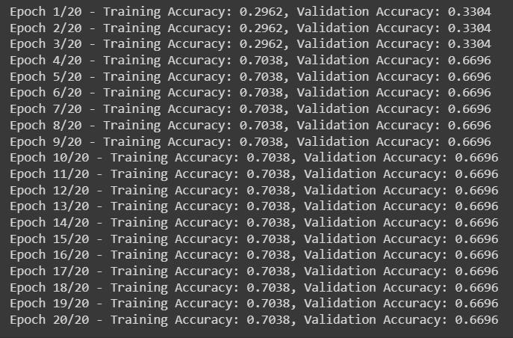

test_accuracy = accuracy_score(y_test_encoded, y_test_pred)

print(f"Testing Accuracy fo Multiple Layer perceptron model :

{test_accuracy}")

plt.plot(range(1, 21), train_accuracies, label='Training Accuracy') plt.plot(range(1, 21), val_accuracies, label='Validation Accuracy') plt.xlabel('Epoch')

plt.ylabel('Accuracy') plt.legend(loc='lower right')

plt.title('Training and Validation Accuracy over Epochs')

plt.show()

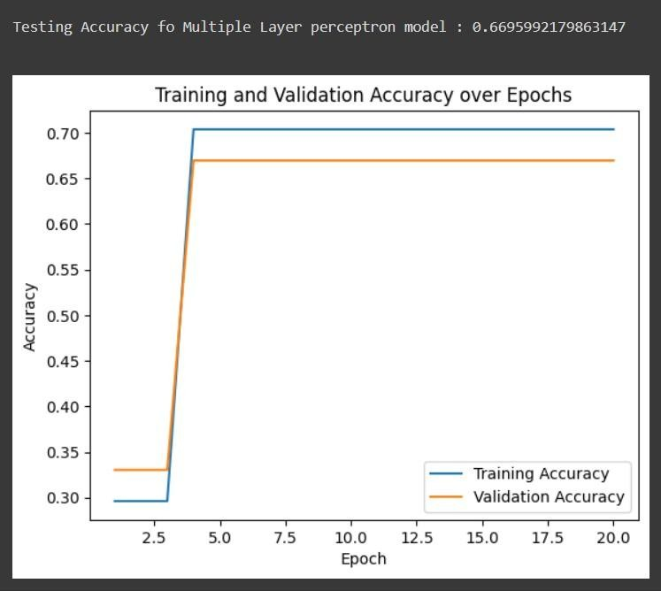

# Inferences

* All the Images in the dataset are **normalized**
* All the Images in the dataset are **resized** for th**e image Enhancement**
* The same Input Images are divided for **training and the testing** with the **ratio** of

**70 : 30** for the Three Models

* The Accuracy For the Three model are shown below

|  |  |
| --- | --- |
| 1) **Convolutional neural network** | **80.15640377998352** |
| **2) Single Layer perceptron model** | **72.14076246334311** |
| **3) Multiple Layer perceptron model** | **66.95992179863147** |

**Github Link:** https://github.com/Anandh-007/handwritten-charachter-recognition

# Learning Outcome

* The Size of the Image dataset will affect the ML model
* While reading the Images we need to consider the image size because it will affect the quality of the Images. It will affect the Accuracy of the Model also
* The Maximum number of Epochs for the Neural network Model plays the major role in the accuracy
* We need to consider the Learning rate for the models.