# UCS2612 Machine Learning Laboratory

A9. Applications of dimensionality reduction techniques

# ANANDH K

3122 21 5001 009

# CSE-A

Description

The two datasets are related to red and white variants of the Portuguese "Vinho Verde" wine. For more details, consult: <http://www.vinhoverde.pt/en/>or the reference [Cortez et al., 2009]. Due to privacy and logistic issues, only physicochemical (inputs) and sensory (the output) variables are available (e.g. there is no data about grape types, wine brand, wine selling price, etc.). These datasets can be viewed as classification or regression tasks. The classes are ordered and not balanced (e.g. there are many more normal wines than excellent or poor ones). Outlier detection algorithms could be used to detect the few excellent or poor wines. Also, we are not sure if all input variables are relevant. So it could be interesting to test feature selection methods. The data can be used to test (ordinal) regression or classification (in effect, this is a multi-class task, where the clases are ordered) methods. Other research issues are feature selection and outlier detection. The data includes two datasets:

* winequality-red.csv - red wine preference samples;
* winequality-white.csv - white wine preference samples;

# Aim

Develop a python program to perform dimensionality reduction using PCA and LDA. Visualize the features from the dataset and interpret the results obtained by the model using Matplotlib library.

Dataset:- <http://www3.dsi.uminho.pt/pcortez/wine/winequality.zip>

# Import Libraries

import numpy as np import pandas as pd

import matplotlib.pyplot as plt

from sklearn.metrics import roc_curve, roc_auc_score from sklearn.model_selection import train_test_split import seaborn as sns

import matplotlib.pyplot as plt

from sklearn.preprocessing import LabelEncoder

from sklearn.preprocessing import StandardScaler, MinMaxScaler from sklearn.preprocessing import StandardScaler

from sklearn.ensemble import RandomForestClassifier,

GradientBoostingClassifier

from sklearn.metrics import accuracy_score, classification_report, confusion_matrix

import numpy as np

import matplotlib.pyplot as plt

Read dataset

*# importing or loading the dataset*

data = pd.read_csv("C:/Users/ashwi/Downloads/ML Lab/A9/winequality/winequality-red.csv",header=0, sep=";")

data.head()

|  |  |  |  |  |  |  |  |  |
| --- | --- | --- | --- | --- | --- | --- | --- | --- |
| fixed a chlorides 0  0.076  1 | cidity  \  7.4  7.8 | volatile | | acidity  0.70  0.88 | citric | acid 0.00  0.00 | residual | sugar  1.9  2.6 |
| 0.098 |  | | 0.76  0.28  0.70 | | 0.04  0.56  0.00 | | 2.3  1.9  1.9 | |
| 2 | 7.8 | |
| 0.092 |  | |
| 3 | 11.2 | |
| 0.075 |  | |
| 4 | 7.4 | |
| 0.076 | | |

|  |  |  |  |  |  |  |  |  |  |
| --- | --- | --- | --- | --- | --- | --- | --- | --- | --- |
|  | free | sulfur | dioxide | total | sulfur | dioxide | density | pH | sulphates |
| \ |  |  |  |  |  |  |  |  |  |
| 0 |  |  | 11.0 |  |  | 34.0 | 0.9978 | 3.51 | 0.56 |
|  |  |  |  |  |  |  |  |  |  |
| 1 |  |  | 25.0 |  |  | 67.0 | 0.9968 | 3.20 | 0.68 |

|  |  |  |  |  |  |  |
| --- | --- | --- | --- | --- | --- | --- |
| 2 |  | 15.0 | 54.0 | 0.9970 | 3.26 | 0.65 |
|  |  |  |  |  |  |  |
| 3 |  | 17.0 | 60.0 | 0.9980 | 3.16 | 0.58 |
|  |  |  |  |  |  |  |
| 4 |  | 11.0 | 34.0 | 0.9978 | 3.51 | 0.56 |
|  |  |  |  | | | |
|  | alcohol | quality |
| 0 | 9.4 | 5 |
| 1 | 9.8 | 5 |
| 2 | 9.8 | 5 |
| 3 | 9.8 | 6 |
| 4 | 9.4 | 5 |

data.describe()

|  |  |  |  |  |
| --- | --- | --- | --- | --- |
| count | fixed acidity volatile acidity 1599.000000 1599.000000 | | citric acid r 1599.000000 | esidual sugar \ 1599.000000 |
| mean | 8.319637 | 0.527821 | 0.270976 | 2.538806 |
| std | 1.741096 | 0.179060 | 0.194801 | 1.409928 |
| min | 4.600000 | 0.120000 | 0.000000 | 0.900000 |
| 25% | 7.100000 | 0.390000 | 0.090000 | 1.900000 |
| 50% | 7.900000 | 0.520000 | 0.260000 | 2.200000 |
| 75% | 9.200000 | 0.640000 | 0.420000 | 2.600000 |
| max | 15.900000 | 1.580000 | 1.000000 | 15.500000 |

chlorides free sulfur dioxide total sulfur dioxide

density \

count 1599.000000 1599.000000 1599.000000

1599.000000

|  |  |  |  |
| --- | --- | --- | --- |
| mean | 0.087467 | 15.874922 | 46.467792 |
| 0.996747 |  |  |  |
| std | 0.047065 | 10.460157 | 32.895324 |
| 0.001887 |  |  |  |
| min | 0.012000 | 1.000000 | 6.000000 |
| 0.990070 |  |  |  |
| 25% | 0.070000 | 7.000000 | 22.000000 |
| 0.995600 |  |  |  |
| 50% | 0.079000 | 14.000000 | 38.000000 |
| 0.996750 |  |  |  |
| 75% | 0.090000 | 21.000000 | 62.000000 |
| 0.997835 |  |  |  |
| max | 0.611000 | 72.000000 | 289.000000 |
| 1.003690 |  |  |  |

|  |  |  |  |  |
| --- | --- | --- | --- | --- |
| count | pH 1599.000000 | sulphates 1599.000000 | alcohol 1599.000000 | quality 1599.000000 |
| mean | 3.311113 | 0.658149 | 10.422983 | 5.636023 |
| std | 0.154386 | 0.169507 | 1.065668 | 0.807569 |

|  |  |  |  |  |  |
| --- | --- | --- | --- | --- | --- |
|  |  |  |  |  |  |
| min | 2.740000 | 0.330000 | 8.400000 | 3.000000 |
| 25% | 3.210000 | 0.550000 | 9.500000 | 5.000000 |
| 50% | 3.310000 | 0.620000 | 10.200000 | 6.000000 |
| 75% | 3.400000 | 0.730000 | 11.100000 | 6.000000 |
|  | max | 4.010000 | 2.000000 | 14.900000 | 8.000000 |

# Data Pre-processing

data.corr()

|  |  |  |  |
| --- | --- | --- | --- |
| f  fixed acidity | ixed acidity volatile acidity 1.000000 -0.256131 | | citric acid \ 0.671703 |
| volatile acidity | -0.256131 | 1.000000 | -0.552496 |
| citric acid | 0.671703 | -0.552496 | 1.000000 |
| residual sugar | 0.114777 | 0.001918 | 0.143577 |
| chlorides | 0.093705 | 0.061298 | 0.203823 |
| free sulfur dioxide | -0.153794 | -0.010504 | -0.060978 |
| total sulfur dioxide | -0.113181 | 0.076470 | 0.035533 |
| density | 0.668047 | 0.022026 | 0.364947 |
| pH | -0.682978 | 0.234937 | -0.541904 |
| sulphates | 0.183006 | -0.260987 | 0.312770 |
| alcohol | -0.061668 | -0.202288 | 0.109903 |
| quality | 0.124052 | -0.390558 | 0.226373 |

residual sugar chlorides free sulfur dioxide \

|  |  |  |  |
| --- | --- | --- | --- |
| fixed acidity | 0.114777 | 0.093705 | -0.153794 |
|  |  |  |  |
| volatile acidity | 0.001918 | 0.061298 | -0.010504 |
|  |  |  |  |
| citric acid | 0.143577 | 0.203823 | -0.060978 |
|  |  |  |  |
| residual sugar | 1.000000 | 0.055610 | 0.187049 |
|  |  |  |  |
| chlorides | 0.055610 | 1.000000 | 0.005562 |
|  |  |  |  |
| free sulfur dioxide | 0.187049 | 0.005562 | 1.000000 |
|  |  |  |  |
| total sulfur dioxide | 0.203028 | 0.047400 | 0.667666 |
|  |  |  |  |
| density | 0.355283 | 0.200632 | -0.021946 |
|  |  |  |  |
| pH | -0.085652 | -0.265026 | 0.070377 |
|  |  |  |  |
| sulphates | 0.005527 | 0.371260 | 0.051658 |
|  |  |  |  |
| alcohol | 0.042075 | -0.221141 | -0.069408 |
|  |  |  |  |
| quality | 0.013732 | -0.128907 | -0.050656 |

total sulfur dioxide density pH

sulphates \

fixed acidity -0.113181 0.668047 -0.682978

0.183006

volatile acidity

0.076470 0.022026 0.234937 -

0.260987

0.312770

citric acid

0.035533 0.364947 -0.541904

0.005527

residual sugar

0.203028 0.355283 -0.085652

0.371260

chlorides

0.047400 0.200632 -0.265026

free sulfur dioxide 0.667666 -0.021946 0.070377

0.051658

total sulfur dioxide 1.000000 0.071269 -0.066495

0.042947

density 0.071269 1.000000 -0.341699

0.148506

pH -0.066495 -0.341699 1.000000 -

0.196648

|  |  |  |
| --- | --- | --- |
| sulphates | | 0.042947 0.148506 -0.196648 |
| 1.000000 |  | |
| alcohol | | -0.205654 -0.496180 0.205633 |
| 0.093595 |  | |
| quality | | -0.185100 -0.174919 -0.057731 |
| 0.251397 |  | |

|  |  |  |
| --- | --- | --- |
|  | alcohol | quality |
| fixed acidity | -0.061668 | 0.124052 |
| volatile acidity | -0.202288 | -0.390558 |
| citric acid | 0.109903 | 0.226373 |
| residual sugar | 0.042075 | 0.013732 |
| chlorides | -0.221141 | -0.128907 |
| free sulfur dioxide | -0.069408 | -0.050656 |
| total sulfur dioxide | -0.205654 | -0.185100 |
| density | -0.496180 | -0.174919 |
| pH | 0.205633 | -0.057731 |
| sulphates | 0.093595 | 0.251397 |
| alcohol | 1.000000 | 0.476166 |
| quality | 0.476166 | 1.000000 |

data.dropna(inplace=True) scaler_standard = StandardScaler()

data_standardized = scaler_standard.fit_transform(data)

scaler_normal = MinMaxScaler()

data_normalized = scaler_normal.fit_transform(data)

data_standardized = pd.DataFrame(data_standardized, columns=data.columns)

data_normalized = pd.DataFrame(data_normalized, columns=data.columns) data_standardized.head()

fixed acidity volatile acidity citric acid residual sugar

chlorides \

0 -0.528360 0.961877 -1.391472 -0.453218 -

0.243707

1 -0.298547 1.967442 -1.391472 0.043416

0.223875

|  |  |  |  |  |  |
| --- | --- | --- | --- | --- | --- |
| 2 | -0.298547 | 1.297065 | -1.186070 | -0.169427 | |
| 0.096353 | |  |  |  |  |
| 3 1.654856 | | -1.384443 | 1.484154 | -0.453218 | - |
| 0.264960 | |  |  |  |  |
| 4 -0.528360 | | 0.961877 | -1.391472 | -0.453218 | - |

0.243707

free sulfur dioxide total sulfur dioxide density pH sulphates \

0 -0.466193 -0.379133 0.558274 1.288643 -

0.128950

0.579207

1

0.872638 0.624363 0.028261 -0.719933

-

0.048089

3

0.461180

4

0.579207

2 -0.083669 0.229047 0.134264 -0.331177

0.107592 0.411500 0.664277 -0.979104 -

-0.466193 -0.379133 0.558274 1.288643 -

|  |  |
| --- | --- |
| alcohol | quality |
| 0 -0.960246 | -0.787823 |
| 1 -0.584777 | -0.787823 |
| 2 -0.584777 | -0.787823 |
| 3 -0.584777 | 0.450848 |
| 4 -0.960246 | -0.787823 |

data_normalized.head()

fixed acidity volatile acidity citric acid residual sugar chlorides \

|  |  |  |  |  |
| --- | --- | --- | --- | --- |
| 0 | 0.247788 | 0.397260 | 0.00 | 0.068493 |
| 0.106845 |  |  |  |  |
| 1 | 0.283186 | 0.520548 | 0.00 | 0.116438 |
| 0.143573 |  |  |  |  |
| 2 | 0.283186 | 0.438356 | 0.04 | 0.095890 |
| 0.133556 |  |  |  |  |
| 3 | 0.584071 | 0.109589 | 0.56 | 0.068493 |

|  |  |  |  |  |
| --- | --- | --- | --- | --- |
| 0 | 0.140845 | 0.098940 | 0.567548 | 0.606299 |
| 0.137725 |  |  |  |  |
| 1 | 0.338028 | 0.215548 | 0.494126 | 0.362205 |
| 0.209581 |  |  |  |  |
| 2 | 0.197183 | 0.169611 | 0.508811 | 0.409449 |
| 0.191617 |  |  |  |  |
| 3 | 0.225352 | 0.190813 | 0.582232 | 0.330709 |
| 0.149701 |  |  |  |  |
| 4 | 0.140845 | 0.098940 | 0.567548 | 0.606299 |
| 0.137725 |  |  |  |  |

|  |  |  |
| --- | --- | --- |
|  | alcohol | quality |
| 0 | 0.153846 | 0.4 |
| 1 | 0.215385 | 0.4 |
| 2 | 0.215385 | 0.4 |
| 3 | 0.215385 | 0.6 |
| 4 | 0.153846 | 0.4 |

# EDA

0.105175

0.106845

free sulfur dioxide total sulfur dioxide density pH sulphates \

4 0.247788 0.397260 0.00 0.068493

plt.figure(figsize=(12, 10))

sns.heatmap(data.corr(), annot=True, cmap='coolwarm', fmt='.2f', linewidths=0.5)

plt.title('Correlation Heatmap') plt.show()

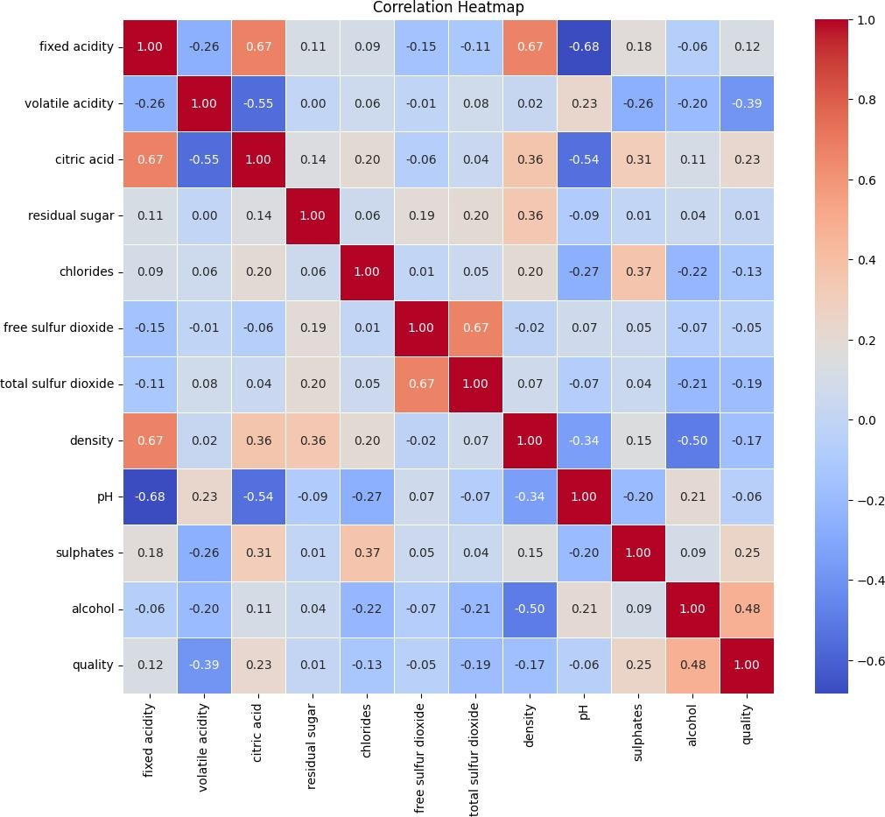

Splitting the data into testing and training

*# distributing the dataset into two components X and Y*

X_red = data.iloc[:, 0:11].values y_red = data.iloc[:, 11].values

X_train_red, X_test_red, y_train_red, y_test_red = train_test_split(X_red,y_red, test_size=0.2, random_state=0)

# Feature engineering

*# performing preprocessing part*

from sklearn.preprocessing import StandardScaler sc = StandardScaler()

X_train_red = sc.fit_transform(X_train_red) X_test_red = sc.transform(X_test_red)

Building PCA model

from sklearn.decomposition import PCA PCa = PCA(n_components = 2)

X_train_red = PCa.fit_transform(X_train_red) X_test_red = PCa.transform(X_test_red)

explained_variance = PCa.explained_variance_ratio_

from sklearn.linear_model import LogisticRegression classifier = LogisticRegression(random_state = 0) classifier.fit(X_train_red, y_train_red)

LogisticRegression(random_state=0) y_pred_red = classifier.predict(X_test_red) from sklearn.metrics import confusion_matrix

cm = confusion_matrix(y_test_red, y_pred_red) print(cm) accuracy_score(y_test_red,y_pred_red)

|  |  |  |  |  |  |  |
| --- | --- | --- | --- | --- | --- | --- |
| [[ | 0 | 0 | 0 | 2 | 0 | 0] |
| [ | 0 | 0 | 4 | 7 | 0 | 0] |
| [ | 0 | 0 | 89 | 45 | 1 | 0] |
| [ | 0 | 0 | 55 | 81 | 6 | 0] |
| [ | 0 | 0 | 4 | 21 | 2 | 0] |
| [ | 0 | 0 | 0 | 2 | 1 | 0]] |

0.5375

# Visualisation of PCA model

*# result through scatter plot*

from matplotlib.colors import ListedColormap

X_set, y_set = X_train_red, y_train_red

X1, X2 = np.meshgrid(np.arange(start = X_set[:, 0].min() - 1,

stop = X_set[:, 0].max() + 1, step = 0.01),

np.arange(start = X_set[:, 1].min() - 1,

stop = X_set[:, 1].max() + 1, step = 0.01))

plt.contourf(X1, X2, classifier.predict(np.array([X1.ravel(), X2.ravel()]).T).reshape(X1.shape), alpha = 0.75,

cmap = ListedColormap(('yellow', 'white', 'aquamarine')))

plt.xlim(X1.min(), X1.max())

plt.ylim(X2.min(), X2.max())

for i, j in enumerate(np.unique(y_set)): plt.scatter(X_set[y_set == j, 0], X_set[y_set == j, 1],

c = ListedColormap(('red', 'green', 'blue'))(i), label

= j)

plt.title('Logistic Regression (Training set)') plt.xlabel('PC1') *# for Xlabel* plt.ylabel('PC2') *# for Ylabel*

plt.legend() *# to show legend*

*# show scatter plot*

plt.show()

C:\Users\nithi\AppData\Local\Temp\ipykernel_4776\4008791166.py:18: UserWarning: *c* argument looks like a single numeric RGB or RGBA sequence, which should be avoided as value-mapping will have precedence in case its length matches with *x* & *y*. Please use the

*color* keyword-argument or provide a 2D array with a single row if you intend to specify the same RGB or RGBA value for all points.

plt.scatter(X_set[y_set == j, 0], X_set[y_set == j, 1],

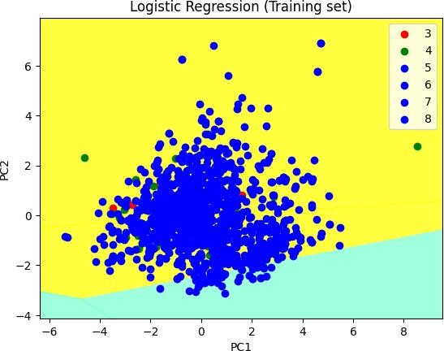

*# Visualising the Test set results through scatter plot*

from matplotlib.colors import ListedColormap X_set, y_set = X_test_red, y_test_red

X1, X2 = np.meshgrid(np.arange(start = X_set[:, 0].min() - 1,

stop = X_set[:, 0].max() + 1, step = 0.01),

np.arange(start = X_set[:, 1].min() - 1,

stop = X_set[:, 1].max() + 1, step = 0.01))

plt.contourf(X1, X2, classifier.predict(np.array([X1.ravel(), X2.ravel()]).T).reshape(X1.shape), alpha = 0.75,

cmap = ListedColormap(('yellow', 'white', 'aquamarine')))

plt.xlim(X1.min(), X1.max())

plt.ylim(X2.min(), X2.max())

for i, j in enumerate(np.unique(y_set)): plt.scatter(X_set[y_set == j, 0], X_set[y_set == j, 1],

c = ListedColormap(('red', 'green', 'blue'))(i), label

= j)

*# title for scatter plot* plt.title('Logistic Regression (Test set)') plt.xlabel('PC1') *# for Xlabel* plt.ylabel('PC2') *# for Ylabel*

plt.legend()

*# show scatter plot*

plt.show()

C:\Users\nithi\AppData\Local\Temp\ipykernel_4776\3957206111.py:19: UserWarning: *c* argument looks like a single numeric RGB or RGBA sequence, which should be avoided as value-mapping will have precedence in case its length matches with *x* & *y*. Please use the

*color* keyword-argument or provide a 2D array with a single row if you intend to specify the same RGB or RGBA value for all points.

plt.scatter(X_set[y_set == j, 0], X_set[y_set == j, 1],

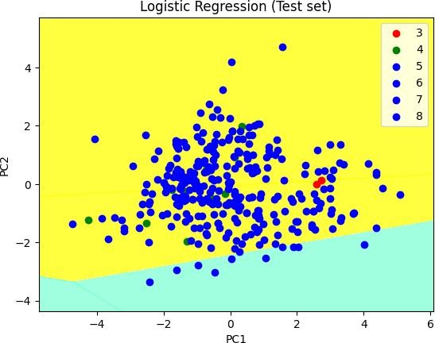

# Building LDA model

from sklearn.discriminant_analysis import LinearDiscriminantAnalysis as LDA

lda = LDA(n_components = 2)

X_train_red = lda.fit_transform(X_train_red, y_train_red) X_test_red = lda.transform(X_test_red)

from sklearn.linear_model import LogisticRegression from sklearn.metrics import accuracy_score classifier = LogisticRegression(random_state = 0) classifier.fit(X_train_red, y_train_red)

LogisticRegression(random_state=0)

y_pred = classifier.predict(X_test_red) print(y_pred)

[5 5 6 6 7 5 6 5 6 5 6 6 6 5 5 5 7 6 6 5 6 6 6 5 5 5 5 6 5 6 6 5 5 5 5

6 5

5 6 6 5 6 6 7 6 5 6 5 6 6 6 5 5 6 5 5 5 6 6 6 5 5 5 6 5 6 6 6 6 6 5 5

5 5

5 6 6 5 5 6 5 5 6 6 5 5 5 6 6 5 5 5 6 6 6 5 6 6 6 6 6 6 5 6 6 6 6 5 6

5 6

5 6 5 6 5 6 6 6 6 5 6 5 5 5 6 5 5 6 6 5 6 6 6 6 5 6 5 6 6 6 5 6 5 6 6

6 7

6 6 6 6 5 6 6 5 6 6 6 5 6 6 6 5 6 5 5 6 5 6 5 5 5 7 5 6 6 6 6 5 5 6 5

5 7

5 5 5 5 5 6 6 6 6 5 5 6 5 5 5 5 6 5 6 5 5 5 6 6 5 6 5 5 5 5 5 6 6 5 5

5 6

6 6 5 5 6 6 6 6 5 6 5 5 6 5 6 6 7 6 5 5 5 5 6 5 5 5 5 6 5 5 5 6 6 5 5

6 5

5 5 6 5 6 6 6 5 5 6 5 6 6 6 6 6 5 6 5 7 6 5 6 6 6 6 5 6 6 6 5 5 6 6 6

5 6

5 5 5 5 5 6 6 5 6 5 5 5 5 5 5 5 5 6 5 7 6 6 6 7]

accuracy = accuracy_score(y_test_red, y_pred) print("Accuracy of LDA model:", accuracy)

Accuracy of LDA model: 0.5375

# Visualisation of LDA model

from matplotlib.colors import ListedColormap X_set, y_set = X_test_red, y_test_red

X1, X2 = np.meshgrid(np.arange(start = X_set[:, 0].min() - 1, stop = X_set[:, 0].max() + 1, step = 0.01), np.arange(start = X_set[:, 1].min() - 1, stop = X_set[:, 1].max() + 1, step = 0.01))

plt.contourf(X1,X2,classifier.predict(np.array([X1.ravel(),X2.ravel()]

).T).reshape(X1.shape), alpha = 0.75, cmap = ListedColormap(('red', 'green', 'blue')))

plt.xlim(X1.min(), X1.max())

plt.ylim(X2.min(), X2.max())

for i, j in enumerate(np.unique(y_set)): plt.scatter(X_set[y_set == j, 0], X_set[y_set == j, 1],

c = ListedColormap(('red', 'green', 'blue'))(i), label

= j)

plt.title('Logistic Regression (Test set)') plt.xlabel('LD1')

plt.ylabel('LD2') plt.legend() plt.show()

C:\Users\nithi\AppData\Local\Temp\ipykernel_4776\531035640.py:12: UserWarning: *c* argument looks like a single numeric RGB or RGBA sequence, which should be avoided as value-mapping will have precedence in case its length matches with *x* & *y*. Please use the

*color* keyword-argument or provide a 2D array with a single row if you intend to specify the same RGB or RGBA value for all points.

plt.scatter(X_set[y_set == j, 0], X_set[y_set == j, 1],

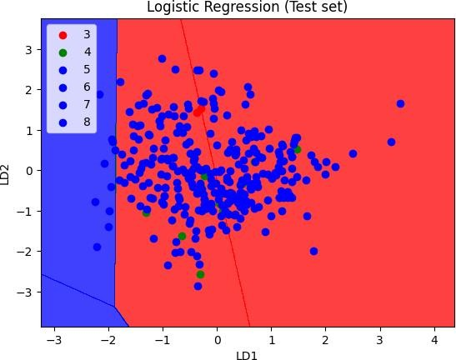

from matplotlib.colors import ListedColormap X_set, y_set = X_train_red, y_train_red

X1, X2 = np.meshgrid(np.arange(start = X_set[:, 0].min() - 1, stop = X_set[:, 0].max() + 1, step = 0.01), np.arange(start = X_set[:, 1].min() - 1, stop = X_set[:, 1].max() + 1, step = 0.01))

plt.contourf(X1,X2,classifier.predict(np.array([X1.ravel(),X2.ravel()]

).T).reshape(X1.shape), alpha = 0.75, cmap = ListedColormap(('red', 'green', 'blue')))

plt.xlim(X1.min(), X1.max())

plt.ylim(X2.min(), X2.max())

for i, j in enumerate(np.unique(y_set)): plt.scatter(X_set[y_set == j, 0], X_set[y_set == j, 1],

c = ListedColormap(('red', 'green', 'blue'))(i), label

= j)

plt.title('Logistic Regression (Training set)') plt.xlabel('LD1')

plt.ylabel('LD2') plt.legend() plt.show()

C:\Users\nithi\AppData\Local\Temp\ipykernel_4776\171321940.py:12: UserWarning: *c* argument looks like a single numeric RGB or RGBA sequence, which should be avoided as value-mapping will have precedence in case its length matches with *x* & *y*. Please use the

*color* keyword-argument or provide a 2D array with a single row if you intend to specify the same RGB or RGBA value for all points.

plt.scatter(X_set[y_set == j, 0], X_set[y_set == j, 1],

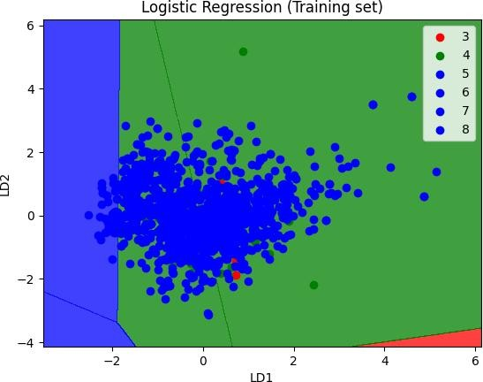

# Inference

1. After applying PCA, you can analyze the principal components to understand which original features contribute the most to the variance in the data. You can also visualize the data in reduced dimensions to explore patterns or clusters.
2. After applying LDA, you can interpret the learned linear discriminants to understand how the classes are separated in the reduced-dimensional space. LDA provides insight into which features are most discriminative for class separation.

# Learning Outcomes

1. Implementation of Pre-processing, EDA and feature selection.
2. Implementation of PCA nad LDA models and visualising it.
3. Displaying the confusion matrix.
4. Understanding the techniques of dimentionality reduction.

**GITHUB LINK**

https://github.com/Anandh-007/Machine-learning-lab/tree/main/ML_A9