UCS2612 Machine Learning Laboratory

A9. Applications of dimensionality reduction techniques

ANANDH K 3122 21 5001 009

CSE-A

Description

The two datasets are related to red and white variants of the Portuguese "Vinho Verde" wine. For more details, consult: <http://www.vinhoverde.pt/en/> or the reference [Cortez et al., 2009]. Due to privacy and logistic issues, only physicochemical (inputs) and sensory (the output) variables are available (e.g. there is no data about grape types, wine brand, wine selling price, etc.). These datasets can be viewed as classification or regression tasks. The classes are ordered and not balanced (e.g. there are many more normal wines than excellent or poor ones). Outlier detection algorithms could be used to detect the few excellent or poor wines. Also, we are not sure if all input variables are relevant. So it could be interesting to test feature selection methods. The data can be used to test (ordinal) regression or classification (in effect, this is a multi-class task, where the clases are ordered) methods. Other research issues are feature selection and outlier detection. The data includes two datasets:

* winequality-red.csv - red wine preference samples;
* winequality-white.csv - white wine preference samples;

Aim

Develop a python program to perform dimensionality reduction using PCA and LDA. Visualize the features from the dataset and interpret the results obtained by the model using Matplotlib library.

Dataset:- <http://www3.dsi.uminho.pt/pcortez/wine/winequality.zip>

Import libraries

import numpy as np import pandas as pd

import matplotlib.pyplot as plt

from sklearn.metrics import roc_curve, roc_auc_score from sklearn.model_selection import train_test_split import seaborn as sns

import matplotlib.pyplot as plt

from sklearn.preprocessing import LabelEncoder

from sklearn.preprocessing import StandardScaler, MinMaxScaler from sklearn.preprocessing import StandardScaler

from sklearn.ensemble import RandomForestClassifier,

GradientBoostingClassifier

from sklearn.metrics import accuracy_score, classification_report, confusion_matrix

import numpy as np

import matplotlib.pyplot as plt

Load dataset

*# importing or loading the dataset*

data1 = pd.read_csv('C:/Users/ashwi/Downloads/ML Lab/A9/winequality/winequality-white.csv', sep=";")

data1.head()

|  |  |  |  |  |
| --- | --- | --- | --- | --- |
| fixed acidity volatile acidity citric acid residual sugar chlorides \ | | | | |
| 0 | 7.0 | 0.27 | 0.36 | 20.7 |
| 0.045 |  |  |  |  |
| 1 | 6.3 | 0.30 | 0.34 | 1.6 |
| 0.049 |  |  |  |  |
| 2 | 8.1 | 0.28 | 0.40 | 6.9 |
| 0.050 |  |  |  |  |
| 3 | 7.2 | 0.23 | 0.32 | 8.5 |
| 0.058 |  |  |  |  |
| 4 | 7.2 | 0.23 | 0.32 | 8.5 |
| 0.058 |  |  |  |  |

|  |  |  |  |  |  |  |  |  |  |
| --- | --- | --- | --- | --- | --- | --- | --- | --- | --- |
|  | free | sulfur | dioxide | total | sulfur | dioxide | density | pH | sulphates |
| \ |  |  |  |  |  |  |  |  |  |
| 0 |  |  | 45.0 |  |  | 170.0 | 1.0010 | 3.00 | 0.45 |
|  |  |  |  |  |  |  |  |  |  |
| 1 |  |  | 14.0 |  |  | 132.0 | 0.9940 | 3.30 | 0.49 |

|  |  |  |  |  |  |  |
| --- | --- | --- | --- | --- | --- | --- |
| 2 |  | 30.0 | 97.0 | 0.9951 | 3.26 | 0.44 |
|  |  |  |  |  |  |  |
| 3 |  | 47.0 | 186.0 | 0.9956 | 3.19 | 0.40 |
|  |  |  |  |  |  |  |
| 4 |  | 47.0 | 186.0 | 0.9956 | 3.19 | 0.40 |
|  |  |  |  | | | |
|  | alcohol | quality |
| 0 | 8.8 | 6 |
| 1 | 9.5 | 6 |
| 2 | 10.1 | 6 |
| 3 | 9.9 | 6 |
| 4 | 9.9 | 6 |

data1.describe()

|  |  |  |  |  |
| --- | --- | --- | --- | --- |
| count | fixed acidity volatile acidity 4898.000000 4898.000000 | | citric acid residual sugar \ 4898.000000 4898.000000 | |
| mean | 6.854788 | 0.278241 | 0.334192 | 6.391415 |
| std | 0.843868 | 0.100795 | 0.121020 | 5.072058 |
| min | 3.800000 | 0.080000 | 0.000000 | 0.600000 |
| 25% | 6.300000 | 0.210000 | 0.270000 | 1.700000 |
| 50% | 6.800000 | 0.260000 | 0.320000 | 5.200000 |
| 75% | 7.300000 | 0.320000 | 0.390000 | 9.900000 |
| max | 14.200000 | 1.100000 | 1.660000 | 65.800000 |

chlorides free sulfur dioxide total sulfur dioxide

density \

count 4898.000000 4898.000000 4898.000000

4898.000000

|  |  |  |  |
| --- | --- | --- | --- |
| mean | 0.045772 | 35.308085 | 138.360657 |
| 0.994027 |  | | |
| std | 0.021848 | 17.007137 | 42.498065 |
| 0.002991 |  | | |
| min | 0.009000 | 2.000000 | 9.000000 |
| 0.987110 |  | | |
| 25% | 0.036000 | 23.000000 | 108.000000 |
| 0.991723 |  | | |
| 50% | 0.043000 | 34.000000 | 134.000000 |
| 0.993740 |  | | |
| 75% | 0.050000 | 46.000000 | 167.000000 |
| 0.996100 |  | | |
| max | 0.346000 | 289.000000 | 440.000000 |
| 1.038980 |  | | |

|  |  |  |  |  |
| --- | --- | --- | --- | --- |
|  | pH | sulphates | alcohol | quality |
| count | 4898.000000 | 4898.000000 | 4898.000000 | 4898.000000 |
| mean | 3.188267 | 0.489847 | 10.514267 | 5.877909 |
| std | 0.151001 | 0.114126 | 1.230621 | 0.885639 |

|  |  |  |  |  |  |
| --- | --- | --- | --- | --- | --- |
|  |  | | | | |
| min | 2.720000 | 0.220000 | 8.000000 | 3.000000 |
| 25% | 3.090000 | 0.410000 | 9.500000 | 5.000000 |
| 50% | 3.180000 | 0.470000 | 10.400000 | 6.000000 |
| 75% | 3.280000 | 0.550000 | 11.400000 | 6.000000 |
|  | max | 3.820000 | 1.080000 | 14.200000 | 9.000000 |

Data pre-processing

data1.corr()

|  |  |  |  |  |  |
| --- | --- | --- | --- | --- | --- |
|  |  | fixed acidity | volatile acidity | citric acid | \ |
| fixed acidity | 1.000000 | -0.022697 | 0.289181 |  |
| volatile acidity | -0.022697 | 1.000000 | -0.149472 |  |
| citric acid | 0.289181 | -0.149472 | 1.000000 |  |
| residual sugar | 0.089021 | 0.064286 | 0.094212 |  |
| chlorides | 0.023086 | 0.070512 | 0.114364 |  |
| free sulfur dioxide | -0.049396 | -0.097012 | 0.094077 |  |
| total sulfur dioxide | 0.091070 | 0.089261 | 0.121131 |  |
| density | 0.265331 | 0.027114 | 0.149503 |  |
| pH | -0.425858 | -0.031915 | -0.163748 |  |
| sulphates | -0.017143 | -0.035728 | 0.062331 |  |
| alcohol | -0.120881 | 0.067718 | -0.075729 |  |
|  | quality | -0.113663 | -0.194723 | -0.009209 |  |

residual sugar chlorides free sulfur dioxide \

|  |  |  |  |
| --- | --- | --- | --- |
| fixed acidity | 0.089021 | 0.023086 | -0.049396 |
|  |  |  |  |
| volatile acidity | 0.064286 | 0.070512 | -0.097012 |
|  |  |  |  |
| citric acid | 0.094212 | 0.114364 | 0.094077 |
|  |  |  |  |
| residual sugar | 1.000000 | 0.088685 | 0.299098 |
|  |  |  |  |
| chlorides | 0.088685 | 1.000000 | 0.101392 |
|  |  |  |  |
| free sulfur dioxide | 0.299098 | 0.101392 | 1.000000 |
|  |  |  |  |
| total sulfur dioxide | 0.401439 | 0.198910 | 0.615501 |
|  |  |  |  |
| density | 0.838966 | 0.257211 | 0.294210 |
|  |  |  |  |
| pH | -0.194133 | -0.090439 | -0.000618 |
|  |  |  |  |
| sulphates | -0.026664 | 0.016763 | 0.059217 |
|  |  |  |  |
| alcohol | -0.450631 | -0.360189 | -0.250104 |
|  |  |  |  |
| quality | -0.097577 | -0.209934 | 0.008158 |

total sulfur dioxide density pH

sulphates \

0.017143

fixed acidity

0.091070 0.265331 -0.425858 -

volatile acidity 0.089261 0.027114 -0.031915 -

|  |  |  |
| --- | --- | --- |
| 0.035728 |  | |
| citric acid 0.121131 0.149503 -0.163748 | |  |
| 0.062331 |  | |
| residual sugar 0.401439 0.838966 -0.194133 - | | |
| 0.026664 |  | |
| chlorides 0.198910 0.257211 -0.090439 | |  |
| 0.016763 |  | |

free sulfur dioxide 0.615501 0.294210 -0.000618

0.059217

total sulfur dioxide 1.000000 0.529881 0.002321

|  |  |  |  |  |  |  |
| --- | --- | --- | --- | --- | --- | --- |
| 0.134562 |  | | | | | |
| density | | 0.529881 | 1.000000 | -0.093591 |  | |
| 0.074493 |  | | | | | |
| pH | | 0.002321 | -0.093591 | 1.000000 |  | |
| 0.155951 |  | | | | | |
| sulphates | | 0.134562 | 0.074493 | 0.155951 |  | |
| 1.000000 |  | | | | | |
| alcohol | | -0.448892 | -0.780138 | 0.121432 | | - |
| 0.017433 |  | | | | | |
| quality | | -0.174737 | -0.307123 | 0.099427 |  | |
| 0.053678 |  | | | | | |

|  |  |  |
| --- | --- | --- |
| fixed acidity | alcohol  -0.120881 | quality  -0.113663 |
| volatile acidity | 0.067718 | -0.194723 |
| citric acid | -0.075729 | -0.009209 |
| residual sugar | -0.450631 | -0.097577 |
| chlorides | -0.360189 | -0.209934 |
| free sulfur dioxide | -0.250104 | 0.008158 |
| total sulfur dioxide | -0.448892 | -0.174737 |
| density | -0.780138 | -0.307123 |
| pH | 0.121432 | 0.099427 |
| sulphates | -0.017433 | 0.053678 |
| alcohol | 1.000000 | 0.435575 |
| quality | 0.435575 | 1.000000 |

data1.dropna(inplace=True) scaler_standard = StandardScaler()

data1_standardized = scaler_standard.fit_transform(data1)

scaler_normal = MinMaxScaler()

data1_normalized = scaler_normal.fit_transform(data1)

data1_standardized = pd.DataFrame(data1_standardized, columns=data1.columns)

data1_normalized = pd.DataFrame(data1_normalized,columns=data1.columns) data1_standardized.head()

fixed acidity volatile acidity citric acid residual sugar chlorides \

|  |  |  |  |
| --- | --- | --- | --- |
| 0 0.172097 | -0.081770 | 0.213280 | 2.821349 - |
| 0.035355 |  |  |  |
| 1 -0.657501 | 0.215896 | 0.048001 | -0.944765 |

|  |  |  |  |  |  |
| --- | --- | --- | --- | --- | --- |
| 0.147747 |  | | | | |
| 2 | 1.475751 | 0.017452 | 0.543838 | 0.100282 | |
| 0.193523 |  |  |  |  |  |
| 3 | 0.409125 | -0.478657 | -0.117278 | 0.415768 |  |
| 0.559727 |  |  |  |  |  |
| 4 | 0.409125 | -0.478657 | -0.117278 | 0.415768 |  |
| 0.559727 |  |  |  |  |  |

free sulfur dioxide total sulfur dioxide density pH sulphates \

0 0.569932 0.744565 2.331512 -1.246921 -

0.349184

1 -1.253019 -0.149685 -0.009154 0.740029

0.001342

2 -0.312141 -0.973336 0.358665 0.475102 -

0.436816

3 0.687541 1.121091 0.525855 0.011480 -

0.787342

4 0.687541 1.121091 0.525855 0.011480 -

0.787342

|  |  |
| --- | --- |
| alcohol | quality |
| 0 -1.393152 | 0.13787 |
| 1 -0.824276 | 0.13787 |
| 2 -0.336667 | 0.13787 |
| 3 -0.499203 | 0.13787 |
| 4 -0.499203 | 0.13787 |

data1_normalized.head()

fixed acidity volatile acidity citric acid residual sugar chlorides \

|  |  |  |  |  |
| --- | --- | --- | --- | --- |
| 0 | 0.307692 | 0.186275 | 0.216867 | 0.308282 |
| 0.106825 |  |  |  |  |
| 1 | 0.240385 | 0.215686 | 0.204819 | 0.015337 |
| 0.118694 |  |  |  |  |
| 2 | 0.413462 | 0.196078 | 0.240964 | 0.096626 |
| 0.121662 |  |  |  |  |

|  |  |  |  |  |
| --- | --- | --- | --- | --- |
| sulphates \  0 | 0.149826 0.373550 0.267785 0.254545 | | | |
| 0.267442 |  |  |  |  |
| 1 | 0.041812 | 0.285383 | 0.132832 | 0.527273 |
| 0.313953 |  |  |  |  |
| 2 | 0.097561 | 0.204176 | 0.154039 | 0.490909 |
| 0.255814 |  |  |  |  |
| 3 | 0.156794 | 0.410673 | 0.163678 | 0.427273 |
| 0.209302 |  |  |  |  |
| 4 | 0.156794 | 0.410673 | 0.163678 | 0.427273 |
| 0.209302 |  |  |  |  |

|  |  |  |
| --- | --- | --- |
|  | alcohol | quality |
| 0 | 0.129032 | 0.5 |
| 1 | 0.241935 | 0.5 |
| 2 | 0.338710 | 0.5 |
| 3 | 0.306452 | 0.5 |
| 4 | 0.306452 | 0.5 |

EDA

3

0.145401

4

0.145401

0.326923

0.147059

0.192771

0.121166

0.326923

0.147059

0.192771

0.121166

free sulfur dioxide total sulfur dioxide density pH

plt.figure(figsize=(12, 10))

sns.heatmap(data1.corr(), annot=True, cmap='coolwarm', fmt='.2f', linewidths=0.5)

plt.title('Correlation Heatmap') plt.show()

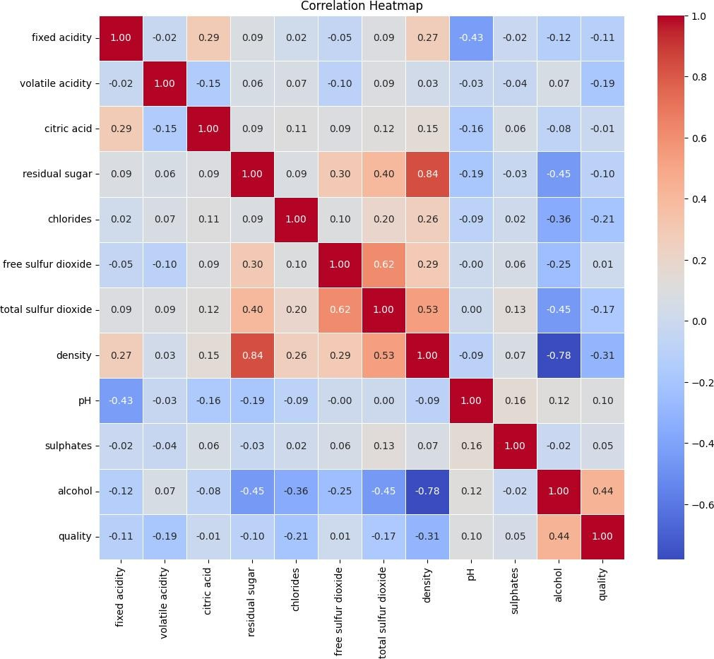

Splitting the data into Testing and training

X_white = data1.iloc[:, 0:11].values y_white = data1.iloc[:, 11].values

X_train_white, X_test_white, y_train_white, y_test_white = train_test_split(X_white,y_white, test_size=0.2, random_state=0)

Feature selection and preprocessing

*# performing preprocessing part*

from sklearn.preprocessing import StandardScaler

sc = StandardScaler()

X_train_white = sc.fit_transform(X_train_white) X_test_white = sc.transform(X_test_white)

Model building(PCA)

from sklearn.decomposition import PCA PCa = PCA (n_components = 2)

X_train_white = PCa.fit_transform(X_train_white) X_test_white = PCa.transform(X_test_white)

explained_variance = PCa.explained_variance_ratio_

from sklearn.linear_model import LogisticRegression classifier_1 = LogisticRegression(random_state = 0) classifier_1.fit(X_train_white, y_train_white)

LogisticRegression(random_state=0)

y_pred_white = classifier_1.predict(X_test_white)

from sklearn.metrics import confusion_matrix as CM c_m_white = CM(y_test_white, y_pred_white) print(c_m_white) accuracy_score(y_test_white,y_pred_white)

|  |  |  |  |  |  |
| --- | --- | --- | --- | --- | --- |
| [[ | 0 | 0 | 2 | 7 0 | 0] |
| [ | 0 | 0 | 10 | 38 3 | 0] |
| [ | 0 | 0 | 77 | 216 2 | 0] |
| [ | 0 | 0 | 67 | 338 4 | 0] |
| [ | 0 | 0 | 16 | 161 6 | 0] |
| [ | 0 | 0 | 1 | 32 0 | 0]] |

0.42959183673469387

print("Accuracy score of PCA model is " , accuracy_score(y_test_white,y_pred_white))

Accuracy score of PCA model is 0.42959183673469387

Result of PCA

*# result through scatter plot*

from matplotlib.colors import ListedColormap

X_set, y_set = X_train_white, y_train_white

X1, X2 = np.meshgrid(np.arange(start = X_set[:, 0].min() - 1,

stop = X_set[:, 0].max() + 1, step = 0.01),

np.arange(start = X_set[:, 1].min() - 1,

stop = X_set[:, 1].max() + 1, step = 0.01))

plt.contourf(X1, X2, classifier_1.predict(np.array([X1.ravel(), X2.ravel()]).T).reshape(X1.shape), alpha = 0.75,

cmap = ListedColormap(('yellow', 'white', 'aquamarine')))

plt.xlim(X1.min(), X1.max())

plt.ylim(X2.min(), X2.max())

for i, j in enumerate(np.unique(y_set)): plt.scatter(X_set[y_set == j, 0], X_set[y_set == j, 1],

c = ListedColormap(('red', 'green', 'blue'))(i), label

= j)

plt.title('Logistic Regression (Training set)') plt.xlabel('PC1') *# for Xlabel* plt.ylabel('PC2') *# for Ylabel*

plt.legend() *# to show legend*

*# show scatter plot*

plt.show()

*# Visualising the Test set results through scatter plot*

from matplotlib.colors import ListedColormap X_set, y_set = X_test_white, y_test_white

X1, X2 = np.meshgrid(np.arange(start = X_set[:, 0].min() - 1,

stop = X_set[:, 0].max() + 1, step = 0.01),

np.arange(start = X_set[:, 1].min() - 1,

stop = X_set[:, 1].max() + 1, step = 0.01))

plt.contourf(X1, X2, classifier_1.predict(np.array([X1.ravel(), X2.ravel()]).T).reshape(X1.shape), alpha = 0.75,

cmap = ListedColormap(('yellow', 'white', 'aquamarine')))

plt.xlim(X1.min(), X1.max())

plt.ylim(X2.min(), X2.max())

for i, j in enumerate(np.unique(y_set)): plt.scatter(X_set[y_set == j, 0], X_set[y_set == j, 1],

c = ListedColormap(('red', 'green', 'blue'))(i), label

= j)

*# title for scatter plot*

plt.title('Logistic Regression (Test set)') plt.xlabel('PC1') *# for Xlabel* plt.ylabel('PC2') *# for Ylabel*

plt.legend()

*# show scatter plot*

plt.show()

Model building(LDA)

from sklearn.discriminant_analysis import LinearDiscriminantAnalysis as LDA

lda = LDA(n_components = 2)

X_train_red = lda.fit_transform(X_train_white, y_train_white) X_test_red = lda.transform(X_test_white)

from sklearn.linear_model import LogisticRegression classifier = LogisticRegression(random_state = 0) classifier.fit(X_train_white, y_train_white)

y_pred_white = classifier_1.predict(X_test_white) print(y_pred_white)

accuracy = accuracy_score(y_test_white, y_pred_white) print("Accuracy of LDA model:", accuracy)

Accuracy of LDA model: 0.42959183673469387

Result of LDA

from matplotlib.colors import ListedColormap X_set, y_set = X_test_white, y_test_white

X1, X2 = np.meshgrid(np.arange(start = X_set[:, 0].min() - 1, stop = X_set[:, 0].max() + 1, step = 0.01), np.arange(start = X_set[:, 1].min() - 1, stop = X_set[:, 1].max() + 1, step = 0.01))

plt.contourf(X1,X2,classifier.predict(np.array([X1.ravel(),X2.ravel()]

).T).reshape(X1.shape), alpha = 0.75, cmap = ListedColormap(('red', 'green', 'blue')))

plt.xlim(X1.min(), X1.max())

plt.ylim(X2.min(), X2.max())

for i, j in enumerate(np.unique(y_set)): plt.scatter(X_set[y_set == j, 0], X_set[y_set == j, 1],

c = ListedColormap(('red', 'green', 'blue'))(i), label

= j)

plt.title('Logistic Regression (Test set)')plt.xlabel('LD1') plt.ylabel('LD2')

plt.legend() plt.show()

from matplotlib.colors import ListedColormap X_set, y_set = X_train_white, y_train_white

X1, X2 = np.meshgrid(np.arange(start = X_set[:, 0].min() - 1, stop = X_set[:, 0].max() + 1, step = 0.01), np.arange(start = X_set[:, 1].min() - 1, stop = X_set[:, 1].max() + 1, step = 0.01))

plt.contourf(X1,X2,classifier.predict(np.array([X1.ravel(),X2.ravel()]

).T).reshape(X1.shape), alpha = 0.75, cmap = ListedColormap(('red', 'green', 'blue')))

plt.xlim(X1.min(), X1.max())

plt.ylim(X2.min(), X2.max())

for i, j in enumerate(np.unique(y_set)): plt.scatter(X_set[y_set == j, 0], X_set[y_set == j, 1],

c = ListedColormap(('red', 'green', 'blue'))(i), label

= j)

plt.title('Logistic Regression (Training set)') plt.xlabel('LD1')

plt.ylabel('LD2') plt.legend() plt.show()

Inferences

1. After applying PCA, you can analyze the principal components to understand which original features contribute the most to the variance in the data. You can also visualize the data in reduced dimensions to explore patterns or clusters.
2. After applying LDA, you can interpret the learned linear discriminants to understand how the classes are separated in the reduced-dimensional space. LDA provides insight into which features are most discriminative for class separation.

Learning Outcomes

1. Implementation of Pre-processing, EDA and feature selection.
2. Implementation of PCA nad LDA models and visualising it.
3. Displaying the confusion matrix.
4. Understanding the techniques of dimentionality reduction.

# GITHUB LINK :

https://github.com/Anandh-007/Machine-learning-lab/tree/main/ML_A9