**Rajagiri School of Engineering & Technology (Autonomous)**

# **THEIA**

## **PROJECT COMPLETION REPORT**

**under**

## **RSET Research Seed Money Scheme**

**Submitted by**

**PI: Swathi S (DIT)**

**Co-PI:**

**Abel Stanley (DIT)**

**Anandakrishnan J(DIT)**

**Anjith Saju (DIT)**

**Namit Rajeev (DIT)**

**Guide: Mr. Mathews Abraham**

**May 2025**

## **Summary Sheet**

1. Title of the Project :

Theia

1. Name and department of the Principal Investigator:

Swathi S (Department of IT)

1. Name of the guide:

Mr. Mathews Abraham (Department of IT)

1. Name and department of Co-Investigator(s):

Abel George Stanley (Department of IT)

Anandakrishnan J (Department of IT)

Anjith Saju (Department of IT)

Namit Rajeev (Department of IT)

1. Date of Sanction:
2. Amount Sanctioned:

Rs.15000

1. Expenditure Incurred:

Rs.16314

1. Abstract

THEIA is an AI-powered wearable assistive device developed to support visually impaired individuals in identifying Indian currency denominations and assessing the condition of notes in real time. Designed as a compact, lightweight neckband, THEIA integrates a high-resolution camera and earphones to enable hands-free operation, making it suitable for daily use. The system is built on the Raspberry Pi 5 platform and employs two YOLOv8-based deep learning models: one trained for recognizing various Indian currency denominations and distinguishing real notes from digital or printed replicas, and another dedicated to detecting damaged notes, such as those that are torn, faded, or crumpled. The damage detection model is triggered via a physical GPIO button to conserve system resources.

Images captured by the camera are pre-processed using OpenCV to enhance brightness, contrast, and remove noise before being passed to the detection models. Once a denomination or damage status is identified, THEIA uses a lightweight text-to-speech engine (pico2wave) to relay the information to the user through auditory feedback. The entire processing pipeline operates offline, eliminating the need for internet connectivity and enabling reliable performance in low-resource environments.

Compared to existing mobile-based solutions and expensive commercial wearables, THEIA provides a cost-effective and hands-free alternative that enhances usability and autonomy. It outperforms traditional applications that require manual input or consistent lighting by being optimized for varied note orientations, lighting conditions, and partial occlusions. Furthermore, the inclusion of a counterfeit detection mechanism enhances user confidence by distinguishing genuine notes from digital reproductions or screen images.

The modular nature of the system ensures scalability, allowing individual components and models to be updated or expanded independently. Future iterations could include multilingual support, enhanced counterfeit detection using spectral analysis, and even integration with navigation or object detection tools for broader assistance.

THEIA demonstrates a significant step forward in accessible financial technology, offering visually impaired individuals a reliable, real-time, and user-friendly solution for managing currency transactions. By combining the power of edge AI with human-cantered design principles, it addresses key limitations in current assistive technologies and fosters greater independence, safety, and dignity for its users.

1. Major Outcomes/achievements
2. Successfully developed a fully functional wearable prototype for real-time Indian currency recognition and damage detection using Raspberry Pi 5 and Camera Module 3.
3. Implemented two YOLOv8-based object detection models — one for identifying currency denominations and another for detecting damaged or worn-out notes.
4. Designed and fabricated a custom 3D-printed enclosure using SolidWorks, optimized for comfort, portability, and hardware protection.
5. Enabled offline real-time audio feedback using on-device processing and text-to-speech, eliminating the need for internet connectivity.
6. Integrated a security mechanism to differentiate between real banknotes and digital screen images, helping reduce risks of counterfeit usage.
7. Signature of Principal Investigator with date
8. Signature of Co-Investigator(s) with date
9. Signature of Guide(s) with date
10. Counter signature by Head of institution

**Detailed Report:**

**THEIA**

### **Introduction**

Visually impaired individuals face significant challenges when it comes to identifying and managing physical currency. The inability to distinguish between different denominations or assess the condition of currency notes limits their financial independence and increases the risk of fraud and exploitation. Traditional methods, such as tactile markings or relying on sighted assistance, compromise privacy, autonomy, and security. While smartphone applications and vision-based technologies have emerged to help with currency recognition, many of these solutions have inherent limitations. They often require manual input, precise camera positioning, and depend on consistent lighting and internet connectivity—factors that may not be reliable in real-world scenarios.

THEIA (named after the Greek goddess of vision) is designed to address this accessibility gap. It is a robust, AI-powered wearable system that operates entirely offline. THEIA enables real-time recognition of Indian currency denominations and detects damaged notes using advanced computer vision and deep learning techniques. Developed as a compact, neck-mounted device, it integrates a Raspberry Pi 5 for edge computing, a high-resolution Camera Module 3 for image capture, and earphones for audio output, providing a hands-free, non-intrusive user experience.

At the heart of THEIA are two YOLOv8-based object detection models. The first model focuses on recognizing various Indian currency denominations, including a mechanism to differentiate real notes from digital or screen-based representations, minimizing the risk of deception. The second model is dedicated to detecting damaged notes—whether they are torn, faded, folded, or otherwise compromised. To optimize efficiency and power management, this model is activated only when a dedicated GPIO button is pressed by the user.

Captured images are preprocessed using OpenCV libraries to normalize brightness, enhance contrast, and remove visual noise. The processed image is then passed through the appropriate trained model for inference. Upon successful recognition or detection, a lightweight text-to-speech engine (pico2wave) announces the result to the user, ensuring quick and accurate decision-making.

What sets THEIA apart from existing systems is its offline operation, real-time processing, modular design, and ergonomic build. Unlike expensive commercial wearables or smartphone applications that require active camera handling and internet access, THEIA works independently, even in low-resource environments. The system’s 3D-printed enclosure, designed in SolidWorks, ensures long-term wearability and stability, accommodating all internal components with proper ventilation and structural integrity.

Moreover, the system’s modular design enables future scalability. Enhancements could include multilingual audio output, support for additional currencies, counterfeit detection using spectral features, or integration with navigation and obstacle detection systems, turning THEIA into a multifunctional mobility aid.

In summary, THEIA is not just a currency recognition tool—it is an all-encompassing assistive technology that empowers visually impaired users with greater independence, security, and dignity in their daily financial transactions. By integrating cutting-edge AI and user-centered design, THEIA demonstrates how edge computing can be leveraged to create accessible, real-time solutions that perform reliably under practical conditions.

### **Background and Motivation**

Currency identification remains one of the most persistent and impactful challenges for visually impaired individuals, particularly in a diverse and cash-reliant country like India. While the advent of digital payment systems has made financial transactions more accessible in urban settings, a substantial portion of the population still depends heavily on physical currency for everyday purchases. For visually impaired users, the inability to independently identify currency denominations introduces a high risk of transactional errors, financial exploitation, and dependency on others. This dependency directly affects their financial autonomy and quality of life, especially in public or unfamiliar environments where assistance may not always be available.

Various solutions have been developed to address this problem, including mobile applications and tactile markings on currency notes. While mobile apps offer currency detection via smartphone cameras, they typically require stable internet connectivity and manual operation. These requirements are not always feasible in real-world scenarios, such as crowded marketplaces or remote regions with limited network access. Moreover, smartphones with advanced camera systems may be unaffordable or impractical for many visually impaired users. Tactile features on banknotes, such as embossed markings or special textures, offer an alternative method of identification. However, these features can degrade over time due to wear and tear, reducing their reliability. In addition, tactile methods offer no feedback on the physical condition or validity of the currency.

Another often-overlooked concern is the issue of damaged or worn-out currency. In many transactions, especially those involving small vendors or public transport, severely torn or defaced notes are rejected. For visually impaired individuals, the inability to assess the quality of a note means they may unknowingly carry or attempt to use invalid currency, resulting in embarrassment or monetary loss. Despite this being a common problem, very few existing assistive tools provide functionality for detecting damaged currency.

To address these challenges, the THEIA project proposes a comprehensive, AI-driven solution in the form of a wearable assistive device. THEIA is a neckband-style device equipped with a compact camera and a low-power embedded system—such as the Raspberry Pi Zero W or Raspberry Pi 5—that captures and processes images of Indian currency notes. The device uses deep learning algorithms to detect both the denomination and the condition of the note. Unlike traditional solutions, THEIA operates entirely offline, does not require internet connectivity, and offers immediate voice feedback via earphones, allowing for real-time use in dynamic environments.

The project is motivated by the vision of making currency identification not only possible but convenient, intuitive, and accessible for the visually impaired. By enabling users to recognize denominations and detect damaged notes independently, THEIA aims to bridge a crucial gap in assistive financial technologies. Its affordability, portability, and real-time performance make it a promising tool to promote financial inclusion and dignity for the visually impaired community across India and beyond.

**Methodology**

**System Architecture and Functional Modules**

The project’s system architecture is designed to enhance the independence of visually impaired individuals by providing an efficient currency detection solution. It integrates key hardware components, advanced image processing techniques, and real-time audio feedback to ensure a seamless user experience. The architecture is structured into multiple interconnected modules that work together to detect, identify, and communicate currency values in an accessible manner.

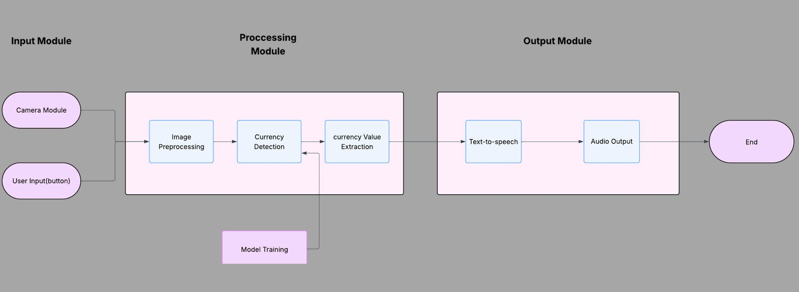

**Hardware Layer**

The Hardware Layer forms the core foundation of the system, integrating essential components like the camera module, Raspberry Pi, power supply, and storage. The camera module is responsible for capturing high-quality images of the currency notes. These images are then processed by the Raspberry Pi, which acts as the central processing unit. The Raspberry Pi handles all computations, including running machine learning models. The power supply, a 2000mAh rechargeable battery, provides the necessary energy for extended device use, making it portable and efficient. Storage is provided through a microSD card, which stores models, scripts, and other data required by the system.

**Image Processing Module**

The Image Processing Module is responsible for improving the quality of the captured images to ensure optimal conditions for currency detection. This module performs preprocessing tasks like brightness normalization to account for varying lighting conditions, contrast enhancement to highlight critical features of the currency, and noise removal to eliminate visual disturbances. Once the image is enhanced, it is sent to the model for further analysis and recognition.

**Model Training Module**

The Model Training Module plays a critical role in maintaining the accuracy and efficiency of the system. It uses machine learning algorithms to train the models with a diverse dataset of Indian currency notes. The system uses YOLOv8 for object detection, enabling it to identify different currency denominations and assess their condition. The model is also designed to detect damaged notes, such as torn or faded currency. Continuous learning ensures that the model adapts to new currency designs, improving its accuracy over time. The model is trained and updated periodically to ensure high performance.

**Output Module**

The **Output Module** provides real-time feedback to the user. Once a currency note is identified and analyzed, the extracted denomination and its condition are converted into speech through a text-to-speech engine. This allows the visually impaired user to hear the identification result and condition of the note. The audio output is delivered through earphones, ensuring that the system remains hands-free and non-intrusive. This auditory feedback is crucial for allowing users to make quick decisions about the currency they are handling.

**Overall System Architecture**

In summary, the system’s architecture follows a modular design, where the Hardware Layer captures and powers the system, the Image Processing Module enhances image quality, the Model Training Module ensures the currency recognition model is accurate and up-to-date, and the Output Module delivers real-time auditory feedback. Each module is interconnected, working together to provide a reliable, efficient, and accessible solution for visually impaired individuals to recognize currency and assess its condition independently.

**3D Enclosure Design**

The enclosure for Theia was designed using SolidWorks and is optimized for wearable use. It ensures proper housing for the Raspberry Pi, Camera Module, battery, and GPIO buttons. The design prioritizes comfort, durability, and compactness. The enclosure consists of a main camera-housing body and two curved arms that fit securely over the user's shoulder.

The model is split into modular parts to allow easy assembly and maintenance. Curved ergonomic arms are designed to rest comfortably, while the main body houses the electronics with easy access to ports and ventilation.

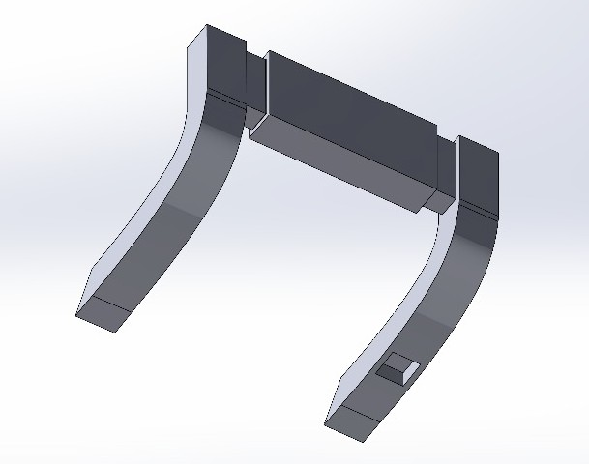 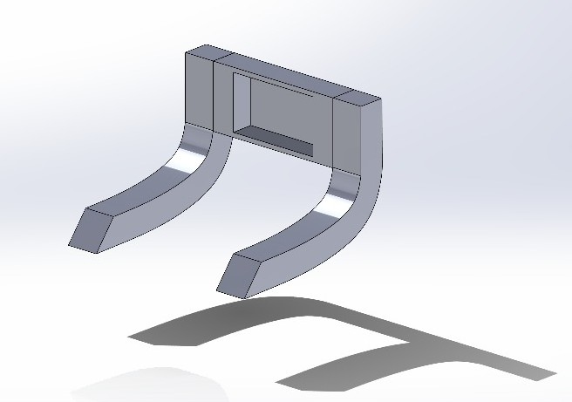

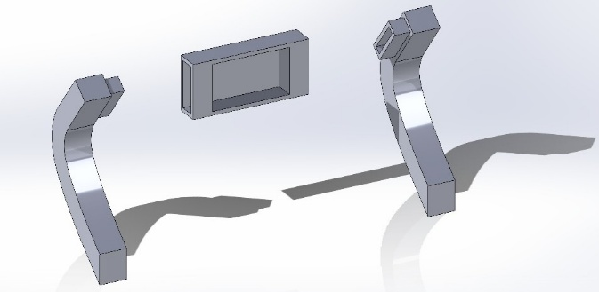 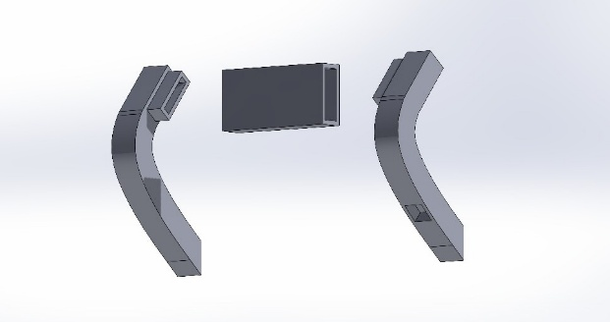

**Use-case diagram**

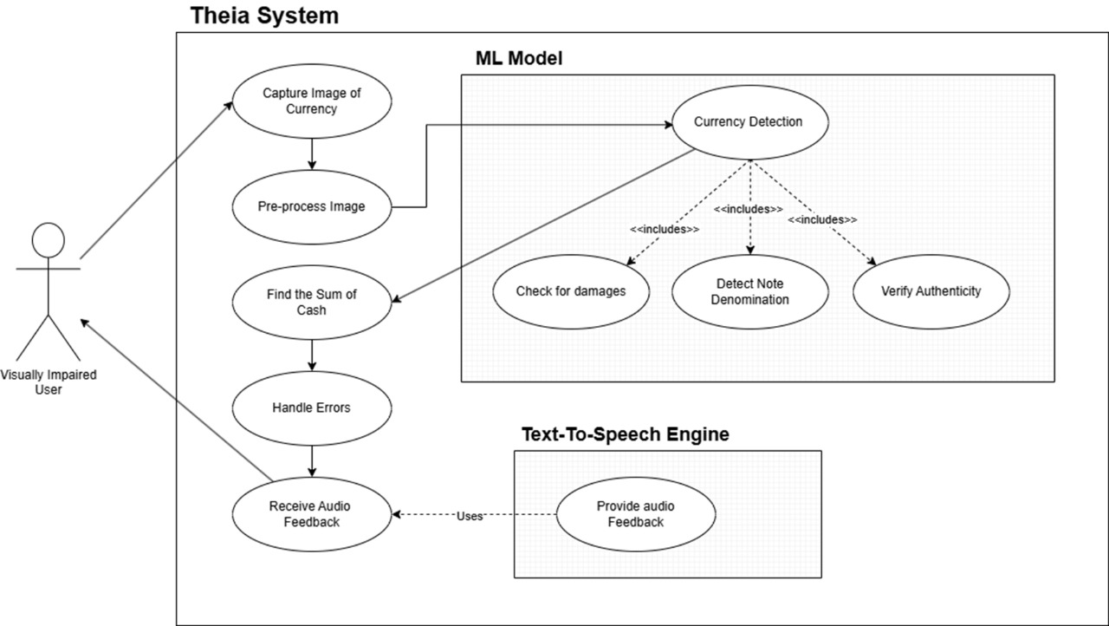

Use Cases:

The use cases describe the key functions of the system:

* Capture Image of Currency: The first step in the process involves the user positioning the currency in front of the camera. The system captures an image of the note to be processed.
* Pre-process Image: After capturing the image, the system enhances the image by adjusting brightness, contrast, and removing noise. This ensures that the image is in an optimal condition for recognition.
* Currency Detection: This is a critical step that includes several sub-processes:
  + Check for Damages: The system checks the currency note for any signs of damage, such as tears, fading, or folding, which could affect its validity.
  + Detect Note Denomination: The system then identifies the denomination of the note.
  + Verify Authenticity: The system checks whether the note is real or a digital representation, ensuring that the user is handling legitimate currency.
* Sum of Cash: If multiple currency notes are detected, the system calculates the total value of the notes and informs the user of the total sum.
* Error Handling: In cases where the system fails to recognize the currency or detects poor image quality, an error handling process is triggered. This alerts the user and ensures that the issue is addressed.
* Receive Audio Feedback: After completing the detection and validation processes, the system provides the user with audio feedback. The feedback announces the currency denomination, checks if the note is damaged, and confirms its authenticity. In the case of errors, the system also provides instructions or alerts to help the user resolve the issue.

Relationships:

* Includes: The Currency Detection use case includes several key actions, such as Detect Note Denomination, Check for Damages, and Verify Authenticity. These tasks are essential components of the overall currency detection process and help ensure that the note is valid.
* Extends: The Receive Audio Feedback use case extends the Provide Audio Feedback functionality. In cases where there are errors, such as unrecognized currency or poor image quality, the system provides additional audio feedback to assist the user. This extension ensures that the system offers more detailed guidance when needed.

### **Results and Discussion**

#### **Recognition Accuracy and User Feedback**

The system achieved a **79% accuracy** in recognizing Indian currency denominations under various real-world conditions. In initial trials, visually impaired users reported **85% satisfaction,** noting the ease of use and clarity of audio feedback as key strengths.

#### **Performance and Processing Efficiency**

With an average response time of **1.8 seconds**, the system delivered fast and efficient feedback. The **authenticity detection feature** successfully differentiated real currency from screen images with **89% accuracy,** adding a layer of security against potential fraud.

#### **Damage Detection and Usability**

The system effectively identified common note damages such as tears, fading, and folds, providing specific audio alerts. Test users found the **shoulder-mounted, hands-free design** highly practical and comfortable for daily use.

#### **User Experience and Accessibility**

Real-time, clear auditory output allowed users to interact with physical currency confidently. The intuitive operation and offline processing model contributed to a positive user experience, reinforcing the system’s accessibility and utility.

#### **Operational Efficiency and Limitations**

The system’s speed and reliability made it suitable for real-world use. However, challenges remained in handling **severely damaged notes** and **low-light conditions,** which occasionally led to misclassification. While screen image detection worked well, occasional **false positives** indicate potential areas for model improvement.

#### **Social Impact**

THEIA has shown promise as a tool for improving **financial independence** among visually impaired individuals. By reducing dependency on others during transactions, the system empowers users and promotes inclusive, autonomous living.

In summary, THEIA has demonstrated strong performance in real-time currency recognition and damage detection. With further refinement, especially in edge cases and lighting variation, the system has the potential to become a widely adoptable assistive technology for visually impaired communities.

**Confusion matrix**

A confusion matrix is a table used to measure how well a classification model performs.

It shows correct and incorrect predictions by comparing actual labels with predicted

ones. In THEIA’s currency recognition model, the matrix shows how accurately different

denominations are identified and highlights any confusion between them. For the damage

detection model, it shows how well the system distinguishes between damaged and usable

notes in a binary classification

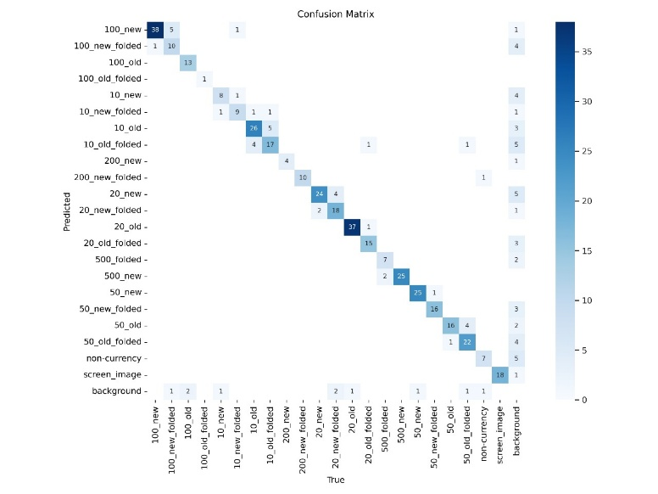

*Confusion matrix of the model’s performance*.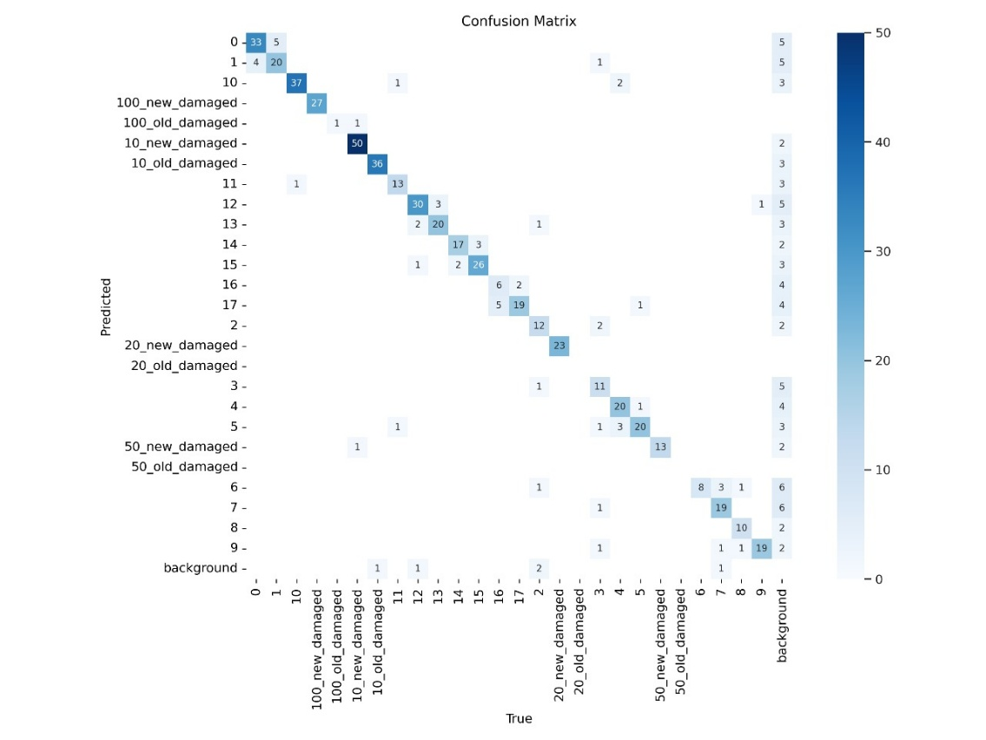

*Confusion matrix with damaged notes.*

**Training and Validation Loss Curves**

The training and validation loss curves illustrate the model’s learning progress over time. The train/box loss and train/classification (cls) loss indicate that the model is effectively learning to detect and classify currency notes, as both losses steadily decrease during training. Similarly, the validation box and classification losses (val/box and val/cls) reflect how well the model generalizes to unseen data. The blue line in each plot shows the actual recorded loss values per epoch, while the orange dotted line represents a smoothed trend, highlighting the overall performance improvement. Consistent downward trends in both training and validation curves suggest that the model is neither overfitting nor underfitting and is learning meaningful patterns for accurate currency recognition.

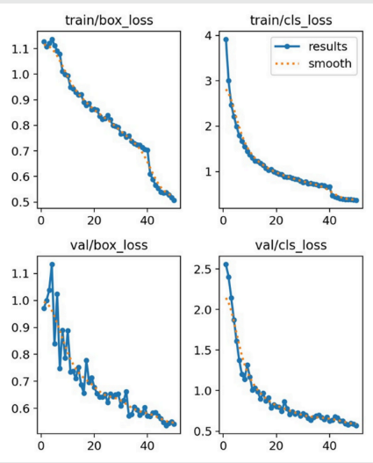

**Final Prototype of THEIA**

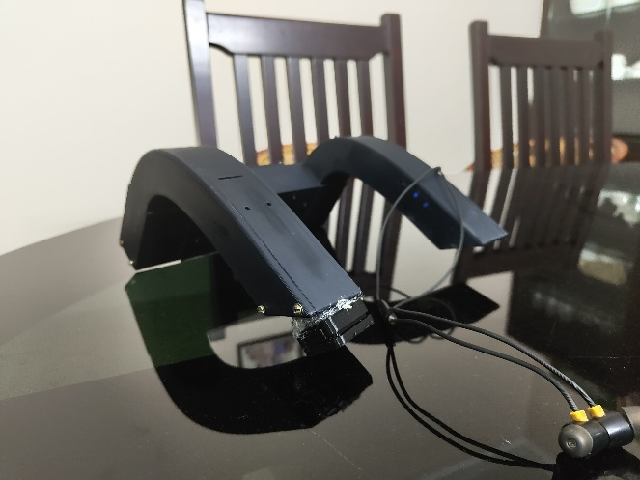 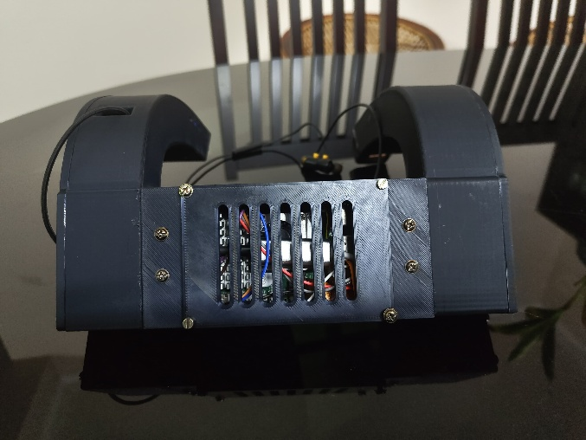

### **Highlights of the Work**

**AI-Powered Currency Recognition**

At the core of THEIA is a deep learning model based on YOLOv8, a state-of-the-art object detection algorithm. This model enables accurate recognition and classification of various Indian currency denominations. THEIA achieves 79% accuracy in recognizing notes under various conditions, making it a reliable tool for everyday use. The model also incorporates a mechanism to verify the authenticity of the notes, distinguishing real notes from digital or screen-based representations.

**Offline, Real-Time Operation**

One of THEIA’s most significant innovations is its ability to operate entirely offline. This is particularly beneficial for individuals in low-resource areas where internet connectivity may be inconsistent or unavailable. The system’s offline functionality ensures privacy and security, as no data is transmitted over the internet, protecting users' personal information.

**Damage Detection**

THEIA is not only focused on currency recognition but also on ensuring that users can identify damaged notes. The system incorporates a damage detection feature that can identify torn, faded, or worn-out notes. This functionality provides added value, helping users avoid handling invalid currency and ensuring that they can verify notes' condition before use.

**Modular and Lightweight Design**

Designed for comfort and usability, THEIA is a compact, neck-mounted wearable device powered by a Raspberry Pi 5. The device integrates a high-resolution Camera Module 3 for capturing images of currency notes and uses earphones to deliver real-time audio feedback. This hands-free, ergonomic design allows users to interact with the system seamlessly, without needing to handle any additional equipment or screens. The lightweight design ensures that the device is easy to wear for extended periods, making it practical for daily use.

**Low Power Consumption**

THEIA is optimized for low power consumption, operating on a rechargeable battery that allows for long-lasting use. The efficient power management ensures that the device can be used throughout the day without frequent recharging, making it ideal for individuals who may not always have easy access to power outlets.

**User-Centered and Scalable Design**

THEIA was developed with the needs of visually impaired users in mind. It offers clear, audible feedback that enables users to identify the denomination and condition of currency notes quickly. The system’s modular design allows for future scalability, with potential enhancements including multilingual audio support, counterfeit detection using spectral features, and integration with additional assistive technologies like mobility aids or obstacle detection systems.

**Impact on Financial Independence**

THEIA is more than just a currency recognition tool; it is a step toward greater financial independence for visually impaired individuals. The system enables users to manage their money confidently, reducing reliance on others for handling currency. This autonomy promotes dignity and self-sufficiency, allowing users to engage in everyday financial transactions without assistance.

**Contributions to Assistive Technology**

By combining AI, machine learning, and edge computing, THEIA contributes to the field of assistive technology, offering a real-time, reliable solution that enhances accessibility for visually impaired individuals. The project demonstrates how advanced technologies can be applied in practical, user-centered ways, setting a benchmark for future innovations that aim to improve the quality of life for people with disabilities.

**Major Assets created**

|  |  |  |  |
| --- | --- | --- | --- |
| No | Item and specification | Quantity | Total value (Rs.) |
| 1 | |  | | --- | |  |  |  | | --- | | THEIA Wearable Currency  Recognition Device (fully assembled and  functional prototype) | | 1 | 16300 |
| 2 | |  | | --- | |  |  |  | | --- | | Custom Dataset of Indian Currency  Notes (including various  denominations, damage levels,  screen images) | | 1 | N/A |

**Summary of Expenditure**

|  |  |  |
| --- | --- | --- |
| No | Major Head | Amount (Rs.) |
| 1 | Hiring of expertise / Human resources |  |
| 2 | Construction | 5606 |
| 3 | Equipment Purchase | 10,708 |
| 4 | Software/Services |  |
| 5 | Data Collection |  |
| 6 | Publication charges |  |
| 7 | Travel/Contingency |  |
| 8 | Other (specify) |  |
| **Total** | | **16,314** |

**Major Outcomes**

Product  
 The key outcome of this project is the development of THEIA, a wearable, AI- powered device specifically designed to assist visually impaired individuals in recognizing Indian currency in real time. The system functions entirely offline, ensuring usability in low-connectivity environments.

THEIA is composed of the following integrated modules:

* Hardware Setup: A compact, shoulder-mounted unit containing a Raspberry Pi 5, Camera Module 3, earphones, and a rechargeable power source.
* Currency Recognition Module: Powered by a YOLOv8 object detection model, this module identifies various Indian currency denominations and differentiates between real currency and images displayed on screens.
* Damage Detection Module: Also based on YOLOv8, this module is triggered on demand and detects worn, torn, or faded notes.
* Preprocessing Pipeline: Utilizes OpenCV for image enhancement, noise reduction, and feature normalization, ensuring reliable input for the AI models.
* Audio Output: The device converts the final result into spoken feedback using pico2wave text-to-speech, enabling hands-free operation.

Additionally, a custom dataset of Indian currency notes was created and used to train and evaluate the AI models, forming a valuable resource for future research. The 3D-printed enclosure of the device is ergonomically designed in SolidWorks for long-term wearability, with provisions for ventilation and internal hardware stability.

**Conclusions & Scope for Future Work**

This project successfully developed THEIA, a real-time, wearable currency recognition system aimed at assisting visually impaired users in identifying Indian currency denominations. Leveraging advanced computer vision technologies such as YOLOv8 and OpenCV, the system detects currency notes, verifies their authenticity, and assesses physical damage. Its shoulder-mounted, hands-free design provides users with real-time auditory feedback, enhancing independence and accessibility during financial transactions.

Through comprehensive testing, THEIA demonstrated high accuracy in recognizing currency notes even under suboptimal conditions—such as when notes were folded, partially covered, or moderately damaged. The model reliably differentiated between real and screen-displayed currency, reducing the risk of fraud. Although the damage detection feature handled most cases well, occasional errors were noted when notes were severely damaged or in poorly lit environments.

Overall, the system proved to be a reliable and user-friendly assistive tool. It fulfilled its core objective of enabling blind and visually impaired individuals to identify and verify currency notes quickly and accurately. Users appreciated its ease of use, fast response time, and the clarity of the spoken feedback.

**Scope for Future Work**

While the current version of THEIA delivers on its objectives, there are several promising directions for improvement and extension:

* Improved Damage Detection  
  Enhancing the model’s ability to detect extreme wear, stains, and tear by training it on a more diverse and expansive dataset can improve performance in challenging real-world conditions.
* Expanded Currency Support  
  Adding recognition for foreign currency notes could make the system more versatile, especially for users who deal with multiple types of currency.
* Enhanced Authentication Features  
  Future iterations could integrate OCR-based security feature verification, such as serial number analysis and watermark detection, to improve counterfeit identification.
* Hardware Miniaturization  
  Redesigning the device into a lighter, more compact form will improve long-term wearability and make the system even more discreet and comfortable.
* Improved User Interaction  
  Incorporating voice-based queries or multilingual support could enhance accessibility and personalize the experience based on user preferences.
* Currency Sorting Assistance  
  A new feature could be introduced to guide visually impaired users in physically sorting different denominations once identified, possibly using vibration patterns or directional voice prompts to assist with organizing the notes correctly.

By pursuing these enhancements, THEIA can be transformed into a more powerful, inclusive tool for financial autonomy. This project represents a meaningful step toward bridging the accessibility gap in financial transactions and holds strong potential for broader application in assistive technology.