Anandhan R
2025166043
Lab Surprise Test – 13/10/2025

Question1: Write the program to compute mean, median, mode, standard deviation, variance, correlation, covariance of given data table format 10X3 matrix where C1 and C2 has integer data type and C3 has character type.

Program
import pandas as pd
import numpy as np
import math

marks = [98,56, "P" ,78,43, "P", 56,23, "F", 67,87, "P", 99,54, "P", 78,27, "F", 77,45, "P", 56,57, "P", 89,34, "F" ,44,43, "P"]

data = np.array(marks).reshape(10,3)

results_mapping = {
"P": 1,
"F": 0
}

df = pd.DataFrame(data, columns=["sub1", "sub2", "result"])
df['sub1'] = pd.to_numeric(df['sub1'])
df['sub2'] = pd.to_numeric(df['sub2'])

df['result'] = df['result'].map(results_mapping)
df['result'] = pd.to_numeric(df['result'])

print("Mean")
print(df[['sub1', 'sub2', 'result']].mean())

print("\nMedian:")
print(df[['sub1', 'sub2', 'result']].median())

print("\nMode:")
print(df[['sub1', 'sub2', 'result']].mode())

print("\nStandard Deviation:")
print(df[['sub1', 'sub2', 'result']].std())

print("\nVariance:")
print(df[['sub1', 'sub2', 'result']].var())

print("\nCorrelation between sub1 and sub2:")
print(df['sub1'].corr(df['sub2']))

print("\nCovariance Matrix:")
print(df[['sub1', 'sub2', 'result']].cov())

print("\nResult Distribution:")
print(df['result'].value_counts())

print("\nOverall Mean")
print(df.mean().mean())

print("\nOverall Median")
print(df.median().median())

print("\nOverall Mode")
print(df.mode().mode())

print("\nOverall Standard Deviation")
print(df.std().std())

print("\nOverall Variance")
print(df.var().var())

Output:
Mean
sub1 74.2
sub2 46.9
result 0.7
dtype: float64

Median:
sub1 77.5
sub2 44.0
result 1.0
dtype: float64

Mode:
sub1 sub2 result
0 56 43.0 1.0
1 78 NaN NaN

Standard Deviation:
sub1 18.449932
sub2 18.290556
result 0.483046
dtype: float64

Variance:
sub1 340.400000
sub2 334.544444
result 0.233333
dtype: float64

Correlation between sub1 and sub2:
0.061307764484815494

Covariance Matrix:
sub1 sub2 result
sub1 340.400000 20.688889 -0.044444
sub2 20.688889 334.544444 6.300000
result -0.044444 6.300000 0.233333

Result Distribution:
result
1 7
0 3
Name: count, dtype: int64

Overall Mean
40.6

Overall Median
44.0

Overall Mode
sub1 sub2 result
0 56 43.0 1.0
1 78 NaN NaN

Overall Standard Deviation
10.327486205085725

Overall Variance
37918.59460905351

Program2: Draw a BarPlot for the following data of company and its profit. Also draw BoxPlot also.
Program:
import matplotlib.pyplot as plt
import numpy as np

companyname = ["Google", "Amazon", "Microsoft", "IBM"]
profit = [3000,5000, 6000, 4500]
plt.figure(figsize=(12,6))

plt.subplot(1,2,1)
plt.bar(companyname, profit)
plt.title("Bar Chart")
plt.xlabel("Company Name")
plt.ylabel("Profit Value")

plt.subplot(1,2,2)
plt.boxplot([profit], label=["Companies"])
plt.title("Box Chart")
plt.ylabel("Profit Value")

plt.tight_layout()
plt.show()

Output:
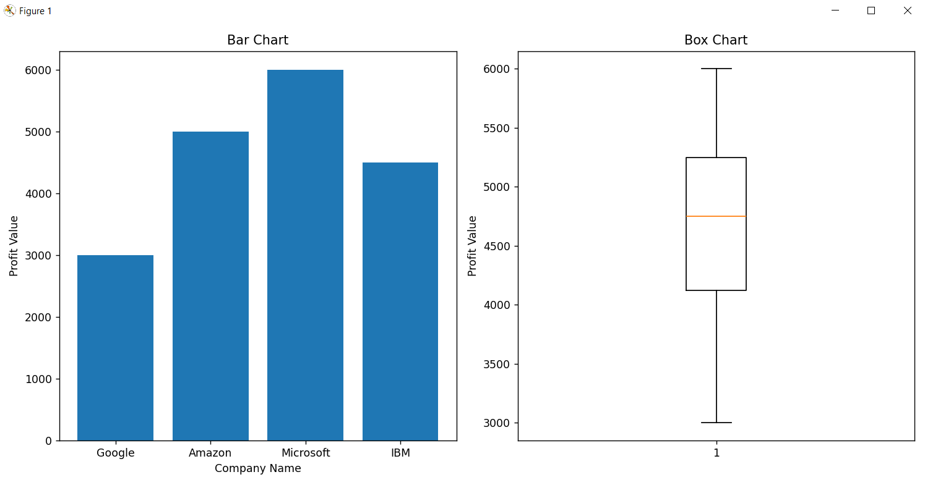

Program 3: Draw a line plot and scatter plot for the following data
Semester -> [1,2,3,4,5,6,7,8]
Grades -> [A+, A, A, D, B+, B, A, A]
Program:
import pandas as pd
import matplotlib.pyplot as plt

data = {
"Semester" : [1,2,3,4,5,6,7,8],
"Grades" : ["A+", "D", "A", "B+", "A+", "A", "D", "B+"]
}
df = pd.DataFrame(data)

print(df)

grade_mapping = {
'A+' : 10,
'A': 9,
'B+' : 8,
'B': 7,
'D' : 4
}

#Converting grades to numeric values
df['Numeric_Grades'] = df['Grades'].map(grade_mapping)

plt.figure(figsize=(12,5))

plt.subplot(1,2,1)
plt.scatter(df['Semester'], df['Numeric_Grades'], color='blue', marker='o')
plt.title("Semester Grades - Scatter Plot")
plt.xlabel("Semester")
plt.ylabel("Grades")
plt.grid(True, linestyle="--", alpha= 0.7)
plt.yticks(list(grade_mapping.values()), list(grade_mapping.keys()))

plt.subplot(1,2,2)
plt.plot(df['Semester'], df['Numeric_Grades'], 'r-o',color='blue', linewidth=2, markersize = 8)
plt.title("Semester Grades - Line Plot")
plt.xlabel("Semester")
plt.ylabel("Grades")
plt.yticks(list(grade_mapping.values()), list(grade_mapping.keys()))
plt.grid(True, linestyle="-", alpha= 0.7)
plt.tight_layout()

plt.show()

Output:
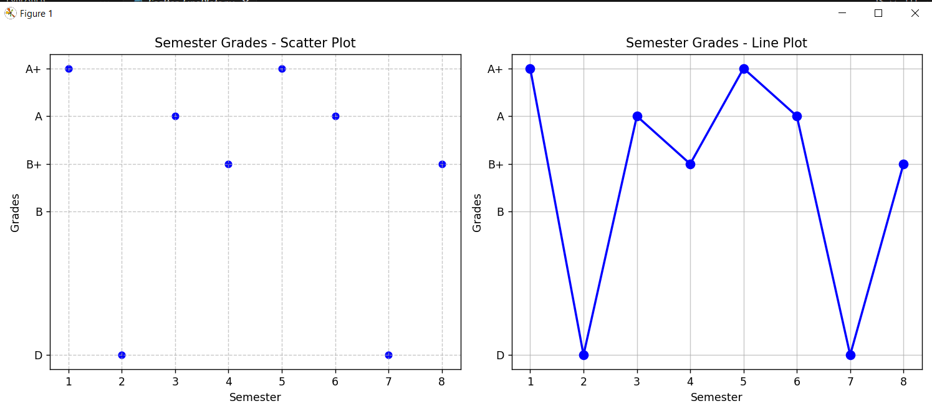

Program4: Clean the dataset with replacing all the column values which contains ? to NAN, create dataset 5X3 and update our csv file
Program
import numpy as np
import pandas as pd

pd.set_option('future.no_silent_downcasting', True)

data = {
'Age': [25, '?', 30, 35, '?', 28],
'Income': ['?', 45000, 55000, '?', 65000, 48000],
'Education': ['Bachelors', '?', 'Masters', 'PhD', 'Bachelors', '?']
}

df = pd.DataFrame(data)

df = df.replace('?', np.nan)

print("\nDataFrame after replacing '?' with NaN:")
print(df)

print("\nData Info after cleaning:")
print(df.info())

print("\nNumber of NaN values in each column:")
print(df.isna().sum())

#Save the cleaned dataset
df.to_csv("cleaned_dataset.csv", index=False)

Output:
