**CO4 PROGRAMS**

1 .Create a database named Employee. Create a collection named empDetails.

use employee

db.createCollection(“empdetails”)

You can use any of the fields Name, Age ,e_mail, phone,salary.

1. Insert 5 documents in it using the different insert() methods and

>db.empdetails.insert({name:"Bhavan",age:58,email:"bhavan123@",phone:9226543210, salary:20000})

>db.empdetails.insertMany([{name:"Mohan",age:51,email:"mohan123@",phone:9826543210,salary:2000},

{name:"Raju",age:35,email:"raju123@",phone:9877654321,salary:30000}])

>db.empdetails.insertMany([{name:"Anandhu",age:20,email:"anandhu123@",phone:9876543210,salary:20000},

{name:"Hari",age:21,email:"hari123@",phone:0987654321,salary:3000}])

1. Find the details of employee whose name is mohan.

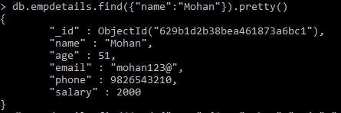

1. Fetch the documents of employees whose salary >=5000.

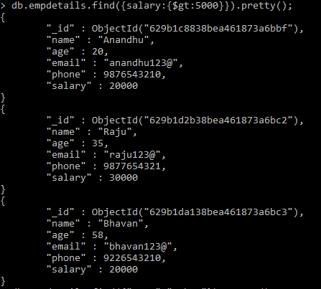

1. Find the documents of employees whose name starts with letter r.

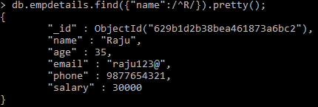

1. Find the documents of employees whose name is not in mohan , raju, bhuvan.

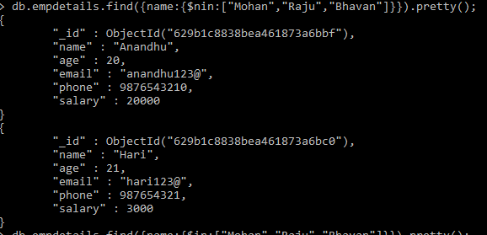

1. Find the documents of employees whose names are mohan , raju, bhuvan.

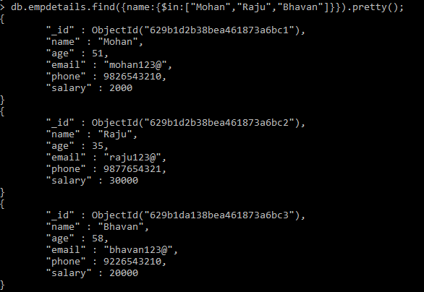

1. Retrieve the details of employees whose age is less than 30. Display only the fields name, salary.

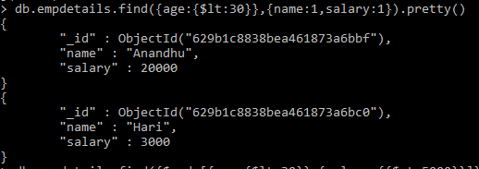

1. Find the details of employees whose salary is >5000 and age is < 30.

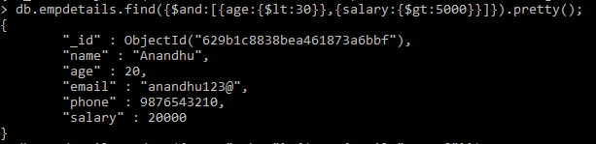

1. Update the e-mail of employee whose name is mohan // findOneAndUpdate().



1. Delete all the documents of employees whose age>56.

