**CO5**

1.**In database Employee.**

1. **Find the average salary of each dept.**

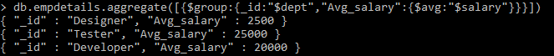

1. **Find the minimum salary of each dept.**

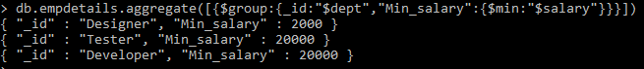

1. **Find the maximum salary of each dept.**

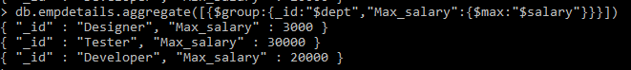

1. **Find the no.of employees of each dept.**

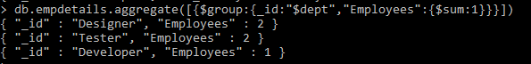

1. **Sort the collection empDetails in descending order of name.**

> db.empdetails.find().sort({name:-1})



1. **Create a text index for ‘name’ and search for names mohan and bhuvan.**

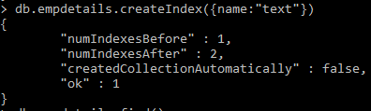

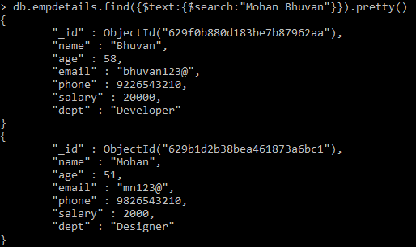

**2.Create a database Inventory and create an orders collection. Apply MapReduce operation for finding the total purchase of each customer.**

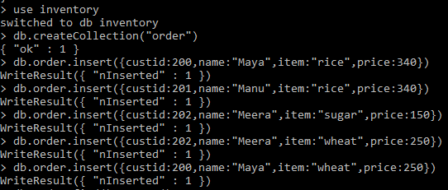

> var mapFunction=function(){emit(this.custid,this.price);};

> var reduceFunction=function(key,values){return Array.sum(values);};

> db.order.mapReduce(mapFunction,reduceFunction,{'out':"map_example"})

{ "result" : "map_example", "ok" : 1 }

