**CO2-1-PROGRAMS**

**PL/SQL**

Q1: Write a PL/SQL program to find the factorial of a given number.

**Program:**

declare

fact number:=1;

n number:=&n;

begin

for i in 2..n

loop

fact:=fact*i;

end loop;

dbms_output.put_line('factorial:'||fact);

end;

/

**Output:**

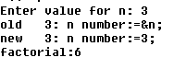

Q2: Write a PL/SQL program to check whether the given no is prime or not.

declare

fact number:=1;

i number;

n number:=&n;

begin

for i in 2..n/2

loop

if n mod i =0

then

fact:=0;

exit;

end if;

end loop;

if fact=0

then

dbms_output.put_line(n||' not is prime');

else

dbms_output.put_line(n||'is prime');

end if;

end;

/

**Output**

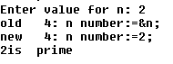

**Functions**

1. Write a PL/SQL program to Check whether a number is Armstrong or not using functions.

**Program**

create or replace function jkamt(n in number)

return number is

s number;

r number;

b number;

l number;

begin

s:=0;

b:=n;

l:=length(n);

while(b>0)

loop

r:=b mod 10;

s:=s+power(r,l);

b:=floor(b/10);

end loop;

return s;

end;

declare

n number:=&n;

s number;

p number;

begin

p:=n;

s:=jkamt(n);

if p=s

then

dbms_output.put_line('Amstrong number');

else

dbms_output.put_line('Not Amstrong');

end if;

end;

/

**OUTPUT**

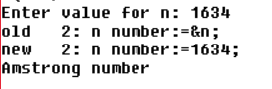

1. Create table that contains itemid , item_name & price of several items sold in a grocery shop, Using functions retrieve the item name & price from table when itemid is given as input.

Program

create table shop(itemid varchar(20) primary key,item_name varchar(20),price number);

insert into shop values('&itemid','&item_name',&number);

create or replace function sh(id number)

return number as

s number;

r number;

n shop.item_name%type;

p shop.price%type;

begin

s:=id;

r:=0;

select item_name,price into n,p from shop where itemid=s;

dbms_output.put_line('Item Name'||n);

dbms_output.put_line('Price'||p);

return 0;

end;

/

declare

n number:=&n;

p number;

begin

p:=sh(n);

end;

/

Ouput

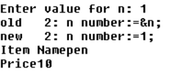

1. Write a PL/SQL function called POW that takes two numbers as 0061 argument and return the value of the first number raised to the power of the second.

**PROGRAM**

create or replace function pow(a number,b number)

return number as

p number;

begin

select power(a,b) into p from dual;

return p;

end;

declare

a number:=&a;

b number:=&b;

begin

dbms_output.put_line('Power is '||pow(a,b));

end;

/

Ouput

