**Cursor**

**1.Calculate Interest for Fixed Deposit Amount Using Cursors.**

**set intrest as 0 and then update it using the program.**

**set 10% intrest for amount less than or equal to 1000.**

**20% for more then 1000 to 5000.**

**30% for above 5000.**

**Program**

create table bank(AccNo varchar(20) primary key,Cust_Name varchar(25),type varchar(20),amount number,Interest int; insert into bank values('&Acno:','&custname:','&type(fd/sa)',&amount,&intrest);

declare

cursor c is select * from bank;

begin

for i in c

loop

if i.amount<=1000

then

update bank set interest=i.amount*.1 where accno=i.accno;

elsif i.amount>1000 and i.amount<5000

then

update bank set interest=i.amount*.2 where accno=i.accno;

elsif i.amount>5000

then

update bank set interest=i.amount*.3 where accno=i.accno;

end if;

end loop;

end;

output

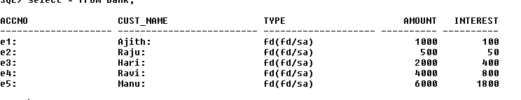

**2. Calculate Electricity Bill Using Cursors**

create table bill(bno varchar(20) primary key,Name varchar(25),amount int,unit int);

insert into bill values('&bno','&name',&amount,&unit);

**Program**

declare

cursor c is select * from bill;

begin

for i in c

loop

if i.unit<=100

then

update bill set amount=i.unit*.1 where bno=i.bno;

elsif i.unit>100 and i.amount<200

then

update bill set amount=i.unit*.2 where bno=i.bno;

elsif i.amount>200

then

update bill set amount=i.unit*.3 where bno=i.bno;

end if;

end loop;

end;

**output**

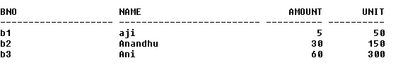

**3.Write PL/SQL code to UPDATE values in created tables by using Implicit Cursors.**

create table company(eid varchar(20) primary key,ename varchar(20),salary int);

insert into company values('&eid','&ename',&salary);

**Program**

declare

rowno number(20);

begin

update company set salary=salary+1000;

if sql%notfound then

dbms_output.put_line('No amount updated');

elsif sql%found then

rowno:=sql%rowcount;

dbms_output.put_line(rowno||' employee salary updated');

end if;

end;

/

**Output**

2 employee salary updated

**4.Given the table works(emp_id,company_name,salary).write a cursor to**

**select the three highest paid employees from the table.**

create table works(emp_id varchar(20) primary key,company_name varchar(20),salary int);

insert into works values('&empid','&company',&salary);

**Program**

declare

cursor c1 is SELECT * FROM (SELECT * FROM works ORDER BY salary desc) WHERE ROWNUM <= 3;

r c1%rowtype;

begin

open c1;

loop

fetch c1 into r;

exit when c1 %notfound;

dbms_output.put_line(r.emp_id||' '||r.company_name||' '||r.salary);

end loop;

end;

/

**Output**

