**CO5 PROGRAMS**

1. Write a Python program to read a file line by line and store it into a list

Program

f1=open("secfile.txt","w")

f1.write("This is my first file in python.\n want to work with files \n This is my third line")

f1=open("secfile.txt","r")

ff=f1.readlines()

print(ff)

Output

['This is my first file in python.\n', ' want to work with files \n', ' This is my third line']

1. Python program to copy odd lines of one file to other

Program

f1=open("secfile.txt","r")

ff=f1.readlines()

with open("odd.txt","w") as f2:

for x in range(0,len(ff)):

if(x%2!=0):

f2.write(ff[x])

Output:

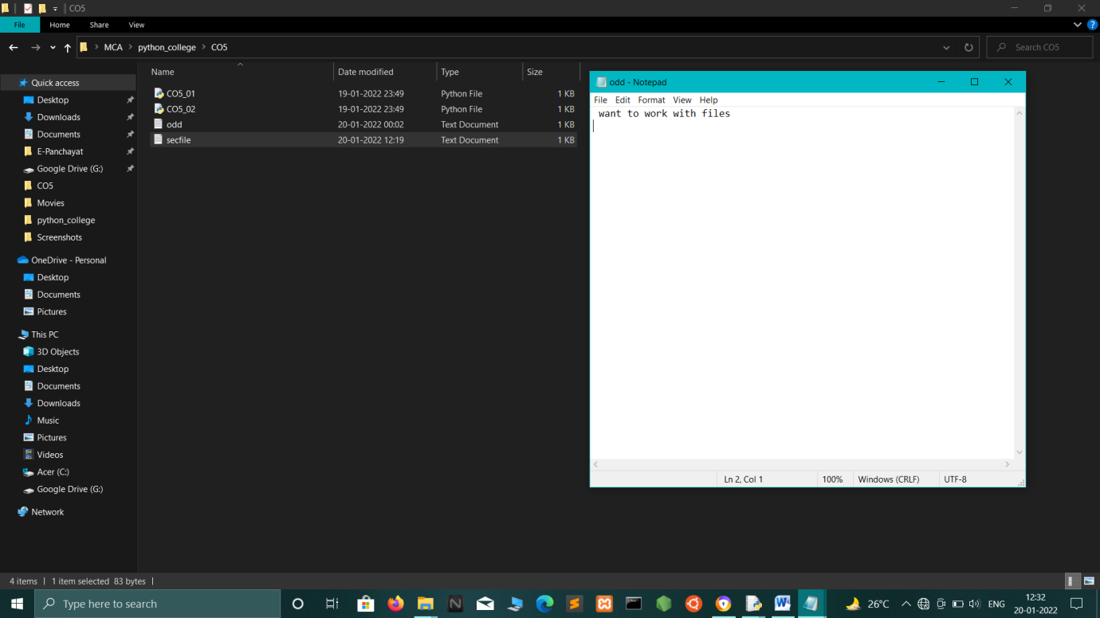

1. Write a Python program to read each row from a given csv file and print a list of strings.

Program:

import csv

# csv file name

filename = "username.csv"

# initializing the titles and rows list

fields = []

rows = []

# reading csv file

cf=open(filename, 'r')

# creating a csv reader object

csvreader = csv.reader(cf)

# extracting field names through first row

fields = next(cf)

print(fields)

print("\n...............\n")

# extracting each data row one by one

for r in csvreader:

rows.append(r)

#print the list containing the rows of csv file

print(rows)

print("\n...............\n")

print('\nFirst 3 rows are:\n')

for r in rows[:3]:

print(*r)

print("\n...............\n")

print("\nThe file content\n")

for sl in rows:

for l in sl:

print(l),

#print(l,end=" ")

print()

cf.close()

Output:

Username; Identifier;Firstname;Lastname

...............

[['booker12;9012;Rachel;Booker'], ['grey07;2070;Laura;Grey'], ['johnson81;4081;Craig;Johnson'], ['jenkins46;9346;Mary;Jenkins'], ['smith79;5079;Jamie;Smith']]

...............

First 3 rows are:

booker12;9012;Rachel;Booker

grey07;2070;Laura;Grey

johnson81;4081;Craig;Johnson

...............

The file content

booker12;9012;Rachel;Booker

grey07;2070;Laura;Grey

johnson81;4081;Craig;Johnson

jenkins46;9346;Mary;Jenkins

smith79;5079;Jamie;Smith

1. Write a Python program to read specific columns of a given CSV file and print the content of the columns.

Program:

import csv

filename = "names.csv"

cf=open(filename, 'r')

#csvreader = csv.reader(cf)

data = csv.DictReader(cf)

print("No Company")

for r in data:

print(r['No'], r['Company'])

1. Write a Python program to write a Python dictionary to a csv file. After writing the CSV file read the CSV file and display the content.

Program:

import csv

field_names = ['No', 'Company', 'Car Model']

cars = [

{'No': 1, 'Company': 'Ferrari', 'Car Model': '488 GTB'},

{'No': 2, 'Company': 'Porsche', 'Car Model': '918 Spyder'},

{'No': 3, 'Company': 'Bugatti', 'Car Model': 'La Voiture Noire'},

{'No': 4, 'Company': 'Rolls Royce', 'Car Model': 'Phantom'},

{'No': 5, 'Company': 'BMW', 'Car Model': 'BMW X7'},

]

with open('Names1.csv', 'w') as csvfile:

writer = csv.DictWriter(csvfile, fieldnames = field_names)

writer.writeheader()

writer.writerows(cars)

#print(".................")

filename = "names1.csv"

cf=open(filename, 'r')

rows=[]

csvreader = csv.reader(cf)

for r in csvreader:

rows.append(r)

for r in rows:

print(*r)

Output:

No Company Car Model

1 Ferrari 488 GTB

2 Porsche 918 Spyder

3 Bugatti La Voiture Noire

4 Rolls Royce Phantom

5 BMW BMW X7

