**UML DIAGRAM**

**ANANDHU UTHAMAN**

**RMCA S4**

**Activity diagram**

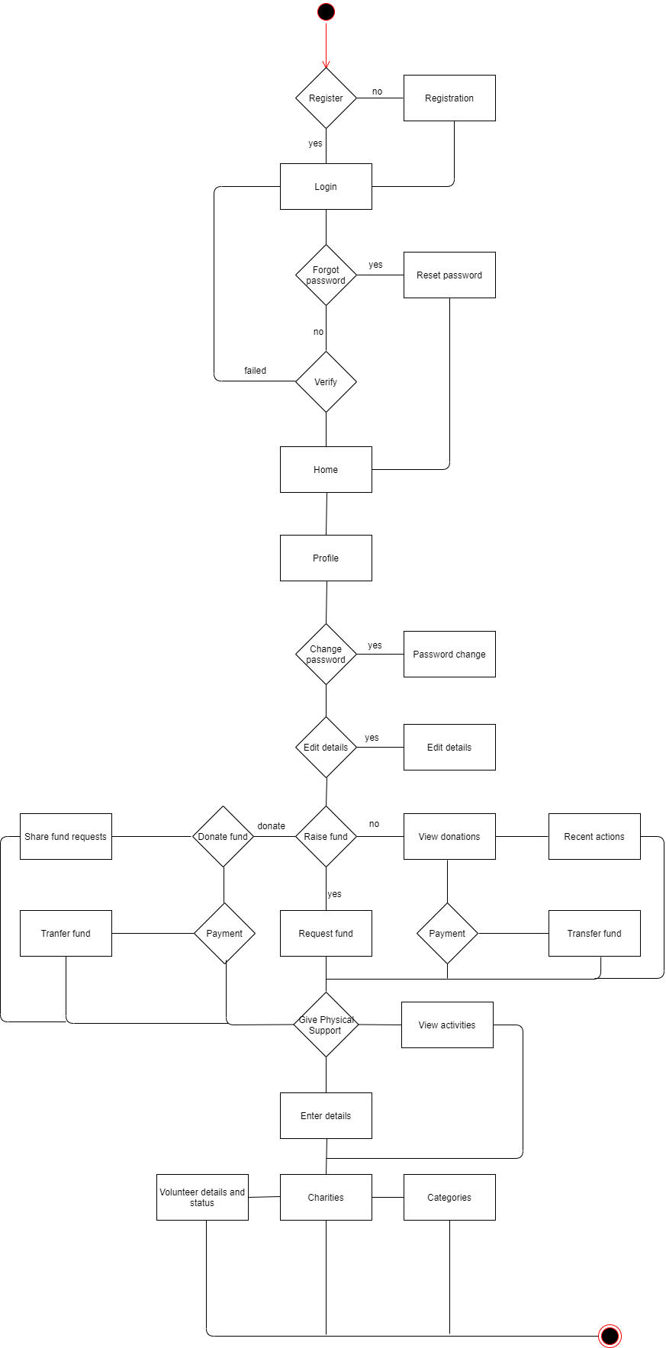

**Class diagram**

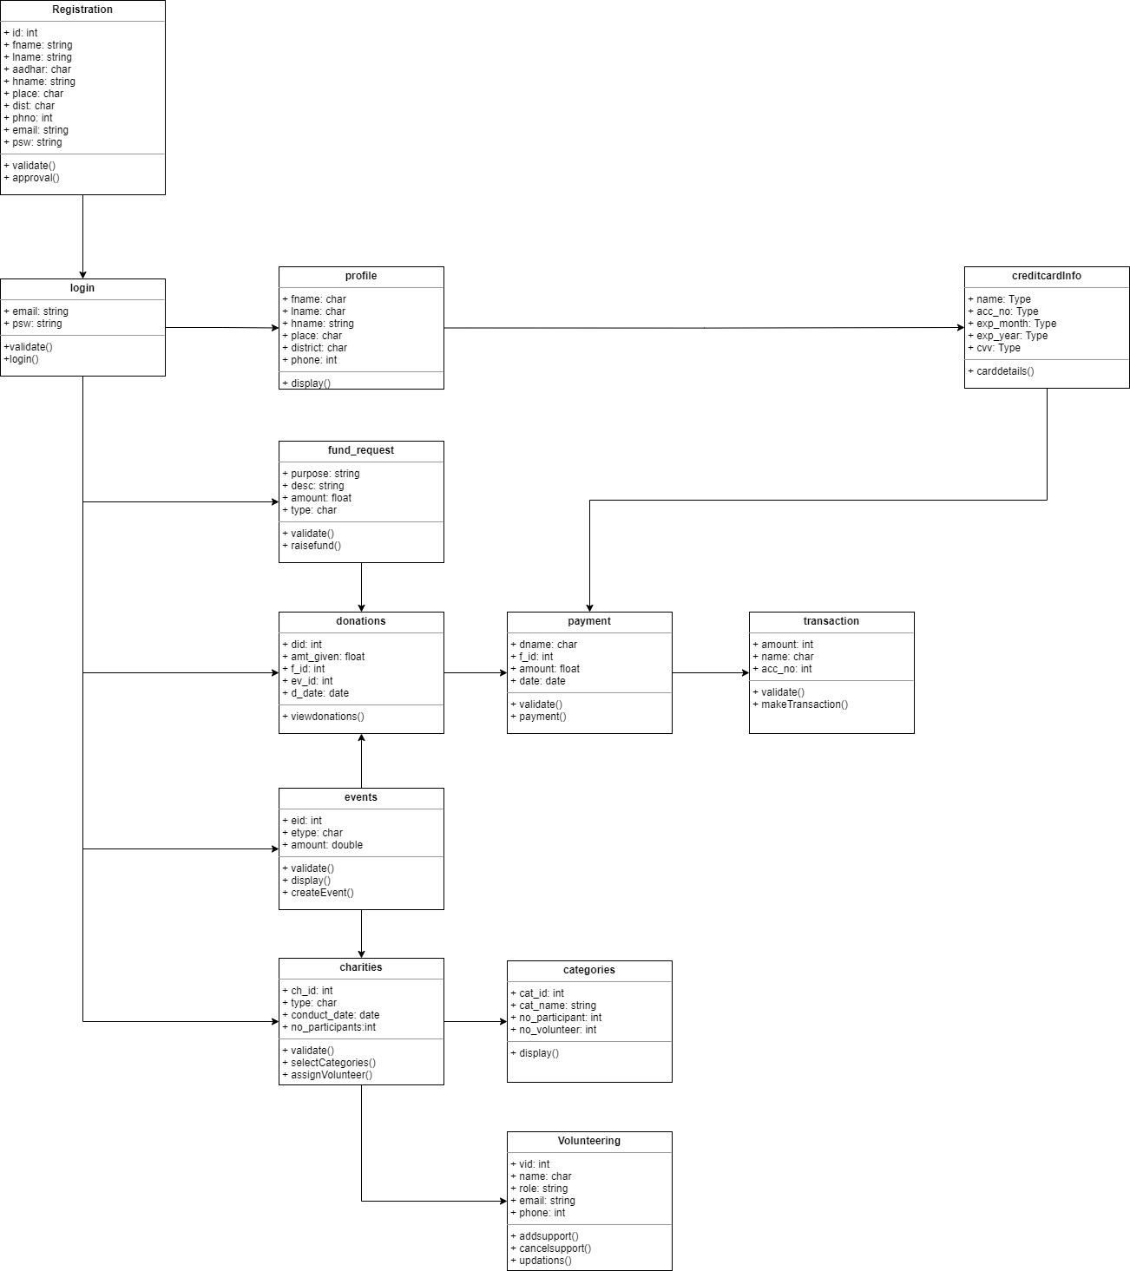

**Deployment diagram**

**user computer**

**database server**

**web server**

presentation layer (web interface)

database interface

log file

MySQL database

web browser

user

**Object diagram**

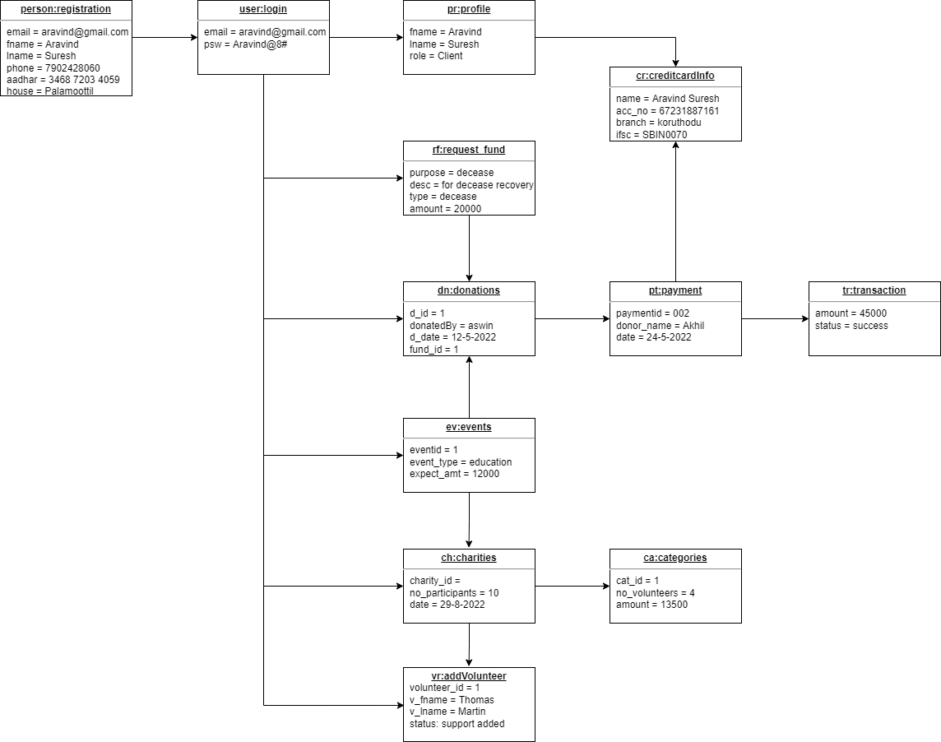

**Component diagram**

charitABLE

issue

physical help

donor

client

donation

volunteer

security

persistence

database

system admin of charitABLE

connect database

encrypton

access control

encrypton

acess control

data acess

data acess

data acess

data acess

**Sequence diagram**

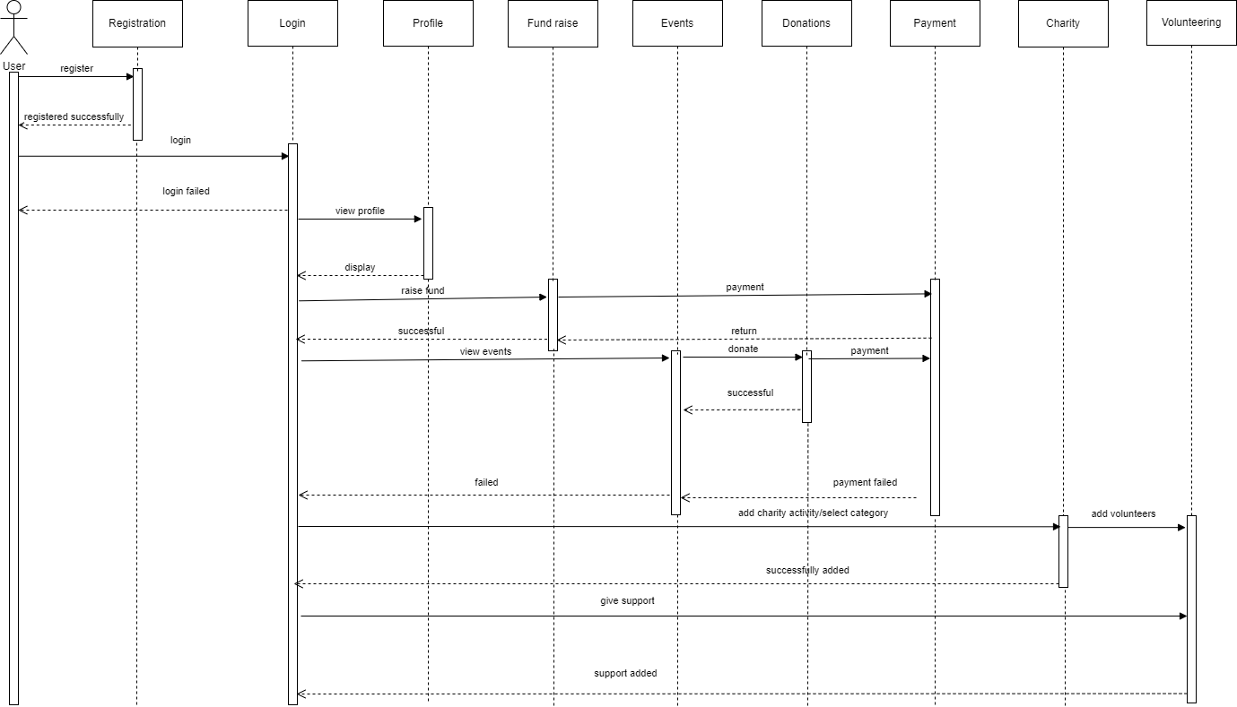

**Use case diagram**

