Animation

# Program 1:

<!DOCTYPE html>  
<html lang="en">  
<head>  
 <meta charset="UTF-8">  
 <meta name="viewport" content="width=device-width, initial-scale=1.0">  
 <title>Simple Animation with CSS Keyframes</title>  
 <style>  
 body {  
 display: flex;  
 justify-content: center;  
 align-items: center;  
 height: 100vh;  
 background-color: #f0f0f0;  
 }  
  
 .animated-square {  
 width: 100px;  
 height: 100px;  
 background-color: blue;  
 animation: changeSize 3s infinite alternate;  
 }  
  
 @keyframes changeSize {  
 0% {  
 transform: scale(1);  
 background-color: blue;  
 }  
 50% {  
 transform: scale(1.5);  
 background-color: green;  
 }  
 100% {  
 transform: scale(1);  
 background-color: red;  
 }  
 }  
 </style>  
</head>  
<body>  
 <div class="animated-square"></div>  
</body>  
</html>

# OutPut :



# Program 2:

<!DOCTYPE html>

<html lang="en">

<head>

    <meta charset="UTF-8">

    <meta name="viewport" content="width=device-width, initial-scale=1.0">

    <title>Bouncing Ball Animation</title>

    <style>

        body {

            display: flex;

            justify-content: center;

            align-items: center;

            height: 100vh;

            background-color: #f0f0f0;

            overflow: hidden; /* Prevents scrollbar from appearing */

        }

        .bouncing-ball {

            width: 50px;

            height: 50px;

            background-color: orange;

            border-radius: 50%; /* Makes the square a circle */

            position: relative; /* Allows movement within the container */

            animation: bounce 2s infinite;

        }

        @keyframes bounce {

            0% {

                transform: translateY(0); /* Starting position */

            }

            50% {

                transform: translateY(-150px); /* Moves up */

            }

            100% {

                transform: translateY(0); /* Returns to starting position */

            }

        }

    </style>

</head>

<body>

    <div class="bouncing-ball"></div>

</body>

</html>

# OutPut :



# Program 3 :

<!DOCTYPE html>

<html lang="en">

<head>

    <meta charset="UTF-8">

    <meta name="viewport" content="width=device-width, initial-scale=1.0">

    <title>Dynamic Percentage Filling Animation</title>

    <style>

        body {

            display: flex;

            justify-content: center;

            align-items: center;

            height: 100vh;

            background-color: #f0f0f0;

            font-family: Arial, sans-serif;

        }

        .progress-container {

            width: 80%; /* Width of the progress bar */

            background-color: #e0e0e0; /* Background color of the container */

            border-radius: 25px; /* Rounded corners */

            overflow: hidden; /* Ensures inner div does not overflow */

            position: relative; /* For positioning the percentage label */

        }

        .progress-bar {

            height: 30px; /* Height of the filling bar */

            width: 0; /* Initial width */

            background-color: #4caf50; /* Color of the filling bar */

            animation: fillAnimation 6s forwards; /* Total animation time */

        }

        .percentage-label {

            position: absolute; /* Positioning it on top of the progress bar */

            width: 100%; /* Full width of the container */

            text-align: center; /* Center the text */

            line-height: 30px; /* Center vertically within the bar */

            color: white; /* Text color */

            font-weight: bold; /* Bold text */

        }

        @keyframes fillAnimation {

            0% {

                width: 0%; /* Start from 0% */

            }

            20% {

                width: 30%; /* Fill to 30% */

            }

            50% {

                width: 60%; /* Fill to 60% */

            }

            80% {

                width: 90%; /* Fill to 90% */

            }

            100% {

                width: 100%; /* Fill to 100% */

            }

        }

    </style>

</head>

<body>

    <div class="progress-container">

        <div class="progress-bar"></div>

        <div class="percentage-label">100%</div> <!-- Final percentage -->

    </div>

</body>

</html>

# OutPut :

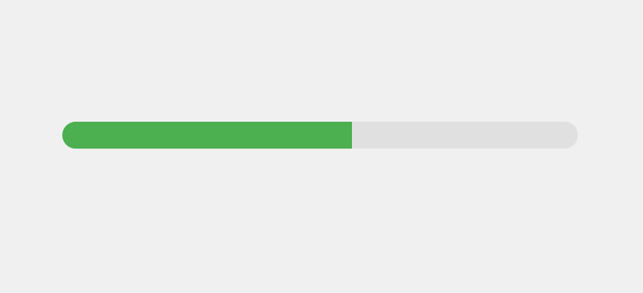

# Program 4 :

<!DOCTYPE html>

<html lang="en">

<head>

    <meta charset="UTF-8">

    <meta name="viewport" content="width=device-width, initial-scale=1.0">

    <title>Circular Loading Animation</title>

    <style>

        body {

            display: flex;

            justify-content: center;

            align-items: center;

            height: 100vh;

            background-color: #f0f0f0;

            font-family: Arial, sans-serif;

        }

        .loader {

            border: 10px solid #e0e0e0; /* Light gray border */

            border-top: 10px solid #4caf50; /* Green color for the top */

            border-radius: 50%; /* Makes it a circle */

            width: 100px; /* Width of the loader */

            height: 100px; /* Height of the loader */

            animation: spin 1s linear infinite; /* Spin animation */

        }

        @keyframes spin {

            0% {

                transform: rotate(0deg); /* Starting rotation */

            }

            100% {

                transform: rotate(360deg); /* Full rotation */

            }

        }

    </style>

</head>

<body>

    <div class="loader"></div>

</body>

</html>

# OutPut :



# Program 5 :

<!DOCTYPE html>

<html lang="en">

<head>

    <meta charset="UTF-8">

    <meta name="viewport" content="width=device-width, initial-scale=1.0">

    <title>Pulsing Circular Loading Animation</title>

    <style>

        body {

            display: flex;

            justify-content: center;

            align-items: center;

            height: 100vh;

            background-color: #f0f0f0;

            font-family: Arial, sans-serif;

        }

        .loader {

            width: 100px; /* Width of the loader */

            height: 100px; /* Height of the loader */

            border-radius: 50%; /* Makes it a circle */

            background-color: #4caf50; /* Green color */

            animation: pulse 1.5s infinite; /* Pulsing animation */

        }

        @keyframes pulse {

            0% {

                transform: scale(1); /* Initial scale */

            }

            50% {

                transform: scale(1.2); /* Scale up */

            }

            100% {

                transform: scale(1); /* Scale back to original */

            }

        }

    </style>

</head>

<body>

    <div class="loader"></div>

</body>

</html>

# OutPut :

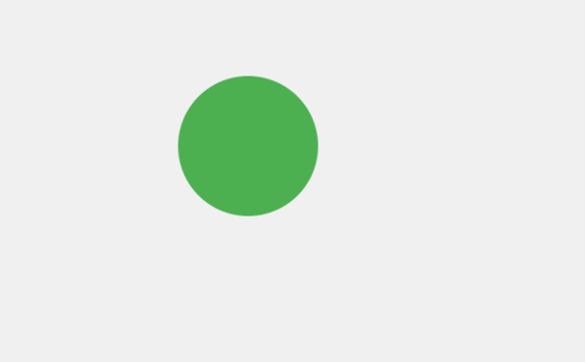

# Program 6 :

<!DOCTYPE html>

<html lang="en">

<head>

    <meta charset="UTF-8">

    <meta name="viewport" content="width=device-width, initial-scale=1.0">

    <title>Continuous Image Fade Animation</title>

    <style>

        body {

            display: flex;

            justify-content: center;

            align-items: center;

            height: 100vh;

            background-color: #f0f0f0;

            font-family: Arial, sans-serif;

        }

        .fade-container {

            width: 400px; /* Width of the container */

            height: 400px; /* Height of the container */

            position: relative;

            overflow: hidden; /* Ensure no overflow */

        }

        .fade-image {

            position: absolute;

            width: 100%; /* Image takes full container */

            height: 100%; /* Image takes full container */

            border-radius: 10px; /* Rounded corners */

            object-fit: cover; /* Cover the container while maintaining aspect ratio */

            opacity: 0; /* Initially hidden */

            animation: fade 6s infinite; /* Fading animation */

        }

        .fade-image:nth-child(1) {

            animation-delay: 0s; /* First image fades in immediately */

            opacity: 1; /* Show the first image */

        }

        .fade-image:nth-child(2) {

            animation-delay: 3s; /* Second image starts fading in after 3 seconds */

        }

        @keyframes fade {

            0%{

                opacity: 0;

            }

            25%{

                opacity: 0.5;

            }

            50%{

                opacity: 1;

            }

            75%{

                opacity: 0.5;

            }

            100%{

                opacity: 0;

            }

        }

    </style>

</head>

<body>

    <div class="fade-container">

        <img class="fade-image" src="https://wallpaperaccess.com/full/31193.jpg" alt="First Image">

        <img class="fade-image" src="https://wallpapercave.com/wp/wp2506871.jpg" alt="Second Image">

    </div>

</body>

</html>

# OutPut :

