Basics

# Program 1:

<html>

<head>

    <title>wrk1</title>

</head>

<body bgcolor="blue" text="yellow">

    <center>NAME:</center>

    <center>ADDRESS:</center>

    <center>PHONE:</center>

    <center>E-MAIL:</center>

</body>

</html>

# OutPut :

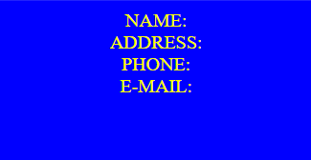

# Program 2 :

<html>

<head>

    <title>wrk2</title>

</head>

<body bgcolor="green">

        <h1>ANGULAR</h1>

    <p>Angular is a platform and framework for building single-page client applications using HTML and TypeScript.

       Angular is written in TypeScript. It implements core and optional functionality as a set of TypeScript libraries that you import into your applications.

       The architecture of an Angular application relies on certain fundamental concepts. The basic building blocks of the Angular framework are Angular components.</p>

    <h1>REACT</h1>

    <p>React can be used to develop single-page, mobile, or server-rendered applications with frameworks like Next.js.

    Because React is only concerned with the user interface and rendering components to the DOM, React applications often rely on libraries for routing and other client-side functionality.

    A key advantage of React is that it only rerenders those parts of the page that have changed, avoiding unnecessary rerendering of unchanged DOM elements.</p>

    <h1>NODE</h1>

    <p>Node.js lets developers use JavaScript to write command line tools and for server-side scripting.

        The ability to run JavaScript code on the server is often used to generate dynamic web page content before the page is sent to the user's web browser.

        Consequently, Node.js represents a "JavaScript everywhere" paradigm, unifying web-application development around a single programming language, as opposed to using different languages for the server- versus client-side programming.</p>

</body>

</html>

# OutPut :

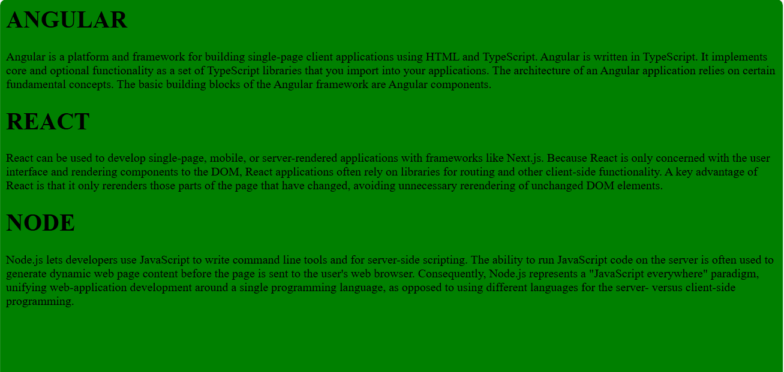

# Program 3 :

<html>

<head>

    <title>wrk3</title>

</head>

<body bgcolor="yellow">

    <center><font color="blue" size="3" face="cursive">NAME:</font></center>

    <center><font color="red" size="5" face="serif">ADDRESS:</font></center>

    <center><font color="green" size="8" face="Times New Roman">PHONE:</font></center>

    <center><font>E-MAIL:</font></center>

</body>

</html>

# OutPut :



# Program 4:

<html>

<head>

    <title>wrk4</title>

</head>

<body bgcolor="pink">

    <h1><font color="blue" size="7" face="impact">ANGULAR</font></h1>

    <font color="orange" size="3" face="cursive">

        <p>Angular is a platform and framework for building single-page client applications using HTML and TypeScript.

        Angular is written in TypeScript. It implements core and optional functionality as a set of TypeScript libraries that you import into your applications.

        The architecture of an Angular application relies on certain fundamental concepts. The basic building blocks of the Angular framework are Angular components.</p>

    </font>

    <h1><font color="red" size="5" face="Arial">REACT</font></h1>

    <font color="white" size="4" face="verdana">

        <p>React can be used to develop single-page, mobile, or server-rendered applications with frameworks like Next.js.

        Because React is only concerned with the user interface and rendering components to the DOM, React applications often rely on libraries for routing and other client-side functionality.

        A key advantage of React is that it only rerenders those parts of the page that have changed, avoiding unnecessary rerendering of unchanged DOM elements.</p>

    </font>

    <h1><font color="yellow" size="8" face="serif">NODE</font></h1>

    <font color="green" size="6" face="times new roman">

        <p>Node.js lets developers use JavaScript to write command line tools and for server-side scripting.

        The ability to run JavaScript code on the server is often used to generate dynamic web page content before the page is sent to the user's web browser.

        Consequently, Node.js represents a "JavaScript everywhere" paradigm, unifying web-application development around a single programming language, as opposed to using different languages for the server- versus client-side programming.</p>

    </font>

</body>

</html>

# OutPut :

