Bootstrap

# Program 1:

<!DOCTYPE html>

<html lang="en">

<head>

    <meta charset="UTF-8">

    <meta name="viewport" content="width=device-width, initial-scale=1.0">

    <title>Bootstrap 5 Starter</title>

    <link href="https://cdn.jsdelivr.net/npm/bootstrap@5.3.2/dist/css/bootstrap.min.css" rel="stylesheet">

</head>

<body>

    <div class="container text-center mt-5">

        <h1>Hello, Bootstrap!</h1>

        <p>This is a basic Bootstrap 5 starter template.</p>

        <button class="btn btn-primary">Click Me</button>

    </div>

    <script src="https://cdn.jsdelivr.net/npm/bootstrap@5.3.2/dist/js/bootstrap.bundle.min.js"></script>

</body>

</html>

# OutPut :

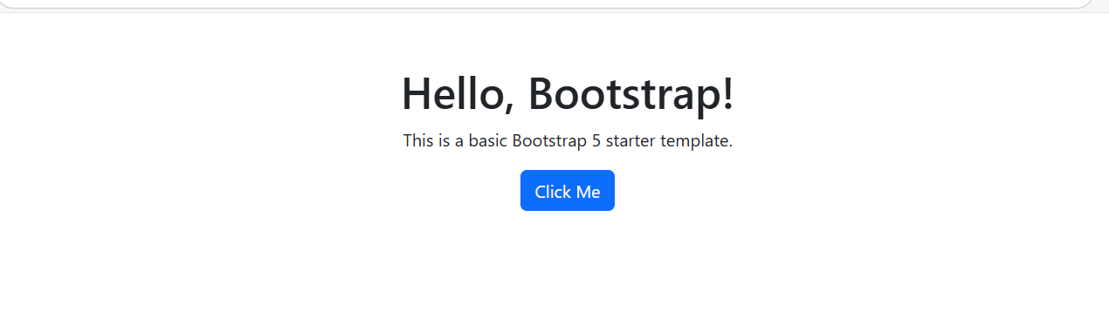

# Program 2 :

<!DOCTYPE html>

<html lang="en">

<head>

    <meta charset="UTF-8">

    <meta name="viewport" content="width=device-width, initial-scale=1.0">

    <title>Bootstrap Navbar</title>

    <link href="https://cdn.jsdelivr.net/npm/bootstrap@5.3.2/dist/css/bootstrap.min.css" rel="stylesheet">

</head>

<body>

    <nav class="navbar navbar-expand-lg navbar-dark bg-dark">

        <div class="container-fluid">

            <a class="navbar-brand" href="#">MySite</a>

            <button class="navbar-toggler" type="button" data-bs-toggle="collapse" data-bs-target="#navbarNav">

                <span class="navbar-toggler-icon"></span>

            </button>

            <div class="collapse navbar-collapse" id="navbarNav">

                <ul class="navbar-nav">

                    <li class="nav-item">

                        <a class="nav-link active" href="#">Home</a>

                    </li>

                    <li class="nav-item">

                        <a class="nav-link" href="#">About</a>

                    </li>

                    <li class="nav-item">

                        <a class="nav-link" href="#">Contact</a>

                    </li>

                </ul>

            </div>

        </div>

    </nav>

    <script src="https://cdn.jsdelivr.net/npm/bootstrap@5.3.2/dist/js/bootstrap.bundle.min.js"></script>

</body>

</html>

# OutPut :

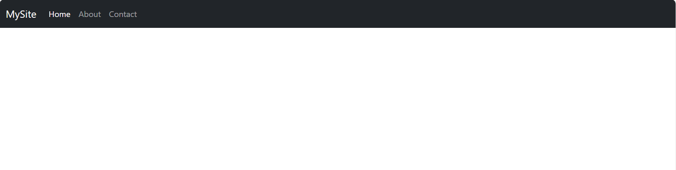

# Program 3 :

<!DOCTYPE html>

<html lang="en">

<head>

    <meta charset="UTF-8">

    <meta name="viewport" content="width=device-width, initial-scale=1.0">

    <title>Bootstrap Card</title>

    <link href="https://cdn.jsdelivr.net/npm/bootstrap@5.3.2/dist/css/bootstrap.min.css" rel="stylesheet">

</head>

<body>

    <div class="container mt-5">

        <div class="card" style="width: 18rem;">

            <img src="https://images.unsplash.com/photo-1619271121705-61b5c3faaae9?w=1000&auto=format&fit=crop&q=60&ixlib=rb-4.0.3&ixid=M3wxMjA3fDB8MHxzZWFyY2h8NHx8YmVhdXRpZnVsJTIwbmF0dXJlfGVufDB8fDB8fHww" class="card-img-top" height="20rem" alt="...">

            <div class="card-body">

                <h5 class="card-title">Card Title</h5>

                <p class="card-text">Some quick example text to build on the card title and make up the bulk of the content.</p>

                <a href="#" class="btn btn-primary">Go somewhere</a>

            </div>

        </div>

    </div>

    <script src="https://cdn.jsdelivr.net/npm/bootstrap@5.3.2/dist/js/bootstrap.bundle.min.js"></script>

</body>

</html>

# OutPut :

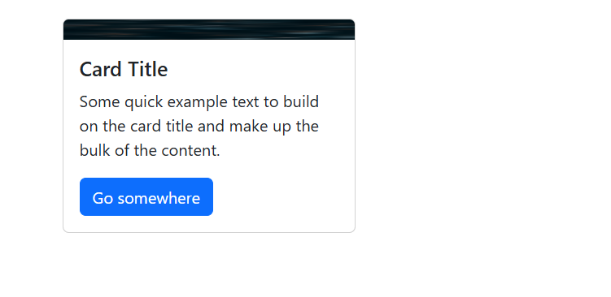

# Program 4:

<!DOCTYPE html>

<html lang="en">

<head>

<meta charset="UTF-8">

<meta name="viewport" content="width=device-width, initial-scale=1.0">

<title>New Bootstrap Modal</title>

<link href="https://cdn.jsdelivr.net/npm/bootstrap@5.3.2/dist/css/bootstrap.min.css" rel="stylesheet">

</head>

<body>

<div class="container mt-5 text-center">

<h2>Newsletter Subscription</h2>

<p>Click the button below to subscribe to our newsletter.</p>

<button type="button" class="btn btn-success" data-bs-toggle="modal" data-bs-target="#subscribeModal">

Subscribe Now

</button>

<!-- Modal Structure -->

<div class="modal fade" id="subscribeModal" tabindex="-1" aria-labelledby="subscribeModalLabel" aria-hidden="true">

<div class="modal-dialog modal-dialog-centered">

<div class="modal-content">

<div class="modal-header bg-success text-white">

<h5 class="modal-title" id="subscribeModalLabel">Subscribe to Our Newsletter</h5>

<button type="button" class="btn-close" data-bs-dismiss="modal" aria-label="Close"></button>

</div>

<div class="modal-body">

<p>Stay updated with our latest news and offers. Enter your email below:</p>

<input type="email" class="form-control mb-3" placeholder="Enter your email" required>

</div>

<div class="modal-footer">

<button type="button" class="btn btn-secondary" data-bs-dismiss="modal">Cancel</button>

<button type="button" class="btn btn-success">Subscribe</button>

</div>

</div>

</div>

</div>

</div>

<script src="https://cdn.jsdelivr.net/npm/bootstrap@5.3.2/dist/js/bootstrap.bundle.min.js"></script>

</body>

</html>

# OutPut :

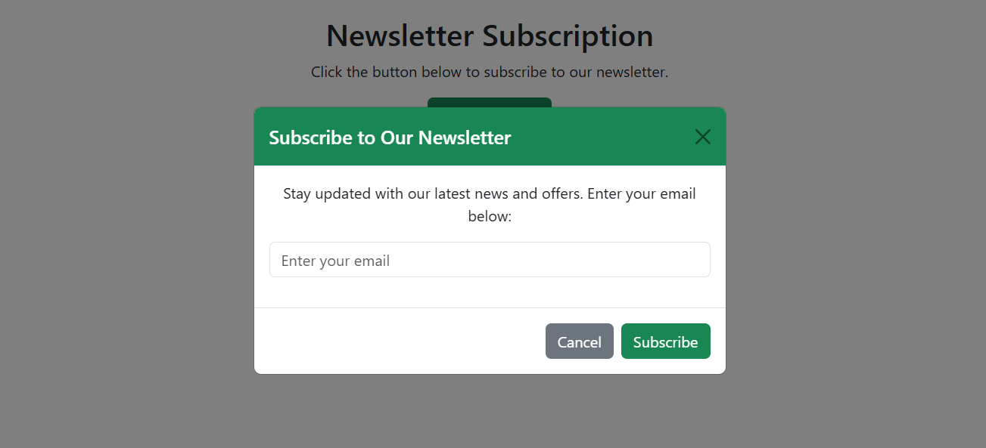

# Program 5 :

<!DOCTYPE html>

<html lang="en">

<head>

    <meta charset="UTF-8">

    <meta name="viewport" content="width=device-width, initial-scale=1.0">

    <title>Bootstrap Table</title>

    <link href="https://cdn.jsdelivr.net/npm/bootstrap@5.3.2/dist/css/bootstrap.min.css" rel="stylesheet">

</head>

<body>

    <div class="container mt-5">

        <h2>Employee Details</h2>

        <table class="table table-bordered">

            <thead>

                <tr>

                    <th>ID</th>

                    <th>Name</th>

                    <th>Department</th>

                </tr>

            </thead>

            <tbody>

                <tr>

                    <td>1</td>

                    <td>John Doe</td>

                    <td>IT</td>

                </tr>

                <tr>

                    <td>2</td>

                    <td>Jane Smith</td>

                    <td>Finance</td>

                </tr>

            </tbody>

        </table>

    </div>

    <script src="https://cdn.jsdelivr.net/npm/bootstrap@5.3.2/dist/js/bootstrap.bundle.min.js"></script>

</body>

</html>

# OutPut :

