Fonts

# Program 1:

<!DOCTYPE html>

<html lang="en">

<head>

  <meta charset="UTF-8">

  <meta name="viewport" content="width=device-width, initial-scale=1.0">

  <title>Sans-Serif Font Example</title>

  <style>

    /* Importing Google Font */

    @import url('https://fonts.googleapis.com/css2?family=Roboto:wght@400;700&display=swap');

    body {

      font-family: 'Roboto', sans-serif;

      font-size: 16px;

      color: #333333;

      line-height: 1.6;

    }

    h1, h2, h3 {

      font-weight: 700;

      color: #222;

    }

    p {

      font-weight: 400;

      color: #555;

      margin-bottom: 15px;

    }

  </style>

</head>

<body>

  <h1>Welcome to My Sans-Serif Font Page</h1>

  <p>This page uses a clean and modern sans-serif font for easy readability and a contemporary look.</p>

</body>

</html>

# OutPut :

Program 2 :

<!DOCTYPE html>

<html lang="en">

<head>

  <meta charset="UTF-8">

  <meta name="viewport" content="width=device-width, initial-scale=1.0">

  <title>Decorative Font with Advanced Attributes</title>

  <style>

    /* Importing Google Font with variable weight */

    @import url('https://fonts.googleapis.com/css2?family=Playfair+Display:wght@400;500;700&display=swap');

    body {

      font-family: 'Playfair Display', cursive;

      font-size: 17px;

      color: #4b4b4b;

      line-height: 1.6;

      font-display: optional; /* Loads only if immediately available */

      font-stretch: 95%; /* Slightly condensed */

      font-variation-settings: "wght" 400; /* Normal weight */

    }

    h1 {

      font-weight: 700; /* Bold weight */

      font-stretch: 110%; /* Expanded */

      color: #b3345b;

    }

    p {

      font-weight: 500; /* Medium weight */

      font-stretch: 85%; /* More condensed */

      color: #555;

      margin-bottom: 10px;

    }

  </style>

</head>

<body>

  <h1>Unique Decorative Styling with Playfair Display</h1>

  <p>This paragraph demonstrates a decorative font with customized weight, stretch, and display settings.</p>

</body>

</html>

OutPut : 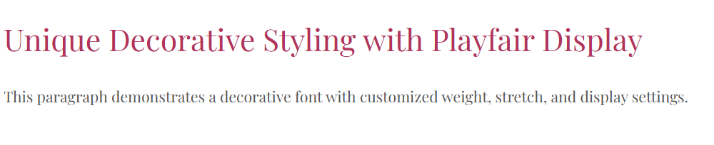

# Program 3 :

<!DOCTYPE html>

<html lang="en">

<head>

  <meta charset="UTF-8">

  <meta name="viewport" content="width=device-width, initial-scale=1.0">

  <title>Serif Font with Advanced Attributes</title>

  <style>

    /* Importing Google Font with variable weight */

    @import url('https://fonts.googleapis.com/css2?family=Merriweather:wght@300;400;700&display=swap');

    body {

      font-family: 'Merriweather', serif;

      font-size: 18px;

      color: #3a3a3a;

      line-height: 1.7;

      font-display: fallback; /* Uses fallback font if loading is delayed */

      font-variation-settings: "wght" 400; /* Normal weight */

      font-stretch: 100%; /* Normal width */

    }

    h1 {

      font-weight: 700; /* Bold heading */

      font-stretch: 120%; /* Expanded heading */

      color: #2a2a2a;

    }

    p {

      font-weight: 300; /* Light weight */

      font-stretch: 85%; /* Condensed width */

      color: #444;

      line-height: 1.8;

    }

  </style>

</head>

<body>

  <h1>Elegant Serif Styling with Merriweather</h1>

  <p>This paragraph uses font-weight and stretch variations to achieve a refined look.</p>

</body>

</html>

# OutPut :

