Icons

# Program 1:

<!DOCTYPE html>

<html lang="en">

<head>

  <meta charset="UTF-8">

  <meta name="viewport" content="width=device-width, initial-scale=1.0">

  <title>Font Awesome Icons</title>

  <!-- Import Font Awesome from CDN -->

  <link rel="stylesheet" href="https://cdnjs.cloudflare.com/ajax/libs/font-awesome/6.4.0/css/all.min.css">

  <style>

    .icon {

      font-family: 'Font Awesome 6 Free';

      font-weight: 900;

      color: #4a4a4a;

      font-size: 30px;

      margin: 10px;

      transition: color 0.3s ease;

    }

    .icon:hover {

      color: #007BFF; /* Change color on hover */

    }

  </style>

</head>

<body>

  <i class="fas fa-home icon" title="Home"></i>

  <i class="fas fa-user icon" title="User"></i>

  <i class="fas fa-envelope icon" title="Envelope"></i>

</body>

</html>

# OutPut :

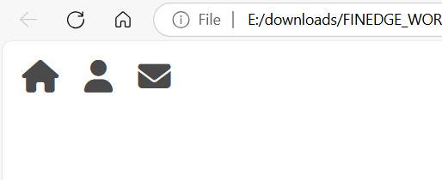

# Program 2 :

<!DOCTYPE html>

<html lang="en">

<head>

  <meta charset="UTF-8">

  <title>Custom SVG Icons Example</title>

  <link rel="stylesheet" href="icons/custom-icons.css">

</head>

<body>

  <!-- Embedded SVG Icons -->

  <svg class="custom-icon" viewBox="0 0 24 24">

    <path d="M10 20v-6h4v6h5v-8h3L12 3 2 12h3v8z"/>

  </svg>

  <svg class="custom-icon" viewBox="0 0 24 24">

    <path d="M12 12c2.7 0 5-2.3 5-5s-2.3-5-5-5-5 2.3-5 5 2.3 5 5 5zm0 2c-3.3 0-10 1.7-10 5v3h20v-3c0-3.3-6.7-5-10-5z"/>

  </svg>

  <svg class="custom-icon" viewBox="0 0 24 24">

    <path d="M20 4H4c-1.1 0-2 .9-2 2v12c0 1.1.9 2 2 2h16c1.1 0 2-.9 2-2V6c0-1.1-.9-2-2-2zm0 4l-8 5-8-5V6l8 5 8-5v2z"/>

  </svg>

</body>

</html>

# OutPut :

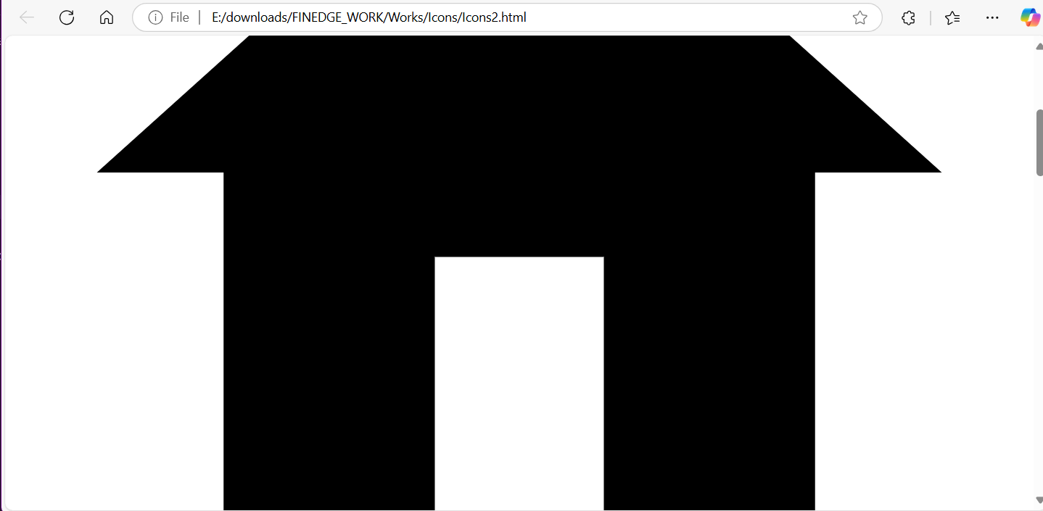

# Program 3 :

<!DOCTYPE html>

<html lang="en">

<head>

    <meta charset="UTF-8">

    <meta name="viewport" content="width=device-width, initial-scale=1.0">

    <title>Document</title>

    <link rel="stylesheet" href="https://cdn.jsdelivr.net/npm/bootstrap-icons@1.11.3/font/bootstrap-icons.min.css">

    <style>

        h1{

            text-align: center;

        }

        i{

            font-size: 50px;

        }

        .icons{

            width: 100%;

            height: 100px;

            background-color: #f1f1f1;

            display: flex;

            justify-content: space-evenly;

            align-items: center;

        }

    </style>

</head>

<body>

    <h1>Welcome..!</h1>

    <div class="icons">

        <div><i class="bi bi-whatsapp"></i></div>

        <div><i class="bi bi-facebook"></i></div>

        <div><i class="bi bi-instagram"></i></div>

        <div><i class="bi bi-twitter"></i></div>

    </div>

</body>

</html>

# OutPut :

