SCSS

# Program 1:

<!DOCTYPE html>

<html lang="en">

<head>

    <meta charset="UTF-8">

    <link rel="stylesheet" href="style/styles.css">

    <meta name="viewport" content="width=device-width, initial-scale=1.0">

    <title>Document</title>

</head>

<body>

    <div class="navbar">

        <ul>

            <li><a href="">Home</a></li>

            <li><a href="">About</a></li>

            <li><a href="">Service</a></li>

            <li><a href="">COntact</a></li>

            <li><a href="">Login</a></li>

        </ul>

    </div>

</body>

</html>

Scss code :

.navbar {

    background-color: #333;

    ul {

      list-style: none;

      margin: 0;

      padding: 0;

      display: flex;

      li {

        padding: 10px 20px;

        a {

          color: #fff;

          text-decoration: none;

          &:hover {

            color: #f39c12;

          }

        }

      }

    }

  }

# OutPut :

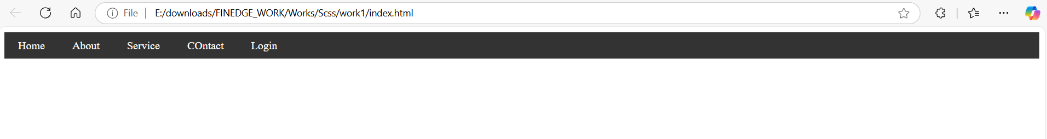

# Program 2 :

<!DOCTYPE html>

<html lang="en">

<head>

    <meta charset="UTF-8">

    <link rel="stylesheet" href="style/styles.css">

    <meta name="viewport" content="width=device-width, initial-scale=1.0">

    <title>Document</title>

</head>

<body>

    <div class="card">

        <img src="https://images.pexels.com/photos/443446/pexels-photo-443446.jpeg?cs=srgb&dl=daylight-forest-glossy-443446.jpg&fm=jpg" width="200" height="300" alt="Card Image">

        <h2>Enhanced Card Title</h2>

        <p>This is an enhanced card with hover effects, responsive images, and a footer section.</p>

        <div class="card-footer">

          <a href="#">Learn More</a>

          <a href="#">Share</a>

        </div>

      </div>

</body>

</html>

Scss code :

$primary-color: #3498db;// Enhanced Mixin for Card Styling with Fixed Dimensions

@mixin card-style($padding: 15px, $border-radius: 8px, $bg-color: #fff) {

  width: 500px;

  height: 500px;

  padding: $padding;

  border-radius: $border-radius;

  background-color: $bg-color;

  box-shadow: 0 2px 4px rgba(0, 0, 0, 0.1);

  transition: transform 0.3s, box-shadow 0.3s, background-color 0.3s;

  overflow: hidden;

  position: relative;

  display: flex;

  flex-direction: column;

  justify-content: space-between;

  &:hover {

    transform: scale(1.05);

    box-shadow: 0 4px 8px rgba(0, 0, 0, 0.2);

    background-color: lighten($bg-color, 5%);

  }

}

// Card Styles Using the Mixin

.card {

  @include card-style(20px, 10px, #f9f9f9);

  margin: 15px auto; // Centering the card horizontally

  font-family: 'Arial', sans-serif;

  color: #333;

  line-height: 1.4;

  h2 {

    margin-top: 0;

    font-size: 1.2rem;

    color: #2c3e50;

    overflow: hidden;

    white-space: nowrap;

    text-overflow: ellipsis;

  }

  p {

    font-size: 0.9rem;

    color: #555;

    flex-grow: 1;

    overflow-y: auto;

    margin: 5px 0;

  }

  // Optional Image with Fixed Height

  img {

    height: 300px;

    width: 100%;

    object-fit: cover;

    border-bottom: 1px solid #e0e0e0;

  }

  // Footer Section for Actions

  .card-footer {

    display: flex;

    justify-content: space-between;

    align-items: center;

    padding-top: 5px;

    border-top: 1px solid #e0e0e0;

    a {

      color: $primary-color;

      text-decoration: none;

      font-weight: bold;

      &:hover {

        text-decoration: underline;

      }

    }

  }

}

# OutPut :

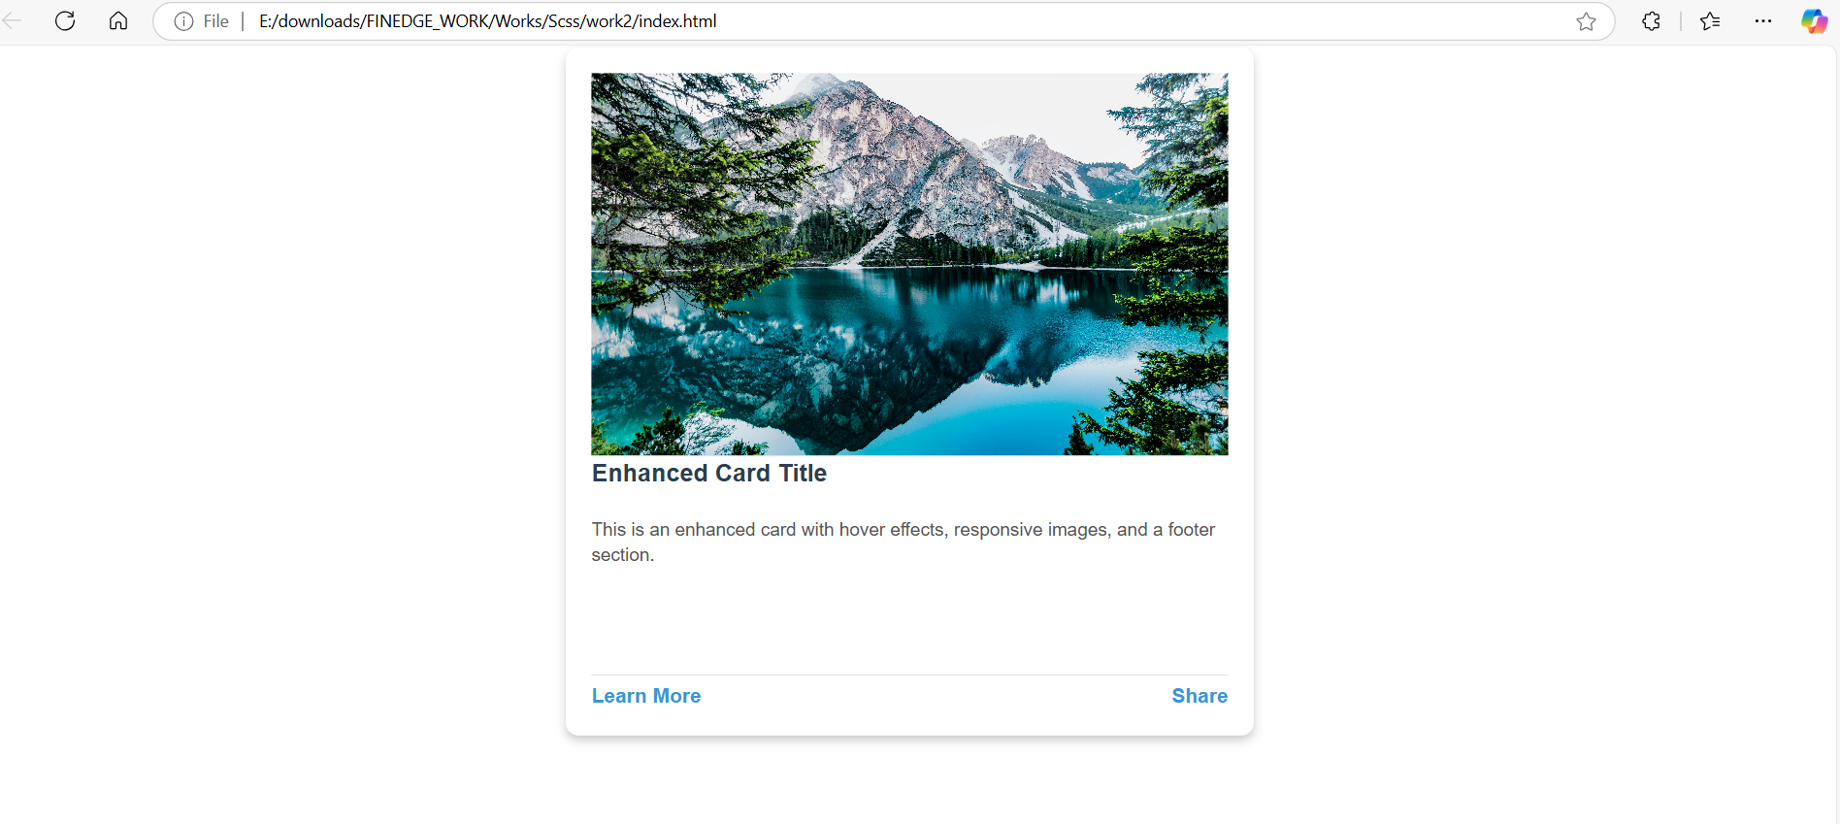

# Program 3 :

<!DOCTYPE html>

<html lang="en">

<head>

  <meta charset="UTF-8">

  <meta name="viewport" content="width=device-width, initial-scale=1.0">

  <title>SCSS Loop Cards Example</title>

  <link rel="stylesheet" href="style/styles.css">

</head>

<body>

  <div class="cards-container">

    <div class="card-primary">

      <h2>Primary Card</h2>

      <p>This is a card styled with the primary color.</p>

    </div>

    <div class="card-secondary">

      <h2>Secondary Card</h2>

      <p>This card uses the secondary color for styling.</p>

    </div>

    <div class="card-danger">

      <h2>Danger Card</h2>

      <p>Use this card to highlight dangerous actions.</p>

    </div>

    <div class="card-warning">

      <h2>Warning Card</h2>

      <p>This card alerts users about something important.</p>

    </div>

    <div class="card-info">

      <h2>Info Card</h2>

      <p>This card provides additional information.</p>

    </div>

  </div>

</body>

</html>

Scss code :

// Color Palette for Cards

$colors: (

  "primary": #3498db,

  "secondary": #2ecc71,

  "danger": #e74c3c,

  "warning": #f39c12,

  "info": #8e44ad

);

// Mixin for card structure

@mixin card-style($color) {

  width: 300px;

  height: 180px;

  margin: 15px;

  padding: 20px;

  background-color: $color;

  border-radius: 12px;

  color: #fff;

  box-shadow: 0 4px 8px rgba(0, 0, 0, 0.2);

  transition: transform 0.3s, box-shadow 0.3s;

  overflow: hidden;

  &:hover {

    transform: scale(1.05);

    box-shadow: 0 6px 12px rgba(0, 0, 0, 0.3);

  }

  h2 {

    font-size: 1.4rem;

    margin: 0 0 10px;

  }

  p {

    font-size: 1rem;

    line-height: 1.5;

  }

}

// Generate Cards with Loop

@each $name in $colors {

  .card-#{$name} {

    @include card-style($color);

  }

}

// Layout for Cards Container

.cards-container {

  display: flex;

  flex-wrap: wrap;

  justify-content: center;

  align-items: center;

  gap: 15px;

}

# OutPut :

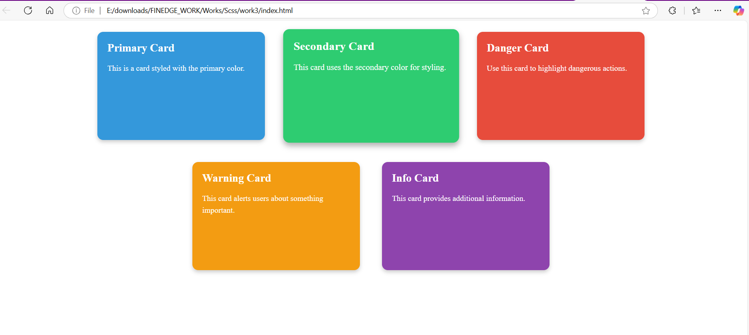

# Program 4 :

<!DOCTYPE html>

<html lang="en">

<head>

  <meta charset="UTF-8">

  <meta name="viewport" content="width=device-width, initial-scale=1.0">

  <title>Styled Table with SCSS</title>

  <link rel="stylesheet" href="style/styles.css">

</head>

<body>

<div class="table-container">

  <table>

    <thead>

      <tr>

        <th>#</th>

        <th>Name</th>

        <th>Age</th>

        <th>City</th>

        <th>Occupation</th>

      </tr>

    </thead>

    <tbody>

      <tr>

        <td>1</td>

        <td>Alice Johnson</td>

        <td>28</td>

        <td>New York</td>

        <td>Engineer</td>

      </tr>

      <tr>

        <td>2</td>

        <td>Bob Smith</td>

        <td>35</td>

        <td>Chicago</td>

        <td>Designer</td>

      </tr>

      <tr>

        <td>3</td>

        <td>Charlie Adams</td>

        <td>24</td>

        <td>San Francisco</td>

        <td>Developer</td>

      </tr>

      <tr>

        <td>4</td>

        <td>Diana Williams</td>

        <td>31</td>

        <td>Miami</td>

        <td>Manager</td>

      </tr>

    </tbody>

    <tfoot>

      <tr>

        <td colspan="5">Total Records: 4</td>

      </tr>

    </tfoot>

  </table>

</div>

</body>

</html>

Scss code :

$table-header-bg: #3498db;

$table-header-color: #fff;

$row-even-bg: #f3f3f3;

$row-odd-bg: #ffffff;

$hover-bg: #e8f4fa;

$border-color: #ddd;

.table-container {

  width: 100%;

  margin: 20px auto;

  overflow-x: auto;

  table {

    width: 100%;

    border-collapse: collapse;

    margin-bottom: 15px;

    font-family: Arial, sans-serif;

    font-size: 16px;

    thead {

      background-color: $table-header-bg;

      color: $table-header-color;

      th {

        padding: 12px 15px;

        text-align: left;

        border-bottom: 2px solid darken($table-header-bg, 10%);

      }

    }

    tbody {

      tr {

        &:nth-child(even) {

          background-color: $row-even-bg;

        }

        &:nth-child(odd) {

          background-color: $row-odd-bg;

        }

        &:hover {

          background-color: $hover-bg;

        }

      }

      td {

        padding: 10px 15px;

        border-bottom: 1px solid $border-color;

      }

    }

    tfoot {

      tr {

        background-color: darken($table-header-bg, 10%);

        color: $table-header-color;

        td {

          padding: 10px 15px;

          font-weight: bold;

        }

      }

    }

  }

}

# OutPut :

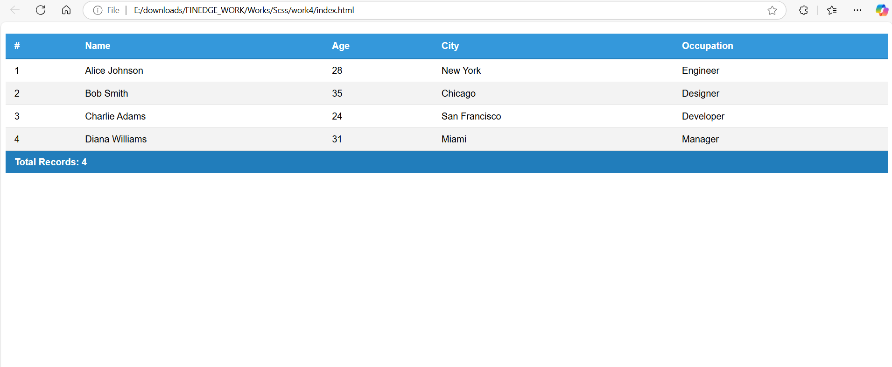

# Program 5 :

<!DOCTYPE html>

<html lang="en">

<head>

  <meta charset="UTF-8">

  <meta name="viewport" content="width=device-width, initial-scale=1.0">

  <title>Profile List with SCSS</title>

  <link rel="stylesheet" href="style/styles.css"> <!-- Ensure SCSS is compiled to CSS -->

</head>

<body>

<div class="profile-list">

  <div class="profile">

    <img src="https://th.bing.com/th/id/OIP.KQyRrvhdN5TJESnxqUPDJwHaIU?w=175&h=197&c=7&r=0&o=5&dpr=1.3&pid=1.7" alt="Alice">

    <h3>Alice Johnson</h3>

    <p>Software Engineer from New York with a passion for coding.</p>

  </div>

  <div class="profile">

    <img src="https://th.bing.com/th/id/OIP.dDfmWh0hRsyjDwDctn9sNwHaHa?w=206&h=206&c=7&r=0&o=5&dpr=1.3&pid=1.7" alt="Bob">

    <h3>Bob Smith</h3>

    <p>A creative designer based in San Francisco.</p>

  </div>

  <div class="profile">

    <img src="https://th.bing.com/th/id/OIP.K9XkyHnbKHGDOda2c4VoKgHaHe?w=192&h=193&c=7&r=0&o=5&dpr=1.3&pid=1.7" alt="Charlie">

    <h3>Charlie Adams</h3>

    <p>A talented developer focusing on front-end frameworks.</p>

  </div>

  <div class="profile">

    <img src="https://th.bing.com/th/id/OIP.Qm6wy174_Gjs2ynJ9KCv_wHaHi?w=197&h=201&c=7&r=0&o=5&dpr=1.3&pid=1.7" alt="Diana">

    <h3>Diana Williams</h3>

    <p>Manager with experience in leading tech teams globally.</p>

  </div>

  <div class="profile">

    <img src="https://th.bing.com/th/id/OIP.mgSff-wElHMioSXScBxlNAHaF8?w=268&h=214&c=7&r=0&o=5&dpr=1.3&pid=1.7" alt="Edward">

    <h3>Edward Evans</h3>

    <p>Data scientist with a love for numbers and analytics.</p>

  </div>

</div>

</body>

</html>

Scss code :

$primary-color: #3498db; // Base color

$shade-amount: 7%; // Lightening step for each profile background

$i: 1;

.profile-list {

  display: flex;

  flex-wrap: wrap;

  justify-content: space-around;

  padding: 20px;

  background-color: #f5f5f5;

  min-height: 100vh;

  gap: 15px;

  .profile {

    width: 250px;

    padding: 15px;

    border-radius: 12px;

    box-shadow: 0 4px 8px rgba(0, 0, 0, 0.1);

    text-align: center;

    color: white;

    transition: transform 0.3s ease;

    cursor: pointer;

    @while $i <= 5 {

      &:nth-child(#{$i}) {

        background-color: lighten($primary-color, $shade-amount * $i);

      }

      $i: $i + 1;

    }

    &:hover {

      transform: scale(1.05);

    }

    img {

      width: 80px;

      height: 80px;

      border-radius: 50%;

      margin-bottom: 10px;

      object-fit: cover;

    }

    h3 {

      margin: 10px 0 5px;

      font-size: 20px;

    }

    p {

      font-size: 14px;

      line-height: 1.4;

    }

  }

}

# OutPut :

