Events

# MouseOver:

<!DOCTYPE html>

<html lang="en">

<head>

    <meta charset="UTF-8">

    <meta name="viewport" content="width=device-width, initial-scale=1.0">

    <title>Mouseover Event</title>

</head>

<body>

    <h1>Mouseover Event Example</h1>

    <div style="width: 100px; height: 100px; background-color: lightblue;"

         onmouseover="showMouseoverAlert()" onmouseout="hideMouseoverAlert()"></div>

    <script>

        function showMouseoverAlert() {

            alert("Mouse is over the box!");

        }

        function hideMouseoverAlert() {

            alert("Mouse left the box!");

        }

    </script>

</body>

</html>

# OutPut :

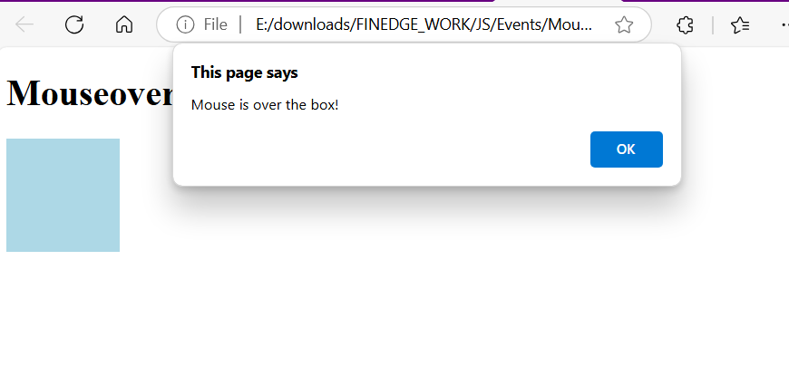

# MouseWheel :

<!DOCTYPE html>

<html lang="en">

<head>

    <meta charset="UTF-8">

    <meta name="viewport" content="width=device-width, initial-scale=1.0">

    <title>Mousewheel Event Example</title>

    <style>

        body {

            font-family: Arial, sans-serif;

            background-color: #f0f0f0;

            display: flex;

            justify-content: center;

            align-items: center;

            height: 100vh;

            margin: 0;

        }

        #messageBox {

            width: 300px;

            padding: 20px;

            background-color: #fff;

            box-shadow: 0 0 10px rgba(0, 0, 0, 0.1);

            text-align: center;

        }

        #message {

            margin-top: 20px;

            font-size: 18px;

            color: #333;

        }

    </style>

</head>

<body>

    <div id="messageBox">

        <button id="sendMessage">Send Message</button>

        <div id="message"></div>

    </div>

    <script>

        document.getElementById('sendMessage').addEventListener('click', function() {

            document.getElementById('message').innerText = 'Scroll the mouse wheel to see the event in action!';

        });

        window.addEventListener('mousewheel', function(event) {

            document.getElementById('message').innerText = 'Mousewheel event detected!';

        });

    </script>

</body>

</html>

# OutPut :

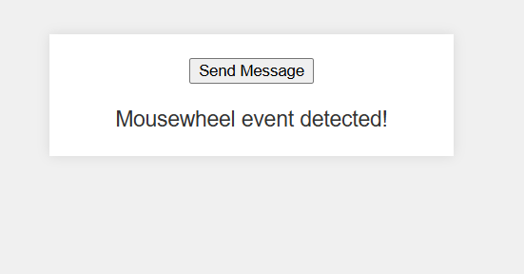

# Onblur Event :

<!DOCTYPE html>

<html lang="en">

<head>

    <meta charset="UTF-8">

    <meta name="viewport" content="width=device-width, initial-scale=1.0">

    <title>Blur Event</title>

</head>

<body>

    <h1>Blur Event Example</h1>

    <input type="text" placeholder="Click and then click outside to trigger blur" onblur="showBlurAlert()">

    <script>

        function showBlurAlert() {

            alert("Input field lost focus!");

        }

    </script>

</body>

</html>

# OutPut :

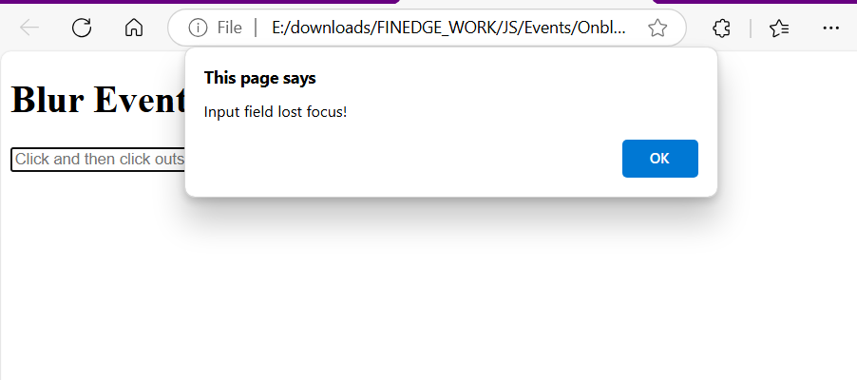

# Onchange Event :

<!DOCTYPE html>

<html lang="en">

<head>

    <meta charset="UTF-8">

    <meta name="viewport" content="width=device-width, initial-scale=1.0">

    <title>Change Event</title>

</head>

<body>

    <h1>Change Event Example</h1>

    <select onchange="showChange()">

        <option value="Option 1">Option 1</option>

        <option value="Option 2">Option 2</option>

        <option value="Option 3">Option 3</option>

    </select>

    <script>

        function showChange() {

            alert("Selected ");

        }

    </script>

</body>

</html>

# OutPut :

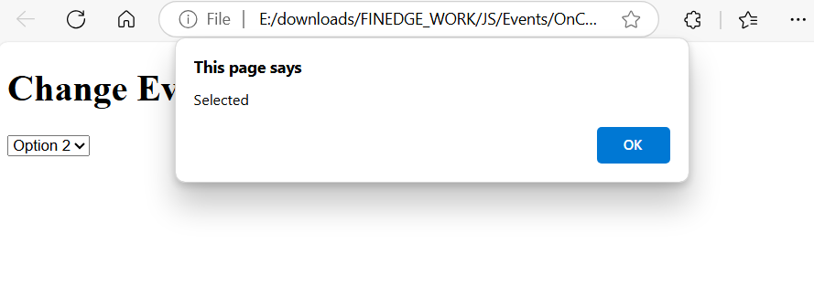

# Onclick Event :

<!DOCTYPE html>

<html lang="en">

<head>

    <meta charset="UTF-8">

    <meta name="viewport" content="width=device-width, initial-scale=1.0">

    <title>Click Event</title>

</head>

<body>

    <h1>Click Event Example</h1>

    <button onclick="showClickAlert()">Click Me</button>

    <script>

        function showClickAlert() {

            alert("Button was clicked!");

        }

    </script>

</body>

</html>

# OutPut :

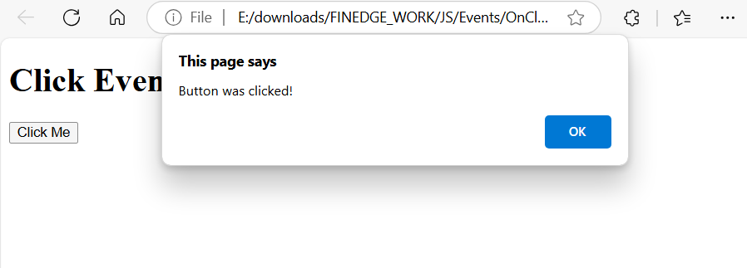

# Oncontextmenu Event :

<!DOCTYPE html>

<html lang="en">

<head>

    <meta charset="UTF-8">

    <meta name="viewport" content="width=device-width, initial-scale=1.0">

    <title>OnContextMenu Event Example</title>

    <style>

        body {

            font-family: Arial, sans-serif;

        }

        .context-menu {

            display: none;

            position: absolute;

            background-color: #f9f9f9;

            box-shadow: 0px 0px 10px rgba(0, 0, 0, 0.1);

            z-index: 1000;

            width: 150px;

        }

        .context-menu ul {

            list-style: none;

            padding: 0;

            margin: 0;

        }

        .context-menu ul li {

            padding: 8px 12px;

            cursor: pointer;

        }

        .context-menu ul li:hover {

            background-color: #e0e0e0;

        }

    </style>

</head>

<body>

    <div id="context-menu" class="context-menu">

        <ul>

            <li onclick="alert('Option 1 clicked')">Option 1</li>

            <li onclick="alert('Option 2 clicked')">Option 2</li>

            <li onclick="alert('Option 3 clicked')">Option 3</li>

        </ul>

    </div>

    <script>

        document.addEventListener('contextmenu', function(event) {

            event.preventDefault();

            const contextMenu = document.getElementById('context-menu');

            contextMenu.style.top = `${event.clientY}px`;

            contextMenu.style.left = `${event.clientX}px`;

            contextMenu.style.display = 'block';

        });

        document.addEventListener('click', function() {

            const contextMenu = document.getElementById('context-menu');

            contextMenu.style.display = 'none';

        });

    </script>

</body>

</html>

# OutPut :

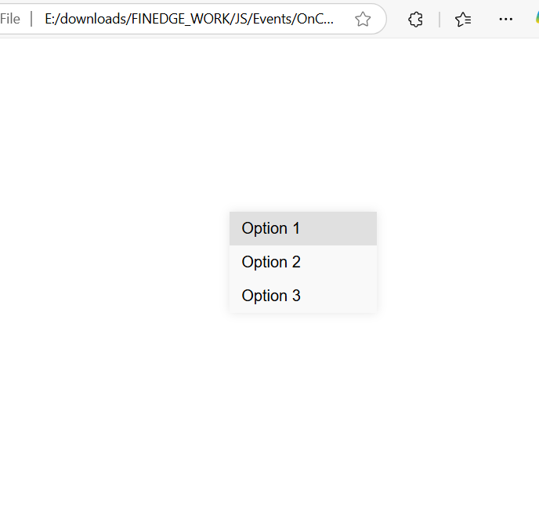

# Ondbclick Event :

<!DOCTYPE html>

<html lang="en">

<head>

    <meta charset="UTF-8">

    <meta name="viewport" content="width=device-width, initial-scale=1.0">

    <title>Double Click Event</title>

</head>

<body>

    <h1>Double Click Event Example</h1>

    <button ondblclick="showDblClickAlert()" >Double Click Me</button>

    <script>

        function showDblClickAlert() {

            alert("Button was double-clicked!");

        }

    </script>

</body>

</html>

# OutPut :

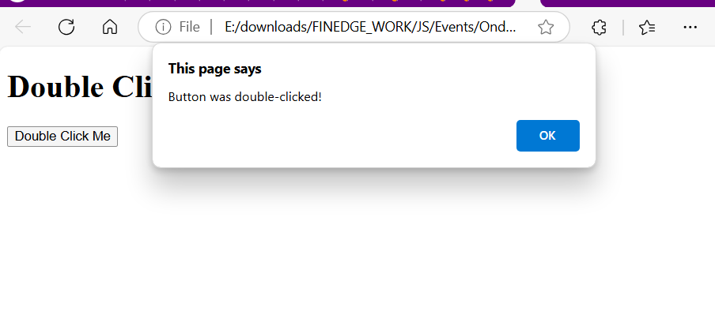

# Onfocus Event :

<!DOCTYPE html>

<html lang="en">

<head>

    <meta charset="UTF-8">

    <meta name="viewport" content="width=device-width, initial-scale=1.0">

    <title>OnFocus Event Example</title>

    <style>

        .input-field {

            padding: 10px;

            border: 2px solid #ccc;

            border-radius: 4px;

            transition: border-color 0.3s;

        }

        .input-field:focus {

            border-color: #66afe9;

            outline: none;

        }

    </style>

</head>

<body>

    <h1>OnFocus Event Example</h1>

    <input type="text" class="input-field" onfocus="handleFocus(event)" placeholder="Focus on me!">

    <script>

        function handleFocus(event) {

            console.log('Input field is focused');

        }

    </script>

</body>

</html>

<p id="message"></p>

<script>

    function handleFocus(event) {

        console.log('Input field is focused');

        document.getElementById('message').innerText = 'Input field is focused';

    }

</script>

# Output :

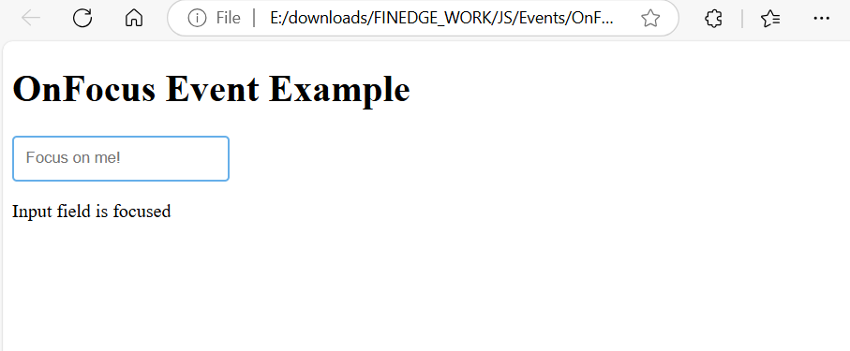

# Onkeydown Event :

<!DOCTYPE html>

<html lang="en">

<head>

    <meta charset="UTF-8">

    <meta name="viewport" content="width=device-width, initial-scale=1.0">

    <title>Keydown Event</title>

</head>

<body>

    <h1>Keydown Event Example</h1>

    <input type="text" placeholder="Press a key" onkeydown="showKeydownAlert()">

    <script>

        function showKeydownAlert() {

            alert("Key down");

        }

    </script>

</body>

</html>

# OutPut :

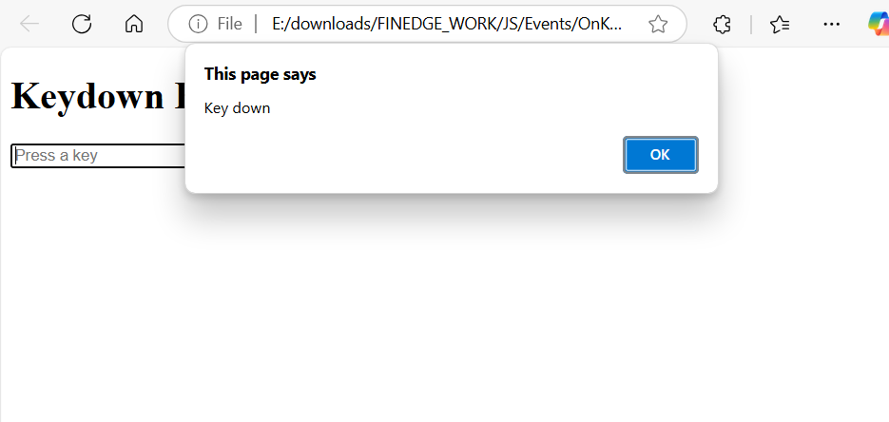

# Onkeypress Event :

<!DOCTYPE html>

<html lang="en">

<head>

    <meta charset="UTF-8">

    <meta name="viewport" content="width=device-width, initial-scale=1.0">

    <title>Keypress Event</title>

</head>

<body>

    <h1>Keypress Event Example</h1>

    <input type="text" placeholder="Type something..." onkeypress="showKeypress()">

    <script>

        function showKeypress(event) {

            alert("Key pressed ");

        }

    </script>

</body>

</html>

# OutPut :

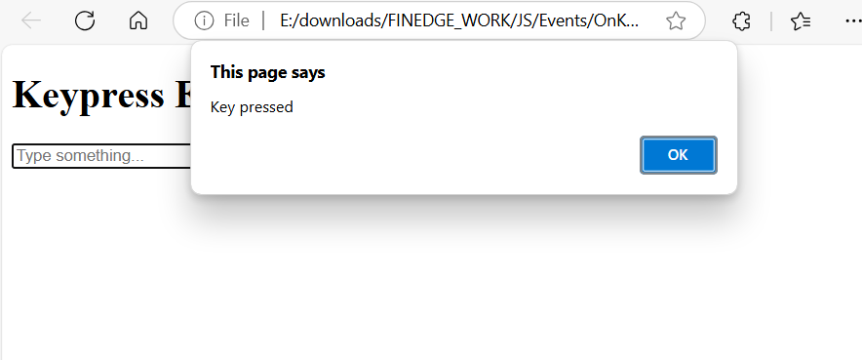

# Onkeyup Event :

<!DOCTYPE html>

<html lang="en">

<head>

    <meta charset="UTF-8">

    <meta name="viewport" content="width=device-width, initial-scale=1.0">

    <title>Keyup Event</title>

</head>

<body>

    <h1>Keyup Event Example</h1>

    <input type="text" placeholder="Release a key" onkeyup="showKeyupAlert()">

    <script>

        function showKeyupAlert() {

            alert("Key up ");

        }

    </script>

</body>

</html>

# OutPut :

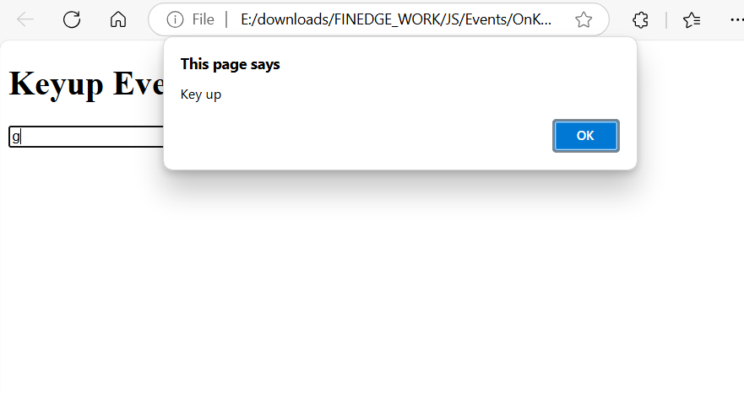

# Onload Event :

<!DOCTYPE html>

<html lang="en">

<head>

    <meta charset="UTF-8">

    <meta name="viewport" content="width=device-width, initial-scale=1.0">

    <title>Onload Event Example</title>

    <style>

        body {

            font-family: Arial, sans-serif;

            background-color: #f0f0f0;

            text-align: center;

            padding-top: 50px;

        }

        #message {

            display: none;

            font-size: 24px;

            color: #333;

        }

    </style>

</head>

<body onload="showMessage()">

    <div id="message">Welcome to the Onload Event Example!</div>

    <script>

        function showMessage() {

            document.getElementById('message').style.display = 'block';

        }

    </script>

</body>

</html>

# OutPut :

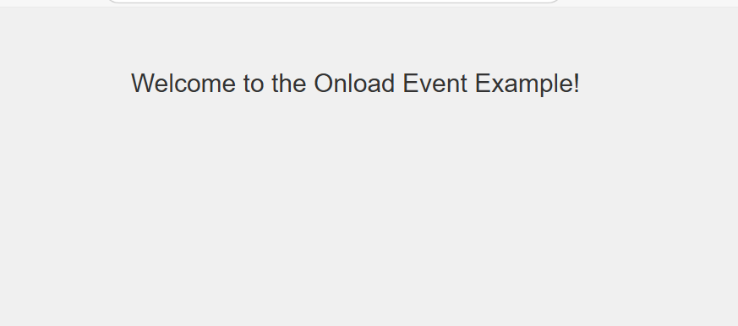

# Onmousewheel Event :

<!DOCTYPE html>

<html lang="en">

<head>

    <meta charset="UTF-8">

    <meta name="viewport" content="width=device-width, initial-scale=1.0">

    <title>Mousewheel Event</title>

</head>

<body>

    <h1>Mousewheel Event Example</h1>

    <div style="width: 100px; height: 100px; background-color: lightcoral;" onmousewheel="showMousewheelAlert()">

        Scroll inside this box

    </div>

    <script>

        function showMousewheelAlert() {

            alert("Mouse wheel scrolled!" );

        }

    </script>

</body>

</html>

# OutPut :

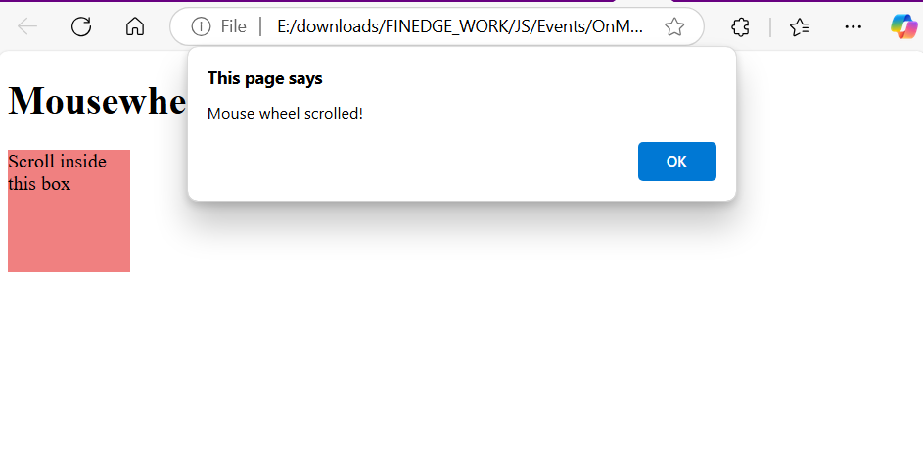

# Onscroll Event :

<!DOCTYPE html>

<html lang="en">

<head>

    <meta charset="UTF-8">

    <meta name="viewport" content="width=device-width, initial-scale=1.0">

    <title>OnScroll Event Example</title>

    <style>

        body {

            height: 2000px; /* To enable scrolling */

        }

        #scrollStatus {

            position: fixed;

            top: 10px;

            left: 10px;

            background-color: lightgray;

            padding: 20px; /* Increased padding */

            border-radius: 5px;

        }

    </style>

</head>

<body onscroll="handleScroll()">

    <div id="scrollStatus">Scroll to see the effect</div>

    <script>

        function handleScroll() {

            const scrollStatus = document.getElementById('scrollStatus');

            scrollStatus.textContent = `Scroll Y: ${window.scrollY}px`;

        }

    </script>

</body>

</html>

# OutPut :

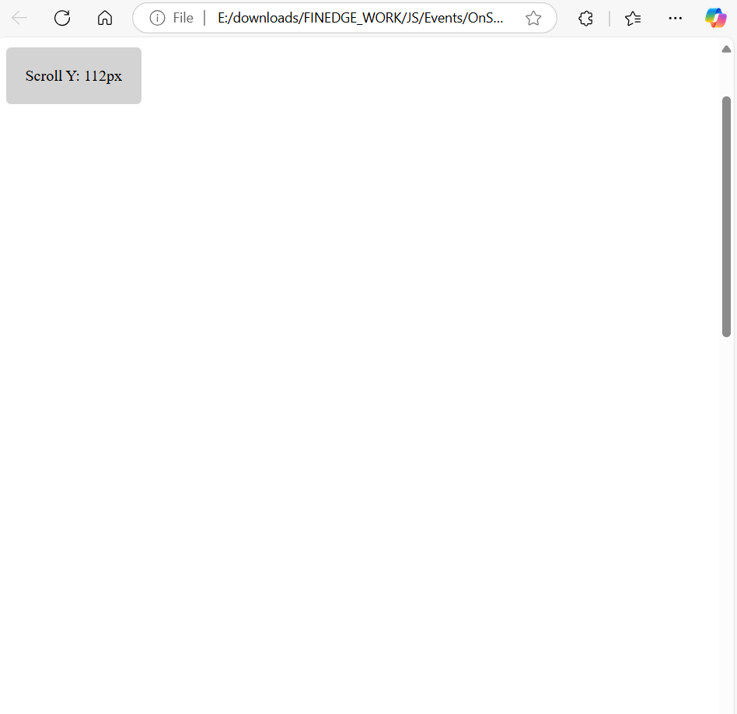

# Onsubmit Event :

<!DOCTYPE html>

<html lang="en">

<head>

    <meta charset="UTF-8">

    <meta name="viewport" content="width=device-width, initial-scale=1.0">

    <title>OnSubmit Event Example</title>

    <style>

        body {

            font-family: Arial, sans-serif;

            margin: 20px;

        }

        form {

            max-width: 300px;

            margin: auto;

            padding: 35px;

            border: 1px solid #ccc;

            border-radius: 5px;

        }

        label {

            display: block;

            margin-bottom: 10px;

        }

        input[type="text"], input[type="submit"] {

            width: 100%;

            padding: 10px;

            margin-bottom: 10px;

        }

    </style>

</head>

<body>

    <form id="myForm" onsubmit="return handleSubmit(event)">

        <label for="name">Name:</label>

        <input type="text" id="name" name="name" required>

        <input type="submit" value="Submit">

    </form>

    <script>

        function handleSubmit(event) {

            event.preventDefault();

            const name = document.getElementById('name').value;

            alert('Form submitted! Name: ' + name);

            return false;

        }

    </script>

</body>

</html>

# OutPut :

