Objects

# Simple object :

<!DOCTYPE html>

<html>

<head>

    <style>

        body {

            font-family: Arial, sans-serif;

            background-color: #f0f0f0;

            margin: 0;

            padding: 20px;

        }

        h2 {

            color: #333;

        }

    </style>

    <title>Person Object</title>

</head>

<body>

    <h2>Person Object Example</h2>

    <script>

        let person = {

            name: "John Doe",

            age: 30,

            gender: "Male",

            greet: function() {

                document.write ("Hello, my name is " + this.name + " and I am " + this.age + " years old.");

            }

        };

        person.greet(); // Outputs: Hello, my name is John Doe and I am 30 years old.

    </script>

</body>

</html>

# OutPut :



# Object with Method :

<!DOCTYPE html>

<html>

<head>

    <style>

        body {

            font-family: Arial, sans-serif;

            margin: 20px;

        }

        h2 {

            color: #333;

        }

    </style>

    <title>Method with this</title>

</head>

<body>

    <h2>Method Using this</h2>

    <script>

        let calculator = {

            a: 10,

            b: 5,

            add: function() {

                return this.a + this.b;

            },

            subtract: function() {

                return this.a - this.b;

            }

        };

       document.write("Addition: " + calculator.add());       // Outputs: Addition: 15

        document.write ("Subtraction: " + calculator.subtract()); // Outputs: Subtraction: 5

    </script>

</body>

</html>

# OutPut :

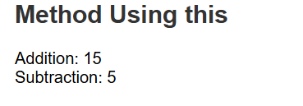

# Dynamic Property access :

<!DOCTYPE html>

<html>

<head>

    <style>

        body {

            font-family: Arial, sans-serif;

            margin: 20px;

        }

        h2 {

            color: #333;

        }

        /* script {

            display: block;

            margin-top: 20px;

        } */

    </style>

    <title>Dynamic Property Access</title>

</head>

<body>

    <h2>Dynamic Property Access Example</h2>

    <script>

        let book = {

            title: "JavaScript Essentials",

            author: "John Smith",

            pages: 350

        };

        let propertyName = "title";

        document.write(book[propertyName]); // Outputs: JavaScript Essentials

    </script>

</body>

</html>

# OutPut :



# Library representation :

<!DOCTYPE html>

<html>

<head>

<style>

    body {

        font-family: Arial, sans-serif;

        background-color: #f0f0f0;

        margin: 20px;

    }

    h2 {

        color: #333;

    }

    .library-info {

        background-color: #fff;

        padding: 20px;

        border-radius: 5px;

        box-shadow: 0 0 10px rgba(0, 0, 0, 0.1);

    }

</style>

    <title>Library Object</title>

</head>

<body>

    <h2>Library Object Example</h2>

    <script>

        let library = {

            name: "City Library",

            books: ["The Great Gatsby", "1984", "To Kill a Mockingbird"],

            listBooks: function() {

                document.write("Books available in " + this.name + ":<br>");

                this.books.forEach((book, index) => {

                    document.write(index + 1 + ". " + book + "<br>");

                });

            },

            addBook: function(newBook) {

                this.books.push(newBook);

                document.write(newBook + " has been added to the library.<br>");

            }

        };

        library.listBooks();

        library.addBook("Moby Dick");

        library.listBooks();

    </script>

</body>

</html>

# OutPut :

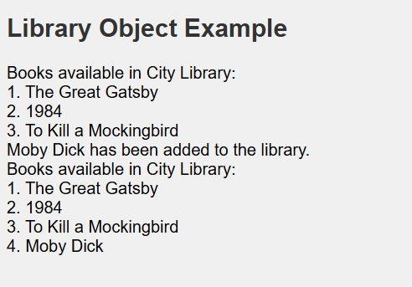

# Reprasenting a Recipe :

<!DOCTYPE html>

<html>

<head>

    <style>

        body {

            font-family: Arial, sans-serif;

            margin: 20px;

        }

        h2 {

            color: #333;

        }

        script {

            display: none;

        }

    </style>

    <title>Recipe Object</title>

</head>

<body>

    <h2>Recipe Object Example</h2>

    <script>

        let recipe = {

            name: "Pancakes",

            ingredients: ["Flour", "Milk", "Eggs", "Sugar", "Butter"],

            steps: [

                "Mix all ingredients",

                "Heat a pan and grease it with butter",

                "Pour the batter and cook both sides",

                "Serve with syrup or toppings of your choice"

            ],

            showIngredients: function() {

                document.write("Ingredients for " + this.name + ": " + this.ingredients.join(", ") + "<br>");

            },

            showSteps: function() {

                document.write("Steps to make " + this.name + ":<br>");

                this.steps.forEach((step, index) => {

                    document.write(index + 1 + ". " + step + "<br>");

                });

            }

        };

        recipe.showIngredients();

        recipe.showSteps();

    </script>

</body>

</html>

# OutPut :

