Startup guide for Lab (GitHub and MATLAB)

Course: ES 421 and ES 510

Instructor: Vipul Silwal

**GitHub**

1. Create account on GitHub (<https://github.com/>)
2. Download Git Desktop for Windows or Mac (<https://desktop.github.com/> . For linux install git using terminal (sudo yum install git or sudo apt-get install git).
3. Open Git Desktop (for Windows/Mac)
   1. Files -> Clone Repository
   2. Git clone classes repository using URL from (<https://github.com/vsilwal/classes>). [see figure 1]
   3. For linux tutorial on Git see this: <https://rogerdudler.github.io/git-guide/>
4. A startup tutorial to git see this: <https://guides.github.com/activities/hello-world/>

**MATLAB**

1. Go to Institute Computer Center website of IIT Roorkee (<https://www.iitr.ac.in/centers/CC/pages/Resources+MATLAB.html>)
2. Scroll to the bottom of the page and click on [Indian Institute of Technology Roorkee’s MATLAB Portal](https://www.mathworks.com/academia/tah-portal/indian-institute-of-technology-roorkee-40701353.html) link (elect Indian zone if asked for). [see figure 2 below]
3. Click on Sign in to get started. [see figure 3]
4. Create an account on Mathworks using your iitr email address [see figure 4]
5. Download Installer [see figure 5]
6. Follow through with the installation process (root password, run exe file, etc)
7. Install using Mathworks account and NOT the Installation Key [see figure 6]
8. Click yes on license agreement [see figure 7]
9. Use your Mathworks account credentials to Install [see figure 8]
10. Click Next [see figure 9]
11. Choose path where you want to install (use default if you don’t know what you are doing) [see figure 10]
12. Use default Toolbox [see figure 11]
13. Keep clicking Next

**Figures**

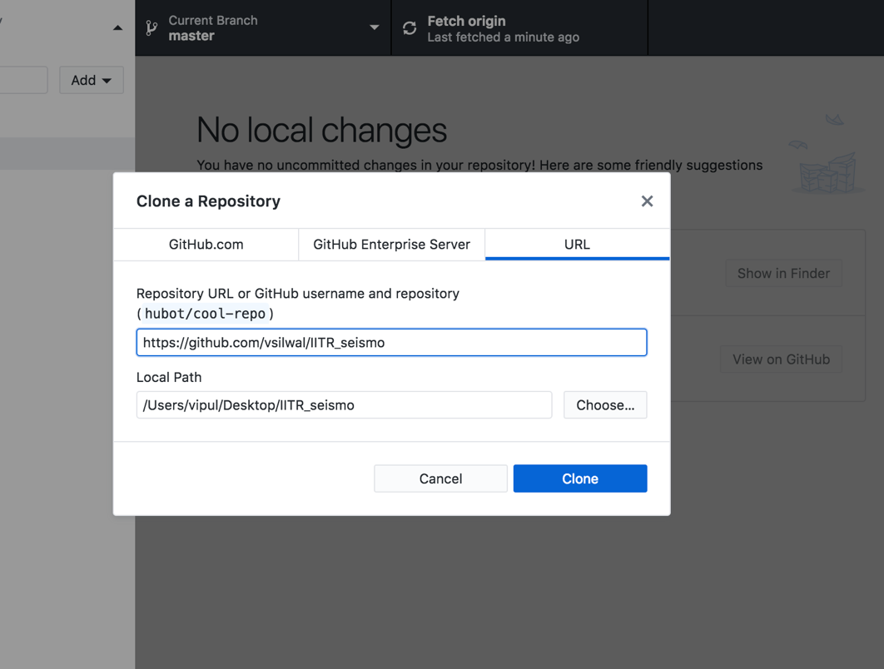

Figure 1



Figure 2

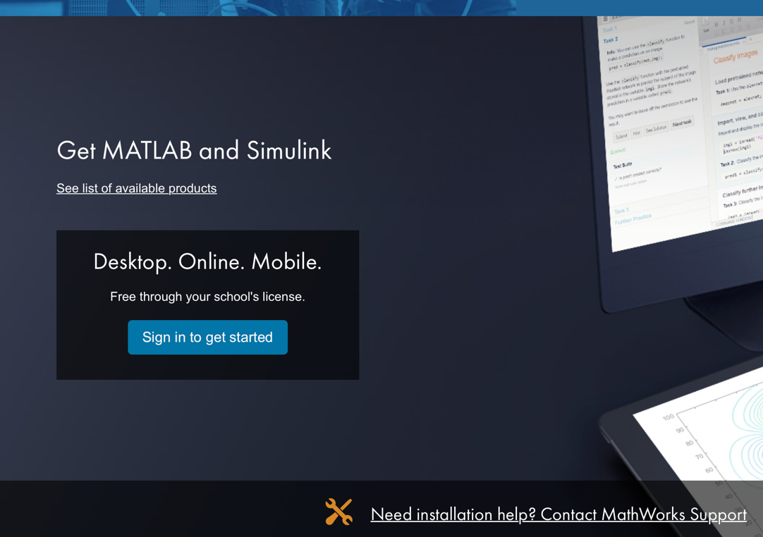

Figure 3

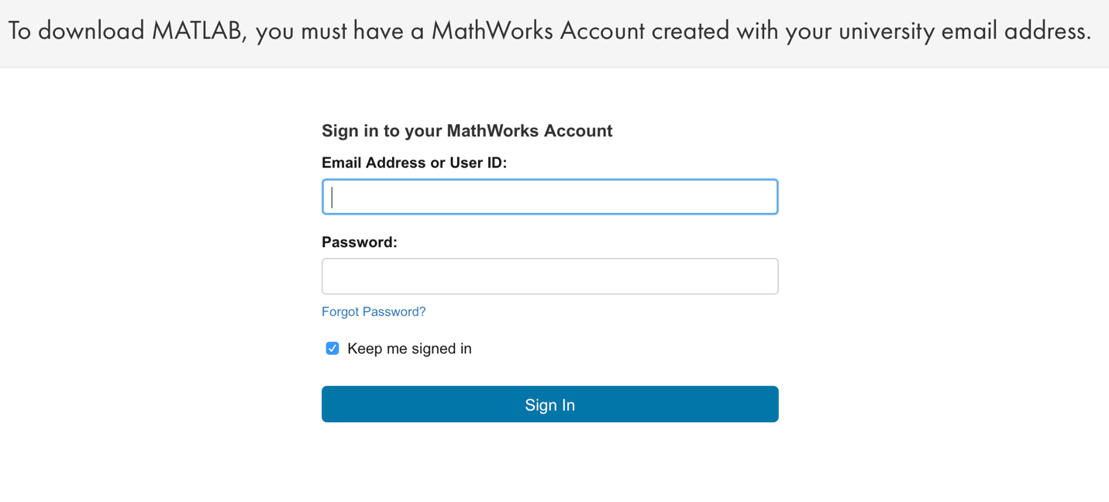

Figure 4

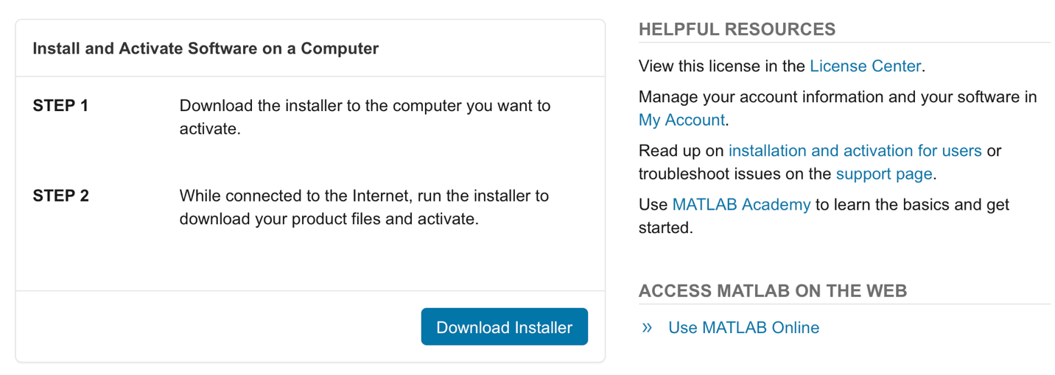

Figure 5

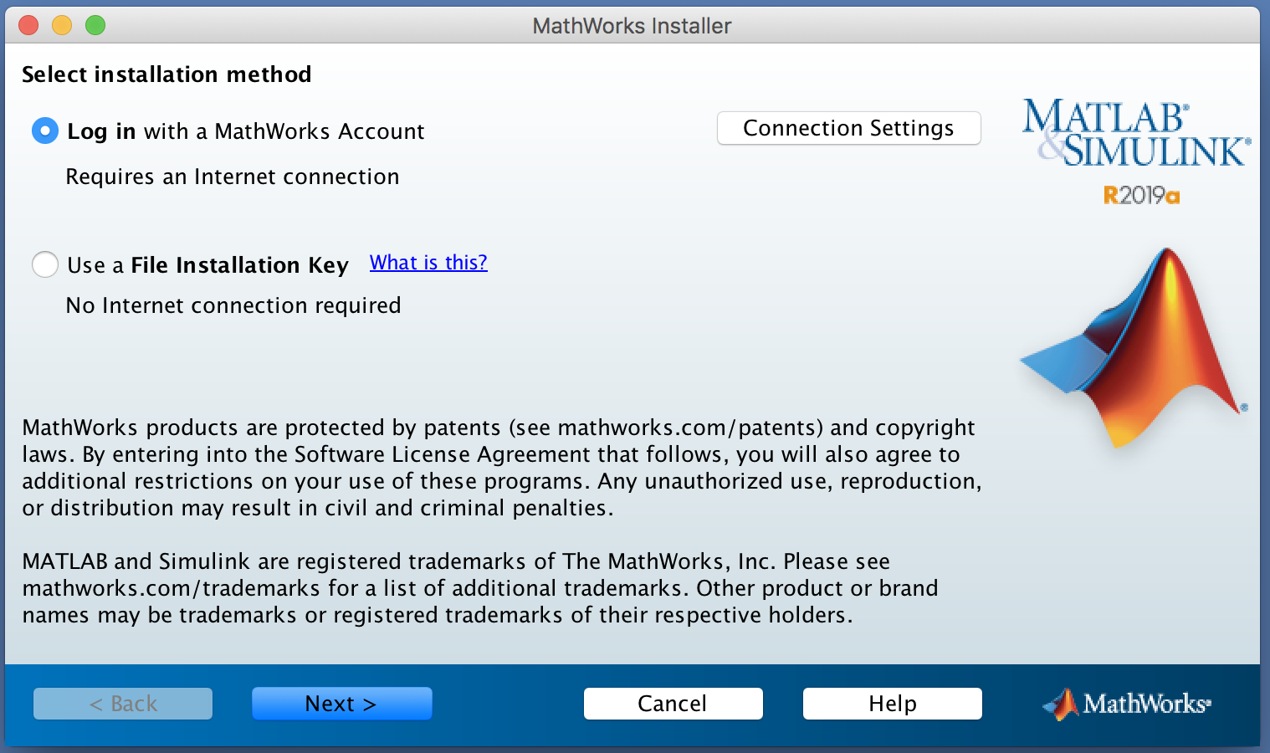

Figure 6

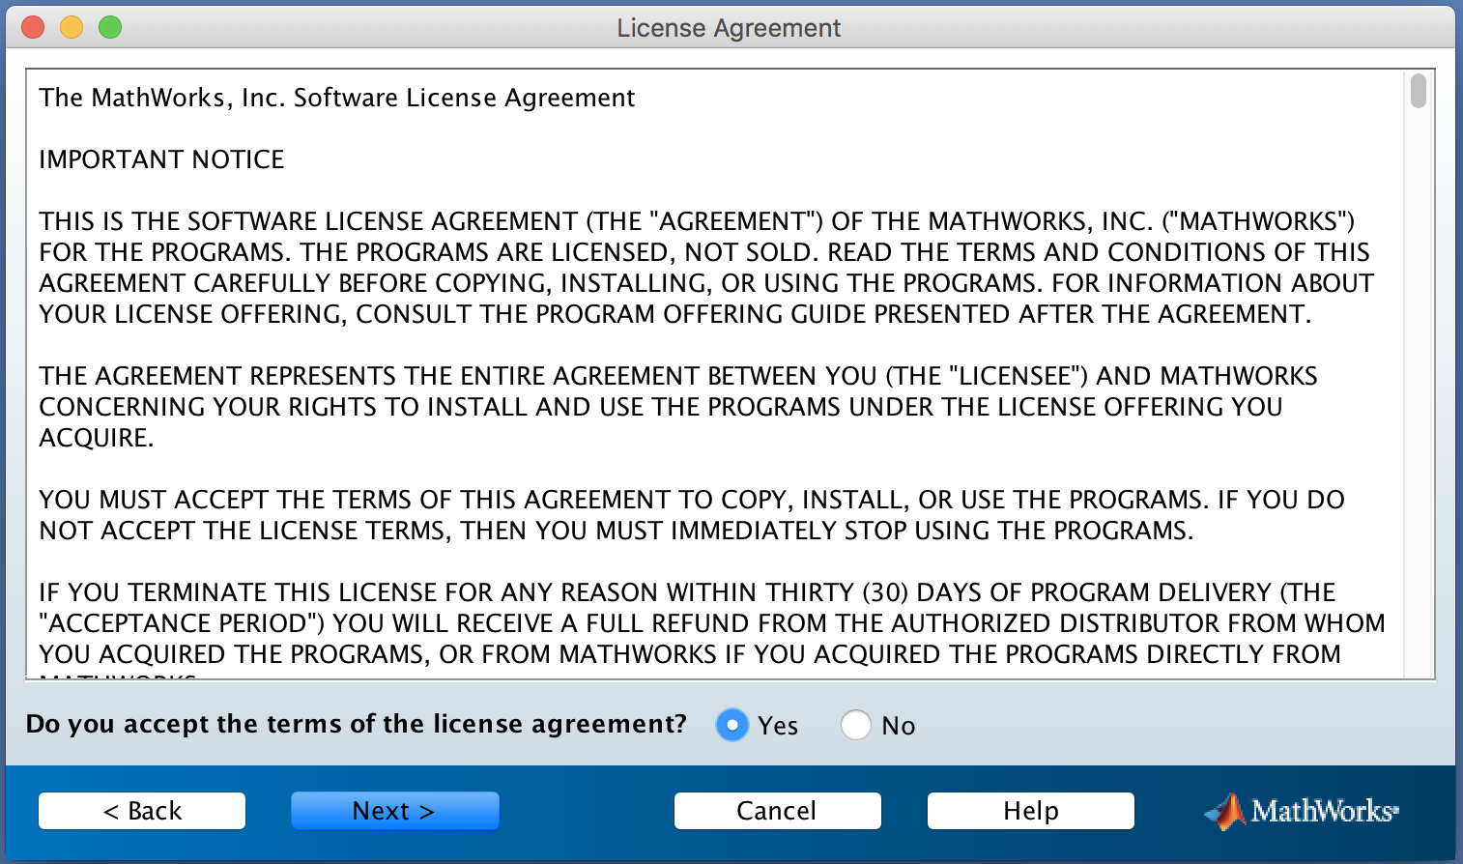

Figure 7

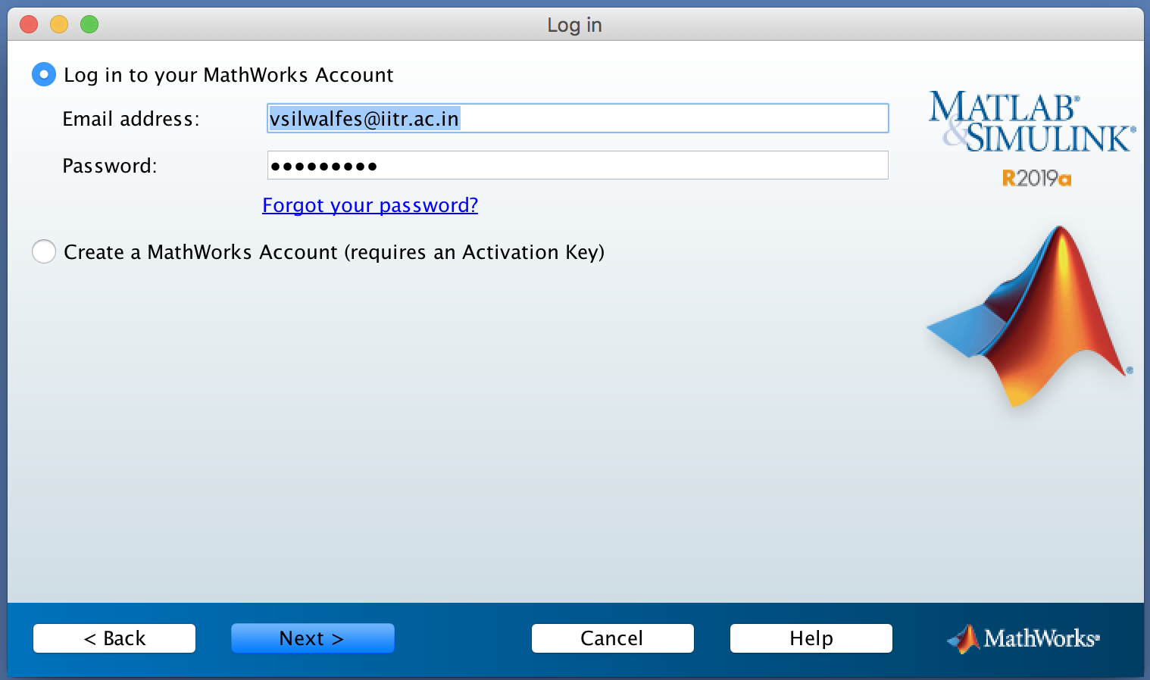

Figure 8

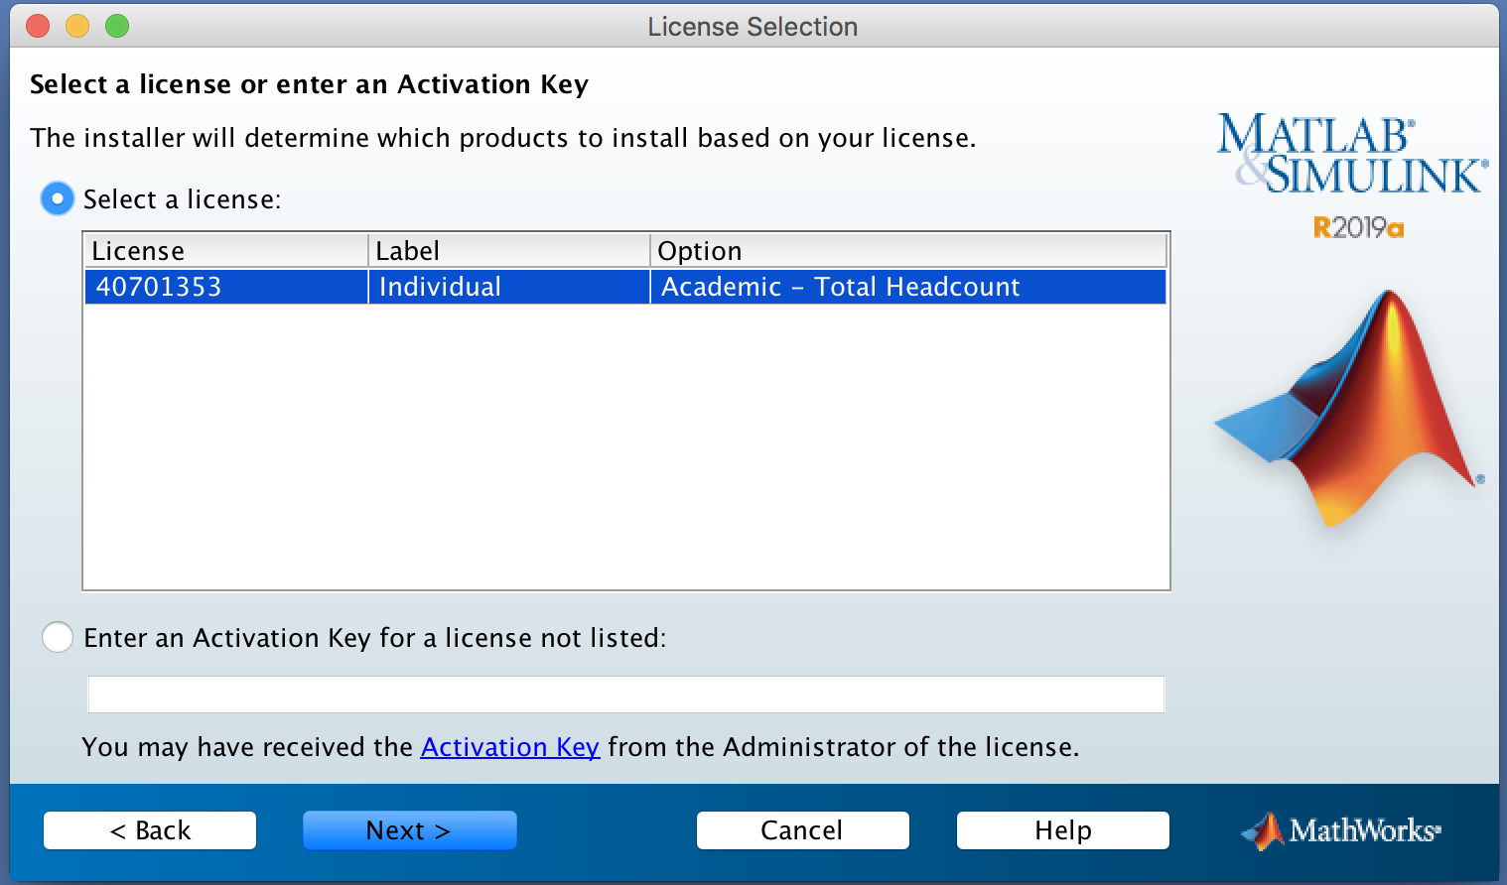

Figure 9

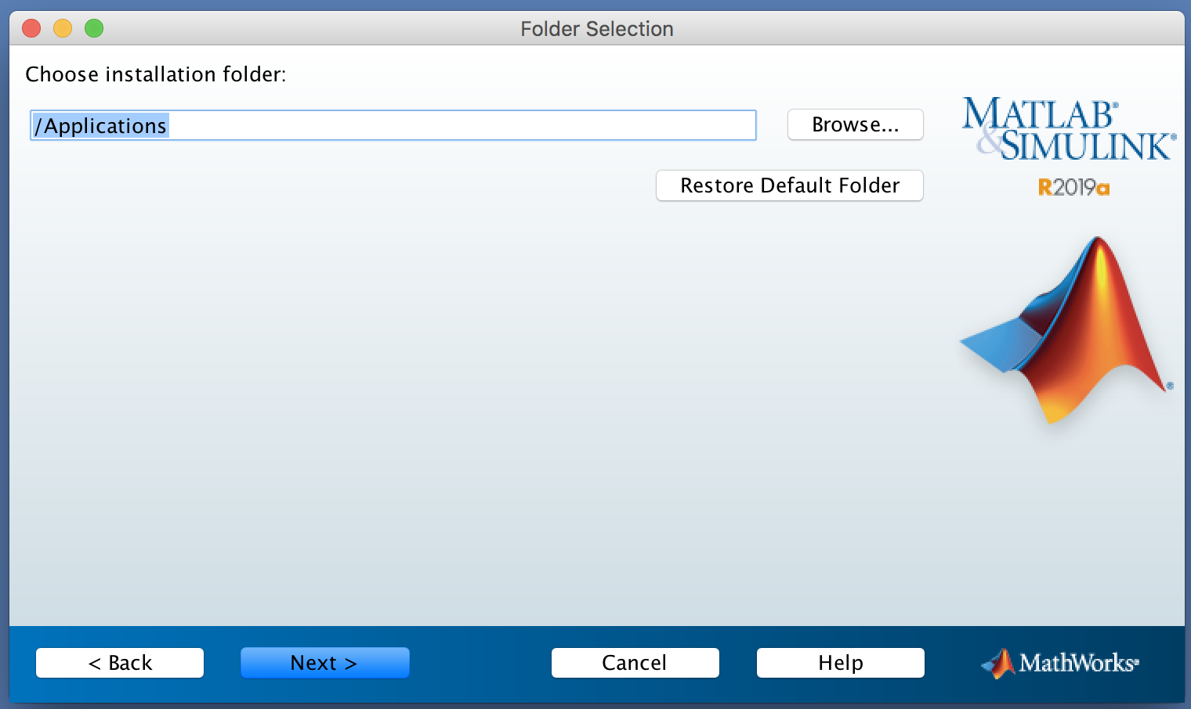

Figure 10

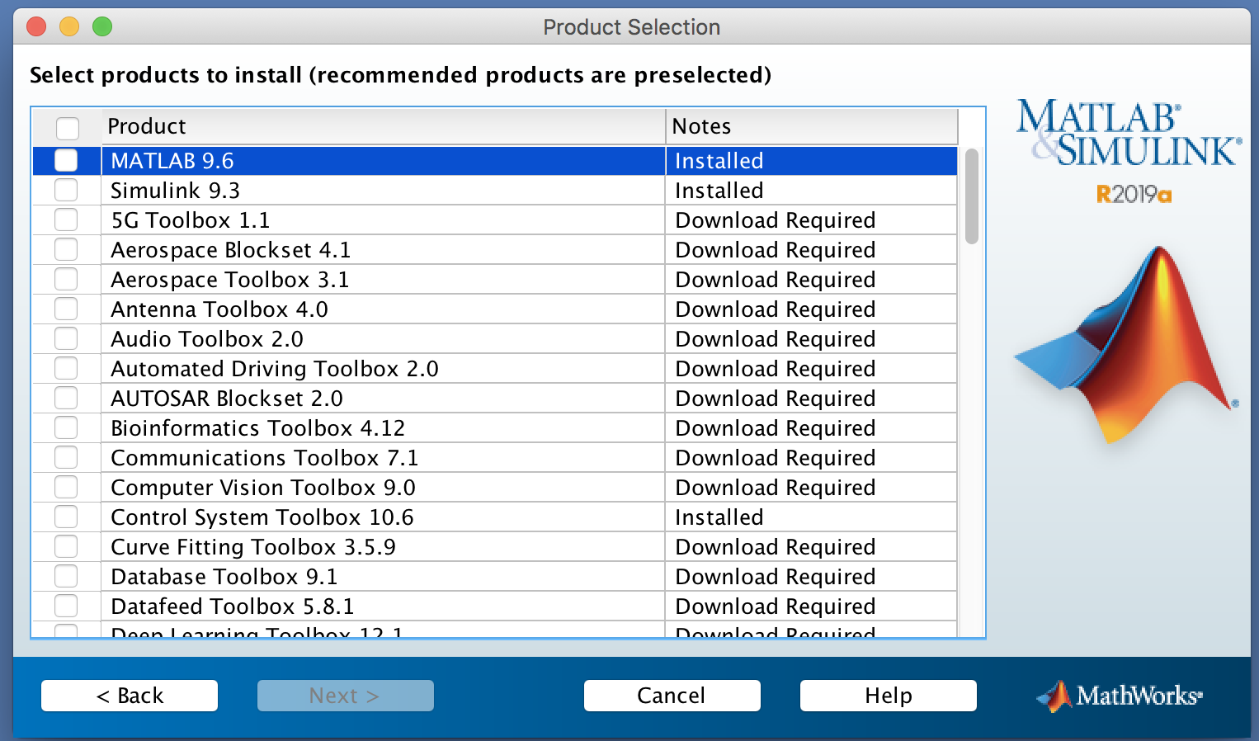

Figure 11