Name : Anand Nandkumar Kadale

PRN : 21620003

**Database Engineering Lab**

Database on Electrical Machines which has tables as given below :

1. Show Tables :

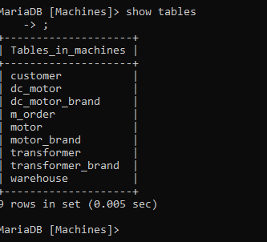

1. Warehouse contents :

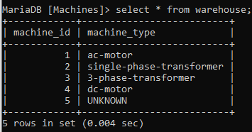

1. Transformer contents :

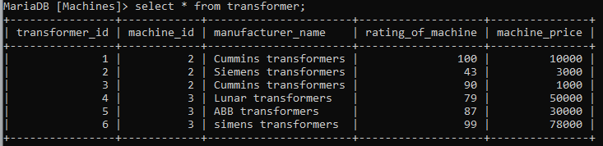

1. Transformer_brand contents :

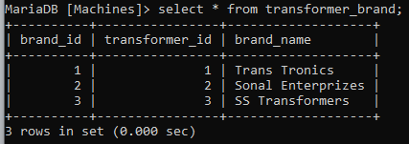

1. Motor Content :

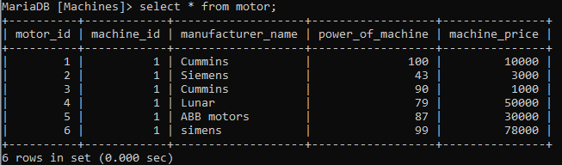

1. Motor_Brand Content :

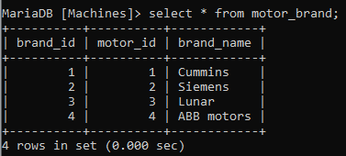

1. Dc Motor contents :

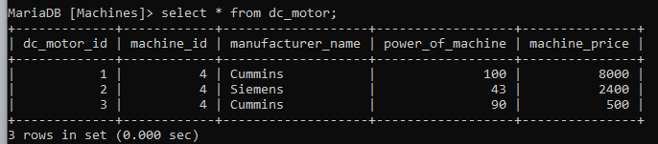

1. DC Motor Brand contents :

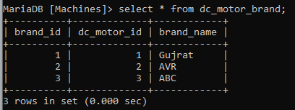

1. Machine Order (m_order) contents :

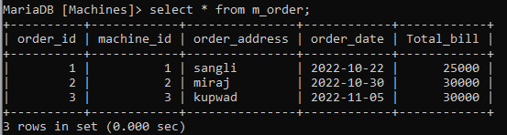

1. Customer Contents :

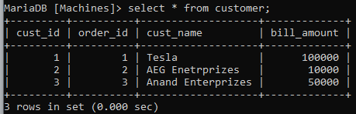

|  |  |  |  |  |  |  |  |  |  |  |
| --- | --- | --- | --- | --- | --- | --- | --- | --- | --- | --- |
|  |  |  |  |  |  |  |  |  |  |  |

* **Queries :**

1. Logical Operator :

Query : select * from machines where power_of_machine=50 or power_of_machine=100;

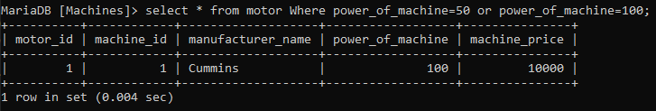

1. Comparison Operator :

Query : select * from dc_motor where power_of_machine >= 50;

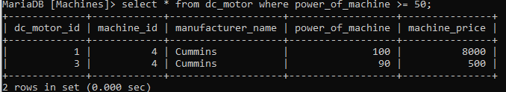

1. Range Operator :

Query : select * from m_order where Total_bill between 20000 and 30000;

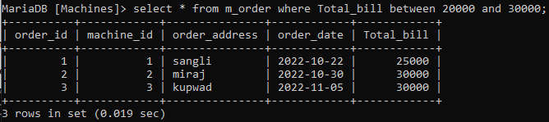

1. In Clouse :

Query : select * from transformer where manufacturer_name IN(‘Cummins transformer’,’Siemens transformer’);

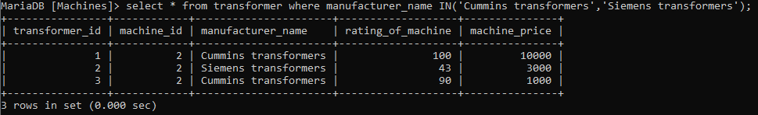

1. Like Clouse :

Query : select * from customer where cust_name like '%E%';

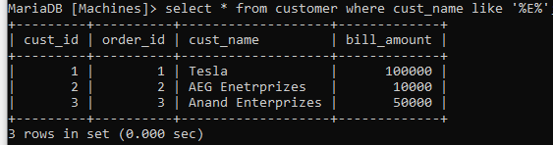

1. Agregation Clouse :

Query : select max(Total_bill) as new from m_order;

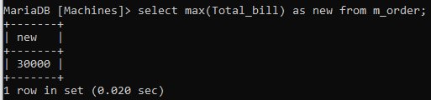

1. Order by clouse :

Query: select * from motor order by power_of_machine;

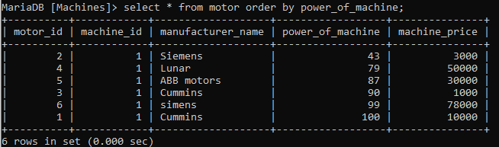

1. Having Clouse :

Query : select count(cust_name), bill_amount, order_id from customer group by order_id having bill_amount > 10000 order by order_id;

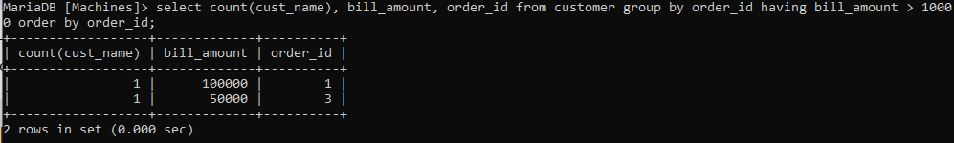

1. Nested Query :

Query : select * from motor where power_of_machine < ( select avg(power_of_machine) from motor);

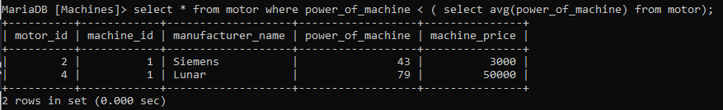

1. Between Clouse :

Query : select * from motor where machine_price not between 1000 and 30000;

