AI-DRIVEN CUSTOMER CHURN PREDICTION
AND RETENTION ANALYTICS

FINAL REVIEW REPORT

Submitted by

ANAND K
Register Number: EC2552001011280
Student ID: 676548

In partial fulfillment of the requirements
For the award of the degree

MASTER OF BUSINESS ADMINISTRATION

MBA – AI AND DATA SCIENCE

Under the guidance of

DR VEENA CHRISTY


SRM INSTITUTE OF SCIENCE AND TECHNOLOGY
Directorate of Online Education
Kattankulathur
2026

CHAPTER 4 – ANALYSIS, FINDINGS, INTERPRETATION AND DISCUSSION
Analysis basis: 426 rows from the supplied questionnaire-response export. All percentages below use 426 as the denominator unless stated otherwise. The findings describe the provided records and should not automatically be generalized to all mobile or internet customers.

4.1 Respondent Profile

What is your age group?
Response | Frequency | Percentage
25–34 | 92 | 21.6
Under 18 | 86 | 20.2
18–24 | 66 | 15.5
55 or above | 62 | 14.6
45–54 | 61 | 14.3
35–44 | 59 | 13.8

What is your gender? (Optional)
Response | Frequency | Percentage
Female | 150 | 35.2
Male | 142 | 33.3
Prefer not to say | 134 | 31.5

How long have you used your current provider?
Response | Frequency | Percentage
6–12 months | 94 | 22.1
1–2 years | 91 | 21.4
More than 5 years | 84 | 19.7
3–5 years | 80 | 18.8
Less than 6 months | 77 | 18.1

Which type of mobile subscription do you currently use with your mobile network operator?
Response | Frequency | Percentage
Prepaid mobile connection (recharge before use) | 116 | 27.2
Postpaid mobile connection (receive a bill after use) | 112 | 26.3
Corporate or company-provided mobile connection | 103 | 24.2
Family or group mobile plan | 95 | 22.3

Which service do you mainly use?
Response | Frequency | Percentage
Both mobile and internet | 158 | 37.1
Home broadband / internet | 149 | 35.0
Mobile phone service | 119 | 27.9

What is your usual payment method?
Response | Frequency | Percentage
Cash | 103 | 24.2
Bank transfer / auto-debit | 85 | 20.0
UPI / digital wallet | 83 | 19.5
Debit card | 81 | 19.0
Credit card | 74 | 17.4

What is your approximate monthly bill?
Response | Frequency | Percentage
₹500–₹999 | 104 | 24.4
Below ₹500 | 88 | 20.7
₹4,000 or above | 84 | 19.7
₹1,000–₹1,999 | 81 | 19.0
₹2,000–₹3,999 | 68 | 16.0
Not applicable / prefer not to say | 1 | 0.2

4.2 Customer Support, Usage and Service Problems

What is your approximate monthly bill?
Response | Frequency | Percentage
₹500–₹999 | 104 | 24.4
Below ₹500 | 88 | 20.7
₹4,000 or above | 84 | 19.7
₹1,000–₹1,999 | 81 | 19.0
₹2,000–₹3,999 | 68 | 16.0
Not applicable / prefer not to say | 1 | 0.2

Does the service provide good value for money?
Response | Frequency | Percentage
2 | 90 | 21.1
5 | 88 | 20.7
4 | 88 | 20.7
3 | 87 | 20.4
1 | 73 | 17.1

How frequently do you use the service?
Response | Frequency | Percentage
Several times a day | 114 | 26.8
Several times a week | 104 | 24.4
Less often | 104 | 24.4
About once a day | 104 | 24.4

4.3 Satisfaction, Reliability, Value and Intentions
Measure | Mean rating | Ratings of 4–5
How often have you contacted customer support in the last 3 months? | N/A (categorical) | 0 (0.0%)
How satisfied are you with the service overall? | 3.00/5 | 174 (40.8%)
How would you rate service reliability and quality? | 2.95/5 | 162 (38.0%)
How often have you experienced service problems or complaints in the last 3 months? | N/A (categorical) | 0 (0.0%)
How likely are you to continue using your provider over the next 6 months? | 3.16/5 | 188 (44.1%)

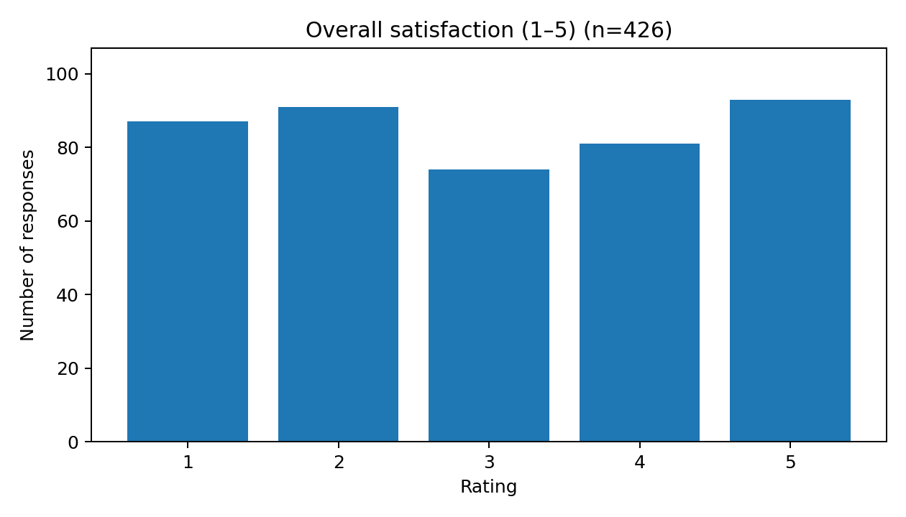
Figure 4.1: Overall satisfaction (1–5).

Overall satisfaction (1–5) — rating distribution
Rating | Frequency | Percentage

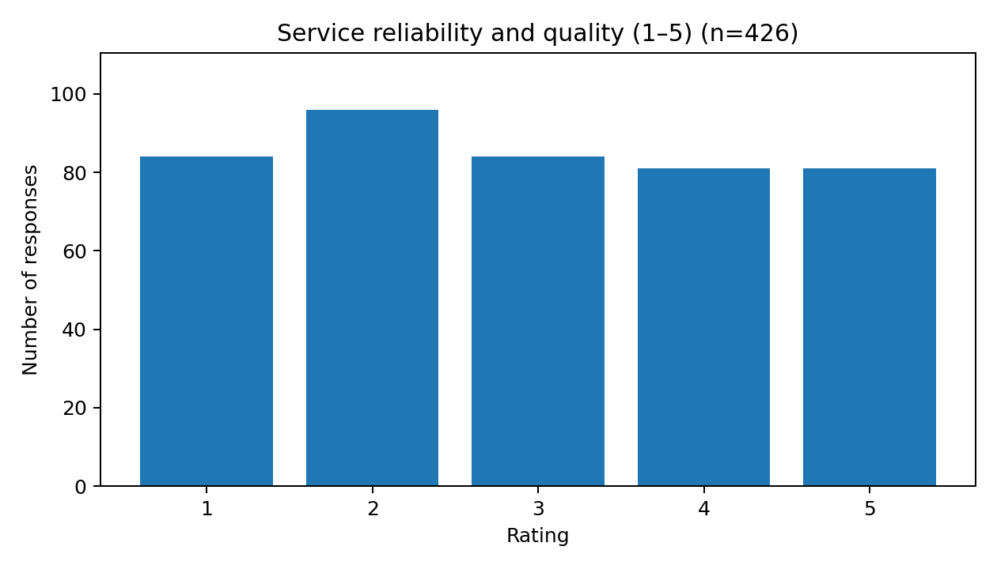
Figure 4.2: Service reliability and quality (1–5).

Service reliability and quality (1–5) — rating distribution
Rating | Frequency | Percentage
1 | 87 | 20.4
2 | 91 | 21.4
3 | 74 | 17.4
4 | 81 | 19.0
5 | 93 | 21.8

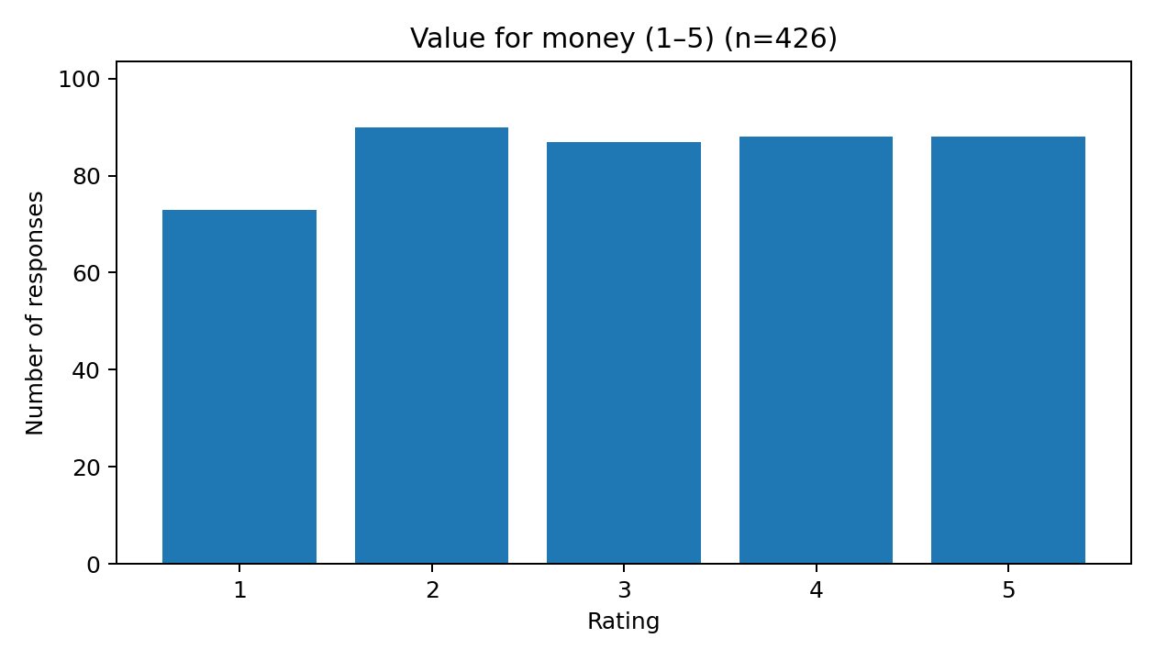
Figure 4.3: Value for money (1–5).

Value for money (1–5) — rating distribution
Rating | Frequency | Percentage
1 | 84 | 19.7
2 | 96 | 22.5
3 | 84 | 19.7
4 | 81 | 19.0
5 | 81 | 19.0

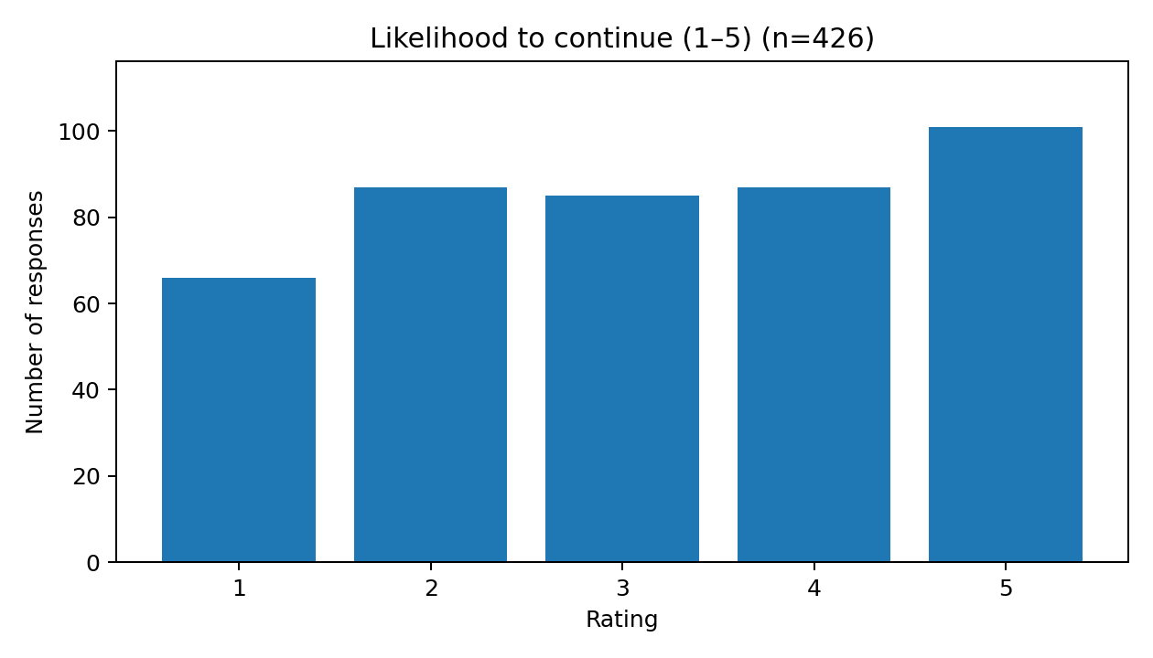
Figure 4.4: Likelihood to continue (1–5).

Likelihood to continue (1–5) — rating distribution
Rating | Frequency | Percentage

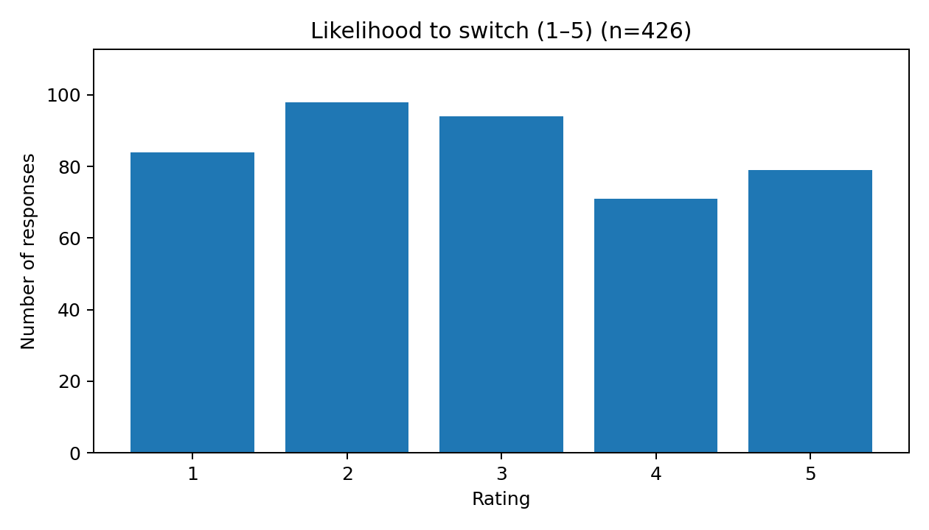
Figure 4.5: Likelihood to switch (1–5).

Likelihood to switch (1–5) — rating distribution
Rating | Frequency | Percentage
1 | 66 | 15.5
2 | 87 | 20.4
3 | 85 | 20.0
4 | 87 | 20.4
5 | 101 | 23.7

4.4 Reasons for Switching and Retention Improvements

How likely are you to switch providers in the next 6 months?
Response | Frequency | Percentage
2 | 98 | 23.0
3 | 94 | 22.1
1 | 84 | 19.7
5 | 79 | 18.5
4 | 71 | 16.7

What is the main reason you might consider switching?
Response | Frequency | Percentage
I am not considering switching | 72 | 16.9
Frequent service interruptions | 64 | 15.0
Poor network / service quality | 61 | 14.3
Poor customer support | 60 | 14.1
Better offer from another provider | 58 | 13.6
Limited features or coverage | 56 | 13.1
High price | 54 | 12.7
Other | 1 | 0.2

4.5 Summary of Descriptive Observations
Area | Observed result | Interpretation
Overall satisfaction | 3.00/5 | Moderate average rating; responses are distributed across all five options.
Reliability and quality | 2.95/5 | Lowest mean among the five rating measures; reliability warrants attention.
Value for money | 3.07/5 | Perceived value is relevant to retention planning.
Likelihood to continue | 3.16/5 | Stated intention only; not a verified retention outcome.
Likelihood to switch | 2.91/5 | Stated intention only; not actual churn.
Open-ended improvement | 7 missing answers | Use coded thematic analysis if a deeper qualitative review is needed.

4.6 Discussion
Overall satisfaction averages 3.00/5; service reliability and quality averages 2.95/5; value for money averages 3.07/5; continuance intention averages 3.16/5; and switching intention averages 3.10/5. These descriptive measures should be interpreted as questionnaire ratings rather than verified churn outcomes.

CHAPTER 5 – AI-DRIVEN CHURN PREDICTION: IMPLEMENTATION FRAMEWORK

5.1 What the Survey Can and Cannot Predict
The questionnaire includes a five-point likelihood-to-switch item, which can be analysed as stated switching intention. It does not include verified future cancellations, port-outs, or inactivity within a defined horizon. Therefore, it should not be relabelled as actual churn and should not be used to claim validated prediction of actual churn.

5.2 Proposed Model Development
Define the churn event (for example, cancellation or inactivity) and prediction horizon with business stakeholders.
Create a customer-period dataset with a clear observation date and verified outcome label.
Use only predictors available at the prediction date and check for target leakage.
Split data by time where feasible; retain a final holdout set for unbiased evaluation.
Build a simple baseline such as Logistic Regression, then compare suitable alternatives such as Random Forest.
Evaluate precision, recall, F1-score, ROC-AUC, confusion matrix, calibration, and business utility.
Review feature explanations, subgroup performance, privacy controls, and retention-intervention outcomes.

5.3 Separate Synthetic Demonstration
The companion pack includes optional Python code for a 300-row synthetic churn dataset with a simulation-generated target. This is a software demonstration only. Its metrics are not calculated from the 426 questionnaire responses and are not evidence of real-world churn-prediction performance. The synthetic dataset is not silently merged with the survey file.

5.4 End-to-End Workflow
Authorised data → Quality checks → Defined churn label → Feature engineering → Time-aware validation → Model comparison → Explainability → Retention action → Outcome measurement

CHAPTER 6 – SUGGESTIONS AND MANAGERIAL RECOMMENDATIONS

6.1 Improve Service Reliability
Monitor repeated outages, coverage issues, dropped sessions, and recurring service complaints. Prioritize fixes by location and service type, then track recurrence and customer feedback after resolution.

6.2 Strengthen Customer Support
Measure first-contact resolution, repeat contacts, time to resolution, and feedback after case closure. Where customers report repeated issues, use a helpful service-recovery follow-up rather than relying only on discounts.

6.3 Improve Perceived Value
Make billing and plan comparisons transparent, recommend plans aligned with usage, and explain renewal terms clearly. Test price or value offers against measured outcomes instead of assuming that discounts always improve retention.

6.4 Use Intention Measures Carefully
Use stated switching intention as one input to customer-experience analysis, not as a substitute for actual churn. Do not label a respondent as a churned customer solely because they select a high switching-intention score.

6.5 Build a Real-World Data Foundation
Maintain a customer-period dataset with observation dates, tenure, plan and billing history, usage trends, support events, complaints, and a verified churn outcome within a specified future window. Document permissions, data lineage, feature definitions, and retention policies.

6.6 Evaluate Retention Interventions
Where feasible, compare intervention outcomes with a control group. Track retention lift, cost per retained customer, offer acceptance, complaint resolution, and customer experience. Prediction alone does not establish that an intervention works.

6.7 Governance and Monitoring
Document model versions, thresholds, performance drift, subgroup differences, retraining criteria, and human-review processes. Restrict access and minimize personal data.

SUPPLEMENTARY DISCUSSION – IMPLEMENTATION, GOVERNANCE AND BUSINESS VALUE

1. Turning a Risk Score into a Retention Decision
A churn probability is not itself a retention strategy. A responsible decision process combines a risk estimate with the likely reason for disengagement, the customer's eligibility for a remedy, intervention cost, and the probability that the intervention changes the outcome. A high-risk customer experiencing repeated outages may require technical remediation, while a customer reacting to price may need a transparent plan comparison. A generic discount may be ineffective where the root cause is service quality.
A useful operational decision is based on expected incremental value. In a simplified framework, expected value equals the estimated probability of preventing churn multiplied by the expected future contribution margin, minus the intervention cost. This estimate should be calibrated with observed campaign outcomes rather than assumed from model scores. It should also consider fairness and customer experience; an offer must not worsen service for customers who do not receive it.
Decision component | Questions for management | Possible measure
Risk | How likely is the customer to churn within the agreed window? | Calibrated probability and risk band
Reason | What actionable issue is visible in the evidence? | Reason code, complaint type, billing or usage signal
Action | What intervention addresses the issue? | Service recovery, plan review, targeted communication
Cost | What resources will the action consume? | Offer cost, agent time, remediation cost
Outcome | Did the customer remain active after the horizon? | Observed churn, retention lift, incremental margin
Safeguard | Was the decision appropriate and fair? | Complaint rate, opt-out rate, subgroup review

2. Proposed Data Architecture
A mature churn analytics solution should keep source data, engineered features, model outputs, and intervention outcomes separable and traceable. The following logical layers can be implemented using a data platform or warehouse. The exact technology should follow organizational architecture and data governance requirements.
Layer | Core content | Control objective
Source / ingestion | Authorised billing, tenure, usage, service incidents, CRM and support events | Document source, permissions and extraction time
Validated / cleaned | Deduplicated customer-period records; standardized codes; missingness flags | Apply schema checks, reconciliation and quality rules
Feature layer | Features available at each prediction date | Prevent leakage; version feature definitions
Label layer | Observed churn according to documented event and horizon | Use verified, reproducible outcome logic
Model layer | Baseline and candidate models, probabilities and metadata | Version model, code, training data and metrics
Decision layer | Risk bands, reason summaries and permitted interventions | Human review, eligibility and offer-cost constraints
Outcome layer | Retention results, campaign exposures and complaints | Evaluate lift, costs, drift and unintended effects

3. Model Validation Plan
Model assessment should begin with a transparent baseline and a pre-registered evaluation plan. Random train/test splitting can exaggerate performance when time patterns or repeated customers are present. For a customer retention use case, a time-aware design is often more representative: train on earlier periods, tune on a later validation period, and retain the most recent period as a final holdout. Where customers contribute multiple periods, all observations from the same customer must be handled carefully to prevent leakage between training and evaluation.
No single metric is sufficient. Accuracy can look acceptable when a model mostly predicts the majority class. Recall indicates how many churners are detected, while precision indicates how many flagged customers actually churned. ROC-AUC measures ranking across thresholds, but it does not directly show calibration or business benefit. Calibration checks whether predictions such as 0.20 correspond approximately to a 20% event frequency. Management should choose the operating threshold in light of contact capacity, customer experience, false-positive cost and missed-churn cost.
Metric | Question answered | Caution
Precision | Among customers flagged, how many churned? | Low precision may waste retention resources
Recall | What proportion of actual churners were flagged? | Higher recall can increase false positives
F1-score | What is the harmonic balance of precision and recall? | Does not encode financial cost
ROC-AUC | Can the model rank churners above non-churners? | Does not prove calibration or intervention value
Calibration | Do predicted probabilities match observed frequencies? | Requires adequate samples and periodic checks
Incremental retention lift | Did the intervention prevent additional churn? | Requires a defensible comparison/control design

4. Risk, Ethics and Governance
Customer analytics can affect how individuals are contacted, offered discounts, or prioritized for support. Data collection should have a valid purpose and an appropriate legal basis. Personal identifiers should be excluded from model inputs unless there is a documented and justified need. Access should be role-based, data transfers protected, and retention periods specified. Model documentation should identify the owner, intended use, excluded uses, training period, validation data, threshold, limitations, and escalation route.
Fairness testing should examine whether data coverage or error rates vary materially across relevant groups. Such testing must be lawful, proportionate, and respectful of privacy; sensitive attributes should not be collected or used casually. A person should not be denied ordinary service because an algorithm assigns a low retention score. Human review is especially important when model outputs trigger costly, intrusive, or consequential action.

5. Study Limitations and Threats to Validity
Sampling limitation: the supplied file does not by itself document a probability sampling method or establish representativeness of all customers.
Self-report limitation: responses may reflect recall, mood, interpretation of rating scales, and willingness to participate.
Construct limitation: stated switching intention is a perception or plan, not verified cancellation, port-out or inactivity.
Temporal limitation: the dataset records survey responses, not a longitudinal customer journey with an observed future outcome.
Causal limitation: frequency tables and means describe patterns but cannot show that a service factor caused a respondent's intention.
Open-response limitation: seven improvement entries are missing; qualitative interpretation should report its coding process and avoid over-generalising.
Model limitation: a model trained on simulated labels can demonstrate code flow but cannot validate real-world performance.
These limitations do not make the questionnaire analysis unusable. They define the appropriate level of inference: describing the supplied records, identifying areas for follow-up, developing a research design, and specifying what additional evidence is needed before operational prediction.

6. Future Research Design
A next-phase study can connect survey perceptions with consented or otherwise authorised operational outcomes using a carefully controlled linkage process. Before collection, define eligibility, sampling, survey timing, consent or participant information, outcome definitions, follow-up horizon, and data minimisation. If the purpose is to test predictive validity, construct the model dataset using only information known before the prediction date and use a future outcome window that is independent of the feature window.
A staged implementation is recommended. Stage one establishes data definitions and quality checks. Stage two evaluates a baseline against time-separated validation data. Stage three reviews calibration, subgroup performance and business costs. Stage four runs a limited pilot with human review and predefined safeguards. Stage five evaluates retention lift using an appropriate comparison group and decides whether to expand, revise or stop the intervention.
Phase | Deliverable | Exit criterion
1. Define | Business churn definition, horizon, owners and permitted use | Definitions signed off and auditable
2. Prepare | Customer-period table, data dictionary, quality report | Labels verified and leakage checks passed
3. Validate | Baseline model, holdout metrics, calibration and subgroup review | Metrics meet agreed technical and business criteria
4. Pilot | Limited, supervised retention workflow | No material safeguard issue; operating process documented
5. Evaluate | Incremental retention, cost and customer experience | Evidence supports scale-up or a documented redesign

SUPPLEMENTARY CHAPTER – OPERATIONAL DESIGN AND ANALYTICAL SPECIFICATION

1. Business Problem Translation
A useful analytics project begins by translating a broad concern—customers may leave—into a specific decision question. The decision question should identify the population being considered, the date at which a prediction would be produced, the event that qualifies as churn, the time horizon, and the action that could follow. Without these definitions, the same term can mean cancellation to one team, a port-out to another, or a period of inactivity to a third. Those different definitions produce different targets and different model results.
For this project, the questionnaire supports descriptive analysis of perceptions and self-reported intentions. It is therefore appropriate to ask which service-experience categories are common in the file and how respondents rated the service. It is not appropriate to infer that an individual has already churned or will definitely leave. A future operational project should state the churn event and horizon in a short, signed-off label specification before any training data are prepared.

1.1 Proposed label specification for a future operational study
Specification field | Example of a documented decision | Why it matters
Unit of analysis | One row per customer at a monthly observation date | Avoids mixing customer-level and transaction-level records
Observation date | Last calendar day of each month | Makes feature availability auditable
Churn event | Verified cancellation or port-out recorded by the provider | Ensures the label reflects an observed event
Prediction horizon | Churn occurring in the next 60 or 90 days | Defines what the probability actually refers to
Eligibility | Active customers at the observation date | Prevents already-churned customers entering the at-risk cohort
Exclusions | Test accounts, duplicate IDs, records with unresolved status | Reduces label noise and ambiguous cases
Label source | Authoritative account status / cancellation record | Supports reproducibility and audit
Data owner | Named operational data owner | Establishes accountability for label quality
The example values in this table are proposed design options, not facts about the current survey or a specific provider. The actual business must approve the event, horizon, exclusions, and source system before implementation.

2. Feature Engineering Strategy
Features should represent the customer's state before the prediction date. Candidate predictors may include tenure, plan type, plan-price changes, usage trend, service interruptions, unresolved complaints, support-contact frequency, payment failures, and recent service quality. These are potential operational fields and are not all present in the supplied questionnaire. The feature dictionary should state each feature's business meaning, source, calculation, time window, refresh frequency, null handling, permitted use and owner.

2.1 Example feature dictionary
Feature | Operational definition (example) | Potential interpretation | Key validation
Tenure days | Days from activation to observation date | Relationship maturity | Confirm activation date quality
Usage change | Current 30-day usage compared with previous 30 days | Possible disengagement or changed need | Handle seasonality and missing events
Complaint count | Number of complaints in a pre-defined lookback window | Service friction | Deduplicate reopened tickets
Repeat issue flag | Whether the same issue recurred during the lookback window | Unresolved experience problem | Define issue taxonomy consistently
Billing failure count | Failed payment events in prior window | Potential friction or involuntary churn risk | Separate failure from intentional cancellation
Price change flag | Plan price changed within lookback window | Potential value perception change | Confirm effective date and customer exposure
Service outage duration | Recorded minutes of interruption in lookback window | Reliability exposure | Validate telemetry and location granularity
Support resolution time | Elapsed time from case opening to closure | Service recovery efficiency | Handle open cases and timestamp zones
Feature engineering can introduce leakage if it uses information that occurs after the prediction date. For example, a final disconnection code, cancellation request, or final bill generated after the observation date may reveal the target directly. Such fields should not be used as predictors for a model intended to forecast churn before those events happen.

3. Analytical Design for Survey Data
The descriptive component should be kept separate from the predictive modelling component. For each categorical question, report counts and percentages using the total response count as the denominator, unless a question has missing values or an explicit skip pattern. State the denominator directly in a table note. For five-point items, report the mean only as a compact summary alongside the distribution, because different response patterns can yield the same mean. Also report the number of valid responses and the proportion selecting ratings four or five when that grouping has a meaningful interpretation.
A mean of 3.00 on a five-point scale should not automatically be called positive or negative without a pre-defined interpretation rule. In the present dataset, satisfaction ratings cover all five categories, and the distribution is more informative than a single average. The reliability mean is 2.95 and value-for-money mean is 3.07. These small differences should not be treated as statistically significant differences without an appropriate inferential design and assumptions.

3.1 Reporting convention
Use the same denominator across comparable items and disclose when it changes.
Round percentages consistently, normally to one decimal place in narrative tables.
Retain the original labels from the survey export except for transparent normalization of obvious punctuation variants.
Do not silently merge response categories with different meanings.
Distinguish a missing response from a response such as “not applicable” or “prefer not to say.”
Show both frequency and percentage so readers can audit the summary.
Use a chart when it reveals a distribution clearly; do not include a chart solely to decorate the report.

4. Reading the Findings as Managerial Signals
The findings can be used to prioritize follow-up questions rather than to make unsupported causal claims. Frequent selection of service interruptions and poor service quality as switching reasons suggests that reliability deserves operational investigation. It does not by itself prove the network is objectively unreliable or that outages caused every intention to switch. To validate that interpretation, a provider would compare survey perceptions with outage records, complaint events and subsequent customer outcomes for an appropriately defined population.
The value-for-money mean of 3.07 suggests responses are mixed rather than uniformly favourable. A management team could examine plan-price clarity, perceived benefits, usage-to-plan fit, and competitor offers. However, a lower rating should not automatically trigger a discount. A plan explanation, proactive bill review, or support intervention may be more suitable for some customers. The choice should be tested using costs and measured outcomes.
Continuance intention averages 3.16, while switching intention averages 2.91. These are separate questions and should not be treated as mathematical opposites: a respondent can anticipate continuing for now while still considering switching under certain conditions. Reporting the two distributions separately is therefore more informative than forcing one into the inverse of the other.

4.1 From signal to testable hypothesis
Observed descriptive signal | Research hypothesis to test | Evidence required
Service interruptions often selected as a switching reason | Customers with more recorded interruptions have a higher subsequent churn rate | Linked outage exposure and verified churn outcomes
Poor support selected by respondents | Longer or repeated unresolved support cases are associated with higher churn | Case histories with observation dates and outcome windows
High price appears among switching reasons | A plan-price change may be associated with increased switching risk for exposed segments | Price history, plan eligibility and comparable control group
Value ratings are mixed | Perceived value differs by plan type or bill band | Segmented survey analysis with sufficient sample sizes
High switching intention is reported | Higher intention may be associated with greater later churn probability | Consent-compliant longitudinal follow-up and verified outcomes
Each hypothesis requires evidence beyond a simple cross-sectional frequency table. A statistical association would still not establish causality. Stronger causal claims require a design that addresses confounding, selection effects, timing and the possibility that the observed relationship is driven by other factors.

5. Practical Retention Intervention Catalogue
Retention actions should address identifiable customer needs and should be measured. The following catalogue provides examples for a future pilot; it is not a claim that these actions have already been implemented or shown to work in this study.
Problem evidence | Candidate intervention | Primary measure | Safeguard
Recorded repeated interruptions | Incident resolution and proactive update | Repeat outage rate; post-incident satisfaction | Do not substitute offers for needed technical repair
Long time to resolve a complaint | Case ownership and callback at closure | Resolution time; repeat contact rate | Respect contact preferences
Plan does not fit usage | Transparent plan review with opt-in change | Plan-fit rating; net retention margin | No dark patterns or misleading savings claims
Unexpected bill or failed payment | Bill explanation and payment support | Billing complaints; involuntary churn | Protect payment and personal information
Customer considering a competitor offer | Provide factual plan comparison | Offer acceptance and subsequent retention | Avoid pressure or unsupported competitor claims
No actionable issue identified | Ask customer preference before outreach | Opt-out, complaint and retention rates | Avoid intrusive contact based only on a score

6. Measurement Framework for a Pilot
A pilot should specify an outcome before launch, select an appropriate comparison approach, and track both intended benefits and possible harms. Retention rate alone can be misleading when groups differ at baseline or when customers who are easier to retain are more likely to receive an offer. Where operationally feasible and ethically appropriate, random assignment among eligible customers provides a strong estimate of incremental impact. Otherwise, the evaluation should disclose its limitations and adjust for known differences where possible.
KPI | Definition to agree before launch | Management use
Retention rate | Share of eligible customers still active at the end of the outcome window | Primary outcome, with denominator specified
Incremental lift | Difference in outcome between intervention and comparison groups | Estimate of action attributable effect under design assumptions
Cost per retained customer | Intervention and delivery cost divided by incremental retained customers | Budget and scale decision
Net contribution impact | Incremental contribution less intervention and delivery costs | Economic value, not just gross response
Complaint / opt-out rate | Share creating a complaint or opting out after contact | Customer experience safeguard
Contact efficiency | Share of outreach resulting in a relevant conversation or action | Workload and process design
Calibration drift | Difference between predicted and observed risk over time | Model monitoring
Data quality failures | Rates of missing, delayed or invalid upstream fields | Operational reliability
All KPI definitions should be stable during the evaluation window. Any change to eligibility, campaign content, churn definition or tracking period should be recorded because it may make before-and-after results difficult to compare.

7. Monitoring and Change Control
A model should not be treated as a one-time deliverable. Customer behaviour, service operations, plan prices, competitor offerings and data pipelines change. A monitoring plan should include data freshness, schema drift, changes in feature distributions, predicted-risk distribution, calibration, precision and recall when labels become available, subgroup differences, intervention response and customer complaints. Monitoring thresholds should have owners and documented actions.
A versioned release process should retain the training-data window, feature definitions, model artefact, source-code version, validation results, threshold, approval record, deployment date and rollback plan. If performance deteriorates, the organization should first examine data quality and business changes before automatically retraining. Retraining on a biased or unstable dataset can perpetuate or worsen errors.

8. Reproducibility and Academic Auditability
Reproducibility requires more than including code. The submission should identify the exact source file, the cleaned file used for analysis, software versions, execution instructions, output files and any transformations. A reader should be able to reconstruct the reported counts from the provided file and determine whether the numbers in the report match the generated tables.
Store the raw CSV as a read-only source and preserve its original filename.
Document each transformation, including normalization of punctuation or spelling.
Generate frequency and missingness tables directly from the cleaned data.
Keep output folders separate from source files to avoid overwriting data.
Use a fixed random seed for any demonstration that requires simulated data.
Record the synthetic status of artificial labels in filenames, code comments and report text.
Re-run the script before submission and reconcile generated means and counts with every report table.

9. Notes for the Final Academic Review
Before submission, verify the exact survey questionnaire against the survey platform, confirm respondent eligibility and distribution procedure, and state any consent wording used. Confirm that all references cited in the literature review appear in the reference list and that entries follow the institution's preferred citation style. Attach the original plagiarism-check report only as evidence of the check actually performed; do not describe a public-web checker as an official institutional report unless the institution identifies it as such.
This report's descriptive survey findings and proposed modelling framework are separate evidentiary components. The final interpretation should remain consistent with this boundary throughout the abstract, findings, conclusion, code appendix and presentation. Any future result from a verified-label model should be clearly identified as belonging to the new operational dataset and evaluation period, not retroactively attributed to the questionnaire records.

CHAPTER 7 – DETAILED ANALYTICAL DESIGN AND BUSINESS INTERPRETATION

7.1 From Questionnaire Results to a Business Question
A useful analytics project begins by separating the question that can be answered now from the question that may be answered after additional data become available. The current questionnaire can describe reported experience and stated intentions. It can help managers prioritize issues for investigation, but it cannot establish which individual customers subsequently cancelled a service. The immediate business question is therefore: which experience dimensions are most prominent in the responses, and how can these observations inform a responsible retention programme?
The distinction matters because a descriptive association, a stated intention and an observed business outcome are different forms of evidence. A respondent may report an intention to switch but remain with the provider because the issue is resolved, switching is inconvenient, or a suitable alternative is unavailable. Conversely, a customer who reports satisfaction may leave because of relocation, a bundled offer, or a change in household needs. A retention strategy should therefore use survey indicators as context, while operational decisions should be assessed against recorded outcomes.

7.2 Interpreting Five-Point Rating Scales
A five-point rating scale is ordinal: the response options have an ordered meaning, but the distance between adjacent categories is not guaranteed to be psychologically identical. Reporting a mean is common and useful for a compact overview, provided it is accompanied by the complete frequency distribution. A mean near the centre of the scale may represent many neutral responses or a polarized mixture of high and low responses. Those patterns imply different management actions.
For that reason, this report recommends presenting the count and percentage for each rating from 1 to 5 alongside the mean. The proportion selecting 4 or 5 can be shown as a simple positive-rating indicator, but it should not be treated as a validated satisfaction index unless its construction is documented. Likewise, low ratings should be interpreted as signals for investigation rather than proof that a particular operational cause exists.

7.3 Reading the Survey as a Set of Related Signals
Reliability, value, support, usage and switching intention may be related, but this descriptive study does not prove their causal order. For example, a low value rating may reflect price, perceived service quality, a household budget constraint or a mismatch between plan features and actual usage. A high support-contact frequency may reflect poor resolution, but it may also reflect a complex product or effective access to support. Follow-up research should measure these possible explanations rather than assuming one interpretation.
A useful next step is to build a cross-tabulation plan. The analyst could compare rating distributions by tenure, subscription type, primary service and bill band, provided each group has sufficient observations and the analysis protects respondent privacy. These comparisons can identify differences worth investigating; they cannot establish causality without an appropriate design. Every chart should state the number of valid observations used and disclose missing responses.

7.4 Recommended Analytical Reporting Standard
State the data source, date of extraction, number of records, and exact fields used.
Define the denominator for every percentage and identify any excluded or missing observations.
Show category counts as well as percentages so small groups are not hidden by rounded percentages.
Use consistent labels, scale direction, number formatting and chart axes across the chapter.
Distinguish observed findings, plausible interpretations and recommendations in separate sentences.
Avoid claims of prediction accuracy when the target variable is not an observed churn outcome.

7.5 Management Implications
The strongest practical value of the current data is diagnostic rather than predictive. Service reliability, perceived value and support experience can be used to structure a service-improvement agenda. Managers should convert each finding into a testable action, assign an accountable owner, define a baseline measure, and agree on a follow-up date. This creates a path from academic analysis to measurable operational learning without overstating what the survey proves.

CHAPTER 8 – DATA ARCHITECTURE AND FEATURE ENGINEERING

8.1 Target Definition Before Model Selection
A churn model must begin with an explicit business definition. A telecommunications provider might define churn as a completed cancellation, a number port-out, or a customer becoming inactive for a stated number of days. These definitions are not interchangeable. The business owner should specify the event, the effective date, the eligible customer population and the prediction horizon—for example, whether the model predicts an event during the next 30, 60 or 90 days.
Each training row should represent a customer at a known observation date. Predictor fields must be available on or before that date, and the outcome must be determined over the agreed future horizon. A model built from a mixture of dates without respecting this order may accidentally learn from information that would not have been available at the time of prediction.

8.2 Example Analytical Data Model
A production data model can be organized around a customer-period fact table supported by dimensions and event tables. The customer dimension contains stable identifiers and appropriate profile attributes. Subscription and billing tables record plan changes, invoices and payment behaviour. Usage aggregates summarize activity over a defined lookback window. Support events capture contacts, complaint categories, resolution time and reopenings. A churn-outcome table records the event date and the rule used to assign the label.
The analytical layer should preserve data lineage. Every feature should have a business definition, source, refresh frequency, lookback period, null-handling rule and owner. Identifiers used for joining data should be access-controlled and excluded from model predictors unless a legitimate, reviewed use is documented. The modelling table should contain only the minimum information necessary for the approved purpose.

8.3 Candidate Feature Groups
Tenure and lifecycle: days since activation, months with the provider, and time since plan change.
Usage trends: change in data or voice usage, active days, usage volatility and sustained decline.
Billing behaviour: bill amount trend, payment delays, failed payments and plan-price changes.
Service experience: outage exposure, repeated incidents, coverage complaints and repair recurrence.
Support experience: contact count, repeat contact rate, resolution duration and unresolved cases.
Commercial context: plan type, contract end date, discount expiry and product bundle changes.
Engagement signals: self-service activity or account changes where collection and use are authorised.

8.4 Leakage and Data Quality Controls
Target leakage occurs when a feature reveals the outcome or is recorded only after the churn event. Examples can include a cancellation reason, a final disconnection status, a closure timestamp, or a retention-team action triggered by a confirmed cancellation. Such fields may produce impressive test scores while being unavailable for genuine prediction. The feature review should examine event timestamps, source-system semantics and the actual point at which a prediction would be made.
Data quality checks should cover unique customer-period keys, duplicate events, valid date ranges, impossible negative values, inconsistent categories, missingness patterns and joins that multiply records unexpectedly. Any imputation or category consolidation must be fitted on training data only when it forms part of the model pipeline. A data-quality report should be retained with each model version.

8.5 Reproducible Data Preparation
The preferred workflow stores raw extracts as immutable, access-controlled inputs and creates separate cleaned and modelling layers. Each run should record the code version, input file identifiers, extraction date, row counts before and after filtering, feature schema and target definition. This helps an independent reviewer reproduce the results and trace differences between model versions. Personal data should not be copied into uncontrolled notebooks or public repositories.

CHAPTER 9 – MODEL EVALUATION, DEPLOYMENT AND MONITORING

9.1 Why a Single Metric Is Not Enough
Churn datasets may be imbalanced: most customers may remain active during a particular horizon. A classifier that predicts every customer as retained can then show high accuracy while failing to identify customers who churn. Evaluation must reflect the business purpose and the relative costs of false alarms and missed churn events.
Precision answers what proportion of customers flagged as high risk actually churned. Recall answers what proportion of churners were identified. The F1-score summarizes the precision–recall trade-off, while ROC-AUC evaluates ranking across thresholds. A confusion matrix shows true positives, false positives, true negatives and false negatives at a chosen threshold. Precision–recall curves can be especially informative when the positive class is uncommon. Probability calibration should also be checked if risk scores are interpreted as probabilities.

9.2 Baselines and Validation Strategy
A simple baseline should be established before evaluating complex models. Depending on the available data, the baseline may be a majority-class predictor or a logistic regression model with a small, defensible feature set. More flexible methods, including random forests, should be compared using the same partitions and target definition. Hyperparameter tuning must not use the final holdout set.
When historical customer records span time, a chronological split is generally more realistic than a random split. Train on earlier periods, validate on a later period, and reserve the most recent period for final evaluation. If multiple rows belong to one customer, the splitting strategy must prevent information about the same customer from leaking across partitions where that would make the evaluation unrealistically optimistic.

9.3 Threshold Selection and Capacity Planning
The default probability threshold of 0.50 is not automatically the best business threshold. A retention team has limited capacity and different interventions have different costs. Threshold selection should estimate the number of customers flagged, expected precision and recall, cost of contact, likely intervention cost and the value of customers retained. A ranked list may be more useful than a binary flag if the business can only contact a fixed number of customers each day.
The model should support an explicit decision process: who receives an alert, what action is permitted, what evidence is shown to the employee, how the action is recorded, and how the result is measured. The risk score itself is not a retention action. Teams should avoid automatic punitive or exclusionary decisions based solely on a score.

9.4 Monitoring After Deployment
Data monitoring: schema changes, missingness, freshness, unexpected category values and feature distributions.
Model monitoring: discrimination, calibration, precision and recall using outcomes once they mature.
Population monitoring: changes in customer mix, product offerings, acquisition channels and service conditions.
Operational monitoring: score delivery latency, alert volumes, staff workload and intervention completion.
Business monitoring: churn rate, retained-customer value, complaints, offer cost and customer experience.
Governance monitoring: model version, approval status, access logs, incidents and documented exceptions.

9.5 Retraining and Retirement
Retraining should not be triggered by an arbitrary calendar alone. A documented policy can combine scheduled reviews with evidence of drift, degraded performance, material product changes or a change in the churn definition. Before release, a candidate model should pass the same validation suite as the existing model and be compared against a clear acceptance threshold. If data quality or performance falls below minimum standards, the responsible owner should be able to revert to the prior model or pause scoring.

9.6 Model Card and Handover
Each model release should have a short model card describing its intended use, prohibited uses, training population, target definition, feature groups, validation period, metrics, known limitations, subgroup checks, human oversight and owner. The handover package should include reproducible code, environment requirements, data schema, run instructions, monitoring thresholds and a process for reporting errors. This documentation is part of the model, not optional administrative paperwork.

CHAPTER 10 – RETENTION INTERVENTION DESIGN AND BUSINESS VALUE

10.1 Segment the Problem Before Choosing an Offer
A retention programme should respond to the reason for risk rather than send the same discount to every flagged customer. A customer experiencing repeated service interruptions may need a technical resolution, while a customer who considers a plan too expensive may benefit from a transparent plan review. A customer contacting support repeatedly may require a named case owner and confirmation that the problem is resolved. The action should match the suspected friction and remain subject to the customer's preferences and eligibility.

10.2 Example Intervention Matrix
Signal to investigate | Possible action | Outcome measure | Control / caution
Repeated service interruptions | Technical investigation and proactive service-recovery update | Repeat incident rate; complaint recurrence | Do not substitute discounts for unresolved faults
Low perceived value | Plan-fit review and clear explanation of charges | Plan acceptance; subsequent churn | Avoid misleading savings claims
Repeated support contacts | Case escalation and follow-up after resolution | Resolution time; repeat contact rate | Protect sensitive case details
Declining usage | Check for legitimate lifecycle or service issues | Usage recovery; observed churn | Decline may be seasonal or intentional
High stated switching intention | Offer an optional feedback or service-recovery conversation | Response rate; later observed churn | Intention is not actual churn

10.3 Measure Incremental Impact
A retention campaign can appear successful because customers who were already likely to stay accepted an offer. Where feasible and ethical, a randomized controlled test or carefully designed comparison group can estimate whether the intervention improves outcomes beyond what would have happened anyway. The experiment should define eligibility, treatment, control, observation period, primary outcome, guardrail metrics and stopping rules before launch.
The primary outcome might be verified retention over a fixed period. Secondary outcomes can include complaint resolution, plan changes, customer satisfaction, cost per retained customer and offer acceptance. Results should be reported with sample sizes and uncertainty, not only a single percentage. If randomization is impractical, the limitations of an observational comparison should be made explicit.

10.4 Business Value Framework
The business case should compare the incremental value of retained customers with the costs of the intervention and model operation. A simple framework is: incremental net benefit = incremental retained-customer value − intervention costs − contact costs − programme operating costs. The estimate should account for customers who would have stayed without intervention and avoid counting the full lifetime value of a customer when only a short retention period is observed.
Useful operating metrics include the proportion of eligible customers contacted, response rate, successful resolution rate, incremental retention lift, cost per incremental retained customer, and complaints or opt-outs caused by the programme. The project should not claim financial savings until these quantities are measured from an appropriate evaluation.

10.5 A Practical 90-Day Roadmap
Days 1–15: agree on churn definition, prediction horizon, business owner, privacy basis and data access.
Days 16–30: profile data sources, create a data dictionary, validate join keys and build quality checks.
Days 31–45: create a customer-period dataset and establish a simple baseline with a chronological split.
Days 46–60: compare candidate models, review calibration, select a threshold and document limitations.
Days 61–75: design a small, controlled retention pilot with clear eligibility and guardrail measures.
Days 76–90: review matured outcomes where possible, document lessons and decide whether to scale.

CHAPTER 11 – ETHICS, PRIVACY, LIMITATIONS AND RESEARCH VALIDITY

11.1 Privacy by Design
Customer data can contain personal, behavioural and commercially sensitive information. A responsible analytics workflow should define the approved purpose, collect only necessary fields, restrict access by role, protect data in transit and at rest, and define retention and deletion periods. Reports and academic appendices should avoid publishing identifiable records. A public repository should contain code and synthetic examples, not confidential source data, credentials, personal identifiers or customer-level exports.

11.2 Fairness and Subgroup Evaluation
Model performance may vary across customer groups, locations, product types or payment arrangements. Such differences can arise from data quality, uneven service availability, historical business practices or different sample sizes. A fairness review should consider whether the model creates avoidable disadvantage, whether the features are justified for the purpose, and whether the proposed action is appropriate. Subgroup metrics should be interpreted cautiously when sample sizes are small, and sensitive attributes should be handled only under an approved governance process.

11.3 Explainability and Human Oversight
An explanation should help a trained employee understand which observed factors contributed to a score, not imply that the model has discovered a definitive cause. Explanations may be global, describing general model behaviour, or local, describing a particular prediction. Correlated features can make feature-attribution rankings unstable. Human reviewers should be able to challenge a score, record contextual information and avoid taking an action that is unsupported by the evidence.

11.4 Research Validity
Construct validity concerns whether a measure represents the concept it is intended to measure. Stated switching intention is related to, but not identical to, churn. Internal validity concerns whether the evidence supports a causal conclusion; the descriptive design does not establish causal effects. External validity concerns generalization beyond the observed responses; the sampling process and respondent population are not sufficiently documented to support broad population claims. Reliability concerns consistency of measurement and processing, which can be improved by documenting the questionnaire, coding rules and analysis script.

11.5 Study Limitations
The supplied survey does not contain verified historical cancellation or inactivity outcomes.
The sampling frame and probability of selection are not established by the export alone.
Self-reported perceptions and intentions may differ from later observed behaviour.
Some item values require careful validation before calculating rating summaries; non-rating frequency questions must not be treated as 1–5 ratings.
The open-ended improvement item contains missing responses, and a formal thematic coding protocol is not established.
A simulated modelling example demonstrates code structure only and does not establish real-world predictive performance.

11.6 Responsible Claims and Academic Transparency
The report should consistently label results as descriptive survey findings and avoid wording such as ‘the model predicts actual churn accurately’ unless this has been demonstrated using verified outcomes and a defensible validation design. Any synthetic dataset, simulated target, generated example or illustrative metric must be identified where it appears. Reproducibility supports transparency, but it does not replace the need for appropriate data, sound study design or institutional review.

11.7 Future Research Design
A follow-up study could link authorised survey responses to observed outcomes only where consent, legal basis, data minimization and institutional approval permit it. A longitudinal design would measure perceptions at a baseline and observe actual behaviour during a defined future window. The analysis plan should predefine the primary outcome, covariates, exclusion rules, missing-data handling and evaluation approach. Where linkage is not appropriate, a separate operational dataset with verified outcomes should be used for predictive modelling.

CHAPTER 12 – CONCLUSION AND FUTURE SCOPE

12.1 Conclusion
This project provides a structured descriptive analysis of 426 questionnaire response records and connects the findings to customer-retention planning. Overall satisfaction averages 3.00/5, reliability and quality averages 2.95/5, value for money averages 3.07/5, continuance intention averages 3.16/5, and switching intention averages 2.91/5. The results identify service reliability, perceived value, and support experience as areas for managerial attention. The findings do not demonstrate causality and cannot validate actual churn prediction because verified churn outcomes are absent.
The results identify service reliability, perceived value, support, and switching-related responses as useful areas for managerial attention. These descriptive findings do not demonstrate causality and cannot validate actual churn prediction because verified churn outcomes are absent. The project’s practical contribution is a reproducible analysis, a transparent distinction between intention and churn, and a clear roadmap for a future operational model.

12.2 Future Scope
Document questionnaire distribution, eligibility criteria, and consent wording for academic auditability.
Conduct thematic coding of the open-ended improvement responses and describe the coding method.
Obtain an authorised historical customer dataset with observed churn outcomes.
Define prediction dates and churn horizons and use time-aware validation.
Compare models with suitable baselines, calibration, explainability, and business-value measures.
Run controlled retention experiments to measure incremental impact.

REFERENCES
Breiman, L. (2001). Random forests. Machine Learning, 45, 5–32.
Fawcett, T. (2006). An introduction to ROC analysis. Pattern Recognition Letters, 27(8), 861–874.
Han, J., Kamber, M., & Pei, J. (2011). Data Mining: Concepts and Techniques (3rd ed.). Morgan Kaufmann.
Hastie, T., Tibshirani, R., & Friedman, J. (2009). The Elements of Statistical Learning (2nd ed.). Springer.
Kuhn, M., & Johnson, K. (2013). Applied Predictive Modeling. Springer.
Parasuraman, A., Zeithaml, V. A., & Berry, L. L. (1988). SERVQUAL: A multiple-item scale for measuring consumer perceptions of service quality. Journal of Retailing, 64(1), 12–40.
Provost, F., & Fawcett, T. (2013). Data Science for Business: What You Need to Know about Data Mining and Data-Analytic Thinking. O’Reilly Media.
Verbeke, W., Martens, D., Mues, C., & Baesens, B. (2011). Building comprehensible customer churn prediction models with advanced rule induction techniques. Expert Systems with Applications, 38(3), 2354–2364.
Zeithaml, V. A. (1988). Consumer perceptions of price, quality, and value: A means-end model and synthesis of evidence. Journal of Marketing, 52(3), 2–22.
Scikit-learn developers. Scikit-learn documentation: preprocessing, model selection, LogisticRegression, RandomForestClassifier, and classification metrics. https://scikit-learn.org/stable/

APPENDIX A – QUESTIONNAIRE
Date: 25 October 2026
The following items correspond to the 17 question fields in the supplied export. Before submission, attach or verify the exact questionnaire exported from the survey platform, including consent wording and answer options.
1. What is your age group?
2. What is your gender? (Optional)
3. How long have you used your current provider?
4. Which type of mobile subscription do you currently use with your mobile network operator?
5. Which service do you mainly use?
6. What is your usual payment method?
7. What is your approximate monthly bill?
8. How often have you contacted customer support in the last 3 months?
9. How satisfied are you with the service overall?
10. How would you rate service reliability and quality?
11. Does the service provide good value for money?
12. How frequently do you use the service?
13. How often have you experienced service problems or complaints in the last 3 months?
14. How likely are you to continue using your provider over the next 6 months?
15. How likely are you to switch providers in the next 6 months?
16. What is the main reason you might consider switching?
17. What improvement would encourage you to stay with your provider?

APPENDIX B – DATA DICTIONARY AND DATA QUALITY NOTES
Field group | Description | Notes
Timestamp | Submission timestamp from the supplied export | 426 unique timestamp values in the supplied file
Profile and service-use items | Age group, gender, tenure, subscription, service, payment, monthly bill | Categorical responses
Support and usage items | Support contacts, usage frequency, service problems | Categorical responses
Five-point ratings | Satisfaction, reliability, value, continuance intention, switching intention | Numeric scale values 1–5
Switching reason | Main reason a respondent might consider switching | Categorical
Improvement response | Improvement that would encourage staying | 7 missing values; free-text field
Churn outcome | Not included in this survey file | No verified churn label; do not infer actual churn from intention

APPENDIX C – SOURCE CODE REPOSITORY
The Python source code and project files for this study are maintained in the GitHub repository below. The repository provides a convenient location to review the project code and associated files.
The accompanying Python script, analyse_survey_and_demo_model.py, reads the cleaned survey CSV, regenerates frequency tables and rating summaries, saves charts, and optionally runs a separate synthetic-label model demonstration if the explicitly labeled synthetic model CSV is supplied. The source code pack contains a README with installation and execution steps.

GitHub repository: https://github.com/Anandk07/MBA_PROJECT
For reproducibility, run the code with the required Python packages and appropriate input CSV files. The survey analysis and any synthetic churn-model demonstration must be interpreted separately. The questionnaire measures stated switching intention; it does not contain verified actual churn outcomes.

APPENDIX D – EXTENDED PYTHON IMPLEMENTATION
This appendix provides a reproducible reference implementation for the descriptive analysis of the supplied questionnaire file. It is intended as a teaching and audit aid. The script does not manufacture a churn outcome from switching intention. A separate synthetic modelling demonstration is optional and should remain explicitly labelled as simulated.

D.1 Environment and inputs
Recommended environment: Python 3.10 or later. Install pandas, numpy, matplotlib, scikit-learn, and python-docx only if document-generation features are separately required. The analysis component needs pandas, numpy, and matplotlib. The input CSV should contain the timestamp and the 17 questionnaire fields. Keep the raw export unchanged and write cleaned outputs to a separate folder.
Example installation command: pip install pandas numpy matplotlib scikit-learn

D.2 Complete reproducible analysis script
"""
AI-Driven Customer Churn Prediction and Retention Analytics
Survey descriptive analysis only; does not infer observed churn.
Usage:
python churn_survey_analysis.py "Survey_Responses_426_Cleaned.csv" --outdir outputs
"""
from pathlib import Path
import argparse
import pandas as pd
import numpy as np
import matplotlib.pyplot as plt

def main(input_csv: str, outdir: str) -> None:
source = Path(input_csv)
output = Path(outdir)
output.mkdir(parents=True, exist_ok=True)

df = pd.read_csv(source)
if df.empty:
raise ValueError("The input CSV contains no response rows.")
if df.shape[1] < 18:
raise ValueError(
f"Expected timestamp plus 17 questionnaire fields; found {df.shape[1]} columns."
)

print(f"Rows: {len(df)}")
print(f"Columns: {len(df.columns)}")
print(f"Exact duplicate rows: {int(df.duplicated().sum())}")

missing = df.isna().sum().rename("missing_count").to_frame()
missing["missing_percent"] = (missing["missing_count"] / len(df) * 100).round(2)
missing.to_csv(output / "missingness_summary.csv")

# The supplied export has 17 questionnaire fields after the timestamp.
question_cols = list(df.columns[1:])
for column in question_cols:
counts = df[column].value_counts(dropna=False)
table = counts.rename_axis("response").reset_index(name="frequency")
table["percentage"] = (table["frequency"] / len(df) * 100).round(2)
safe_name = "".join(ch.lower() if ch.isalnum() else "_" for ch in column)
table.to_csv(output / f"frequency_{safe_name[:50]}.csv", index=False)

# Numeric Likert items in this questionnaire.
likert_labels = {
"overall_satisfaction": df.columns[8],
"reliability_quality": df.columns[9],
"value_for_money": df.columns[10],
"continuance_intention": df.columns[13],
"switching_intention": df.columns[14],
}
summaries = []
for label, column in likert_labels.items():
values = pd.to_numeric(df[column], errors="coerce")
valid = values.dropna()
summaries.append({
"measure": label,
"valid_n": int(valid.size),
"missing_n": int(values.isna().sum()),
"mean": round(float(valid.mean()), 3) if not valid.empty else np.nan,
"median": float(valid.median()) if not valid.empty else np.nan,
"rating_4_or_5_n": int(valid.isin([4, 5]).sum()),
"rating_4_or_5_percent": round(float(valid.isin([4, 5]).mean() * 100), 2)
if not valid.empty else np.nan,
})
dist = valid.value_counts().reindex([1, 2, 3, 4, 5], fill_value=0)
fig, ax = plt.subplots(figsize=(7, 4.5))
ax.bar(dist.index.astype(str), dist.values)
ax.set_xlabel("Rating (1–5)")
ax.set_ylabel("Responses")
ax.set_title(f"{label.replace('_', ' ').title()} (n={len(valid)})")
fig.tight_layout()
fig.savefig(output / f"{label}_distribution.png", dpi=180)
plt.close(fig)

pd.DataFrame(summaries).to_csv(output / "rating_summary.csv", index=False)

reason_col = df.columns[15]
reason_counts = df[reason_col].value_counts(dropna=False).rename_axis(
"switching_reason"
).reset_index(name="frequency")
reason_counts["percentage"] = (
reason_counts["frequency"] / len(df) * 100
).round(2)
reason_counts.to_csv(output / "switching_reason_summary.csv", index=False)

improvement_col = df.columns[16]
improvement = df[improvement_col].fillna("").astype(str).str.strip()
improvement = improvement[improvement.ne("")]
improvement.value_counts().rename_axis("improvement_text").reset_index(
name="frequency"
).to_csv(output / "improvement_responses_verbatim.csv", index=False)

print("Completed. Outputs written to:", output.resolve())
print("Reminder: stated switching intention is not observed churn.")

if __name__ == "__main__":
parser = argparse.ArgumentParser()
parser.add_argument("input_csv", help="Path to the questionnaire response CSV")
parser.add_argument("--outdir", default="outputs", help="Output directory")
args = parser.parse_args()
main(args.input_csv, args.outdir)

D.3 Model development template for a future verified-label dataset
The following modelling outline is appropriate only when an authorised customer-period dataset includes a verified churn outcome and predictors measured before the prediction date. Do not run it against the questionnaire's switching-intention field as though that were actual churn.
# Template only: requires a customer-level dataset with a verified churn label.
# Replace column names after documenting the data dictionary and label definition.
import pandas as pd
from sklearn.compose import ColumnTransformer
from sklearn.pipeline import Pipeline
from sklearn.preprocessing import OneHotEncoder, StandardScaler
from sklearn.impute import SimpleImputer
from sklearn.linear_model import LogisticRegression
from sklearn.metrics import classification_report, confusion_matrix, roc_auc_score
from sklearn.model_selection import train_test_split

df = pd.read_csv("authorised_customer_outcomes.csv")
target = "verified_churn" # e.g., 1 = observed churn in a pre-defined future window
X = df.drop(columns=[target, "customer_id", "observation_date"], errors="ignore")
y = df[target].astype(int)

numeric = X.select_dtypes(include=["number"]).columns.tolist()
categorical = X.select_dtypes(exclude=["number"]).columns.tolist()
preprocess = ColumnTransformer([
("num", Pipeline([
("imputer", SimpleImputer(strategy="median")),
("scale", StandardScaler())
]), numeric),
("cat", Pipeline([
("imputer", SimpleImputer(strategy="most_frequent")),
("onehot", OneHotEncoder(handle_unknown="ignore"))
]), categorical)
])
model = Pipeline([
("prep", preprocess),
("classifier", LogisticRegression(max_iter=1000, class_weight="balanced"))
])
X_train, X_test, y_train, y_test = train_test_split(
X, y, test_size=0.2, stratify=y, random_state=42
)
model.fit(X_train, y_train)
pred = model.predict(X_test)
prob = model.predict_proba(X_test)[:, 1]
print(confusion_matrix(y_test, pred))
print(classification_report(y_test, pred, zero_division=0))
print("ROC-AUC:", roc_auc_score(y_test, prob))

D.4 Interpretation and deployment checklist
Confirm the churn event and prediction horizon with the business owner before building labels.
Use observation-time features only; remove fields that reveal the future outcome.
Prefer a time-based holdout when future deployment is the target use case.
Report precision, recall, F1-score, ROC-AUC, calibration, threshold costs, and confusion matrix.
Document feature availability, privacy/legal basis, access control, retention period, and data lineage.
Pilot retention actions with a control group where feasible and measure incremental lift.
Monitor population shift, data quality, subgroup error patterns, calibration and intervention outcomes.

APPENDIX E – IMPLEMENTATION CHECKLIST AND TECHNICAL SPECIFICATION

E.1 Data governance checklist
Control | Minimum documentation | Status for the current questionnaire study
Purpose | Document why each field is collected and how it is used | Descriptive academic analysis only
Source and authority | Record export system, export date, file owner and access permission | The report uses the supplied questionnaire export
Data minimisation | Exclude identifiers not needed for the stated research question | No direct customer identifier is used in the described questionnaire fields
Access control | Restrict source and working files to authorised users | Follow university and project storage requirements
Quality checks | Record row count, schema, missingness, duplicates and allowed values | 426 rows; 18 columns; 7 missing free-text improvement answers
Transformation log | Describe every recoding, normalization and removal | Preserve original data; document punctuation normalization if applied
Retention | State when working files should be deleted or archived | Follow university and any applicable survey commitments
Disclosure | Explain limitations and avoid individual-level claims | The results are reported in aggregate

E.2 Example data-quality rules
Data-quality rules should be testable and should produce a report rather than relying on manual visual inspection. For this dataset, checks can verify that the timestamp and 17 questionnaire fields exist, each Likert item contains values from one to five, categorical labels belong to documented response lists, and the open-ended item has either a text value or a missing value. A duplicate check should be defined at row level and, where appropriate, at submission identifier level. A timestamp that is unique does not alone prove that every response is valid or eligible.
Rule | Test concept | Response when a check fails
Schema | Expected 18 columns in expected order or documented names | Stop execution and report absent/unexpected fields
Scale range | Likert values are integers 1–5 | List invalid values; do not silently clip them
Categorical values | Each closed-ended label belongs to allowed categories | Inspect the source label and determine whether a documented recode is needed
Missingness | Count missing values by field | Report missingness; do not impute free text as a real response
Duplicates | Exact duplicate rows count | Investigate before removing; retain audit trail
Denominator | Frequency table total reconciles with non-missing plus missing entries | Show denominator in the table and investigate discrepancies
Percentages | Percentages sum to approximately 100% for mutually exclusive categories | Account for rounding and missing-response treatment

E.3 Documentation standard for the analysis pipeline
Each execution should record the input filename, file checksum where practical, execution date, Python version, package versions, row and column counts, missingness summary, exact duplicate count, output directory, and any warnings. This record helps resolve situations where the data export changes after a report has already been written. If the survey continues receiving responses, treat each export as a new data snapshot and record the cutoff time.

E.4 Suggested project folder structure
MBA_PROJECT/
data/
raw/Survey_Responses_Original.csv
processed/Survey_Responses_426_Cleaned.csv
demo/Synthetic_Churn_Model_Demo_300_Not_Real_Customers.csv
src/
churn_survey_analysis.py
model_demo_verified_label_template.py
outputs/
missingness_summary.csv
rating_summary.csv
switching_reason_summary.csv
frequency_*.csv
*_distribution.png
docs/
project_report.docx
data_dictionary.xlsx
execution_log.txt
README.md

E.5 Example README content
Project: AI-Driven Customer Churn Prediction and Retention Analytics

Purpose
- Summarize the supplied 426-response questionnaire export.
- Generate frequency tables, missingness summaries, rating statistics and charts.
- Keep all simulated modelling demonstrations separate from observed survey data.

Requirements
- Python 3.10+
- pandas, numpy, matplotlib

Run
python churn_survey_analysis.py "Survey_Responses_426_Cleaned.csv" --outdir outputs

Inputs
- Survey_Responses_426_Cleaned.csv: questionnaire export used for descriptive analysis.
- Synthetic_Churn_Model_Demo_300_Not_Real_Customers.csv: optional simulated demonstration only; it is not real customer outcome data.

Important interpretation
Questionnaire switching intention is not verified actual churn. No predictive performance from synthetic labels should be interpreted as evidence of operational model accuracy.

E.6 Handover questions for a future business owner
Who owns the definition of churn, and which system is authoritative for the event?
How far ahead must the risk score provide useful warning for an intervention to work?
Which customer segments are eligible for contact or an offer, and which are excluded?
What is the true cost of a false positive, a missed churner, and each intervention?
How will campaign exposure and customer response be logged for evaluation?
Who is responsible for fairness, privacy, security, monitoring, and model rollback?
What evidence is required before a model may influence operational decisions?

APPENDIX F – REPRODUCIBILITY, TESTING AND RUNBOOK

F.1 Suggested Project Structure
A clear folder structure separates data, code, outputs and documentation. Keep confidential inputs outside the public source repository and provide a small synthetic sample for demonstrating the pipeline.
project/
data/ # local, access-controlled input files
src/ # reusable analysis and modelling modules
outputs/tables/ # generated summary tables
outputs/figures/ # generated charts
docs/ # data dictionary and model card
tests/ # validation tests
requirements.txt # pinned Python dependencies
README.md # setup and execution instructions

F.2 Pre-Run Checklist
Confirm the CSV path and verify that the file is the intended 426-record survey export.
Check column names, data types, row count, duplicate rows and missing-value counts.
Confirm that rating fields contain only the expected values and that frequency questions are not treated as ratings.
Create an output directory and avoid overwriting raw input files.
Record the Python and package versions used for the run.
Review generated tables and figures against the source data before inserting them into the report.

F.3 Testing and Acceptance Criteria
A reproducible analysis should include simple tests for key assumptions. Examples include checking that category counts sum to the valid response count, percentages sum to approximately 100% after rounding, rating frequencies sum to the number of valid ratings, and no unintended duplicate columns are created. Tests should fail visibly if expected columns are missing or if a rating field contains an unexpected value. Model-training tests should also verify that the target is binary, the train/test split is leakage-safe and the evaluation code uses only the held-out records.

F.4 Example Quality-Control Pseudocode
assert dataframe is not empty
assert expected_columns are present
assert customer_period_key is unique
assert all rating values are within the permitted scale
assert outcome definition and prediction horizon are documented
assert train dates precede validation dates
assert holdout data were not used for model selection
save row counts, missingness report, schema and run timestamp

F.5 Results Review Checklist
Check that each chart title identifies the measure and sample size.
Confirm that narrative statements match the displayed table values.
Check that means, percentages and missing-value counts are not copied from earlier drafts without recalculation.
Label synthetic results as illustrative and keep them separate from survey findings.
Save the final Word file, code, output tables and original inputs as separate versioned artifacts.

APPENDIX G – PLAGIARISM CHECK REPORTS
Reports generated on 31 October 2026
Purpose. This appendix records the two public-web plagiarism-check reports supplied for the complete project report. The original checker PDFs are reproduced in full after this summary, in the same order as the report links below.

Report 1 – Main project report
Checker date and time: 31 October 2026, 10:23 UTC
Document length: 9,795 words
Checking scope: Live web; 10 sources examined
Reported result: 0% matched; 100% unique
Matched-source information: Two entries are listed: “In Partial Fulfilment of the Requirements” (6 words) and a DIGITX article (5 words); both are shown as 0% of the document.
Original report link: https://plagiarism.free/check/1286bad59aaa40d685f988bc5b0834b2/

Report 2 – Remaining project content
Checker date and time: 31 October 2026, 10:26 UTC
Document length: 4,672 words
Checking scope: Live web; 4 sources examined
Reported result: 0% matched; 100% unique
Matched-source information: Two entries are listed: “Family Plans” (10 words) and “MTech CS” (5 words); both are shown as 0% of the document.
Original report link: https://plagiarism.free/check/8afbc4649ed74bb9bdf3478fa68055e1/

Interpretation and limitations
Both supplied reports display 0% matched and 100% unique. These are the results reported by Plagiarism.Free for the two separate submissions; they should not be added together or represented as one combined scan. The checker states that its results are indicative, not conclusive, and that it compares text with publicly accessible web pages at the time of checking. It may not detect material in offline, paywalled, unindexed or private databases, including academic submission archives. These reports should therefore not be described as official SRM similarity reports unless the University or project guide confirms that this checker is accepted.
The two original PDF reports are attached below for verification. Report 1 contains 12 pages and Report 2 contains 6 pages.

Report 1 – Original checker report (page 1 of 12)


Report 1 – Original checker report (page 2 of 12)


Report 1 – Original checker report (page 3 of 12)


Report 1 – Original checker report (page 4 of 12)


Report 1 – Original checker report (page 5 of 12)


Report 1 – Original checker report (page 6 of 12)


Report 1 – Original checker report (page 7 of 12)


Report 1 – Original checker report (page 8 of 12)


Report 1 – Original checker report (page 9 of 12)


Report 1 – Original checker report (page 10 of 12)


Report 1 – Original checker report (page 11 of 12)


Report 1 – Original checker report (page 12 of 12)


Report 2 – Original checker report (page 1 of 6)


Report 2 – Original checker report (page 2 of 6)


Report 2 – Original checker report (page 3 of 6)


Report 2 – Original checker report (page 4 of 6)


Report 2 – Original checker report (page 5 of 6)


Report 2 – Original checker report (page 6 of 6)


APPENDIX H – GLOSSARY
Term | Meaning in this report
Actual churn | An observed cancellation, port-out, or defined inactivity event recorded within a specified horizon.
Churn horizon | The future period during which the outcome label is observed.
Customer-period dataset | A table containing one row per customer at a defined observation date or period.
Data leakage | Use of information unavailable at the prediction date or directly revealing the target outcome.
Feature engineering | Transforming source fields into documented predictors for analysis or modelling.
Calibration | Agreement between predicted probabilities and observed event frequencies.
Retention intervention | An action intended to address a customer issue and reduce the chance of leaving.
Switching intention | 2.91/5
Synthetic data | Artificially generated data created for demonstration or testing rather than directly observed customers.
Time-aware validation | Evaluation that respects the temporal order between training data and future observations.

