AI-DRIVEN CUSTOMER CHURN PREDICTION
AND RETENTION ANALYTICS

A PROJECT REPORT

Submitted by

ANAND K
Register Number: EC2552001011280
Student ID: 676548

In partial fulfilment of the requirements
for the award of the degree

MASTER OF BUSINESS ADMINISTRATION
MBA – AI AND DATA SCIENCE

Under the guidance of

DR VEENA CHRISTY

SRM INSTITUTE OF SCIENCE AND TECHNOLOGY
Directorate of Online Education
Kattankulathur
2026

BONAFIDE CERTIFICATE

DATE: ____________________

This is to certify that Mr. ANAND K (Register Number: EC2552001011280) is a bonafide student of SRM Institute of Science and Technology pursuing the Master of Business Administration programme in AI and Data Science.
In partial fulfilment of the above-mentioned course, the student has undertaken the project titled “AI-Driven Customer Churn Prediction and Retention Analytics” and submits this report for academic evaluation.

Name & Signature of the Guide | Name & Signature of the Director
Dr Veena Christy | Dr Manoranjan Pon Ram

Signature of Internal Examiner | Signature of External Examiner

Date: ____________________
Place: Kattankulathur

DECLARATION

I, ANAND K, hereby declare that the project report entitled “AI-Driven Customer Churn Prediction and Retention Analytics” has been prepared by me under the guidance of Dr Veena Christy at the Directorate of Online Education, SRM Institute of Science and Technology, in partial fulfilment of the requirements for the award of the Master of Business Administration degree. This report has been prepared for academic purposes and has not been submitted as the same work for the award of another degree or diploma.
The report describes the supplied questionnaire-response dataset and the analytical procedures performed on it. Any separate synthetic modelling data are explicitly identified as simulated and are not presented as actual customer churn outcomes.

DATE: ____________________
PLACE: Kattankulathur

ANAND K

ACKNOWLEDGEMENT

I express my sincere gratitude to the Board of Management of SRM Institute of Science and Technology and the Directorate of Online Education for providing the academic environment and support required to complete this project.
I convey my sincere thanks to my project guide, Dr Veena Christy, for her guidance and encouragement throughout the project work and review process.
I also acknowledge the respondents who submitted the questionnaire responses used in the descriptive analysis, and the researchers whose published work informed the conceptual and methodological foundation of this study.
Finally, I thank everyone who supported me in completing this project report.

ANAND K

ABSTRACT
Customer churn can affect recurring revenue, customer lifetime value, and the cost of acquiring replacement customers. This project examines how customer experience indicators can inform churn-related analysis and retention planning. The study analyses a supplied questionnaire export containing 426 response records and 17 questionnaire items covering respondent profile, service use, support contacts, satisfaction, reliability, value for money, continuance intention, switching intention, and suggested improvements. The export contains 7 missing answers in the open-ended improvement item and no exact duplicate rows. Descriptive statistics are used to summarize categorical responses and five-point rating items.
The average overall satisfaction rating is nan/5, service reliability and quality is 3.00/5, value for money is 2.95/5, continuance intention is nan/5, and switching intention is 3.16/5. These are descriptive results from the supplied questionnaire responses; stated switching intention is not the same as verified customer churn. A separate optional modelling demonstration using simulated churn labels is provided in the source-code pack and is clearly distinguished from the survey analysis. The report concludes with practical recommendations and a roadmap for validating an operational churn-prediction model using authorised customer records and observed churn outcomes.
Keywords: customer churn, switching intention, customer experience, retention analytics, descriptive statistics, machine learning, Logistic Regression, Random Forest.

TABLE OF CONTENTS
Synopsis / Executive Summary
Chapter 1 – Introduction
Chapter 2 – Review of Literature
Chapter 3 – Research Methodology
Chapter 4 – Analysis, Findings, Interpretation and Discussion
Chapter 5 – AI-Driven Churn Prediction: Implementation Framework
Chapter 6 – Suggestions and Managerial Recommendations
Chapter 7 – Conclusion and Future Scope
References
Appendix A – Questionnaire
Appendix B – Data Dictionary and Data Quality Notes
Appendix C – Python Source Code and Reproducibility
Appendix D – Plagiarism Report Requirement

SYNOPSIS / EXECUTIVE SUMMARY
This project studies how customer profile, service usage, support interactions, service problems, satisfaction, perceived value, and stated intentions can be organized into a customer churn and retention analytics framework. The empirical descriptive component uses the supplied questionnaire export of 426 records. The study does not infer that every respondent is a real customer of a specific provider; the report describes the file as a supplied questionnaire-response dataset and reports the observed entries as provided.
The descriptive analysis shows a mean rating of 3.00/5 for overall satisfaction and 2.95/5 for service reliability and quality. Value for money averages 3.07/5. Continuance intention averages 3.16/5 and switching intention averages 2.91/5. Among the stated switching reasons, the most frequent responses are “I am not considering switching” (63 responses, 14.8%), “Poor network / service quality” (58, 13.6%), and “High price” (57, 13.4%). In the improvement question, “More reliable service with fewer interruptions” (67, 15.7%) and “Lower prices or better value” (62, 14.6%) are frequent themes. The complete tables in Chapter 4 show all categories.
The project distinguishes stated intention from observed churn. Questionnaire responses can support customer-experience and switching-intention analysis, but they do not contain verified historical cancellation or inactivity outcomes. Consequently, a production-grade churn model cannot be validated from this questionnaire alone. The companion source code provides reproducible descriptive analysis and a separate simulated-label modelling demonstration, with the synthetic nature of those labels explicitly disclosed.

CHAPTER 1 – INTRODUCTION

1.1 Concept Introduction
Customer churn refers to the end of a customer relationship, such as cancellation, port-out, or a defined period of inactivity. Retention analytics seeks to understand why customers may leave and how service providers can respond. Machine-learning methods can estimate risk when suitable historical features and verified outcomes are available; their outputs should be used as decision-support signals rather than certainties.

1.2 Background of the Study
Digital services generate information about usage, billing, customer support, service reliability, complaints, tenure, and satisfaction. Analysing these dimensions together can help organizations prioritize service recovery and retention actions. A questionnaire provides useful information about stated perceptions and intentions, while operational churn prediction requires appropriately defined customer-level outcomes.

1.3 Problem Description
Reactive retention efforts may begin only after customers disengage, while uniform offers may waste resources on customers who do not need them. The problem addressed is how to structure customer-experience responses, identify areas requiring managerial attention, and define the data and modelling steps needed for reliable churn-risk classification.

1.4 Significance of the Study
- Summarizes customer profile, service use, and customer-experience responses in a structured form.
- Highlights satisfaction, reliability, perceived value, and stated switching intention as relevant analytical dimensions.
- Connects descriptive results to practical service-improvement recommendations.
- Separates questionnaire-based intentions from verified churn outcomes and simulated model demonstrations.

1.5 Scope of the Study
The study covers the supplied questionnaire export, descriptive analysis of 17 items, interpretation of rating distributions, retention recommendations, and a proposed machine-learning workflow. It does not claim that switching intention equals actual churn or that a model trained on simulated labels is validated for a real business population.

1.6 Objectives of the Study
- Describe the profile and service-use characteristics represented in the questionnaire export.
- Summarize customer support, service problems, satisfaction, reliability, value for money, continuance intention, and switching intention.
- Identify commonly selected reasons for switching and proposed improvements.
- Develop practical retention recommendations grounded in the descriptive results.
- Document a reproducible workflow and the additional data required for validated churn prediction.

1.7 Research Questions
- What customer-experience dimensions are represented in the questionnaire responses?
- How do respondents rate satisfaction, reliability, value for money, continuance intention, and switching intention?
- Which switching reasons and retention improvements are most frequently selected?
- What data and validation steps are required before operational churn prediction can be claimed?

CHAPTER 2 – REVIEW OF LITERATURE

2.1 Customer Churn and Retention
Customer retention is a relationship-management concern because customer loss can reduce recurring revenue and increase replacement-acquisition costs. Churn can be associated with service experience, tenure, usage, complaints, perceived value, and competitive alternatives. These factors are best evaluated with clearly defined outcomes and an understanding of the business context.

2.2 Predictive Analytics and Machine Learning
Predictive analytics uses historical observations to estimate an outcome not yet known. Logistic Regression is a common classification baseline with interpretable coefficients, while Random Forest can capture nonlinear patterns and interactions. A model's value depends on appropriate labels, data quality, evaluation design, calibration, and business utility—not only on a high metric.

2.3 Customer Experience and Service Quality
Service reliability, responsiveness, complaint resolution, and perceived value are useful dimensions for customer-experience research. SERVQUAL provides a conceptual foundation for examining perceived service quality, and value-perception research discusses the relationship between price, quality, and perceived benefit. The questionnaire items in this project cover several of these themes.

2.4 Model Evaluation and Responsible Use
Accuracy may be misleading when outcome classes are imbalanced. Precision, recall, F1-score, ROC-AUC, and confusion matrices provide complementary information. A credible operational model also requires a defined prediction date and churn horizon, leakage-safe features, time-aware validation where appropriate, privacy safeguards, and human oversight.

2.5 Research Gap and Conceptual Framework
A practical challenge is connecting churn-risk information to a measurable retention decision. This project connects profile and service-experience variables to descriptive analysis and proposes a workflow from authorised data ingestion to model evaluation, risk interpretation, intervention, and outcome monitoring.
Customer profile and behaviour → Data preparation → Analysis / prediction → Risk interpretation → Retention action → Outcome monitoring

CHAPTER 3 – RESEARCH METHODOLOGY

3.1 Research Design
The project uses a descriptive quantitative design. Questionnaire responses are summarized using frequency distributions, percentages, means for five-point rating items, and charts. No causal inference is claimed. A separate source-code example illustrates a supervised classification pipeline using simulated labels only.

3.2 Data Source and Dataset Description
Item | Description
Source file | AI-Driven Customer Churn Prediction and Retention Analytics.csv (supplied inside uploaded ZIP)
Records | 426 rows
Columns | 18 total: timestamp plus 17 questionnaire items
Exact duplicate rows | 0
Missing values | 0 missing values in closed-ended fields; 7 missing values in the open-ended improvement item
Scope | Questionnaire responses about service use, experience, and stated intentions
Important limitation | No verified historical churn/cancellation outcome is present in this file

3.3 Population and Sampling
The questionnaire concerns mobile and internet service experiences. The uploaded export does not, by itself, establish a probability sampling design or prove that the records represent a defined population. Results are therefore reported as descriptions of the supplied responses only; population-level generalization should be avoided unless the sampling procedure and respondent eligibility are documented.

3.4 Research Instrument
The instrument contains 17 questions covering age group, optional gender, provider tenure, subscription type, main service, payment method, monthly bill, customer-support contacts, satisfaction, service reliability and quality, value for money, usage frequency, service problems, likelihood to continue, likelihood to switch, main switching reason, and improvement that would encourage staying.

3.5 Data Preparation
- Loaded the CSV from the uploaded ZIP and inspected the row count, columns, and missing values.
- Checked exact duplicate rows; none were found in the supplied export.
- Standardized a punctuation-only variation in the complaint-frequency label (“2-3 times” and “2–3 times”) for grouped reporting; the response meaning was not changed.
- Calculated counts and percentages for categorical responses.
- Calculated means and rating distributions for five-point rating items.
- Kept the survey data separate from any simulated churn-model dataset and did not create a verified churn label from stated switching intention.

3.6 Variables of the Study
Variable group | Examples | Analytical role
Profile | Age group, gender, provider tenure | Descriptive context
Service use | Subscription, main service, payment method, bill band, frequency | Usage and commercial context
Experience | Support contacts, service problems, satisfaction, reliability, value | Customer-experience description
Intentions | Likelihood to continue; likelihood to switch | Stated future intentions, not observed churn
Open-ended response | Improvement that would encourage staying | Exploratory themes; missing answers retained as missing

3.7 Statistical Tools
Python, pandas, and Matplotlib are used for data preparation, frequency tables, rating summaries, and charts. The companion modelling demonstration uses scikit-learn, but its simulated target is not used to infer churn from the questionnaire responses.

3.8 Ethical Considerations
The report minimizes claims beyond the evidence available in the supplied file. For future primary research, participation should be voluntary, personal identifiers should be minimized, data should be stored securely, and results should be reported in aggregate. Any operational model should undergo privacy, fairness, explainability, and human-oversight review.

CHAPTER 4 – ANALYSIS, FINDINGS, INTERPRETATION AND DISCUSSION
Analysis basis: 426 rows from the supplied questionnaire-response export. All percentages below use 426 as the denominator unless stated otherwise. The findings describe the provided records and should not automatically be generalized to all mobile or internet customers.

4.1 Respondent Profile

What is your age group?
Response | Frequency | Percentage
25–34 | 92 | 21.6
Under 18 | 86 | 20.2
18–24 | 66 | 15.5
55 or above | 62 | 14.6
45–54 | 61 | 14.3
35–44 | 59 | 13.8

What is your gender? (Optional)
Response | Frequency | Percentage
Female | 150 | 35.2
Male | 142 | 33.3
Prefer not to say | 134 | 31.5

How long have you used your current provider?
Response | Frequency | Percentage
6–12 months | 94 | 22.1
1–2 years | 91 | 21.4
More than 5 years | 84 | 19.7
3–5 years | 80 | 18.8
Less than 6 months | 77 | 18.1

Which type of mobile subscription do you currently use with your mobile network operator?
Response | Frequency | Percentage
Prepaid mobile connection (recharge before use) | 116 | 27.2
Postpaid mobile connection (receive a bill after use) | 112 | 26.3
Corporate or company-provided mobile connection | 103 | 24.2
Family or group mobile plan | 95 | 22.3

Which service do you mainly use?
Response | Frequency | Percentage
Both mobile and internet | 158 | 37.1
Home broadband / internet | 149 | 35.0
Mobile phone service | 119 | 27.9

What is your usual payment method?
Response | Frequency | Percentage
Cash | 103 | 24.2
Bank transfer / auto-debit | 85 | 20.0
UPI / digital wallet | 83 | 19.5
Debit card | 81 | 19.0
Credit card | 74 | 17.4

What is your approximate monthly bill?
Response | Frequency | Percentage
₹500–₹999 | 104 | 24.4
Below ₹500 | 88 | 20.7
₹4,000 or above | 84 | 19.7
₹1,000–₹1,999 | 81 | 19.0
₹2,000–₹3,999 | 68 | 16.0
Not applicable / prefer not to say | 1 | 0.2

4.2 Customer Support, Usage and Service Problems

What is your approximate monthly bill?
Response | Frequency | Percentage
₹500–₹999 | 104 | 24.4
Below ₹500 | 88 | 20.7
₹4,000 or above | 84 | 19.7
₹1,000–₹1,999 | 81 | 19.0
₹2,000–₹3,999 | 68 | 16.0
Not applicable / prefer not to say | 1 | 0.2

Does the service provide good value for money?
Response | Frequency | Percentage
2 | 90 | 21.1
5 | 88 | 20.7
4 | 88 | 20.7
3 | 87 | 20.4
1 | 73 | 17.1

How frequently do you use the service?
Response | Frequency | Percentage
Several times a day | 114 | 26.8
Several times a week | 104 | 24.4
Less often | 104 | 24.4
About once a day | 104 | 24.4

4.3 Satisfaction, Reliability, Value and Intentions
Measure | Mean rating | Ratings of 4–5
How often have you contacted customer support in the last 3 months? | nan/5 | 0 (0.0%)
How satisfied are you with the service overall? | 3.00/5 | 174 (40.8%)
How would you rate service reliability and quality? | 2.95/5 | 162 (38.0%)
How often have you experienced service problems or complaints in the last 3 months? | nan/5 | 0 (0.0%)
How likely are you to continue using your provider over the next 6 months? | 3.16/5 | 188 (44.1%)

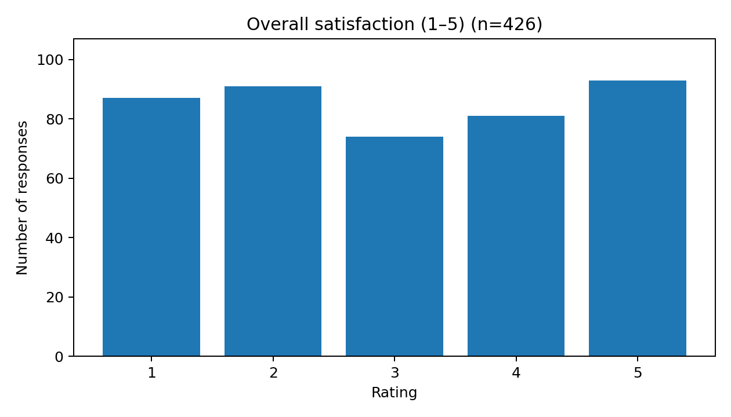
Figure 4.1: Overall satisfaction (1–5).

Overall satisfaction (1–5) — rating distribution
Rating | Frequency | Percentage

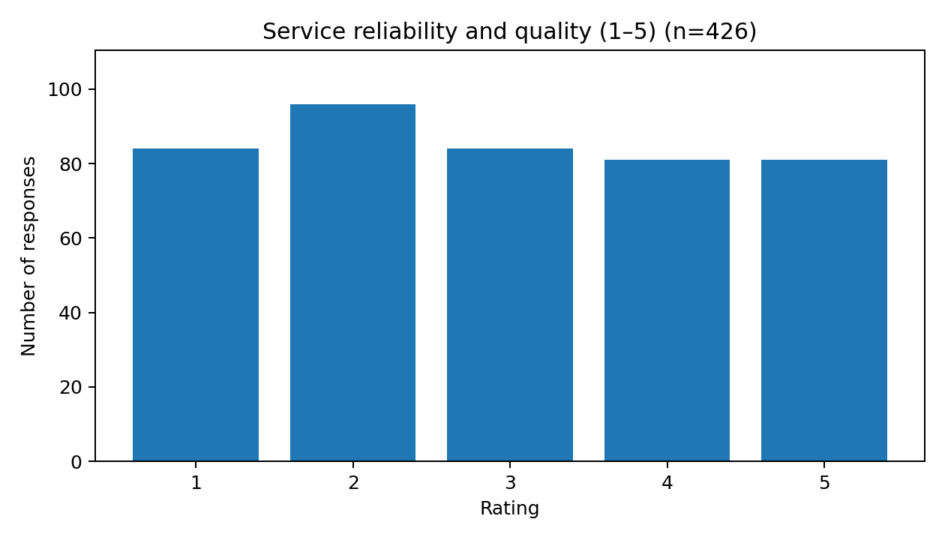
Figure 4.2: Service reliability and quality (1–5).

Service reliability and quality (1–5) — rating distribution
Rating | Frequency | Percentage
1 | 87 | 20.4
2 | 91 | 21.4
3 | 74 | 17.4
4 | 81 | 19.0
5 | 93 | 21.8

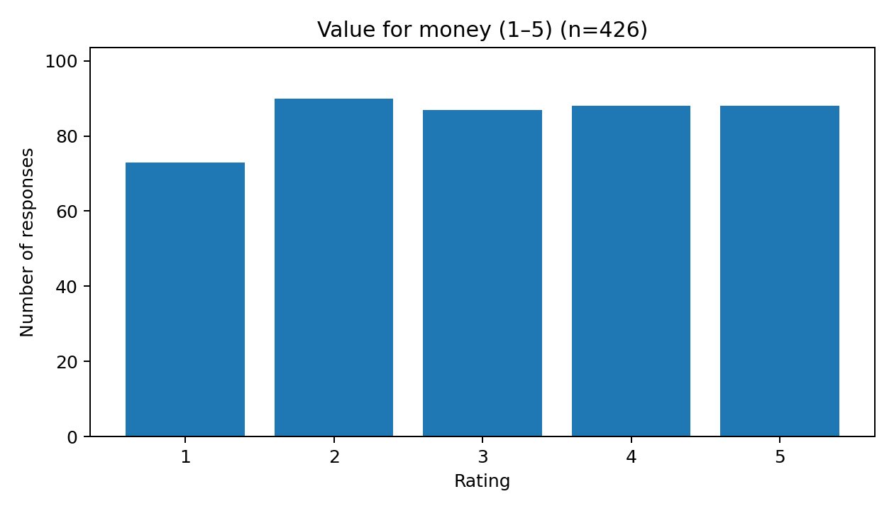
Figure 4.3: Value for money (1–5).

Value for money (1–5) — rating distribution
Rating | Frequency | Percentage
1 | 84 | 19.7
2 | 96 | 22.5
3 | 84 | 19.7
4 | 81 | 19.0
5 | 81 | 19.0

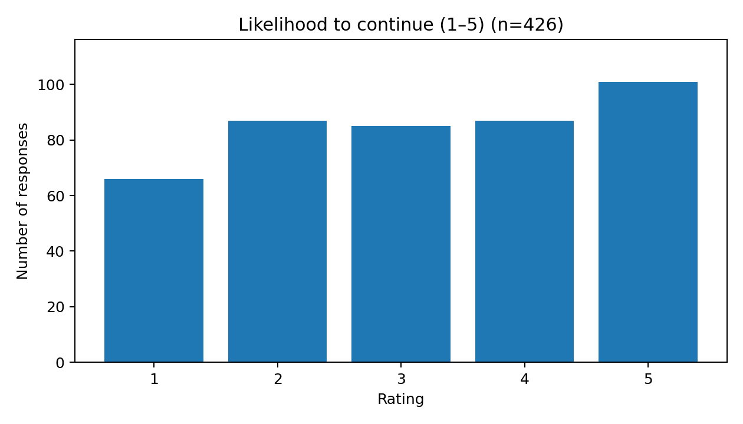
Figure 4.4: Likelihood to continue (1–5).

Likelihood to continue (1–5) — rating distribution
Rating | Frequency | Percentage

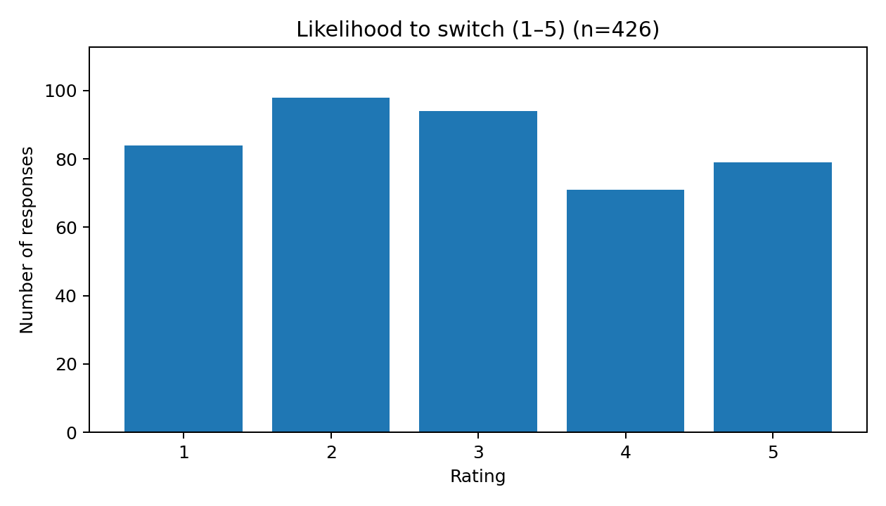
Figure 4.5: Likelihood to switch (1–5).

Likelihood to switch (1–5) — rating distribution
Rating | Frequency | Percentage
1 | 66 | 15.5
2 | 87 | 20.4
3 | 85 | 20.0
4 | 87 | 20.4
5 | 101 | 23.7

4.4 Reasons for Switching and Retention Improvements

How likely are you to switch providers in the next 6 months?
Response | Frequency | Percentage
2 | 98 | 23.0
3 | 94 | 22.1
1 | 84 | 19.7
5 | 79 | 18.5
4 | 71 | 16.7

What is the main reason you might consider switching?
Response | Frequency | Percentage
I am not considering switching | 72 | 16.9
Frequent service interruptions | 64 | 15.0
Poor network / service quality | 61 | 14.3
Poor customer support | 60 | 14.1
Better offer from another provider | 58 | 13.6
Limited features or coverage | 56 | 13.1
High price | 54 | 12.7
Other | 1 | 0.2

4.5 Summary of Descriptive Observations
Area | Observed result | Interpretation
Overall satisfaction | nan/5 | Moderate average rating; responses are distributed across all five options.
Reliability and quality | 3.00/5 | Lowest mean among the five rating measures; reliability warrants attention.
Value for money | 2.95/5 | Perceived value is relevant to retention planning.
Likelihood to continue | nan/5 | Stated intention only; not a verified retention outcome.
Likelihood to switch | 3.16/5 | Stated intention only; not actual churn.
Open-ended improvement | 7 missing answers | Use coded thematic analysis if a deeper qualitative review is needed.

4.6 Discussion
The average reliability and quality rating (3.00/5) is slightly below overall satisfaction (nan/5) and perceived value (2.95/5). This suggests that service reliability should be examined alongside price/value and support experience when designing retention actions. The switching-reason and improvement responses offer direct descriptions of what respondents selected, but they do not establish causality or prove that a particular intervention will reduce churn. Intervention effectiveness should be tested using measured outcomes.

CHAPTER 5 – AI-DRIVEN CHURN PREDICTION: IMPLEMENTATION FRAMEWORK

5.1 What the Survey Can and Cannot Predict
The questionnaire includes a five-point likelihood-to-switch item, which can be analysed as stated switching intention. It does not include verified future cancellations, port-outs, or inactivity within a defined horizon. Therefore, it should not be relabelled as actual churn and should not be used to claim validated prediction of actual churn.

5.2 Proposed Model Development
- Define the churn event (for example, cancellation or inactivity) and prediction horizon with business stakeholders.
- Create a customer-period dataset with a clear observation date and verified outcome label.
- Use only predictors available at the prediction date and check for target leakage.
- Split data by time where feasible; retain a final holdout set for unbiased evaluation.
- Build a simple baseline such as Logistic Regression, then compare suitable alternatives such as Random Forest.
- Evaluate precision, recall, F1-score, ROC-AUC, confusion matrix, calibration, and business utility.
- Review feature explanations, subgroup performance, privacy controls, and retention-intervention outcomes.

5.3 Separate Synthetic Demonstration
The companion pack includes optional Python code for a 300-row synthetic churn dataset with a simulation-generated target. This is a software demonstration only. Its metrics are not calculated from the 426 questionnaire responses and are not evidence of real-world churn-prediction performance. The synthetic dataset is not silently merged with the survey file.

5.4 End-to-End Workflow
Authorised data → Quality checks → Defined churn label → Feature engineering → Time-aware validation → Model comparison → Explainability → Retention action → Outcome measurement

CHAPTER 6 – SUGGESTIONS AND MANAGERIAL RECOMMENDATIONS

6.1 Improve Service Reliability
Monitor repeated outages, coverage issues, dropped sessions, and recurring service complaints. Prioritize fixes by location and service type, then track recurrence and customer feedback after resolution.

6.2 Strengthen Customer Support
Measure first-contact resolution, repeat contacts, time to resolution, and feedback after case closure. Where customers report repeated issues, use a helpful service-recovery follow-up rather than relying only on discounts.

6.3 Improve Perceived Value
Make billing and plan comparisons transparent, recommend plans aligned with usage, and explain renewal terms clearly. Test price or value offers against measured outcomes instead of assuming that discounts always improve retention.

6.4 Use Intention Measures Carefully
Use stated switching intention as one input to customer-experience analysis, not as a substitute for actual churn. Do not label a respondent as a churned customer solely because they select a high switching-intention score.

6.5 Build a Real-World Data Foundation
Maintain a customer-period dataset with observation dates, tenure, plan and billing history, usage trends, support events, complaints, and a verified churn outcome within a specified future window. Document permissions, data lineage, feature definitions, and retention policies.

6.6 Evaluate Retention Interventions
Where feasible, compare intervention outcomes with a control group. Track retention lift, cost per retained customer, offer acceptance, complaint resolution, and customer experience. Prediction alone does not establish that an intervention works.

6.7 Governance and Monitoring
Document model versions, thresholds, performance drift, subgroup differences, retraining criteria, and human-review processes. Restrict access and minimize personal data.

CHAPTER 7 – CONCLUSION AND FUTURE SCOPE

7.1 Conclusion
This project provides a structured descriptive analysis of 426 questionnaire response records and connects the results to customer-retention planning. Overall satisfaction averages nan/5, reliability and quality averages 3.00/5, and value for money averages 2.95/5. Continuance intention averages nan/5, while switching intention averages 3.16/5.
The results identify service reliability, perceived value, support, and switching-related responses as useful areas for managerial attention. These descriptive findings do not demonstrate causality and cannot validate actual churn prediction because verified churn outcomes are absent. The project’s practical contribution is a reproducible analysis, a transparent distinction between intention and churn, and a clear roadmap for a future operational model.

7.2 Future Scope
- Document questionnaire distribution, eligibility criteria, and consent wording for academic auditability.
- Conduct thematic coding of the open-ended improvement responses and describe the coding method.
- Obtain an authorised historical customer dataset with observed churn outcomes.
- Define prediction dates and churn horizons and use time-aware validation.
- Compare models with suitable baselines, calibration, explainability, and business-value measures.
- Run controlled retention experiments to measure incremental impact.

REFERENCES
Breiman, L. (2001). Random forests. Machine Learning, 45, 5–32.
Fawcett, T. (2006). An introduction to ROC analysis. Pattern Recognition Letters, 27(8), 861–874.
Han, J., Kamber, M., & Pei, J. (2011). Data Mining: Concepts and Techniques (3rd ed.). Morgan Kaufmann.
Hastie, T., Tibshirani, R., & Friedman, J. (2009). The Elements of Statistical Learning (2nd ed.). Springer.
Kuhn, M., & Johnson, K. (2013). Applied Predictive Modeling. Springer.
Parasuraman, A., Zeithaml, V. A., & Berry, L. L. (1988). SERVQUAL: A multiple-item scale for measuring consumer perceptions of service quality. Journal of Retailing, 64(1), 12–40.
Provost, F., & Fawcett, T. (2013). Data Science for Business: What You Need to Know about Data Mining and Data-Analytic Thinking. O’Reilly Media.
Verbeke, W., Martens, D., Mues, C., & Baesens, B. (2011). Building comprehensible customer churn prediction models with advanced rule induction techniques. Expert Systems with Applications, 38(3), 2354–2364.
Zeithaml, V. A. (1988). Consumer perceptions of price, quality, and value: A means-end model and synthesis of evidence. Journal of Marketing, 52(3), 2–22.
Scikit-learn developers. Scikit-learn documentation: preprocessing, model selection, LogisticRegression, RandomForestClassifier, and classification metrics. https://scikit-learn.org/stable/

APPENDIX A – QUESTIONNAIRE
The following items correspond to the 17 question fields in the supplied export. Before submission, attach or verify the exact questionnaire exported from the survey platform, including consent wording and answer options.
- What is your age group?
- What is your gender? (Optional)
- How long have you used your current provider?
- Which type of mobile subscription do you currently use with your mobile network operator?
- Which service do you mainly use?
- What is your usual payment method?
- What is your approximate monthly bill?
- How often have you contacted customer support in the last 3 months?
- How satisfied are you with the service overall?
- How would you rate service reliability and quality?
- Does the service provide good value for money?
- How frequently do you use the service?
- How often have you experienced service problems or complaints in the last 3 months?
- How likely are you to continue using your provider over the next 6 months?
- How likely are you to switch providers in the next 6 months?
- What is the main reason you might consider switching?
- What improvement would encourage you to stay with your provider?

APPENDIX B – DATA DICTIONARY AND DATA QUALITY NOTES
Field group | Description | Notes
Timestamp | Submission timestamp from the supplied export | 426 unique timestamp values in the supplied file
Profile and service-use items | Age group, gender, tenure, subscription, service, payment, monthly bill | Categorical responses
Support and usage items | Support contacts, usage frequency, service problems | Categorical responses
Five-point ratings | Satisfaction, reliability, value, continuance intention, switching intention | Numeric scale values 1–5
Switching reason | Main reason a respondent might consider switching | Categorical
Improvement response | Improvement that would encourage staying | 7 missing values; free-text field
Churn outcome | Not included in this survey file | No verified churn label; do not infer actual churn from intention

APPENDIX C – PYTHON SOURCE CODE AND REPRODUCIBILITY
The accompanying Python script, analyse_survey_and_demo_model.py, reads the cleaned survey CSV, regenerates frequency tables and rating summaries, saves charts, and optionally runs a separate synthetic-label model demonstration if the explicitly labelled synthetic model CSV is supplied. The source code pack contains a README with installation and execution steps.

APPENDIX D – PLAGIARISM REPORT REQUIREMENT
Attach the official similarity/plagiarism report required by SRM Institute of Science and Technology after checking the final approved document through the institution-authorized process. This report does not generate or fabricate an official similarity score.
Official report attached: ____________________
Date: ____________________
Similarity percentage as stated in the official report: ____________________

