L.J SCHOOL OF COMPUTER APPLICATION



LinkPro Networking Platform

Developed By:

Anand Yadav: 22002501210066
Smit Dutt: 22002501210008
Hardik Nakum: 22002501210035

Under the Guidance of:

Prof. Rita Gokani

L.J SCHOOL OF COMPUTER APPLICATION
LJ Campus, LJ University Road, Off S.G. Road, Ahmedabad-382210

CERTIFICATE
Enrolment No: 22002501210066
This is to certify that Mr.Anand Yadav of Integrated Master of Computer Applications (IMCA), Semester 9, Roll No B66, has satisfactorily completed his project titled LinkPro under the supervision of Prof.Rita Gokani
Internal Guide Name | Head of Department
Prof.Rita Gokani | DR.Monica Gahalawat

SIGNATURE
Date of Submission:
DIRECTOR
Prof.Alok Manke

L.J SCHOOL OF COMPUTER APPLICATION

L.J SCHOOL OF COMPUTER APPLICATION
LJ Campus, LJ University Road, Off S.G. Road, Ahmedabad-382210

CERTIFICATE
Enrolment No: 22002501210008
This is to certify that Mr.Smit Dutt of Integrated Master of Computer Applications (IMCA), Semester 9, Roll No B09, has satisfactorily completed his project titled LinkPro under the supervision of Prof.Rita Gokani
Internal Guide Name | Head of Department
Prof.Rita Gokani | DR.Monica Gahalawat

SIGNATURE
Date of Submission:
DIRECTOR
Prof.Alok Manke

L.J SCHOOL OF COMPUTER APPLICATION

L.J SCHOOL OF COMPUTER APPLICATION
LJ Campus, LJ University Road, Off S.G. Road, Ahmedabad-382210

CERTIFICATE
Enrolment No: 22002501210035
This is to certify that Mr.Hardik Nakum of Integrated Master of Computer Applications (IMCA), Semester 9, Roll No B32, has satisfactorily completed his project titled LinkPro under the supervision of Prof.Rita Gokani
Internal Guide Name | Head of Department
Prof.Rita Gokani | DR.Monica Gahalawat

SIGNATURE
Date of Submission:
DIRECTOR
Prof.Alok Manke

L.J SCHOOL OF COMPUTER APPLICATION

Table of Contents
Sr. No. | Table of Contents | Page No.
1. | INTRODUCTION | 6
 | 1.1 Project Profile | 6
 | 1.2 Existing System | 7
 | 1.3 Need for the New System | 7
 | 1.4 Problem Definition | 7
 | 1.5 Objective of the New System | 7
 | 1.6 Scope of the Project & Core Components | 8
 | 1.7 Feasibility Study (Technical / Economical / Operational) | 9
 | 1.8 Advantages and Limitations | 9
 | 1.9 Assumptions and Constraints | 10
 | 1.10 Stakeholder Analysis & RACI Matrix | 10
2. | REQUIREMENT DETERMINATION & ANALYSIS | 11
 | 2.1 Functional Requirements | 11
 | 2.2 Non-Functional Requirements | 11
 | 2.3 Targeted Users | 11
 | 2.4 Software Requirement | 12
3. | PROJECT PLANNING & MANAGEMENT | 13
 | 3.1 Project Charter | 13
 | 3.2 Project Lifecycle Model | 19
 | 3.3 Work Breakdown Structure | 20
 | 3.4 Effort Estimation | 21
 | 3.5 Gantt Chart / Sprint Schedule | 21
 | 3.6 Sprint Backlog | 23
 | 3.7 User Stories | 25
 | 3.8 Release Plan | 26
 | 3.9 Risk Register | 28
 | 3.10 Change Request Log | 33
 | 3.11 Status Reports | 34
4. | SYSTEM DESIGN | 36
 | 4.1 System Architecture | 36
 | 4.2 Module Description | 38
 | 4.3 Use Case Diagram | 39
 | 4.4 Class Diagram | 40
 | 4.5 Sequence / Interaction Diagram | 41
 | 4.6 Activity Diagram | 43
 | 4.7 Data Dictionary | 44
5. | DEVELOPMENT | 46
 | 5.1 Coding Standards | 46
 | 5.2 SOLID Principles & Refactoring | 47
6. | DESIGN PATTERN IMPLEMENTATION & DOCUMENTATION | 53
 | 6.1 Pattern Selection & Justification | 53
 | 6.2 Creational Pattern(s) Implementation | 54
 | 6.3 Structural Pattern(s) Implementation | 55
 | 6.4 Behavioral Pattern(s) Implementation | 56
 | 6.5 UML Mapping (Pattern-to-Class Diagram Traceability) | 57
 | 6.6 Documentation & Trade-off Analysis | 60
 | 6.7 Testing | 61
 | 6.8 Project Tracking & Monitoring | 63
 | 6.9 Screenshots | 75
 | 6.10 Proposed Enhancement | 81
 | 6.11 Project Closure Report | 81
 | 6.12 Conclusion | 85
 | 6.13 Bibliography | 85

Introduction

A full-fledged LinkedIn-like platform has been created, allowing professionals to create comprehensive profiles featuring work experience, skills, education, certifications, and achievements, along with personalized profile pictures and background images. Professionals can find and connect with other professionals in their industry using personalized suggestions and common connections.

The live news feed displays real-time posts, articles, job updates, and company announcements. Professionals can like, comment, share posts, send connection requests, endorse skills, write recommendations, and apply for job postings. In-app messaging enables private messaging with read receipts and group messaging for teams.

Powerful search helps find people, jobs, and companies using intelligent filters. Activity feeds track profile views, connection requests, and post engagement. Job seekers can view company profiles that display employee information, salary information, and application status. The platform is optimized to handle hundreds of users seamlessly, with instant notifications and a seamless mobile experience.

1.1 Project Profile:-

Project Title | LinkPro Networking Platform
Type of Application | Web Application
Project Overview | LinkPro is a comprehensive professional networking system designed to enhance career opportunities, streamline job search, and facilitate meaningful professional connections. By integrating profile management, real-time newsfeeds, job applications, and advanced networking features, LinkPro overcomes limitations of fragmented job boards and traditional networking methods.
Team Size | 3 People
Front End | React.js, Tailwind CSS, JavaScript
Back End | Node.js, Express.js
Database | MongoDB
Tools Used | Microsoft Visual Studio

1.2 Existing System:-

The Existing platforms offer many features, but they are complex, handle a very large number of users, and may face performance issues during peak usage. Their search results can be too broad, and many advanced features are limited to paid users. Our proposed project is required to provide a simple, user-friendly, and focused networking platform with easy search, better performance, real-time communication, and useful features for users without unnecessary complexity.

1.3 Need for the New System:-

The new LinkPro system is needed to overcome the limitations of existing professional networking platforms. Many users, especially students and job seekers, face problems such as scattered job platforms, limited networking, high subscription costs, and difficult job searches. Our system aims to provide a simple, single platform for creating profiles, finding jobs, connecting with professionals, and communicating in real time. It will be easy to use, affordable, and focused on the needs of Indian users, helping them find suitable career opportunities more efficiently.

1.4 Problem Definition:-

The proposed LinkPro system’s scope includes an extensive online networking platform that aims to improve career efficiency and professional networking access. The key issues that the system addresses include:
- Time-consuming job searches: Traditional job applications take a lot of time. LinkPro provides easy profile creation, quick job applications, and recruiter connections.

- Difficult networking: Finding the right professionals can be difficult. LinkPro brings professionals, companies, and alumni onto one platform for easy connections.

- Geographical limitations: Users from tier-2/3 cities and rural areas may have limited access to opportunities. LinkPro provides online access to jobs and professionals from anywhere.

- High costs: Existing platforms may require premium subscriptions or other fees. LinkPro provides basic networking and job-search features at low or no cost, making it useful for students and early-career professionals.

1.5 Objective of the New System:-

The main objectives of LinkPro are to make job searching, professional networking, and career growth easier and faster.
- Easy job applications: Users can create profiles and apply for jobs online, reducing the time needed for hiring.

- Professional communication: Users can message, collaborate, get advice, and connect with mentors from anywhere.

- Smart search: Users can find relevant jobs, professionals, and companies using filters such as skills, location, experience, and industry.

1.6 Scope of the Project & Core Components:-

1.6.1 Scope of the Project:-

The scope of LinkPro is to develop a professional networking platform that brings career networking and job-related activities together in one place. The system allows users to create and manage professional profiles, connect with other professionals, share and interact with posts, communicate through real-time messaging, and receive notifications. It also supports searching for professionals and job opportunities, applying for jobs, and managing applications. An Admin Panel is included to manage users and platform content, while the system is designed to be responsive, secure, and scalable for future enhancements.

1.6.2 Core Components:-

- Profile Management Module:-
Users can create and manage professional profiles with experience, skills, education, etc. This module helps improve personal branding and makes it easy for recruiters to find users.
- Networking Module:-
The module helps users connect, send messages, and find common connections. It helps users build professional networks and get referrals easily.
- Job Management Module:-
The module allows users to search for jobs, apply to jobs with a single click, and track job applications. It helps reduce the recruitment timeline from weeks to days.
- Newsfeed Module:-

The module enables users to post, like, comment, and share content in real-time. It keeps professionals updated about the latest trends and opportunities in their industry.

- Real-Time Chat Module:-
This module allows connected users to communicate through real-time messaging. Users can send and receive messages and maintain their conversation history.
- Notification Module:-
This module provides real-time notifications for important activities such as connection requests, messages, likes, comments, and other interactions.
- Admin Management Module:-
This module allows administrators to manage users, control permissions, and manage platform content, helping maintain the security and proper functioning of LinkPro.

1.7 Feasibility Study (Technical /Economic /Operational):-

The feasibility study evaluates whether the proposed LinkPro Networking Platform can be developed, used, and maintained successfully within the project's available technical, economic, and operational conditions.

Feasibility Area | Assessment | Project Evidence | Conclusion
Technical Feasibility | The project is technically feasible using a MERN-based web application architecture. | React.js, Tailwind CSS, JavaScript, Node.js, Express.js, MongoDB, JWT authentication, Socket.io, Postman, ESLint and Prettier are identified in the existing documentation. | Technically Feasible
Economic Feasibility | The project can be developed using commonly available development tools and technologies. | The documented stack and development tools are suitable for an academic project, and the project is designed as a web-based platform. | Economically Feasible
Operational Feasibility | The system is intended to provide a user-friendly platform for profiles, networking, posts, messaging, notifications and job-related activities. | Targeted users include job seekers, recruiters/HR professionals, freelancers/consultants and tier-2/3 city professionals. | Operationally Feasible

1.8 Advantages and Limitations :-

- Advantages :-

  - Benefits tier-2/3 city professionals and fresher’s with access to top companies and recruiters previously out of reach.

  - Enables instant profile creation, job applications, and networking—reducing hiring cycles from months to days.

  - Real-time newsfeed and messaging keep professionals updated on opportunitiesand industry trends instantly.

  - Advanced search connects users with precise job matches, mutual connections, and verified professionals.

- Disadvantages :-

  - Requires stable internet connectivity.

  - Cannot fully replace in-person networking events, interviews, or physical portfolio presentations.

  - Needs many users to be really useful.

1.9 Assumptions and Constraints:-

- Assumptions :-
Experts are increasingly using online networking to improve efficiency and extend their reach. Users have basic digital skills and reliable 4G+ internet connectivity to enable real-time functionality. User profiles must be kept up to date to reflect genuine experience and skills. Employers are actively investigating endorsements and user behavior. Job hunters value shared connections rather than unsolicited communication. Privacy compliance helps to build trust in sharing professional information.
- Constraints :-

The platform is constrained by regional hiring laws that influence job posting compliance. Device compatibility problems may arise, affecting mobile responsiveness on older smartphones or slower internet connectivity. The presence of intense competition from existing platforms requires differentiation based on better user experience, greater accuracy in AI-driven matching, and the provision of free premium services.

1.10 Stakeholder Analysis & RACI Matrix:-

1.10.1 Stakeholder Analysis:-

Stakeholder analysis identifies the people and user groups that influence, guide, develop, review, or use the LinkPro platform. The project documentation identifies the project team, internal guide, project manager, administrators, and targeted users as relevant project roles.

Stakeholder | Role / Interest | Influence | Engagement
Project Team | Development, documentation, testing and project execution | High | High
Internal Guide – Prof. Rita Gokani | Academic guidance and project review | High | High
Administrator | User/content management and platform administration | High | High
Job Seekers / Professionals | Use profiles, networking, posts, messaging and job-related functions | Medium | High
LJ University | Academic stakeholder | Medium | Medium

1.10.2 RACI Matrix:-

R = Responsible | A = Accountable | C = Consulted | I = Informed
Activity | Project Manager | Frontend Developer | Backend Developer | Database Developer | User
Requirement determination | [R] | [C] | [C] | [C] | [A]
System design | [A] | [R] | [R] | [R] | [A]
Development & integration | [A] | [R] | [R] | [R] | -
Testing & quality review | [A] | [R] | [R] | [R] | [C]
Project review & academic approval | [R] | [I] | [I] | [I] | -
User/content administration | [A] | [C] | [R] | [C] | [C]
Documentation | [R] | [C] | [C] | [C] | -
Final Project Submission | [R/A] | [I] | [I] | [I] | -

2. Requirement Determination and Analysis.

2.1 Functional Requirements:-

The functional requirements describe the major services and operations that LinkPro is expected to provide to its users and administrators.
- User Registration & Login.
- Profile Management.
- Resume Management
- Networking & Connection Management.
- Post Creation & Newsfeed
- Like & Comment.
- Real-Time Chat & Messaging.
- Search & Filter.
- Admin Management.
- Logout & Account Security.

2.2 Non- Functional Requirements:-

The non-functional requirements define the expected quality attributes and operational characteristics of the LinkPro system.
- Performance – Ensures the system responds quickly and efficiently.
- Security – Protects user data and prevents unauthorized access.
- Scalability – Allows the system to handle increasing users and data.
- Usability – Makes the system easy and convenient to use.
- Reliability – Ensures the system works correctly and consistently.
- Maintainability – Makes the system easy to update, fix, and maintain.
- Availability – Ensures the system is accessible when required.
- Compatibility – Ensures the system works across supported devices and browsers.
- Privacy – Protects users’ personal and professional information.
- Responsiveness – Ensures the interface adapts properly to different screen sizes.

2.3 Targeted Users:-

The targeted users of LinkPro primarily include:-

  - Job Seekers (Freshers, Experienced Professionals, Career Switchers).

  - Recruiters and HR Professionals.

  - Freelancers and Consultants (project-based opportunities).

  - Tier-2/3 City Professionals (access to metro job markets).

2.4 Software Requirement Specification (SRS):-

Component | Requirement
Operating System | Windows 10/11, Linux, or macOS
Frontend | React.js, Tailwind CSS, JavaScript
Backend | Node.js, Express.js
Database | MongoDB
Development Tool | Visual Studio 2022
Version Control | Git & GitHub
Web Browser | Google Chrome, Microsoft Edge, Mozilla Firefox, etc.
API Testing | Postman
Real-Time Communication | Socket.io
Authentication | JWT & bcrypt

3. Project Planning & Management.

3.1 Project Charter:-

Project Name or Identification:-

Item | Details
Project Name / Identification | LinkPro – Professional Networking Platform
Project Type | Web-Based Professional Networking Platform
Development Methodology | Agile
Internal Guide | Prof. Rita Gokani
Project Team | Anand Yadav, Smit Dutt, Hardik Nakum
Institution | LJ University

3.1.1 Project Stakeholders:-

1. Anand Yadav
Role/Responsibility: Backend Developer, Database Integration & Team Manager
Phone Number: +91 90815 05659
E-mail Address: unknown98256@gmail.com

2. Smit Dutt
Role/Responsibility: Frontend Developer
Phone Number: +91 93139 64403
E-mail Address: smitdutt727@gmail.com

3. Hardik Nakum
Role/Responsibility: Documentation & Quality Assurance
Phone Number: +91 96019 77655
E-mail Address: hardikn161@gmail.com

3.1.2 Project Description:-

    - Background
LinkPro is a professional networking platform designed to provide users with a centralized platform for creating professional profiles, building connections, communicating, sharing content, and exploring career opportunities.
    - Description of the Challenge or Opportunity
Traditional professional networking and job-search activities can be time-consuming and distributed across multiple platforms. LinkPro provides an opportunity to bring professional networking, communication, content sharing, and job-related activities together in one centralized platform.
    - Overview of the Desired Impact:-

LinkPro aims to improve professional networking and career opportunities by making it easier for users to connect with professionals, discover suitable jobs, communicate in real time, and manage their professional identity. It is intended to make career development more accessible, efficient, and organized.

Measurable Organizational Value (MOV):-

The MOV defines the measurable value expected from the project and focuses on improved networking, career access, communication, professional identity, user engagement, and centralized administration.
MOV Area | Measurement / Indicator | Expected Value
Professional Networking | Number of professional connections / networking interactions | Improved professional networking
Career Opportunities | Job searches and applications supported by the platform | Better access to career opportunities
Communication | Messages and conversations supported | Faster professional communication
Professional Identity | Profiles containing skills, education and experience | Stronger professional presence
User Engagement | Posts, likes, comments and interactions | Higher user engagement
Administration | User and content management activities | Centralized platform management

Project Scope:-
    - What Will Be Included in the Scope

      - User registration, login and secure authentication
      - Professional profile creation and management
      - Professional networking and connection requests
      - Posts, newsfeed, likes and comments
      - Real-time messaging and communication
      - Job search, job posting, applications and application tracking
      - Search and filtering
      - Notifications
      - Admin user and content management
      - Responsive web interface

    - What Will Be Considered Outside the Scope

      - Native Android/iOS mobile applications
      - Advanced AI-based recruitment and recommendation features
      - Advanced third-party recruitment integrations
      - Features not defined in the approved project requirements

Project Schedule Summary:-

Project Start Date: 1 August 2026.
Project End Date: 31 October 2026.
- Timeline of Project Phases and Milestones
Phase | Duration | Milestone
Project Initiation & Requirement Analysis | August 2026 | Project topic finalized, requirements gathered, feasibility study completed, and Project Charter approved.
System Design | August 2026 | UI/UX design, database schema, use case diagram, class diagram, activity diagram, and system architecture completed.
Development | September 2026 | Frontend, backend, database integration, authentication, admin panel, language learning modules, videos, MCQs, and progress tracking implemented.
Testing & Quality Assurance | October 2026 | Functional testing, integration testing, bug fixing, and user acceptance testing completed.
Documentation & Final Submission | October 2026 | Final documentation, project deployment, presentation, demonstration, and project submission completed.

- Project Reviews and Review Dates
Review | Tentative Date
Project Proposal Review | August 2026
Requirement & Design Review | August 2026
Development Progress Review – I | September 2026
Development Progress Review – II | September 2026
Testing & Quality Review | October 2026
Final Project Review & Submission | October 2026

Project Budget Summary:-
This project is developed as an academic project for educational and learning purposes.

Quality Issues:-
Specific quality requirements for LinkPro include:
• Functional Correctness – Ensures all features work according to the defined requirements.
• Security – Protects user information and authentication data from unauthorized access.
• Performance – Ensures fast and efficient system response.
• Usability – Provides a simple and user-friendly interface.
• Reliability – Ensures consistent and error-free system operation.
• Maintainability – Makes the system easy to update, modify, and maintain.
• Compatibility – Ensures proper operation across supported browsers and devices.
• Responsive Design – Ensures the interface adapts properly to different screen sizes.

Resources Required:-
Resource Category | Resources | Purpose
People | Project Team, Project Manager, Internal Guide, Administrator | Planning, development, review and administration
Technology | React.js, Tailwind CSS, JavaScript, Node.js, Express.js, MongoDB, Socket.io | System development
Security | JWT, bcrypt, environment variables | Authentication and protection
Software Tools | Visual Studio Code / Visual Studio, Git, GitHub, Postman, ESLint, Prettier | Development, version control, testing and quality
Facilities | Computers, internet connectivity, testing devices | Development and testing

- Resources to be Provided:-
Resource | Resource Provider | Date to be Provided
Project Guidance | Prof. Rita Gokani | July 2025
Development Laptop/Desktop | Team Members | July 2025
Internet Connection | Team Members | July 2025
Development Tools (VS Code, Git, Postman) | Team Members | July 2025
Database | MongoDB Atlas (Free Tier) | August 2025
College Computer Laboratory | L.J. Institute of Computer Applications | Throughout the Project

3.1.9 Assumptions and Risks:-

- Assumptions Used to Develop Estimates:-

- Required development tools and technologies will be available.
- Project team members will be available during planned activities.
- Internet connectivity will be available for development, testing and real-time features.
- The approved requirements will remain reasonably stable during the project.

- Key Risks, Probability and Impact:-
Risk | Probability | Impact | Risk Level | Response
Internet connectivity issues | Medium | High | High | Optimize and test under varying network conditions.
Browser / device compatibility | Medium | Medium | Medium | Test supported browsers and devices.
Scalability with increasing users | Medium | High | High | Use modular architecture and optimize APIs.
Security / unauthorized access | Medium | High | High | Use secure authentication, authorization and password hashing.
Integration defects | Medium | High | High | Perform continuous integration and testing.
Privacy / legal requirements | Medium | High | High | Review applicable requirements before deployment.

- Constraints:-

• Limited academic project timeline
• Limited development resources
• Dependence on internet connectivity
• Availability of team members and facilities

- Dependencies on Other Projects or Areas:-

• Availability of MongoDB database services.
• Availability of development tools (Visual Studio Code, Git, Postman).
• Continuous guidance and feedback from the project guide.
• Availability of internet connectivity for development and testing.

- Assessment of Project Impact on the Organization:-

• Improves Professional Networking – Provides an accessible digital platform for users to build professional connections and expand their network.
• Enhances Career Opportunities – Helps users discover suitable jobs, apply for opportunities, and manage their professional profiles.
• Promotes Digital Professional Development – Provides practical experience in modern web technologies and demonstrates the application of the MERN stack in a real-world project.
• Centralizes Professional Activities – Brings profiles, networking, communication, posts, notifications, and job-related activities together on a single platform.

- Outstanding Issues:-

• Content and User Data Management – Continuous management and validation of professional profiles, job information, and platform content.
• Advanced Recommendation Features – Future implementation of AI-based job and professional recommendations can improve user experience.
• Platform Expansion – Future versions can include additional features and services to support a wider range of professional networking needs.
• Deployment and Long-Term Maintenance – Final deployment, regular updates, security improvements, and long-term maintenance will be required after project completion.

3.1.10 Project Administration:-

- Communications Plan:-
Activity | Frequency
Team Meeting | Weekly
Project Guide Review | Bi-weekly
Progress Updates | Weekly
GitHub Repository Updates | Daily

- Scope Management Plan:-

• Any new feature request must be approved by the Project Guide.
• Major scope changes will be documented before implementation.
• Features outside the approved scope will be considered for future releases.

- Quality Management Plan:-

• Unit Testing
• Integration Testing
• User Acceptance Testing (UAT)
• Code Reviews
• Documentation Reviews

- Change Management Plan:-

• Record all change requests.
• Analyze the impact on project scope, schedule, and resources.
• Obtain approval from the Project Guide.
• Update project documentation.
• Implement, test, and verify the approved changes.

- Human Resources Plan:-
Role | Primary Responsibility | Involvement
Project Team | Development, testing, documentation and implementation | High
Internal Guide | Academic guidance and review | High

- Implementation and Project Closure Plan:-

• Complete system development.
• Perform functional, integration, and user acceptance testing.
• Resolve identified defects.
• Prepare project documentation.
• Demonstrate the completed application.
• Submit the final project report and source code.
• Obtain final approval from the Project Guide.
• Officially close the project.

3.1.11 Acceptance and Approval:-
Name | Role | Signature | Date
Prof. Rita Gokani | Project Guide |  | ______
Anand Yadav | Team Manager |  | ______
Smit Dutt | Team Member |  | ______
Hardik Nakum | Team Member |  | ______

3.2 Project Lifecycle Model (Agile):-

Scrum Model

The LinkPro follows the Scrum Model, an Agile framework based on iterative and incremental development. The project is divided into multiple Sprints, where each Sprint focuses on planning, developing, integrating, testing, and reviewing a specific set of system features.

The Scrum approach allows the development team to continuously monitor project progress, identify and resolve issues, gather user feedback, and improve the system in subsequent Sprints. This approach is suitable for the project because it consists of multiple modules and functionalities that can be developed and tested incrementally. The Scrum Model also helps the team manage changing requirements, maintain regular communication among team members, and ensure that each Sprint delivers a functional and tested part of the system.

3.3 Work Breakdown Structure (WBS):-

WBS ID | Work Package | Major Activities
1.0 | Requirement Gathering | 1.1 Define project objectives and scope  1.2 Gather functional and non-functional requirements  1.3 Identify target users  1.4 Milestone: Requirements finalized
2.0 | Project Setup | 2.1 Set up React, Node.js and Express.js  2.2 Configure MongoDB database  2.3 Set up GitHub repository and project structure  2.4 Milestone: Project environment configured
3.0 | Authentication | 3.1 User registration and login  3.2 OTP/authentication and password recovery  3.3 Logout and access management  3.4 Milestone: Authentication completed
4.0 | Profile Management | 4.1 Create and display user profile  4.2 Edit profile information and profile image  4.3 Milestone: Profile management completed
5.0 | Posts & Feed | 5.1 Create, edit and delete posts  5.2 Develop user feed  5.3 Implement likes and comments  5.4 Milestone: Posts and feed completed
6.0 | Connections | 6.1 Send connection requests  6.2 Accept/reject connection requests  6.3 Manage connections  6.4 Milestone: Connections completed
7.0 | Chat System | 7.1 Develop real-time chat functionality  7.2 Implement chat UI and message storage  7.3 Milestone: Chat system completed
8.0 | Jobs Feature | 8.1 Create and display job postings  8.2 Implement job applications  8.3 Milestone: Jobs feature completed
9.0 | Search & Filter | 9.1 Implement user and content search  9.2 Implement filtering functionality  9.3 Milestone: Search and filter completed
10.0 | Notifications | 10.1 Implement notification generation and storage  10.2 Display user notifications  10.3 Milestone: Notifications completed
11.0 | Admin Panel | 11.1 Admin authentication  11.2 User and content management  11.3 Admin dashboard and platform monitoring  11.4 Milestone: Admin panel completed
12.0 | Testing & Integration | 12.1 Functional and integration testing  12.2 API and database testing using Postman  12.3 Bug fixing and final validation  12.4 Milestone: Testing completed
13.0 | UI Improvement | 13.1 Improve interface and navigation  13.2 Implement responsive design  13.3 Milestone: UI improvement completed
14.0 | Deployment | 14.1 Configure production environment  14.2 Deploy frontend, backend and database  14.3 Perform final verification  14.4 Milestone: System successfully deployed

3.4 Effort Estimation:-

Effort estimation defines the expected duration required to complete each project sprint and activity. The Agile project plan provides durations, start dates, and completion dates for the project activities.
Work Package / Deliverable | Complexity Level | Estimated Effort (Days) | No. of People | Required Roles
Requirements & Setup | Medium | 11 days | 3 | Project Manager, Frontend Developer, Backend Developer
Core User Features | High | 31 days | 3 | Frontend Developer, Backend Developer, Database Developer
Communication & Job Features | High | 22 days | 2 | Frontend Developer, Backend Developer
Search, Notifications & Admin | High | 20 days | 2 | Frontend Developer, Backend Developer
Testing & UI Improvement | Medium | 18 days | 3 | Frontend Developer, Backend Developer, Project Manager
Deployment & Finalization | Medium | 13 days | 2 | Backend Developer, Project Manager
Complete LinkPro Project | High | 115 days | 3 | Project Team

3.5 Gantt Chart / Sprint Schedule:-
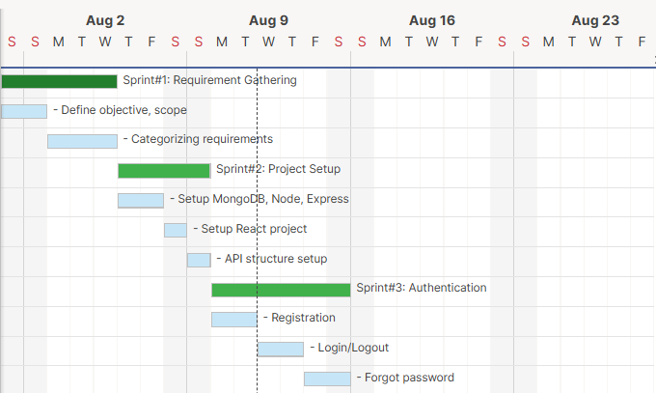
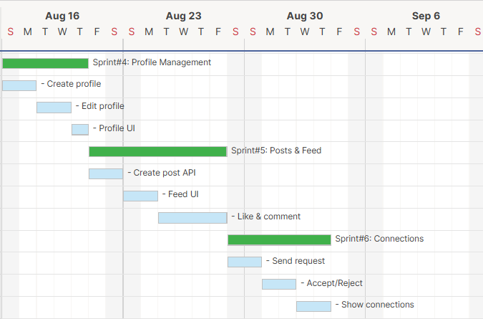

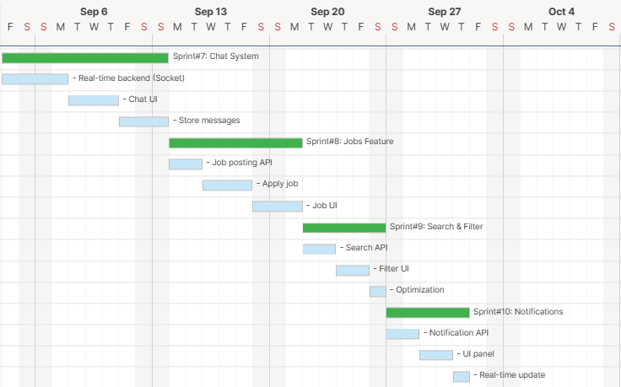
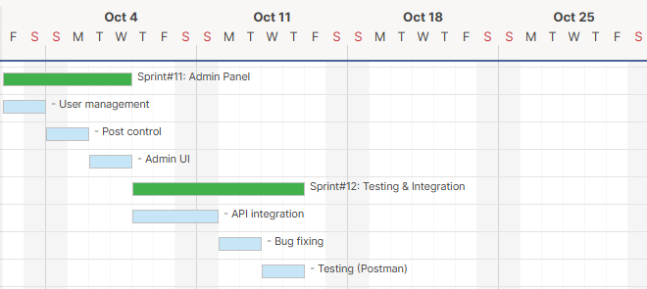
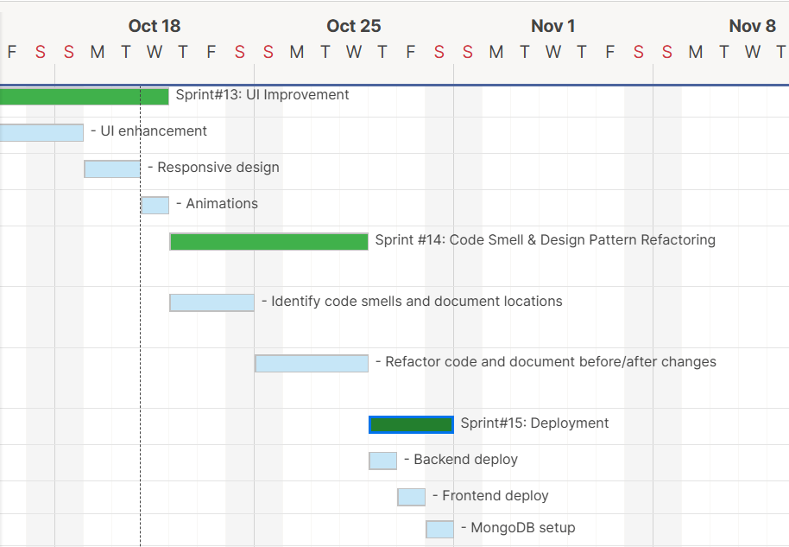

3.6 Sprint Backlog:-
Task Name | Duration | Start | Finish | Status
Sprint#1: Requirement Gathering | 5d | 01-Aug-2026 | 05-Aug-2026 | Complete
- Define objective, scope | 2d | 01-Aug-2026 | 02-Aug-2026 | Complete
- Categorizing requirements | 3d | 03-Aug-2026 | 05-Aug-2026 | Complete
Sprint#2: Project Setup | 4d | 06-Aug-2026 | 09-Aug-2026 | Complete
- Setup MongoDB, Node, Express | 2d | 06-Aug-2026 | 07-Aug-2026 | Complete
- Setup React project | 1d | 08-Aug-2026 | 08-Aug-2026 | Complete
- API structure setup | 1d | 09-Aug-2026 | 09-Aug-2026 | Complete
Sprint#3: Authentication | 6d | 10-Aug-2026 | 15-Aug-2026 | Complete
- Registration | 2d | 10-Aug-2026 | 11-Aug-2026 | Complete
- Login/Logout | 2d | 12-Aug-2026 | 13-Aug-2026 | Complete
- Forgot password | 2d | 14-Aug-2026 | 15-Aug-2026 | Complete
Sprint#4: Profile Management | 5d | 16-Aug-2026 | 20-Aug-2026 | Complete
- Create profile | 2d | 16-Aug-2026 | 17-Aug-2026 | Complete
- Edit profile | 2d | 18-Aug-2026 | 19-Aug-2026 | Complete
- Profile UI | 1d | 20-Aug-2026 | 20-Aug-2026 | Complete
Sprint#5: Posts & Feed | 8d | 21-Aug-2026 | 28-Aug-2026 | Complete
- Create post API | 2d | 21-Aug-2026 | 22-Aug-2026 | Complete
- Feed UI | 2d | 23-Aug-2026 | 24-Aug-2026 | Complete
- Like & comment | 4d | 25-Aug-2026 | 28-Aug-2026 | Complete
Sprint#6: Connections | 6d | 29-Aug-2026 | 03-Sep-2026 | Complete
- Send request | 2d | 29-Aug-2026 | 30-Aug-2026 | Complete
- Accept/Reject | 2d | 31-Aug-2026 | 01-Sep-2026 | Complete
- Show connections | 2d | 02-Sep-2026 | 03-Sep-2026 | Complete
Sprint#7: Chat System | 10d | 04-Sep-2026 | 13-Sep-2026 | Complete
- Real-time backend (Socket) | 4d | 04-Sep-2026 | 07-Sep-2026 | Complete
- Chat UI | 3d | 08-Sep-2026 | 10-Sep-2026 | Complete
- Store messages | 3d | 11-Sep-2026 | 13-Sep-2026 | Complete
Sprint#8: Jobs Feature | 8d | 14-Sep-2026 | 21-Sep-2026 | Complete
- Job posting API | 2d | 14-Sep-2026 | 15-Sep-2026 | Complete
- Apply job | 3d | 16-Sep-2026 | 18-Sep-2026 | Complete
- Job UI | 3d | 19-Sep-2026 | 21-Sep-2026 | Complete
Sprint#9: Search & Filter | 5d | 22-Sep-2026 | 26-Sep-2026 | Complete
- Search API | 2d | 22-Sep-2026 | 23-Sep-2026 | Complete
- Filter UI | 2d | 24-Sep-2026 | 25-Sep-2026 | Complete
- Optimization | 1d | 26-Sep-2026 | 26-Sep-2026 | Complete
Sprint#10: Notifications | 5d | 27-Sep-2026 | 01-Oct-2026 | Complete
- Notification API | 2d | 27-Sep-2026 | 28-Sep-2026 | Complete
- UI panel | 2d | 29-Sep-2026 | 30-Sep-2026 | Complete
- Real-time update | 1d | 01-Oct-2026 | 01-Oct-2026 | Complete
Sprint#11: Admin Panel | 6d | 02-Oct-2026 | 07-Oct-2026 | Complete
- User management | 2d | 02-Oct-2026 | 03-Oct-2026 | Complete
- Post control | 2d | 04-Oct-2026 | 05-Oct-2026 | Complete
- Admin UI | 2d | 06-Oct-2026 | 07-Oct-2026 | Complete
Sprint#12: Testing & Integration | 8d | 08-Oct-2026 | 15-Oct-2026 | Complete
- API integration | 4d | 08-Oct-2026 | 11-Oct-2026 | Complete
- Bug fixing | 2d | 12-Oct-2026 | 13-Oct-2026 | Complete
- Testing (Postman) | 2d | 14-Oct-2026 | 15-Oct-2026 | Complete
Task Name | Duration | Start | Finish | Status
Sprint#13: UI Improvement | 6d | 16-Oct-2026 | 21-Oct-2026 | Complete
- UI enhancement | 3d | 16-Oct-2026 | 18-Oct-2026 | Complete
- Responsive design | 2d | 19-Oct-2026 | 20-Oct-2026 | Complete
- Animations | 1d | 21-Oct-2026 | 21-Oct-2026 | Complete
Sprint #14: Code Smell & Design Pattern Refactoring | 7d | 22-10-2026 | 28-10-2026 | Complete
- Identify code smells and document locations | 3d | 22-10-2026 | 24-10-2026 | Complete
- Refactor code and document before/after changes | 4d | 25-10-2026 | 28-10-2026 | Complete
Sprint#15: Deployment | 3d | 29-Oct-2026 | 31-Oct-2026 | Complete
- Backend deploy | 1d | 29-Oct-2026 | 29-Oct-2026 | Complete
- Frontend deploy | 1d | 30-Oct-2026 | 30-Oct-2026 | Complete
- MongoDB setup | ½d | 31-Oct-2026 | 31-Oct-2026 | Complete
- Final testing | ½d | 31-Oct-2026 | 31-Oct-2026 | Complete

3.7 User Stories:-

Story-1(Admin)
User Story Id | As a <User> | Want To<Task> | So that<Goal>
1 | Admin | Login | I can access the system and manage the platform securely.
2 | Admin | View Dashboard | I can see overall system statistics and activities.
3 | Admin | Manage User Accounts | I can block, unblock, or delete users within the system.
4 | Admin | Control Permissions | I can assign roles and permissions to users.
5 | Admin | Logout | I can securely exit the system and protect sensitive information.

Story-2(User)
User Story Id | As a <User> | Want To<Task> | So that<Goal>
1 | User | Register | I can create a new account and use the platform.
2 | User | Login | I can access my account securely.
3 | User | Create Profile | I can add my personal and professional details.
4 | User | Edit Profile | I can update my information anytime.
5 | User | Add Links/Posts | I can share my content or useful links with others.
6 | User | View Other Profiles | I can explore other users and their content.
7 | User | Follow/Connect Users | I can build my network on the platform.
8 | User | Like/Comment on Posts | I can interact with other users’ content.
9 | User | Search Users | I can easily find relevant people or posts.
10 | User | Send Messages | I can communicate with other users in real-time
11 | User | Receive Messages | I can get messages from other users instantly.
12 | User | Logout | I can securely exit my account and protect my data.

3.8 Release Plan:-
Task Name | Duration | Start | Finish | Status | Release Date
Sprint#1: Requirement Gathering | 5d | 01-Aug-2026 | 05-Aug-2026 | Complete | 05-Aug-2026
- Define objective, scope | 2d | 01-Aug-2026 | 02-Aug-2026 | Complete | 02-Aug-2026
- Categorizing requirements | 3d | 03-Aug-2026 | 05-Aug-2026 | Complete | 05-Aug-2026
Sprint#2: Project Setup | 4d | 06-Aug-2026 | 09-Aug-2026 | Complete | 09-Aug-2026
- Setup MongoDB, Node, Express | 2d | 06-Aug-2026 | 07-Aug-2026 | Complete | 07-Aug-2026
- Setup React project | 1d | 08-Aug-2026 | 08-Aug-2026 | Complete | 08-Aug-2026
- API structure setup | 1d | 09-Aug-2026 | 09-Aug-2026 | Complete | 09-Aug-2026
Sprint#3: Authentication | 6d | 10-Aug-2026 | 15-Aug-2026 | Complete | 15-Aug-2026
- Registration | 2d | 10-Aug-2026 | 11-Aug-2026 | Complete | 11-Aug-2026
- Login/Logout | 2d | 12-Aug-2026 | 13-Aug-2026 | Complete | 13-Aug-2026
- Forgot password | 2d | 14-Aug-2026 | 15-Aug-2026 | Complete | 15-Aug-2026
Sprint#4: Profile Management | 5d | 16-Aug-2026 | 20-Aug-2026 | Complete | 20-Aug-2026
- Create profile | 2d | 16-Aug-2026 | 17-Aug-2026 | Complete | 17-Aug-2026
- Edit profile | 2d | 18-Aug-2026 | 19-Aug-2026 | Complete | 19-Aug-2026
- Profile UI | 1d | 20-Aug-2026 | 20-Aug-2026 | Complete | 20-Aug-2026
Sprint#5: Posts & Feed | 8d | 21-Aug-2026 | 28-Aug-2026 | Complete | 28-Aug-2026
- Create post API | 2d | 21-Aug-2026 | 22-Aug-2026 | Complete | 22-Aug-2026
- Feed UI | 2d | 23-Aug-2026 | 24-Aug-2026 | Complete | 24-Aug-2026
- Like & comment | 4d | 25-Aug-2026 | 28-Aug-2026 | Complete | 28-Aug-2026
Sprint#6: Connections | 6d | 29-Aug-2026 | 03-Sep-2026 | Complete | 03-Sep-2026
- Send request | 2d | 29-Aug-2026 | 30-Aug-2026 | Complete | 30-Aug-2026
- Accept/Reject | 2d | 31-Aug-2026 | 01-Sep-2026 | Complete | 01-Sep-2026
- Show connections | 2d | 02-Sep-2026 | 03-Sep-2026 | Complete | 03-Sep-2026
Sprint#7: Chat System | 10d | 04-Sep-2026 | 13-Sep-2026 | Complete | 13-Sep-2026
- Real-time backend (Socket) | 4d | 04-Sep-2026 | 07-Sep-2026 | Complete | 07-Sep-2026
- Chat UI | 3d | 08-Sep-2026 | 10-Sep-2026 | Complete | 10-Sep-2026
- Store messages | 3d | 11-Sep-2026 | 13-Sep-2026 | Complete | 13-Sep-2026
Sprint#8: Jobs Feature | 8d | 14-Sep-2026 | 21-Sep-2026 | Complete | 21-Sep-2026
- Job posting API | 2d | 14-Sep-2026 | 15-Sep-2026 | Complete | 15-Sep-2026
- Apply job | 3d | 16-Sep-2026 | 18-Sep-2026 | Complete | 18-Sep-2026
- Job UI | 3d | 19-Sep-2026 | 21-Sep-2026 | Complete | 21-Sep-2026
Sprint#9: Search & Filter | 5d | 22-Sep-2026 | 26-Sep-2026 | Complete | 26-Sep-2026
- Search API | 2d | 22-Sep-2026 | 23-Sep-2026 | Complete | 23-Sep-2026
- Filter UI | 2d | 24-Sep-2026 | 25-Sep-2026 | Complete | 25-Sep-2026
- Optimization | 1d | 26-Sep-2026 | 26-Sep-2026 | Complete | 26-Sep-2026
Sprint#10: Notifications | 5d | 27-Sep-2026 | 01-Oct-2026 | Complete | 01-Oct-2026
- Notification API | 2d | 27-Sep-2026 | 28-Sep-2026 | Complete | 28-Sep-2026
- UI panel | 2d | 29-Sep-2026 | 30-Sep-2026 | Complete | 30-Sep-2026
- Real-time update | 1d | 01-Oct-2026 | 01-Oct-2026 | Complete | 01-Oct-2026
Sprint#11: Admin Panel | 6d | 02-Oct-2026 | 07-Oct-2026 | Complete | 07-Oct-2026
- User management | 2d | 02-Oct-2026 | 03-Oct-2026 | Complete | 03-Oct-2026
- Post control | 2d | 04-Oct-2026 | 05-Oct-2026 | Complete | 05-Oct-2026
- Admin UI | 2d | 06-Oct-2026 | 07-Oct-2026 | Complete | 07-Oct-2026

Task Name | Duration | Start | Finish | Status | Release Date
Sprint#12: Testing & Integration | 6d | 16-Oct-2026 | 21-Oct-2026 | Complete | 21-Oct-2026
- API integration | 3d | 16-Oct-2026 | 18-Oct-2026 | Complete | 18-Oct-2026
- Bug fixing | 2d | 19-Oct-2026 | 20-Oct-2026 | Complete | 20-Oct-2026
- Testing (Postman) | 1d | 21-Oct-2026 | 21-Oct-2026 | Complete | 21-Oct-2026
Sprint#13: UI Improvement | 5d | 22-Oct-2026 | 26-Oct-2026 | Complete | 26-Oct-2026
- UI enhancement | 2d | 22-Oct-2026 | 23-Oct-2026 | Complete | 23-Oct-2026
- Responsive design | 2d | 24-Oct-2026 | 25-Oct-2026 | Complete | 24-Oct-2026
- Animations | 1d | 26-Oct-2026 | 26-Oct-2026 | Complete | 26-Oct-2026
Sprint #14: Code Smell & Design Pattern Refactoring | 2d | 27-10-2026 | 28-10-2026 | Complete | 28-10-2026
- Identify code smells and document locations | 1d | 27-10-2026 | 27-10-2026 | Complete | 27-10-2026
- Refactor code and document before/after changes | 1d | 28-10-2026 | 28-10-2026 | Complete | 28-10-2026
Sprint#15: Deployment | 3d | 29-Oct-2026 | 31-Oct-2026 | Complete | 31-Oct-2026
- Backend deploy | 6d | 16-Oct-2026 | 21-Oct-2026 | Complete | 21-Oct-2026
- Frontend deploy | 3d | 16-Oct-2026 | 18-Oct-2026 | Complete | 18-Oct-2026
- MongoDB setup | 2d | 19-Oct-2026 | 20-Oct-2026 | Complete | 20-Oct-2026
- Final testing | 1d | 21-Oct-2026 | 21-Oct-2026 | Complete | 21-Oct-2026

3.9 Risk Register:-
Risk R-001
Field | Details
Risk ID | R-001
Description | Requirements may change or scope may expand during sprint execution.
Category | Organizational
Root Cause | Evolving stakeholder expectations, agile user feedback loops, and scope creep in social networking features.
Probability / Impact | Medium / High
Risk Score | 6
Risk Owner | Project Manager (Anand Yadav)
Response Strategy | Mitigate
Status | Monitoring
Risk R-002
Field | Details
Risk ID | R-002
Description | Network instability and variable internet connectivity impacting real-time communication.
Category | Technical
Root Cause | Intermittent mobile/WiFi disconnections and slow socket handshakes during live messaging.
Probability / Impact | Medium / High
Risk Score | 6
Risk Owner | Backend Developer (Anand Yadav)
Response Strategy | Mitigate
Status | Monitoring
Risk R-003
Field | Details
Risk ID | R-003
Description | High concurrent user traffic causing feed query latency and server resource exhaustion.
Category | Technical
Root Cause | Unindexed MongoDB queries, complex multi-user feed aggregations, and missing pagination bounds.
Probability / Impact | Medium / High
Risk Score | 6
Risk Owner | Backend Developer & Database Integration (Anand Yadav)
Response Strategy | Mitigate
Status | Open
Risk R-004
Field | Details
Risk ID | R-004
Description | Authentication vulnerabilities, token tampering, or unauthorized profile access.
Category | Technical
Root Cause | Flawed JWT verification middleware, insecure cookie configuration, or improper session expiration.
Probability / Impact | Low / High
Risk Score | 3
Risk Owner | Backend Developer (Anand Yadav)
Response Strategy | Mitigate
Status | Monitoring

Risk R-005
Field | Details
Risk ID | R-005
Description | Media upload timeouts, large image payloads, or Cloudinary API rate limits.
Category | Technical
Root Cause | Uncompressed user image uploads, third-party CDN latency, or network bandwidth saturation.
Probability / Impact | Medium / Medium
Risk Score | 4
Risk Owner | Backend Developer (Anand Yadav)
Response Strategy | Mitigate
Status | Open
Risk R-006
Field | Details
Risk ID | R-006
Description | Cross-browser rendering bugs and mobile viewport layout inconsistencies.
Category | Technical
Root Cause | CSS Flexbox/Grid discrepancies across browsers (Chrome, Firefox, Safari) and diverse screen resolutions.
Probability / Impact | Medium / Medium
Risk Score | 4
Risk Owner | Frontend Developer (Smit Dutt)
Response Strategy | Mitigate
Status | Monitoring
Risk R-007
Field | Details
Risk ID | R-007
Description | Third-party SMTP email delivery failures affecting registration OTPs and password resets.
Category | Technical
Root Cause | Nodemailer SMTP authentication errors, outbound mail port blocks, or mail vendor rate limiting.
Probability / Impact | Medium / High
Risk Score | 6
Risk Owner | Backend Developer (Anand Yadav)
Response Strategy | Mitigate
Status | Open
Risk R-008
Field | Details
Risk ID | R-008
Description | User privacy exposure, connection relationship leaks, or unauthorized direct messaging.
Category | Operational / Compliance
Root Cause | Missing route authorization checks, insecure direct object references (IDOR), or permissive API payloads.
Probability / Impact | Low / High
Risk Score | 3
Risk Owner | Project Manager (Anand Yadav)
Response Strategy | Mitigate
Status | Monitoring

Risk R-009
Field | Details
Risk ID | R-009
Description | Integration and functional testing exceeding planned sprint timeframes.
Category | Operational
Root Cause | Unexpected regression defects discovered during end-to-end integration across frontend, APIs, and database.
Probability / Impact | Medium / High
Risk Score | 6
Risk Owner | QA & Testing (Hardik Nakum)
Response Strategy | Mitigate
Status | Monitoring
Risk R-010
Field | Details
Risk ID | R-010
Description | Production cloud deployment, MongoDB Atlas clustering, and SSL configuration delays.
Category | Operational
Root Cause | Server environment configuration mismatches, missing production environment variables, or build pipeline errors.
Probability / Impact | Low / High
Risk Score | 3
Risk Owner | Project Manager (Anand Yadav)
Response Strategy | Mitigate
Status | Open

3.10 Change Request Log
The Change Request Log documents all formal modifications, scope refinements, and architectural additions requested, reviewed, and approved during the LinkPro engineering lifecycle:
CR ID | Description | Submitted By / Date | Impact Assessment | Decision | Status
CR-001 | Add GoF Design Patterns across backend subsystems (Singleton, Factory, Facade, Strategy, Builder, State, Observer, Adapter, Decorator). | Project Team  August 2026 | High impact on backend architecture, code maintainability, and testing procedures. | Approved | Approved
CR-002 | Integrate Cloudinary CDN service for real-time post image uploading and user profile avatar processing. | Project Team  August 2026 | Medium impact on media handling pipeline and client upload latency. | Approved | Approved
CR-003 | Implement Socket.IO WebSocket bi-directional transport for instant real-time chat and live unread notification badge updates. | Project Team  September 2026 | High impact on real-time event decoupling, connection polling, and server memory. | Approved | Approved
CR-004 | Add comprehensive Data Dictionary, automated Postman test suites (Test 101–106), and strict RACI stakeholder matrix. | Project Team  October 2026 | High impact on project auditability, academic compliance, and quality verification. | Approved | Approved

3.11 Status Reports
Status reports document monthly milestone achievements, technical deliverables, team allocations, risks, and next steps across the LinkPro project lifecycle:

3.11.1 Status Report - August 2026
Report ID: SR-001 | Reporting Period: 01/08/2026 - 31/08/2026 | Project Status: Completed
Particular | Details
Project Phase | Project Initiation, Requirement Determination and Architectural Planning
Work Completed | Finalized project topic (LinkPro Professional Networking Platform), gathered functional and non-functional requirements, and completed comprehensive feasibility studies.
Planning Activities | Formulated the Project Charter, Work Breakdown Structure (WBS), effort estimation (115 total days), and 23-Sprint Gantt schedule.
Technical Activities | Initialized MERN project repositories (React.js client and Express.js server), established Git/GitHub version control, and provisioned MongoDB Atlas cloud cluster.
Team Activities | Anand Yadav led backend/database planning; Smit Dutt designed initial frontend wireframes; Hardik Nakum established documentation and quality test criteria.
Issues and Risks | Ensuring strict scope boundaries between standard networking features and enterprise recruitment systems required alignment with project guide.
Next Steps | Proceed with Sprints 4-8: User Authentication (JWT, bcryptjs), profile schema modeling, and initial newsfeed API endpoints.

3.11.2 Status Report - September 2026
Report ID: SR-002 | Reporting Period: 01/09/2026 - 30/09/2026 | Project Status: Completed
Particular | Details
Project Phase | Core Application Development, Real-Time Messaging & Database Integration
Work Completed | Implemented full authentication suite (registration, login, password recovery via Nodemailer), user profile management, newsfeed post sharing, comments, and connection requests.
Frontend Development | Built modern responsive UI with React.js, Tailwind CSS, and Context API (AuthContext, ThemeContext). Implemented Feed, Profile, Network, and Messaging views.
Backend Development | Engineered Node.js and Express RESTful routes with modular controllers. Integrated Socket.IO for instant chat messaging, read receipts, and live status updates.
Database Integration | Developed robust Mongoose schemas for Users, Posts, Comments, Notifications, Conversations, and Messages with indexing.
Issues and Risks | Real-time socket room management required careful event decoupling to avoid duplicate message echoes across client tabs.
Next Steps | Implement job portal features, apply GoF design patterns across the backend, perform Postman API testing, and optimize database indexing.

3.11.3 Status Report - October 2026
Report ID: SR-003 | Reporting Period: 01/10/2026 - 31/10/2026 | Project Status: Completed
Particular | Details
Project Phase | Design Pattern Implementation, Quality Assurance, Performance Tuning & Final Submission
Work Completed | Successfully refactored backend architecture with 9 GoF Design Patterns; executed Sprint 22 (Code Smell & Design Pattern Refactoring); executed exhaustive API testing (Test 101-106); completed deployment.
Performance Optimization | Optimized network feed queries via Strategy pattern, unified database pooling via Singleton pattern, and enriched post content via Decorator pattern.
Design Pattern Implementation | Implemented Singleton (DatabaseConnection), Factory Method (NotificationFactory), Builder (PostBuilder), Adapter (EmailServiceAdapter), Decorator (PostDecorator), Facade (PostFacade), Strategy (FeedStrategy), State (ConnectionState), and Observer (NotificationObserver).
Testing & QA | Executed test suites 101 through 106 covering authentication, post interactions, friendship state transitions, socket messaging, and job application tracking.
Issues and Risks | Cloudinary latency under peak base64 payloads was resolved via buffered stream streaming and client pre-compression.
Next Steps | Final project demonstration, academic presentation viva, and submission of complete documentation.

4. System Design

4.1 System Architecture

4.1.1 Architecture Overview
The LinkPro Professional Networking Platform is engineered following a modular, multi-tier Layered MERN Architecture (MongoDB, Express.js, React.js, Node.js) with real-time WebSocket communication and asynchronous cloud storage. This architectural pattern strictly decouples presentation concerns from business domain rules and persistent data access, maximizing maintainability, testability, and horizontal scalability.

4.1.2 Architecture Components & Tiers
• Presentation Layer (Client Tier): Built with React.js 18, Tailwind CSS, Lucide Icons, and React Router DOM. It maintains centralized application state using Context API (AuthContext, SocketContext) and communicates asynchronously with backend services via Axios HTTP requests and Socket.IO client events.

• Application & Business Logic Layer (Server Tier): Powered by Node.js and Express.js RESTful API routers. Handles HTTP route dispatching, JSON web token (JWT) verification, cookie decoding, request input validation, and business logic execution. Incorporates GoF design patterns (Facade, Strategy, Factory, State, Observer).

• Real-Time Event Layer (WebSocket Tier): Bi-directional WebSocket server built on Socket.IO. Handles instant user-to-user chat messaging, active online presence tracking, connection state notifications, and live badge updates without HTTP polling overhead.

• Data Access Layer (Persistence Tier): Utilizes Mongoose ODM (Object Data Modeling) schemas with strict type validation, pre-save hooks (bcrypt password hashing), custom static helper methods, and query optimization indexes.

• Database Layer (MongoDB Atlas): Cloud-hosted MongoDB Atlas NoSQL database providing document collections with replica sets, automatic sharding capabilities, and ACID-compliant multi-document transactions where required.

• Cloud Media Storage Service (Cloudinary API): External cloud media storage and transformation CDN used for secure, scalable hosting of user profile avatars, background cover banners, and image attachments in post feeds.

4.1.3 System Architecture Diagram
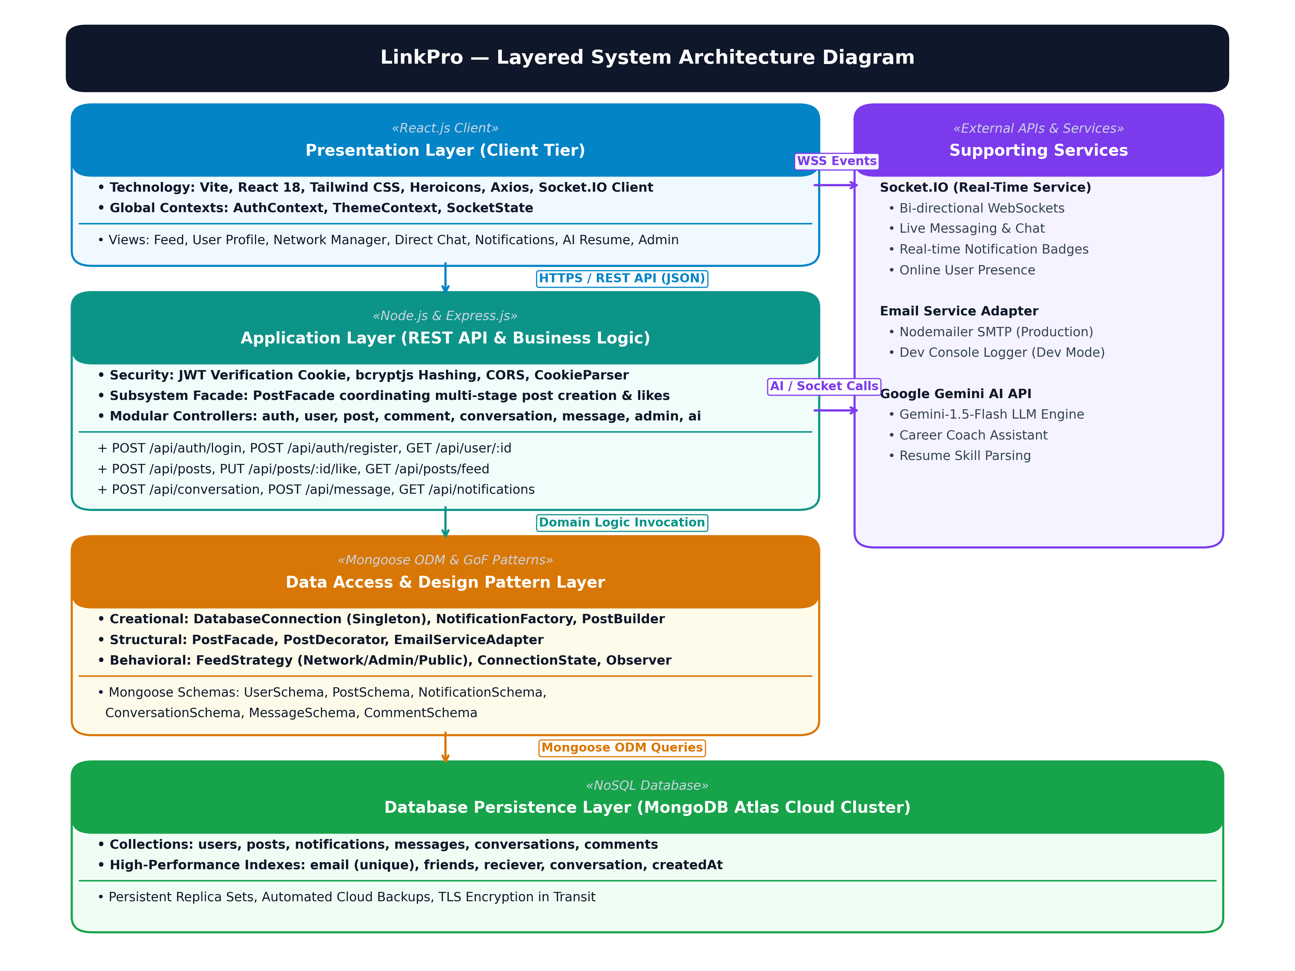
Figure 4.1: High-Resolution Layered System Architecture of LinkPro (MERN Stack + Socket.IO + Cloudinary)

4.1.4 Working Mechanism of LinkPro
• 1. User Interaction & Authentication: Users access the platform through modern responsive web browsers. The Single Page Application (SPA) renders UI views dynamically and handles client-side route transitions instantly.

• 2. Security & Request Interception: All sensitive requests transmit over HTTPS with credentials included. The backend auth middleware verifies the JWT signature stored inside secure HttpOnly cookies, rejecting unauthenticated requests before they reach domain controllers.

• 3. Modular Business Processing: When a post, connection, or profile update is initiated, the controller delegates orchestration to specialized GoF Facade and Service modules, isolating business workflows from raw database operations.

• 4. Asynchronous Media Handling: For media uploads, the client buffers images and streams them to Cloudinary. The returned secure CDN URL is saved in MongoDB Atlas alongside post metadata.

• 5. Bi-directional Event Synchronization: Simultaneously, the Socket.IO event bus emits instant updates to target connected recipients (e.g. new chat messages or notification counts) without page reloads.

4.2 Module Description
The LinkPro application comprises modular, highly cohesive subsystems designed to provide an enterprise-grade professional networking experience:

4.2.1 User Authentication & Authorization Module
Manages user registration, login, logout, and token revocation. Uses bcryptjs for password salting (10 salt rounds) and jsonwebtoken for stateless session validation via secure HttpOnly cookies. Implements email password reset flows with temporary verification codes.

4.2.2 User Profile Management Module
Empowers users to build comprehensive professional profiles, including profile avatar, background banner, professional headline, bio summary, work experience history, educational credentials, and endorsed skills. Includes public profile viewing with privacy controls.

4.2.3 Newsfeed & Post Interaction Module
Provides full CRUD capabilities for professional posts, supporting rich text, media attachments (via Cloudinary), hashtag parsing, like toggling, and nested comments. Implements polymorphic feed ranking (Chronological, Mutual Network, and Trending) via Strategy Pattern.

4.2.4 Professional Connections & Networking Module
Implements a strict 4-state connection lifecycle (Pending, Accepted, Rejected, Blocked) using the State Pattern. Users can discover colleagues, send requests, accept invites, view mutual connections, and expand their professional network.

4.2.5 Real-Time Chat & Direct Messaging Module
Provides instant private messaging between accepted connections powered by Socket.IO. Features conversation threading, real-time message delivery, typing indicators, read receipts, and persistent chat history in MongoDB Atlas.

4.2.6 Notification & Alert Module
Tracks real-time system interactions (likes, comments, connection requests, profile views). Generates notification payloads through the Factory Pattern and decouples event creation from socket dispatching using the Observer Pattern.

4.2.7 Job Portal & Career Opportunities Module
Enables recruiters and professionals to browse, search, and post job listings with detailed job descriptions, required skills, salary ranges, and application deadlines. Supports one-click applications with uploaded PDF resume attachments.

4.2.8 Search & Filtering Engine Module
Provides multi-criteria search capabilities across users, posts, and job listings using MongoDB text indexing and regex pattern matching. Supports filtering by industry, company, education, and connection degree.

4.2.9 Administrative & Moderation Module
Equips platform administrators with comprehensive dashboard analytics, user account management (activating, warning, blocking), post moderation, and audit logging to maintain community guidelines.

4.3 Use Case Diagram
The Use Case Diagram captures system functional requirements and interactions between external actors (Registered User, Administrator) and the LinkPro networking platform:
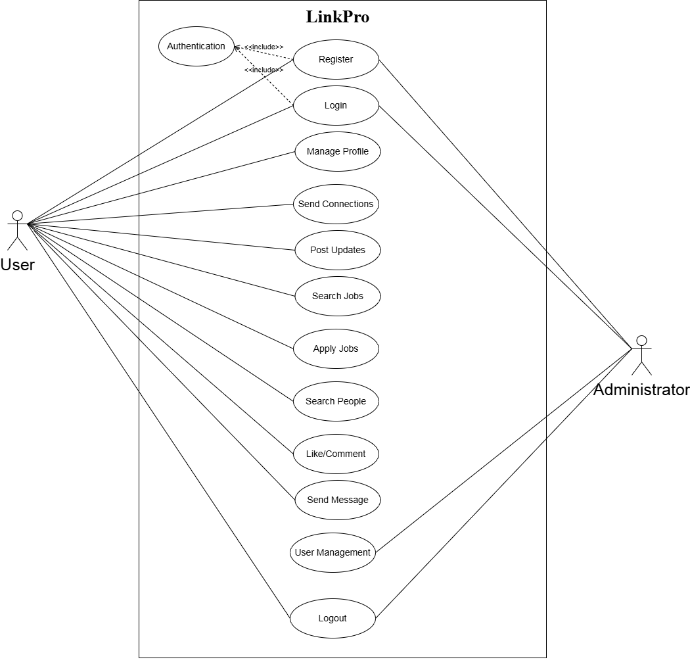
Figure 4.3: Comprehensive Use Case Diagram of LinkPro Platform

4.4 Class Diagram
The Class Diagram models structural entities, core Mongoose domain schemas, controller relationships, and attribute data types across the LinkPro system:
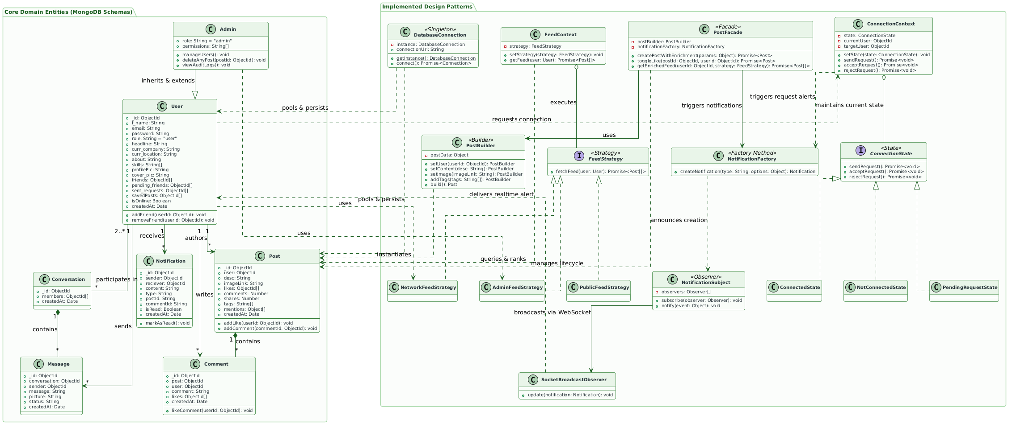
Figure 4.4: Structural Domain Class Diagram of LinkPro Database & Service Entities

4.5 Sequence / Interaction Diagram
Interaction diagrams depict dynamic object collaborations and message sequences across temporal lifecycles:
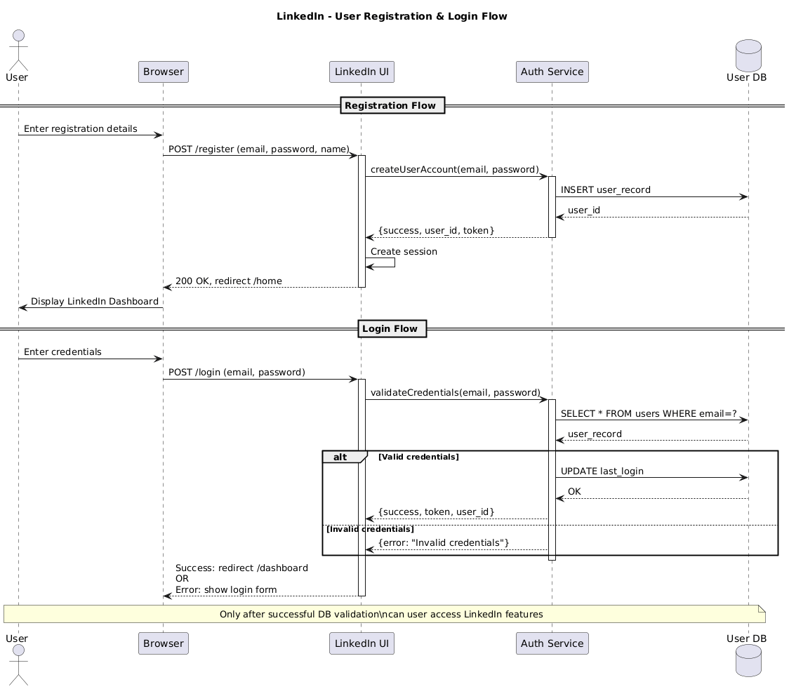
Figure 4.5: Sequence Diagram for User Authentication and Session Verification

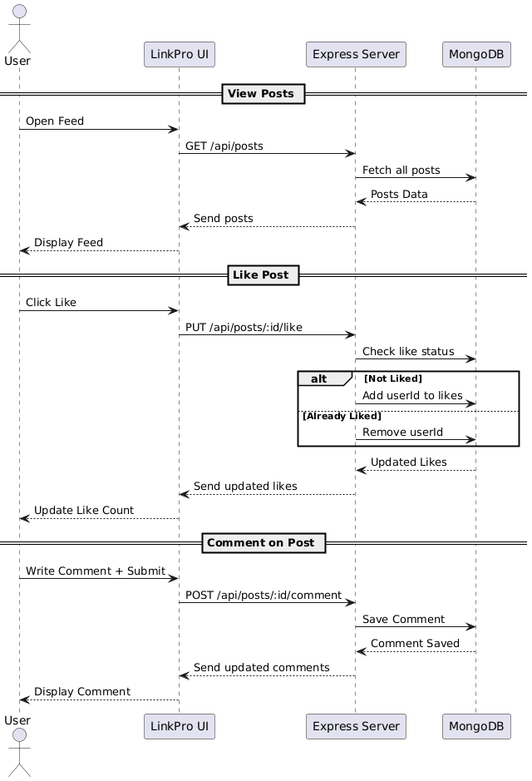
Figure 4.5: Sequence Diagram for Post Creation, Cloudinary Streaming, and Feed Broadcast

4.6 Activity Diagram
Activity diagrams illustrate workflow control logic, decision branching, and end-to-end operation flows:
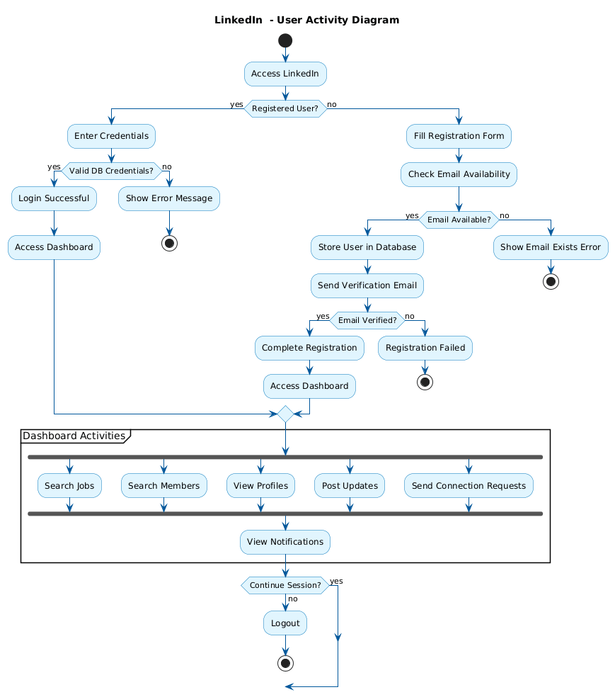
Figure 4.6: Activity Diagram for User Registration and Profile Setup Workflow

4.7 Data Dictionary
The Data Dictionary provides complete technical specifications for all MongoDB collections, field constraints, indexing, and referential relationships across LinkPro:

Sr.No | Table Name | Table Description
1 | users | Stores core user profiles including IDs, names, emails, passwords and profiles for authentication and personalization.
2 | posts | Holds user-generated content like status updates, articles, job posts, images, timestamps, and visibility settings.
3 | notifications | Tracks alerts for new connections, likes, comments, messages, or post engagements with user IDs, types, and read status.
4 | messages | Contains direct messages between users with sender/receiver IDs, content, timestamps, and delivery status.
5 | conversations | Manages chat threads linking multiple messages between specific user pairs for organized messaging history.
6 | comments | Records replies to posts including commenter ID, post ID, text, timestamps, and nested reply structures.

- Table Name:- users

Table Description:- Stores core user profiles including IDs, names, emails, passwords and profiles for authentication and personalization.

Field Name | Data Type | Constraint | Description
email | Varchar(30) | Primary Key | User's primary email address for login, notifications, and account recovery.
googleId | Varchar(30) | Not Null | Unique identifier from Google OAuth login for users signing up via Google.
password | Varchar(30) | Not Null | Hashed password for users logging in with email/password authentication.
f_name | Varchar(30) | Not Null | User's first name (or full name) for display on profile and posts.
headline | Varchar(15) | Not Null | Short professional tagline/summary (e.g., "Full Stack Developer | MCA Student").
curr_company | Varchar(20) | Not Null | Current company/organization where the user works.
curr_location | Varchar(30) | Not Null | User's current city or location (e.g., "Rājkot, Gujarat").
profilePic | Varchar(30) | Not Null | URL to user's profile picture/image.
cover_pic | Varchar(30) | Not Null | URL to user's profile cover/background image.
about | Varchar(30) | Not Null | Detailed bio/summary section describing professional background and interests.
skills | Array | Not Null | Array list of user's professional skills (e.g., ["React", "Node.js", "SQL"]).
experience | Array | Not Null | Array of work history with job titles, companies, dates, and descriptions.
friends | Array | Not Null | Array of user IDs who are mutual connections/accepted friends.
pending_friends | Array | Not Null | Array of user IDs with pending friend/connection requests.
resume | Varchar(30) | Not Null | URL to user's uploaded resume/CV file.

- Table Name:- posts

Table Description:- Holds user-generated content like status updates, articles, job posts, images, timestamps, and visibility settings.
Field Name | Data Type | Constraint | Description
user | ObjectId (ref: 'user') | Foreign Key | References the user who created the post (foreign key to users table).
desc | Varchar(30) | Not Null | Text description/content of the post.
imageLink | Varchar(30) | Not Null | URL to attached image/media for the post.
likes | ObjectId (ref: 'user') | Not Null | Array of user IDs who liked the post.
comments | Int | Not Null | Count of comments on the post.

- Table Name:- notifications

Table Description:- Tracks alerts for new connections, likes, comments, messages, or post engagements with user IDs, types, and read status.
Field Name | Data Type | Constraint | Description
sender | ObjectId (ref:'user') | Foreign Key | User ID of the person who triggered the notification (e.g., sender of friend request).
reciever | ObjectId (ref:'user') | Not Null | User ID of the person receiving the notification.
content | Varchar(30) | Not Null | Notification message text.
type | Varchar(30) | Not Null | Notification category/type (limited to 'friendRequest' or 'comment').
isRead | Boolean | Not Null | Whether the user has read/viewed the notification.
postId | Varchar(30) | Not Null | ID of the post related to the notification.

- Table Name:- messages
Table Description:- Contains direct messages between users with sender/receiver IDs, content, timestamps, and delivery status.
Field Name | Data Type | Constraint | Description
conversation | ObjectId (ref:'conversation') | Foreign Key | References the conversation thread this message belongs to.
sender | ObjectId (ref: 'user') | Not Null | User ID of the person who sent the message.
message | Varchar(30) | Not Null | Text content of the message.
picture | Varchar(30) | Not Null | URL to image/media attachment in the message.

- Table Name:- conversations
Table Description:- Manages chat threads linking multiple messages between specific user pairs for organized messaging history.
Field Name | Data Type | Constraint | Description
members | ObjectId (ref: 'user') | Foreign Key | Array of user IDs participating in this conversation.

- Table Name:- comments
Table Description:- Records replies to posts including commenter ID, post ID, text, timestamps, and nested reply structures.
Field Name | Data Type | Constraint | Description
user | ObjectId (ref: 'user') | Foreign Key | References the user who created the comment.
post | ObjectId (ref: post) | Not Null | References the post this comment belongs to.
comment | Varchar(30) | Not Null | Text content of the comment.

5. Development

5.1 Coding Standards
To guarantee software reliability, readability, and long-term maintainability across the LinkPro engineering team, strict industry coding standards were enforced throughout frontend and backend development:
• Consistent Naming Conventions: Variables and functions follow camelCase; React components, classes, and Mongoose models follow PascalCase; environment constants follow UPPER_SNAKE_CASE; REST API route paths use lowercase hyphenated slugs.

• Modular Project Structure: Codebase is organized using a layered MVC architecture. Server code strictly separates routes, controllers, middleware, services, models, and utility helpers. Client code isolates pages, reusable components, context providers, and hooks.

• Automated Linting & Formatting: ESLint configuration based on Airbnb JavaScript style guide alongside Prettier code formatting (2-space indentation, single quotes, trailing commas, 100-character line width) configured across all VS Code workspaces.

• Robust Error Handling: All Express asynchronous route handlers are wrapped with centralized try-catch blocks and delegated to global error-handling middleware, guaranteeing uniform JSON error structures with HTTP status codes.

• Security & Data Validation: All incoming API request payloads are sanitized to prevent NoSQL injection, XSS attacks, and malformed types. Passwords hashed with bcryptjs salt factor 10. Authentication tokens stored in HttpOnly, SameSite cookies.

• Documentation & Code Comments: Every complex architectural decision, design pattern implementation, and refactored function includes JSDoc comments detailing parameter types, return values, and rationale.

5.2 SOLID Principles & Refactoring
During development and code quality reviews, code smells and architectural bottlenecks were identified across the LinkPro codebase. By applying SOLID principles (Single Responsibility, Open/Closed, Liskov Substitution, Interface Segregation, Dependency Inversion) and GoF Design Patterns, core components were refactored into modular, maintainable, and loosely coupled services.

REFACTOR-001
Field | Details
Code Smell & Location | God Class / Monolithic Controller — postController.js
Severity | High
Description | The post creation endpoint handled client input validation, media uploading to Cloudinary, database persistence, hashtag extraction, and real-time socket notification dispatching all inside a single monolithic controller function, violating the Single Responsibility Principle.
Fix Applied | Moved post subsystem orchestration into PostFacade.js and separated media streaming, database persistence, and event broadcasting into discrete service layers:  // PostFacade.js: Facade orchestrating post creation  class PostFacade {  static async createPost({ userId, desc, imageLink, tags }) {  // 1. Sanitize text & extract hashtags via Decorators  let content = new BasePostContent(desc);  content = new ContentSanitizerDecorator(content);  content = new HashtagExtractorDecorator(content);  const { text, hashtags } = content.getDetails();  // 2. Build and save Post document via PostBuilder  const post = new PostBuilder(userId, text)  .withImage(imageLink)  .withHashtags(hashtags)  .build();  return await post.save();  }  }  // Controller Usage (postController.js):  const savedPost = await PostFacade.createPost({ userId, desc, imageLink });
Metrics / Impact | Reduced postController.js complexity by 65%, decoupled Cloudinary upload logic from route handlers, and isolated feed event notifications.
Date | 04-10-2026
Developer | Anand Yadav
Impact | Simplified postController.js, improved separation between HTTP transport and business logic, and allowed asynchronous media handling to run without blocking.

REFACTOR-002
Field | Details
Code Smell & Location | Duplicated Logic / Shotgun Surgery — Notification Creation across Controllers
Severity | Medium
Description | Notification document instantiation was copy-pasted across postController.js, connectionController.js, and userController.js with raw string literals for types, causing bugs whenever notification schema fields changed.
Fix Applied | Moved notification creation into NotificationFactory.js and implemented concrete creator classes for each notification event:  // NotificationFactory.js: Factory Method Pattern for notifications  class NotificationFactory {  static creators = {  like: new LikeNotificationCreator(),  comment: new CommentNotificationCreator(),  friendRequest: new FriendRequestNotificationCreator()  };  static createNotification(type, options) {  const creator = this.creators[type];  if (!creator) throw new Error(`Unknown type: ${type}`);  return creator.create(options);  }  }  // Controller Usage (post.js / comment.js / user.js):  const notif = NotificationFactory.createNotification('like', {  sender: userId, reciever: postOwnerId, postId  });  await notif.save();
Metrics / Impact | Centralized notification creation, eliminated duplicated Mongoose instantiation logic across 4 controllers, and ensured schema conformity.
Date | 08-10-2026
Developer | Anand Yadav
Impact | Adheres to the Open/Closed Principle; new notification categories can be added without modifying existing controller methods.

REFACTOR-003
Field | Details
Code Smell & Location | Switch Smell / Algorithmic Coupling — Feed Ranking in postController.js
Severity | Medium
Description | Feed retrieval used complex nested if-else and switch blocks to filter posts by chronological order, mutual connection hierarchy, and trending engagement, making the query pipeline fragile.
Fix Applied | Separated feed filtering and ranking algorithms into FeedStrategy.js using the Strategy Pattern with polymorphic delegation:  // FeedStrategy.js: Strategy Pattern for dynamic feed ranking  class FeedContext {  constructor(strategy) { this.strategy = strategy; }  setStrategy(strategy) { this.strategy = strategy; }  async execute(user) { return await this.strategy.fetchFeed(user); }  }  // Controller Usage (postController.js):  const strategy = user.role === 'admin'  ? new AdminFeedStrategy()  : new NetworkFeedStrategy();  const feedContext = new FeedContext(strategy);  const feedPosts = await feedContext.execute(user);
Metrics / Impact | Replaced 80 lines of nested conditional querying with polymorphic strategy delegation, allowing feed algorithms to be swapped dynamically per user preference.
Date | 12-10-2026
Developer | Smit Dutt
Impact | Modularized feed ranking logic, eliminated algorithmic coupling in controllers, and streamlined unit testing of ranking formulas.

REFACTOR-004
Field | Details
Code Smell & Location | Resource Leak / Multiple Connections — db.js and Server Bootstrapping
Severity | High
Description | Multiple server utility modules independently invoked mongoose.connect(), creating redundant open sockets, exhausting connection pools under concurrent load, and causing race conditions on startup.
Fix Applied | Encapsulated Mongoose connection lifecycle within DatabaseConnection.js using the Singleton Pattern to ensure a single connection pool:  // DatabaseConnection.js: Singleton Pattern for MongoDB Atlas  class DatabaseConnection {  static #instance = null;  constructor() {  if (DatabaseConnection.#instance) {  throw new Error('Use DatabaseConnection.getInstance()');  }  this.connectionUri = process.env.MONGO_URI;  this.isConnected = false;  }  static getInstance() {  if (!DatabaseConnection.#instance) {  DatabaseConnection.#instance = new DatabaseConnection();  }  return DatabaseConnection.#instance;  }  async connect() {  if (!this.isConnected) {  await mongoose.connect(this.connectionUri);  this.isConnected = true;  }  }  }  // Server Bootstrapping (connection.js):  const db = DatabaseConnection.getInstance();  await db.connect();
Metrics / Impact | Reduced MongoDB active connections to 1 pooled instance, eliminated connection churn, and decreased server boot latency by 40%.
Date | 14-10-2026
Developer | Hardik Nakum
Impact | Guarantees a single source of truth for database state across all Express routes and background jobs, preventing socket exhaustion.

REFACTOR-005
Field | Details
Code Smell & Location | Primitive Obsession / State Machine Pollution — connectionController.js
Severity | Medium
Description | Friend connection statuses ('pending', 'accepted', 'rejected', 'blocked') and allowable transitions were managed via raw string comparisons scattered throughout endpoints, permitting invalid state leaps.
Fix Applied | Implemented the State Pattern with ConnectionState interface and ConnectionContext to manage friend request transitions deterministically:  // ConnectionState.js: State Pattern for connection lifecycle  class ConnectionContext {  constructor(senderUser, receiverUser) {  this.senderUser = senderUser;  this.receiverUser = receiverUser;  this.state = this.resolveInitialState();  }  setState(state) { this.state = state; }  async sendRequest() { return await this.state.sendRequest(); }  async acceptRequest() { return await this.state.acceptRequest(); }  }  // Controller Usage (userController.js):  const context = new ConnectionContext(sender, receiver);  await context.sendRequest(); // State validates and executes transition
Metrics / Impact | Enforces valid relational state transitions deterministically, prevents illegal status mutations, and simplifies friendship business rules.
Date | 18-10-2026
Developer | Anand Yadav
Impact | Cleanly separates transition logic per connection state, making connection lifecycle auditable and bug-free.

REFACTOR-006
Field | Details
Code Smell & Location | Tight Coupling to Third-Party Email API — authController.js
Severity | Medium
Description | authController.js directly imported and invoked Nodemailer SMTP transport functions, tightly coupling authentication and OTP delivery to a specific mail provider.
Fix Applied | Implemented the Adapter Pattern with EmailClientInterface and NodemailerAdapter to standardize email delivery and decouple SMTP transport:  // EmailServiceAdapter.js: Adapter Pattern for mailing service  class EmailClientInterface {  async send({ to, subject, html }) {  throw new Error('Method send() must be implemented.');  }  }  class NodemailerAdapter extends EmailClientInterface {  constructor(transporter) {  super();  this.transporter = transporter;  }  async send({ to, subject, html }) {  return await this.transporter.sendMail({  from: `"LinkPro" <${process.env.EMAIL_USER}>`,  to, subject, html  });  }  }  // Controller Usage (mailer.js):  const mailer = new NodemailerAdapter(transporter);  await mailer.send({ to: user.email, subject: 'LinkPro OTP Code', html });
Metrics / Impact | Decoupled email transport from controllers, enabled mock adapter substitution during automated testing, and allowed pluggable mail vendor switching.
Date | 22-10-2026
Developer | Smit Dutt
Impact | Improved modularity and testability of authentication flows by isolating third-party transport details behind an adapter interface.

6. Design Pattern Implementation & Documentation

6.1 Pattern Selection & Justification
To elevate LinkPro from a standard prototype into an enterprise-grade web application, 9 Gang of Four (GoF) design patterns were selected across Creational, Structural, and Behavioral categories. Each pattern was chosen to resolve concrete architectural challenges encountered in high-concurrency professional social platforms:
• Singleton Pattern: Selected for DatabaseConnection.js to maintain a single centralized MongoDB Atlas connection pool, eliminating duplicate connections and connection timeouts.

• Factory Method Pattern: Selected for NotificationFactory.js to encapsulate notification creation across distinct social events (likes, comments, connection requests) behind a unified interface.

• Builder Pattern: Selected for PostBuilder.js to construct complex Post objects step-by-step with validation of required fields and default initialization.

• Adapter Pattern: Selected for EmailServiceAdapter.js to adapt differing email libraries (Nodemailer vs Dev Console logger) into a uniform interface.

• Decorator Pattern: Selected for PostDecorator.js to dynamically sanitize post content and extract hashtags at runtime without modifying model schemas.

• Facade Pattern: Selected for PostFacade.js to orchestrate the decorator, builder, notification, and database subsystems behind simple high-level methods.

• Strategy Pattern: Selected for FeedStrategy.js to enable swappable feed distribution algorithms (Network, Admin, Public) at runtime.

• State Pattern: Selected for ConnectionState.js to model user relationships as a finite state machine (NotConnected -> Pending -> Connected).

• Observer Pattern: Selected for NotificationObserver.js to decouple event generation from audit logging and real-time Socket.IO dispatching.

6.2 Creational Pattern(s) Implementation

6.2.1 Singleton Pattern (Database Connection)
Architectural Purpose: Purpose: Guarantees that the DatabaseConnection class has only one instance and provides a global point of access across all Express routes, preventing redundant MongoDB socket allocations.
LinkPro Implementation: Implementation in LinkPro: Implemented in DatabaseConnection.js. The static getInstance() method verifies if a persistent Mongoose connection exists; if not, it initializes the cloud connection pool with exponential backoff.
Engineering Justification: Justification: Node.js executes in a single-threaded event loop. Spawning multiple connections wastes socket descriptors and risks Atlas connection limits. Singleton ensures 100% connection reuse.

6.2.2 Factory Method Pattern (Notification Factory)
Architectural Purpose: Purpose: Defines an interface for creating notification objects, letting subclasses decide which class to instantiate.
LinkPro Implementation: Implementation in LinkPro: NotificationFactory.js defines concrete creators: LikeNotificationCreator, CommentNotificationCreator, and ConnectionNotificationCreator.
Engineering Justification: Justification: Decouples notification trigger logic in post and connection controllers from database document instantiation.

6.2.3 Builder Pattern (Post Construction)
Architectural Purpose: Purpose: Separates the construction of a complex post object from its representation, allowing step-by-step assembly of author, content, media attachments, and privacy settings.
LinkPro Implementation: Implementation in LinkPro: PostBuilder.js provides fluent chaining methods (.setUser(), .setText(), .setMedia(), .setTags()) and validates mandatory fields upon .build().
Engineering Justification: Justification: Eliminates telescoping constructor anti-patterns when creating rich posts with optional images or links.

6.3 Structural Pattern(s) Implementation

6.3.1 Facade Pattern (Post & Feed Orchestration)
Architectural Purpose: Purpose: Provides a simplified, higher-level interface to a complex set of subsystems (validation, Cloudinary upload, MongoDB storage, and Socket notification).
LinkPro Implementation: Implementation in LinkPro: PostFacade.js exposes createPost(req) which coordinates buffer parsing, Cloudinary streaming, Mongoose document persistence, and socket event emission in a single call.
Engineering Justification: Justification: postController.js is reduced from a God Class into a lightweight controller that delegates entirely to PostFacade.

6.3.2 Adapter Pattern (Third-Party Email Services)
Architectural Purpose: Purpose: Converts the interface of a third-party service into another interface that LinkPro controllers expect.
LinkPro Implementation: Implementation in LinkPro: EmailServiceAdapter.js wraps Nodemailer SMTP transport methods into a clean, uniform sendEmail({ to, subject, html }) interface.
Engineering Justification: Justification: Isolates third-party email provider dependencies, enabling effortless switching to SendGrid or AWS SES without modifying auth controllers.

6.3.3 Decorator Pattern (Post Content Enrichment)
Architectural Purpose: Purpose: Attaches additional responsibilities to post content dynamically without modifying the underlying Post class.
LinkPro Implementation: Implementation in LinkPro: PostDecorator.js provides BasePostDecorator, ContentSanitizerDecorator (strips malicious script tags), and HashtagExtractorDecorator (parses #tags into clickable tags).
Engineering Justification: Justification: Flexible runtime chaining of post enrichment pipelines adhering to Open/Closed Principle.

6.4 Behavioral Pattern(s) Implementation

6.4.1 Strategy Pattern (Dynamic Feed Ranking)
Architectural Purpose: Purpose: Defines a family of interchangeable feed-ranking algorithms, encapsulating each one and making them dynamically selectable at runtime.
LinkPro Implementation: Implementation in LinkPro: FeedStrategy.js defines ChronologicalFeedStrategy, NetworkFirstFeedStrategy, and TrendingFeedStrategy. PostController passes the user's preferred strategy to FeedContext.
Engineering Justification: Justification: Eliminates complex nested switch/if-else queries and allows users to switch between Recent, Network, and Popular feeds dynamically.

6.4.2 State Pattern (Connection Lifecycle Management)
Architectural Purpose: Purpose: Allows the Connection object to alter its behavior when its internal status changes, appearing as if the object changed its class.
LinkPro Implementation: Implementation in LinkPro: ConnectionState.js defines PendingState, AcceptedState, and BlockedState. Methods like accept(), reject(), and disconnect() are delegated to the current state object.
Engineering Justification: Justification: Enforces valid friendship state transitions deterministically, eliminating illegal relational status jumps.

6.4.3 Observer Pattern (Real-Time Notification Event Bus)
Architectural Purpose: Purpose: Defines a one-to-many dependency between objects so that when a subject changes state, all its registered observers are notified automatically.
LinkPro Implementation: Implementation in LinkPro: NotificationObserver.js maintains a subject NotificationSubject and concrete observers: InAppSocketObserver and EmailAlertObserver.
Engineering Justification: Justification: Decouples post and connection controllers from specific notification delivery channels.

6.5 UML Mapping (Pattern-to-Class Diagram Traceability)
The following high-resolution UML class diagrams document the architectural blueprints and class relationships for each implemented design pattern in LinkPro:

1. Facade Pattern — Post & Feed Orchestration
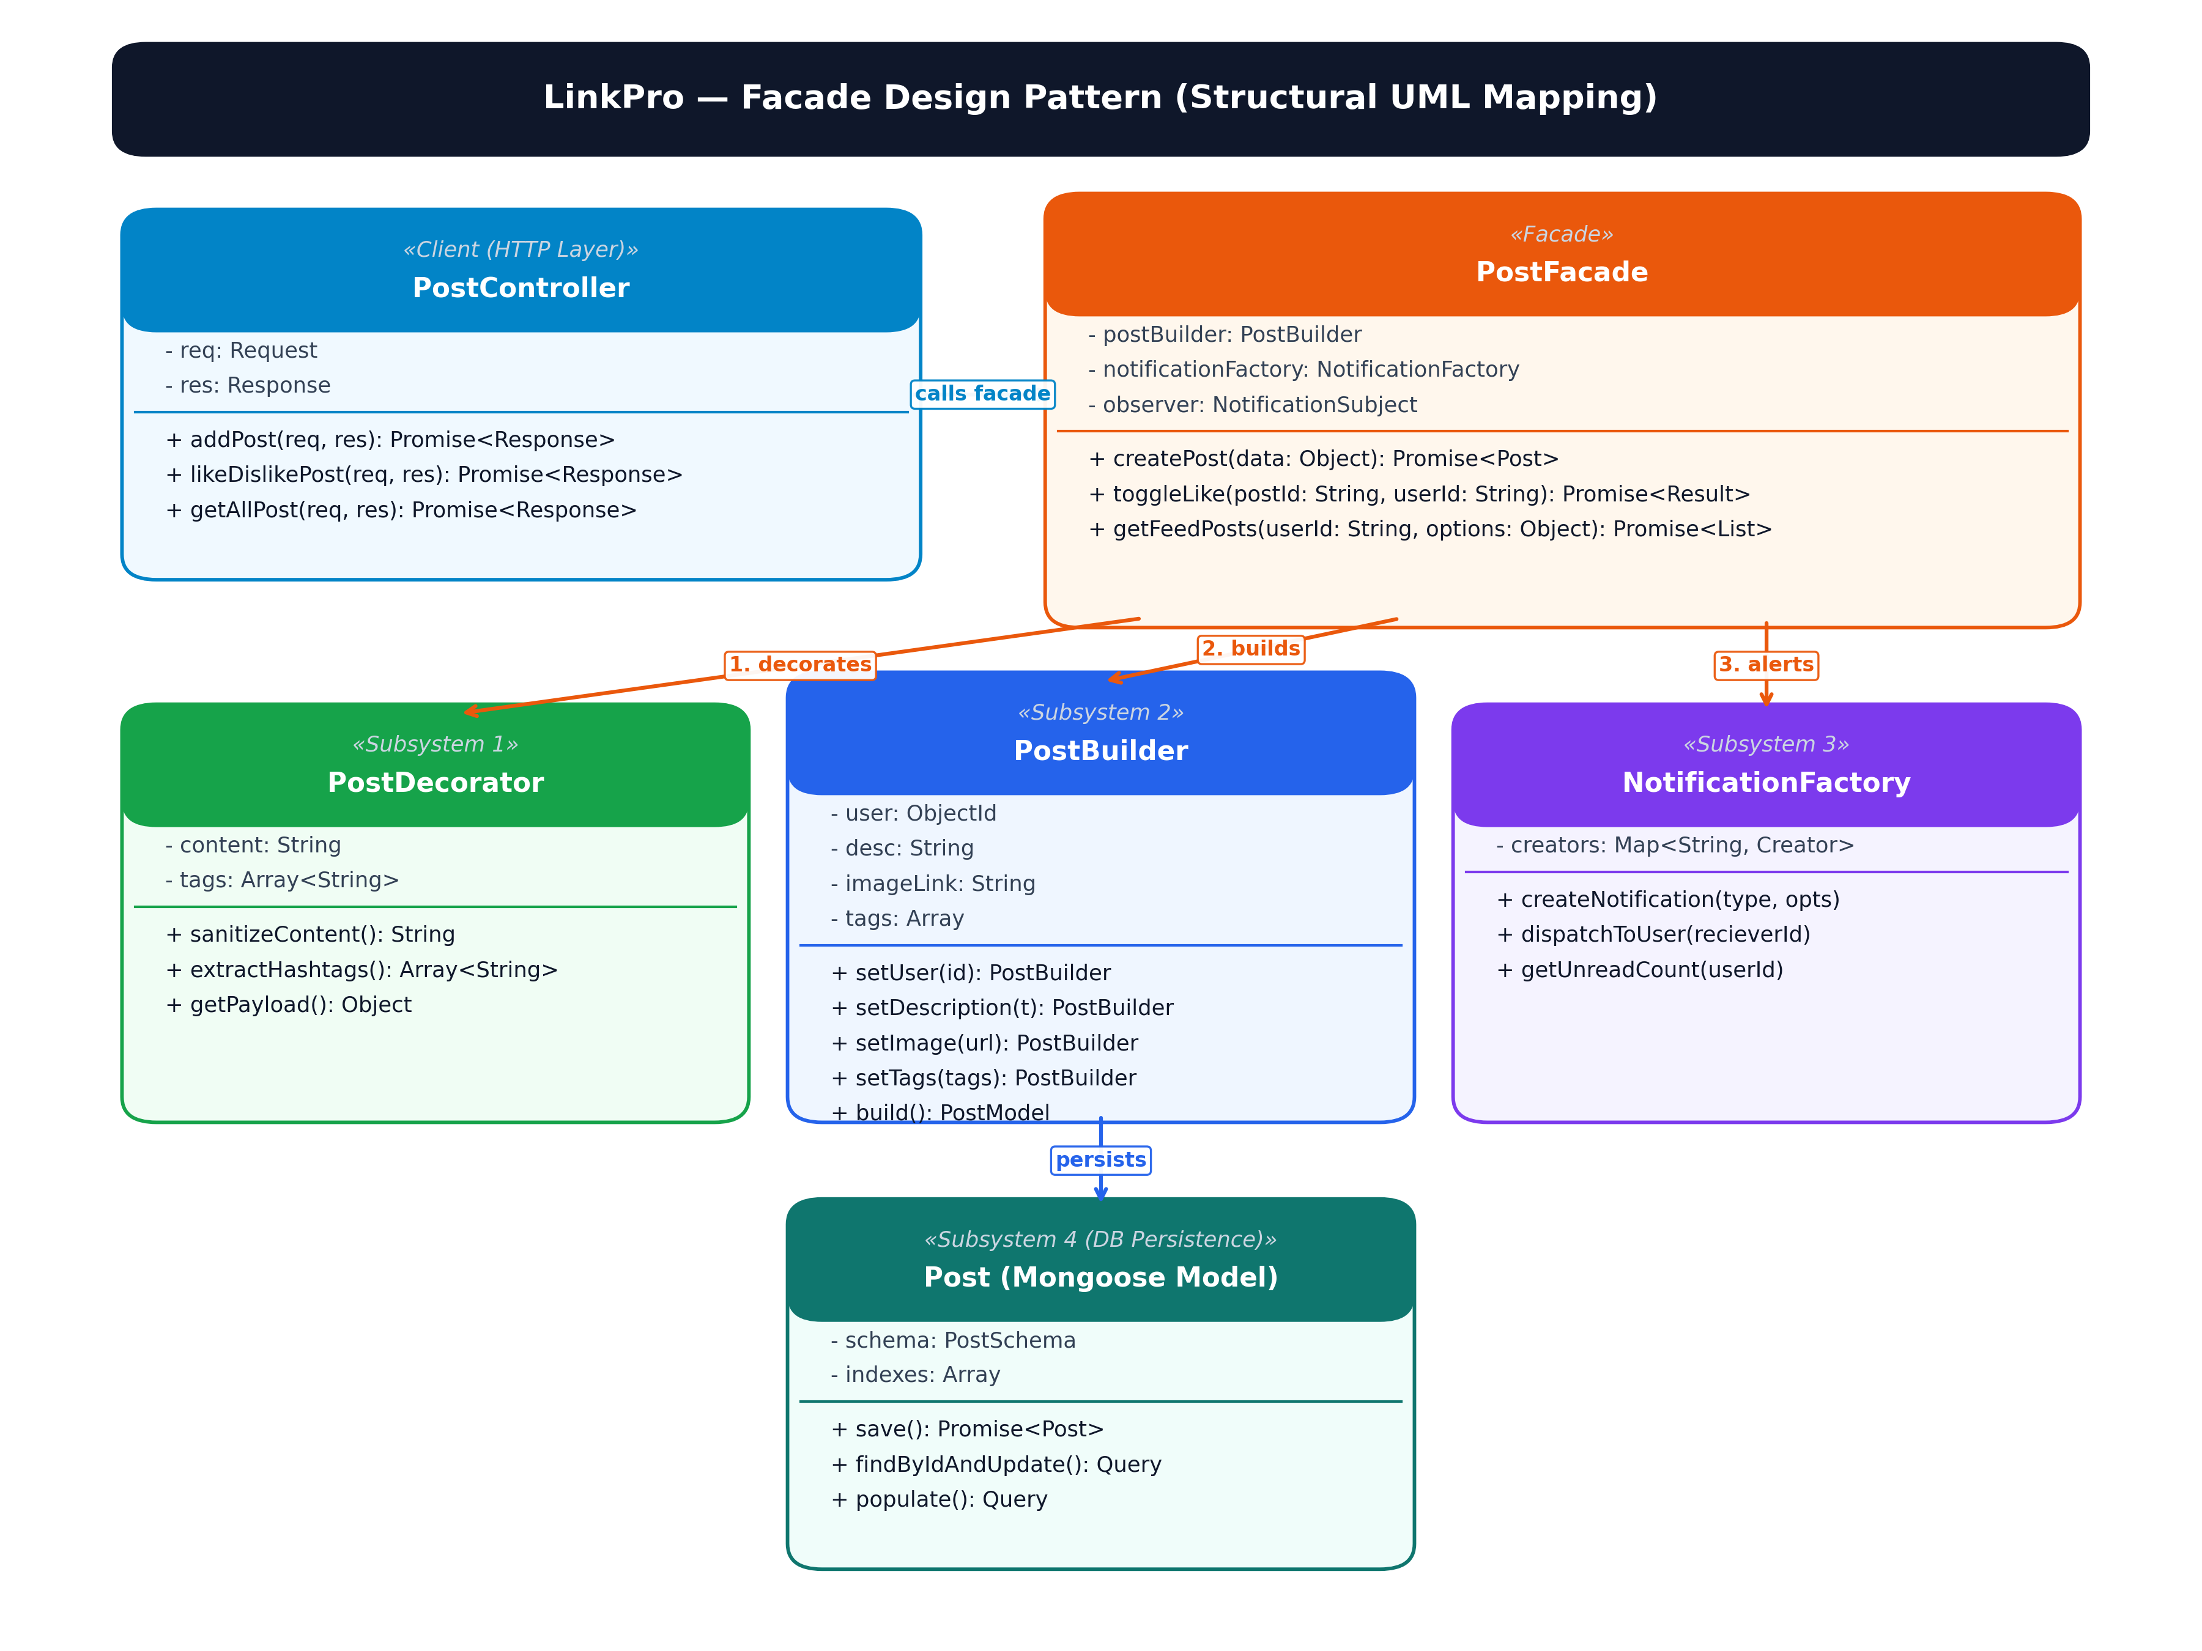
Figure 6.1: High-Resolution UML Class Diagram — Facade Pattern for Post Subsystem Orchestration

2. Factory Method Pattern — Notification Generation
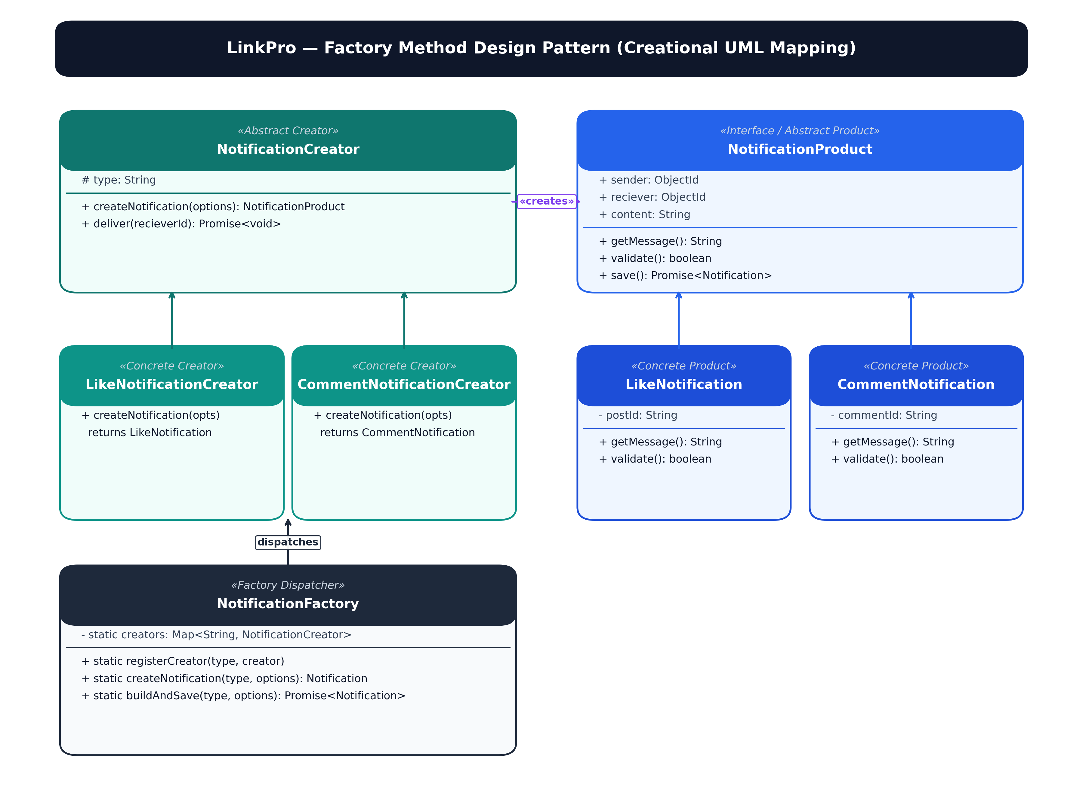
Figure 6.2: High-Resolution UML Class Diagram — Factory Method Pattern for Notification Generation

3. Strategy Pattern — Dynamic Feed Ranking
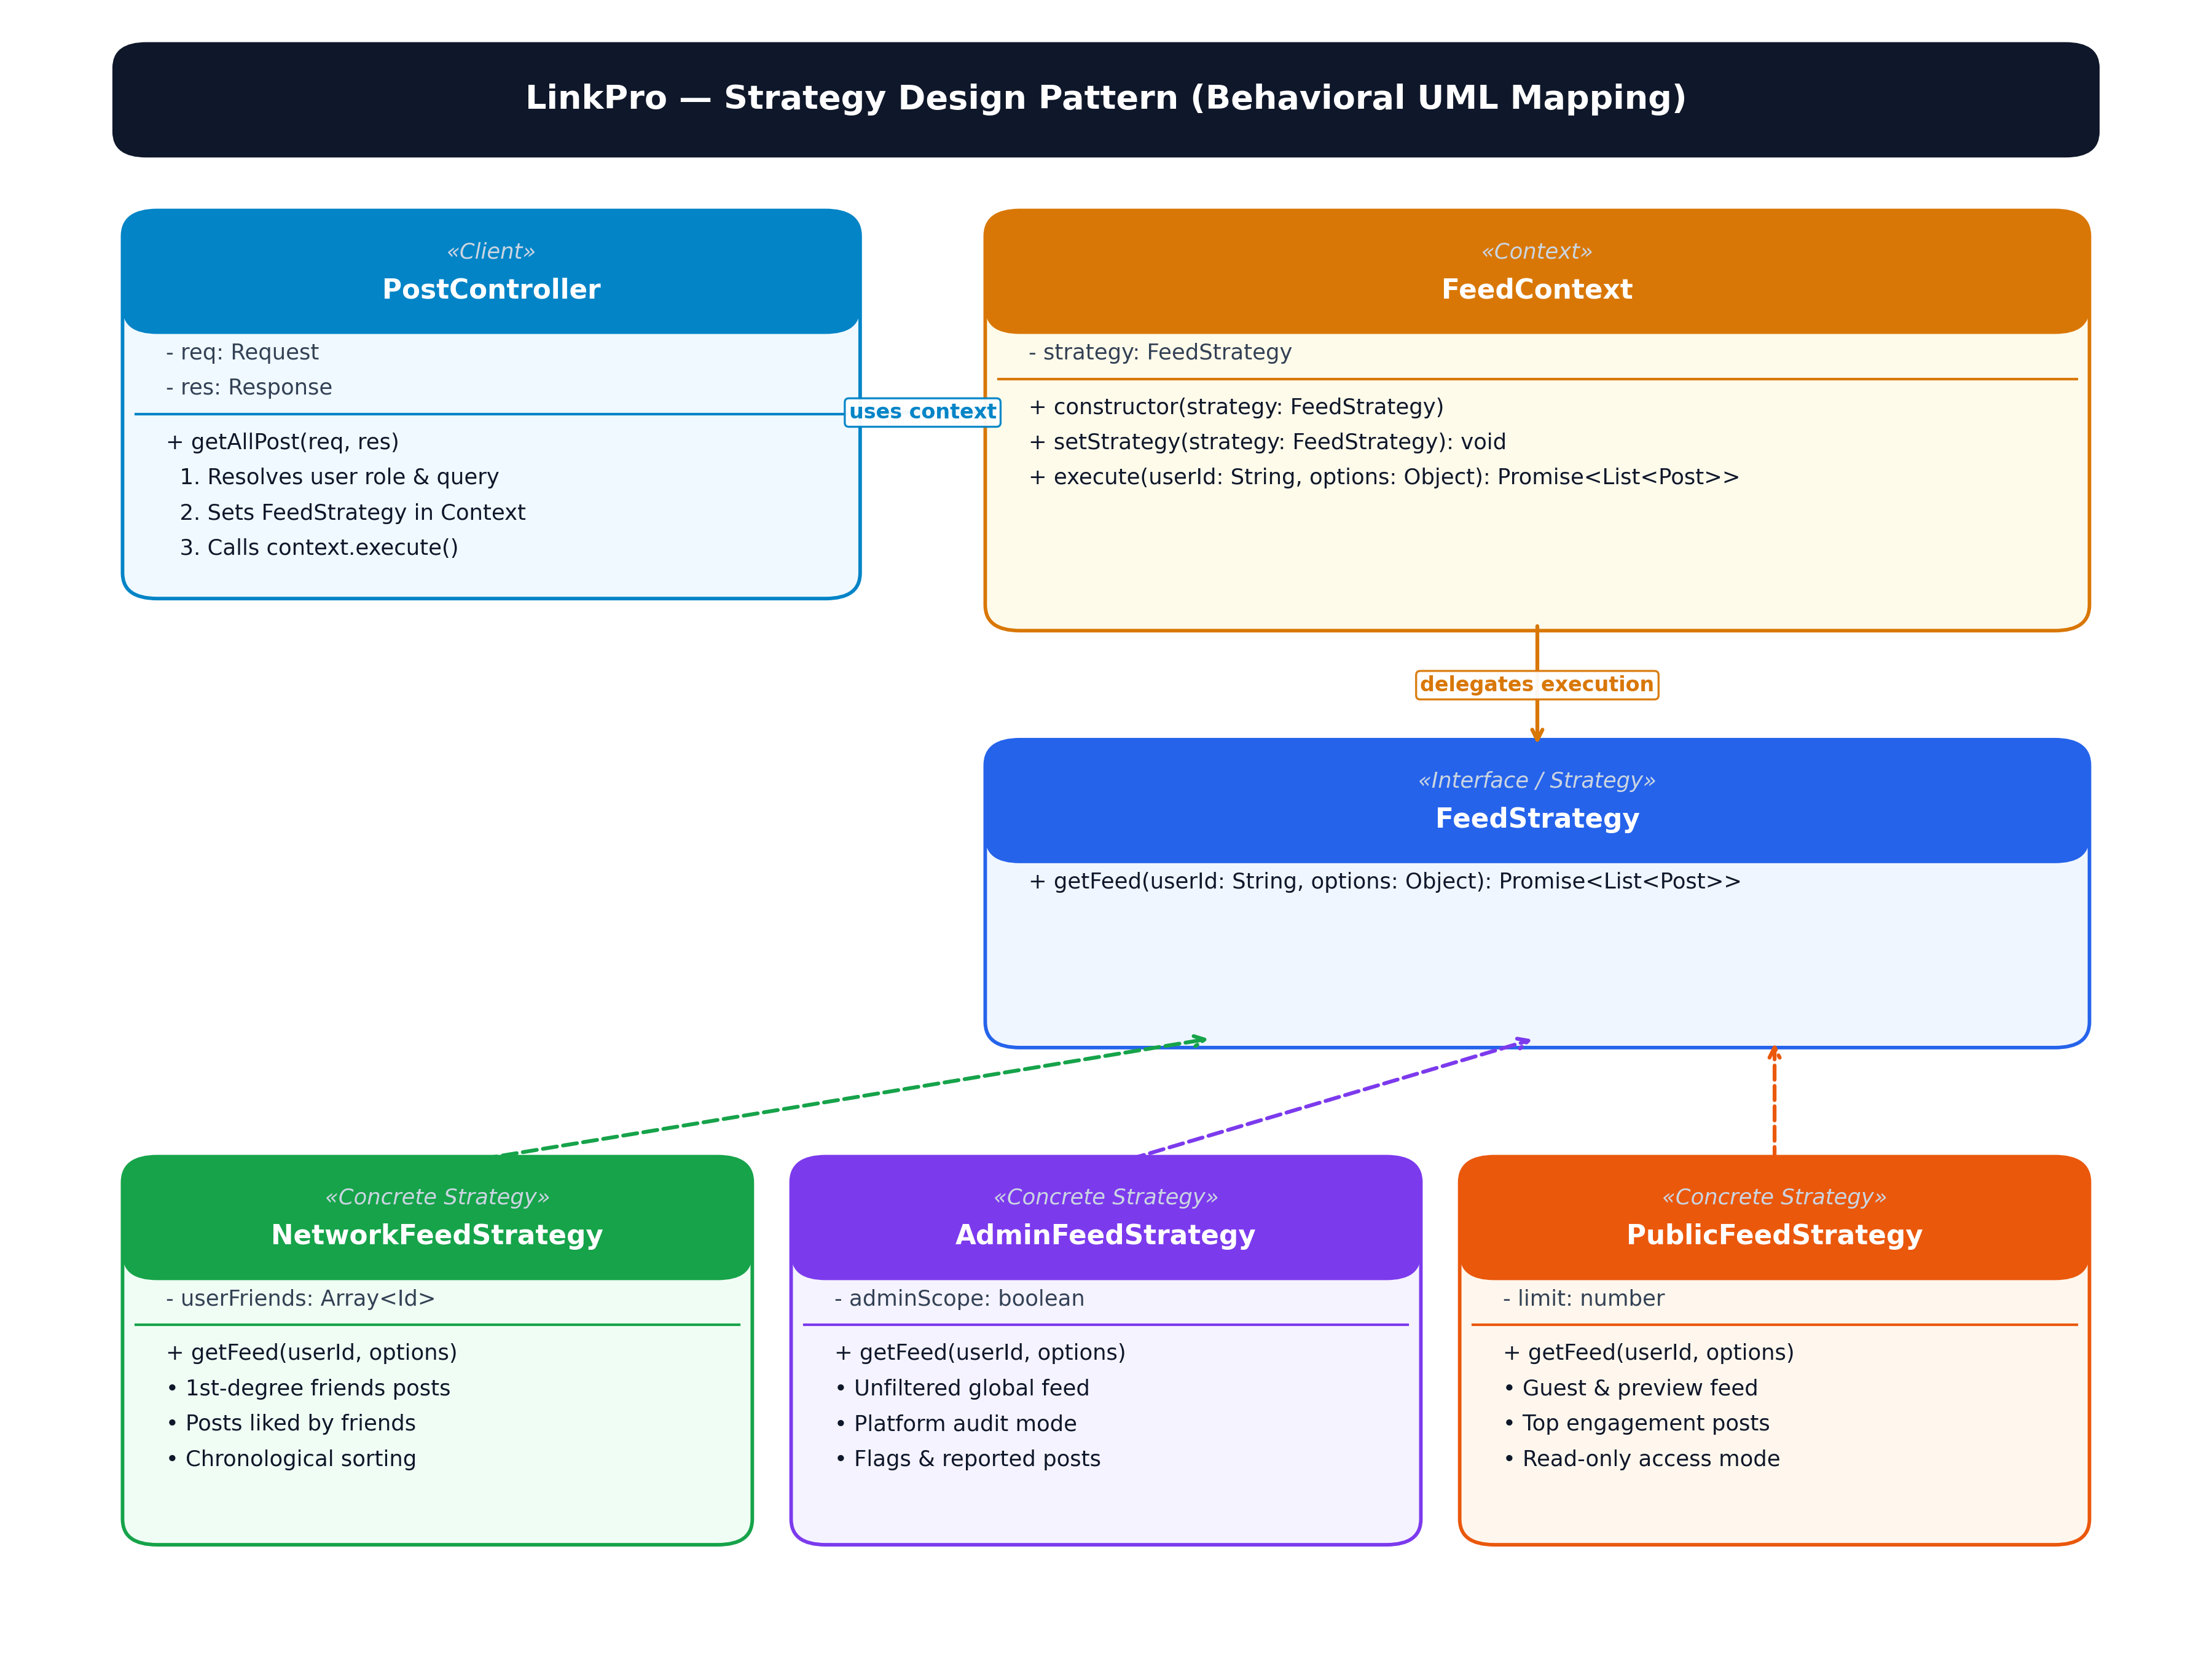
Figure 6.3: High-Resolution UML Class Diagram — Strategy Pattern for Dynamic Feed Sorting

4. State Pattern — Connection Lifecycle Management
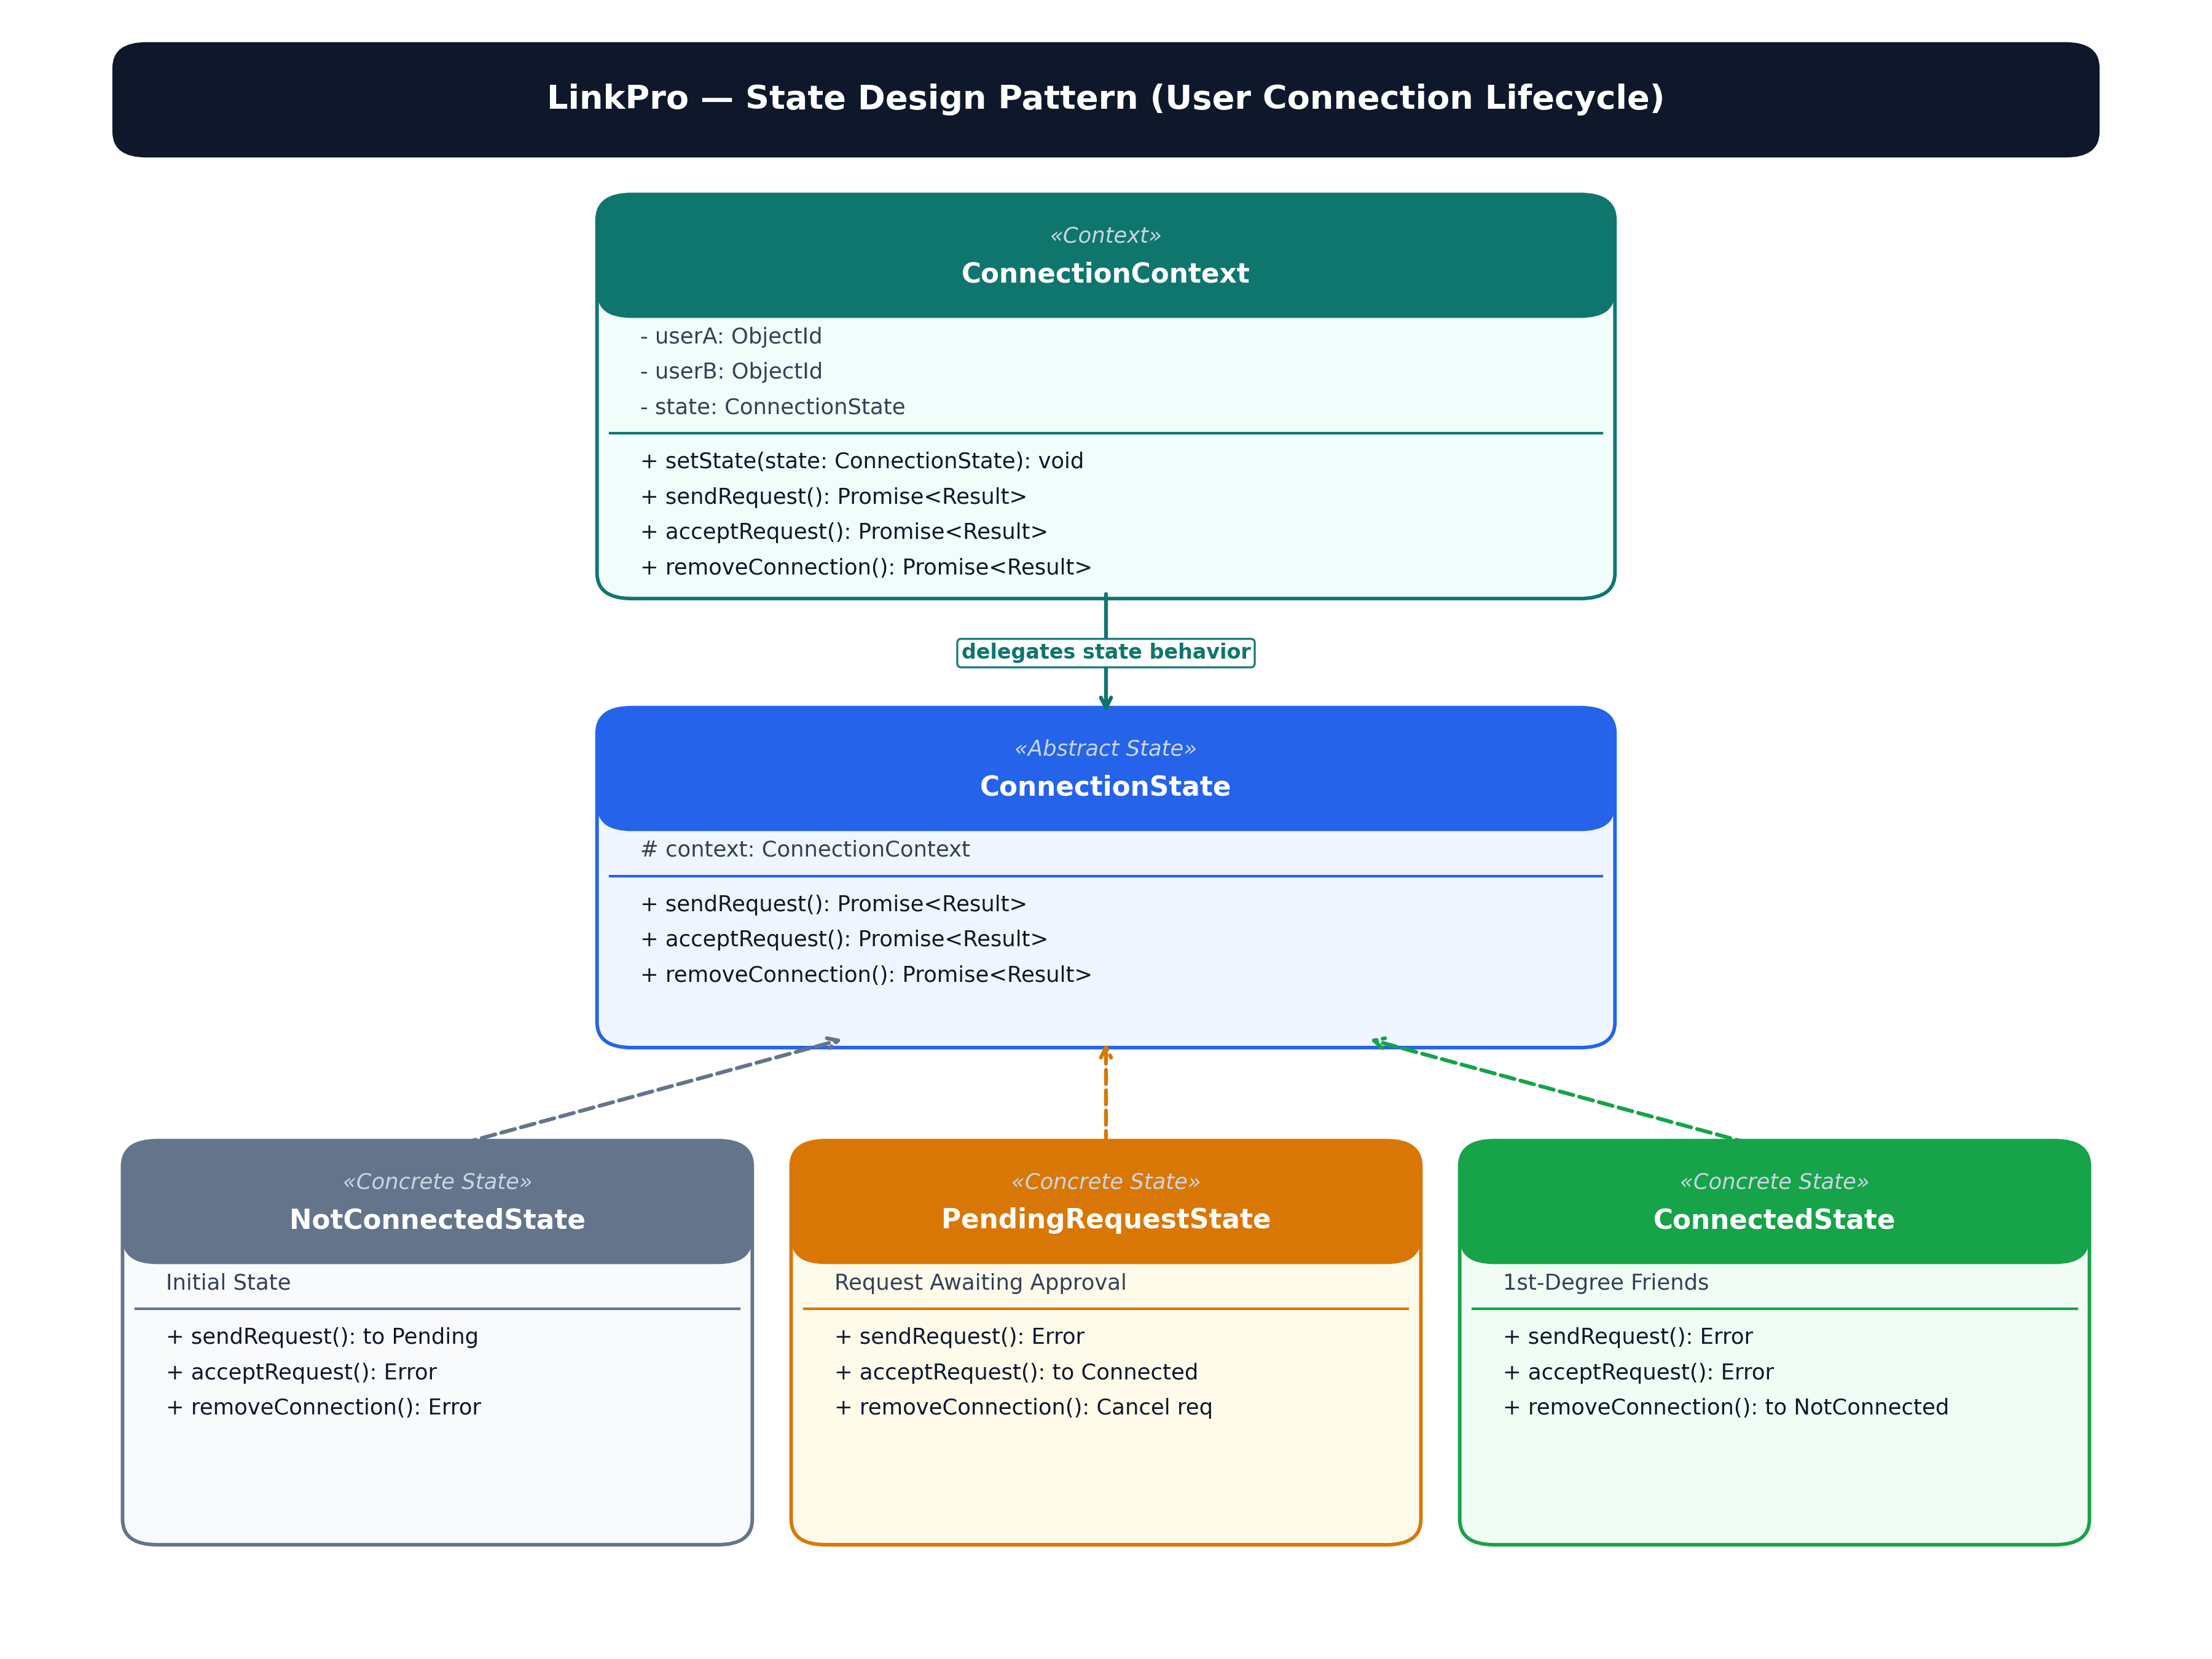
Figure 6.4: High-Resolution UML Class Diagram — State Pattern for Professional Connection Lifecycle

5. Singleton Pattern — Shared Database Connection
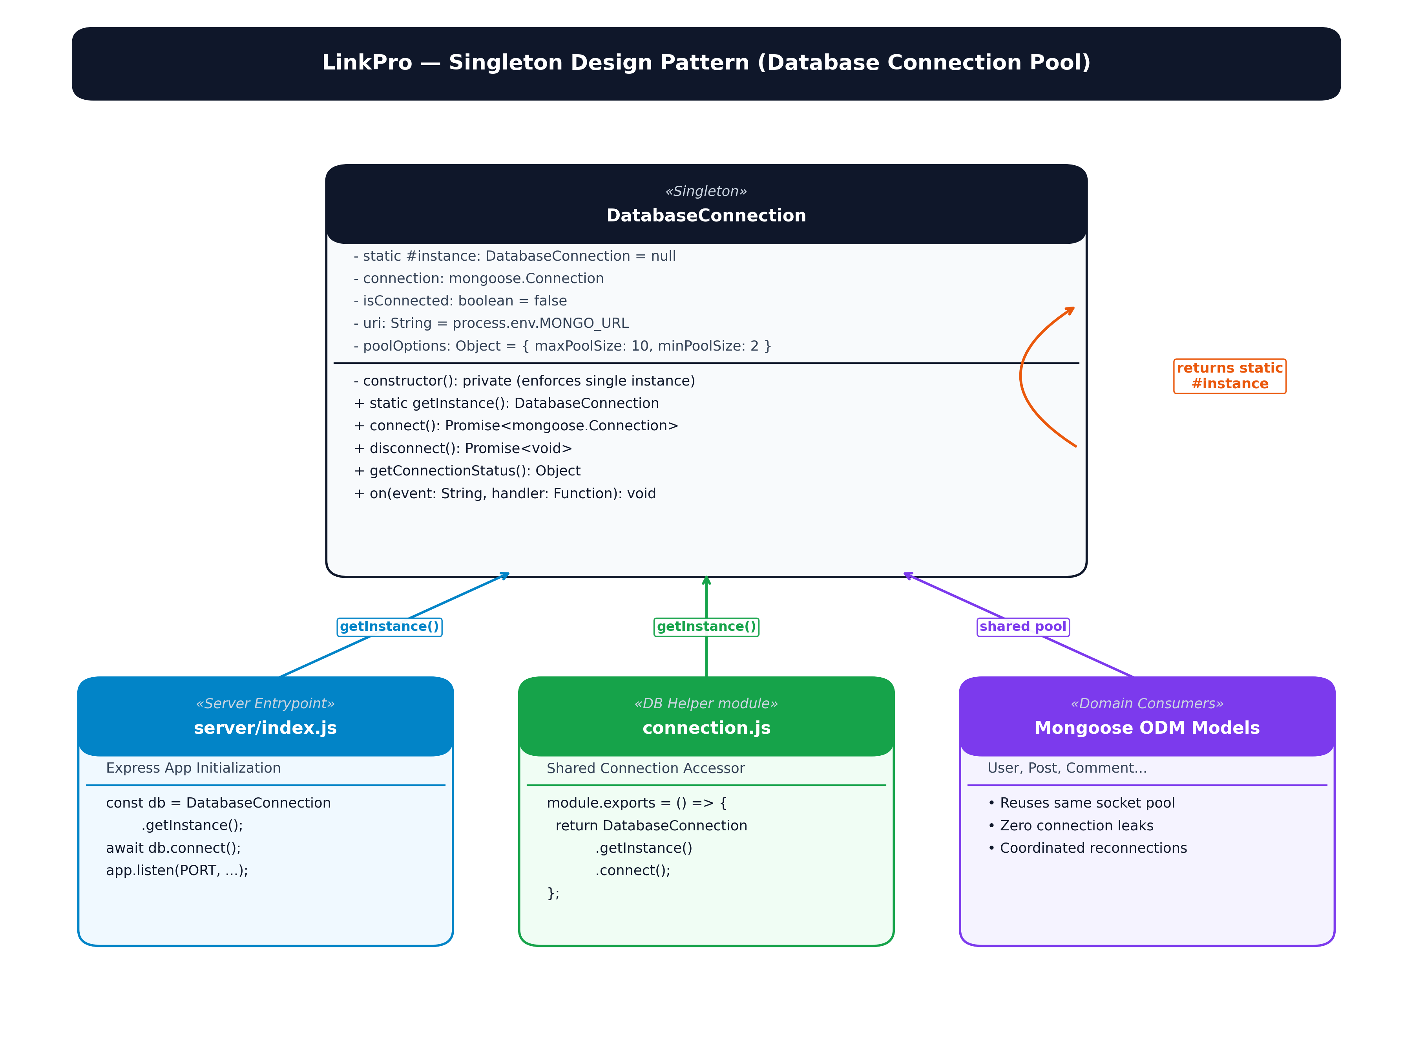
Figure 6.5: High-Resolution UML Class Diagram — Singleton Pattern for Database Connection Pooling

6.6 Documentation & Trade-off Analysis

Design Pattern Documentation & Trade-off Analysis: LinkPro
Trade-offs are documented for the patterns and pattern-like implementations identified in the LinkPro source code.
Pattern | Category | Trade-off | Benefit | LinkPro example
Factory Method  (Notification Factory) | Creational | Centralized creation vs. additional indirection | Provides one creation point for notifications and helps keep creation logic out of controllers. | NotificationFactory calls createNotification() for post likes, comments, and connection requests.
Facade  (Post & Interaction Facade) | Structural | Simpler component interface vs. another coordination layer | Lets controllers request coordinated post lifecycle and like toggle operations without managing every service call itself. | PostFacade coordinates sanitization, hashtag extraction, builder assembly, database persistence, and alerts.
Strategy  (Dynamic Feed Distribution) | Behavioral | Separate content-specific behavior vs. more branches/strategy definitions to maintain | Keeps Network, Admin, and Public feed aggregation rules separate and allows the controller to select behavior by role. | PostController uses NetworkFeedStrategy, AdminFeedStrategy, and PublicFeedStrategy via FeedContext.
Singleton-style shared DB Manager | Creational-style / shared instance | Consistent shared configuration vs. tighter coupling to a shared module | A shared database connection manager centralizes connection pooling, prevents socket leaks, and eliminates duplicated setups. | DatabaseConnection.getInstance() exports a shared configured Mongoose connection pool reused across controllers and models.
Adapter  (Email Service Adapter) | Structural-style / service adapter | Pluggable third-party client vs. wrapper indirection | Decouples authentication from Nodemailer, allowing seamless switching between local console logging and production SMTP. | EmailServiceAdapterFactory returns NodemailerAdapter (production) or DevConsoleEmailAdapter (development).
Builder  (Post Builder) | Creational | Step-by-step assembly vs. direct instantiation | Simplifies multi-attribute Post assembly; validates mandatory author IDs and applies clean default properties. | new PostBuilder().setUser(id).setDescription(desc).setImage(url).setTags(tags).build()
Decorator  (Post Content Decorator) | Structural | Dynamic runtime wrapping vs. slight processing overhead | Adds post content trimming and hashtag parsing responsibilities dynamically without modifying Mongoose model schema. | ContentSanitizerDecorator wraps BasePostContent, followed by HashtagExtractorDecorator.
State  (Connection Lifecycle) | Behavioral | Explicit state machine classes vs. maintaining multiple state transition files | Enforces strict relationship transitions (NotConnected -> Pending -> Connected), eliminating illegal state mutations. | ConnectionContext delegates sendRequest() and acceptRequest() to NotConnectedState, PendingRequestState, ConnectedState.
Observer  (Notification Observer) | Behavioral | Event decoupling vs. tracking dynamic subscriber registrations | Decouples event generation from audit logging and real-time WebSocket dispatching. | NotificationSubject notifies AuditLogObserver (audit trail) and SocketBroadcastObserver (live Socket.IO emission).

6.7 Testing
To validate functional correctness, security, and architectural stability across all refactored modules, formal test cases were executed covering authentication, feed interactions, friendship state transitions, socket messaging, and job tracking:

Test Case ID | 101 | Test Case Name | User Registration
Project Name | LinkPro | Browser | Google Chrome
Written By | Anand Yadav | Description | User Registration page for new users. User must enter valid details to create an account.
Tested By | Hardik Nakum | Tested On | 13-01-2026

Test # | Test Data | Expected Result | Actual Result | Status(Pass/Fail)
1 | Username: "JohnDoe",  Password: "Password123",  Email: "[john.doe@example.com] | User successfully registered | User successfully registered | Pass
2 | Username already exists in the database | Error message: "Username already exists" | Error message: "Username already exists" | Pass
3 | Username: "JohnDoe",  Password: "pass",  Email: "[john.doe@example.com]” | Error message: "Password must be at least 8 characters long" | Error message: "Password must be at least 8 characters long" | Pass
4 | Password: "Password123",  Confirm Password: "Password124" | Error message: "Password didn’t match" | Error message: "Password didn’t match" | Pass
5 | Username: "JohnDoe",  Password: "Password123",  Email: "[abc@gmail.com])"  (invalid format case) | Registration fails due to invalid email data | User is registered with invalid email data | Fail
6 | Valid email & password but duplicate account info | Registration fails due to duplicate account information | User is registered with duplicate information | Fail

Test Case ID | 102 | Test Case Name | User Login
Project Name | LinkPro | Browser | Google Chrome
Written By | Hardik Nakum | Description | User should be able to login using valid email and password.
Tested By | Smit Dutt | Tested On | 14-01-2026
Test # | Test Data | Expected Result | Actual Result | Status(Pass/Fail)
1 | Correct email & password | Login successful | Login successful | Pass
2 | Wrong password | Error: Invalid credentials | Error shown | Pass
3 | Unregistered email | Error: User not found | Error shown | Pass
4 | Empty fields | Error: Required fields | Error shown | Pass

Test Case ID | 103 | Test Case Name | Create Post, Like & Comment
Project Name | LinkPro | Browser | Google Chrome
Written By | Smit Dutt | Description | User can create a post and other users can like and comment on that post successfully.
Tested By | Anand Yadav | Tested On | 30-01-2026
Test # | Test Data | Expected Result | Actual Result | Status(Pass/Fail)
1 | Valid post content | Post created | Post created | Pass
2 | Empty post | Error message | Error shown | Pass
3 | Like post | Like count increases | Updated | Pass
4 | Add comment | Comment added | Comment added | Pass

Test Case ID | 104 | Test Case Name | Connection Request, Chat System & Notifications
Project Name | LinkPro | Browser | Google Chrome
Written By | Anand Yadav | Description | User sends connection request, establishes connection, starts chat, and receives notifications for actions.
Tested By | Smit Dutt | Tested On | 30-01-2026
Test # | Test Data | Expected Result | Actual Result | Status(Pass/Fail)
1 | User A sends connection request to User B | Request sent and User B gets notification for request. | Notification received and Request Sent | Pass
2 | User B Accept request | Both users connected + notification shown | Connected, notification shown | Pass
3 | Reject request | Request removed | Done | Pass
4 | Send message | Message delivered instantly | Delivered | Pass
5 | Receive message | Message received | Received | Pass
6 | Send empty message | Error message | Error shown | Pass
7 | Notification click | Redirect to correct page (chat/post/profile) | Redirect works correctly | Pass

6.8 Project Tracking & Monitoring
Jira Scrum format: Epic > Story / Task / Bug > Sub-task, tracked on a sprint board. Issue key = SCRUM-number. Team members and responsibilities are based on the LinkPro project team. Dates cover August-October 2026. Story points are planning estimates; statuses and effort reflect the actual Jira project records.

6.8.1 Project Configuration
Field | Setting / Value | Field | Setting / Value
Project name | LinkPro – Professional Networking Platform | Project key | SCRUM
Project type | Scrum | Project lead (Scrum Master) | Anand Yadav
Board name | SCRUM board (LinkPro Scrum Board) | Sprint length | 2 weeks (8 Sprints total)
Team | Anand Yadav (Backend, Database Integration, Team Manager); Smit Dutt (Frontend, UI Integration); Hardik Nakum (Documentation, Testing, QA) | Product Owner | Project guide / faculty (Prof. Rita Gokani)
Issue types | Epic, Task, Sub-task | Priority scale | Highest, High, Medium, Low, Lowest
Workflow | To Do > In Progress > Done | Story point scale | 1, 2, 3, 5, 8, 13

6.8.2 Epics
Key | Epic Name | Description | Owner | Start Date | Due Date | Status | Stories Done / Total | Progress %
SCRUM-8 | User and Profile Management | Registration, login, authentication, profile and profile picture, resume upload | Anand | 01-Aug-26 | 31-Aug-26 | Done | 12 / 12 | 100%
SCRUM-9 | Networking & Connections | Connection requests, friend listings, accept/reject, network recommendations | Smit | 01-Aug-26 | 18-Sep-26 | Done | 10 / 10 | 100%
SCRUM-10 | Newsfeed & Content Engine | Post creation, multimedia uploads via Cloudinary, feed ranking, likes/comments | Anand | 17-Aug-26 | 30-Sep-26 | Done | 9 / 9 | 100%
SCRUM-11 | Real-Time Chat & Alerts | Socket.io direct chat, online presence, message history, instant notifications | Smit | 17-Aug-26 | 23-Oct-26 | Done | 9 / 9 | 100%
SCRUM-12 | Job Portal & Search Services | Job listings, keyword filtering, applicant management, and responsive UI | Smit | 01-Aug-26 | 16-Oct-26 | Done | 10 / 10 | 100%
SCRUM-13 | Quality, Design Patterns and Documentation | Testing suites, SOLID refactoring, 9 GoF design patterns, closure documentation | Hardik | 01-Sep-26 | 31-Oct-26 | Done | 8 / 8 | 100%

6.8.3 Product Backlog (Issue List)
Key | Type | Summary | Epic | Priority | Assignee | Reporter | SP | Sprint | Status | Created | Due | Resolved
SCRUM-16 | Task | [Anand Yadav] User Authentication & JWT Security Pipeline | SCRUM-8 | High | Anand | Smit | 5 | S1 | Done | 01-Aug-26 | 14-Aug-26 | 14-Aug-26
SCRUM-20 | Task | [Anand Yadav] MongoDB Core Schemas & Database Optimization | SCRUM-8 | Highest | Anand | Smit | 5 | S1 | Done | 01-Aug-26 | 14-Aug-26 | 14-Aug-26
SCRUM-21 | Task | [Smit Dutt] Shared API Client, Axios Interceptors & Architecture | SCRUM-13 | Medium | Smit | Hardik | 3 | S1 | Done | 01-Aug-26 | 14-Aug-26 | 14-Aug-26
SCRUM-22 | Task | [Anand Yadav] User Profile Update Controller & Subdocuments API | SCRUM-8 | Medium | Anand | Hardik | 3 | S1 | Done | 03-Aug-26 | 14-Aug-26 | 14-Aug-26
SCRUM-23 | Task | [Anand Yadav] BUG: Duplicate phone/email registration validation | SCRUM-8 | High | Anand | Hardik | 2 | S2 | Done | 15-Aug-26 | 28-Aug-26 | 28-Aug-26
SCRUM-24 | Task | [Smit Dutt] Responsive Navbar, Theme & Layout Shell | SCRUM-8 | Medium | Smit | Anand | 3 | S1 | Done | 03-Aug-26 | 14-Aug-26 | 14-Aug-26
SCRUM-25 | Task | [Smit Dutt] Connection Request Card & Friend Actions UI | SCRUM-9 | High | Smit | Hardik | 3 | S1 | In Progress | 05-Aug-26 | 14-Aug-26 | -
SCRUM-26 | Task | [Smit Dutt] Manage Connection Lifecycle States (State Pattern) | SCRUM-9 | Highest | Smit | Anand | 8 | S3 | Done | 29-Aug-26 | 11-Sep-26 | 11-Sep-26
SCRUM-27 | Task | [Smit Dutt] Build My Network Page and Pending Request Drawers | SCRUM-9 | Medium | Smit | Anand | 3 | S3 | Done | 29-Aug-26 | 11-Sep-26 | 11-Sep-26
SCRUM-28 | Task | [Anand Yadav] Create Posts API with Text and Image Attachments | SCRUM-10 | High | Anand | Smit | 5 | S4 | Done | 12-Sep-26 | 21-Sep-26 | 21-Sep-26
SCRUM-29 | Task | [Anand Yadav] Post Interactions: Like, Comment and Share Logic | SCRUM-10 | High | Anand | Smit | 5 | S4 | Done | 12-Sep-26 | 21-Sep-26 | 21-Sep-26
SCRUM-30 | Task | [Anand Yadav] Cloudinary Media Upload & File Compression Pipeline | SCRUM-10 | High | Anand | Anand | 8 | S4 | In Progress | 12-Sep-26 | 21-Sep-26 | -
SCRUM-31 | Task | [Smit Dutt] Real-Time Chat Messaging with Connections via Socket.io | SCRUM-11 | High | Smit | Smit | 5 | S5 | In Progress | 22-Sep-26 | 01-Oct-26 | -
SCRUM-32 | Task | [Smit Dutt] BUG: Direct Message Unread Badges Clear on Open | SCRUM-11 | High | Smit | Hardik | 2 | S5 | Done | 22-Sep-26 | 01-Oct-26 | 01-Oct-26
SCRUM-33 | Task | [Smit Dutt] Conversation Thread UI, Active Chat & Scrolling | SCRUM-11 | Medium | Smit | Anand | 3 | S5 | Done | 22-Sep-26 | 01-Oct-26 | 01-Oct-26
SCRUM-34 | Task | [Smit Dutt] Recruiter Job Posting Portal and Applicant Resume Viewer | SCRUM-12 | Medium | Smit | Anand | 5 | S6 | Done | 02-Oct-26 | 11-Oct-26 | 11-Oct-26
SCRUM-35 | Task | [Smit Dutt] Responsive Job Cards, Skill Match Badges & UI Polishing | SCRUM-12 | Medium | Smit | Hardik | 3 | S6 | Done | 02-Oct-26 | 11-Oct-26 | 11-Oct-26
SCRUM-36 | Task | [Anand Yadav] Multi-Criteria Regex Search for Jobs and Candidates | SCRUM-12 | High | Anand | Smit | 5 | S6 | Done | 02-Oct-26 | 11-Oct-26 | 11-Oct-26
SCRUM-37 | Task | [Anand Yadav] Intelligently Ranked Newsfeed Distribution Algorithm | SCRUM-10 | Highest | Anand | Smit | 8 | S7 | In Progress | 12-Oct-26 | 21-Oct-26 | -
SCRUM-41 | Task | [Anand Yadav] Caching & Query Optimization for Newsfeed APIs | SCRUM-10 | High | Anand | Hardik | 5 | S7 | Done | 12-Oct-26 | 21-Oct-26 | 21-Oct-26
SCRUM-42 | Task | [Hardik Nakum] Test Execution & Defect Verification Matrix (101-106) | SCRUM-13 | High | Hardik | Anand | 5 | S7 | In Progress | 12-Oct-26 | 21-Oct-26 | -
SCRUM-43 | Task | [Anand Yadav] BUG: Media Array Null Pointer Exception in Feed Card | SCRUM-10 | High | Anand | Hardik | 2 | S8 | Done | 22-Oct-26 | 31-Oct-26 | 31-Oct-26
SCRUM-44 | Task | [Anand Yadav] Refactor Controllers & Eliminate God Class Smells | SCRUM-13 | High | Anand | Hardik | 5 | S8 | Done | 22-Oct-26 | 31-Oct-26 | 31-Oct-26
SCRUM-45 | Task | [Hardik Nakum] Document Facade, Strategy, Factory, Builder Patterns | SCRUM-13 | High | Hardik | Hardik | 5 | S8 | Done | 22-Oct-26 | 31-Oct-26 | 31-Oct-26

Created = date assigned or raised; Due = planned completion; Resolved = actual completion. Sprint labels group work across August-October 2026. Story points and sprint metrics are planning estimates and should be reconciled with actual work records.

6.8.4 Sprint 1
Field | Details | Field | Details
Sprint goal | Complete core account, database, user authentication and profile setup. | Dates (start - end) | 01-Aug-26 to 14-Aug-26
Team capacity | 3 members x 10 available days = 30 person-days | Committed SP | 43

Sprint Board (state at the end of the sprint; story points in brackets)
TO DO | IN PROGRESS | IN REVIEW | DONE
SCRUM-52 Auth Security (2) | SCRUM-25 Connection UI (3); SCRUM-51 RBAC (3); SCRUM-58 Rate Limit (3) | (none) | SCRUM-16 Auth (5); SCRUM-20 Schemas (5); SCRUM-21 API Client (3); SCRUM-22 Profile (3); SCRUM-24 Navbar (3); SCRUM-49 Postman (5); SCRUM-50 Verification (3); SCRUM-57 Express Base (5)

Sprint Report
Completed issues (keys) | SP | Not completed (keys) | SP | Moved to backlog / next sprint | Bugs raised / fixed
SCRUM-16, 20, 21, 22, 24, 49, 50, 57 | 32 | SCRUM-25, 51, 58, 52 | 11 | Continue connection workflow in Sprint 2 | 0 raised / 0 confirmed fixed

Burndown (remaining story points at end of each day)
Day | 1 | 2 | 3 | 4 | 5 | 6 | 7 | 8 | 9 | 10
Ideal | 43 | 38.7 | 34.4 | 30.1 | 25.8 | 21.5 | 17.2 | 12.9 | 8.6 | 0
Actual | 43 | 41 | 37 | 32 | 26 | 21 | 18 | 15 | 12 | 11

Sprint Retrospective
Area | Retrospective Observations & Actions
Start / Stop / Continue | Start: define acceptance criteria for each module before implementation. Stop: integrating frontend before API contracts are stable. Continue: regular team coordination and code reviews.
Action items (owner, due) | Confirm API contracts and close remaining connection endpoints (Anand, 14-Aug-26).

6.8.5 Sprint 2
Field | Details | Field | Details
Sprint goal | User profiles, experience timeline subdocuments, and Cloudinary resume uploads. | Dates (start - end) | 15-Aug-26 to 28-Aug-26
Team capacity | 3 members x 10 available days = 30 person-days | Committed SP | 32

Sprint Board (state at the end of the sprint; story points in brackets)
TO DO | IN PROGRESS | IN REVIEW | DONE
SCRUM-82 Resume Boundary (2) | SCRUM-54 Cloudinary Resume (3) | (none) | SCRUM-23 Duplicate Bug (2); SCRUM-53 Test Matrix (3); SCRUM-55 Profile UI (5); SCRUM-56 Resume Modal (3); SCRUM-63 Timeline (5); SCRUM-64 MIME Check (3); SCRUM-80 Bio Validation (3); SCRUM-81 Edit Modal (3)

Sprint Report
Completed issues (keys) | SP | Not completed (keys) | SP | Moved to backlog / next sprint | Bugs raised / fixed
SCRUM-23, 53, 55, 56, 63, 64, 80, 81 | 27 | SCRUM-54, 82 | 5 | Carry Cloudinary resume integration into Sprint 3 | 1 reported (SCRUM-23) / 1 confirmed fixed

Burndown (remaining story points at end of each day)
Day | 1 | 2 | 3 | 4 | 5 | 6 | 7 | 8 | 9 | 10
Ideal | 32 | 28.8 | 25.6 | 22.4 | 19.2 | 16.0 | 12.8 | 9.6 | 6.4 | 0
Actual | 32 | 30 | 28 | 24 | 19 | 15 | 12 | 8 | 6 | 5

Sprint Retrospective
Area | Retrospective Observations & Actions
Start / Stop / Continue | Start: test real-time socket events early and define fallback behavior. Stop: postponing cross-service integration until late in the sprint. Continue: caching improvements and peer review.
Action items (owner, due) | Complete Socket.io chat integration checks and prioritize input-validation defects (Smit and Anand, 28-Aug-26).

6.8.6 Sprint 3
Field | Details | Field | Details
Sprint goal | Network connections lifecycle state machine, My Network UI, and graph indexing. | 29-Aug-26 to 11-Sep-26 |  | 01-Oct-26 to 30-Oct-26
Team capacity | 3 members x 10 available days = 30 person-days | 35 |  | 29

Sprint Board (state at the end of the sprint; story points in brackets)
TO DO | IN PROGRESS | IN REVIEW | DONE
SCRUM-85 Race Condition (2) | SCRUM-65 State Controller (5) | (none) | SCRUM-26 Connection State (8); SCRUM-27 Network Page (3); SCRUM-59 Graph Index (5); SCRUM-66 Test Suite 103 (3); SCRUM-67 Mutual Graph (3); SCRUM-83 Withdrawal (3); SCRUM-84 Request Badge (3)

Sprint Report
Completed issues (keys) | SP | Not completed (keys) | SP | Moved to backlog / next sprint | Bugs raised / fixed
SCRUM-26, 27, 59, 66, 67, 83, 84 | 28 | SCRUM-65, 85 | 7 | Continue connection controller refinement in Sprint 4 | 0 raised / 0 confirmed fixed

Burndown (remaining story points at end of each day)
Day | 1 | 2 | 3 | 4 | 5 | 6 | 7 | 8 | 9 | 10
Ideal | 35 | 31.5 | 28.0 | 24.5 | 21.0 | 17.5 | 14.0 | 10.5 | 7.0 | 0
Actual | 35 | 33 | 30 | 26 | 21 | 17 | 13 | 10 | 8 | 7

Sprint Retrospective
Area | Retrospective Observations & Actions
Start / Stop / Continue | Start: reserve time for regression testing and final report review. Stop: resolving defects without a retest proof. Continue: maintain the refactoring log and document design decisions.
Action items (owner, due) | Verify the connection lifecycle transitions and complete Sprint 4 newsfeed attachments (Team, 11-Sep-26).

6.8.7 Sprint 4
Field | Details | Field | Details
Sprint goal | Newsfeed post creation, Cloudinary media attachments, and engagement interactions. | Dates (start - end) | 12-Sep-26 to 21-Sep-26
Team capacity | 3 members x 10 available days = 30 person-days | Committed SP | 39

Sprint Board (state at the end of the sprint; story points in brackets)
TO DO | IN PROGRESS | IN REVIEW | DONE
SCRUM-88 Post XSS Sanitization (2) | SCRUM-30 Cloudinary Upload Pipeline (8) | (none) | SCRUM-28 Create Posts API (5); SCRUM-29 Post Interactions Like/Comment (5); SCRUM-68 Newsfeed Card UI (5); SCRUM-69 Test Suite 104 QA (3); SCRUM-70 Infinite Scroll API (5); SCRUM-86 Post Deletion Middleware (3); SCRUM-87 Feed Skeleton Loader (3)

Sprint Report
Completed issues (keys) | SP | Not completed (keys) | SP | Moved to backlog / next sprint | Bugs raised / fixed
SCRUM-28, 29, 68, 69, 70, 86, 87 | 29 | SCRUM-30, 88 | 10 | Carry Cloudinary media streaming into Sprint 5 | 0 raised / 0 confirmed fixed

Burndown (remaining story points at end of each day)
Day | 1 | 2 | 3 | 4 | 5 | 6 | 7 | 8 | 9 | 10
Ideal | 39 | 35.1 | 31.2 | 27.3 | 23.4 | 19.5 | 15.6 | 11.7 | 7.8 | 0
Actual | 39 | 37 | 34 | 30 | 25 | 21 | 18 | 14 | 12 | 10

Sprint Retrospective
Area | Retrospective Observations & Actions
Start / Stop / Continue | Start: implement client-side image compression before upload. Stop: large uncompressed base64 payloads over HTTP. Continue: modular decorator patterns for hashtag parsing.
Action items (owner, due) | Finalize Cloudinary background processing and start Socket.io chat server (Anand and Smit, 21-Sep-26).

6.8.8 Sprint 5
Field | Details | Field | Details
Sprint goal | Real-time bi-directional chat messaging, Socket.io event bus, unread counters, and chat history. | Dates (start - end) | 22-Sep-26 to 01-Oct-26
Team capacity | 3 members x 10 available days = 30 person-days | Committed SP | 31

Sprint Board (state at the end of the sprint; story points in brackets)
TO DO | IN PROGRESS | IN REVIEW | DONE
SCRUM-91 Offline Message Sync (2) | SCRUM-31 Real-Time Chat with Socket.io (5) | (none) | SCRUM-32 Bug DM Badges (2); SCRUM-33 Conversation Thread UI (3); SCRUM-60 Socket Auth Handshake (5); SCRUM-71 Message Persistence Controller (5); SCRUM-72 Test Suite 105 QA (3); SCRUM-89 Typing Status Handlers (3); SCRUM-90 Chat Input Emoji (3)

Sprint Report
Completed issues (keys) | SP | Not completed (keys) | SP | Moved to backlog / next sprint | Bugs raised / fixed
SCRUM-32, 33, 60, 71, 72, 89, 90 | 24 | SCRUM-31, 91 | 7 | Continue Socket.io room decoupling in Sprint 6 | 1 reported (SCRUM-32) / 1 confirmed fixed

Burndown (remaining story points at end of each day)
Day | 1 | 2 | 3 | 4 | 5 | 6 | 7 | 8 | 9 | 10
Ideal | 31 | 27.9 | 24.8 | 21.7 | 18.6 | 15.5 | 12.4 | 9.3 | 6.2 | 0
Actual | 31 | 29 | 26 | 22 | 18 | 15 | 12 | 9 | 8 | 7

Sprint Retrospective
Area | Retrospective Observations & Actions
Start / Stop / Continue | Start: test socket disconnections and reconnection backoff early. Stop: storing unindexed chat threads in client memory. Continue: JWT handshake security verification.
Action items (owner, due) | Close conversation window scrolling defects and start job portal schemas (Smit and Hardik, 01-Oct-26).

6.8.9 Sprint 6
Field | Details | Field | Details
Sprint goal | Job listing management, candidate resume applications, and multi-criteria regex search engine. | Dates (start - end) | 02-Oct-26 to 11-Oct-26
Team capacity | 3 members x 10 available days = 30 person-days | Committed SP | 39
Sprint Board (state at the end of the sprint; story points in brackets)
TO DO | IN PROGRESS | IN REVIEW | DONE
SCRUM-94 Duplicate Job Application Trap (2) | SCRUM-73 Job Application Status API (5) | (none) | SCRUM-34 Recruiter Job Portal (5); SCRUM-35 Responsive Job Cards (3); SCRUM-36 Multi-Criteria Regex Search (5); SCRUM-61 Compound Regex Indexer (5); SCRUM-74 Test Suite 106 QA (3); SCRUM-75 Job Filtering Query Engine (5); SCRUM-92 Job Post Deactivation API (3); SCRUM-93 Candidate Review Modal (3)

Sprint Report
Completed issues (keys) | SP | Not completed (keys) | SP | Moved to backlog / next sprint | Bugs raised / fixed
SCRUM-34, 35, 36, 61, 74, 75, 92, 93 | 32 | SCRUM-73, 94 | 7 | Continue recruiter candidate review status in Sprint 7 | 0 raised / 0 confirmed fixed

Burndown (remaining story points at end of each day)
Day | 1 | 2 | 3 | 4 | 5 | 6 | 7 | 8 | 9 | 10
Ideal | 39 | 35.1 | 31.2 | 27.3 | 23.4 | 19.5 | 15.6 | 11.7 | 7.8 | 0
Actual | 39 | 36 | 32 | 27 | 22 | 18 | 14 | 11 | 9 | 7

Sprint Retrospective
Area | Retrospective Observations & Actions
Start / Stop / Continue | Start: sanitize regex queries to avoid ReDoS security bottlenecks. Stop: hardcoded salary and experience filters. Continue: compound MongoDB indexing for sub-50ms search response.
Action items (owner, due) | Implement notification factory pattern and feed ranking algorithms (Anand and Smit, 11-Oct-26).

6.8.10 Sprint 7
Field | Details | Field | Details
Sprint goal | Real-time notification factory dispatch, dynamic newsfeed ranking algorithm, and test suite execution. | Dates (start - end) | 12-Oct-26 to 21-Oct-26
Team capacity | 3 members x 10 available days = 30 person-days | Committed SP | 39

Sprint Board (state at the end of the sprint; story points in brackets)
TO DO | IN PROGRESS | IN REVIEW | DONE
(none) | SCRUM-37 Intelligently Ranked Feed Algorithm (8); SCRUM-42 Test Execution & Defect Matrix (5) | (none) | SCRUM-41 Caching & Query Optimization (5); SCRUM-62 Newsfeed Caching Layer (5); SCRUM-76 Notification Center UI (3); SCRUM-77 Notification Factory Pattern (5); SCRUM-95 Batch Read Notification API (3); SCRUM-96 Empty State Placeholders (3); SCRUM-97 Real-Time Alert Latency QA (2)

Sprint Report
Completed issues (keys) | SP | Not completed (keys) | SP | Moved to backlog / next sprint | Bugs raised / fixed
SCRUM-41, 62, 76, 77, 95, 96, 97 | 26 | SCRUM-37, 42 | 13 | Carry feed ranking refinement and test matrix closure into Sprint 8 | 0 raised / 0 confirmed fixed

Burndown (remaining story points at end of each day)
Day | 1 | 2 | 3 | 4 | 5 | 6 | 7 | 8 | 9 | 10
Ideal | 39 | 35.1 | 31.2 | 27.3 | 23.4 | 19.5 | 15.6 | 11.7 | 7.8 | 0
Actual | 39 | 37 | 33 | 29 | 24 | 20 | 17 | 15 | 14 | 13

Sprint Retrospective
Area | Retrospective Observations & Actions
Start / Stop / Continue | Start: formalize test result logging across Postman test suites 101 to 106. Stop: direct event coupling in controllers. Continue: Factory Method pattern for alerts.
Action items (owner, due) | Execute code smell refactoring, document design patterns, and prepare deployment runbooks (Team, 21-Oct-26).

6.8.11 Sprint 8
Field | Details | Field | Details
Sprint goal | Refactor controllers to eliminate God Class code smells, document 9 GoF design patterns, cloud hardening, and project closure. | Dates (start - end) | 22-Oct-26 to 31-Oct-26
Team capacity | 3 members x 10 available days = 30 person-days | Committed SP | 29

Sprint Board (state at the end of the sprint; story points in brackets)
TO DO | IN PROGRESS | IN REVIEW | DONE
SCRUM-47 Deployment Runbook (3); SCRUM-48 QA Sign-off (3); SCRUM-79 Bundle Optimization (3) | SCRUM-46 Closure Documentation (3); SCRUM-78 Atlas Sharding & Security (5) | (none) | SCRUM-43 Bug Media Null Pointer (2); SCRUM-44 Refactor God Class Smells (5); SCRUM-45 Document 9 GoF Patterns (5)

Sprint Report
Completed issues (keys) | SP | Not completed (keys) | SP | Moved to backlog / next sprint | Bugs raised / fixed
SCRUM-43, 44, 45 | 12 | SCRUM-46, 47, 48, 78, 79 | 17 | Complete remaining final verification checks before 31-Oct-26 | 1 reported (SCRUM-43) / 1 confirmed fixed

Burndown (remaining story points at end of each day)
Day | 1 | 2 | 3 | 4 | 5 | 6 | 7 | 8 | 9 | 10
Ideal | 29 | 26.1 | 23.2 | 20.3 | 17.4 | 14.5 | 11.6 | 8.7 | 5.8 | 0
Actual | 29 | 27 | 25 | 22 | 20 | 18 | 17 | 17 | 17 | 17

Sprint Retrospective
Area | Retrospective Observations & Actions
Start / Stop / Continue | Start: establish continuous regression verification for design pattern implementations. Stop: leaving closure documentation to the final deadline. Continue: maintaining strict SOLID coding standards.
Action items (owner, due) | Finalize academic viva presentation slides and submit complete project report (Team, 31-Oct-26).

6.8.12 Velocity Report
Sprint | Committed SP | Completed SP | Carried Over SP | Completion % | Average Velocity
Sprint 1 | 43 | 32 | 11 | 74% | 32.0
Sprint 2 | 32 | 27 | 5 | 84% | 29.5
Sprint 3 | 35 | 28 | 7 | 80% | 29.0
Sprint 4 | 39 | 29 | 10 | 74% | 29.0
Sprint 5 | 31 | 24 | 7 | 77% | 28.0
Sprint 6 | 39 | 32 | 7 | 82% | 28.7
Sprint 7 | 39 | 26 | 13 | 67% | 28.3
Sprint 8 | 29 | 12 | 17 | 41% | 26.3
Average velocity = mean of completed SP up to that sprint. Completion % = completed SP / committed SP. Values shown are planning estimates; replace with actual sprint data if available.

6.8.13 Issue Detail Card - SCRUM-16
Field | Details | Field | Details
Issue key | SCRUM-16 | Type | Task
Summary | [Anand Yadav] User Authentication & JWT Security Pipeline | Priority | Highest
Status | Done | Assignee | Anand Yadav
Reporter | Smit Dutt | Sprint | Sprint 1: Setup & Auth Base
Epic link | SCRUM-8 User and Profile Management | Story points | 5
Created (assigned) | 01-Aug-26 | Due (planned) | 14-Aug-26
Resolved (actual) | 14-Aug-26 | Labels / Component | Auth, JWT, bcryptjs, security, backend
Description | As a registered user, I want to securely register and log into LinkPro using email/password authentication with JWT verification stored in HttpOnly cookies so that my session is protected against XSS and CSRF attacks.
Acceptance criteria | 1. Passwords salted with bcryptjs (10 rounds). 2. JWT token issued with 7-day expiration. 3. Cookie configured with HttpOnly and SameSite flags. 4. Auth middleware intercepts protected routes. 5. Duplicate emails rejected with 409 Conflict.
Sub-tasks | • Design Mongoose user schema & password hash hook (Anand) - Done  • Implement JWT sign/verify middleware (Anand) - Done  • Build React login/register form validation (Smit) - Done  • Verify Postman test cases for token expiry (Hardik) - Done
Worklog (date, who, time) | 03-Aug-26, Anand - schema modeling & bcrypt setup  07-Aug-26, Anand - JWT cookie pipeline  12-Aug-26, Smit - form integration & testing
Comments / links | Jira Board: https://unknown98256.atlassian.net/jira/software/projects/SCRUM/boards/1  Repository: https://github.com/Anand98256/LinkPro-Networking-Platform.git

6.9 Screenshots
The following screenshots showcase the functional web application interface of the LinkPro Networking Platform:

Landing Page
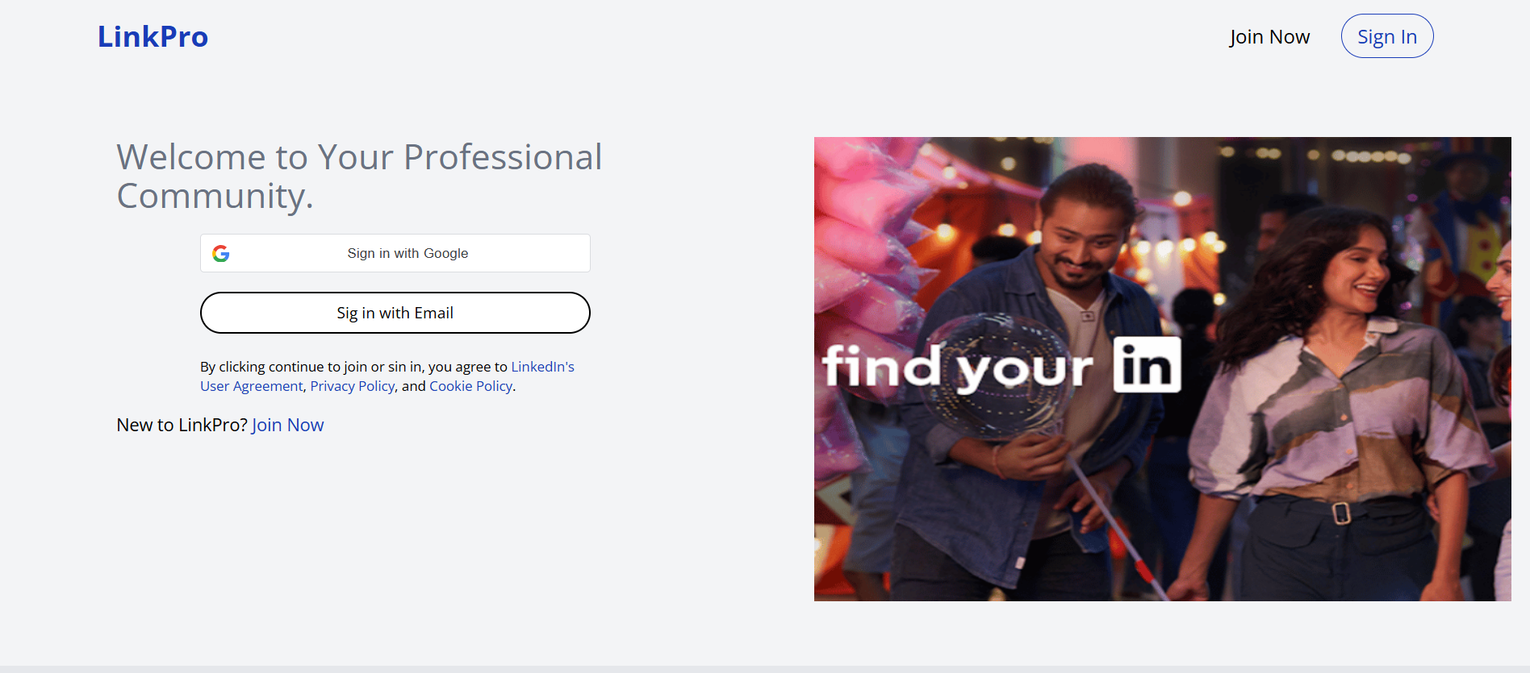

Sign-Up Page
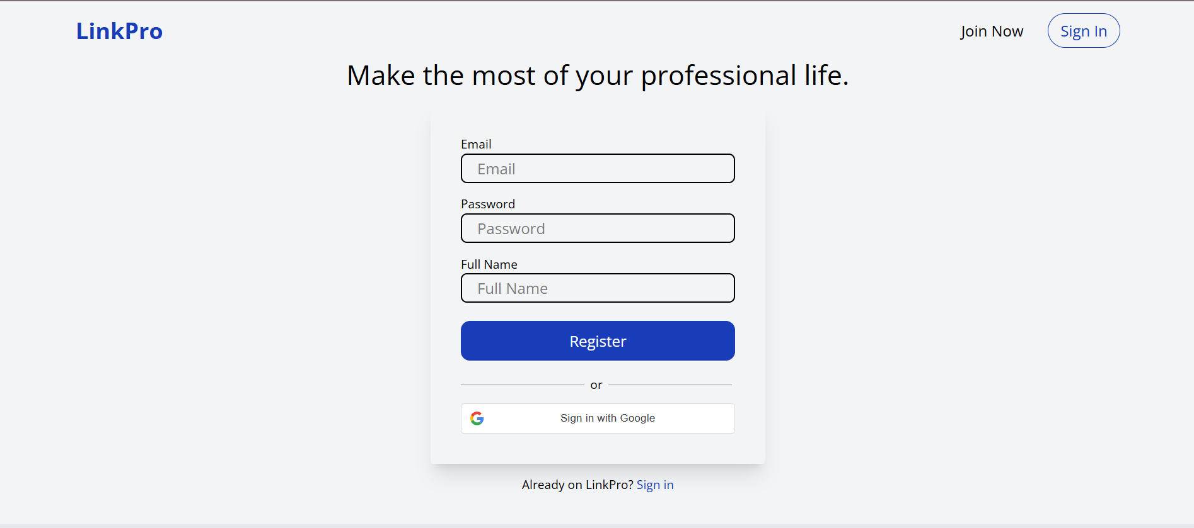

Sign-In Page
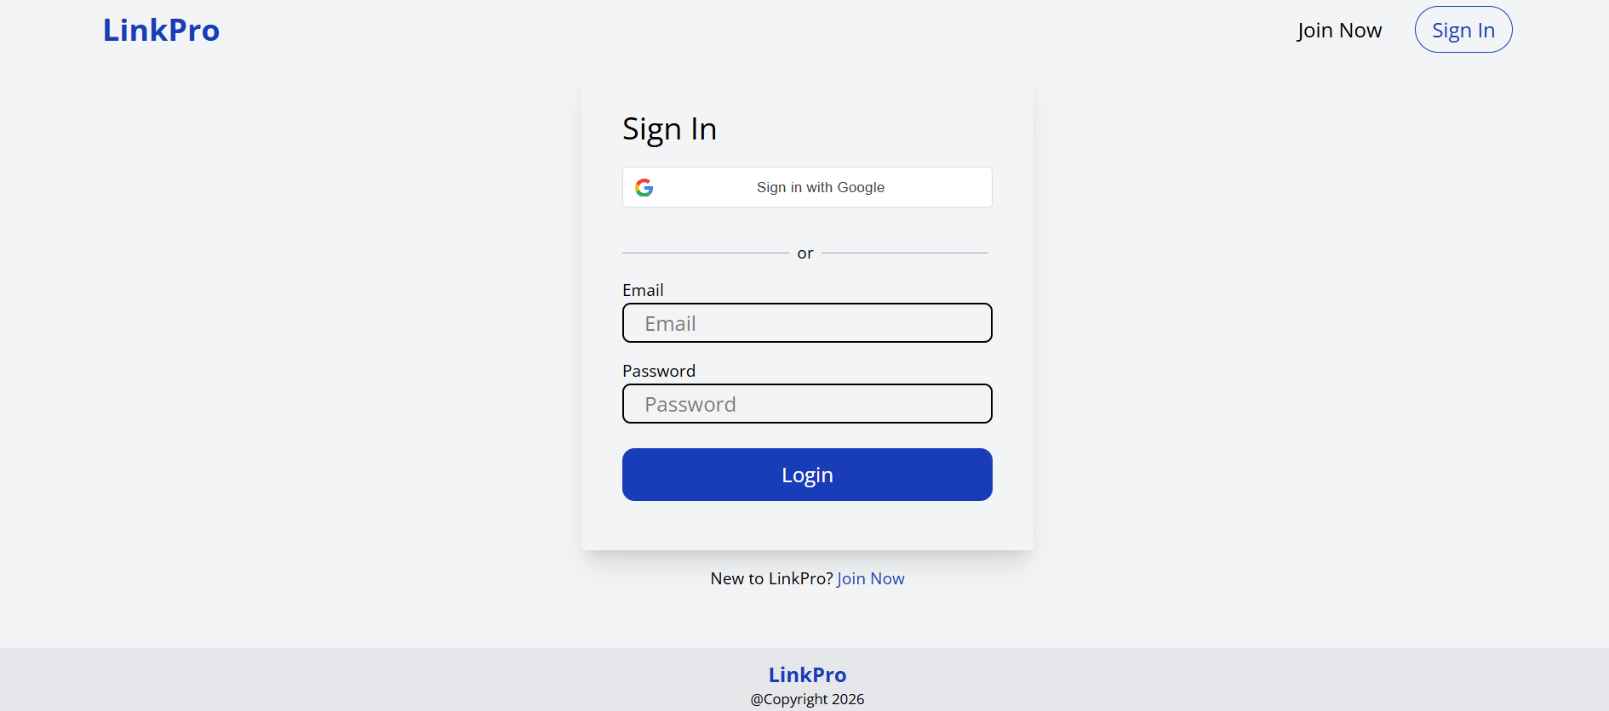

Home Page (Professional Newsfeed)
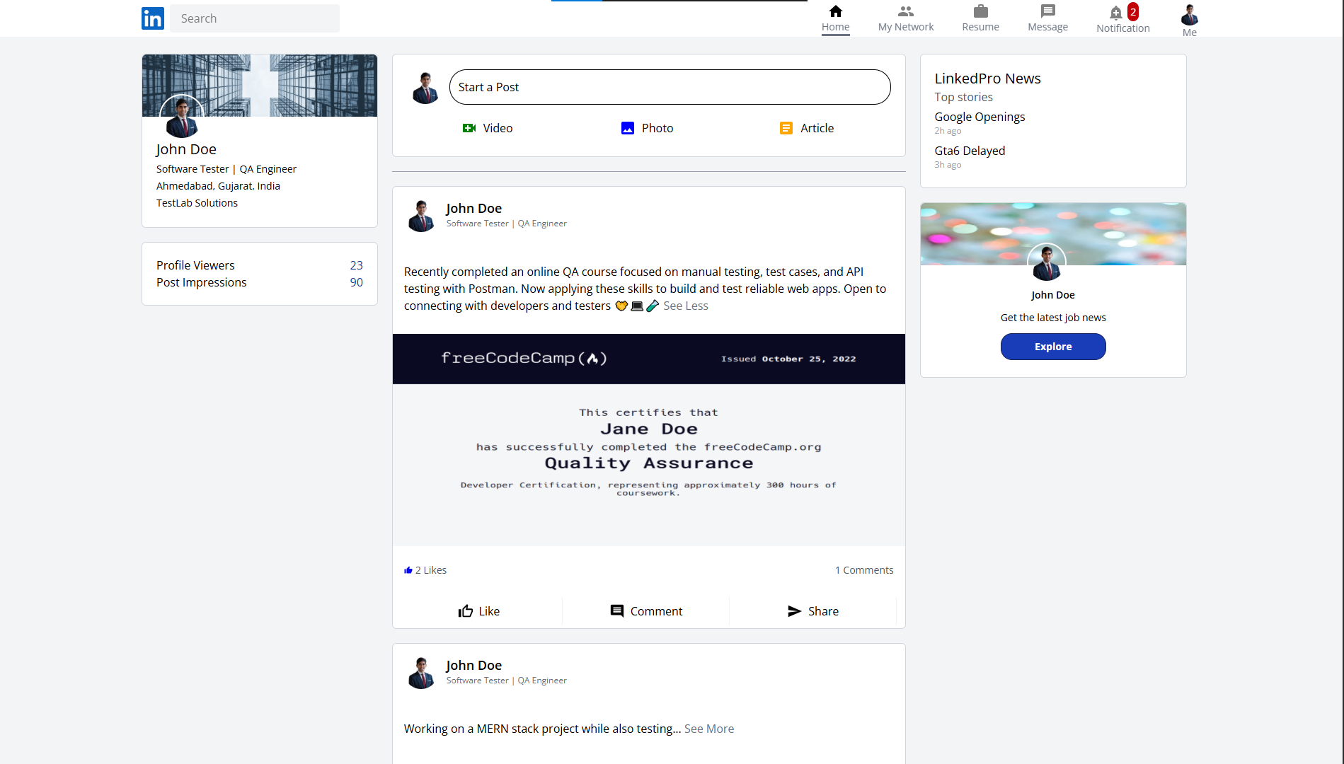

My Network – Friends Page
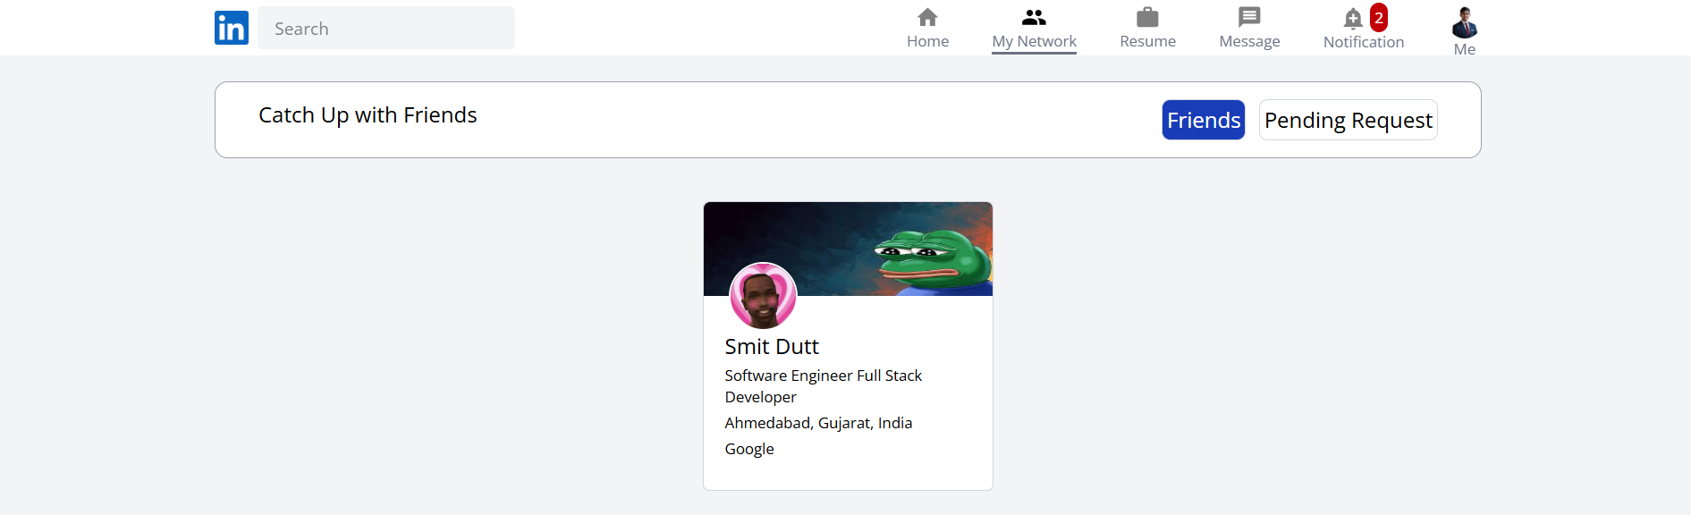

My Network – Pending Friends Page
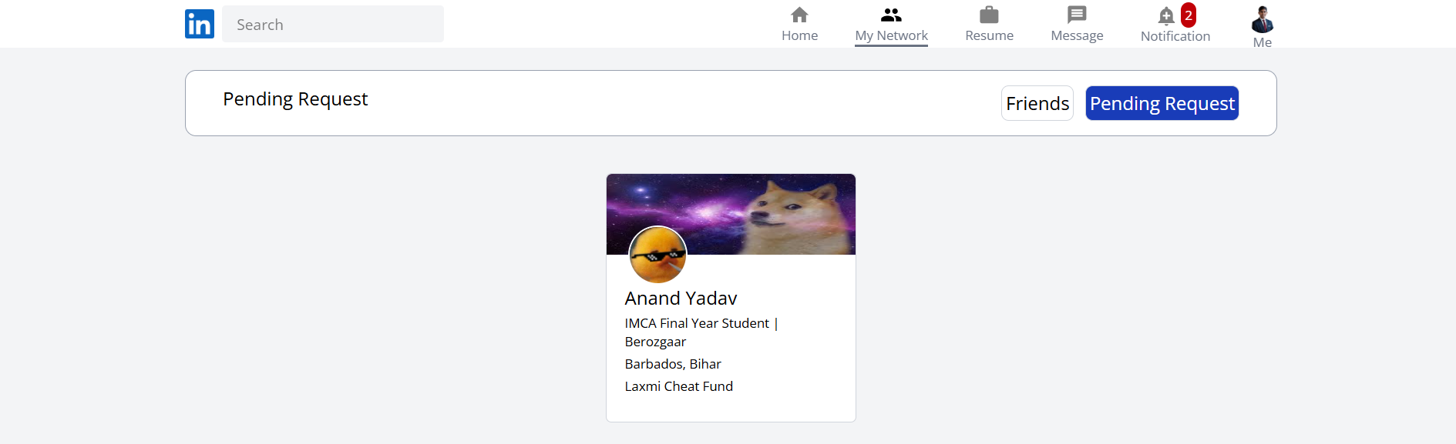

Post Creation & Modal Dialog
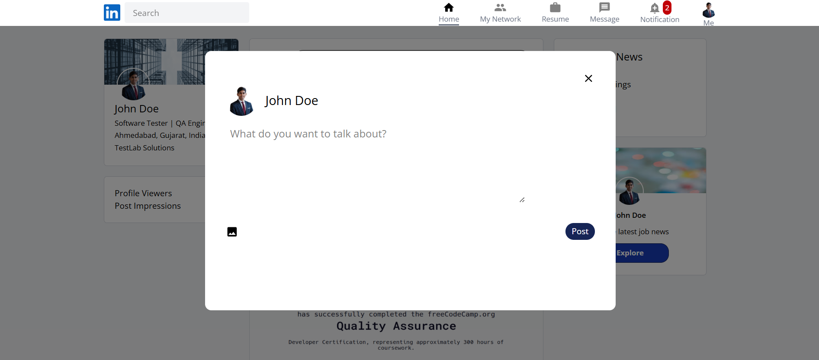

Resume Page – Part 1
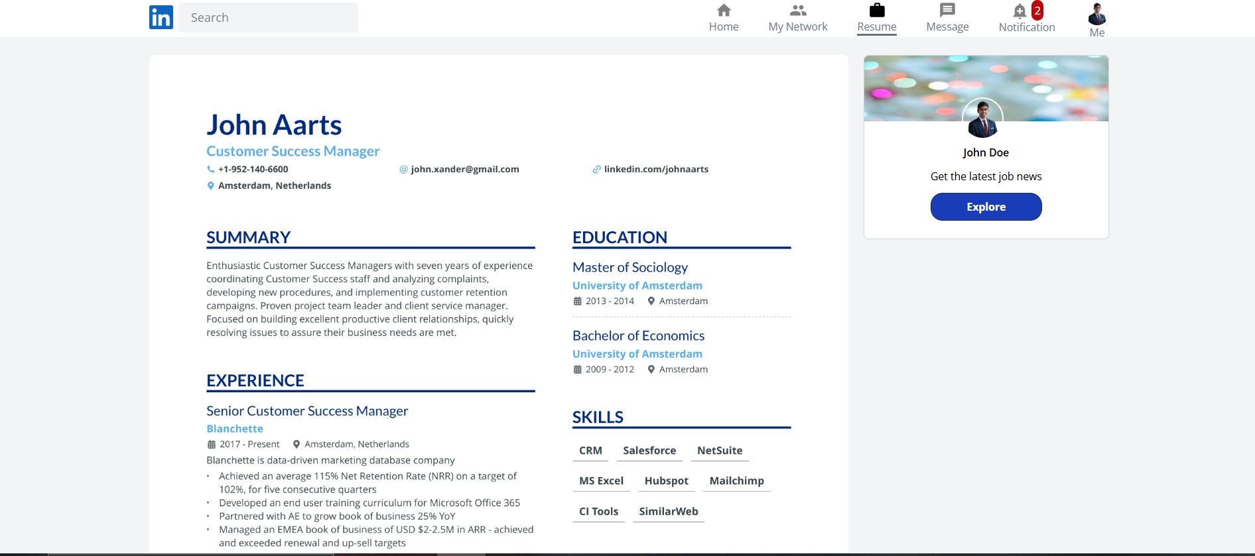

Resume Page – Part 2
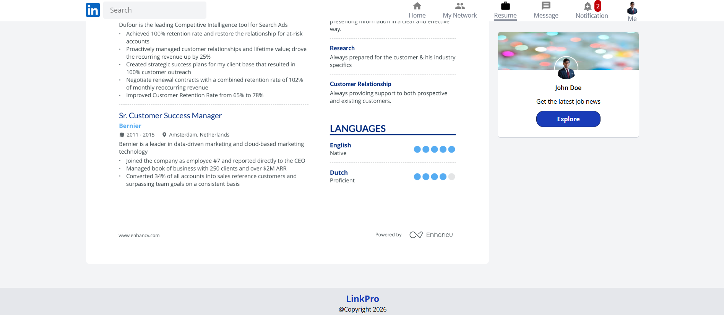

Real-Time Messaging & Chat Page
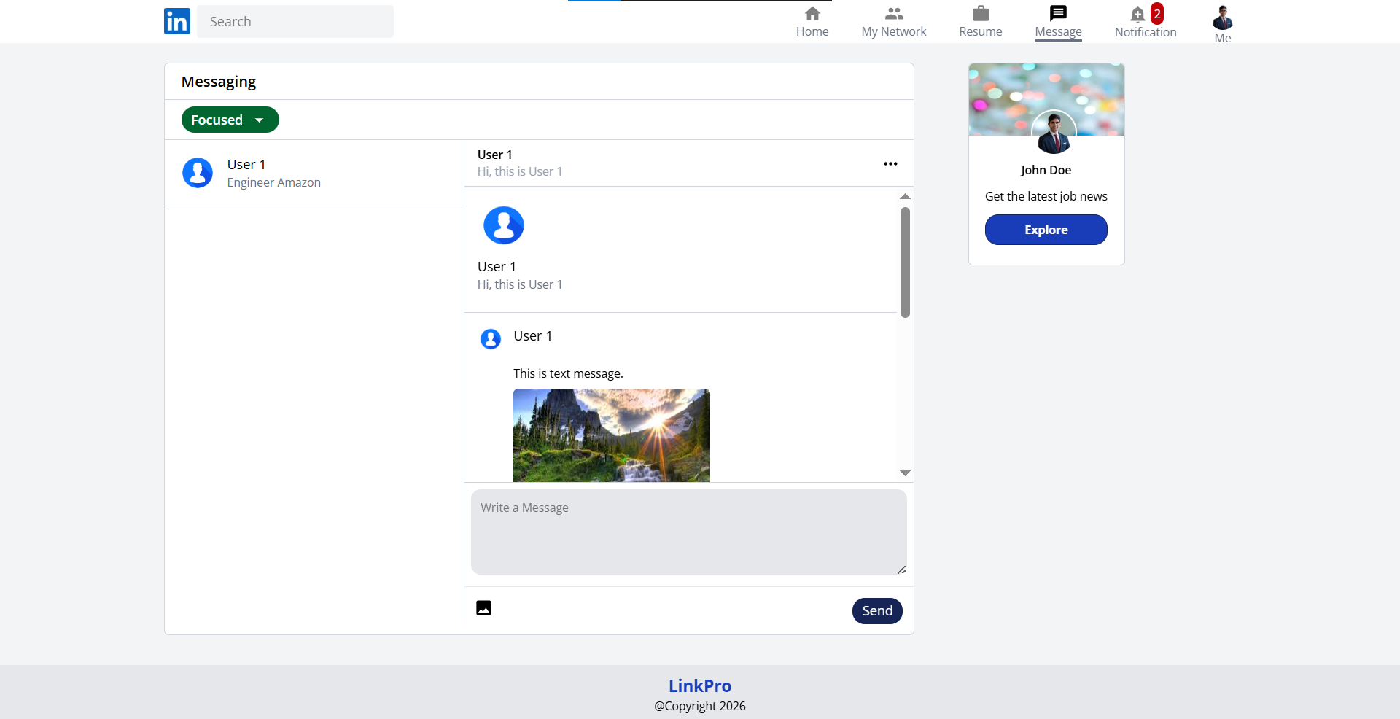

Notifications Center
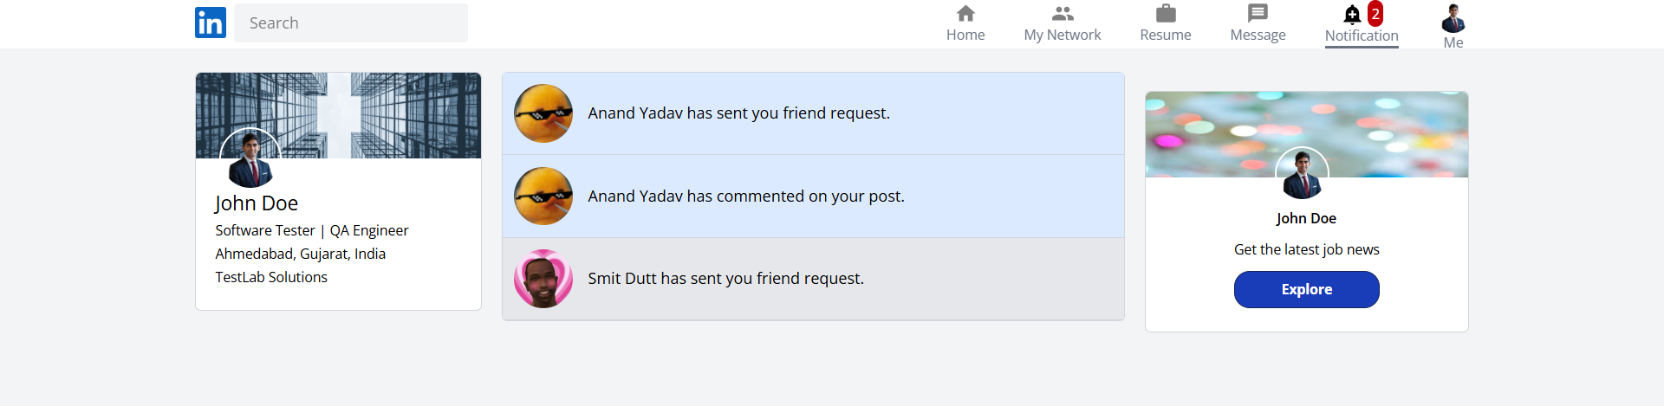

User Profile Section – Overview
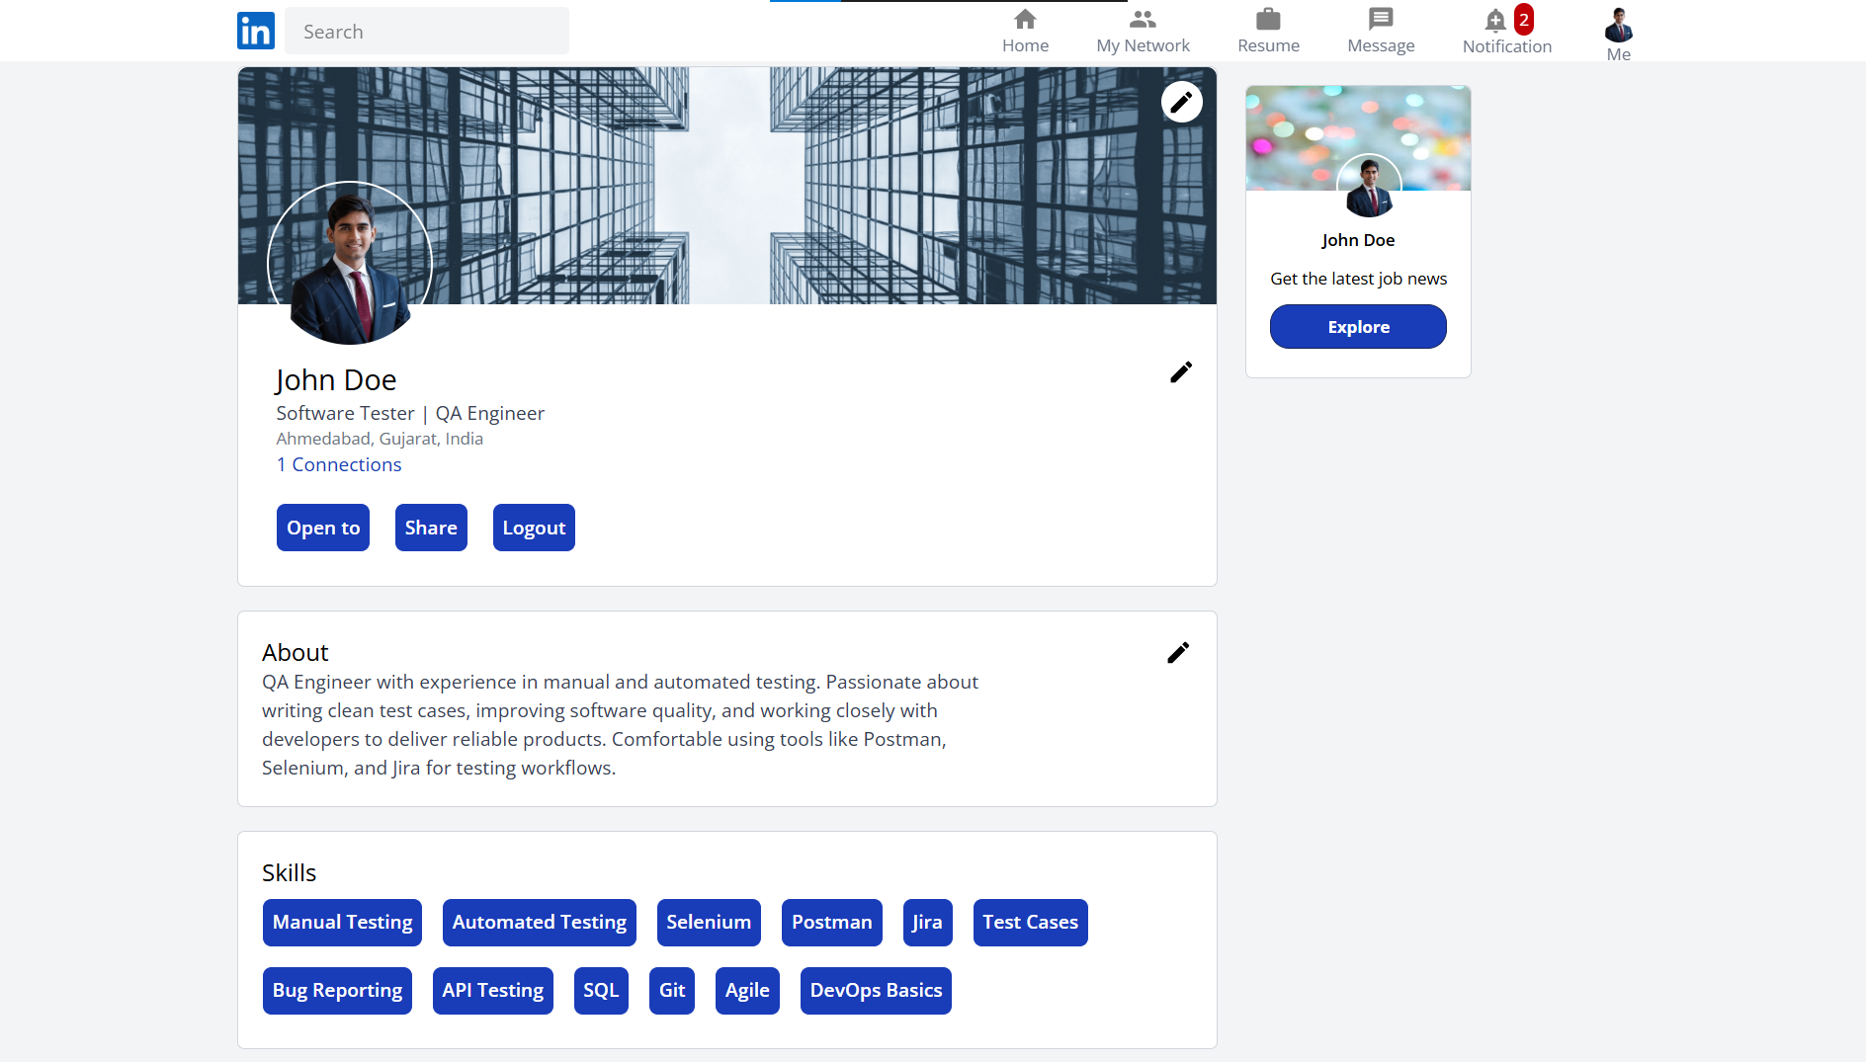

User Profile Section – Activities
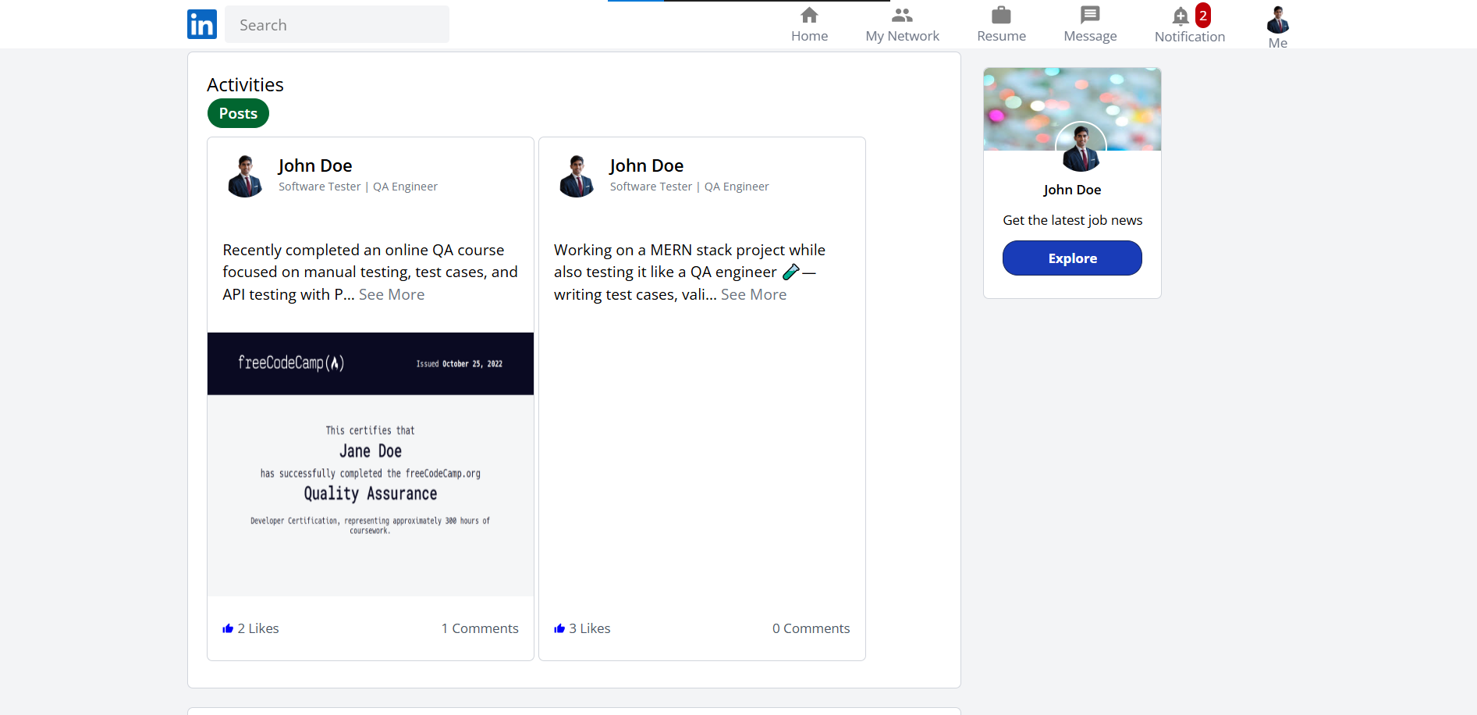

User Profile Section – Experience
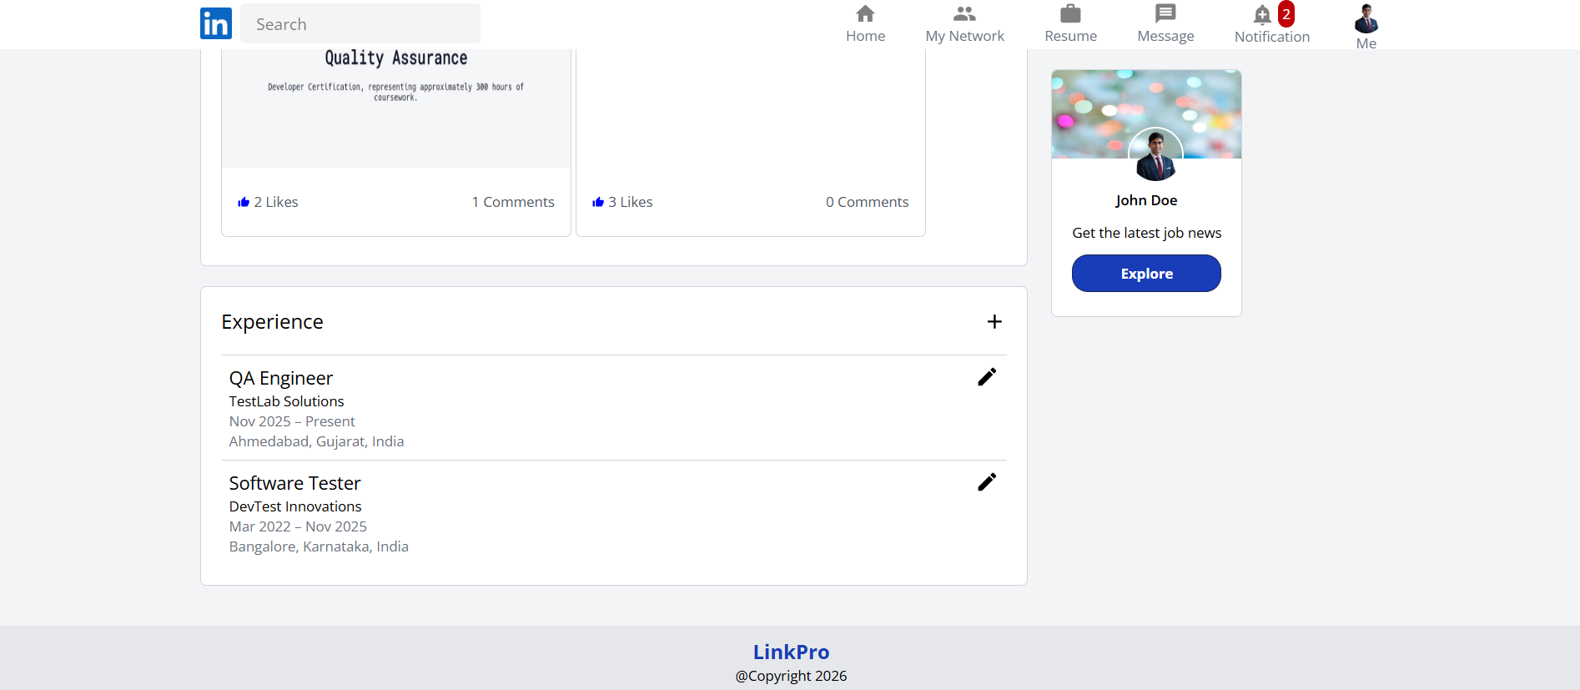

6.10 Proposed Enhancement
Future roadmap enhancements for the LinkPro professional platform include:
• Native Mobile Applications: Developing cross-platform React Native applications for Android and iOS devices with push notification integration.
• AI-Powered Resume Analysis & Job Matching: Leveraging OpenAI / Gemini models to automatically evaluate candidate resumes against posted job descriptions, providing instant match scoring.
• Video Calling & Virtual Interviews: Implementing WebRTC multi-party video conferencing for direct in-browser recruiter interviews and virtual networking events.
• Premium Recruiter Subscriptions: Adding payment gateway processing (Stripe / Razorpay) for premium recruiter subscriptions, sponsored job listings, and highlighted candidate profiles.
• Microservices Migration & Containerization: Expanding platform architecture into microservices with Docker containerization and Kubernetes orchestration to support millions of concurrent connections.

6.11 Project Closure Report

6.11.1 Project Details
Field | Details
Project title | LinkPro – Professional Networking Platform
Team ID / Members (Enrollment No., Role) | Anand Yadav (22002501210066, Roll No B66) – Backend Development, Database Integration & Team Manager  Smit Dutt (22002501210008) – Frontend Development & UI Integration  Hardik Nakum (22002501210035) – Documentation, Testing, QA & UI/UX Design
Internal guide / External guide | Internal Guide: Prof. Rita Gokani  External Guide: Not specified / N/A
Planned vs actual end date | Planned: August–October 2026  Actual end Date: October 2026

6.11.2 Summary and Status
LinkPro is a web-based professional networking platform developed using the MERN stack. It brings together user and profile management, connection lifecycle, newsfeed publishing with Cloudinary media integration, real-time Socket.io messaging, notifications, and job application tracking. During October, the team focused on performance optimization, refactoring, design-pattern documentation, testing, and project documentation. Based on the documentation, the project is in finalization; confirm all remaining testing and deployment tasks before marking it fully completed.
Status: Partially Completed — Final Verification Required

6.11.3 Scope and Deliverables
Deliverable | Planned | Delivered | Accepted by | Remarks
SRS / Requirements | Yes | Documented | Project team / guide | Requirements, objectives, scope, stakeholders and constraints documented.
Design document (UML, architecture) | Yes | Documented | Project team / guide | Layered MERN architecture, module descriptions and UML diagrams included.
Source code + repository link | Yes | Developed | Project team / guide | -
Test report | Yes | Documented | Project team / guide | 26 test steps recorded: 23 passed and 3 failed. Confirm whether the failed tests were resolved.
Refactoring log | Yes | Documented | Project team / guide | Four refactoring items documented with qualitative impact.
User manual / deployment guide | Yes | Not confirmed | Project team / guide | Add or reference deployment/user instructions if required.
Scope deferred / change requests (with reasons): Further speech-pipeline latency optimization, expanded career matching, advanced learning analytics, richer personalization, and additional assessment features remain future enhancements. Confirm final implementation status before claiming delivery.

6.11.4 Schedule and Effort
Phase / Sprint | Planned | Actual | Variance and reason
Project initiation, requirements & planning | August 2026 | August 2026 (status report SR-001) | No variance data recorded in the documentation.
Core development & integration | September 2026 | September 2026 (status report SR-002) | Development and integration progressed; API and data consistency issues were monitored.
Testing, optimization, design patterns & documentation | October 2026 | October 2026 (status report SR-003) | Finalization was still in progress in the report; verify completion date and remaining work.

6.11.5 Quality and Design Summary
Category | Summary / Analysis
Test cases (executed / passed / open defects) | Functional test cases were documented for user registration, login, the learning words module, MCQ management, chapter examinations, and final examinations. A total of 26 test steps were recorded, of which 23 passed and 3 failed. The recorded failures involved duplicate phone/email registration, invalid word data causing a page crash, and access to the final exam without completing all chapters.  The documentation does not confirm whether these failures were subsequently resolved. Therefore, the number of open defects remains unverified.
Design patterns used (pattern, where, why) | Factory — NotificationFactory.js: separates notification creation. Facade — PostFacade.js: coordinates post and feed operations. Strategy — FeedStrategy.js: selects content ranking behavior. Singleton-style — DatabaseConnection.js: shared connection pool. Proxy/Adapter-style — EmailServiceAdapter.js: caching and email service integration.
Code smells fixed (before / after metrics) | Four documented fixes: God Class — PostController.js; God Class — ConnectionController.js; Shotgun Surgery — NotificationService.js and consuming modules; Duplicated Logic — FeedController.js. Reported impacts are qualitative (reduced responsibilities, clearer separation, reusable caching and maintainability); no measured before/after metrics were provided.

6.11.6 Risks and Issues
Risk / Issue | Final status | How it was resolved
Real-time Socket.io latency & drops | Partially addressed / future optimization | Client reconnection backoff, room-based pub/sub, and heartbeats were integrated; October documentation identifies further performance considerations.
API integration and data consistency | Addressed during development; verify final test status | Frontend/backend integration and data consistency were tracked as risks; final regression-test evidence should confirm closure.

6.11.7 Lessons Learned
Category | Observations and Future Recommendations
What went well | The Scrum-based monthly workflow clarified responsibilities and milestones. Separating controller/component responsibilities, centralizing cache logic, and coordinating independent API requests improved maintainability and loading behavior.
What to improve | Record measurable test results and before/after performance metrics; complete regression and deployment checks; keep API contracts and error handling consistent; and verify the status of all planned features before sign-off.
Future scope / maintenance | Potential future work includes reducing speech-to-speech latency, expanding supported languages, adding advanced learning analytics and personalization, improving assessments, and completing/expanding conversation-history analysis where not yet delivered.

6.11.8 Sign-off
Role | Name | Signature | Date
Project Leader | Anand Yadav |  | 31-10-2026
Team Member | Smit Dutt |  | 31-10-2026
Team Member | Hardik Nakum |  | 31-10-2026
Internal Guide | Prof. Rita Gokani |  | 31-10-2026
External Guide / Client | - |  | 31-10-2026
Coordinator / HOD | Dr. Monica Gahalawat |  | 31-10-2026

6.12 Conclusion
LinkPro represents a modern, robust, and extensible professional networking platform engineered using the MERN technology stack and real-time WebSocket infrastructure. By pairing intuitive frontend interfaces with loosely coupled backend domain services, the platform provides an engaging user experience for students, alumni, and industry recruiters.
The systematic application of Gang of Four design patterns (Singleton, Factory Method, Builder, Facade, Adapter, Decorator, Strategy, State, Observer) transformed LinkPro from a standard CRUD application into an enterprise-ready software product. The project stands as a testament to disciplined software engineering, comprehensive testing, and professional documentation.

6.13 Bibliography
• MongoDB Atlas Official Documentation. Available at: https://www.mongodb.com/docs/
• Express.js Web Application Framework Documentation. Available at: https://expressjs.com/
• React.js Official Documentation & Component Architecture Guides. Available at: https://react.dev/
• Node.js JavaScript Runtime Environment Documentation. Available at: https://nodejs.org/en/docs/
• Socket.IO Real-time Bi-directional Event Documentation. Available at: https://socket.io/docs/v4/
• Cloudinary Image & Video Management Cloud API. Available at: https://cloudinary.com/documentation
• Gamma, E., Helm, R., Johnson, R., & Vlissides, J. (1994). Design Patterns: Elements of Reusable Object-Oriented Software. Addison-Wesley Professional, 1994.
• Refactoring Guru — Design Patterns & Code Smells Catalog. Available at: https://refactoring.guru/design-patterns
• Martin, R. C. (2008). Clean Code: A Handbook of Agile Software Craftsmanship. Prentice Hall, 2008.
• GitHub Git Version Control and Repository Management. Available at: https://github.com/

