jQuery

Introduction

- The DOM is an API to access HTML elements allowing us to use JavaScript to access elements by their ID and name and manipulate them. jQuery is a JavaScript library that greatly simplifies manipulating the DOM, thus allowing developers to to write simple code to provide an enhanced user experience.

- There is a jQuery function that selects HTML element(s) and returns a jQuery object that wraps the element(s). Then, there are over 300 methods for manipulating the elements through the jQuery object. Below, I list a few of these methods. Keep in mind that these methods/functions work on a single element or a collection of them:

Function | Description
css | Change CSS dynamically
addClass | Apply a currently defined CSS class. See also: removeClass, toggleClass
animate | Animate anything very simply.
append | Insert contents into an element(s). See also: prepend, after, before
preventDefault | Stops any element with a default action from firing
data | Attach data to an element
match | Filtering string values
find | Searches for elements that meet a criteria
children | Find all the children elements of an element
hide | Hides an element(s). See also: show

- Some methods return jQuery objects which allows function calls to be chained. Other methods return an HTML element(s) and so the jQuery methods do not apply. Finally, some methods just perform an action on the element(s).

- See the jQuery API for information on the available methods.

How does jQuery Work?

- Use the jQuery function to select the element(s) you are interested in. For example, to select all the <h2> tags:

var h2s = jQuery("h2");

Then, to change the text that is displayed in all these elements:

h2s.html("Header is changed");

- The jQuery function has an alias, $, thus, we can write the first line above:

var h2s = $("h2");

- Unless there was a need to define a variable, we would usually just chain the operations together:

$("h2").html("Header is changed");

- The basic syntax is:

$(selector).action()

- $ – Used to access jQuery
- selector – Used to find HTML element(s)
- action – Action to be performed on the element(s)

- Examples:

$(this).hide() // hides the current element.
$("p").hide() // hides all <p> elements.
$(".test").hide() // hides all elements with class="test".
$("#test").hide() // hides the element with id="test".

- The major selectors are:

Type | Description | Example
Element | Selects all elements of a particular type | $(“p”)
Id | Selects the element with a specific id | $(“#balance”)
Class | Selects all elements with a particular CSS class | $(“.checkbook”)
Attribute | Selects all elements with a particular attribute value | $( "input[name='first_name']" );

- Some other selectors:

$(“*”) | Selects all elements
$(this) | Selects the current HTML element
$("p.intro") | Selects all <p> elements with class="intro"
$("p:first") | Selects the first <p> element
$("ul li:first") | Selects the first <li> element of the first <ul>
$("ul li:first-child") | Selects the first <li> element of every <ul>
$("[href]") | Selects all elements with an href attribute
$("a[target='_blank']") | Selects all <a> elements with a target attribute value equal to "_blank"
$("a[target!='_blank']") | Selects all <a> elements with a target attribute value NOT equal to "_blank"
$(":button") | Selects all <button> elements and <input> elements of type="button"
$("tr:even") | Selects all even <tr> elements
$("tr:odd") | Selects all odd <tr> elements

The Document Ready Event

- Consider the hideParagraph JavaScript function below that uses jQuery. This function doesn’t actually hide paragraphs. What it does is:

- Assign the click event to all paragraphs
- Define an event handler via an anonymous function which hides a paragraph when it is clicked.

function hideParagraph() {
$("p").click(function () {
$(this).hide();
});
}

- Almost all jQuery functions are inside the document ready event. This is done so that no jQuery code can run until the page has finished loading. For example, the hideParagraph function would be executed like this:

$(document).ready(hideParagraph);

- The more usual way to write this would be to use an anonymous function to implement the event handler for the ready event.

<script>
$(document).ready(function () {
$("p").click(function () {
$(this).hide();
});
// Assign more event handlers
});
</script>

- Technical Note (optional): Notice above that we still pass an anonymous function to the click function. If we were to write this as a named function, we would need to define a parameter and pass it which is a little more involved. We won’t consider passing arguments. The obvious advantage to naming functions is that we can reuse them.

function hideParagraph() {
$("p").click(function () {
$(this).hide();
});
}

$(document).ready(hideParagraph);

- The general syntax is:

$(document).ready(function(){

// jQuery methods go here...

});
Example

- Example – Illustrates “hello world” using jQuery. Also shows how to hide and redisplay a button.

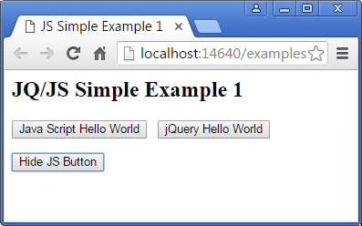 | 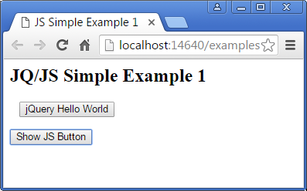

<html>
<head>
<title>JS Simple Example 1</title>
<script src="jquery-1.11.2.js"></script>

<script>
$(document).ready(function () {
$("#jqButton").click(function () {
alert("jQuery Hello World");
});

$("#hide").click(function () {
if ($(this).text() === "Hide JS Button") {
$("#jsButton").hide();
$(this).text("Show JS Button");
}
else if ($(this).text() === "Show JS Button") {
$("#jsButton").show();
$(this).text("Hide JS Button");
}
});
});
</script>
</head>

<body>
<h2>JQ/JS Simple Example 1</h2>
<form id="hello">
<button type="button" id="jsButton" onclick="helloWorld()">
Java Script Hello World</button>&nbsp;&nbsp;
<button type="button" id="jqButton">jQuery Hello World</button>
<p>
<button type="button" id="hide">Hide JS Button</button>
</p>
</form>

</body>
</html>

Note:

- In JavaScript, “===” returns true only when the operands are the same type and the contents are the same.

Using jQuery

- You can use jQuery in one of two ways:

- Include it from a Content Delivery Network (CDN) by adding this in head section:

<script src="https://ajax.googleapis.com/ajax/libs/jquery/3.3.1/jquery.min.js"></script>

- Download it from: http://jquery.com/download/

And then put it in your folder where you pages are. Then, reference it by adding this in the head section:

<script src="jquery-3.3.1.min.js"></script>

Examples

- Example – Illustrates processing form elements

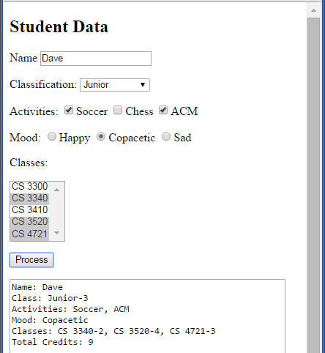

$(document).ready(function () {
$("#process").click(function () {
var name = $("#name").val();
var classificationDesc = $("#classification option:selected").text();
var classificationNum = $("#classification option:selected").val();
var activities = [];
$("input[name='activities']:checked").each(function() {
activities.push($(this).val());
});
var mood = $("input[name='mood']:checked").val();

var classes = [];
var credits = [];
var totalCredits = 0;
$("#classes option:selected").each(function () {
classes.push($(this).text());
credits.push($(this).val());
totalCredits += parseInt($(this).val());
});

var message = "Name: " + name + "\n";
message += "Class: " + classificationDesc + "-" + classificationNum + "\n";
message += "Activities: ";
for (i = 0; i < activities.length; i++)
message += activities[i] + (i<activities.length-1 ? ", " : "");
message += "\nMood: " + mood + "\n";
message += "Classes: ";
for (i = 0; i < classes.length; i++)
message += classes[i] + "-" + credits[i] + (i < classes.length - 1 ? ", " : "");
message += "\nTotal Credits: " + totalCredits;

$("#message").val(message);
});
});

HTML

<p>Name <input id="name" class="inVals" type="text" /></p>

<p>Classification:
<select id="classification" class="inVals" name="D1">
<option value="1">Freshman</option>
<option value="2">Sophomore</option>
<option value="3">Junior</option>
<option value="4">Senior</option>
</select>
</p>

<p>Activities:
<input name="activities" class="acts" type="checkbox" value="Soccer" />Soccer
<input name="activities" class="acts" type="checkbox" value="Chess" />Chess
<input name="activities" class="acts" type="checkbox" value="ACM" />ACM
</p>

<p>Mood:
<input name="mood" type="radio" value="Happy" />Happy
<input name="mood" type="radio" value="Copacetic" />Copacetic
<input name="mood" type="radio" value="Sad" />Sad
</p>

<p>Classes:</p>

<select size="5" id="classes" multiple="multiple">
<option value="3">CS 3300</option>
<option value="2">CS 3340</option>
<option value="4">CS 3410</option>
<option value="4">CS 3520</option>
<option value="3">CS 4721</option>
</select>

<p><button type="button" id="process">Process</button></p>

<p><textarea rows="10" id="message" cols="50"></textarea></p>

