Name : Anand Parmar
Roll no : MCA020
Subject : DevOps
Lab – 8 : Introduction to Continuous Integration

1. Practice CI-CD pipeline using github actions. Create a pipeline to deploy python app to Azure app service

Step – 1 : Create web-App in azure
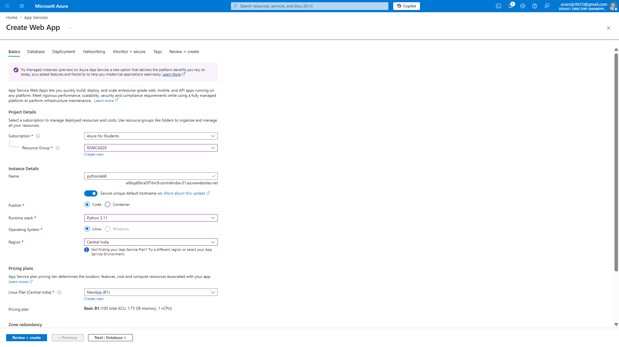

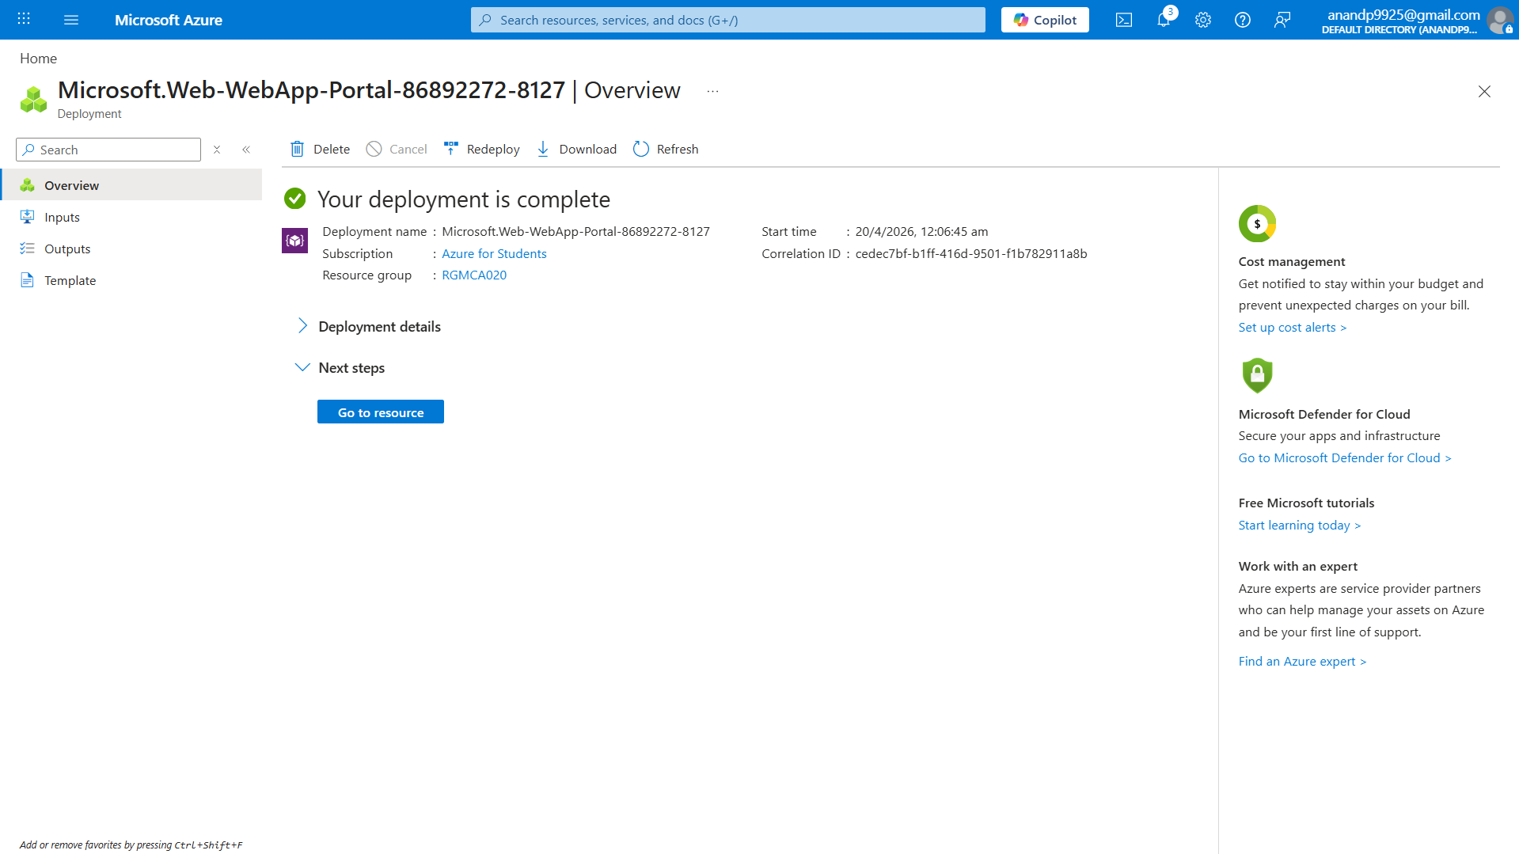
Step – 2 : Create test and python file
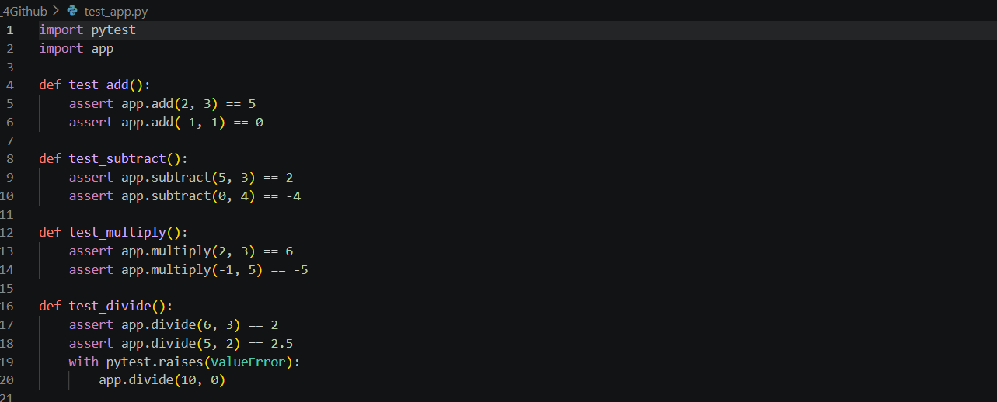

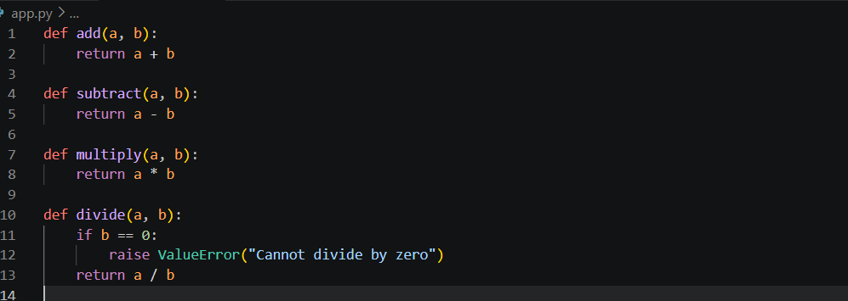

Step – 3 : Enable SCM Basic Auth Publishing Credential and Download Profile
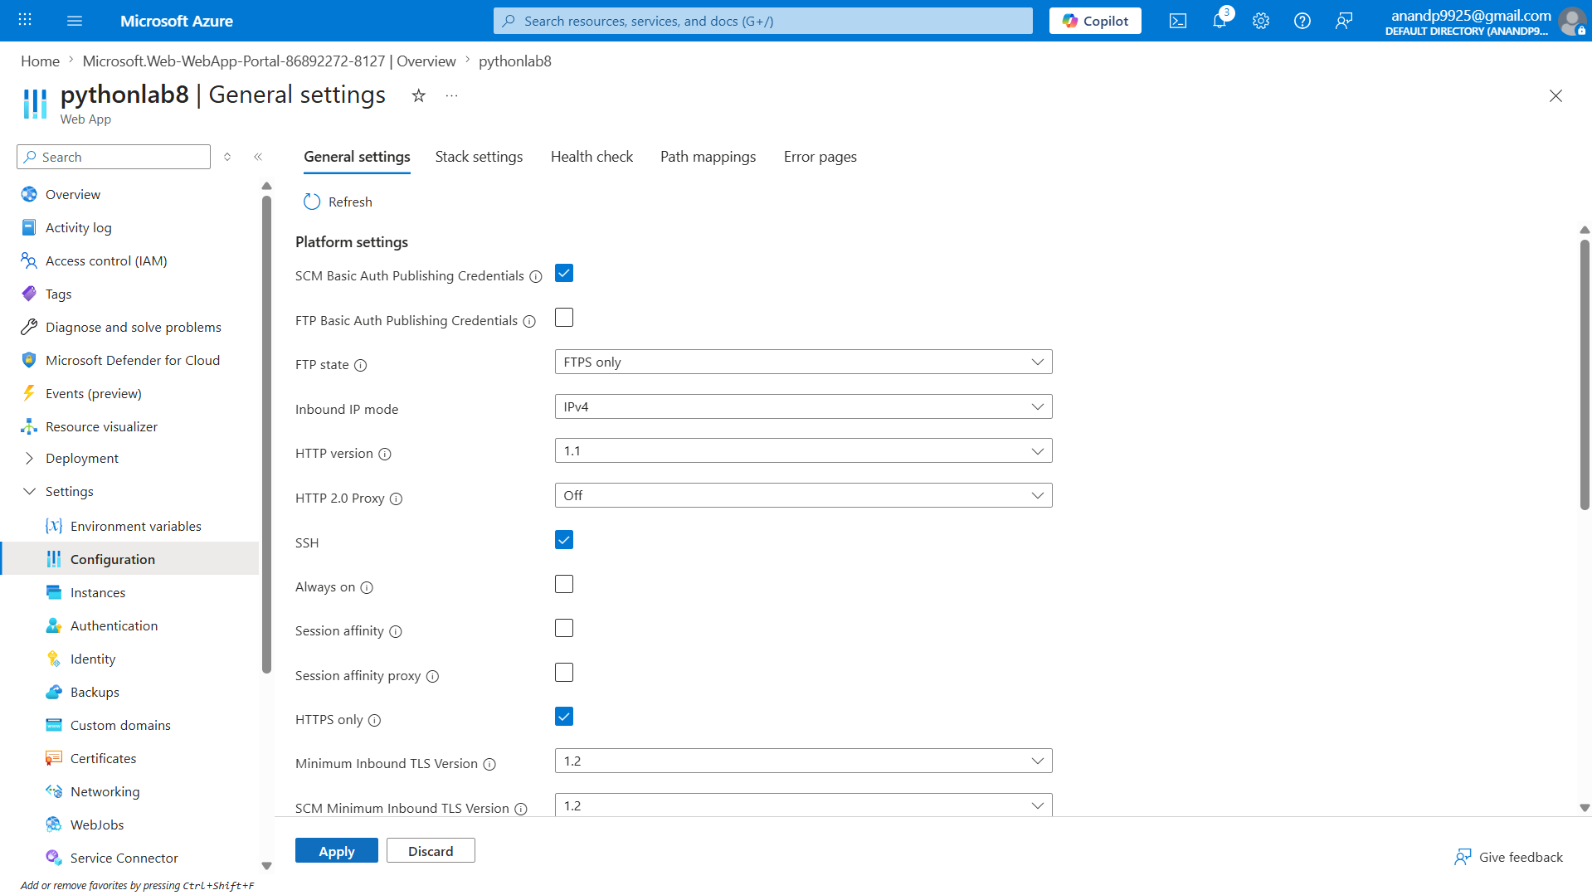
Step – 4 :Create requirements.txt empty file

Step-3 push in to git rapo
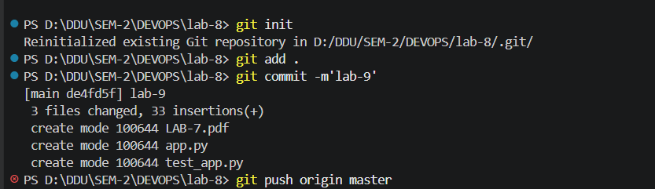

Step4: go to app and enable SCM Basic Auth Publishing and apply
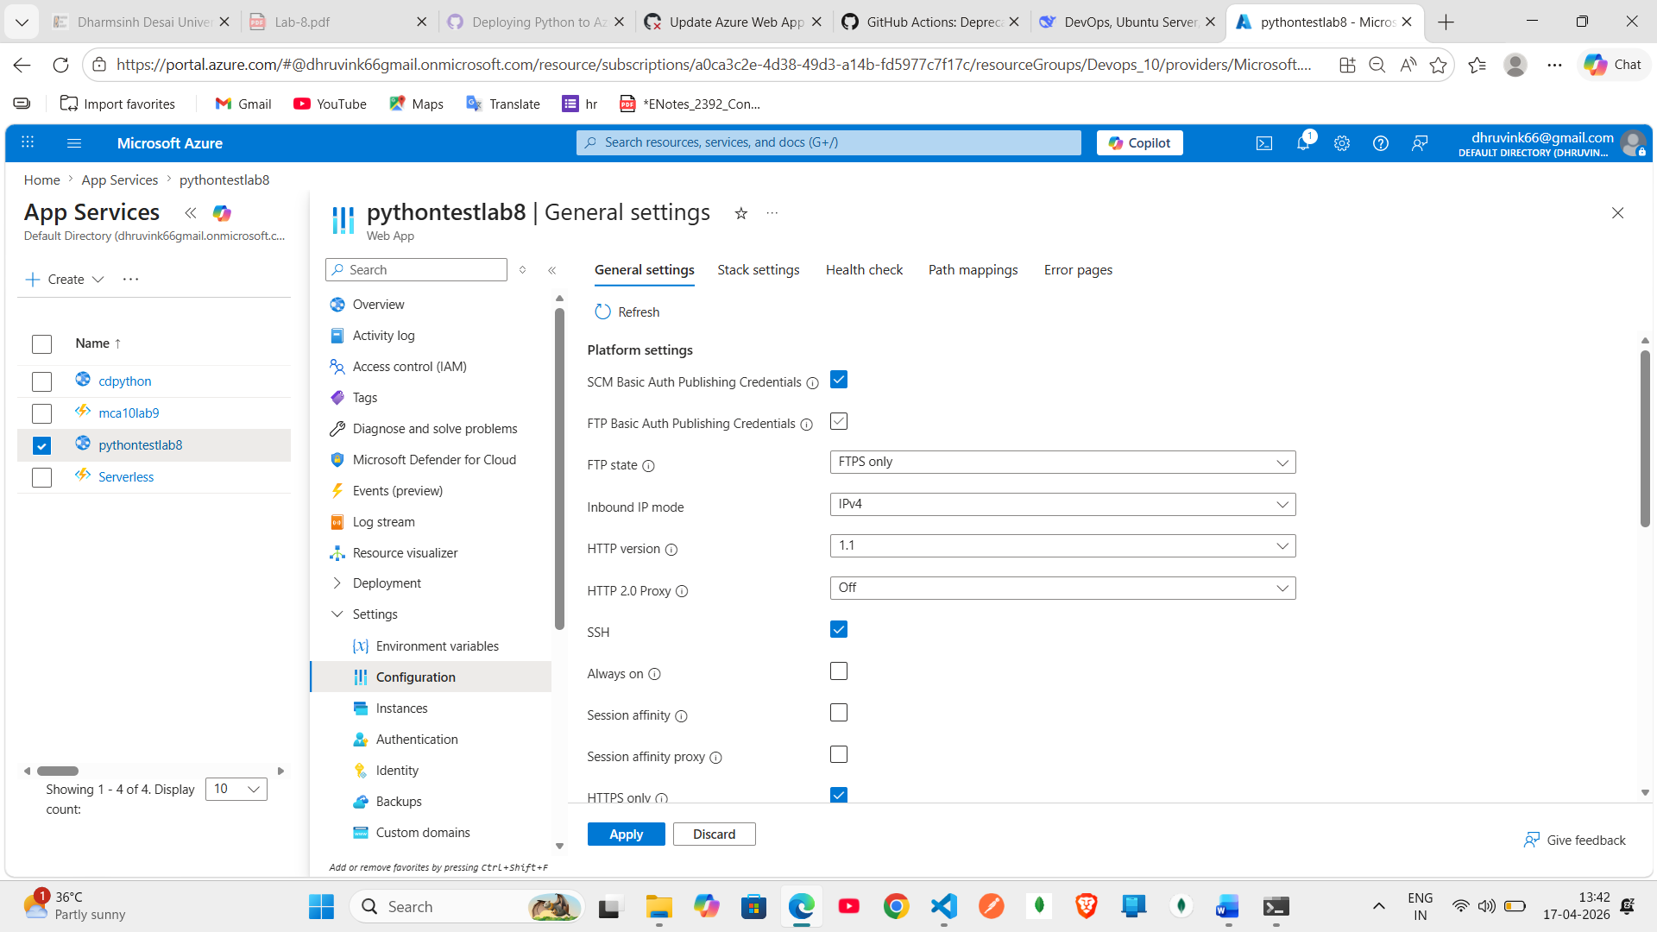
Step-5: now download publish profile
Step 6: open file and copy text
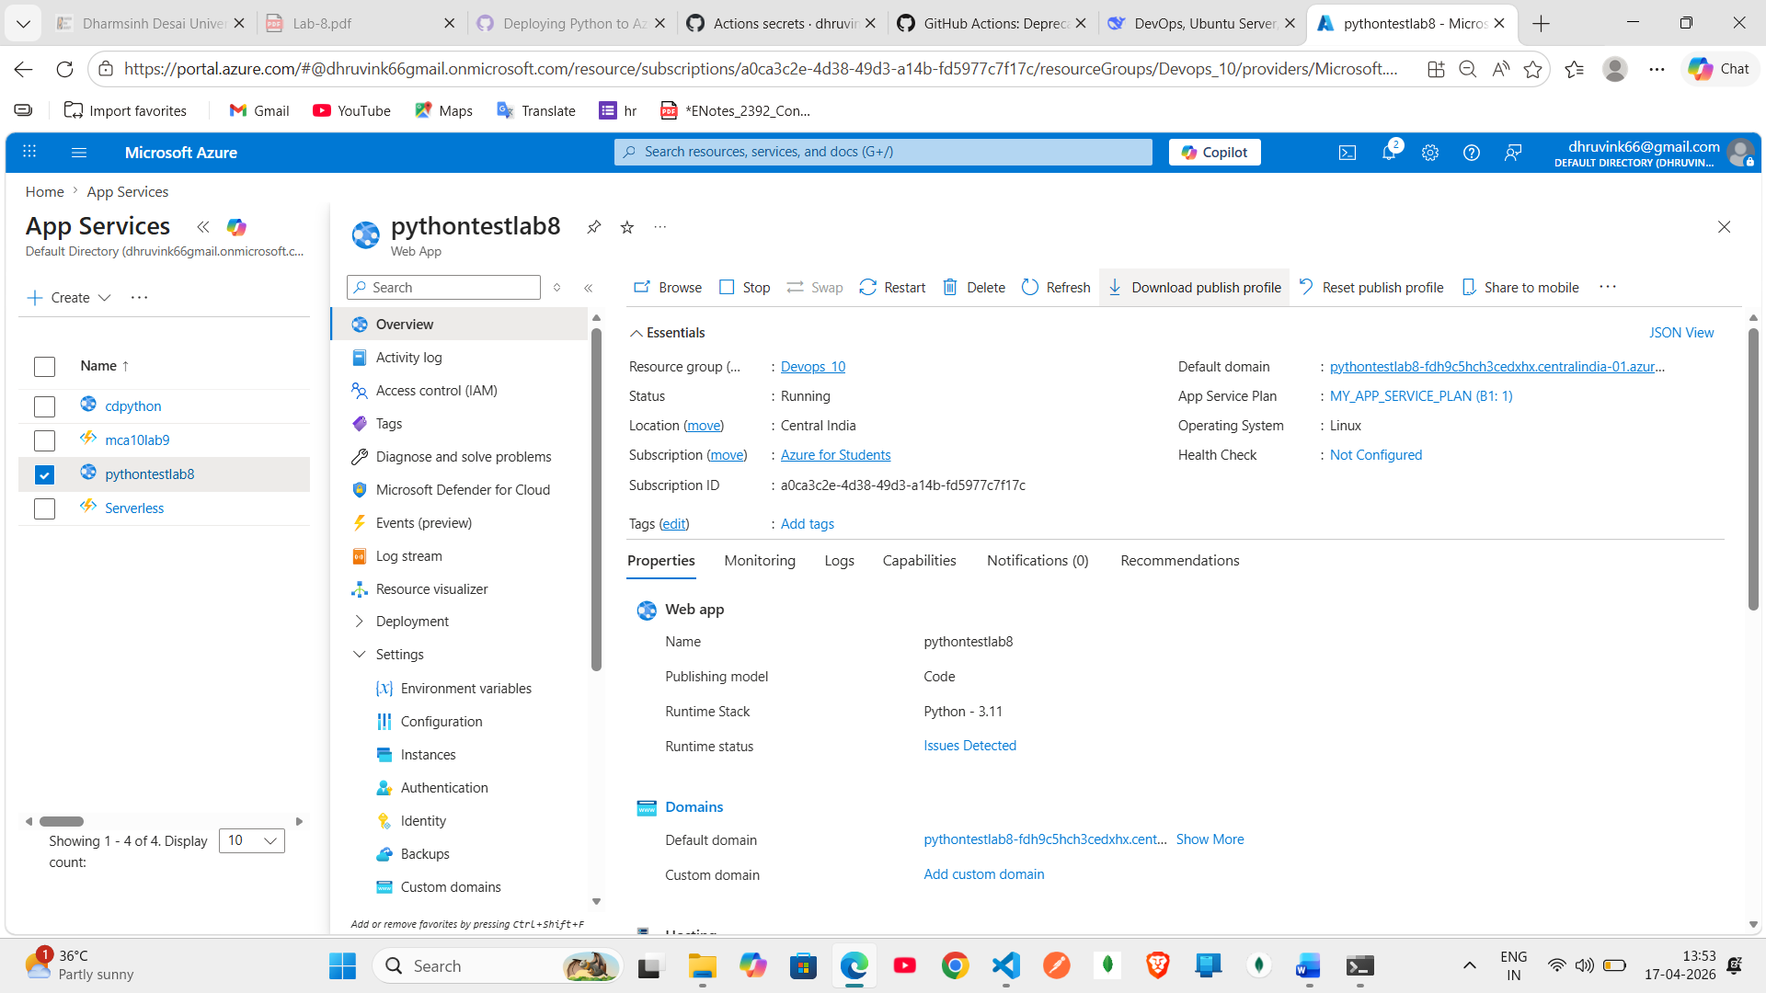

Step-7 :create env var and paste text in it and apply
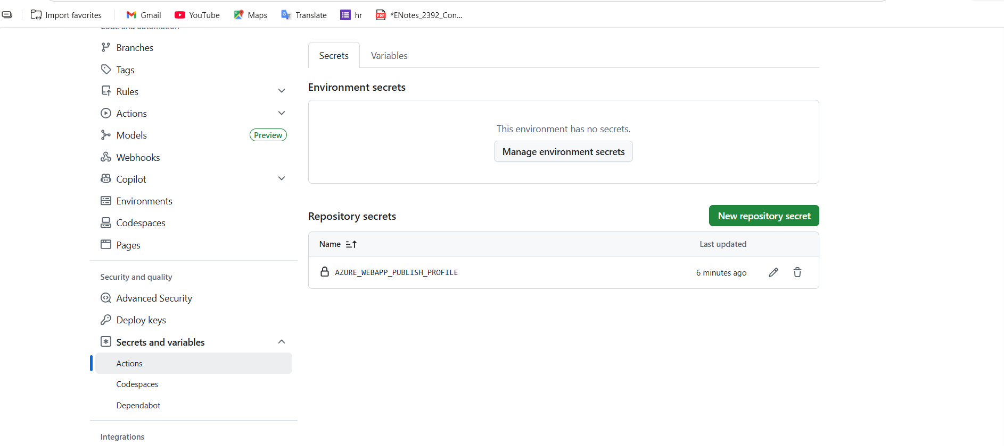

Step-8 : go to action scroll down and click on deplu a python app to an azure it create a yml file then
Edit your app name and python version
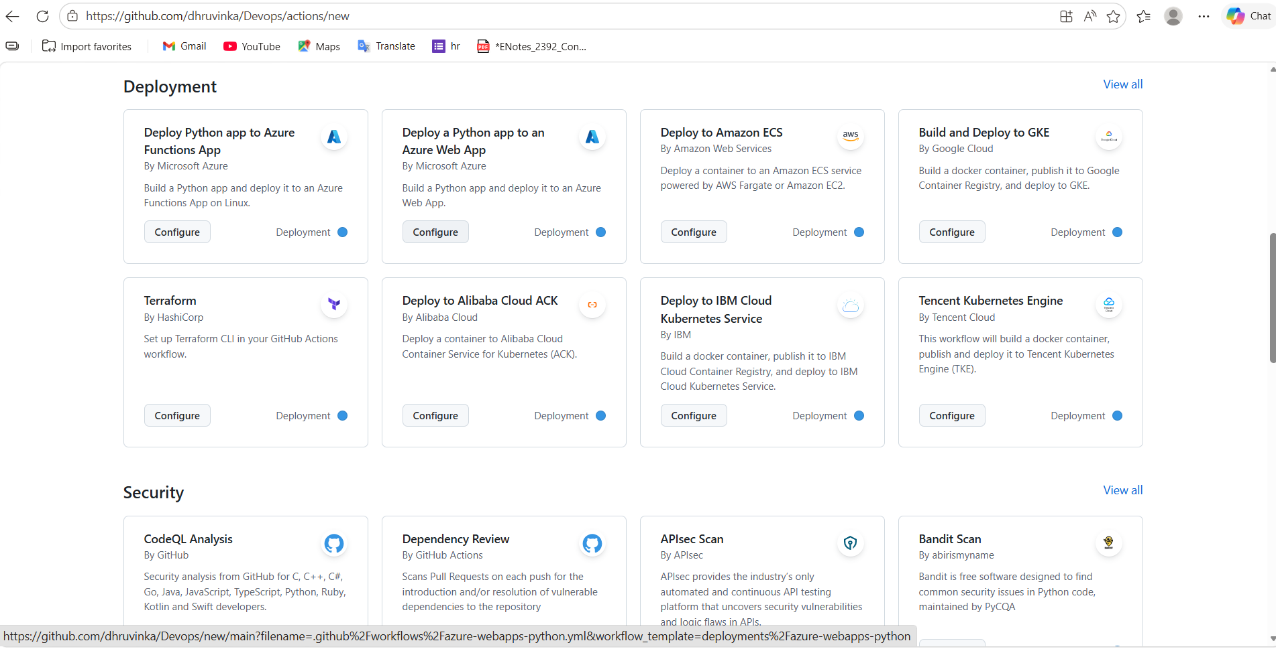

Step-9 : now commit and click on action so build and deploy must green otherwise ci-cd is not working

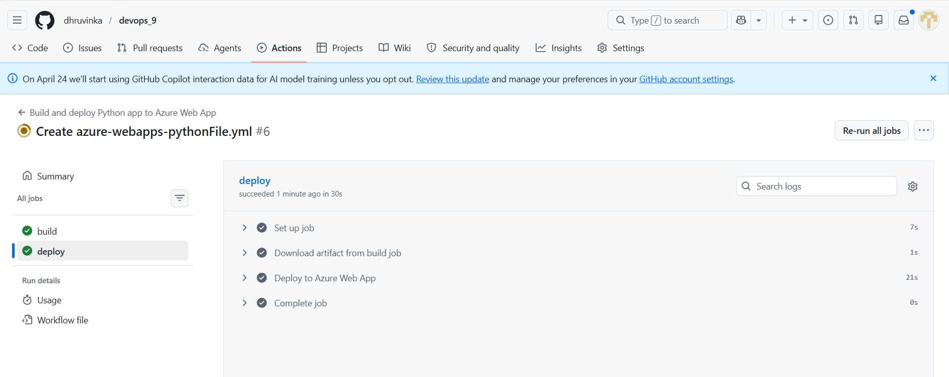

2. Practice CI-CD pipeline using github actions. Create a pipeline to deploy Node app to Azure app service.
Step-1 create app.js
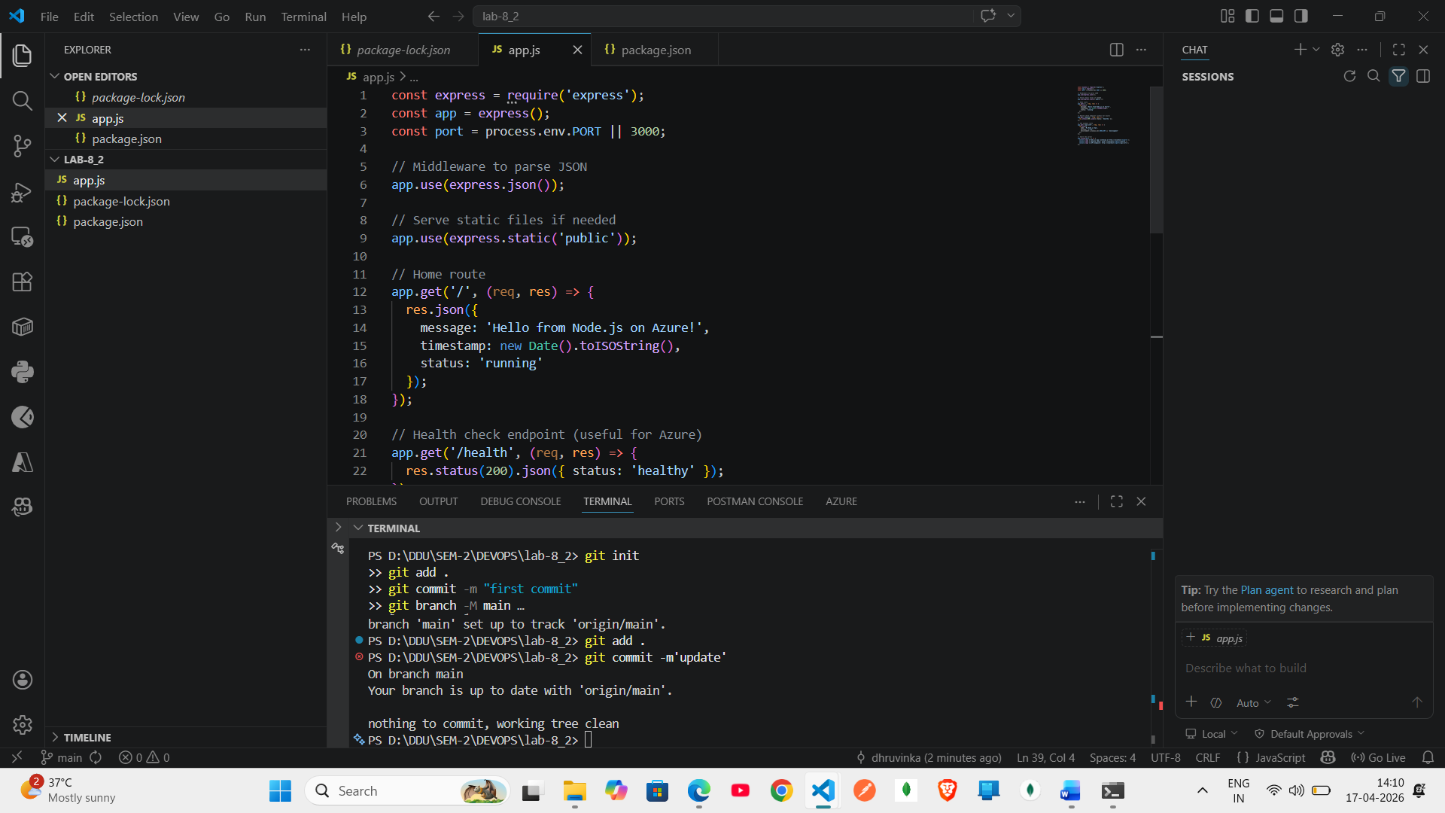
Step-2 create pakage.json
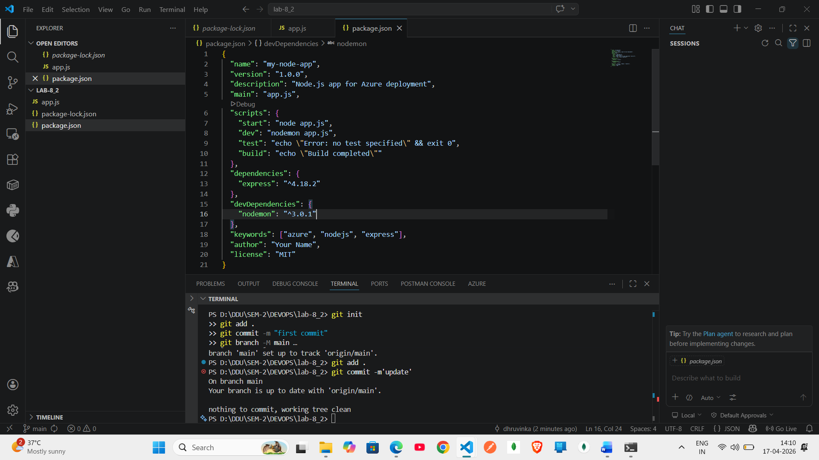

Step-3 : create web app with node
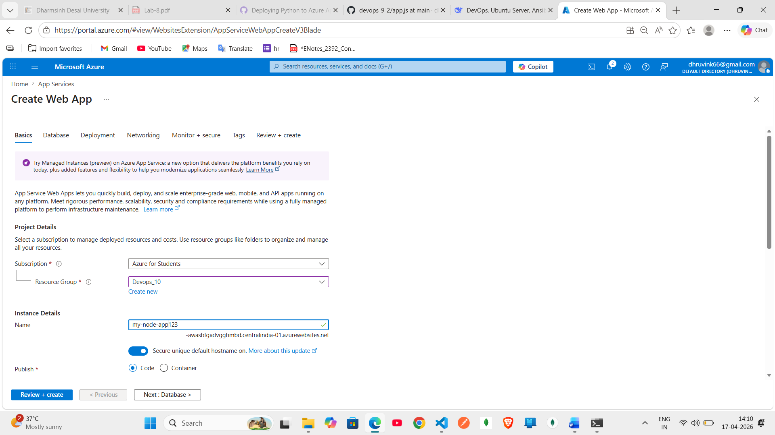

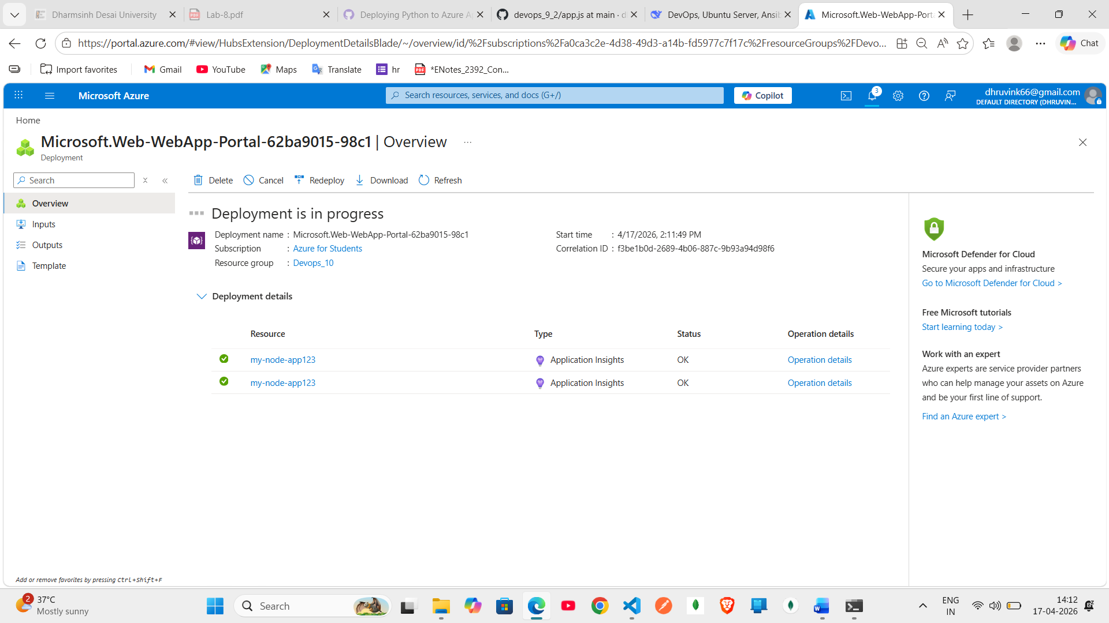

Step-4 : public as per Q1
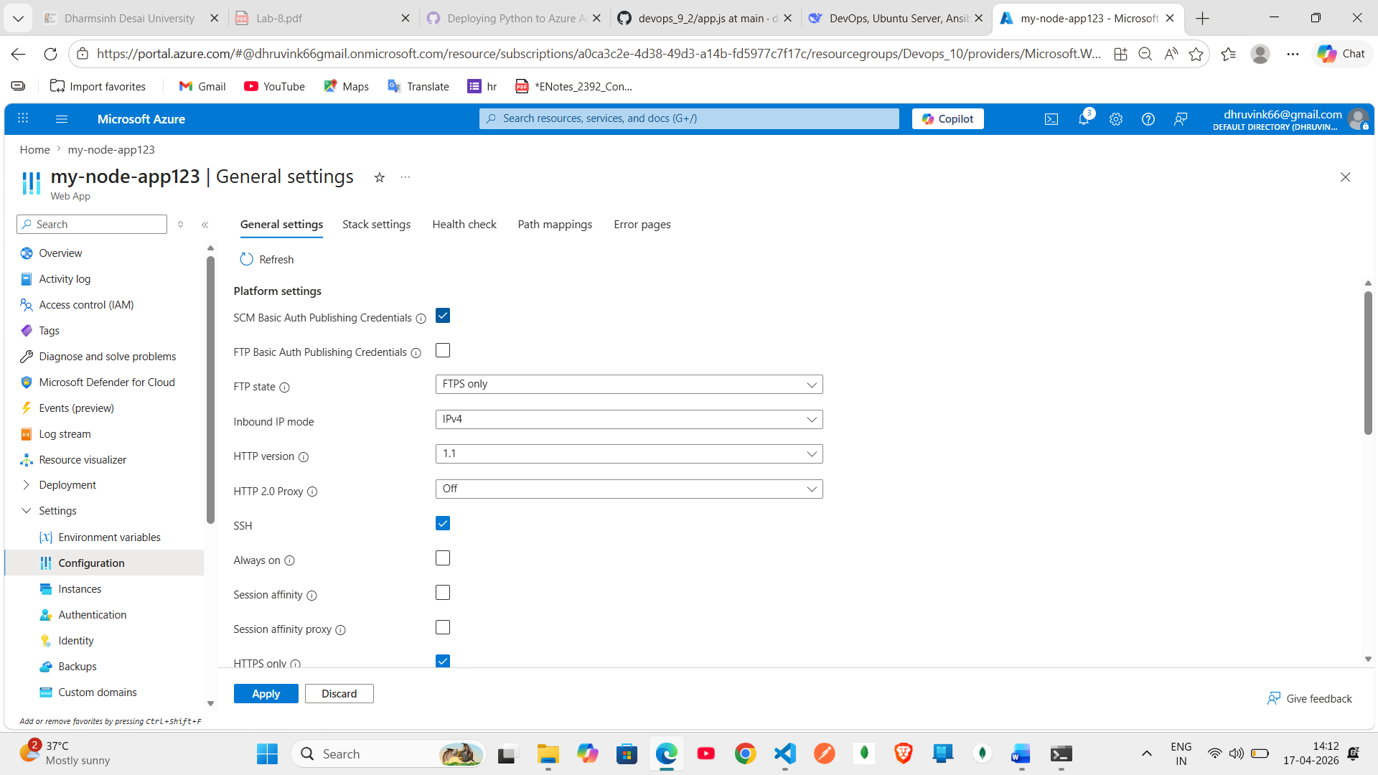
Step-5 add in env var

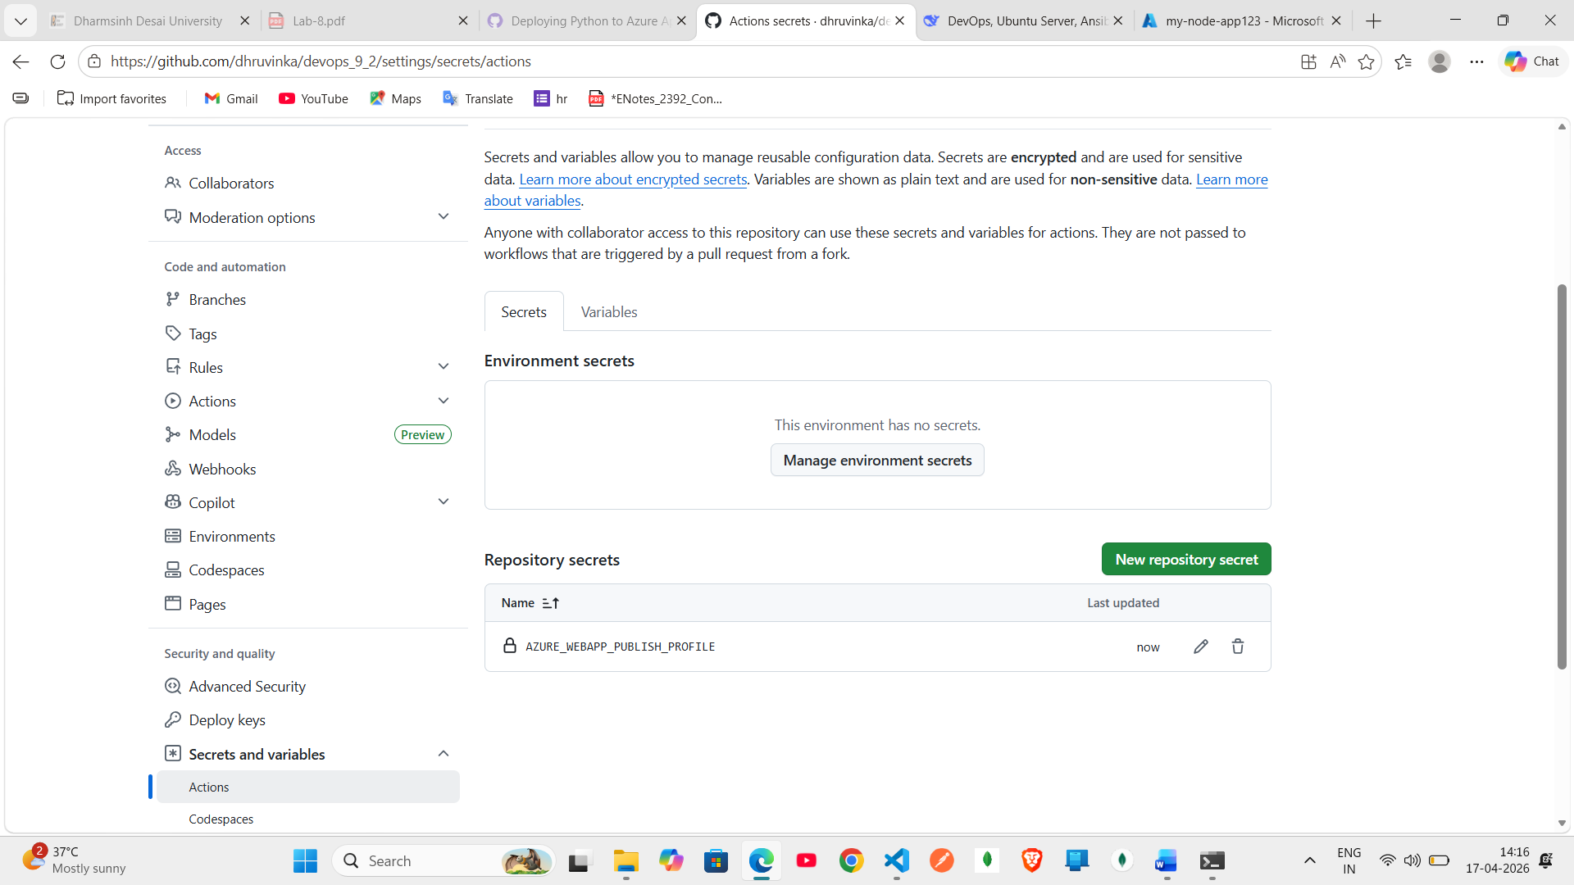

Step-6 : go to action selct deploy node.js and update name and version
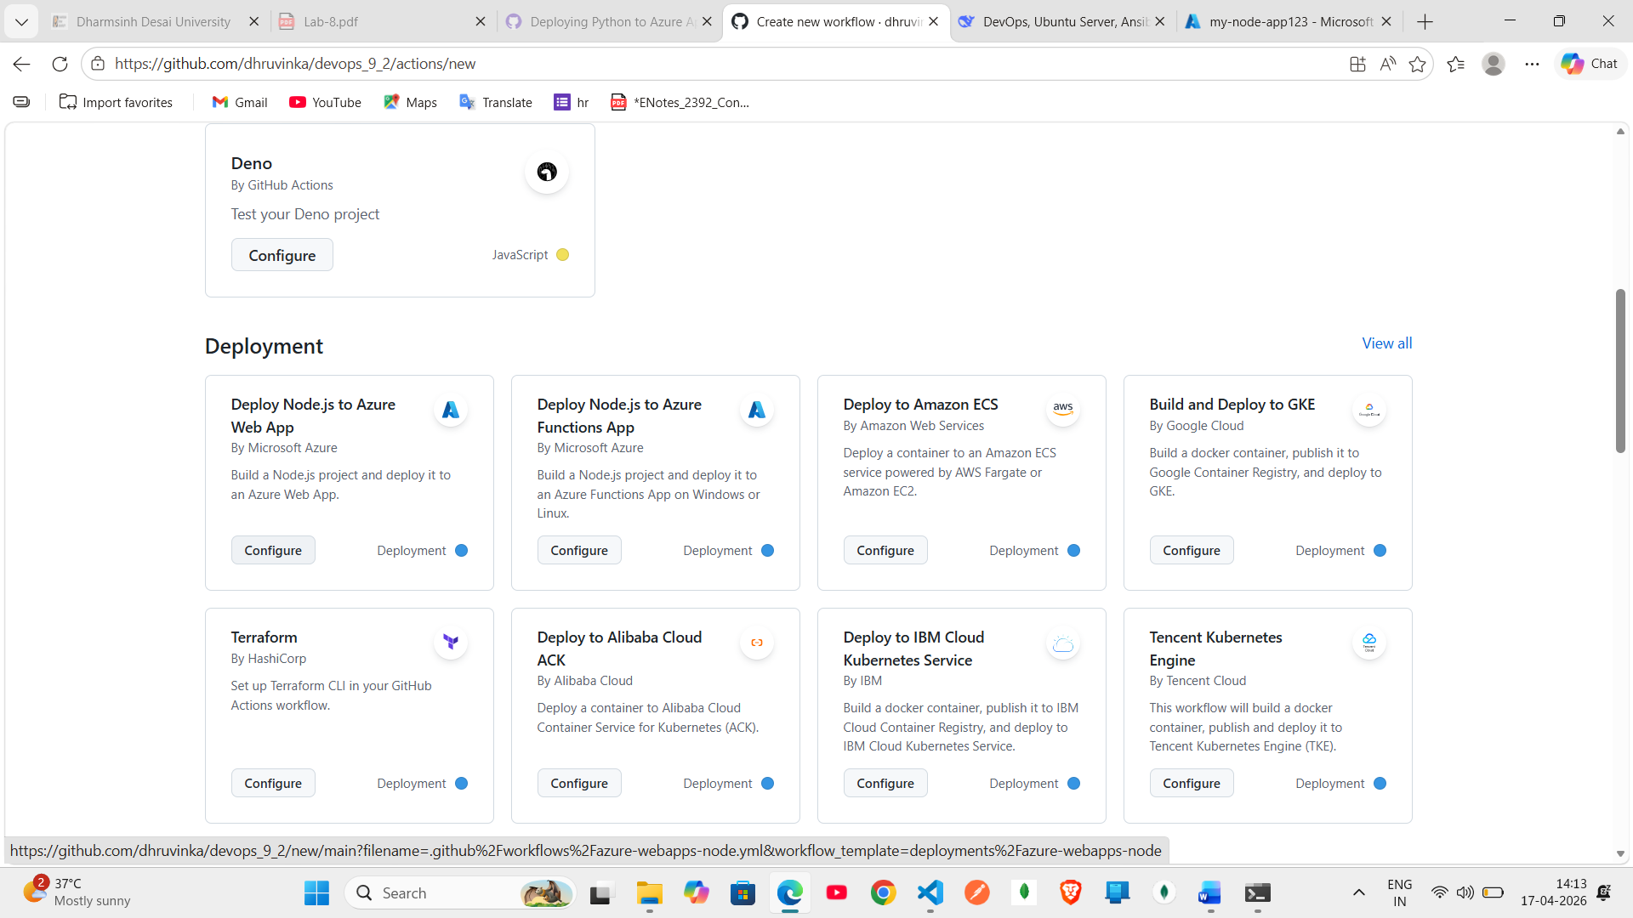

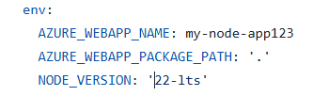
Step-7 : commit and then go to action see left hand side build and deploy
