AI Health Coach — Product Strategy

Microsoft Copilot · Principal PM Case Study · 2026

Contents
EXECUTIVE SUMMARY 2
SECTION 1: GLOBAL HEALTH USER SEGMENTATION 3
Segment A: The Overwhelmed First-Timer 3
Segment B: The Chronic Condition Navigator 3
Segment C: The Burned-Out Busy Professional 4
Segment D: The Performance Chaser 4
Segment E: The Reluctant Re-Starter 5
SECTION 2: PRIORITIZATION MATRIX 6
SECTION 3: THE RECOMMENDATION 7
SECTION 4: PROBLEMS FACED BY CHRONIC CONDITION NAVIGATORS 7
Problem 1: Daily health decisions are made against invisible, simultaneous variables 7
Problem 2: When the day goes off-plan, nothing catches the fall 8
Why these are the right problems to solve 8
SECTION 5: SOLUTIONING 9
Data Availability Assumption 9
What connected data enables and what it does not replace 9
Solution 1: Condition-Aware Daily Nutrition Guidance 10
Feature 1A: The Progressive Health Profile without any Setup Gate 10
Feature 1B: Snap & Analyze — Photo Food Logging with Condition-Aware Feedback 11
Feature 1C: Pre-Meal Decision Support 12
Solution 2: The Adherence System 12
Feature 2A: The Daily Micro-Commitment 13
Feature 2B: Lapse Detection and Compassionate Re-engagement 13
Feature 2C: The Plan Adaptation Engine 14
Feature 2D: Weekly Progress Report. Key performance indicators are outcomes, NOT Metrics 15
SECTION 6: THE MICRO-SIGNALS PERSONALIZATION FLYWHEEL 16
Every interaction captures signals that no form would capture 16
SECTION 7: SCOPE DECISIONS 17
SECTION 8: EVALS ARCHITECTURE — GROUNDED, KIND, BOUNDED 18
Four Layers 18
Layer 0: Feature Extraction (before retrieval, every message) 18
Layer 1: RAG over Controlled Medical Corpus 18
Layer 2: Claim-Level Verification (inference-time gate) 18
Layer 3: Human Review Queue (calibration) 18
Tone Criteria (Run on Every Response — This is Non-Negotiable) 19
RAI metrics 19
SECTION 9: METRICS & SUCCESS MEASUREMENT 19
APPENDIX 20

Citation convention:
Numbered superscripts refer to sources; Superscripts [M1] refer to derived math. Sources and Derived math available in the Appendix section

EXECUTIVE SUMMARY

The gap: 589 million people live with Type 2 Diabetes globally¹ For a patient with HbA1c above target the ADA recommends quarterly check-ins, meaning roughly 4 doctor visits per year²; each averages approximately 15 minutes of face time³ That is 60 minutes of expert guidance against 8,760 hours of daily life^{M1} Between those visits, they make hundreds of daily decisions about food, activity, stress, and sleep completely alone, with no feedback on whether those decisions are actually working.

The bet: Build a conversational AI health coach embedded in Microsoft Copilot that closes this gap not by replacing doctors, but by being present for every decision that happens between doctor visits.

The design principle: The product does not ask users to fit their lives around it. It fits around their lives. Every recommendation is condition-aware, culturally grounded, and built around the constraints and patterns of the specific person not a generic health-conscious user.

The compounding advantage: Unlike every other health app, this product gets meaningfully better every week. Not because users fill in forms but because the product learns from how they interact with it. By Week 4, it knows things about the user that they never explicitly said.

SECTION 1: GLOBAL HEALTH USER SEGMENTATION

Segmentation approach: Need-based and behavioral, not demographic. Who are people by their relationship with their health and NOT age or income bracket.

Segment A: The Overwhelmed First-Timer

Who they are: Just decided to "get healthy", primarily triggered by a life event (a bad checkup, visible weight gain, a wedding, turning 30). They're motivated but don't know where to start.

Global TAM: ~800M active health app users globally⁵

Behavioral signature:
- Googles "how to lose weight fast" and gets 10 conflicting answers
- Downloads multiple health apps, uses them for a few days, abandons them
- Starts a diet Monday, gives up by Thursday
- Wants to exercise but doesn't know what routine fits them

Key frustration: "There's so much advice out there. I don't know what to believe or where to start."

3 Most Pressing Problems:

- Paralysis by information overload: Too much conflicting health advice (Google, Instagram, friends, doctors all say different things). The inability to start is itself the core failure.
- Generic advice that doesn't fit real life. Recommendations that ignore their schedule, food preferences, cultural diet, budget, or physical constraints are useless and quickly abandoned.
- Motivation collapse within 7–10 days. No habit loop is formed, no feedback that progress is happening, no accountability. The initial spike of motivation hits a wall of inertia.

Segment B: The Chronic Condition Navigator

Who they are: Living with a diagnosed lifestyle-linked condition such as Type 2 Diabetes, Pre-Diabetes, Hypertension, PCOS, or Metabolic Syndrome. For them, health management is not optional but is a daily responsibility.

Global TAM: 1.5B+ people globally with at least one chronic metabolic/lifestyle condition⁶

Behavioral signature:
- Sees a doctor every 2-3 months but lives with their condition every single day
- Receives a 1-page diet handout from their doctor that doesn't fit their actual life
- Anxious about making the "wrong" food choice
- Many times, knows what they should do, but struggles to keep doing it
- Desperate for practical, daily, condition-specific guidance

Key frustration: "My doctor tells me what not to eat. Nobody tells me what I should actually eat today, given everything going on in my life."

3 Most Pressing Problems:

- Daily nutrition confusion specific to their condition and not "what should I eat to be healthy" but "what should I eat right now, today, given my blood sugar this morning, the dinner I have tonight, and the fact that I'm Indian and rice is my primary source of carbs. Diet modifications to Brown rice feels achievable but whole wheat pasta or quinoa is ruled out because I don’t know if I will like pasta or quinoa." The question is real, daily, and has no good answer today.
- Adherence collapse after 2–3 weeks. The knowing-doing gap. 80%+ of people with Type 2 Diabetes know the lifestyle changes needed. Fewer than 20% sustain them past 3 months. There is no product that catches the early signs of a lapse and intervenes before the user fully gives up.
- The 2-3 month gap between doctor visits: Their condition changes daily. Their guidance updates every 3–6 months. In between, they are making hundreds of high-stakes decisions completely alone, with no feedback loop.

Segment C: The Burned-Out Busy Professional

Who they are: High-functioning career person, 28–45. Health is a priority in their mind but consistently loses to work, family, and fatigue. They know what to do. They just can't do it.

Global TAM: ~600M addressable knowledge workers globally⁷

Behavioral signature:
- Plans meals and workouts on Sunday, fails to execute by Tuesday
- Stress-eats during crunch periods
- Gym membership unused for 3 months
- Wants a plan that fits an unpredictable schedule

Key frustration: "I know I should be doing better. I just don't have the time or energy to figure it all out every day."

3 Most Pressing Problems:
- No time to plan nutrition — Defaults to whatever is fastest and most convenient (often unhealthy). The cost of deciding what to eat healthy is higher than the cost of eating badly. Reducing the decision fatigue is the unlock.
- No health routine that survives real life — Rigid plans (meal prep every Sunday, gym at 6am every day) fail the moment one thing changes. What they need is a system that adapts to their week, not one that punishes them for missing it.
- Stress as the primary health saboteur — Work stress directly drives poor sleep, emotional eating, and skipped exercise. A health coach that doesn't acknowledge the stress context is not actually helpful.

Segment D: The Performance Chaser

Who they are: Already fit and disciplined. Runs, lifts, cycles. Wants to push further — optimize recovery, break plateaus, improve metrics.

Global TAM: ~200–250M serious fitness enthusiasts globally⁸

Behavioral signature:
- Tracks workouts, macros, VO2 max
- Researches protein timing and periodization
- Frustrated when progress stalls despite consistent effort

Key frustration: "I'm already doing the work. I just want to know what to tweak to keep improving."

3 Most Pressing Problems:
- Plateau with no clear diagnosis. Doing the same workouts but results have stalled. The problem is not effort, instead it is the inability to identify what specifically to change (volume, intensity, nutrition timing, recovery).
- Nutrition optimization is complex: Getting the protein timing right, macro targets, and micronutrient gaps right requires research most people don't have time to do correctly. The gap between "eating healthy" and "eating for performance" is large.
- Recovery mismanagement: Overtraining is as common as undertraining among this segment. Without real-time signals on HRV, sleep quality, and load, they push through when they should rest.

Segment E: The Reluctant Re-Starter

Who they are: Returning to health after a major life disruptions such as post-pregnancy, post-surgery, after a health scare, or after a prolonged period of neglect.

Global TAM: ~150–200M people globally at any given time⁹

Behavioral signature:
- High motivation, but also high fear of doing something wrong
- Lost baseline fitness and starting from scratch physically and emotionally
- Needs structured, confidence-building guidance

Key frustration: "I want to get back to being healthy, but I'm scared. My body has changed and I don't know my limits anymore."

3 Most Pressing Problems:
- Uncertainty about what is physically safe: Post-event, they don't know what exercises are safe, how hard to push, or what foods might interfere with their recovery. This uncertainty causes paralysis. They end up doing nothing because they're afraid of doing the wrong thing.
- Psychological barrier: Shame, fear, and loss of confidence are often more debilitating than the physical limitation. They compare themselves to who they were before. A product that ignores this emotional dimension will fail them.
- Need for progressive, milestone-based structure. Generic plans overwhelm or under-challenge them. They need a program that starts where they are today, not where they were before, and shows clear, small milestones so they can feel progress.

SECTION 2: PRIORITIZATION MATRIX

Scoring Framework (1–5 scale, 5 = highest)

Parameter | What It Measures
Problem Acuteness | How painful and urgent is this problem? Are there real consequences if unsolved?
Daily Engagement Likelihood | How often does this problem surface in the user's daily life?
TAM | How many people globally face this problem?
Underserved by Current Solutions | How poorly do today's apps and tools solve this?
AI Superiority | Can an AI health coach solve this significantly better than what exists today?
Behavior Change Readiness | Is the user motivated and ready to act?
Long-Term Retention Potential | Will solving this keep them coming back for months, not days?
Microsoft Unfair Advantage | Does Microsoft have a structural, hard-to-replicate advantage to serve this segment?

The Matrix
Segment | Acuteness | Daily Engagement | TAM | Underserved | AI Superiority | Motivation | Retention | MS Advantage | TOTAL
A — Overwhelmed First-Timer | 3 | 3 | 5 | 3 | 4 | 3 | 2 | 3 | 26
B — Chronic Condition Navigator | 5 | 5 | 5 | 5 | 5 | 5 | 5 | 5 | 40
C — Burned-Out Busy Professional | 3 | 4 | 4 | 3 | 4 | 3 | 3 | 4 | 28
D — Performance Chaser | 2 | 4 | 2 | 2 | 3 | 4 | 3 | 2 | 22
E — Reluctant Re-Starter | 4 | 4 | 3 | 4 | 4 | 5 | 4 | 3 | 31

A short note on Microsoft's unfair advantages
- Bing can surface real-time clinical guidelines, drug-food interactions, and condition-specific research at marginal cost — the exact information this segment needs daily
- FTE physicians inside Microsoft product teams means clinical accuracy is built in, not bolted on
- Windows distribution reaches this segment in their homes and workplaces without friction
- Azure's FHIR-compliant (Fast Healthcare Interoperability Resources) health data infrastructure provides a credible, secure path to EHR integration that some startups might take years to build

SECTION 3: THE RECOMMENDATION

Chosen Segment: The Chronic Condition Navigator

Specifically: People living with Type 2 Diabetes or Pre-Diabetes

Why this specific condition:
- 589 million diagnosed diabetics globally; 635 million adults with impaired glucose tolerance¹
- Almost entirely lifestyle-driven → behavior change directly moves measurable outcomes
- Daily feedback loop exists (blood sugar, food, activity) → the product can show users it's working
- The gap between what users need (daily guidance) and what they get (4 visits per year²) is critical in this segment

A short note on the Global scope of the product
This is a global product. The target user could be in Bangalore, in Sheffield, in Mexico City, in Lagos. The cultural context differs. What constitutes a "healthy meal" varies radically by region, by cuisine, by income level. The product's photo food logging and dietary recommendations must resolve geographic and cultural context at inference time. "Rajma chawal" in Punjab ≠ "pinto beans with tortillas" in Mexico unlike what you might see in a generic nutritional database. This cultural resolution is a core product requirement.

SECTION 4: PROBLEMS FACED BY CHRONIC CONDITION NAVIGATORS

Problem 1: Daily health decisions are made against invisible, simultaneous variables

The surface-level problem looks like a nutrition question: "what should I eat?" The actual problem is harder. For a person with Type 2 Diabetes, every daily food and activity decision is made against at least three variables. Products in the market today do not surface all three at once.

Variable 1: Real-time condition state. A fasting blood sugar reading of 142 in the morning changes what the right breakfast looks like compared to a reading of 118. A post-lunch reading that is still elevated means something different from one that is trending down. The right choice is not static, but shifts with the number. The problem is that the number lives in a glucose meter, and the advice lives in a separate app and we should them in real time.

Variable 2: Stress as a physiological input, not just a feeling. Anticipatory stress caused by a difficult meeting, a deadline, a family conflict etc triggers cortisol. Cortisol signals the liver to release stored glucose. For a person with T2D, this means blood sugar can rise significantly before they have eaten anything and can remain elevated for hours after a stressor ends. This is not widely understood by patients. Today, nothing connects the emotional state of the person to the clinical state of their blood sugar in real time. The two are tracked in completely separate places, if at all.

Variable 3: Behavioral constraints that repeat and compound. A person who consistently skips lunch when their morning runs long will experience a predictable blood sugar pattern every time: glucose dips mid-afternoon, the body releases cortisol to correct it, blood sugar spikes again, energy crashes. The pattern is knowable. It repeats. And yet no product today catches it, names it, or intervenes before it repeats the next busy day.

These three variables interact. A high morning reading, a stressful afternoon event, and a skipped lunch on the same day create a compounding effect that is worse than any one of them alone. As the Health team of Microsoft Copilot, we have an opportunity to reason about these three variables together!

Problem 2: When the day goes off-plan, nothing catches the fall

The adherence problem in T2D is widely documented. Lifestyle adherence drops sharply within the first few months across multiple studies⁴, and the failure is consistently attributed not to lack of knowledge but to the absence of two things: a shorter (within 24 hrs) feedback loop and a recovery path when things go wrong.

Shorter feedback loop: HbA1c is measured quarterly. But the decisions that move HbA1c happen every few hours. A person with T2D makes dozens of health-relevant choices on any given day, such as what to eat, whether to take a walk, how to handle a stressful hour, and receives no signal on any of them until the next blood test, which is often weeks or months later. Decisions made in a feedback vacuum eventually stop feeling worth making. Not because the person has stopped caring, but because caring without feedback is exhausting in a way that willpower cannot sustain.

Recovery path when the day goes sideways: When a person eats something they shouldn't, or skips the walk they planned, or has a harder day than expected, nothing catches that fall. Apps record it as a calorie overconsumption or a broken streak. The emotional effect is Shame. The behavioral effect is often a spiral, one bad choice becomes evidence of failure, which makes the next bad choice easier to make. We have an opportunity to offer what is actually required – an explanation of what happened physiologically, a specific action to take in the next 30 minutes, and a clear signal that one imperfect meal DOES NOT undo a week of progress.

Why these are the right problems to solve

Solving these problems is what converts a useful product into one people do not leave. The user who sees their blood sugar trend downward over three weeks, despite imperfect meals and stressful days, now has evidence that the product works. Evidence of progress is the most durable retention mechanism that exists. No streak, no gamification, and no reminder can replicate it.

Problem 1 solves: WHAT to do (daily guidance → daily engagement)
Problem 2 solves: AM I GETTING BETTER? + HOW DO I GET BACK?
(feedback loop + recovery path → retention)

A complete behavior change system for the highest-stakes health segment, one that creates daily habit, shows real progress between doctor visits, and never lets a bad day become a reason to give up.

Existing apps are targeting the wrong problem: They built information products such as calorie counters (healthify.me), step trackers (fitbit), meal databases (myfitnesspal) for people who need a lifestyle health copilot to support with micro decisions. Information is not the barrier. Most people with T2D know what they should eat. The barrier is making the right decision today/NOW, with incomplete information, under time pressure, in a stressful week, when the easiest option is often the wrong one.

SECTION 5: SOLUTIONING

Data Availability Assumption

The case study explicitly assumes that data from wearables, EHR systems, and health and fitness apps is securely connected and available to the coach. This assumption is load-bearing because it changes what the product can do on Day 1 and how quickly personalization becomes meaningful. For the Chronic Condition Navigator segment specifically, here is what that connected data actually contains and what it enables:

- From EHR systems: This is the highest-value source for our segment. A T2D patient's EHR contains their HbA1c history (including the most recent reading and the trend over prior visits), their current medication list (Metformin dosage, insulin regimen if applicable, statins, blood pressure medications), comorbidities that constrain advice, and most recent lab panel (fasting glucose, cholesterol, kidney function markers). Without this connection, the coach has to ask. With it, the coach already knows. What this means for the product is that Day 1 advice is clinically grounded even before the user has typed a single message!
- From wearables: Activity levels and step counts provide a baseline for what "movement" actually looks like for this user. NOT what they self-report, but what they DO. Sleep duration and quality are directly relevant
- From health and fitness apps: Historical meal logs, if they exist, give the coach a prior on eating patterns such as meal timing, typical foods, frequency of logging gaps (which are themselves behavioral signals). Prior workout logs establish exercise baseline and any self-reported constraints.

What connected data enables and what it does not replace

With this data, the coach enters Day 1 knowing the user's clinical baseline, their medication context, their sleep and activity patterns, and their EHR-confirmed health goals. For the product, what this means is that the first response is not generic. Instead it is already personalized to a person with HbA1c 7.4, on Metformin, averaging 5,800 steps per day, with a doctor-set target of below 7.0.

What it does not replace is behavioral and lifestyle context. The things that only surface through conversation. Connected data tells the coach what the user's body is doing. However, it does not tell the coach that the user tends to skip lunch when meetings run long, that they find it easier to commit to a walk before 9am than after noon, that they are more likely to follow through on recommendations with the mechanism explained, or that stress from work is the primary driver of their afternoon eating patterns. The two work together: connected data provides the clinical foundation on Day 1 and personalization by gleaning micro-signals based on users’ responses builds the behavioral and lifestyle layer week by week.

Solution 1: Condition-Aware Daily Nutrition Guidance

The job to be done: Help a person with Type 2 Diabetes answer the question "what should I eat right now?" with an answer that is specific to their condition, their cultural diet, their day's context, and their goals.

Feature 1A: The Progressive Health Profile without any Setup Gate

A living profile of the user's health context that builds automatically through every interaction, and NOT through a setup form / First Run Experience/onboarding. The coach is useful from message one. The profile deepens as a natural byproduct of that usefulness.

- Dietary constraints: allergies, vegetarian/vegan/cultural preferences
- Goal: blood sugar control, weight loss, energy improvement, others
- Lifestyle: cooking frequency, typical meal times, eating-out habits

Example of how it works:

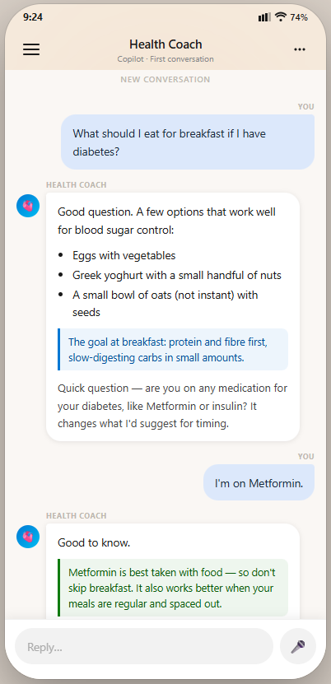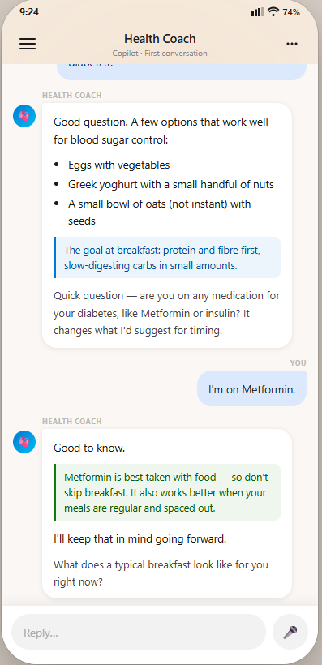

What just happened: The coach answered the question immediately, delivered value before asking anything, and learned two things — the condition and the medication — through a natural exchange. No form. No setup. The profile creation has begun.

Feature 1B: Snap & Analyze — Photo Food Logging with Condition-Aware Feedback

The user takes a photo of any meal. The coach identifies the food, estimates portion sizes, calculates nutrition, and gives feedback specific to their condition and not simply report calorie counts and macro and micro nutrients.

What makes it condition-aware:
- A calorie-counting app tells a diabetic user that a bowl of white rice is "350 calories — 22% of your daily target."
- Copilot Health tells them: "This is about 60g of fast-digesting carbs — it'll likely spike your blood sugar within 30–45 minutes. If you're going to have it, eat the vegetables and protein first. That slows glucose absorption."

Example of how it works:

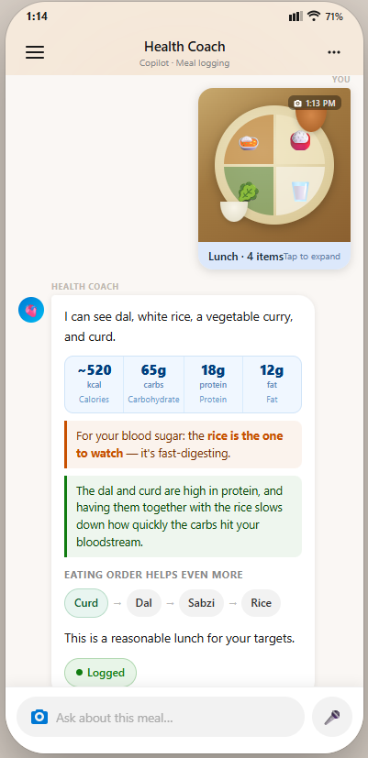

Why Bing is the moat here: Real-time regional food databases, nutritional data from current sources, culturally-resolved meal identification — all served at near-zero marginal cost via Bing infrastructure. Competitors either build static food databases (expensive, always outdated) or pay per search API call at retail rates.

Feature 1C: Pre-Meal Decision Support

Before a meal outside such as a restaurant, a family event, or a work lunch, the user asks the coach what to eat. The coach gives a specific, actionable answer.

Example of how it works:

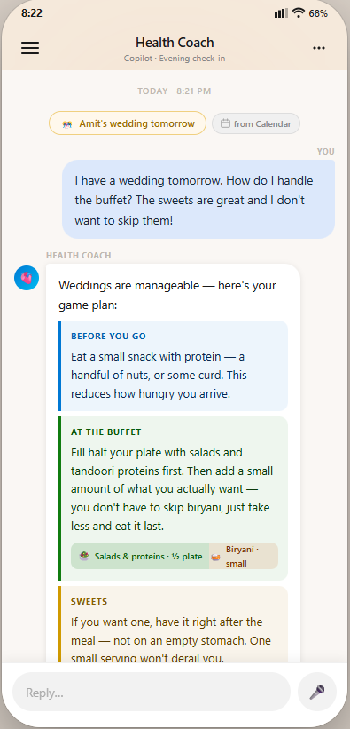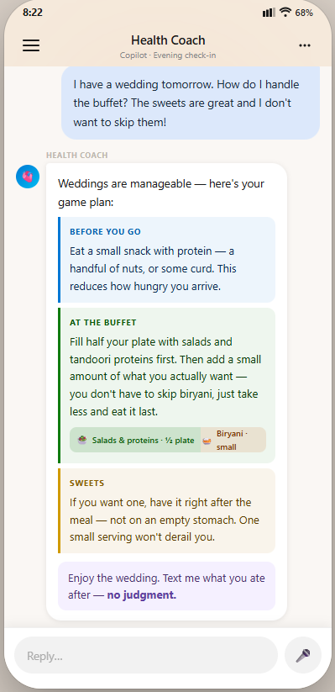

Solution 2: The Adherence System

The job to be done: Detect when the user is starting to slip and before they fully give up, intervene with compassion, not guilt. Then adapt the plan to meet them where they are.

Research on behavior change identifies three moments of failure
- The decision fatigue moment: Too many choices, user defaults to the easiest option
- The setback spiral: One bad day becomes "I've failed, what's the point"
- The plan rigidity trap: The plan can't accommodate real life, so the user can't accommodate the plan

Feature 2A: The Daily Micro-Commitment

Each morning, the coach asks the user for one small, specific commitment for the day. Not a plan. Not a goal. One thing.

Example of how it works:

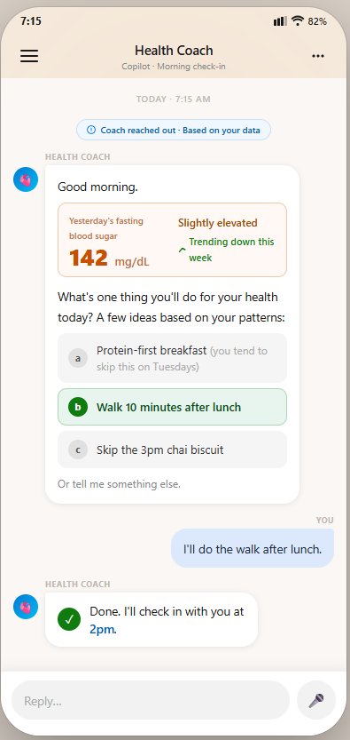

The commitment is chosen by the user, not assigned. This is the key to autonomy and ownership.

Feature 2B: Lapse Detection and Compassionate Re-engagement

The AI monitors behavioral signals to detect early signs of disengagement before the user has consciously given up.

Example signals the system watches:
- No food log for 48+ hours after a habit of daily logging
- Consecutive days of meals that diverge significantly from targets
- No morning check-in for 3+ days
- A spike in blood sugar readings without a corresponding check-in

Example of how it works:

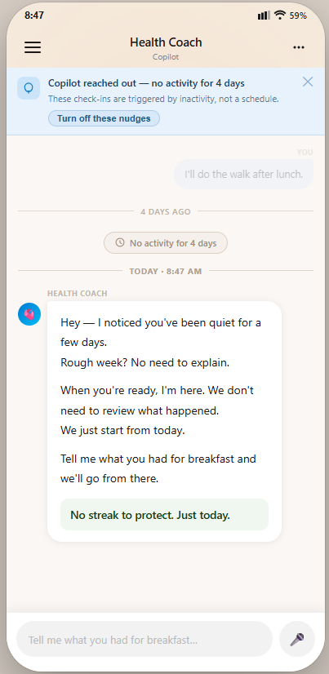

Feature 2C: The Plan Adaptation Engine

When life disrupts the routine, disruptions such as travel, illness, a stressful work period, the plan adapts rather than breaking.

Example of how it works:

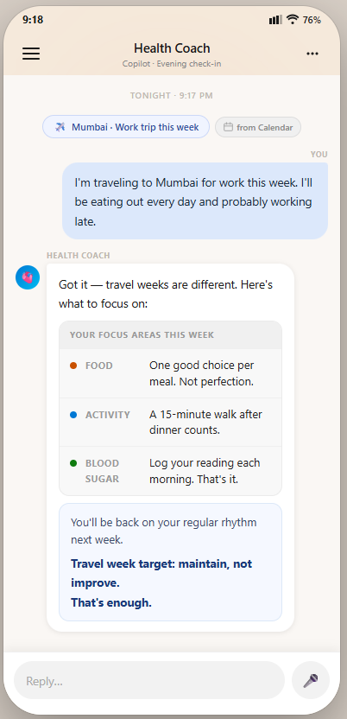

Feature 2D: Weekly Progress Report. Key performance indicators are outcomes, NOT Metrics

What most apps do: "You logged 4/7 days. You hit your calorie target 3/7 days. Your streak is 0."

What Health Copilot does:

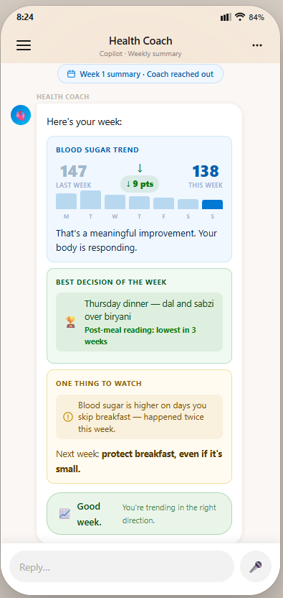

SECTION 6: THE MICRO-SIGNALS PERSONALIZATION FLYWHEEL

Personalization using micro-signals is the core architectural story. It is what separates this product from other existing health apps, and it is what makes "the product gets better with use" a tangible, demonstrable property.

Every interaction captures signals that no form would capture

- Did the user ask "why?" or just act on the recommendation? → coaching style signal
- Did the user engage with the cortisol explanation or skip past it? → depth preference signal
- What constraints did they mention in passing? → no-go area signal
- What does their schedule look like? → timing and availability signal
- How do they talk about stress? → anxiety capture signal

None of this requires a form. It happens during conversation.

WEEK 1 | WEEK 2 | WEEK 4+
Minimum viable context  • T2D, HbA1c, meds  • That’s it  ↓ micro-signals ↓  “Useful Day 1” | Noticeably more personal  • Coaching style adapted  • No-go areas respected  • Stress patterns known  • Calendar context active  “Product is learning” | Coach knows this person’s life  • Breakfast skip pattern  • Walk timing preference  • Stress-to-spike correlation  • Lapse warning signals  “Coach knows me”

SECTION 7: SCOPE DECISIONS

In Scope — Year 1

Capability | Rationale
Conversational daily coaching (T2D / Pre-T2D) | Core use case. Structures the day around a morning micro-commitment, afternoon check-in, and evening reflection
Photo food logging with condition-aware, culturally-resolved feedback | Zero-friction daily engagement driver. No manual entry. One photo closes the loop on the highest-leverage health variable.
Adaptive personalization engine | Profile built through conversation and micro-signals. Never forms. Wearable data (sleep, activity, HR) enriches the signal. Gets meaningfully better every week without the user doing anything extra.
Evidence-grounded, clinician-connected recommendations | EHR-derived goal context (doctor's HbA1c target as the north star). Bing-grounded for lifestyle claims; controlled medical corpus for clinical recommendations. Trust and accuracy at scale.

Out of Scope

What | Why Out
Elaborate onboarding / FRE | Kills Week 1 retention.
Medical diagnostics or treatment recommendations | Regulatory boundary. We are a coach, not a doctor. This line must not blur.
Fitness/workout planning | This is not relevant for our user segment (T2D, pre-T2D)
Real-time Continuous Glucose Monitor (CGM) feedback | Market penetration of CGM is not very deep, yet. Phase 2+
Social / community features | Distraction from core daily value. Personal health is private.
Mental health counseling | Detect and escalate. Do not counsel.
Generic wellness advice (no health context) | Not the use case we're optimizing for.
Medication reminders or dosage advice | Regulatory boundary. Out of scope.

SECTION 8: EVALS ARCHITECTURE — GROUNDED, KIND, BOUNDED

Trust is the product's most fragile asset. A single factually wrong medical claim, a single moment where the coach feels judgmental, a single missed escalation of a mental health crisis can destroy user trust irreversibly. The evals architecture is a product design requirement.

Four Layers

Layer 0: Feature Extraction (before retrieval, every message)
- Named Entity Extraction (NER) and specialized Food Entity Extraction component for food entity extraction that includes geographic + cultural context resolution (note – “thali” means totally different things in Ludhiana, Punjab, India and Trichy, Tamil Nadu, India – hence the recommendation for a specialized Food Entity Extraction component)
- Session context injection: today's glucose reading, stress signals (from calendar integration)
- Longitudinal pattern injection: behavioral features – micro-signals from nightly batch processing
- Output: enriched retrieval query that knows this person, today, right now

Layer 1: RAG over Controlled Medical Corpus
- Corpus: PubMed RCTs, ADA guidelines, WHO, Region specific medical research (e.g ICMR for India-specific medical research)
- Quarterly review of the corpus
- Retrieval: Use keyword search and semantic search (dense vectors) and combine the results using rank based weights

Layer 2: Claim-Level Verification (inference-time gate)
- Generative Evaluator (G-Eval or LLM-as-a-judge) grounding score per atomic claim: Something like [≥3.5 serve, 2.0–3.5 hedge, <2.0 remove]
- Quantitative claims should require exact-match: numbers, percentages, decimals etc must appear verbatim in the source
- Tone G-Eval running in parallel:
  - responses cannot guilt the user,
  - proportional urgency (e.g low urgency – normal coaching, moderate urgency for repeated high readings of blood sugar level and high urgency / escalate for severe symptoms or self-harm intent),
  - forward path present (Note: this is already there in Copilot too – safe to assume that we will get this feature for free)
- Harm classifier

Layer 3: Human Review Queue (calibration)
- Triage messages into the human review queue: e.g 5% baseline sample, 20% for quantitative claims, 100% of user flagged responses
- False negatives caught by human judges are added to the regression eval set to retune the “serve / hedge / remove” thresholds so similar ungrounded claims are blocked going forward.

Tone Criteria (Run on Every Response — This is Non-Negotiable)

Criterion | What It Means
Guilt absence | No language that frames deviation as failure. “Missed,” “failed,” “broke,” “cheat”
Forward path present | Every response ends with something the user can do next. Not what they did wrong.
Urgency proportional | A missed lunch is not a medical emergency. The coach does not treat it like one.

RAI metrics

  - Claim grounding rate (support rate): % of medical claims that are supported by retrieved sources. Quant claims should be supported verbatim
  - Over-refusal rate (false positives): % of safe/answerable questions that got refused or over-hedged (this matters because over tightening of hallucinations reduces usefulness)
  - Escalation accuracy (false negatives must be ~0)
    - Escalation recall: % of true crisis cases escalated (this should be effectively 100%).
    - Refusal precision/recall: for disallowed medical advice boundaries.
  - Calibration of uncertainty (hedging quality): When the model is uncertain, does it hedge appropriately and ask clarifying questions vs. confidently guessing?
  - Citation precision (relevance): % of cited sources that actually support at least one claim in the answer (human-judged or LLM-judged with spot checks).
  - Tone safety metrics:
    - “Felt judged” rate (user-reported – we need to build a UX for the user to give this feedback)
    - Automated tone violations: guilt language, disproportionate urgency, no forward path.

SECTION 9: METRICS & SUCCESS MEASUREMENT

The AI Health Coach will be explicitly optimized for user engagement and repeat usage. Accordingly, Engagement and Retention will serve as the primary success metrics. Given the nature of an AI‑driven health experience, Responsible AI metrics (outlined the previous section) will be tracked with equal rigor alongside business outcomes.

Business goal | Metric | Definition
Engagement | Users are active for 3+ days in a 7 day period | Users who submitted a prompt and are active for 3 or more days in a 7 day period, active is considered if the user had > 1 intentional action per day
Retention | Week 1 Retained Users | Users who submitted a prompt and returned within the next 7-day window
Retention | Week 4 Retained Users | Users who submitted a prompt and returned within the next 28-day window

In addition to Health-specific engagement/retention and RAI metrics, we need Copilot-level metrics that answer two questions: (1) is Health expanding the Copilot user base (adoption), and (2) is Health improving overall Copilot engagement and retention (incrementality), without simply shifting usage from other Copilot experiences. These should be measured with cohorting (Health users vs. non-Health users, matched on baseline Copilot activity) and, with controlled experiments (feature holdouts / A-B tests).
Copilot-wide metric | Definition (what we measure)
Health user penetration | % of Copilot all-up active users who used at least one Health feature in the last 28 days
Overall Copilot engagement lift (per-user) | Change in total Copilot engagement for users exposed to Health features vs. a comparable control group. This will be measured as – intentional actions per week across all Copilot scenarios.
Overall Copilot retention lift | Change in Copilot week-1 and week-4 retention for users exposed to Health features vs. control. We will look at “any Copilot activity,” not just Health activity.

APPENDIX

A. SOURCES

- “589 million people live with Type 2 Diabetes globally”
IDF Diabetes Atlas (11th edition / 2025)
https://diabetesatlas.org/ [diabetesatlas.org]
(Press page for the 11th edition) https://idf.org/news/idf-diabetes-atlas-11th-edition/ [idf.org]
“635 million adults (aged 20–79) worldwide are living with impaired glucose tolerance (IGT)” https://diabetesatlas.org/data-by-indicator/impaired-glucose-tolerance-igt-estimates-20-79-y/people-with-igt-in-1000s/

- “ADA recommends quarterly check-ins / A1c assessment about every 3 months when not at goal”
ADA Standards of Care (2025), Diabetes Care Supplement
ADA landing page: https://professional.diabetes.org/standards-of-care [profession...abetes.org]
Specific section indicating more frequent (e.g., every 3 months) when not meeting goals:
https://diabetesjournals.org/care/article/48/Supplement_1/S128/157561/6-Glycemic-Goals-and-Hypoglycemia-Standards-of
- “Average doctor visit is ~15 minutes face time”
Tai-Seale, McGuire, Zhang (Health Services Research, 2007)
Europe PMC / full text reference: https://europepmc.org/article/pmc/2254573 [europepmc.org]
- T2D Medication and Lifestyle Adherence. Cramer JA. *A Systematic Review of Adherence With Medications for Diabetes.* Diabetes Care. 2004. Reviewed in: *Adherence to Therapies in Patients with Type 2 Diabetes.* PMC3889324. URL: https://pmc.ncbi.nlm.nih.gov/articles/PMC3889324/
- 800M active health app users globally. Statista (Health & fitness apps topic). https://www.statista.com/topics/9204/health-and-fitness-apps/
- Metabolic Syndrome: ~1.54B adults globally
https://preview-www.nature.com/articles/s41467-025-67268-5.pdf
- Global TAM: ~600M addressable knowledge workers globally https://my.idc.com/getdoc.jsp?containerId=US53760925
- Global TAM of 200M to 250M performance chasers
  - 184M global gym members
  - non gym endurance / outdoor athletes
  - × filtered to disciplined, metric driven, performance oriented users
  - → ~200–250M global Performance Chasers (conservative range)
  - https://zipdo.co/gym-membership-statistics/ https://www.statista.com/topics/1743/running-and-jogging/ https://press.strava.com/articles/strava-releases-annual-year-in-sport-trend https://www.exercise.com/grow/gym-membership-statistics/
- Global TAM: ~150–200M of reluctant restarters

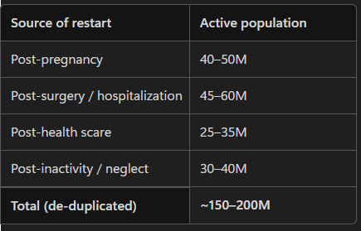

https://www.ejog.org/article/S0301-2115%2825%2900952-2/fulltext https://biologyinsights.com/how-many-surgeries-are-performed-each-year/ https://www.medicalnewstoday.com/articles/deconditioning-syndrome https://www.who.int/news/item/01-02-2024-global-cancer-burden-growing--amidst-mounting-need-for-services https://www.who.int/publications/i/item/9789240096905 https://www.medicalnewstoday.com/articles/deconditioning-syndrome

B. DERIVED MATH

**[M1] Expert guidance hours vs. daily life hours**
```
Annual doctor guidance time:
4 visits × 15 min per visit = 60 minutes per year

Annual hours of daily life:
365 days × 24 hours = 8,760 hours per year

Ratio: 8,760 hours of daily life : 1 hour of expert guidance
= 8,760 : 1
```

Microsoft’s structural advantages

These are structural moats that competitors cannot replicate without years of investment or fundamental changes to their business model.

Bing Search Index — structural cost advantage
Every user query that requires web-grounded health information such as medical research, nutrition data, drug interactions, clinical guidelines, can be served through Bing at marginal cost. Competitors building AI health products must pay retail rates for every search such query. Microsoft's cost per query is structurally lower, which matters at tens of millions of daily active users.

Azure OpenAI Exclusive Commercial Partnership
Microsoft holds exclusive commercial deployment rights to OpenAI models via Azure, accessing frontier model capability at infrastructure cost rather than retail API markup. This compounds the Bing cost advantage and widens the unit economics gap versus competitors.

Windows Distribution — 1B+ monthly active devices
Copilot users have friction-free access to AI health coach without requiring a new app download. Many competitors do not have this surface.

FTE Physicians Inside Product Teams
Microsoft employs medical doctors and clinical researchers as full-time product employees within its health and research divisions. This gives us clinical rigor built in from the inside

Azure FHIR-Compliant Health Data Infrastructure
A credible, secure path to EHR integration that competitors would take years to build.

