DEVICE REQUEST IMPLEMENTATION July-11

Step-1

Give application name

Description

Next- give roles as

Device management

Release management

Dispatch management

End user

Next-select classic and mobile

Next-create a new table by extending the TASK table

Next-give table label—Device Request and auto number

In the manage section manage the access controls to the roles

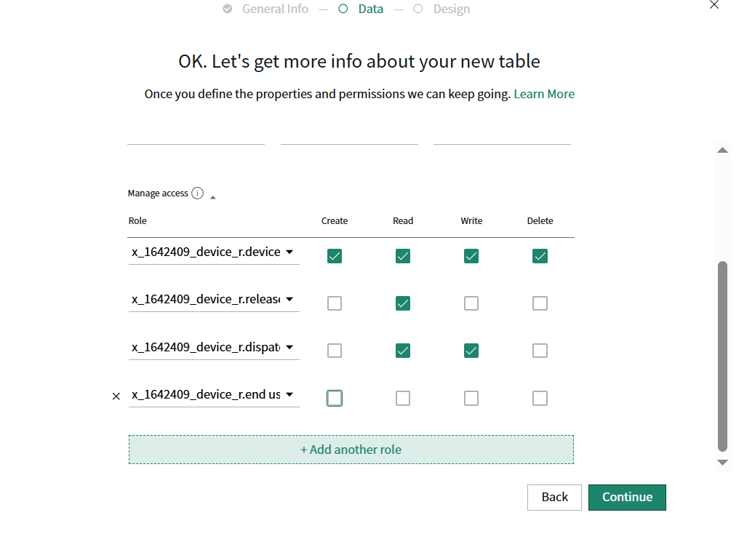

Next-connect our application to the GitLab

--Go to our application and click on the source control and then link to the source control

--next go the gitlab and create a repository and click on the code then copy the https url and paste in the our application

-- for crediantials you need to add your crediantials in the instance on discovery_credentials this table or you can simply search as crediantials in the APP navigator and create your’s

Studio features

--whatever you click on your application it will open in the new tab

-- whatever you want to create you can create by clicking on the create new application there you have all options to create

Step-2

--Now create a Devices table and extend the table with cmdb_ci(configuration item table) because in servicenow the cmdb contains

information about all the significant IT components within an organization, including hardware, software, systems, and even personal

These are the individual IT components that are tracked and managed within the CMDB. Examples include servers, applications, databases, network devices, and even people who are part of the IT system.

Step-3

--for configuring the form of the devices table go to the create new application and in ui forms select the form and table_name(devices) or you can directly configure the form in our instance also

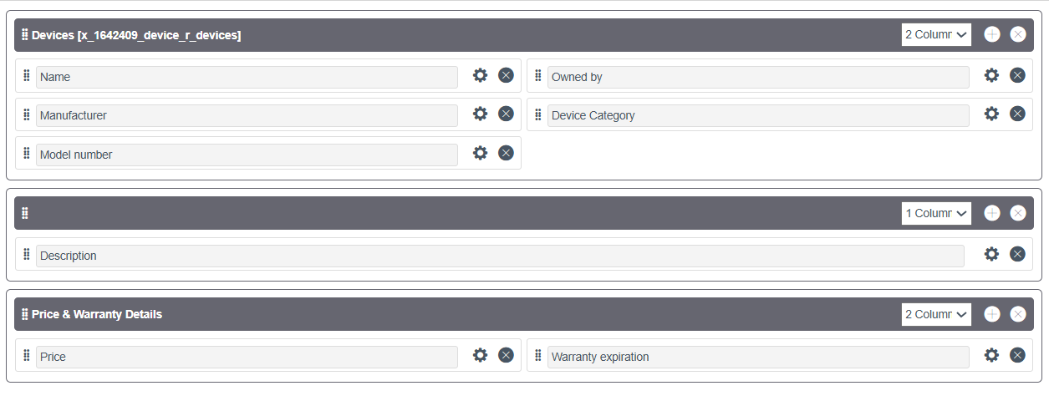

Step-4

Configuring the Device Request table which we created initially

--open the form by clicking the create application file and select the form and then select the table

--configure the form

-- I created the device details section using dot walking but in the class sir created custom fields and then written script for that

--in delivery details section we have 2 fields i.e approvals and assignment group

-- Make the device details section fields read only using the ui policy no from the dictionary override and from the configure dictionary because dictionary override work for the extended table fields not for the dot walking fields

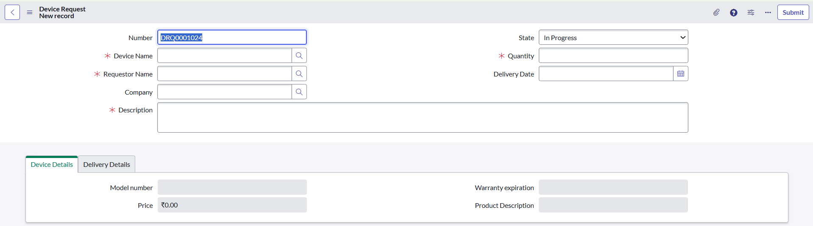

Step-5

We are going to create the catalog and catalog items

--click on the create application file or go to your instance from All navigator you can search maintain items then you can add the items to the catalogs

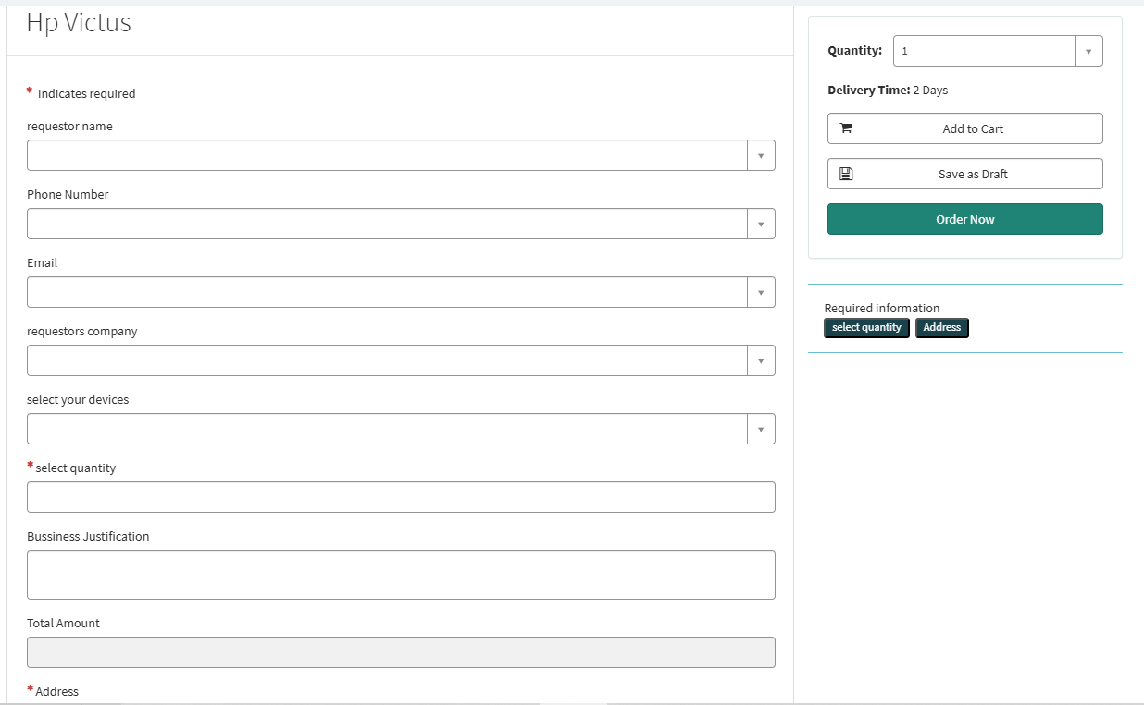

In the above fig requestor name is references by user table,requestors company is referencing by core_company table,select your ideas is referenceing by devices table,remaining are normal variables but for the price we need to write the script for auto populate the price of the item when we select the item from the device table.

We also added the email and phone number which are reference fields

Step-6 Validations of catalog items (Autopopulating values)

For Autopopulating the values in catalog items we have option called AutoPopulate

In which we have 3 fields there are

Dependent Question – on which this is depending means by selecting the item the values to be populate

Reference—selecting the table

Dot Walk Path—select which value you want to populate means which field value

The below fig represent the validation for the select_quantity field , it is work as if any non integer is entered then the alert msg is shown as well as it clears the value

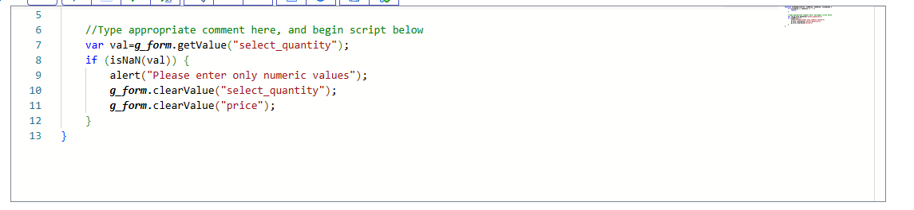

It is a price autopopulate validation when ever you enter the quantity it automatically calculate and then autopopulate values

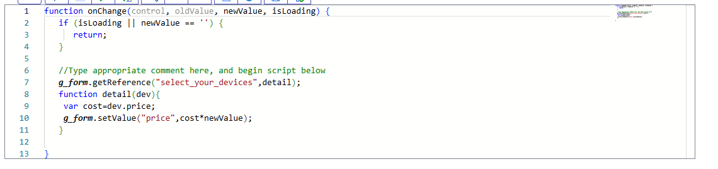

Now we are performing validations on the device request form

--When the device name is empty at the time of loading the sections are disable and when we select the device name and save the form the sections are autopopulate with values

Note—we already done dot walking for the autopopulate the values but if you want to write the script for that you can write by using the getReference()

--we also created a ui policy for the delivery date visible condition is whenever the state is delivered then delivery date is visible otherwise it is hidden ,in this we just used a filter later in the ui action part we written then conditions

--we also created the ui policy for the catalog item for the business justification i.e whenever the quantity is more than the 3 then you mandatorly need to give the reason

Step-7 Flow Designer for the Service catalog

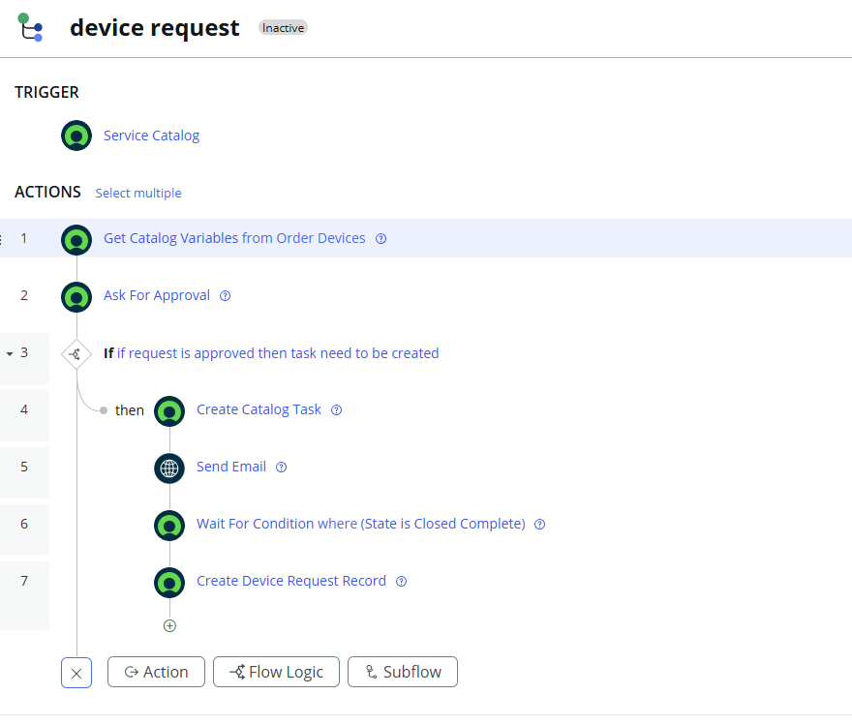

--This is create task action in this if the requested item is approved then one record is created in the task table for this requested item.

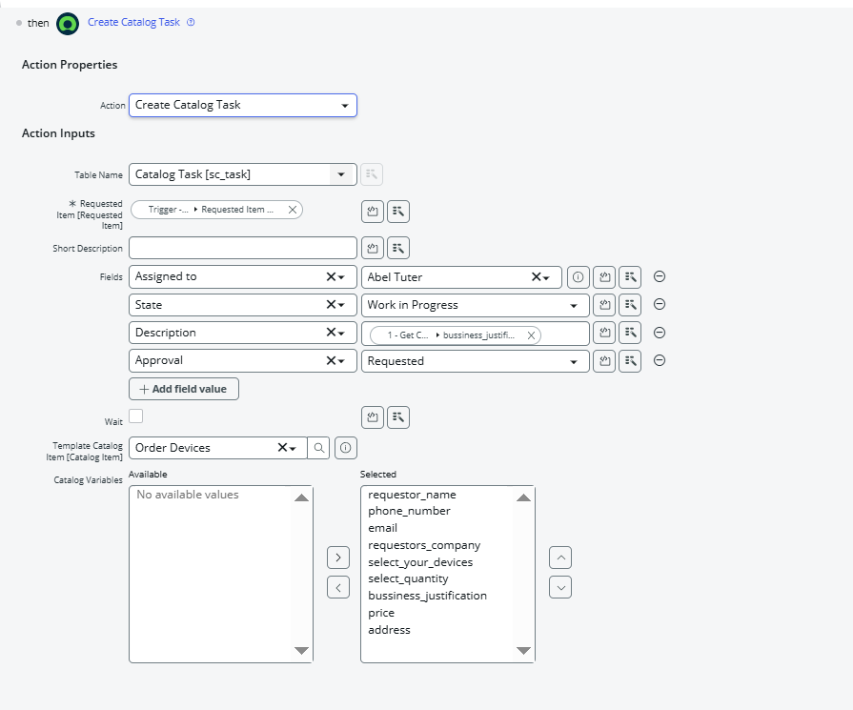

--in this you need to remove the wait check box other wise the flow will wait in the create catalog task step only

NOTE—you need to add your flow to your catalog item-process engine then only it works as on your flow otherwise it work as the default flow