MAILCHIMP

1) Create List

After signup first you have to create a list in which you will add your subscribers.

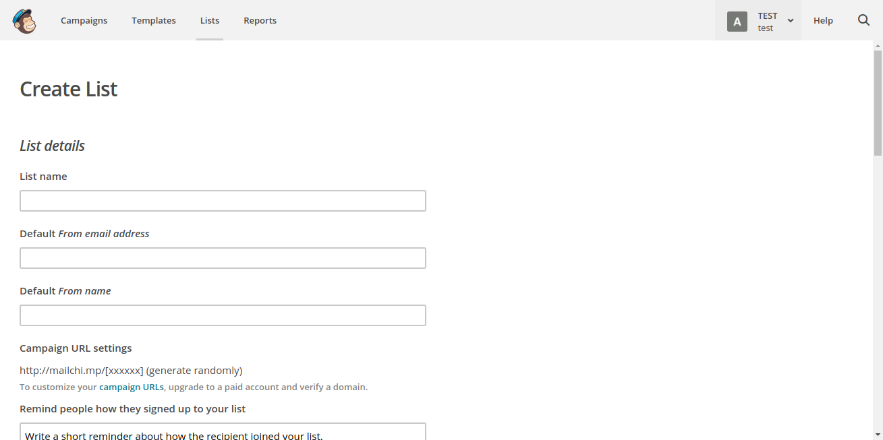

After adding list

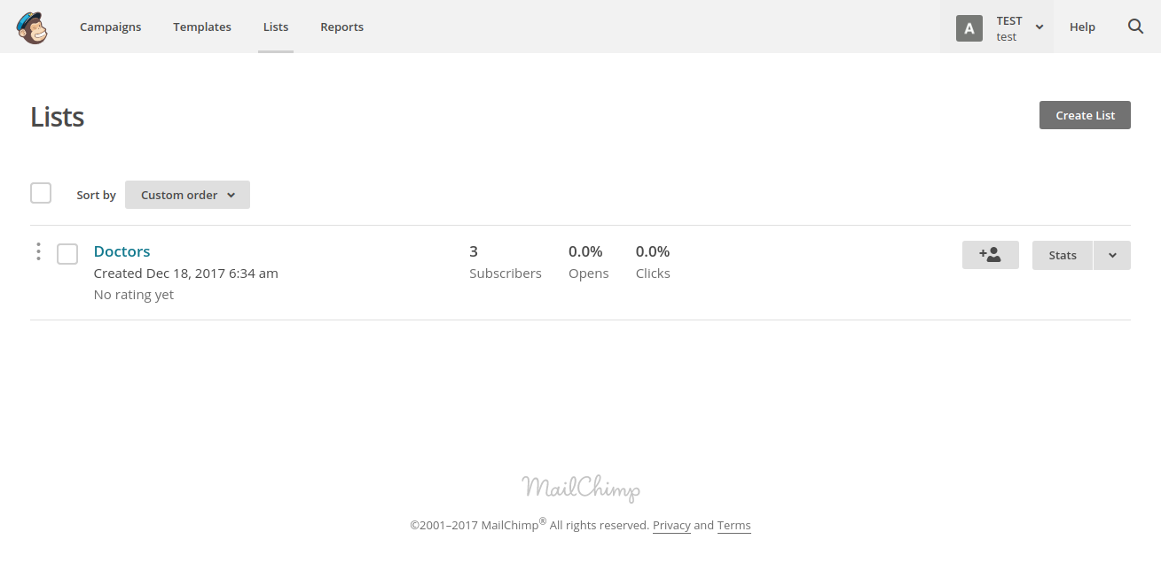

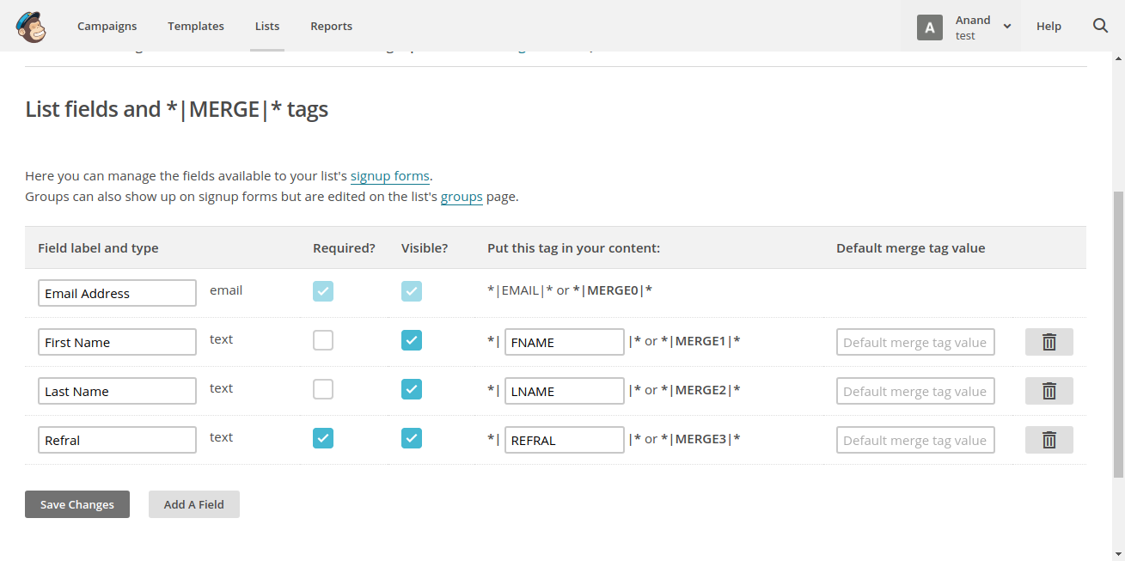2) Add the extra feilds that need to be added other than default feilds. For example:- a new feild refral is added for segmentation.

3) Now we need to add the subscribers.For adding subscribers there are two method add one by one manually or import .csv or .txt file.

i) Add Manually

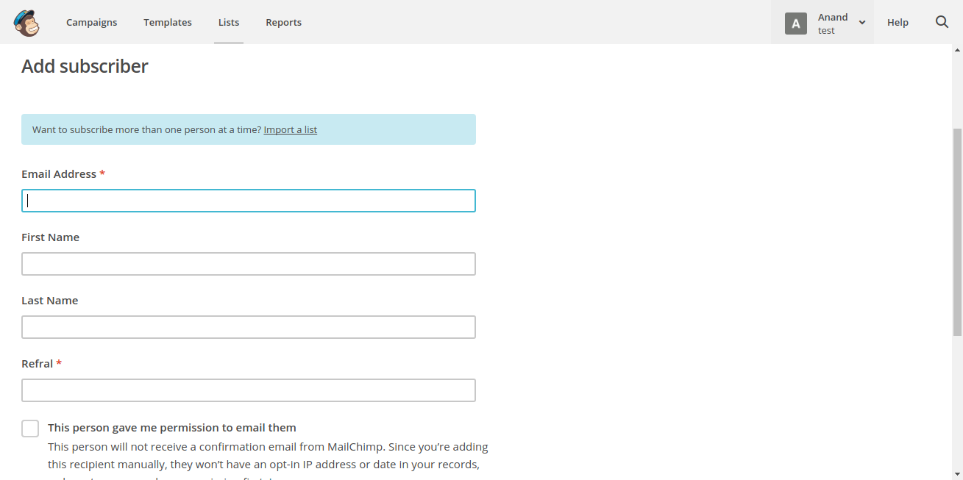

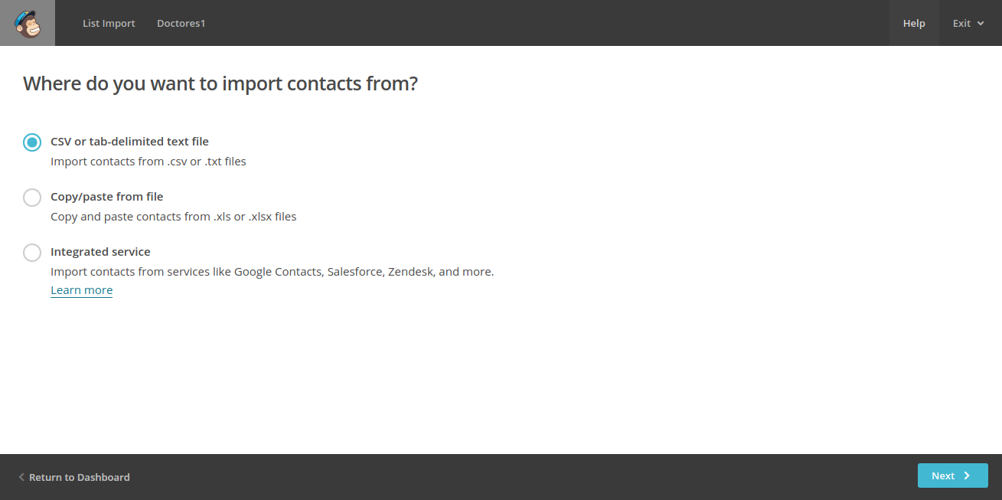ii) Import file

4) Now you can create a sublist or segment in the list according to your conveneince.

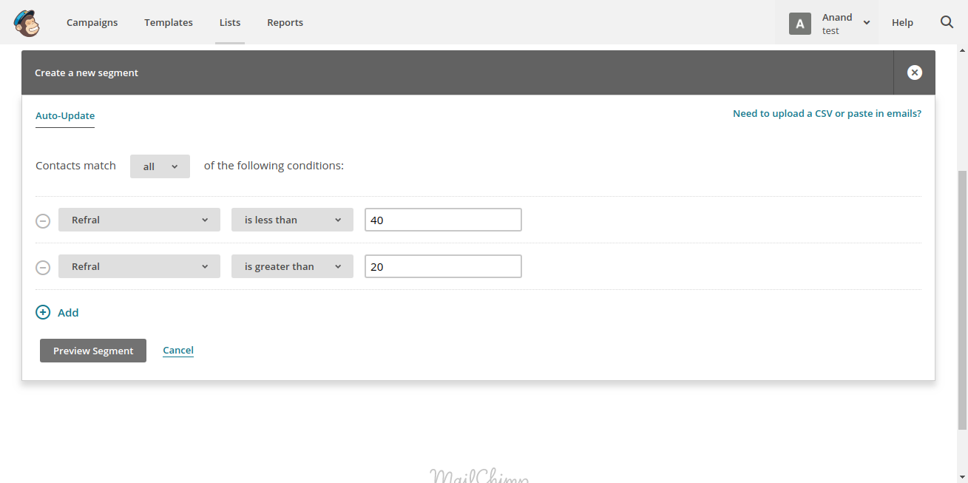

5) After creating segmented lists in your main list you can make auto responders or you can also manually send email to any list you want.

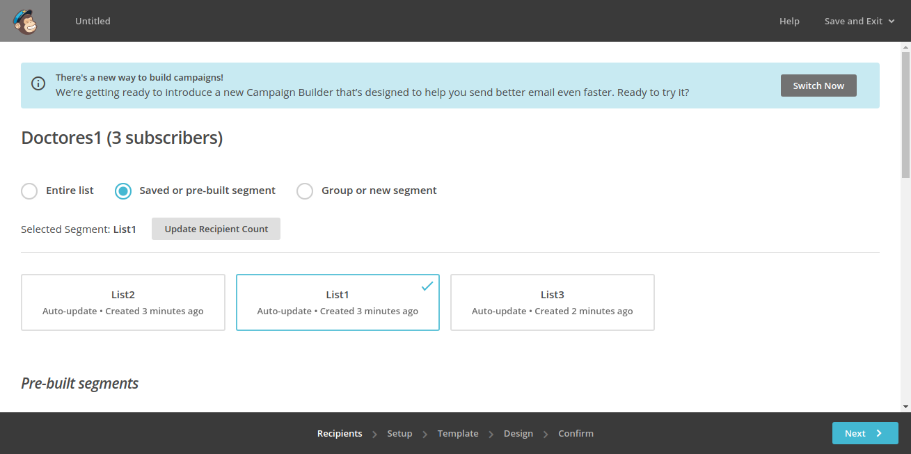

6) After sending a email to a list a campaign of it is made and in the reports section you can see the data like who has opened the mail,number of mails sent etc.

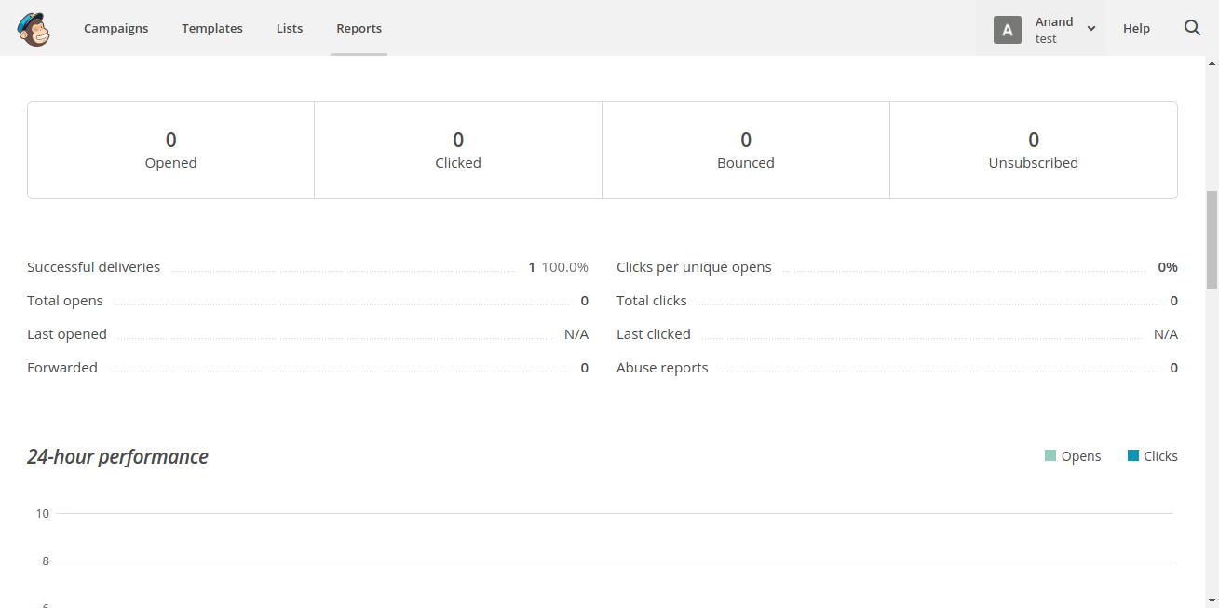i) Overview

ii) Other options

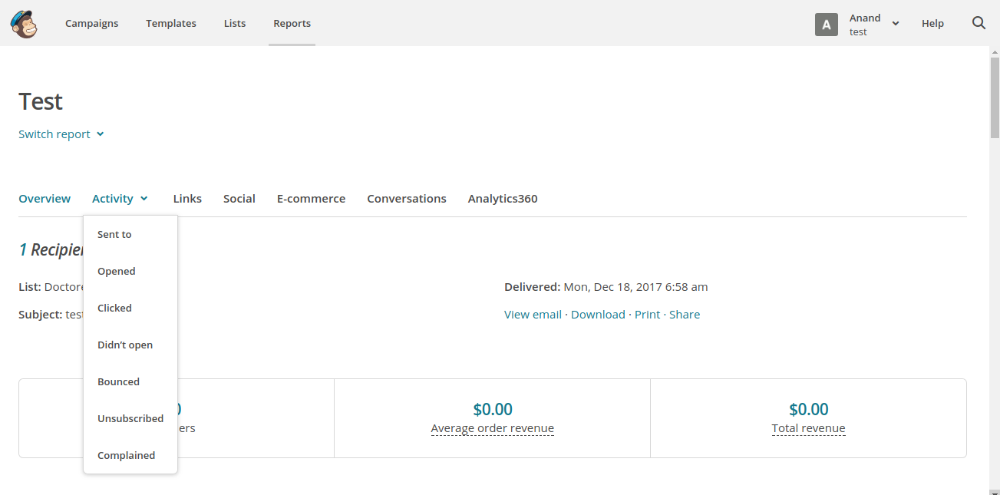

So overall mailchimp is easy to use and it covers all our requirements till now.