1Find 8^3 using power function   
2.Find exponent of 5  
3.Find remainder of 15/7 & 15.7/7  
4.Truncate 125.815 to one decimal position  
5.Truncate 125.815 to -2 decimal places  
6.Round the value 3.147 to 2 digits  
7.Find greatest of three names  
8.Find least of 3 names   
9.Find the absolute value of -3.14

**Answers :**

1. select power(8,3) from dual;  


2. select exp(5) from dual;  


3(a). select remainder(15,7) from dual;  
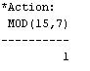

3(b). select remainder(15.7,7) from dual;  
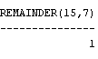

4. select trunc(125.815,1) from dual;  


5. select trunc(125.815,-2) from dual;  
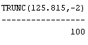

6. select round(3.147) from dual;  


7. select greatest('Anandu','Maddie','Ryan') from dual;  


**8**. select least('Anandu','Maddie','Ryan') from dual;  


**9**. select abs(-3.14) from dual;  
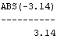

**Date Functions :**

**Questions:**

**1.** Display system date and time using systimestamp() function.  
**2**. Display system time as now using to_char function.  
**3**. Use to_char function to display date and time in different formats.  
**4.** Create a table person with fields name and date of birth (DOB), DOB is of type ‘date’ and populate the table with 5 tuples.  
**5.** Find name, age of each person (months_between)  
**6.** Find person’s name and last date of birth month.  
**7**. Find the name and next day of birth date. (next_day)  
**8**. Create table named account_details, with fields: atm_no, acc_holder, valid_from, exp_date. Populate the table with 10 tuples.   
1. Find out how many months have passed, since Chassie has started an account   
2. Find the account holder who has started the account most recently.  
3. How many days are remaining for Ryan’s atm card to get expired, displayed as ‘days_left’.  
4. The bank has decided to extend the expiry dates for a few of its early customers, all customers who have started their account before jan 1, 2009 gets their expiry date extended by 1 year. Update the database.  
5. Display the current system date as today and show the remaining days for the expiry of each account holder with their names.  
6. Whose atm card has got the greatest deadline for expiry?  
7. The valid from date of Maddie was wrongly entered in the bank it should be replaced with the next day.  
8. Display the details corresponding to all customers whose account were started in the current year.  
9. Using extract function display the expiry year for all the account holders.

**Answers:**

**1.** select systimestamp from dual;  


**2.** select to_char(sysdate, ‘HH:MI:SS') as now from dual;  


3. SELECT to_char(sysdate,'DD-MON-YY hh:MI') as format_1,to_char(sysdate, 'DD-MON-YYYY HH:MI:SS') as format_2 from dual;  
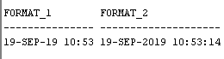

4. create table person(

name varchar2(25),

dob date);  
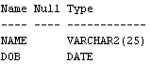  
insert into person values('Prem',to_date('2005/04/30', 'yyyy/mm/dd'));  
insert into person values('Sheeran',to_date('2009/12/12', 'yyyy/mm/dd'));  
insert into person values('Anastasia',to_date('2007/01/12', 'yyyy/mm/dd'));  
insert into person values('Ryan',to_date('2012/07/21', 'yyyy/mm/dd'));  
insert into person values('Anandu',to_date('2003/05/03', 'yyyy/mm/dd'));

select * from person;  
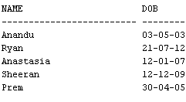

5. select name,round(months_between(TRUNC(sysdate), dob)/12) as age from person;  
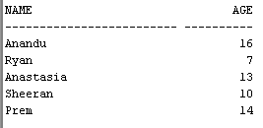

6. select name,1+trunc(last_day(dob))-trunc(dob,'MM') as last_day_of_month from person;  
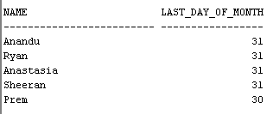

7. select name,add_months( to_date(dob,'dd-mm-yy'), 12 )-1 as next_birthday from person;  
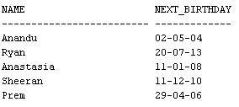

8. create table account_details(

atm_no varchar2(25),

acc_holder varchar2(25),

valid_from date,

exp_date date);  
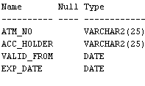

insert into account_details values('123456700','Prem',to_date('2005/04/30', 'yyyy/mm/dd'),to_date('2015/04/30', 'yyyy/mm/dd'));

insert into account_details values('123456701','Sheeran',to_date('2009/12/12', 'yyyy/mm/dd'),to_date('2019/04/30', 'yyyy/mm/dd'));

insert into account_details values('123456702','Anastasia',to_date('2007/01/12', 'yyyy/mm/dd'),to_date('2017/04/30', 'yyyy/mm/dd'));

insert into account_details values('123456703','Ryan',to_date('2012/07/21', 'yyyy/mm/dd'),to_date('2022/04/30', 'yyyy/mm/dd'));

insert into account_details values('123456704','Anandu',to_date('2003/05/03', 'yyyy/mm/dd'),to_date('2013/04/30', 'yyyy/mm/dd'));

insert into account_details values('123456705','Maddie',to_date('2005/04/30', 'yyyy/mm/dd'),to_date('2015/04/30', 'yyyy/mm/dd'));

insert into account_details values('123456706','Christina',to_date('2011/12/12', 'yyyy/mm/dd'),to_date('2021/04/30', 'yyyy/mm/dd'));

insert into account_details values('123456707','Nessie',to_date('2015/01/12', 'yyyy/mm/dd'),to_date('2025/04/30', 'yyyy/mm/dd'));

insert into account_details values('123456708','Chloe',to_date('2008/07/21', 'yyyy/mm/dd'),to_date('2018/04/30', 'yyyy/mm/dd'));

insert into account_details values('123456709','Chassie',to_date('2003/05/03', 'yyyy/mm/dd'),to_date('2013/04/30', 'yyyy/mm/dd'));

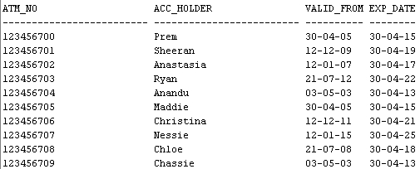

8.1. select round(months_between(TRUNC(sysdate), valid_from)/12) as months_active from account_details

where acc_holder='Chassie';  


8.2 .   
alter table account_details  
add months_active int;

update account_details  
set months_active=round(months_between(TRUNC(sysdate), valid_from)/12);

select acc_holder from account_details where months_active=(select max(months_active) from account_details);  
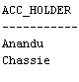

8.3.   
select round(exp_date-sysdate) as days_left from account_details

where acc_holder='Ryan';  
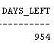

8.4.  
update account_details set exp_date=add_months( to_date(exp_date,'dd-mm-yy'), 12 )-1 where valid_from>to_date('01-01-09','dd-mm-yy');

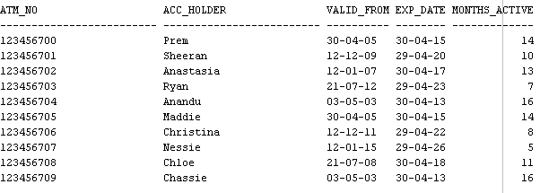

8.5.  
select to_char(sysdate,'dd-mm-yy')as today,round(exp_date-sysdate) as days_left from account_details  
where round(exp_date-sysdate)>0;  
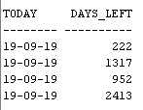

8.6.  
alter table account_details  
add day_till_deadline int;

update account_details set day_till_deadline=round(exp_date-sysdate) where exp_date>sysdate;  
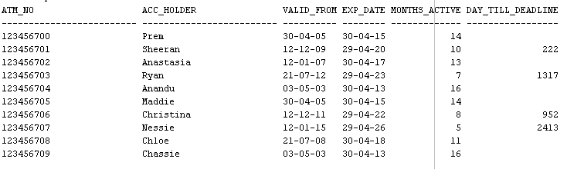

8.7.  
update account_details set valid_from=valid_from+ 1 where acc_holder='Maddie';  
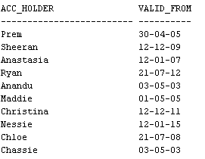

8.8.  
select * from account_details where to_char(valid_from, 'yyyy')=to_char(sysdate,'yyyy'); 

8.9.  
select acc_holder,extract(year from exp_date) from account_details;  
