**String functions and pattern matching**

* Length
* Lower
* Upper
* Concate
* Initcap
* reverse
* Substring
* Instring
* Ltrim
* Rtrim
* lpad
* rpad

**A) Use the system table dual for the following questions:**1. Find the reverse of the string: ‘My name is Khan’.  
2. Use ltrim function on ‘123231xyztech’ so as to obtain the o/p ‘tech’.  
3. Use rtrim function on ‘computer ‘ to remove the trailing spaces.  
4. Perform rpad on the string ‘computer’ to obtain the output as ‘computerxxxxx’.  
5. Use instring function to find the first occurrence of ‘e’ in the string ‘welcome to kerala’.  
6. Perform initcap function on a given string ‘HeLlO TheRe LofI’.  
7. Find the length of the string ‘Relational database management systems’.  
8. Concatenate the strings ‘julius’ and ‘ceaser’, also concatenate your first name and last names.  
9. Use substring function to retrieve the substring ‘is’ from the string ‘India is my country’.  
10. Use instring function to find the second occurrence of ‘k’ from the last of the string ‘Making of a king’.

**B) Create a table account details fields (acc_no, cust_name, branch_no, phone_no) and populate the table with 10 tuples**1.Find the name of all people whose name start with the alphabet ‘d’.  
2. List the names of all branches containing the substring ‘new’. (insert ‘New Jersey’, ‘new Delhi’, ‘New York’ etc.)  
3. List all the names of customers as cust_name in upper case format.  
4. List the names of the customers where the fourth letter is ‘n’ and the last letter is ‘n’.  
5. List the names starting on ‘d’ third letter is ‘a’, and containing the substring ‘eli’.  
6. List the names, acc_no of people whose acc_no ends in numeric ‘6’.  
7. Update and display the table acc_details so that all cust_names are in upper case format   
8. List the names of all people ending on the alphabet ‘t’,   
9. List all the names in acc_details table in reverse.  
10. Display all the phone numbers including the country code +91. (use lpad function)  
11. Display all the acc_no and account details where the starting alphabet associated with the account number should be removed.  
12. Display the details of all people whose acc_no starts in ‘4’ and the name contains the substring ‘Williams’.

**Answers:**

1. 1. select reverse('My name is Khan') from dual;  
   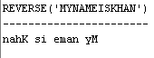  
     
   2. select ltrim('123231xyztech','123231xyz') as trim from dual;  
     
     
   3. select rtrim('computer ') as trim from dual;  
     
     
   4. select rpad('computer',13,'x') as padded from dual;  
     
     
   5. select instr('welcome to kerala','e') as loc_of_e from dual;  
     
     
   6. select initcap('HeLlO TheRe LofI') as init_cap from dual;  
   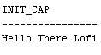  
     
   7. select length('Relational database management systems') as length from dual;  
     
     
   8. select concat('Julius','Ceaser') as concat from dual;  
     
   select concat('Anandu', 'R') as concat from dual;  
     
     
   9. select substr('India is unfortunately my country',7,2) as sub from dual;  
     
     
   10. select instr('Making of a king','k',2,2) as second_occur from dual;  
   
2. create table acc_details(acc_no int,cust_name varchar2(25),branch varchar2(25), pho_no int);  
   insert into acc_details values(123456,'Anandu','New Delhi',1234567890);

insert into acc_details values(143457,'Dani','New Jersey',123452310);

insert into acc_details values(143358,'Clara','New York',122452310);

insert into acc_details values(243358,'Nikhit','Amristar',122453310);

insert into acc_details values(243350,'Afthab','Kochi',122353310);

insert into acc_details values(241750,'Alphonse','Padmi',122353333);

insert into acc_details values(211750,'Stebin','Venice',144323333);

insert into acc_details values(222156,'Kennith','Queens',1342333332);

insert into acc_details values(222956,'Santhosh','Serengeti',6342333332);

insert into acc_details values(221142,'Aishwarya','Hong Kong',8942333332);  
insert into acc_details values(123123,'Anandan','Kerala',1231231231);  
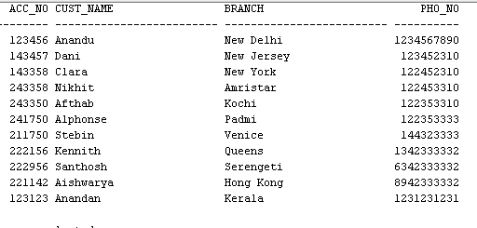  
1. select cust_name from acc_details where cust_name like 'D%';  
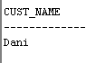  
  
2. select branch from acc_details where branch like '%New  
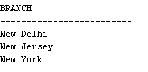  
3. select upper(cust_name) as cust_name from acc_details;  
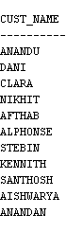  
  
4. select cust_name from acc_details where cust_name like '_n%n';  
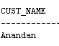  
  
5. insert into acc_details values(193123,'Dia Elizabeth','Kydrabad',123132231);  
select cust_name from acc_details where cust_name like 'D_a%Eli%';  
  
  
6. select cust_name,acc_no from acc_details where acc_no like '%6';  
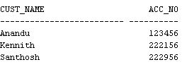

7. update acc_details set cust_name = upper(cust_name);  
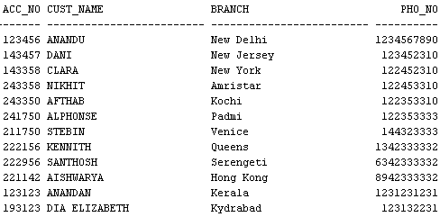  
  
8.