create table angles(

angle int,

sine float,

cos float,

tan float,

cot float,

sec float,

cosec float);

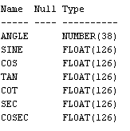

insert into angles(angle) values(0);

insert into angles(angle) values(30);

insert into angles(angle) values(45);

insert into angles(angle) values(60);

insert into angles(angle) values(90);

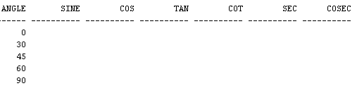

update angles

set sine= ROUND(sin((angle\*(22/7))/180),2);

update angles

set cos= ROUND(cos((angle\*(22/7))/180),2);

update angles

set tan= ROUND(tan((angle\*(22/7))/180),2)

where angle < 90;

update angles

set cot=round(1/tan,2)

where angle>0;

update angles

set sec= round(1/cos,2)

where angle<90;

update angles

set cosec= round(1/sine,2)

where angle>0;

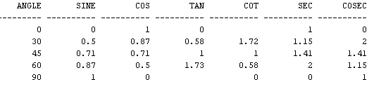

select ceil(8.29) from dual;



select floor(9.76) from dual;



select sqrt(625) from dual;



select least(24,2,3,65,-4) from dual;

