create table book(b_id int,b_auth varchar(25), isbn char(14), b_name varchar(30), publisher varchar(25), bill_no int, category varchar(20), price int);

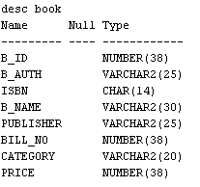

insert into book values (1,’Anandu’,’123Abc78900000’,’ Data Science Beginners guide ‘,’ Google 99901 Education’,’ 749);

insert into book values(1 Anandu’,’123Abc78900001 Coming of hero’,’Martha Hunt’,99902’,’History’,’ 349);

insert into book values( 1 Anandu, 123Abc78900001 Coming of hero,’Martha Hunt ‘, 99902 History,349);

insert into book values(6,'Mark','123Abc78900004','database handling','SJCET',99905,'Education',549);

insert into book values(5,'vanessa','123Abc78900003','To be great','Taylor Swift',99904,'Action',549);

insert into book values(4,'Clara','123Abc78900002','Coming of sun','Martha mark',99903,'History',249);

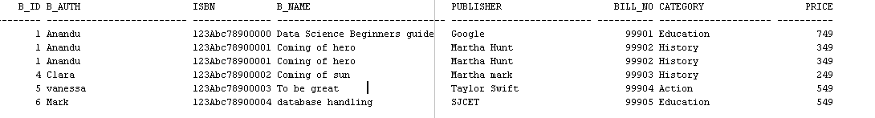

select upper(b_name)as title, upper(b_auth) as author from book where price>500;

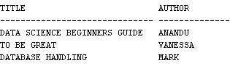

select substr(b_name,0,4),upper(isbn) from book where price between 500 and 1000;

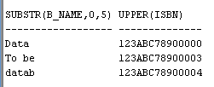

select b_name, length(b_name) from book;

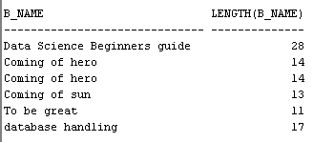

select concat(concat(b_auth,' has written book '),b_name) from book;

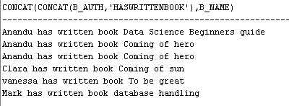

select * from book where b_name like '%data%' or b_name like '%Data%'; 