Create a table named ‘subjects’ with the attributes sub_id, sub_name (both should not be null), populate the table and then alter table to add set sub_id as the primary key.

create table subjects(

sub_id int not null,

sub_name varchar(25) not null);

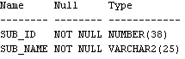

insert into subjects values (1,'Mathematics');

insert into subjects values (2,'Physics');

insert into subjects values (3,'Chemistry');

insert into subjects values (4,'Biology');

insert into subjects values (5,'English');

insert into subjects values (6,'Geography');

insert into subjects values (7,'History');

insert into subjects values (8,'Civics');

insert into subjects values (9,'SUPW');

insert into subjects values (10,'Germen');

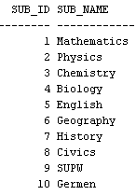

alter table subjects

add primary key(sub_id);



Crate table staff with attributes staff_id(unique), staff_name, dept, age (should be greater than 22), and salary (should be less than 35k).

Print details from staff

Delete check constraint on salary

Delete unique constraint on staff_id

create table staff(

staff_id int,

staff_name varchar(25),

dept varchar(25),

age int,

salary int,

constraint uni Unique (staff_id),

constraint chec1 check (age>22),

constraint chec2 check (salary<35000));



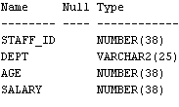

insert into staff values (1,'Anandu','DataScience',25,34990);

insert into staff values (2,'Anastasia','IOT',23,31000);

insert into staff values (3,'Ryan','DataScience',30,21900);

insert into staff values (4,'Christina','Marketing',33,34000);

insert into staff values (5,'Clara','HR',31,12340);

insert into staff values (6,'Maddie','HR',35,15000);

insert into staff values (7,'Ankit','HR',29,32000);

insert into staff values (8,'Megha','Marketing',26,21378);

insert into staff values (9,'Chandrapal','Civil',24,15768);

insert into staff values (10,'Aishwarya','IOT',25,32000);

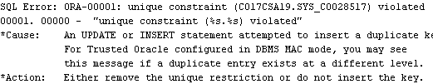

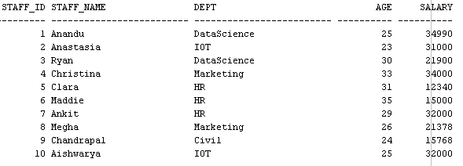

Delete the unique constraint on staff_id

alter table staff drop constraint uni;



Delete the check constraint on salary

alter table staff drop constraint chec2;



3. Create table named bank with attributes : band_code (set as primary key type varchar2(3)), band_name (should not be null), head_office, branches (int >0)

4. Create table branch with attributes branch_id (primary key), branch_name(default new delhi), bank_id (foreign key – from table bank)

Delete the bank with bank_code sbt and make sure that the corresponding entries are getting deleted from tables

Drop the primary key using alter command

create table bank(

bank_code varchar2(3) primary key,

bank_name varchar2(25) not null,

head_office varchar2(25),

branch int,

constraint branch check (branch>0));



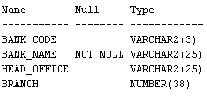

insert into bank values('sbt','State Bank Of Travancore','Trivandrum',1);

insert into bank values('bob','Bank Of Baroda','Thrissur',4);

insert into bank values('pnb','Punjab National Bank','Kollam',6);

insert into bank values('sib','South Indian Bank','Kottayam',7);

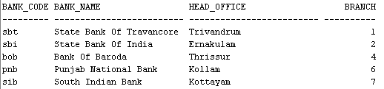

create table branch(

branch_id int,

branch_name varchar2(25) default 'New Delhi',

bank_id varchar2(3),

constraint pk primary key (branch_id),

constraint fk

FOREIGN KEY (bank_id) REFERENCES bank(bank_code) ON DELETE CASCADE

);



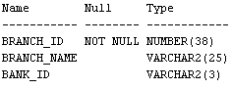

insert into branch values(1,'State Bank Of Travancore','sbt');

insert into branch values(2,'State Bank Of Travancore','sbt');

insert into branch values(3,'State Bank Of India','sbi');

insert into branch values(4,'State Bank Of India','sbi');

insert into branch values(5,'Bank Of Baroda','bob');

insert into branch values(6,'Bank Of Baroda','bob');

insert into branch values(7,'Punjab National Bank','pnb');

insert into branch values(8,'Punjab National Bank','pnb');

insert into branch values(9,'south Indian Bank','sib');

insert into branch values(10,'South Indian Bank','sib');

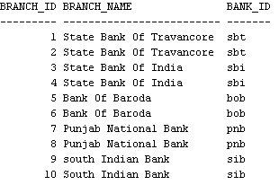

insert into branch(branch_id,bank_id) values(123,'sib');

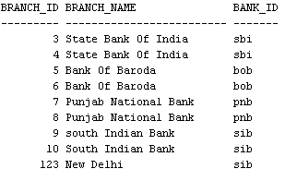

delete from bank where bank_code='sbt';

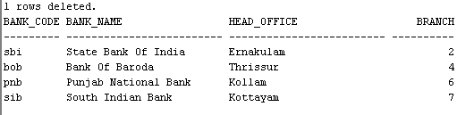

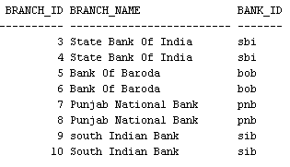

insert into branch(branch_id,bank_id) values(123,'sib');

alter table branch drop constraint pk;



Create a view named sales_staff hold the details of all staff working in HR department

create view sales_staff as select * from staff where dept='HR';

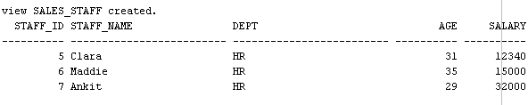

Update the view sales_staff to include the details of staff belonging to HR dept whose salary > 20000

create view sales_staff as select * from staff where dept='HR' and salary>20000;

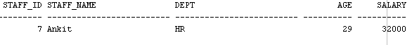

Drop table branch and create another table named branch and name all the constraints as below :

Constraint name

|  |  |  |
| --- | --- | --- |
| Constraint name | Attribute | constraint |
| Pk | Branch_id | Primary key |
|  | Branch_name | Default new delhi |
| Fk | Bank_id | Foreign key |
|  |  |  |
|  |  |  |

create table branch(

branch_id int,

branch_name varchar2(25) default 'New Delhi',

bank_id varchar2(3),

constraint pk primary key (branch_id),

constraint fk

FOREIGN KEY (bank_id) REFERENCES bank(bank_code) ON DELETE CASCADE

);

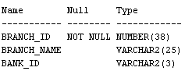

Delete default constraint and primary key constraint using alter

alter table branch drop constraint pk;



Delete the view sales

drop view sales_staff;

