**Join statements, set operations, nested queries and grouping**

**Aim:** To get introduced to

1. Union

2. Intersection

3. Minus

4. Join

5. Nested Queries

6. Group by and having

**Q**. Amazon is one of the largest online stores operating in united states of America, they’re maintaining four tables in their database – the items table, customers table, orders table, and delivery table. Each of these tables contains the following attributes

**item**

|  |  |  |  |  |  |  |  |  |  |
| --- | --- | --- | --- | --- | --- | --- | --- | --- | --- |
| Item_id (pimary key) | Item_name(type =varchar(50) | category | price | Instock (type = int, >=0) |  |  |  |  |  |

**customer**

|  |  |  |  |  |  |  |  |  |  |
| --- | --- | --- | --- | --- | --- | --- | --- | --- | --- |
| Cust_id | Cust_name | Address | State |  |  |  |  |  |  |

**Order**

|  |  |  |  |  |  |  |
| --- | --- | --- | --- | --- | --- | --- |
| Order_id (primary key) | Item_id (foreign key) | Quantity (type=int) | Order_date (type=date) | Delivery |  |  |

**Delivery**

|  |  |  |  |  |  |  |
| --- | --- | --- | --- | --- | --- | --- |
| Delivery_id | Cust_id (foreign key) | Order_id (foreign key) |  |  |  |  |

Create the above tables and populate them with appropriate data.

1 .List the details of all customers who have placed an order

2. List the details of all the customers whose orders have been delivered

3. Find the order date for all customers whose name starts in the letter ‘j’

4. Display the name and price of all items bought by the customer ‘Mickey’.

5. List the details of all customers who have placed an order after jan, 2013 and not received delivery of items

6. Find the item_id of items which has either been ordered or not delivered (use set union)

7. Find the name of all customers who have placed an order and have their orders delivered. (Use SET INTERSECTION)

8. Find the name of all customers who have placed an order but not having their orders delivered. (Use SET MINUS)

9. Find the name of the customer who has placed the most number of orders.

10. Find the details of all customers who have purchased items exceeding a price of 5000$

11. Find the name and address of customers who has not ordered a “Samsung Galaxy S4”.

12. Perform left outer join and right outer join on customers and orders table

13.Find the details of all customers grouped by ‘state’

14. Display the details of all items grouped by category and having a price greater than average price of all items.

CREATE TABLE ITEMS(ITEM_ID INT PRIMARY KEY, ITEM_NAME VARCHAR(50), CATEGORY VARCHAR(50), PRICE INT, INSTOCK INT);

INSERT INTO ITEMS VALUES(101,'Oneplus 6','PHONE',750,7);

INSERT INTO ITEMS VALUES(102,'GALAXY S4','PHONE',250,2);

INSERT INTO ITEMS VALUES(103,'JBL T160BT','HEADSET',50,4);

INSERT INTO ITEMS VALUES(104,'IPHONE CHARGER','CHARGER',10,6);

INSERT INTO ITEMS VALUES(105,'JBL LIVE 500BT','HEADSET',200,1);

INSERT INTO ITEMS VALUES(106,'pOCO F1','PHONE',400,0);

INSERT INTO ITEMS VALUES(107,'VRBOX','ELECTRONICS',150,5);

INSERT INTO ITEMS VALUES(108,'PIXEL 4','PHONE',700,2);

INSERT INTO ITEMS VALUES(109,'SONY MDX110','HEADSET',500,3);

INSERT INTO ITEMS VALUES(110,'LG 4K HDR','TV',1200,6);

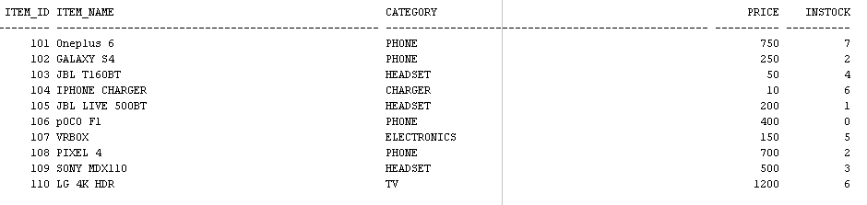

CREATE TABLE CUSTOMERS(CUST_ID INT PRIMARY KEY,CUST_NAME VARCHAR(20),ADDRESS VARCHAR(25),STATE VARCHAR(20));

INSERT INTO CUSTOMERS VALUES(201,'ANANDU R','ERNAKULAM','KERALA');

INSERT INTO CUSTOMERS VALUES(202,'CLARA','LONDON','BRITAN');

INSERT INTO CUSTOMERS VALUES(203,'SUCHITA','KOLAR','KARNATAKA');

INSERT INTO CUSTOMERS VALUES(204,'CHRISTINA','WESTMINISTER','LOS ANGELES');

INSERT INTO CUSTOMERS VALUES(206,'MEGHA','ERNAKULAM','KERALA');

INSERT INTO CUSTOMERS VALUES(207,'CHANDRAPAL','ALAPPUZHA','KERALA');

INSERT INTO CUSTOMERS VALUES(208,'ANKIT','RC APARTMENTS','MADHYAPRADESH');

INSERT INTO CUSTOMERS VALUES(209,'AKANSHA','SR BUILDINGS','MUMBAI');

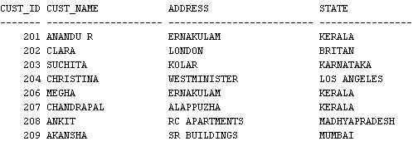

CREATE TABLE ORDERS(ORDER_ID INT PRIMARY KEY,ITEM_ID INT,CUST_ID INT,QUANDITY INT, ORDER_DATE DATE,FOREIGN KEY (ITEM_ID) REFERENCES ITEMS(ITEM_ID),FOREIGN KEY (CUST_ID) REFERENCES CUSTOMERS(CUST_ID));

INSERT INTO ORDERS VALUES(10,101,205,1,'11/05/2010');

INSERT INTO ORDERS VALUES(11,103,201,2,'12/11/2009');

INSERT INTO ORDERS VALUES(12,110,210,1,'15/06/2015');

INSERT INTO ORDERS VALUES(13,102,204,1,'04/04/2014');

INSERT INTO ORDERS VALUES(14,105,209,1,'08/06/2016');

INSERT INTO ORDERS VALUES(15,104,206,3,'12/03/2013');

INSERT INTO ORDERS VALUES(16,101,207,2,'15/07/2011');

INSERT INTO ORDERS VALUES(17,107,202,2,'04/11/2017');

INSERT INTO ORDERS VALUES(18,108,203,2,'30/12/2013');

INSERT INTO ORDERS VALUES(19,110,208,3,'28/10/2010');

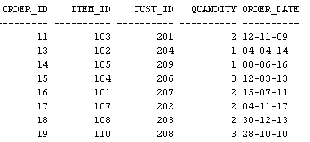

CREATE TABLE DELIVERY(DELIVERY_ID INT PRIMARY KEY,CUST_ID INT,ORDER_ID INT,FOREIGN KEY (CUST_ID) REFERENCES CUSTOMERS(CUST_ID),FOREIGN KEY (ORDER_ID) REFERENCES ORDERS(ORDER_ID));

INSERT INTO DELIVERY VALUES(1001,201,11);

INSERT INTO DELIVERY VALUES(1002,207,16);

INSERT INTO DELIVERY VALUES(1003,208,19);

INSERT INTO DELIVERY VALUES(1005,201,11);

INSERT INTO DELIVERY VALUES(1006,206,15);

SELECT ORDERS.ORDER_ID, CUSTOMERS.CUST_ID , CUSTOMERS.CUST_NAME, ORDERS.ORDER_DATE FROM ORDERS INNER JOIN Customers ON ORDERS.CUST_ID=CUSTOMERS.CUST_ID;

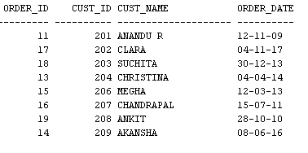

SELECT customers.cust_id, customers.cust_name,customers.address,customers.state from customers inner JOIN delivery ON DELIVERY.CUST_ID=CUSTOMERS.CUST_ID;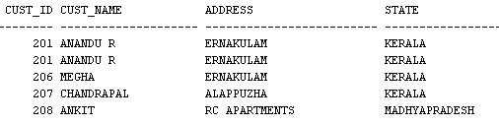

SELECT CUSTOMERS.CUST_NAME, ORDERS.ORDER_DATE FROM ORDERS INNER JOIN Customers ON ORDERS.CUST_ID=CUSTOMERS.CUST_ID where customers.cust_name like 'C%';

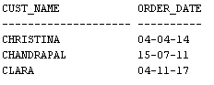

SELECT ITEM_NAME, PRICE FROM ITEMS WHERE ITEM_ID IN(SELECT ITEM_ID FROM ORDERS WHERE CUST_ID IN(SELECT CUST_ID FROM CUSTOMERS WHERE CUST_NAME='ANANDU R'));

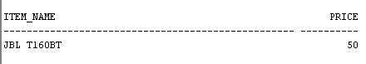

SELECT customers.cust_id, customers.cust_name,customers.address,customers.state FROM CUSTOMERS WHERE cust_id in(select cust_id from orders where extract(year from order_date)>2012);

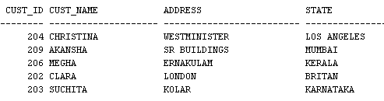

6. Find the item_id of items which has either been ordered or not delivered (use set union)

7. Find the name of all customers who have placed an order and have their orders delivered. (Use SET INTERSECTION)

8. Find the name of all customers who have placed an order but not having their orders delivered. (Use SET MINUS)

9. Find the name of the customer who has placed the most number of orders.

10. Find the details of all customers who have purchased items exceeding a price of 5000$

11. Find the name and address of customers who has not ordered a “Samsung Galaxy S4”.

12. Perform left outer join and right outer join on customers and orders table

13.Find the details of all customers grouped by ‘state’

14. Display the details of all items grouped by category and having a price greater than average price of all items.