Lab 2: Web Fundamentals and Assistive   
Technologies

Semantic HTML, CSS and JavaScript are the core components that make web apps accessible. The testing team has found accessibility defects in your code and asked for the issues to be corrected. Your task is to spot the bad coding and fix it.

# Objectives

In this lab you will:

* Recognize common accessibility issues in web code.
* Apply basic HTML, CSS and JavaScript understanding to fix accessibility issues.

# Instructions

You need to have:

* + Google Chrome
  + Code editor like [Visual Studio Code](https://code.visualstudio.com/)
  + [Colour Contrast Analyser (CCA)](https://www.tpgi.com/color-contrast-checker/)

References to utilize during this lab:

* + [HTML element reference](https://www.w3schools.com/tags/default.asp)
  + [CSS reference](https://www.w3schools.com/cssref/index.php)
  + [HTML events attribute](https://www.w3schools.com/tags/ref_eventattributes.asp)
* Analyze the code using Chrome Inspector.
* Identify the issue in the code.
* Open the file containing the code in Visual Studio Code (or your chosen code editor).
* Correct the code to address the issue.
* Once you've made the necessary changes, save the file as described below.

# Lab Submission

On Brightspace, provide the URL of your published pages

https://YOURACCOUNT.github.io/CST8914-lab2/

# Overall Instructions

* Fork & clone <https://github.com/TouficS/CST8914-lab2>
  + Fork the provided accessible GitHub repository to create your copy.
  + Clone the forked repository to your local machine.
* Add your GitHub repositoryto your favorite
* Publish the forked web page   
  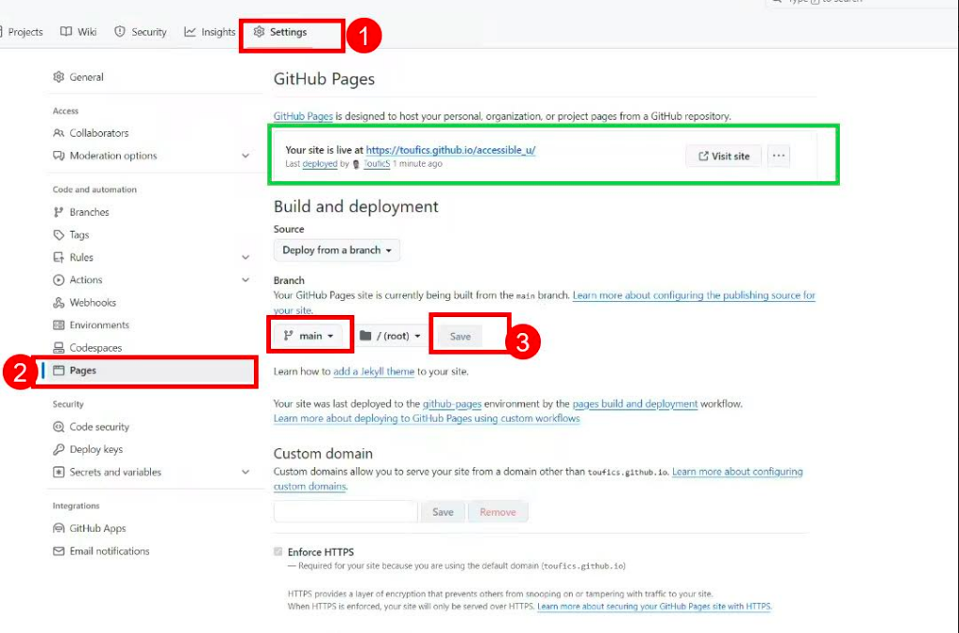

# 

# Question 1- HTML

You are provided with HTML code that contains errors including unclosed paragraph tags, missing image alt attributes, and an unclosed unordered list. These errors can make it challenging for people using assistive technology to properly interpret the content. Your task is to identify and correct these errors in the HTML code.

Once fixed, use the [Markup Validation Service](https://validator.w3.org/) to validate the code (switch to validate by direct input).

# Question 2- CSS

Your code contains an image and a list of links, but their accessibility is currently poor. The image is being used to display text, which can be problematic for users relying on screen readers. Additionally, there is no clear indication that the list items are links, and it's difficult to determine which link the user is currently focused on.

# Question 3- CSS & HTML

The content you have includes a button with improper semantics. Therefore, it is not recognized by screen readers. In addition, the background & text color are hard to see for persons with low vision.

**Tool to practice:** Use Colour Contrast Analyser (CCA) to address the color contrast issue. Select a different color combination that pass the accessibility standards “WCAG 2.1 1.4.3 Contrast AA contrast ratio.” [Tutorial: How to use Color Contrast Analyser (video, 2m 33s)](https://www.section508.gov/training/web-software/andi-training-videos/color-contrast-analyzer/)

# Question 4- JavaScript

You are provided with a button that displays text when the user hovers the mouse pointer over it. Keyboard only users must be able to display the text using the keyboard without needing to use a mouse.