

《编译系统设计实践》

实验三：语法制导翻译与生成中间代码

学号： 031502248
姓名： 左文航
年级： 15级
学院： 数计学院
专业： 计算机

实验时间：2016－2017学年第一学期
任课教师：刘秉瀚
目录
一、实验目的 3
二、实验内容 3
三、设计思路 3
1.算数表达式的翻译 3
2.布尔表达式的回填 4
3.控制流的回填 5
四、代码设计 6
1.函数设计 6
2.流程图 7
五、实验结果 7
第一组测试样例 7
第二组测试样例 8
第三组测试样例 9
第四组测试样例 9
第五组测试样例 11
六、实验心得 12
七、附 12
1. void work3_trainslate(int state, int k) 12
2. void backpatch(string truelist, int M) 18

一、实验目的
通过语法制导或翻译模式生成中间代码。

二、实验内容
理解并应用课本的语法制导定义。
参考课本264页图6-43，课本267页图6-46。
或者课本258页图6-36，图6-37。
在自底向上语法分析基础上设计语义规则（语法制导翻译），将源程序翻译为四元式输出，若有错误将错误信息输出。
实验报告必须包括设计的思路，以及测试报告（输入测试例子，输出结果）。

三、设计思路
利用实验二的自底向上的文法,在规约时,实现算数表达式翻译、布尔表达式的回填、控制流语句的回填。

1.算数表达式的翻译
1.(13)
statement → ident := expression
statnment.nextlist = nextlist
statement.code = gen(top.get(ident.lexme) '=' expression.addr)

2.(5)
const-assignment-list → ident = number $
const-assignment-list.code = gen(top.get(ident.lexme) '=' top.get(number.lexme))

3.(6)
const-assignment-list → const-assignment-list , ident = number $
gen(top.get(ident.lexme) '=' top.get(number.lexme))

4.(31)
expression → expression1 adding-operator term
expression.addr = new Temp()
gen(expression.addr ‘=’expression1.addr adding-operator term.addr

5.(35)
term → term1 multiplying-operator factor
term.addr = new Temp()
gen(term.addr = term.addr multiplying-operator factor.addr)

6.(29)
expression → term $
expression.addr = top.get(id.lexeme)

7.(30)
expression → adding-operator term $
expression.addr = new Temp()
gen(E.addr '=' 'minus' term.addr)

8.(34)
term → factor
term.addr = factor.addr

9.(38)
factor → ident $
factor.addr = ident.addr

10.(39)
factor → number $
factor.addr = number.addr

11.(40)
factor → ( expression ) $
factor.addr = expression.addr

12.(32)
adding-operator → + $
adding-operator.addr = +

13.(33)
adding-operator → - $
adding-operator.addr = -

14.(36)
multiplying-operator → * $
multiplying-operator.addr = *

15.(37)
multiplying-operator → / $
multiplying-operator.addr = /

2.布尔表达式的回填
16.(21)
condition → expression1 relation expression2 $
condition.truelist = makeist()
gen('if' expression1.addr relation.addr expression2.addr 'goto' condition.true)
gen('goto' condition.false)

17.(23)
relation → = $
relation.addr = =

18.(24)
relation → <> $
relation.addr = <>

19.(25)
relation → < $
relation.addr = <

20.(26)
relation → > $
relation.addr = >
21.(27)
relation → <= $
relation.addr = <=

22.(28)
relation → >= $
relation.addr = >=

3.控制流的回填
23.(16)
statement → if condition then M2 statement1 M1 $

backpath(condition.truelist,M.instr2)
backpath(condition.falselist,M.instr1)

statement.nextlist = merge(condition.falselist,statement1.nextlist)

24.(17)
statement → while condition do statement1 $
begin = newlabel()
condition.true = newlabel()
condition.false = statement.label()
statement1.next = begin

gen("goto" begin)

25.(41)
M → ε $
M.instr = nextlist

26.(15)
statement → begin statement-list end $
statement.nextlist = statment-list.nextlist;

27.(19) statement-list → statement $
28.(20) statement-list → statement-list ; statement $
statement-list.nextlist = statement.nextlist

29.(17)
statement → while M1 condition M2 do statement1 M3 $
backpatch(statement1.nextlist,M1.instr)
backpatch(condition.truelist,M2.instr)
backpatch(condition.falselist,M3.instr + 1)
statement.nextlist = condition.falselist
gen('goto' M1.instr)

四、代码设计

1.函数设计
void work3_init()
初始化变量

void work3_open_file()
打开本次作业需要用到的文件

void work3_close_file()
关闭本次作业需要用到的文件

void work3_read()
读入需要分析的代码

int Temp()
生成新的中间变量

void insert_num(char *str,int num)
对输出的字符串串进行插入操作,
当num<0时,表示插入的是id[-num],
当num>10000时,表示插入的是数字number[num-10000]
其他情况下,插入的是 中间变量 tnum.

void work3_solve()
对输入的文法进行自低向上分析

void work3_trainslate(int state,int k)
在规约时,对归约的语句state和当前输入第k个字符进行,进行翻译和中间代码的生成

void backpatch(string truelist,int M)
对于链表 truelist 里所有的 四元式进行回填 ,填入M

void work3_Print()
输出四元式

2.流程图

五、实验结果

第一组测试样例
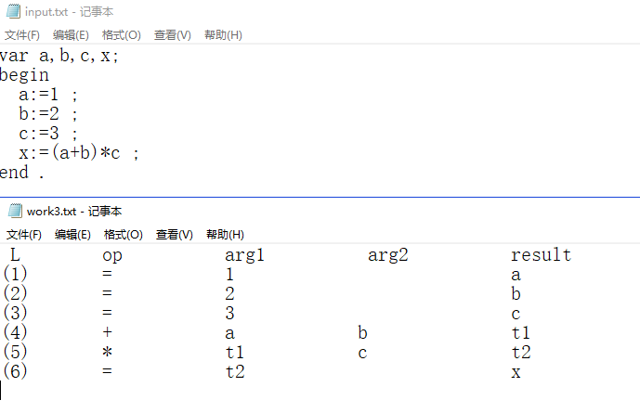

第二组测试样例
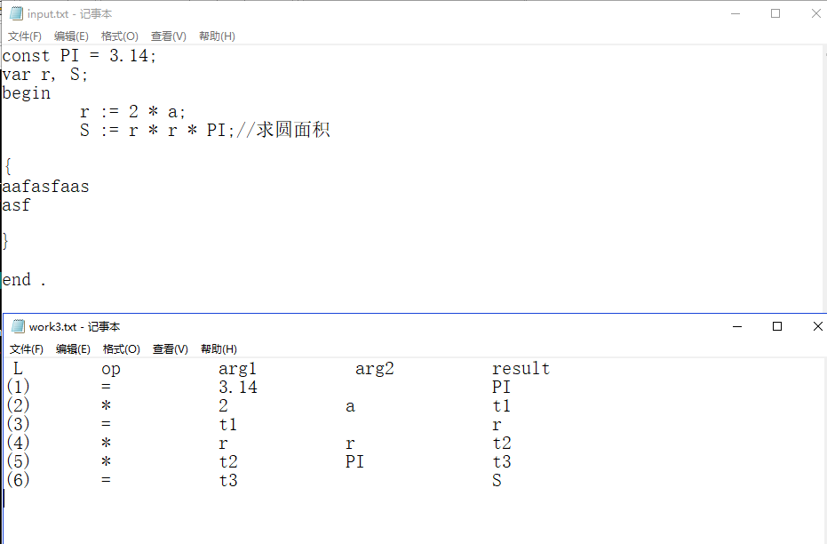

第三组测试样例
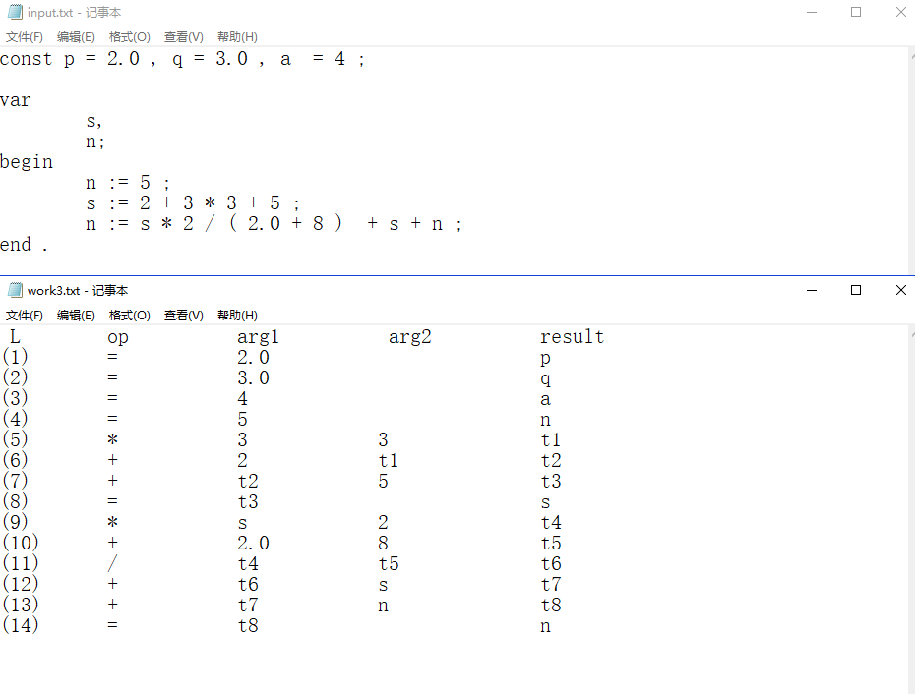

第四组测试样例

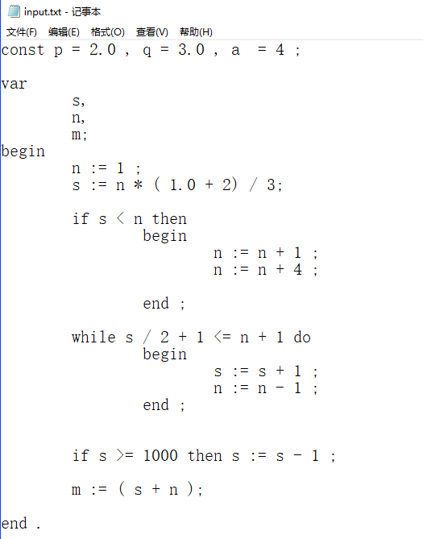
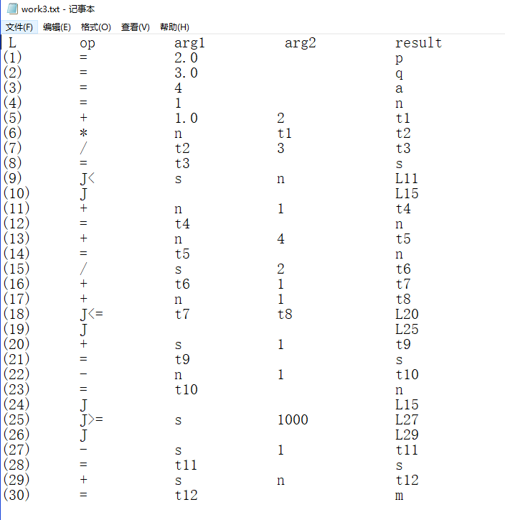

第五组测试样例
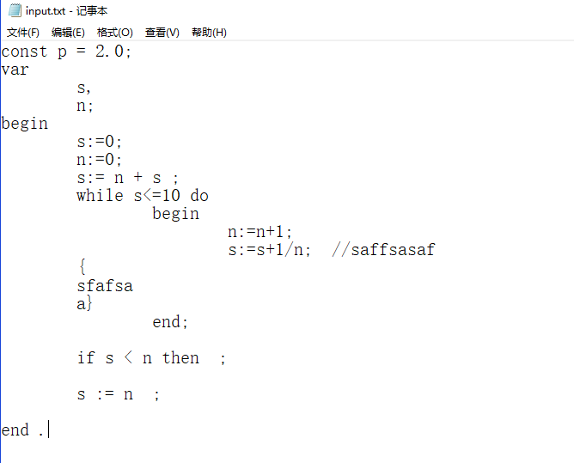
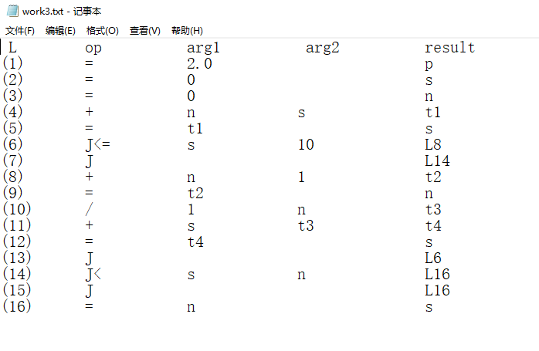

六、实验心得

七、附
核心代码如下:

1. void work3_trainslate(int state, int k)

void work3_trainslate(int state, int k)
{
int op = 10, arg1 = 22, arg2 = 35, result = 50;
char *str = work3_p[p_len];

int id = k, num = k, len;
if (state == 5 || state == 6) //赋值 id = num
{
while (strlen(read_id[id]) == 0)--id;
while (strlen(read_num[num]) == 0) --num;

//op
str[op] = '=';

//arg1
len = strlen(read_num[num]);
for (int i = 0; i<len; ++i) str[i + arg1] = read_num[num][i];

//result
len = strlen(read_id[id]);
for (int i = 0; i<len; ++i) str[i + result] = read_id[id][i];

read_id[id][0] = '\0';

p_len++;
}
else if (state == 13) // id = expression;
{

string next = ""; next += p_len;
statement_nextlist.push(next);

//op
str[op] = '=';

//arg1
int num = expr.top(); expr.pop();
str[arg1] = 't';
insert_num(str + arg1 + 1, num);

//result
while (strlen(read_id[id]) == 0)--id;
len = strlen(read_id[id]);
for (int i = 0; i<len; ++i) str[i + result] = read_id[id][i];

read_id[id][0] = '\0';
p_len++;
}
else if (state == 31) // expression1 adding-operator term
{
int t1 = Temp();
int t2 = expr.top(); expr.pop();
int o = oper.top(); oper.pop();
int t3 = term.top(); term.pop();

str[op] = String[o][0];

//arg1
str[arg1] = 't';
insert_num(str + arg1 + 1, t2);

//arg2
str[arg2] = 't';
insert_num(str + arg2 + 1, t3);

//result
str[result] = 't';
insert_num(str + result + 1, t1);

expr.push(t1);
p_len++;
}
else if (state == 35) //term1 multiplying-operator factor
{
int t1 = Temp();
int t2 = term.top(); term.pop();
int o = oper.top(); oper.pop();
int t3 = factor.top(); factor.pop();

str[op] = String[o][0];

//arg1
str[arg1] = 't';
insert_num(str + arg1 + 1, t2);

//arg2
str[arg2] = 't';
insert_num(str + arg2 + 1, t3);

//result
str[result] = 't';
insert_num(str + result + 1, t1);

term.push(t1);
p_len++;
}
else if (state == 29) //expression = term
{
int t = term.top(); term.pop();
expr.push(t);
}
else if (state == 30) //expression = adding-operator term
{
int t1 = Temp();
int o = oper.top(); oper.pop();
int t2 = term.top(); term.pop();

str[op] = String[o][0];

//arg1
str[arg1] = 't';
insert_num(str + arg1 + 1, t2);

//result
str[result] = 't';
insert_num(str + result + 1, t1);

expr.push(t1);
strcpy(work3_p[p_len++], str); put_i++;
}
else if (state == 34)// term.addr = factor.addr
{
int t = factor.top(); factor.pop();
term.push(t);
}
else if (state == 38)// factor.addr = ident.addr
{
while (strlen(read_id[id]) == 0)--id;
factor.push(-id);

}
else if (state == 39)
{
while (strlen(read_num[num]) == 0)--num;

factor.push(num + 10000);
}
else if (state == 40)
{
int t = expr.top(); expr.pop();
factor.push(t);
}
else if (state == 32 || state == 33 || state == 36 || state == 37) //op = +-/*
{
int o = k;
while (read_op[o] == 0) --o;
oper.push(read_op[o]);
read_op[o] = 0;

}
else if (state >= 23 && state <= 28)
{
int re = G[state][1];
rela.push(re);
}
else if (state == 21) // E1 rep E2
{
string truelist = "";
truelist += p_len;

string falselist = "";
falselist += p_len + 1;

condition_truelist.push(truelist);
condition_falselist.push(falselist);

int rel = rela.top(); rela.pop();
int t2 = expr.top(); expr.pop();
int t1 = expr.top(); expr.pop();

//op
str[op] = 'J';
int len = strlen(String[rel]);
for (int i = 0; i < len; ++i) str[op + i + 1] = String[rel][i];

//arg1
str[arg1] = 't';
insert_num(str + arg1 + 1, t1);

//arg2
str[arg2] = 't';
insert_num(str + arg2 + 1, t2);

//result
str[result] = 'L';
p_len++;

// return;
//goto L

str = work3_p[p_len];

str[op] = 'J';
str[result] = 'L';
// insert_num(str+result+1,p_len);
p_len++;

}
else if (state == 41) //M.instr = nextlist
{
M.push(p_len);
}
else if (state == 16)//statement = if condition then M statement1 M $
{
string truelist = condition_truelist.top(); condition_truelist.pop();
string falselist = condition_falselist.top(); condition_falselist.pop();
int M_list1 = M.top(); M.pop();
int M_list2 = M.top(); M.pop();

backpatch(truelist, M_list2);

backpatch(falselist, M_list1);

string s_nextlist1 = statement_nextlist.top(); statement_nextlist.pop();
string s_nextlist = falselist + s_nextlist1;//merge
statement_nextlist.push(s_nextlist);

}
else if (state == 13 || state == 16)
{
string next = ""; next += p_len;
statement_nextlist.push(next);
}
else if (state == 15)
{
string statement_list = statement_list_nextlist.top(); statement_list_nextlist.pop();
statement_nextlist.push(statement_list);
}
else if (state == 19 || state == 20)
{
string list = statement_nextlist.top(); statement_nextlist.pop();
statement_list_nextlist.push(list);
}
else if (state == 18)
{
string ss = "";
int a = 0;
ss += a;
statement_nextlist.push(ss);
}
else if (state == 17) //statement = while M1 condition M2 do statement1 M3 $
{
string statement1 = statement_nextlist.top(); statement_nextlist.pop();
string ctruelist = condition_truelist.top(); condition_truelist.pop();
string cfalselist = condition_falselist.top(); condition_falselist.pop();

int M3 = M.top(); M.pop();
int M2 = M.top(); M.pop();
int M1 = M.top(); M.pop();
backpatch(statement1, M1);
backpatch(ctruelist, M2);;
backpatch(cfalselist, M3 + 1);

statement_nextlist.push(cfalselist);

cout << "M1 = " << M1 << endl;
char *str = work3_p[p_len];
str[op] = 'J';
str[result] = 'L';
insert_num(str + result + 1, M1);
p_len++;
}
}

2. void backpatch(string truelist, int M)

//回填,truelist填入 goto M
void backpatch(string truelist, int M)
{
int q = M;
int op = 10, arg1 = 22, arg2 = 35, result = 50;
for (int i = 0; i < truelist.length(); ++i)
{
int p = (int)truelist[i];
char *str = work3_p[p] + result;
insert_num(str + 1, q);
}
}

