Q5. The answers provided by the Speaker/Spot seemed credible and believable overall.
Q6. I believe the speaker/Spot provided accurate answers to all of my questions.
Q7. I felt comfortable and at ease throughout my interaction with the speaker/Spot.
Q8. The Speaker/Spot’s responses felt socially appropriate for the situation.
Q9. The speaker/Spot responded in a way that made the interaction feel personal.
Q10. I did NOT enjoy interacting with the speaker/Spot.
Q11. For this question, select the “4” in the following scale
Q12. The Speaker/Spot felt unapproachable during the interaction.
Q13. The speaker/Spot 's communication style did NOT feel natural.
Q14. I believe the speaker/Spot provided wrong answers.
Q15. The speaker/Spot’s responses were coherent and maintained a consistent tone and quality.
Q16. I enjoyed interacting with the speaker/Spot.
Q17. I think the speaker/Spot is approachable.

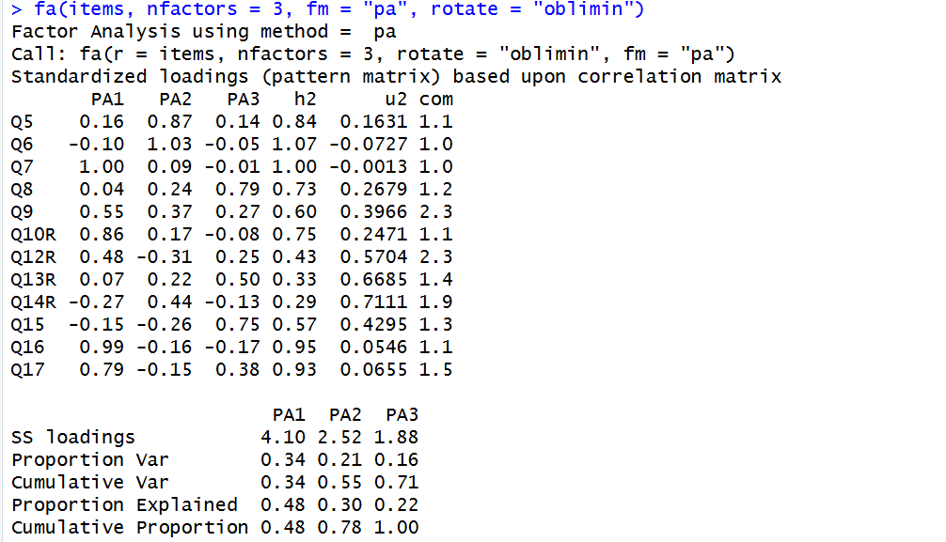

PA1 PA2 PA3 h2 u2 com
Q5 0.16 0.87 0.14 0.84 0.1631 1.1
Q6 -0.10 1.03 -0.05 1.07 -0.0727 1.0
Q7 1.00 0.09 -0.01 1.00 -0.0013 1.0
Q8 0.04 0.24 0.79 0.73 0.2679 1.2
Q9 0.55 0.37 0.27 0.60 0.3966 2.3
Q10R 0.86 0.17 -0.08 0.75 0.2471 1.1
Q12R 0.48 -0.31 0.25 0.43 0.5704 2.3
Q13R 0.07 0.22 0.50 0.33 0.6685 1.4
Q14R -0.27 0.44 -0.13 0.29 0.7111 1.9
Q15 -0.15 -0.26 0.75 0.57 0.4295 1.3
Q16 0.99 -0.16 -0.17 0.95 0.0546 1.1
Q17 0.79 -0.15 0.38 0.93 0.0655 1.5

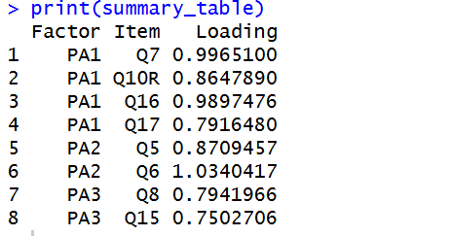

Factor Item Loading
1 PA1 Q7 0.9965100
2 PA1 Q10R 0.8647890
3 PA1 Q16 0.9897476
4 PA1 Q17 0.7916480
5 PA2 Q5 0.8709457
6 PA2 Q6 1.0340417
7 PA3 Q8 0.7941966
8 PA3 Q15 0.7502706

