KLE TECHNOLOGICAL UNIVERSITY, HUBBALLI.
DEPARTMENT OF BACHELORE IN COMPUTER APPLICATION
KLE Society’s


Gate 0 Assessment
Transaction based Ledger and Balance System

BACHELORE OF COMPUTER APPLICATION

Submitted by:
Anannya Bindagi – 01FE24ICA023
Harshita Jujar – 01FE24ICA051
Shwetha Baligeri. -01FE24ICA009
Swapna Rangain – 01FE24ICA029

Under the Guidance of
Prof. Pavankumar Vadavi
Prof. Prajna Bhat

GATE 0

A1) Problem statement with stakeholders named (who is affected, and how)
What problem is the project intended to solve? Who are the stakeholders, who is affected, and how?
1. Problem Statement
Our project is titled Transaction-Based Ledger and Balance System, demonstrated through a Vehicle Rental and Return Ledger.
In a vehicle rental service, maintaining rental and return records manually or separately may lead to errors. For example, a vehicle that is already rented might be rented again, a return might be recorded more than once, or the owner might find it difficult to determine the current availability of a vehicle from previous records.
The proposed system aims to address these problems by maintaining vehicle rental and return transactions in a structured database. It will validate transactions according to predefined rules, preserve the transaction history, and derive the current availability of each vehicle from the accepted rental and return records.
The system is proposed for development. Its correctness will need to be verified through implementation and testing
2. Stakeholders
Stakeholder | Role and how they are affected
Owner/Administrator | Maintains vehicle and customer details, records rentals and returns, and checks vehicle availability. Incorrect records can make rental management difficult.
Customer | May be affected if vehicle availability or rental and return records are incorrect. Customers will not directly operate the application in the proposed scope.
Project Developer | Analyses the requirements, designs the database and application, implements validation rules, and tests the system.
Project Guide/Evaluator | Reviews the requirements, design, implementation, and testing to assess whether the project meets its objectives.

3. Expected Outcome
The proposed system is intended to help the owner maintain organised transaction records, prevent invalid rental and return operations through validation, and determine vehicle availability from accepted transaction history.

A2) AS-IS workflow and TO-BE workflow drawn
1. AS-IS Workflow (Existing Process)
Description
The AS-IS workflow represents the existing process before introducing the proposed system. For this project, we consider an example in which the vehicle owner maintains rental and return records manually in a register and checks vehicle availability
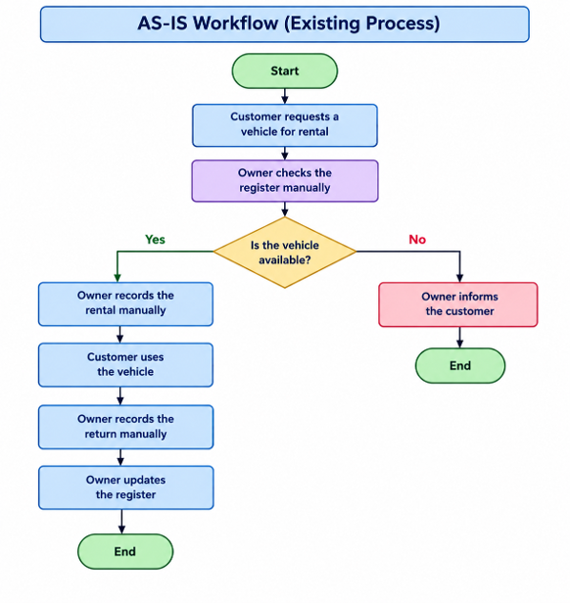

Explanation
- The customer requests a vehicle for rental.
- The owner checks the register manually to determine whether the vehicle is available.
- If the vehicle is available, the owner records the rental in the register.
- The customer uses the vehicle and returns it later.
- The owner records the return and updates the register.
- If the records are incomplete or not updated correctly, the actual availability of the vehicle may be difficult to determine.

2. TO-BE Workflow (Proposed System)

Description
The TO-BE workflow represents the proposed process after developing the Transaction-Based Ledger and Balance System. In this system, the owner will record rental and return transactions through the application. The system will validate the transactions, store accepted records, and derive vehicle availability from the transaction history.

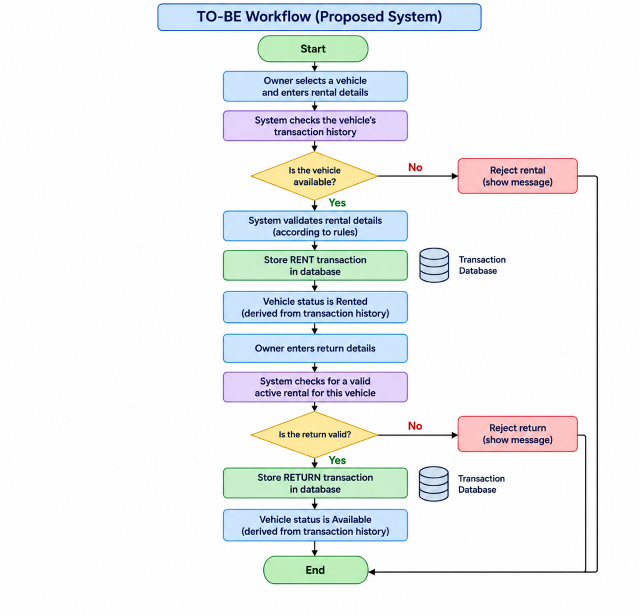

Explanation
- The owner opens the application and selects a vehicle.
- The owner enters the rental details.
- The system checks the vehicle's transaction history to determine whether it is available.
- If the vehicle already has an active rental, the system rejects the new rental transaction.
- If the vehicle is available and the rental details satisfy the predefined rules, the system accepts and stores the rental transaction.
- The system derives the vehicle's status as Rented from the accepted transaction history.
- When the vehicle is returned, the owner enters the return details.
- The system checks whether a valid active rental exists for that vehicle.
- If the return is valid, the system accepts and stores the return transaction.
- The system derives the vehicle's status as Available from the updated transaction history.
- If the return is invalid or has already been recorded, the system rejects it without changing the derived vehicle status.

Difference between AS-IS and TO-BE Workflow
AS-IS Workflow (Current Example Process) | TO-BE Workflow (Proposed System)
Rental and return details are maintained manually in the example process. | Rental and return transactions will be stored in a structured database.
The owner checks vehicle availability manually. | The system will derive vehicle availability from accepted transactions.
Errors may occur if records are not updated correctly. | Predefined validation rules will reject invalid transactions.
Previous transactions may require manual checking. | The owner will be able to refer to the stored transaction history.
The process depends on manual checking and updating. | The application will perform defined checks before accepting transactions.

Conclusion
The AS-IS workflow illustrates the limitations of maintaining vehicle rental and return records manually. The TO-BE workflow describes the proposed system, which will validate transactions, maintain a structured history, and derive vehicle availability from accepted rental and return transactions. The proposed workflow will be implemented and tested during the development phase.

A3) Scope and out-of-scope list; feasibility and risk note
1. Scope
The project, Transaction-Based Ledger and Balance System, will be demonstrated using a Vehicle Rental and Return Ledger.
The system will allow the owner or administrator to:
- Add and maintain vehicle details.
- Add and maintain customer details.
- Record vehicle rental transactions.
- Record vehicle return transactions.
- Validate transactions before saving them.
- Check vehicle availability using previously recorded transactions.
- Display the current status of each vehicle as Available or Rented.
- Maintain transaction history for future reference.
2. Out of Scope
The following features will not be included in this project:
- Customer login or self-service access.
- Online vehicle booking.
- Online payment processing.
- Deposit and refund management.
- Late-fee calculation.
- AI/ML-based predictions or recommendations.
- GPS tracking or IoT integration.
- Advanced fleet management features.
3. Feasibility
The project is technically feasible because it can be developed using Python, Flask, HTML, CSS, JavaScript, and MySQL. These technologies are suitable for building a basic web application with database storage and transaction validation.
The project is also feasible within the available time because it focuses on essential vehicle rental and return operations rather than advanced features.
4. Risks and Limitations
- Incorrect transaction details may lead to incorrect vehicle status.
- Invalid or duplicate rental and return transactions must be rejected.
- Database errors may affect transaction storage.
- The system's accuracy depends on the correctness of the information entered by the owner.
- The project will demonstrate basic rental and return management and will not cover every feature of a commercial vehicle rental system.

A4) Integration Map v1 — which of the five course areas will appear, and where
Integration Map v1 – Integration of Five Course Areas
The project, Transaction-Based Ledger and Balance System, will demonstrate the application of five foundational course areas through a Vehicle Rental and Return Ledger.

Sl. No. | Course Area | Where It Appears in the Project
1 | Database Management Systems (DBMS) | MySQL will store vehicle details, customer details, and rental and return transaction records. Relationships between tables will maintain data consistency.
2 | Object-Oriented Programming (OOP) | Python classes and objects can represent vehicles, customers, and transactions, helping organize the application logic.
3 | Web Technology | HTML, CSS, and JavaScript will provide the user interface, while Flask will handle requests and connect the interface to the application logic.
4 | Software Engineering | Requirement analysis, scope definition, system design, development planning, and documentation will guide the project development process.
5 | Software Testing | Test cases will verify valid rentals, invalid rentals, valid returns, duplicate returns, and correct vehicle availability status.

THEME-SPECIFIC EVIDENCE - Ledger and Money Systems
B1) What currently cannot be proved is named - a disputed balance, a mismatch, or an item nobody can trace
Theme-Specific Evidence – What Currently Cannot Be Proved?
In a vehicle rental business, rental and return details may be maintained manually in a paper register. If these records are incomplete, unclear, or duplicated, it may be difficult for the owner to verify the actual status of a vehicle.
For example, a vehicle may be recorded as available even though it has not been returned by the previous customer. If the rental or return entry is missing or duplicated, the owner may not be able to verify whether the vehicle is actually available or still rented.
What cannot currently be proved reliably: Whether a vehicle has an active rental or has been returned, based on complete and traceable rental and return records.
Justification and proposed solution: Manual records may not consistently validate transactions or clearly link each return to its corresponding rental. The proposed system will record rental and return transactions, validate them against predefined rules, and derive the current vehicle status from accepted transaction history. This will help the owner verify whether a vehicle is available or rented.

