KLE TECHNOLOGICAL UNIVERSITY, HUBBALLI.
DEPARTMENT OF BACHELORE IN COMPUTER APPLICATION
KLE Society’s


A Project SRS document
Transaction based Ledger and Balance System
Submitted in partial fulfilment of the requirement for degree
BACHELORE OF COMPUTER APPLICATION

Submitted by:
Anannya Bindagi – 01FE24ICA023

Under the Guidance of
Prof. Pavankumar Vadavi
Prof. Prajna Bhat

Introduction
Many real-world activities involve transactions that change the current state or availability of a resource. Vehicle rental is one such activity, where maintaining vehicle details, recording rentals and returns, and tracking vehicle availability are essential. Managing these records manually can make it difficult to identify available vehicles and trace changes in their status.
The proposed project, Transaction-Based Ledger and Balance System, applies a transaction-based approach to vehicle rental and return management. It records rental and return operations in chronological order and derives the current availability of each vehicle from valid transaction records. This helps maintain accurate records and prevents invalid operations, such as renting an already rented vehicle or recording a return without an active rental.
The system provides a simple web interface for managing vehicle and customer details, recording transactions, checking vehicle availability, viewing transaction history, and generating basic reports. It applies foundational concepts from Database Management Systems (DBMS), Object-Oriented Programming (OOP), Web Technologies, Data Structures and Programming, and Software Engineering to develop a manageable and maintainable system.

1.1 Purpose

The purpose of this project is to develop a transaction-based system for managing vehicle rentals and returns efficiently. The system maintains rental and return records, validates transactions, and determines the current availability of vehicles based on their transaction history. It aims to reduce record-keeping errors, prevent invalid operations, and provide reliable information about vehicle availability.

Scope
The project focuses on the basic operations required for vehicle rental and return management. Its main features include:
- Maintaining vehicle and customer details.
- Recording vehicle rental and return transactions.
- Validating rental and return operations.
- Deriving and displaying current vehicle availability.
- Maintaining chronological transaction history.
- Providing basic reports on rentals, returns, and vehicle availability.

Objectives
The main objectives of the project are:
- To maintain vehicle and customer information systematically.
- To record rental and return transactions accurately.
- To derive the current availability of vehicles from valid transaction records.
- To prevent invalid rental and return operations through validation.
- To maintain transaction history for tracking and verification.
- To apply foundational concepts of DBMS, OOP, Web Technologies, and Software Engineering in developing a reliable system.

Intended Audience
This document is intended for project guides, faculty members, evaluators, developers, and students who want to understand the requirements and functionality of the proposed system. It describes the purpose, scope, features, constraints, and technical requirements of the Transaction-Based Ledger and Balance System. It can also be used as a reference during system design, development, testing, and maintenance.

1.5 Document Overview
This Software Requirements Specification (SRS) describes the requirements of the Transaction-Based Ledger and Balance System for vehicle rental and return management. It includes the project introduction, purpose, scope, objectives, functional and non-functional requirements, business rules, system constraints, hardware and software requirements, references, and possible future enhancements. This document provides a clear understanding of the system's expected behaviour and serves as a guide throughout the software development process.

1.6 Foundational Concepts Used
The project applies the following foundational concepts:

- Database Management Systems (DBMS): Used to store and manage vehicle details, customer information, and rental and return transaction records systematically.
- Data Structures and Programming: Used to organize records and implement the logic required to validate transactions and determine vehicle availability.
- Object-Oriented Programming (OOP): Used to organize the application into classes and objects, improving code reusability and maintainability.
- Web Technologies: Used to develop the user interface and enable users to interact with the system through web pages.
- Software Engineering and SDLC: Used to follow a systematic development process involving requirement analysis, design, implementation, testing, and maintenance.
- Data Validation and Integrity: Used to ensure that rental and return operations follow the defined business rules and that transaction records remain consistent.

Specific Requirements
System requirement describes the functional and operational requirements of the transaction based ledger and balance system. It specifies the main features and operations that the system must support for vehicle rental and return management.

2.1 Functional Requirements
2.1 Functional Requirements
Functional requirements describe the operations that the system must perform.
Requirement ID | Functional Requirement | Description
FR-01 | Manage Vehicle Details | The system shall allow the administrator to add, view, search and update vehicle details, including vehicle ID, registration number and vehicle type.
FR-02 | Manage Customer Details | The system shall allow the administrator to add, view, search and update customer details, including customer ID, name and contact number.
FR-03 | Record Rental Transaction | The system shall allow the administrator to record a rental transaction by providing a unique transaction ID, vehicle, customer, rental date and required details.
FR-04 | Record Return Transaction | The system shall allow the administrator to record a return transaction by referring to the original rental transaction.
FR-05 | Validate Transactions | The system shall validate required fields, unique transaction IDs, vehicle availability and applicable business rules before accepting a transaction.
FR-06 | Reject Invalid Transactions | The system shall reject incomplete, duplicate or rule-breaking transactions and display a suitable error message.
FR-07 | Maintain Transaction Ledger | The system shall store accepted rental and return transactions in a chronological ledger associated with the relevant vehicle.
FR-08 | Derive Vehicle Availability | The system shall calculate and display the current availability of each vehicle from its valid rental and return transaction history.
FR-09 | View and Search Transaction History | The system shall allow the administrator to view and search transaction records using details such as vehicle ID, transaction ID, transaction type or date.
FR-10 | Generate Basic Reports | The system shall provide basic reports showing vehicle availability, rental transactions, return transactions and transaction history.
FR-11 | Maintain Transaction Traceability | The system shall maintain transaction details, including the transaction date and time and the identifier of the person who recorded the transaction. Accepted transaction records shall be protected from direct modification or deletion.

Non-Functional Requirement
Non-Functional Requirement | Description
Performance | The system shall respond to user requests, such as searching for vehicles and viewing transaction history, within a reasonable time.
Reliability | The system shall maintain accurate vehicle and transaction records and provide consistent availability information.
Usability | The system shall provide a simple and user-friendly interface that allows users to perform operations easily.
Data Integrity | The system shall maintain consistent records by validating inputs and preventing duplicate transaction IDs and invalid operations.
Security | The system shall restrict database access to the application and handle user inputs carefully to reduce the risk of unauthorized access and invalid data entry.
Maintainability | The system shall be designed using modular code so that individual components can be tested, corrected, and modified easily.
Portability | The system shall be capable of running on commonly used operating systems with a compatible web browser and database setup.
Accuracy | The system shall derive vehicle availability from valid rental and return records to minimize errors in the displayed status.

2.3 Business Rules and System Constraints
- Each vehicle, customer, and transaction shall have a unique identifier.
- A vehicle shall be rented only if it is available and has no active rental.
- A return shall be accepted only when a corresponding active rental exists.
- All valid rental and return transactions shall be recorded in chronological order.
- Vehicle availability shall be derived from valid transaction records, and invalid operations shall be rejected.
- The system shall use Java, Java Servlets, JDBC, MySQL, HTML, CSS, and JavaScript.
- The system shall require a compatible Java environment, a database, and a web server or servlet container to operate.

Hardware and Software Requirements
This section describes the basic hardware and software needed to develop and run the proposed system.

3.1 Hardware Requirements
- Computer or laptop capable of running a web browser, Python development tools, and MySQL.
- Minimum 4 GB RAM recommended; 8 GB is preferable for smoother development.
- Sufficient disk space for Python, VS Code, MySQL, required libraries, and project files.
- A processor capable of running the required development tools and database software.

Software Requirements
- Operating System: Windows.
- Programming Language: Python.
- Frontend/Web Technologies: HTML5, CSS3, and JavaScript.
- Backend Framework: Flask.
- Database: MySQL.
- Database Connectivity: MySQL Connector for Python.
- Database Tool: MySQL Workbench.
- Development Tool: Visual Studio Code (VS Code).
- Web Browser: Google Chrome or Microsoft Edge.

Purpose of the Technologies
- Python is used to implement the application logic.
- Flask is used to handle web requests and connect the user interface with the application logic.
- HTML, CSS and JavaScript are used to develop the web pages and user interactions.
- MySQL is used to store vehicle, customer and transaction records.
- MySQL Connector/Python is used to connect the Flask application with the MySQL database.
- VS Code is used for writing and managing the project code.
- MySQL Workbench is used

System Architecture
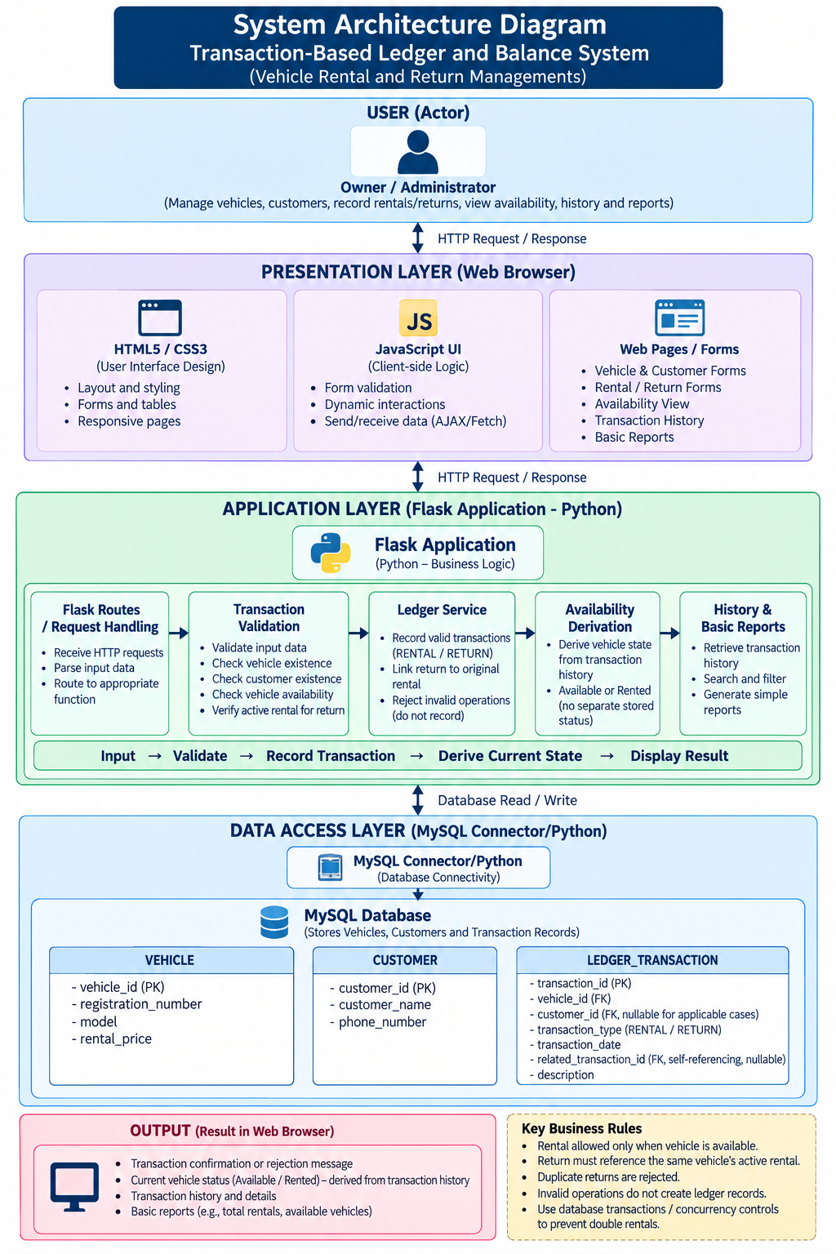

ER Diagram
The Entity Relationship Diagram represents the database structure of the system.
The Vehicle entity stores the basic details of each vehicle. The Customer entity stores customer information required for rental operations. The Ledger_Transaction entity stores rental and return transaction details.
Each transaction is associated with a vehicle and a customer through foreign keys. The related_transaction_id field is used to connect a return transaction with the original rental transaction.
Primary keys uniquely identify records, while foreign keys maintain relationships between the tables. Database constraints help prevent duplicate and inconsistent records.

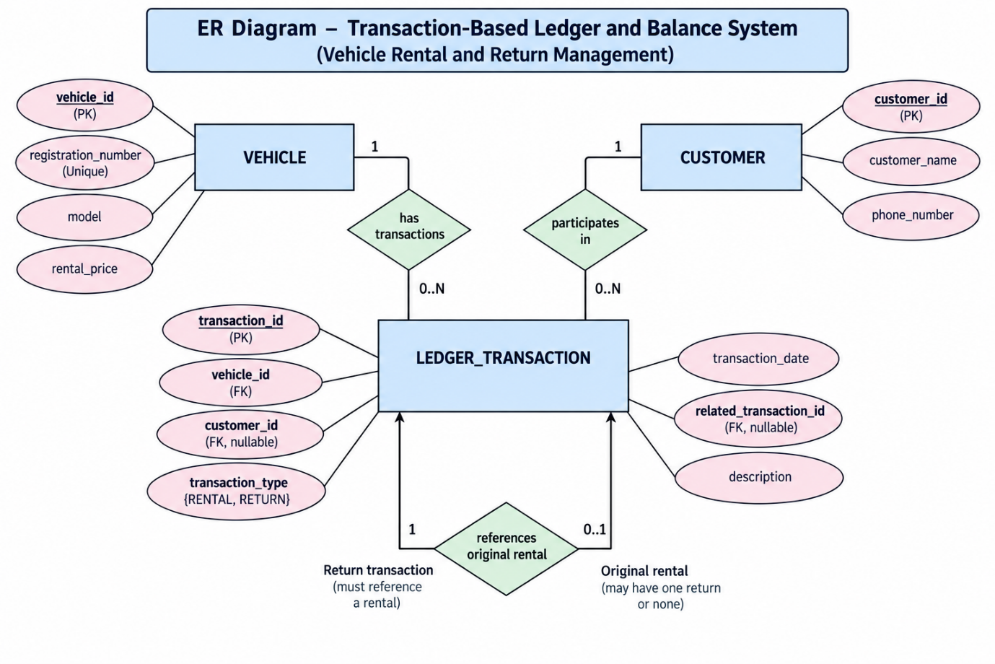

UML Diagrams
Unified Modeling Language (UML) diagrams are used to represent the structure and behaviour of the proposed system.
The Use-case Diagram shows the operations performed by the administrator or rental staff.
The Activity Diagram represents the step-by-step flow of rental and return transactions, including validation and rejection of invalid operations.
The Sequence Diagram shows how the user interface, application logic and database interact during transaction processing.
The Class Diagram represents the main classes, their attributes, methods and relationships.
The State Diagram represents the possible vehicle states and the transitions between Available and Rented based on accepted rental and return transactions.

  - Activity Diagram
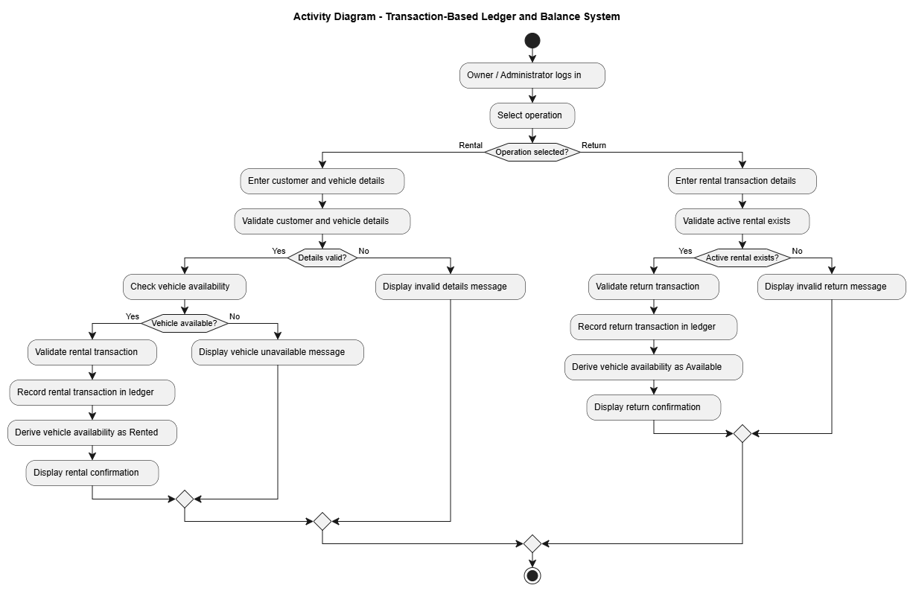

  - Use-case Diagram
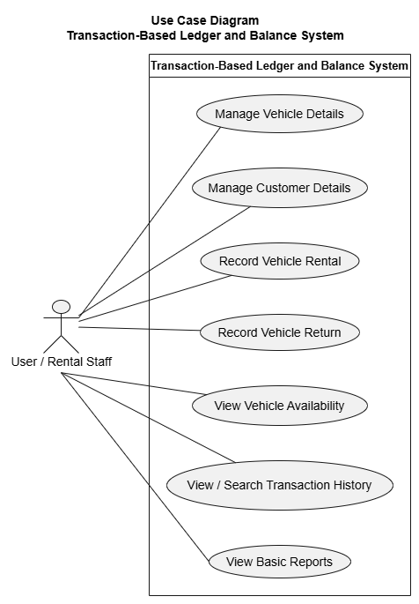

  - Sequence Diagram

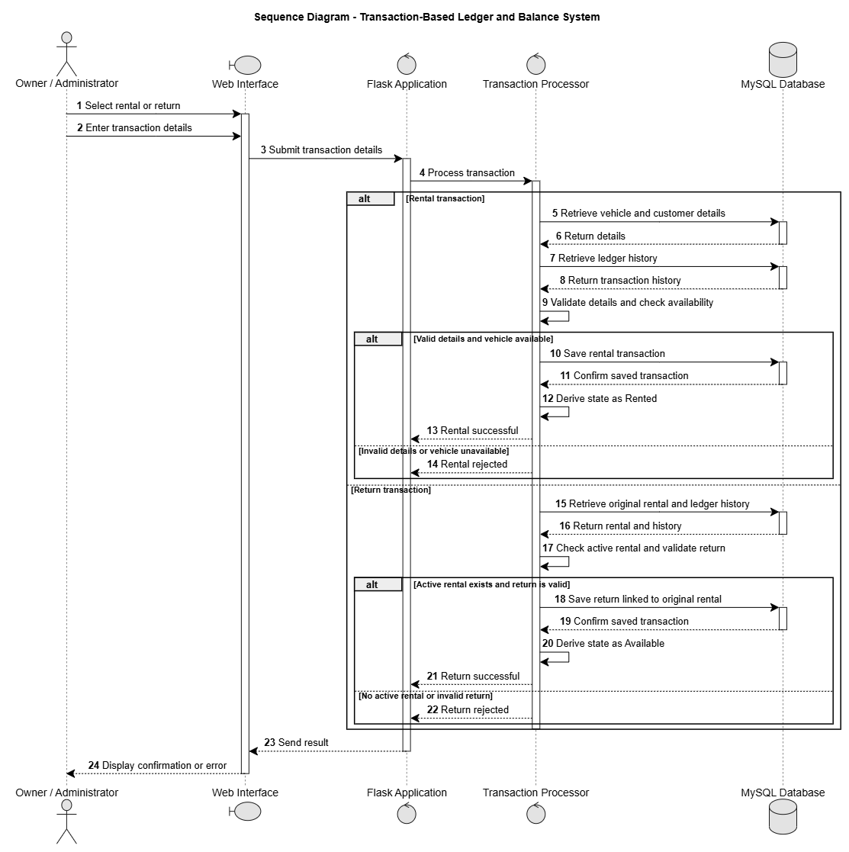

  - Class Diagram

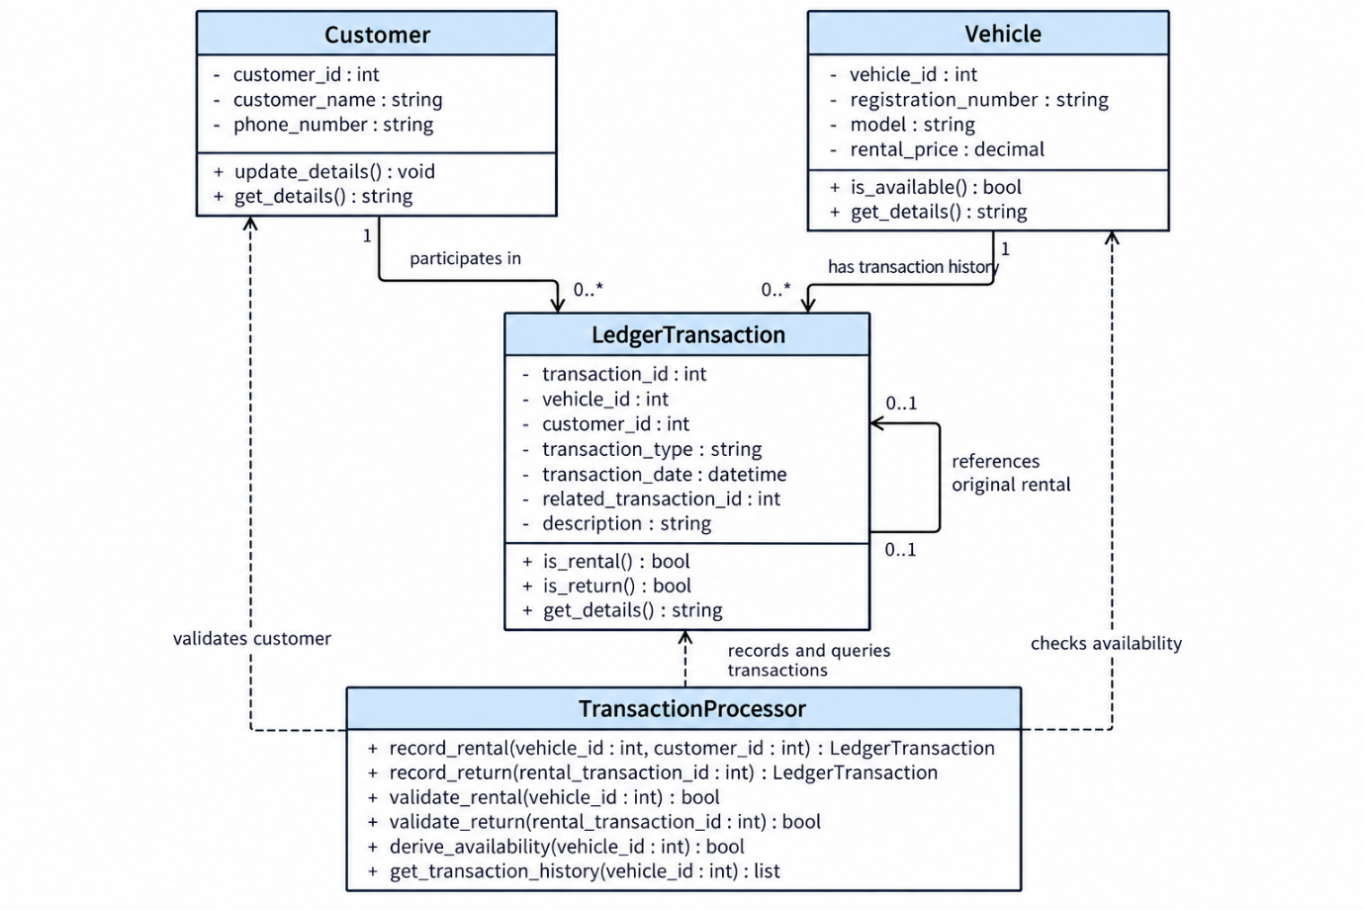

  - State Diagram
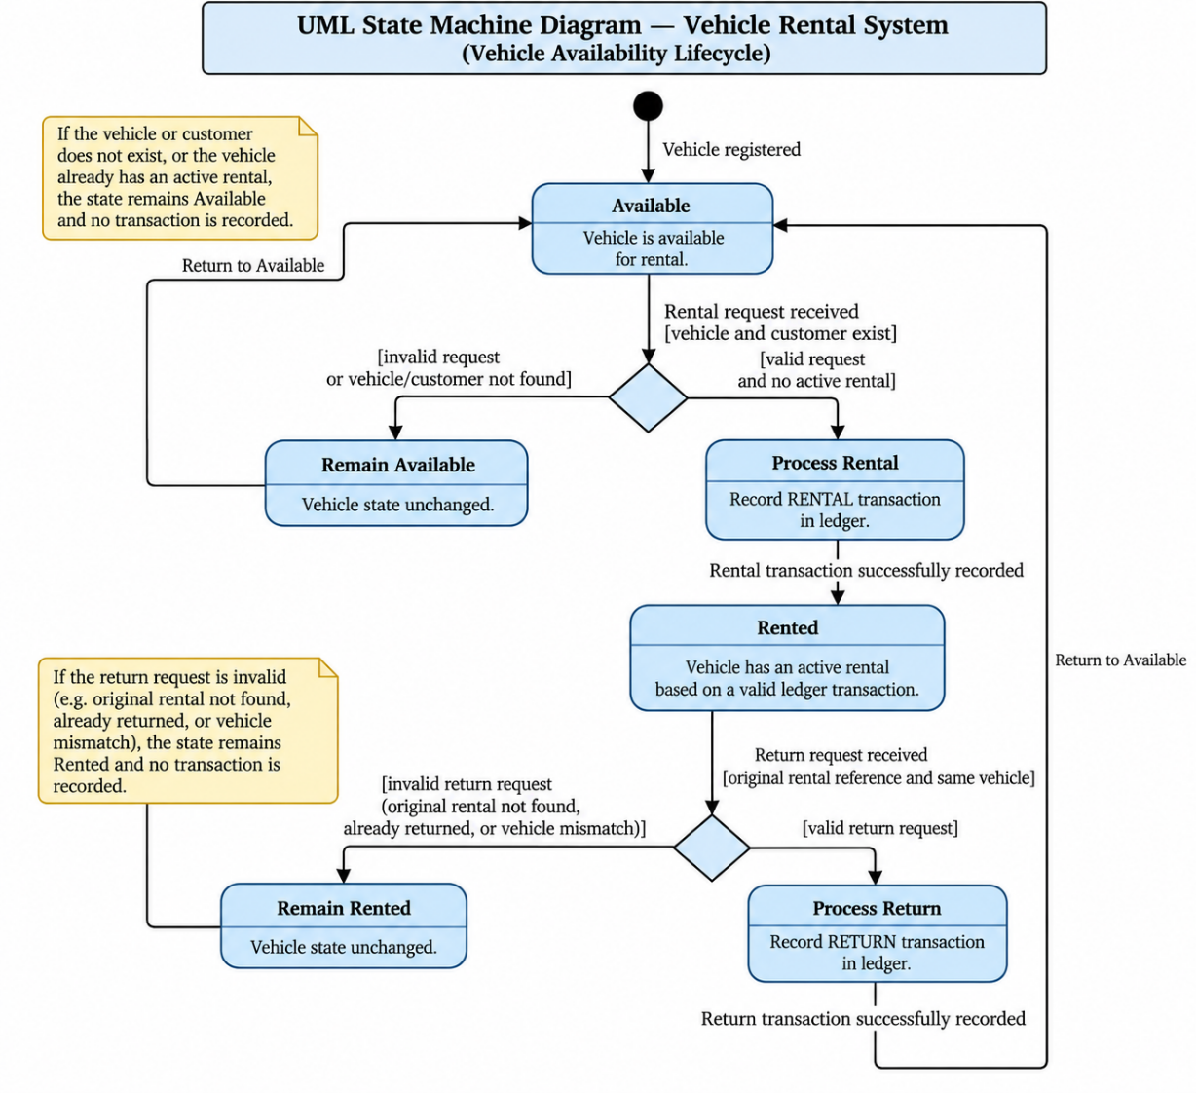

Data Flow Diagrams
Data Flow Diagrams represent how information moves through the system.
The Level 0 DFD provides an overall view of the system and its interaction with the administrator or rental staff.
The Level 1 DFD divides the system into major processes such as vehicle management, customer management, rental and return processing, transaction storage and availability display.
The Level 2 DFD provides a more detailed view of transaction processing. It explains the validation of transaction details, checking of vehicle availability, storage of accepted transactions and display of the resulting vehicle state.

  - Level0 diagram
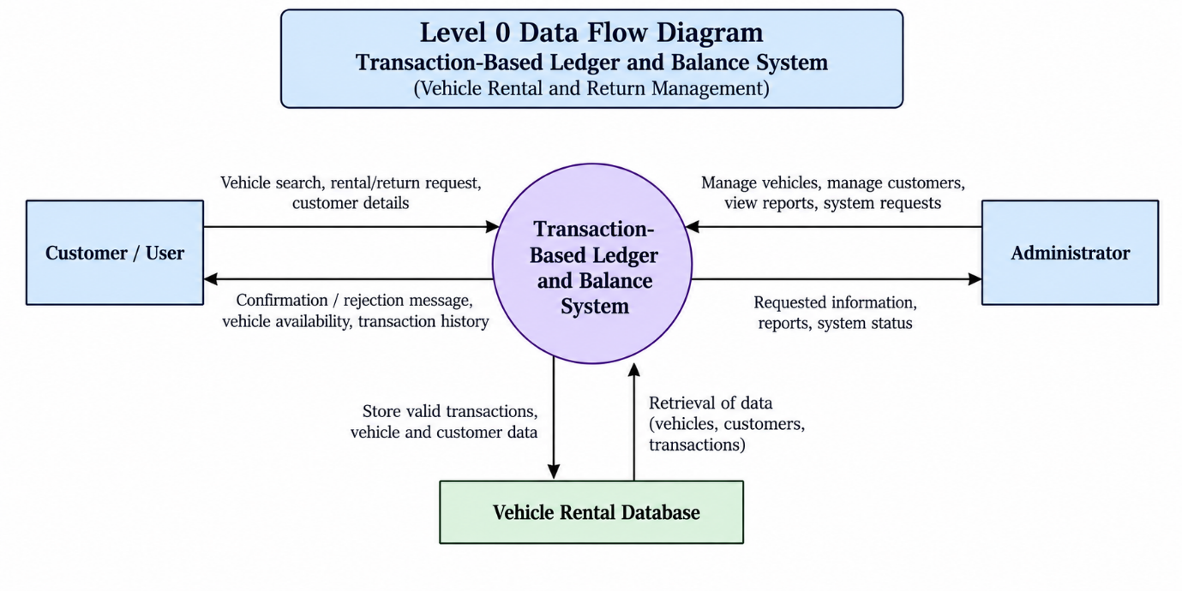

  - Level1 Diagram
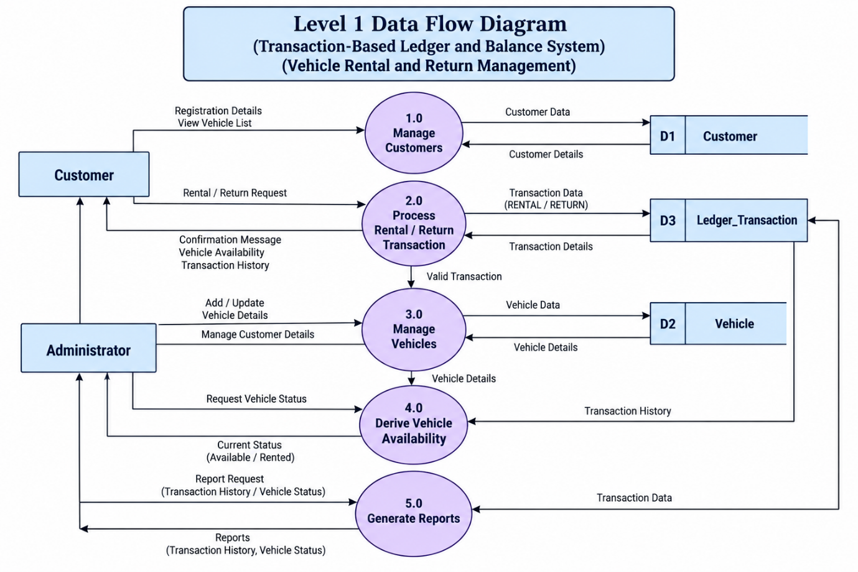
  - Level2 DFD

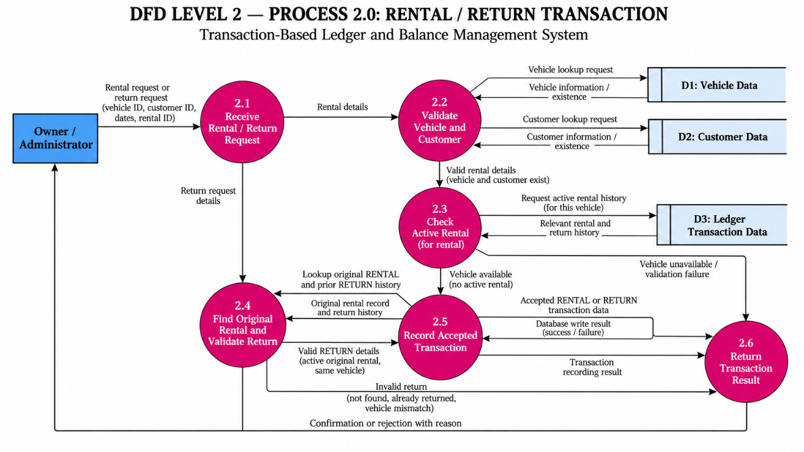

5. Future Enhancement
- The current project focuses on recording vehicle rental and return transactions and maintaining their history. The system can be improved in the future by adding the following features:
- Role-Based Access: Different access permissions can be provided to the owner, administrator and staff to improve security.
- Online Vehicle Booking: Customers can be allowed to view available vehicles and book them online.
- Late-Fee Calculation: The system can automatically calculate additional charges when a vehicle is returned late.
- Payment Integration: Online payment facilities can be added to allow customers to make payments through the system.
- Advanced Search and Reports: More search options and detailed reports can be added to make it easier to manage rental records and check vehicle availability.
- Support for Other Transactions: The system can be extended to handle other activities, such as borrowing and returning resources, deposits and refunds.
- These features are not included in the current project. They may be added in future versions of the system.

6. Conclusion
- The Transaction-Based Ledger and Balance System aims to provide a structured method for recording, validating and maintaining transaction history. The system demonstrates how the current state or availability of a resource can be derived from accepted transactions instead of being manually updated.
- The mechanism is demonstrated through vehicle rental and return operations, where valid rental and return transactions determine the current availability of each vehicle. The system also focuses on preventing invalid operations and maintaining traceable transaction records.

- The project applies the foundational concepts of DBMS, Data Structures and Programming, OOP, Web Technologies, and Software Engineering and SDLC. The proposed system will be developed using Python, Flask and MySQL, with testing and validation carried out to check its correctness and consistency.

4. References
- Python Software Foundation. Python Documentation. Python Documentation
- Pallets Projects. Flask Documentation. Flask Documentation
- Oracle. MySQL Reference Manual. MySQL Reference Manual
- Oracle. MySQL Connector/Python Developer Guide. MySQL Connector/Python Documentation
- Microsoft. Visual Studio Code Documentation. Visual Studio Code Documentation
- Course materials for Database Management Systems (DBMS), Data Structures and Algorithms (DSA), Web Technologies, Object-Oriented Programming (OOP), Software Engineering and Software Testing.
- BCA Mini Project Framework and Gate Assessment Guidelines provided by the department.

