**FLASK BACKEND**

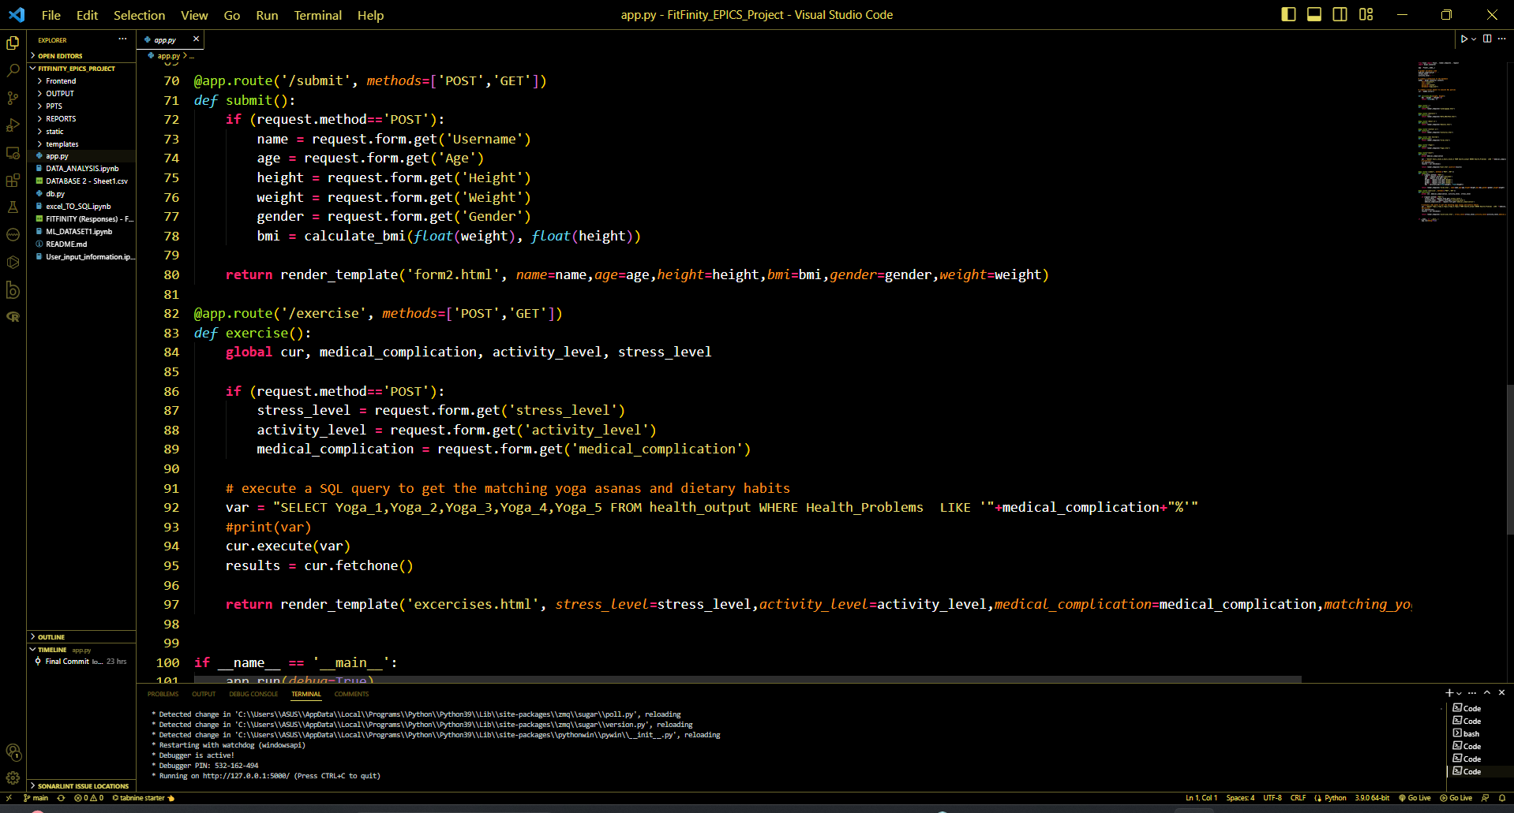

**FRONTEND LANDING PAGE**

