Game Design Document

Fill up the following document

1. Write the title of your project.

Ans: TASC

1. What is the goal of the game?

Ans: Complete all four missions to get recruited in TASC team.

1. Write a brief story of your game.

Ans: TASC – Threat Analysis and Surveillance cell ,is an undercover team operating under the guidance of NIA (National Investigation Agency).

TASC has lost a few agents in the last covert operation against the rebels. On completion of the next four missions you can get qualified to be recruited by TASC.

1. Which are the playing characters of this game?

* Playing characters are the ones who respond to the user based on the input from the user.
* Cars, monkeys, dinos, wizards, etc., are the playing characters in the game.

|  |  |  |
| --- | --- | --- |
| Number | Character Name | What can this character do? |
| 1 | Gun | You need to shoot bullets from the gun at the target |
| 2 | Car | Race to reach a certain amount of point |
| 3 | Hands | They will help to catch the flowers |
| 4 |  |  |
| 5 |  |  |
| 6 |  |  |
| 7 |  |  |
| 8 |  |  |

1. Which are the Non-Playing Characters of this game?

* Non-Playing characters are the ones that don't have an action or behavior when the user interacts with the game.
* Hurdles, stones, bananas, coins, etc., are non-playing characters in the game.

|  |  |  |
| --- | --- | --- |
| Number | Character Name | What can this character do? |
| 1 | Stones | They act as hurdels |
| 2 | Target | You have to hit it with the bullet |
| 3 | bullets | You need to aim them at the target |
| 4 | Flower | You have to catch them with hands |
| 5 | Cactus | You don’t have to catch them |
| 6 |  |  |
| 7 |  |  |
| 8 |  |  |

Draw your imagination of this game. What does this game look like?

* Draw the game either on your computer or on paper.
* Add images of the game scenes to show each of the playing and non-playing characters at least once.

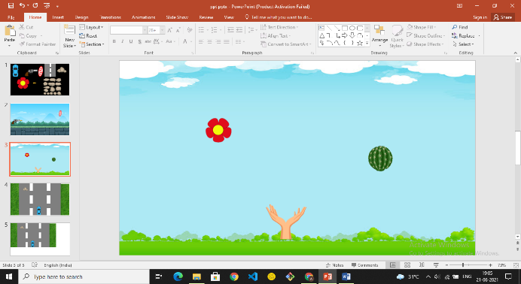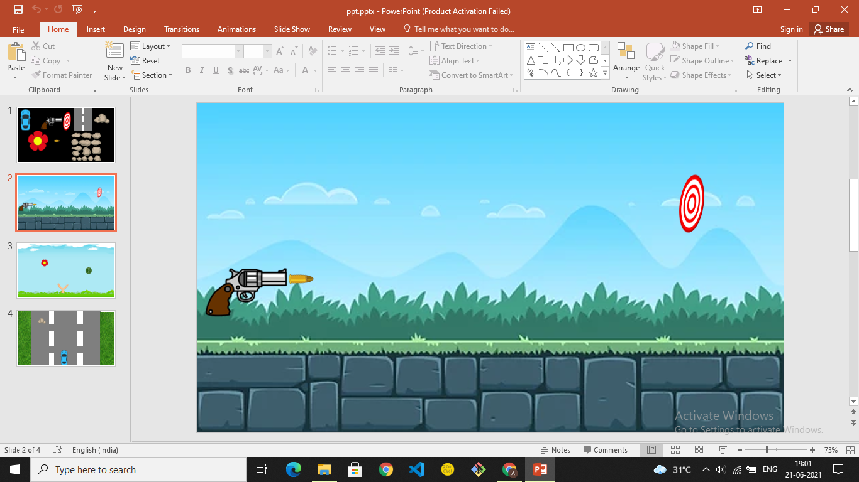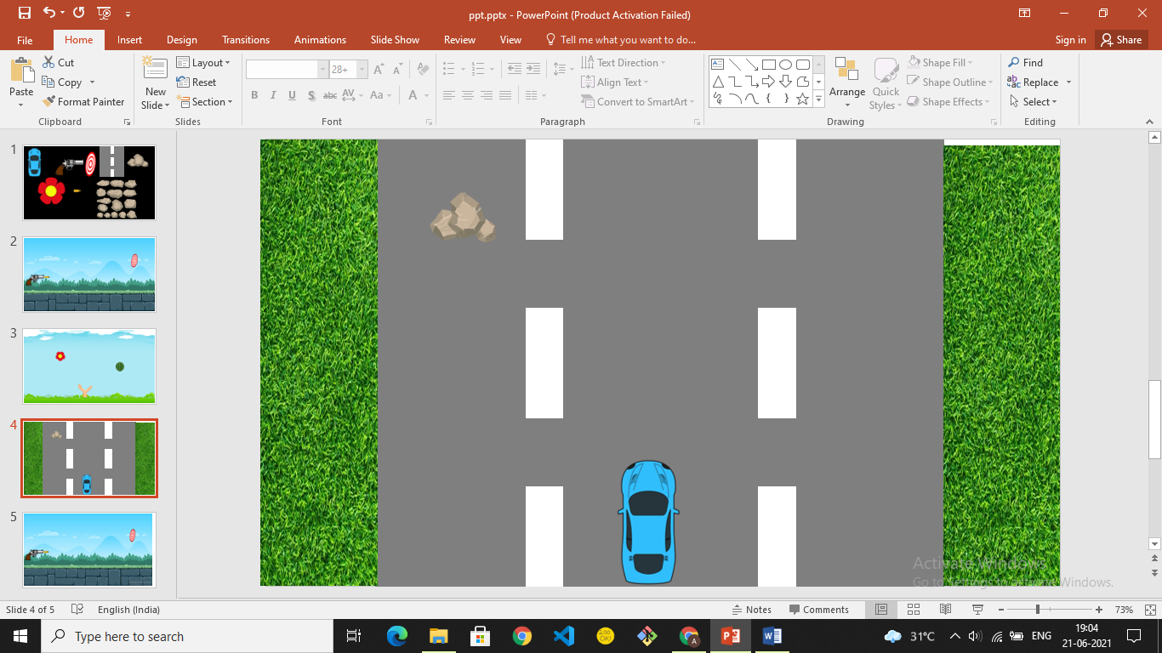

How do you plan to make your game engaging?

Ans: Every mission will give points. Post completion of all four missions you get the opportunity to get recruited by TASC.