**Transactions**

**SQL TRANSACTIONS**

Transactions combine a collection of tasks into a single execution unit. Each transaction starts with a specific task and ends when all of the tasks in the group are completed successfully. The transaction fails if any of the tasks fails. As a result, a transaction has only two outcomes- success or failure.

The commands listed below are used to control transactions. It is important to note that these statements cannot be used to create tables and must be used in conjunction with DML commands such as INSERT, UPDATE, and DELETE.

**1. BEGIN TRANSACTION:** It denotes the beginning of an explicit or local transaction.

**2. SET TRANSACTION:** Gives a transaction a name.

Syntax:

START TRANSACTION transaction_name ;

**3. COMMIT:** All changes are recorded together in the database if everything is in order with all statements within a single transaction. The COMMIT command saves all transactions to the database that have occurred since the previous COMMIT or ROLLBACK command.

Syntax

COMMIT;

Example

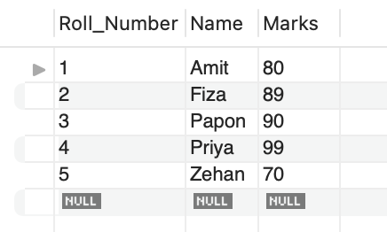

START TRANSACTION;

UPDATE Students SET Marks = "100" where Name_ = "Papon"

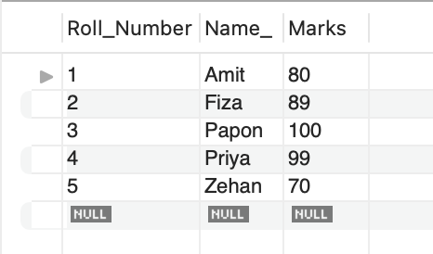

**4. ROLLBACK** - It is a transactional control language used in SQL to undo transactions that were not saved in the database. The command is only used to undo changes made since the previous COMMIT.

Syntax

ROLLBACK;

Example

START TRANSACTION;

UPDATE Students SET Marks = "100" where Name_ = "Papon";

ROLLBACK;

