Lab 1 — Task 1: Jenkinsfile Defining Pipeline Stages
Anant Goel Jenkins 2.568.2 | Job: devops-lab1-pipeline

Objective
Create a Jenkinsfile defining pipeline stages (build, test, deploy) and demonstrate a declarative pipeline execution.

Step 1 — Write the Jenkinsfile
A declarative Jenkinsfile was created at the root of the repository. It defines three stages executed in sequence, plus a post block that reports the overall outcome. Declarative syntax is used, identified by the top-level pipeline block.
pipeline {
agent any

stages {
stage('Build') {
steps {
echo 'Building application...'
sh 'python3 --version'
sh 'python3 -m py_compile app.py'
echo 'Build stage complete'
}
}

stage('Test') {
steps {
echo 'Running unit tests...'
sh 'python3 -m unittest test_app.py -v'
}
}

stage('Deploy') {
steps {
echo 'Deploying application...'
sh 'mkdir -p /tmp/deploy && cp app.py /tmp/deploy/'
sh 'python3 /tmp/deploy/app.py'
echo 'Deployed successfully'
}
}
}

post {
success { echo 'Pipeline completed successfully' }
failure { echo 'Pipeline failed' }
}
}

Stage responsibilities
Build — verifies the Python environment and compiles app.py to bytecode, failing the pipeline immediately on any syntax error.
Test — runs the unit test suite in verbose mode. A failing assertion aborts the pipeline before deployment.
Deploy — copies the verified application to the deployment directory and executes it there to confirm the deployed artifact runs.

Step 2 — Commit the Jenkinsfile to version control
Keeping the Jenkinsfile in the repository means the pipeline definition is versioned alongside the application code (pipeline as code).
cd ~/devops-lab1
git add Jenkinsfile
git commit -m "Add declarative Jenkinsfile with build, test and deploy stages"
git push

Step 3 — Create the Pipeline job
A new job of type Pipeline named devops-lab1-pipeline was created. Rather than pasting the script into Jenkins, the definition is set to Pipeline script from SCM so that Jenkins reads the Jenkinsfile from the GitHub repository on every build.
Definition : Pipeline script from SCM
SCM : Git
Repository URL : https://github.com/yatharthchopra2424/devops-lab1.git
Branch Specifier : */main
Script Path : Jenkinsfile
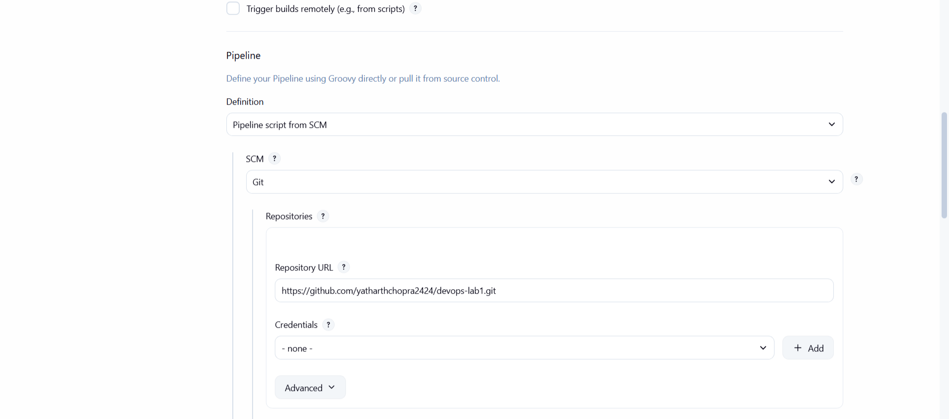
Figure 1 — Pipeline definition set to "Pipeline script from SCM" reading from the GitHub repository

Figure 2 — Script Path set to Jenkinsfile at the repository root

Step 4 — Execute the pipeline
The pipeline was run from the job page. Jenkins checked out revision 0f33ebc6fcc42e4d996870d040571e2bdfb83b71 from refs/remotes/origin/main, loaded the Jenkinsfile, and executed all three stages in order, completing successfully in 9.3 seconds.
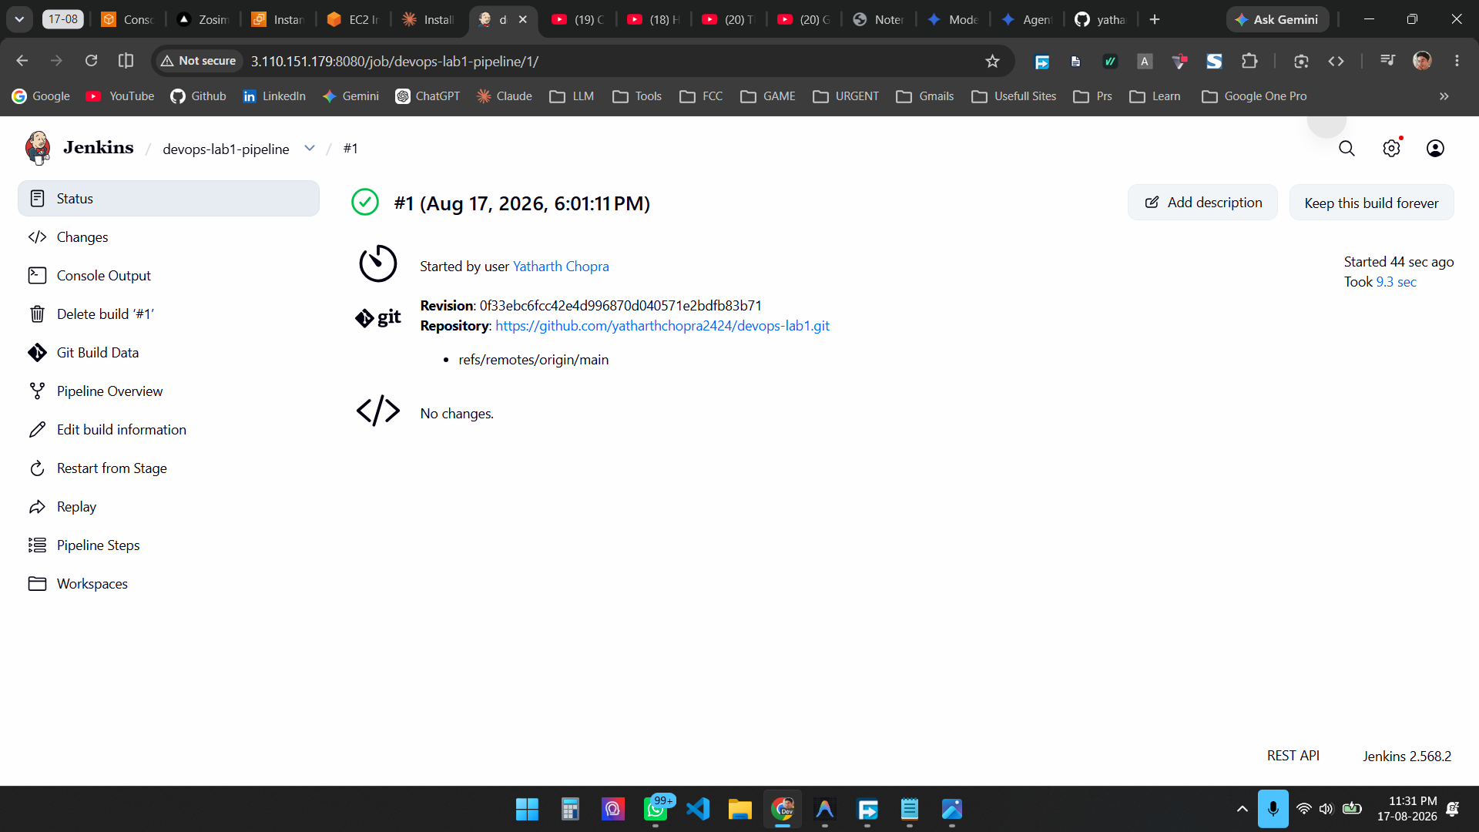
Figure 3 — Pipeline build #1 completed successfully using the Jenkinsfile pulled from GitHub

Result
A declarative Jenkinsfile defining Build, Test and Deploy stages was written, committed to the GitHub repository, and executed by a Jenkins Pipeline job configured to read the pipeline definition from source control. The pipeline ran all three stages in sequence and finished successfully. Task 4 is complete.

