Lab 1 — Task 2: Set Up Version Control Using Git
Anant Goel

Objective
Initialize a Git repository, stage and commit changes, create branches, merge branches, and push the repository to GitHub.

Step 1 — Initialize the repository and add source files
A working directory is created and initialized as a Git repository. A small Python application and a matching unit test are added as the source code for the project.
mkdir ~/devops-lab1 && cd ~/devops-lab1
git init
app.py
def greet(name):
return f"Hello, {name}!"

if __name__ == "__main__":
print(greet("DevOps"))
test_app.py
import unittest
from app import greet

class TestApp(unittest.TestCase):
def test_greet(self):
self.assertEqual(greet("DevOps"), "Hello, DevOps!")

if __name__ == "__main__":
unittest.main()

Step 2 — Stage and commit
git add .
git commit -m "Initial commit: app and unit test"
Output: [main (root-commit) 1f560df] Initial commit: app and unit test — 2 files changed, 14 insertions(+)
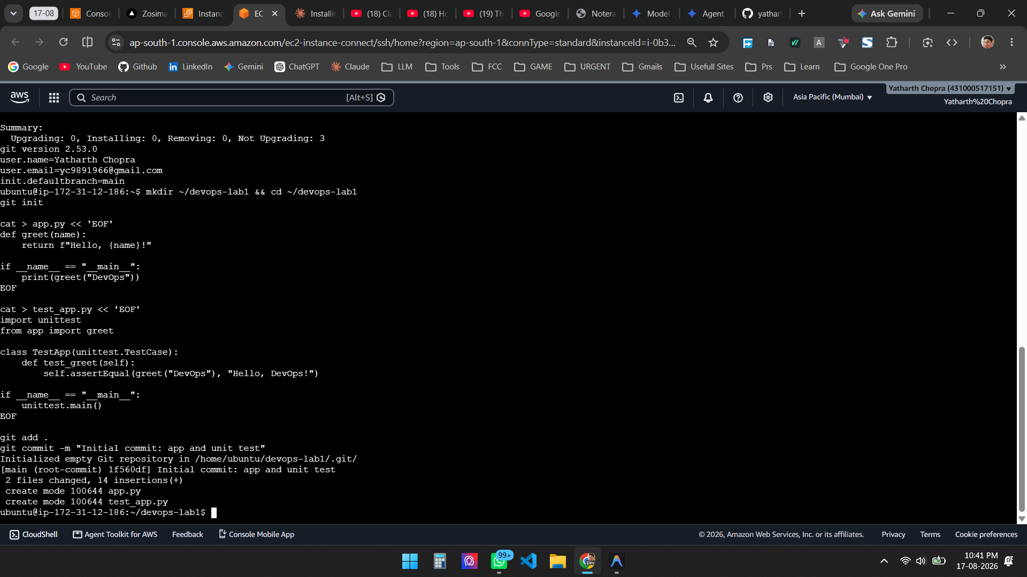
Figure 1 — Repository initialized, source files created, and the initial commit recorded

Step 3 — Create a branch and commit on it
A feature branch is created, a new function is added to app.py, and the change is committed on that branch.
git checkout -b feature/farewell

# append farewell() to app.py
git add app.py
git commit -m "Add farewell function"

Step 4 — Merge the branch back into main
Returning to main and merging brings the feature branch changes into the mainline.
git checkout main
git merge feature/farewell
Because main had not advanced, Git performed a fast-forward merge. A second feature branch was therefore created and merged with --no-ff, which forces Git to record an explicit merge commit and preserves the branch topology in the history.
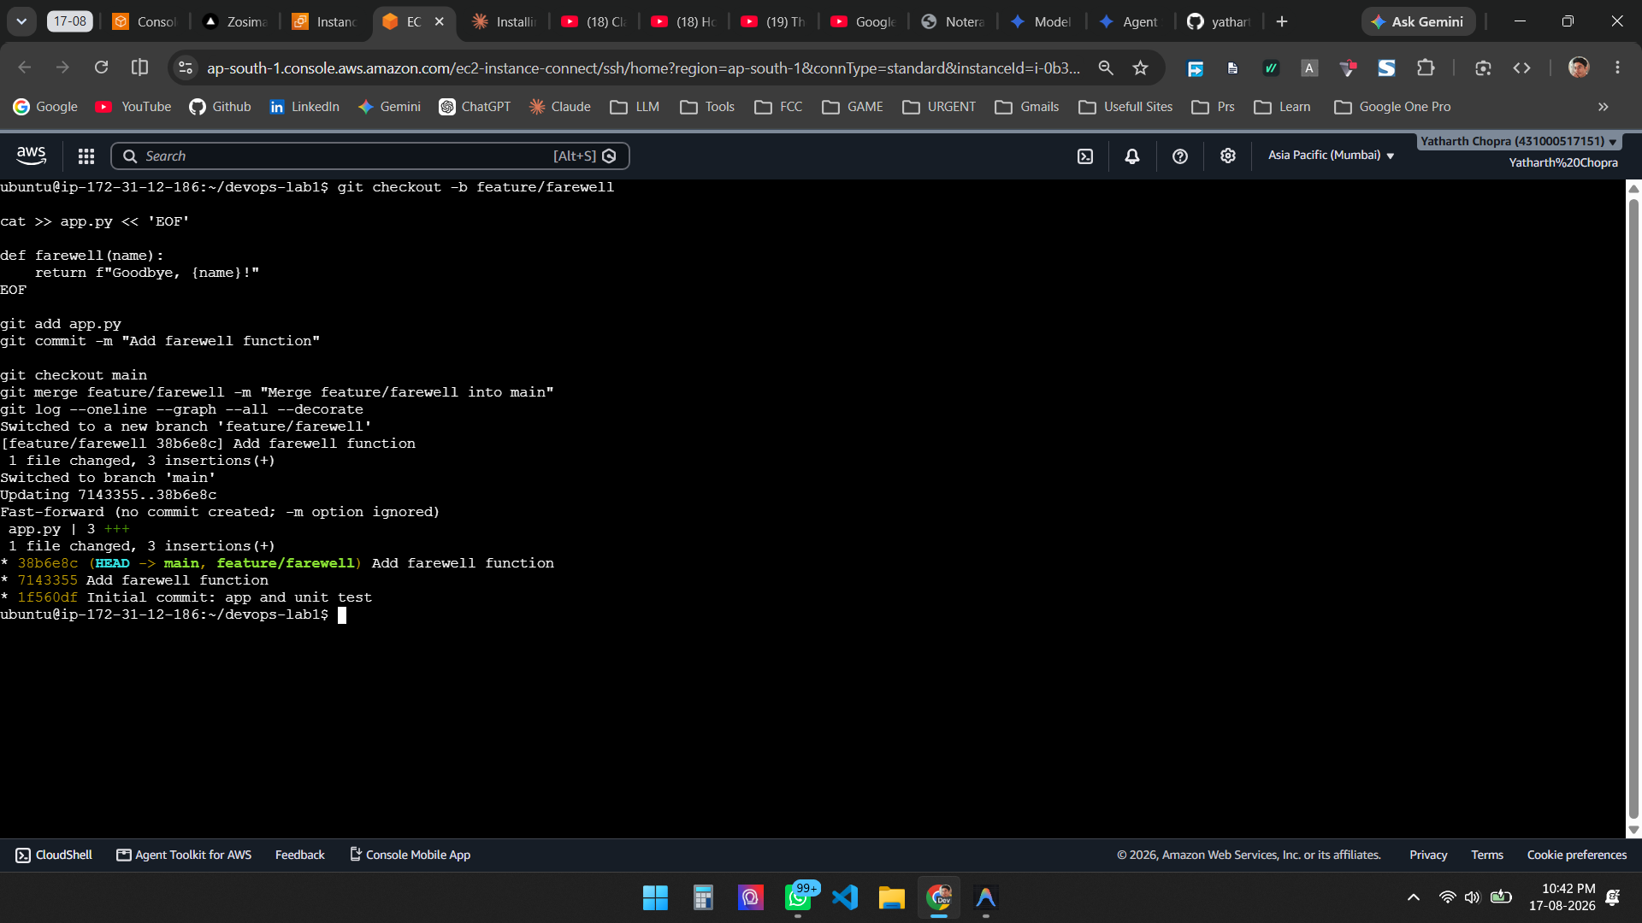
Figure 2 — Branch created, committed, and merged into main (fast-forward merge)

Step 5 — Second branch with an explicit merge commit
git checkout -b feature/uppercase

# append shout() to app.py
git add app.py && git commit -m "Add shout function"

git checkout main
git merge --no-ff feature/uppercase -m "Merge feature/uppercase into main"
git log --oneline --graph --all --decorate
The commit graph now shows the branch diverging from main and rejoining at merge commit 639e54a:
* 639e54a (HEAD -> main) Merge feature/uppercase into main
|\
| * 40c3e68 (feature/uppercase) Add shout function
|/
* 38b6e8c (origin/main, feature/farewell) Add farewell function
* 7143355 Add farewell function
* 1f560df Initial commit: app and unit test
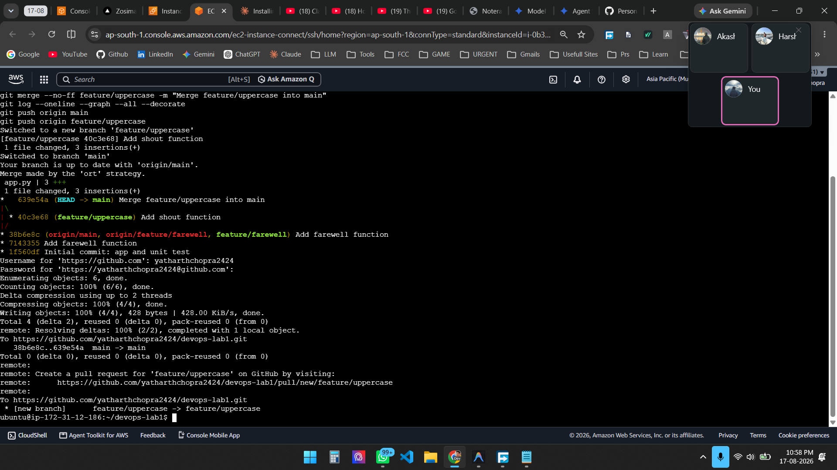
Figure 3 — Explicit merge commit created with --no-ff; the commit graph shows the branch splitting and rejoining

Step 6 — Push the repository to GitHub
A remote named origin is added pointing at the GitHub repository, and both main and the feature branches are pushed. Authentication over HTTPS uses a GitHub Personal Access Token, as password authentication for Git operations is no longer supported.
git remote add origin https://github.com/yatharthchopra2424/devops-lab1.git
git remote -v

git push -u origin main
git push origin feature/farewell
git push origin feature/uppercase
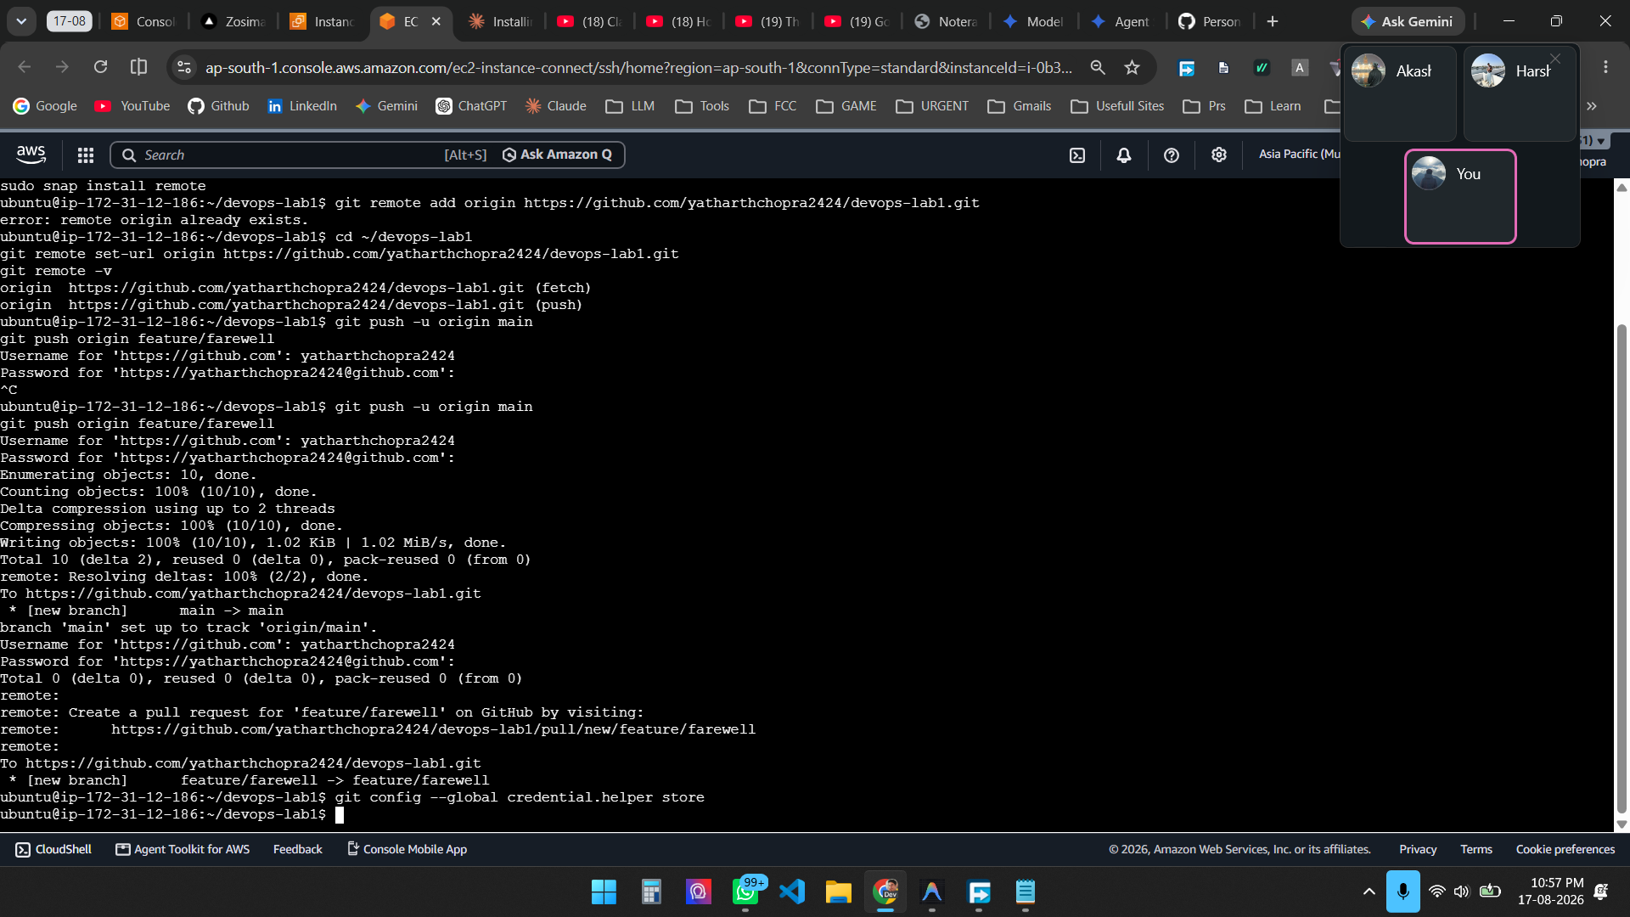
Figure 4 — Remote configured and branches pushed successfully to GitHub

Step 7 — Verify on GitHub
The repository on GitHub shows 5 commits across 3 branches, with the merge commit as the latest change on main.
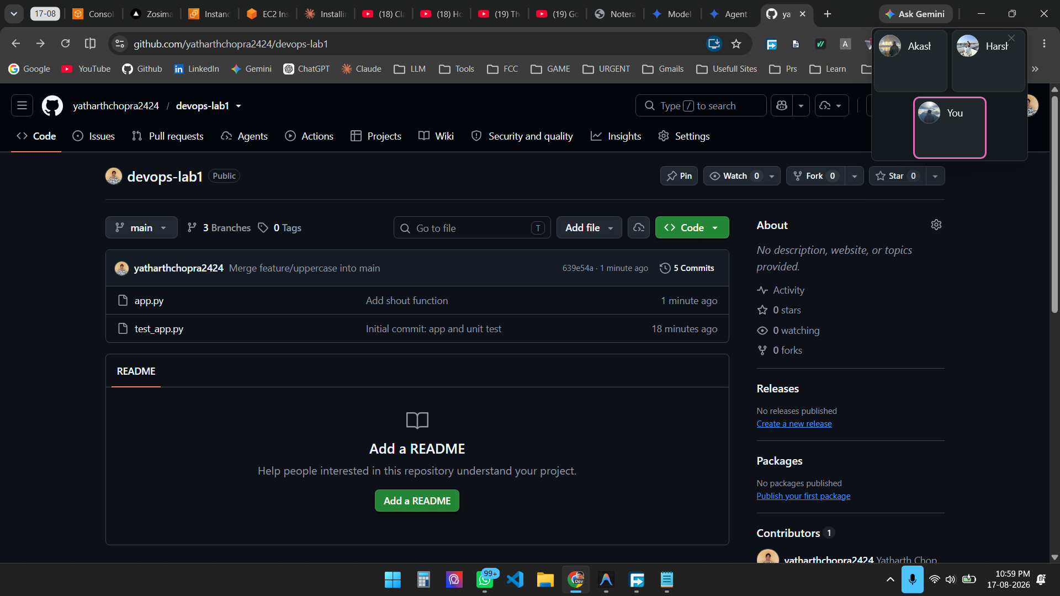
Figure 5 — Repository on GitHub showing 3 branches, 5 commits, and the merge commit at the top of main

Result
A Git repository was initialized locally, changes were staged and committed, two feature branches were created and merged into main (one fast-forward and one with an explicit merge commit), and the complete repository with all branches was pushed to GitHub. Task 2 is complete.

