Lab 1 — Task 3: Basic Jenkins CI/CD Pipeline
Anant Goel | Jenkins 2.568.2 on AWS EC2 | Job: devops-lab1-freestyle

Objective
Implement a basic Jenkins CI/CD pipeline that pulls source code from the GitHub repository and triggers an automated build.

Prerequisite — Jenkins executor availability
Jenkins takes its built-in node offline when the temporary directory has less than 1 GiB free. On this instance /tmp is a tmpfs sized at 455 MiB, so the threshold could never be met and no build would ever start. Jenkins was reconfigured to use a temporary directory on the root filesystem instead.
sudo mkdir -p /var/lib/jenkins/tmp
sudo chown jenkins:jenkins /var/lib/jenkins/tmp

sudo tee /etc/systemd/system/jenkins.service.d/override.conf << EOF
[Service]
Environment="JAVA_OPTS=-Djava.awt.headless=true \
-Djava.io.tmpdir=/var/lib/jenkins/tmp"
EOF

sudo systemctl daemon-reload
sudo systemctl restart jenkins
The built-in node was then brought back online, making both build executors available.

Step 1 — Create the Freestyle project
A new Freestyle project named devops-lab1-freestyle was created from the Jenkins dashboard (New Item → Freestyle project).

Step 2 — Configure Source Code Management
Git is selected as the SCM and pointed at the GitHub repository created in Task 2. No credentials are required because the repository is public. The branch specifier restricts builds to the main branch.
Repository URL : https://github.com/yatharthchopra2424/devops-lab1.git
Credentials : - none - (public repository)
Branch Specifier : */main
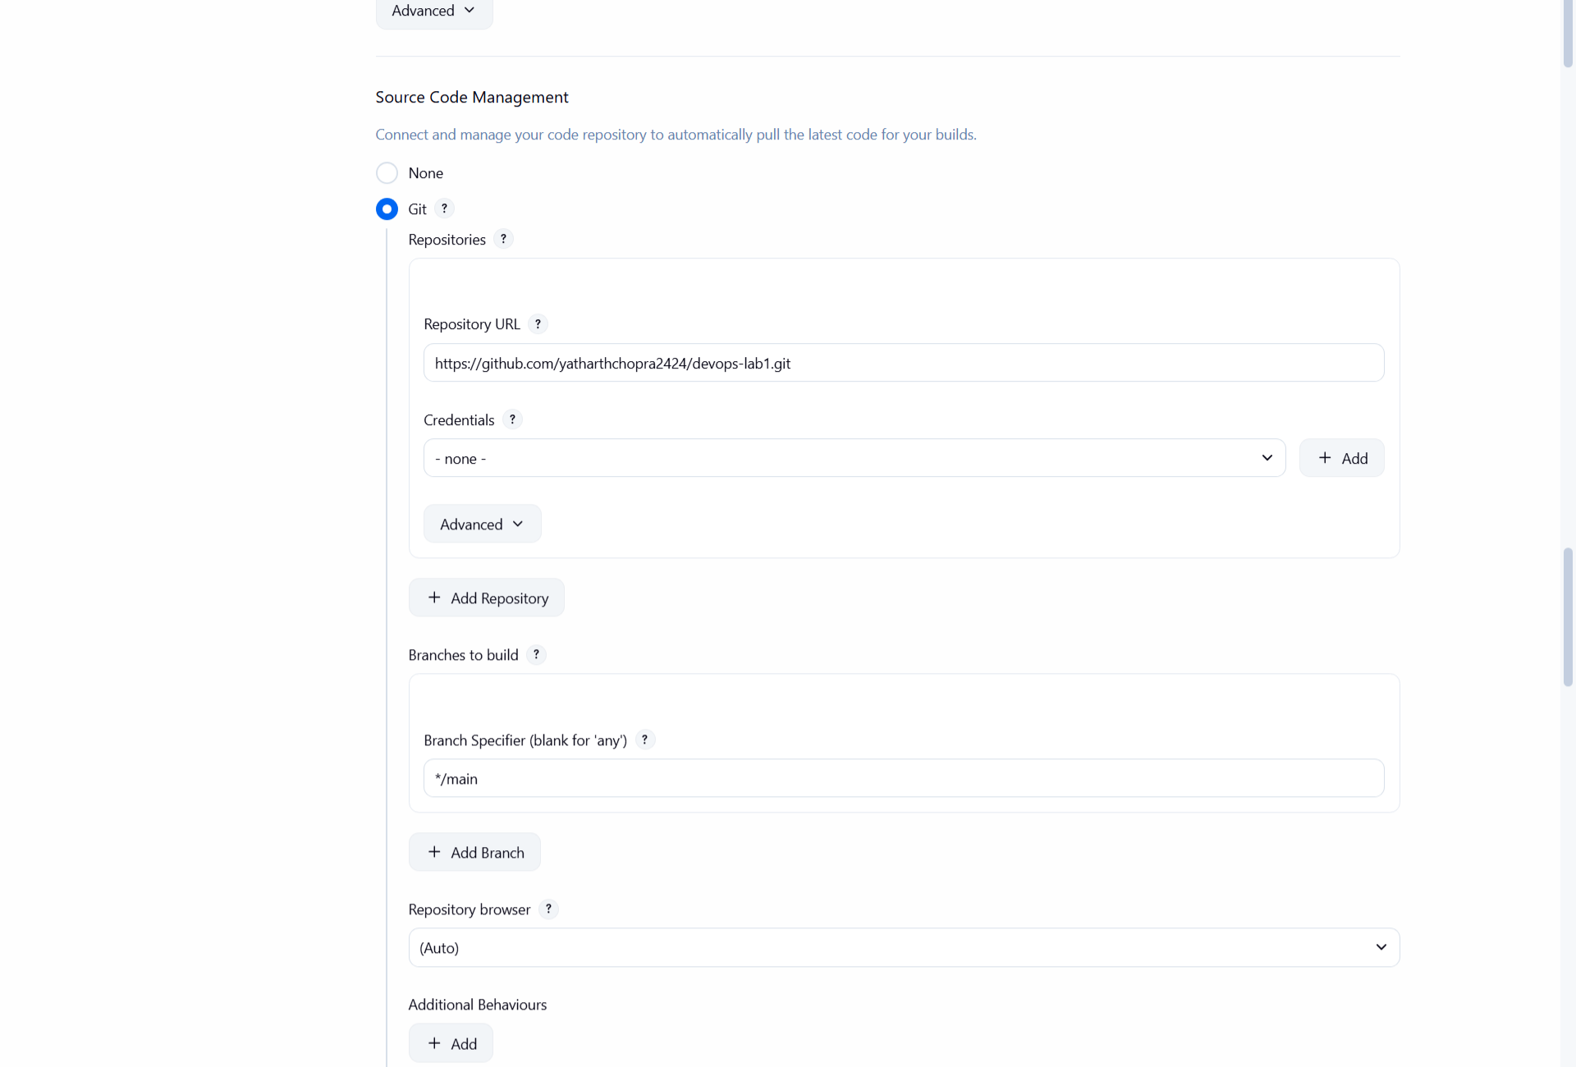
Figure 1 — Source Code Management configured to pull from the GitHub repository on branch main

Step 3 — Configure the automated build trigger
Poll SCM is enabled with the schedule H/5 * * * *, which instructs Jenkins to check the repository for new commits every five minutes and start a build automatically whenever a change is detected. This is what makes the pipeline automated rather than manual.
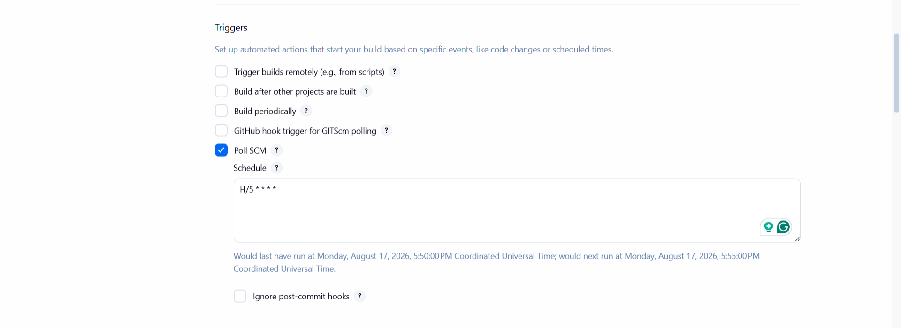
Figure 2 — Poll SCM trigger enabled with a five-minute polling schedule

Step 4 — Define the build step
An Execute shell build step compiles and verifies the application by printing the build environment, running the application, and executing the unit test suite.
echo "=== Build started on $(hostname) ==="
python3 --version
python3 app.py
echo "=== Running tests ==="
python3 -m unittest test_app.py -v
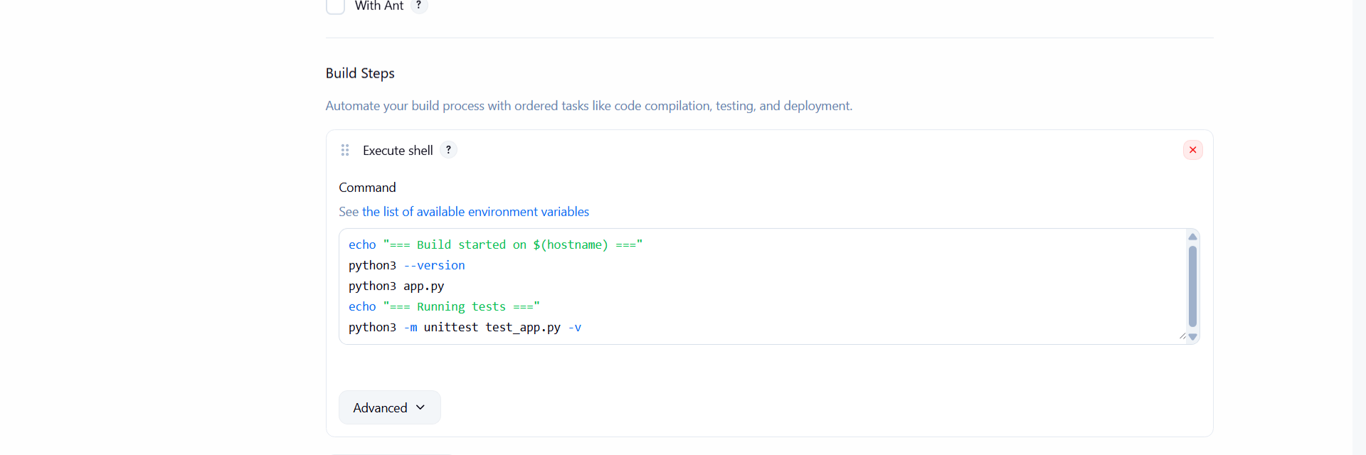
Figure 3 — Execute shell build step running the application and its unit tests

Step 5 — Manual build (Build Now)
The first build was started manually to verify the configuration. Jenkins cloned the repository at revision 7192aacad20cd7bb75f7bd32702a6d3a8922e025 from refs/remotes/origin/main and completed successfully in 4.5 seconds.
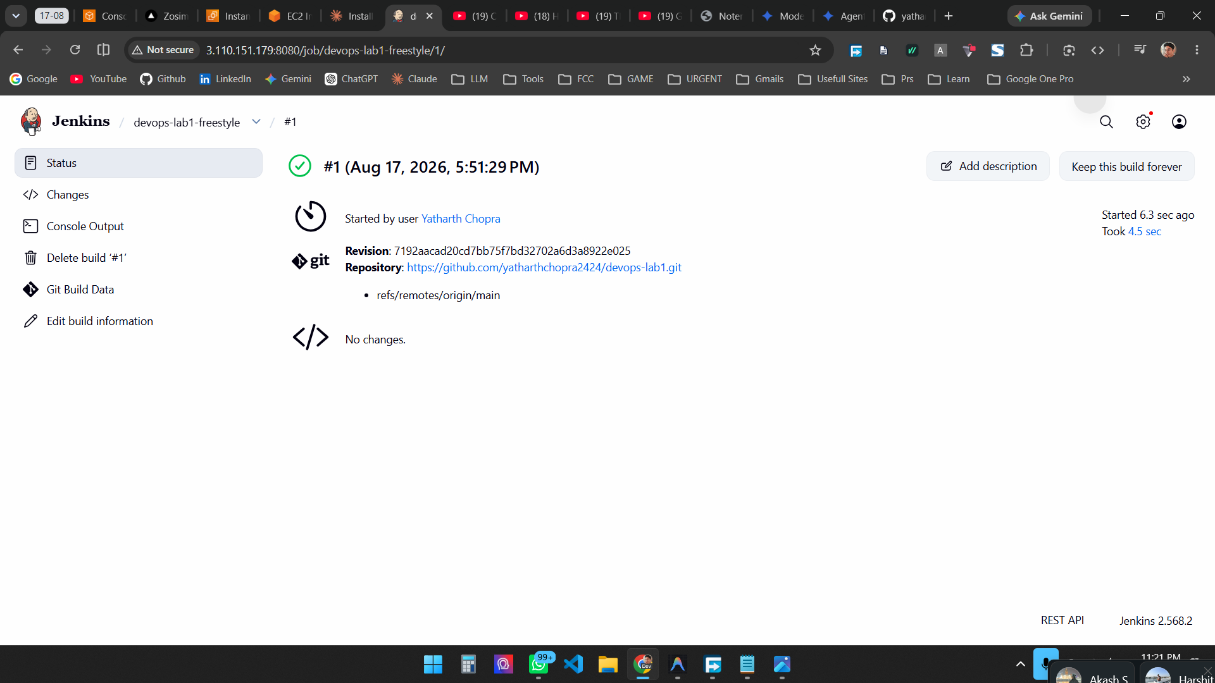
Figure 4 — Build #1 completed successfully, showing the Git revision pulled from the GitHub repository

Step 6 — Trigger an automated build from a commit
To demonstrate the automated trigger, a change was committed and pushed to GitHub. No action was taken in Jenkins.
cd ~/devops-lab1
cat >> README.md << EOF

## Build Pipeline
Automated build triggered via Jenkins SCM polling.
EOF

git add README.md
git commit -m "Update README to trigger automated Jenkins build"
git push
Output: [main b89da58] Update README to trigger automated Jenkins build — 1 file changed, 3 insertions(+), pushed to origin/main (28064bf..b89da58).
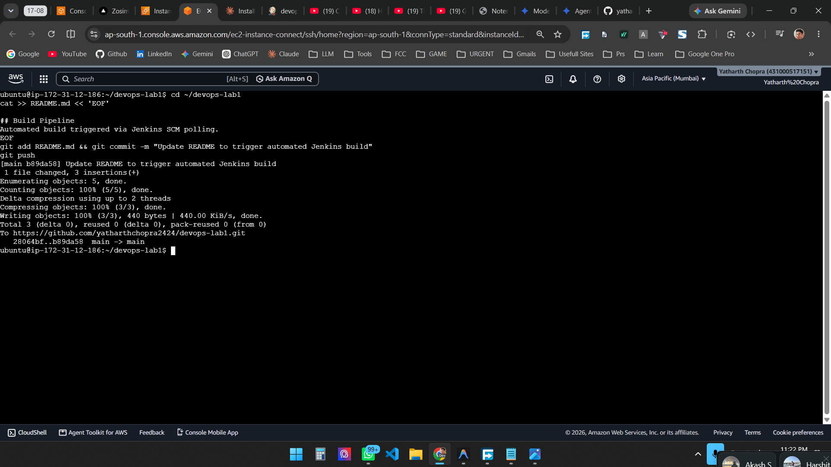
Figure 5 — Commit pushed to GitHub; Jenkins polls the repository and starts the next build without manual intervention

Result
A Jenkins Freestyle project was configured to pull source code from the GitHub repository over Git and to poll the repository every five minutes for changes. A manual build confirmed the configuration works end to end, and a subsequent commit pushed to GitHub caused Jenkins to detect the change and start a build automatically. Task 3 is complete.

