**Doctor Appointment App**

**NAME MID**

Anant Shekhar M1060949

Channakeshava V M1060982

Paras Chowdhary M1061002

Pragati Alur M1061034

Sanhita Sen (SPOC) M1061012

**Home Page**

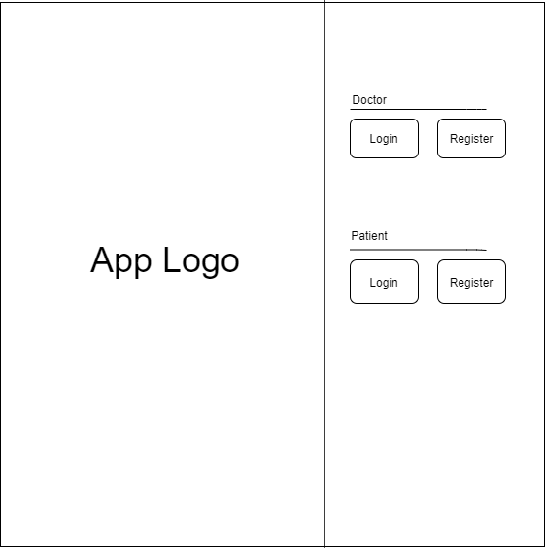

* This will be landing or home page of our project, this page contains our application logo to the left.
* It also contains two buttons named login and register for both patient and doctor on the right side of the page, on clicking any of these buttons a new page will open where either the patient or doctor will be able to login or register.

**Registration Page for Patient**

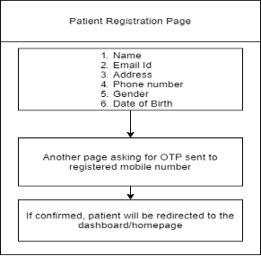

* This will be our registration page for the patient where there will be a form to fill the name, email-id, address, phone number, gender, date of birth of the patient.
* When the patient submits this form, the patient will be redirected to another page where it asks the patient to enter the OTP sent to the registered mobile number.
* After validating the OTP, the page displays a message saying you are registered and then it redirects to the patient dashboard or patient home page.

**Registration Page for Doctor**

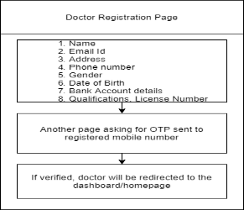

* This will be our registration page for the doctor where there will be a form to fill the name, email-id, address, phone number, gender, date of birth, bank account details, qualification, license number of the doctor.
* When the doctor submits this form, he/she will be redirected to another page where it asks the doctor to enter the OTP sent to the registered mobile number.
* After validating the OTP, the page displays a message saying ‘you are registered’ and then it redirects to the doctor dashboard or doctor home page.

**Login Page for Patient or Doctor**

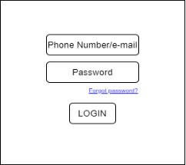

* This will be our Login Page for both doctor and patient where they can login using their email or phone number.
* If the doctor or patient has forgotten their password, they can click on **forgot password** and then they will be redirected to another page where they will be able to reset their password, if the login validation goes right then the patient or doctor will be redirected to their respective dashboards.

**Forgot Password Page for Patient or Doctor**

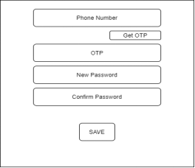

* If the patient or doctor clicks on **forgot password**, they will be redirected to this page where they will have to enter their phone number and click on ‘Get OTP’ button to receive OTP to their registered mobile numbers.
* Then they will have to enter the OTP, give their new password and enter the same password in the confirm password field.
* After filling all the fields, when the doctor or patient clicks on save the validation will be done if everything goes well the page will display password changed successfully or else it will display failed to change the password try again, after the password is reset the doctor or patient can login using their new password.

**Patient Dashboard**

* After a successful login, the patient is going to redirect to the Patient Dashboard page. This page will have three components-
* Header where app logo, Patient name and profile picture of patient will be displayed.
* A side navigation bar where four different types of services (home, book an appointment, upload reports, edit profile) will be provided.
* Main area where different components will be rendered based on the patient's clicks. 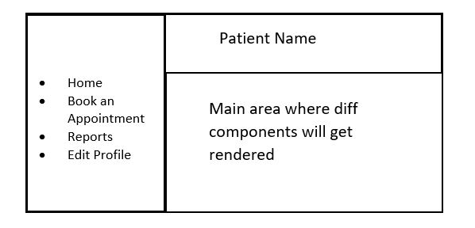

logout

**Home Component**

* This component shows all existing appointments booked by the patient for a particular day like date, time slot and doctor’s name as shown in below diagram.

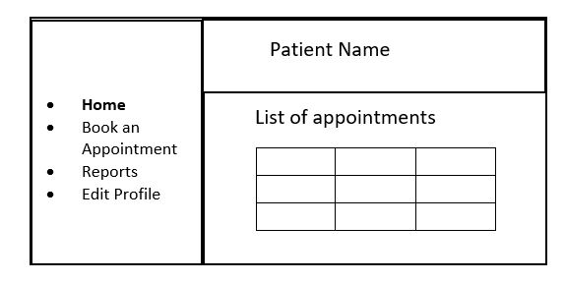

logout

**Book an Appointment Component**

* Whenever a patient clicks on this button, the main area will get rendered by a list of all the nearby clinics based on the address provided by the patient in his profile.

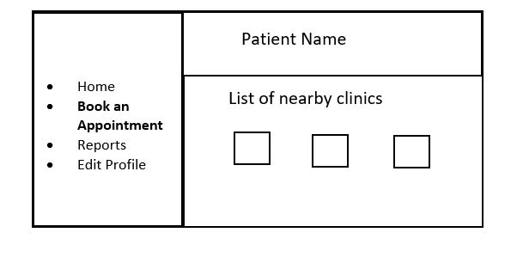

logout

* Then the patient can click on any of the provided clinics to see details of the doctor like his specialization, years of experience, qualifications and other patients’ reviews about that doctor.
* Now, if a patient is interested, he/she will be able to book an appointment by clicking on the ‘Book’ button.

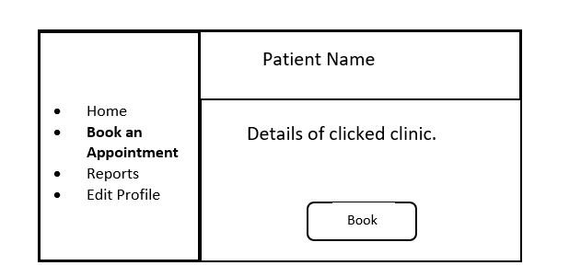

logout

* Clicking on the ‘book’ button takes the patient to the next page where he/she will be able to book an available slot for any date.

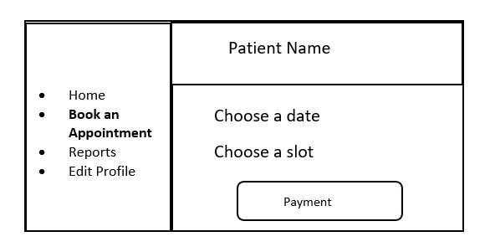

logout

* After selecting a date and a slot, patient will be redirected to the payment gateway page where he/she makes the payment as per the clinic’s rate by entering his/her credit card details.

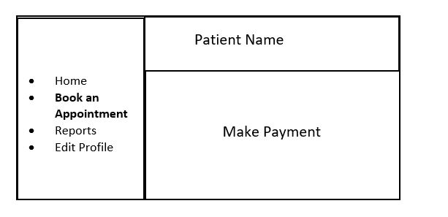

logout

* If payment is successful, then the appointment is booked and the patient will be redirected to the homepage.

**Reports Component**

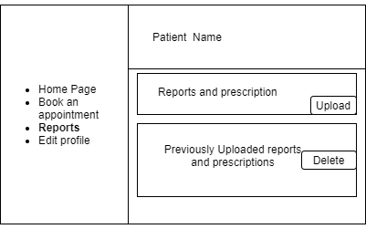

logout

* In the Reports option, all the prescriptions, test reports will be displayed along with that delete button will be provided.
* If the patient clicks on the delete button, the associated file will be deleted.
* On the right-hand side, upload button will be provided which will enable the patient to upload new files
* The patient will be able to upload
* Test reports,
* Previous prescriptions
* Once the patient clicks the upload button, the file will be uploaded and all the files will be displayed.

**Edit Profile Component**

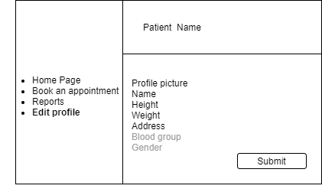

logout

* In edit profile option, the patient will be able to update/change their:
* Profile picture
* Name
* Date of birth
* Height
* Weight
* Address
* Once the user clicks the update button which will be provided at the end of form, the user will be able to see the updated values.
* Gender, Blood Group fields will be disabled.

**Doctor Dashboard**

* Once a doctor logs in, a page similar to the below diagram will open up. The page will have 3 sections:
  + The header, containing the doctor name.
  + A navbar to the left.
  + Another section to the right.

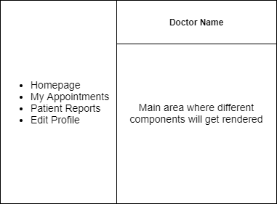

logout

* Whenever the doctor clicks on any of the nav links, that particular page will be displayed on the right.

**Home Component**

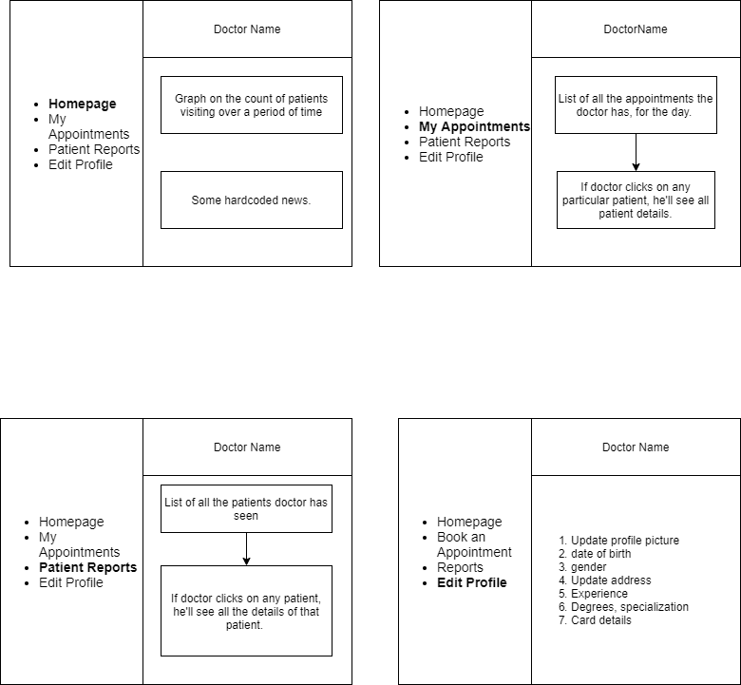

logout

* Homepage will consist of a bar graph, showing the count of patients who have visited the doctor.
* It will also contain some hard-coded news and health care tips.

**My Appointments Component**

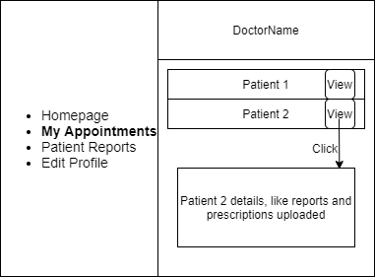

Logout

logout

* When the doctor clicks on this nav link, all his upcoming appointments will be displayed to the right in the form of a list.
* Each list item consists of patient name, booking date and slot time.
* If the doctor clicks the ‘View’ button, that particular patient’s details will be displayed.

**Patient Report Component**:

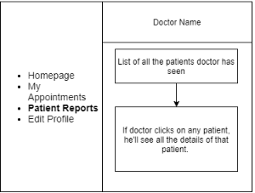

logout

* Once the doctor clicks on the patient reports page, on his right he will be able to see all the patients appointed to him.
* Once the doctor clicks on the particular patient he will be able to see all the details of the patients, reports and medical prescriptions
* By seeing these details, the doctor can analyze the health of the patient and gives the further suggestions to the patient.

**Edit Profile Component**

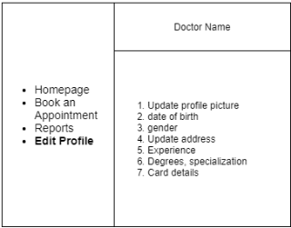

logout

* + Once the doctor clicks on the edit profile button a edit profile page will be rendered to the right side.
  + The doctor can edit and update his personal details here.
  + The doctor can update his profile picture, data of birth, gender, address, experience, degrees, specialization and card details.

Both the patient and the doctor can logout of the application by clicking on the logout button provided at the bottom of the page.