**PROJECT REPORT**

**ON**

**E-GOVERNANCE**



In the partial fulfillment of the requirements of

**MASTER OF COMPUTER APPLICATION**

|  |  |
| --- | --- |
| **Supervised By** | **Submitted by** |
| Dr. Pankaj Nagar  (Director UCCS&IT)  Mr. Hanuman Ram Choudhary  (Project Guide) | **ANANT JAIN**  **Roll no. : 1950105** |
|  |
|  |

MCA Vth Semester

2017-2020 Batch

UNIVERSITY CENTER FOR COMPUTER SCIENCE

& INFORMATION TECHNOLOGY

UNIVERSITY OF RAJASTHAN, JAIPUR

CERTIFICATE

This is to certify that the project report on ‘E-Governance’ is a confide record of the work done by ANANT JAIN during the Vth semester and submitted in partial fulfillment of the requirement of the degrees of Master of Computer Application of University of Rajasthan.

Submitted for the University exam held on 05/02/2020.

Dr. PANKAJ NAGAR

(DIRECTOR)

ACKNOWLEDGMENT

We are indebted to many people who have aided, motivate, encouraged and helped us in the development of this project report. It is our pleasure to acknowledge all those people.

First of all, we like to express our sincere gratitude to Lord God Almighty whose grace has always been here with us for the successful completion of this project. We wish to express our deep sense of gratitude and indebtedness to our Lecturers and project guide, for their full support and valuable guidance while completing the project. We would like to thank our friends for their invaluable moral support and help throughout this project study.

We specially thanks to our project supervisors Dr. PANKAJ NAGAR (Director UCCS&IT) and Mr. Hanuman Ram Choudhary. Our heartfelt thanks will always be there for our parents for the unending supports and encouragement they have given.

ANANT JAIN

(MCA V semester)

**Index**

* Introduction
* What is E-Governance
* Defining E-Governance
* Objectives
  + External Strategic objectives
  + Internal Strategic objectives
* Components of E-Governance
  + Technical Component
  + Social Component
  + Political Component
  + Psychological Component
  + Service Component
* Types of E-Governance
  + G2G
  + G2C
  + G2B
  + G2E
* E-Governance Maturity Model
  + Information
  + Interaction
  + Transaction
  + Transformation
* Impact of Technology
* Indian E-Government Initiatives
* Challenges for Development
* References

**INTRODUCTION**

Governments all over the world are in pursuit of Information and Communication Technologies (ICT)-based solutions for facilitating good governance. The phe-nomenon is popularly known as e-governance or e-government as per varying country contexts. In the recent past, different terms have been coined to re-brand it alongside the emerging technological developments. Some of the buzzwords in this context are joined-up government, whole-of government, one-stop government, connected government and open government; the latest being digital government.

Irrespective of the various terminologies used to describe the phenomenon, practitioners across the world continue to experience serious challenges in their efforts to connect government and citizens for achieving good governance. This is particularly so in the context of developing countries. There have been more failures than successes in terms of achievement of intended outcomes. The peculiarity with the ICT-based systems is that they get matured over a period of time with increased participation of end users. Further, due to various operational constraints, the government departments generally prefer ‘As-is’ computerization of traditionally established systems. For example, even though the National eGovernance Plan (NeGP) and the second Administrative Reforms Commission (ARC) of India emphasized on re-engineering of government processes and rationalization of organizational structures, there are only a limited number of e-governance projects where such an approach could be said to have been methodically adopted. This prevents innovative usage of ICT to improve system performance. It is also

experienced that expectations of end users of such systems keep rising as they gradually become accustomed to technology usage and become more and more aware about the power of ICT as being practiced in the corporate sector. As a result, the objectives and scope conceptualized before launching of such projects generally fall short of matching the growing levels of user expectations. With limited project resources and rigid governance framework, the government is often found wanting in responding to the emerging demands of citizens.

Implementation of ICT-based projects within the boundaries of a government department is relatively easier as the situation, actors and processes are within the control of the concerned department. The context, however, becomes much more complex in the case of e-governance projects where it is generally required to address social, political, administrative, economic, and technical issues simultaneously.

In the recent past, several e-governance projects have been taken up at the center as well as state government levels in India. Massive budgetary allocations were made for the National e-Governance Plan (NeGP) in India to support certain identified projects to be implemented in mission mode by the respective line Ministries at center and state government levels. As part of this strategic intervention by the government, some of the initiatives are reported to be successfully implemented in select urban and rural areas. The unfinished NeGP has now been subsumed in the NeGP 2.0 or e-kranti as part of a highly ambitious ‘Digital India Program’ supported with an astronomical budget of about INR 1000 billion.

The learning issues presented in this report, are expected to provide the knowledge about E-Governance, its type, its components and some successful E-Governance project of Indian Government.

**WHAT IS E-GOVERNANCE**

Imagine a situation in which all interaction with the government can be done through one counter 24 hours a day, 7 days a week, without waiting in lines at government offices. Now it is possible through E-governance. If governments are willing to decentralise responsibilities and processes and they start to use electronic means such as the Internet. Each citizen can then make contact with the government through a website where all forms, legislation, news and other information will be available 24/7. Of course, at first the front office will retain several communication channels, such as physical counters, telephone, (e-)mail and Internet to serve everyone properly, but this will change dramatically in the next few years. In Europe and the USA, commercial banks already work according to this concept. Only in a few very special situations one has to go to a physical counter. Most transactions can be done at either an ATM, by mail or by the Internet, which has saved banks an enormous amount of costs. In other words, they do more work, with less people, in less time and with less and smaller offices: They use the Internet. Government, as a collector and source of information, may also follow this trend, in order to serve its customers (citizens, businesses, and other interest groups) better and to save costs by making internal operations more efficient.

**DEFINING E-GOVERNANCE**

Many definitions exist for e-governance. Before presenting an overall definition of e-governance, the relation between governance, e-democracy and e-government is explained.

E-democracy refers to the processes and structures that encompass all forms of electronic interaction between the Government (elected) and the citizen (electorate).

E-government is a form of e-business in governance and refers to the processes and structures needed to deliver electronic services to the public (citizens and businesses), collaborate with business partners and to conduct electronic transactions within an organizational entity.

E-Governance : In this report e-governance is defined as the application of electronic means in (1) the interaction between government and citizens and government and businesses, as well as (2) in internal government operations to simplify and improve democratic, government and business aspects of Governance.

The term interaction stands for the delivery of government products and services, exchange of information, communication, transactions and system integration.

Government consists of levels and branches. Government levels include central, national, regional, provincial, departmental and local government institutions. Examples of government branches are Administration, Civil Service, Parliament and Judiciary functions.Government operations are all back-office processes and inter-governmental interactions within the total government body.

Examples of electronic means are Internet and other ICT applications.

**OBJECTIVES**

The strategic objective of e-governance is to support and simplify governance for all parties -government, citizens and businesses. The use of ICTs can connect all three parties and support processes and activities. In other words, in e-governance uses electronic means to support and stimulate good governance. Therefore the objectives of e-governance are similar to the objectives of good governance. Good governance can be seen as an exercise of economic, political, and administrative authority to better manage affairs of a country at all levels, national and local.

Regarding e-government, the distinction is made between the objectives for internally focused processes (operations) and objectives for externally focused services.

**External strategic objectives** : The external objective of e-government is to satisfactorily fulfil the public’s needs and expectations on the front-office side, by simplifying their interaction with various online services. The use of ICTs in government operations facilitates speedy, transparent, accountable, efficient and effective interaction with the public, citizens, business and other agencies.

**Internal strategic objectives** : In the back-office, the objective of e-government in government operations is to facilitate a speedy, transparent, accountable, efficient and effective process for performing government administration activities. Significant cost savings (per transaction) in government operations can be the result.

It can be concluded that e-governance is more than just a Government website on the Internet. Political, social, economic and technological aspects determine e-governance.

**COMPONENTS OF E-GOVERNANCE**

**1. Technical Component :** This relates to electronic and communication technology to develop better connectivity within and with the system. It requires the use of digital devices to access and share information, developments of Databases, establishment of networking to facilitate the communication and educate the users to work with the technology.

**2. Social Component:** Social component in E-Governance means the interaction of society with government. Using E-Governance governments works for the welfare of society, by means of fast and transparent access to information and services. A vigilant society can be evolved where they can raise their voices by questioning the governmental decisions.

**3. Political Component:** It is essential aspect of governance. This refers to the importance of enactment of laws to stop society from disintegration. It holds responsibility of rationalizing various operative framework by enacting laws and it helps to maintain and sustain the cohesive force that is required by society to integrate its people and abide them to follow a uniform policy to fulfill their targets.

**4. Psychological Component:** Facilitate formation and inculcation of right type of attitudes in the people. Provide readiness to connect to people, to listen to their queries, to look for solution, to improve communication quality, and help to develop constructive collaborative social relationship.

**5. Service Component:** It refers to provide good services to citizens to assimilate the basic needs and also to full fill the expectations of common man. E-governance develops a constant pressure on the government to respond to public demands as this leads to the realization of power they can exercise on government to maintain impartiality, integrity and transparency in its functioning.

**TYPES OF E-GOVERNANCE**

**1. Government to Government :** Technology is used to increase the flow of information and services within and between different government entities. This kind of interaction is only within the sphere of government and can be both horizontal i.e. between different government agencies, or vertical i.e. between national, provincial and local government agencies. The primary objective is to increase efficiency, performance and output.

**2. Government to Citizens:** An interface is created between the government and citizens which enables the citizens to benefit from efficient delivery of large range of public services. This expands the availability and accessibility of public services on the one hand and improves the quality of service on the other and provide 27 x 7 access to those services.

**3. Government to Business:** in this type E-Government tools are used to aid the business community. The object is to cut red tape, save time, reduce operational costs and to create a more transparent business environment when dealing with the government. It provide services like : licensing, permits, procurement and revenue collection.

**4. Government to Employees:** itprovides the two-way communication process between the organization and the employee. Use ICT tools to help in making these interaction fast and efficient and Help to increase satisfaction levels of employees.

**E-GOVERNANCE MATURITY MODEL**

According to Gartner, e-governance will mature according the four-phase e-governance maturity model. These phases have been defined based on experiences with e-commerce and e-governance in Europe and other Western regions.

|  |  |  |  |
| --- | --- | --- | --- |
| Early 90’s | Information | → | Presence |
| Mid 90’s | Interaction | → | Intake process |
| Present | Transaction | → | Complete transaction |
| Future | Transformation | → | Integration and organisational changes |

In each of the four phases, the delivery of online services and use of ICTs in government operations serve one or more of the aspects of e-governance: democracy, government, business.

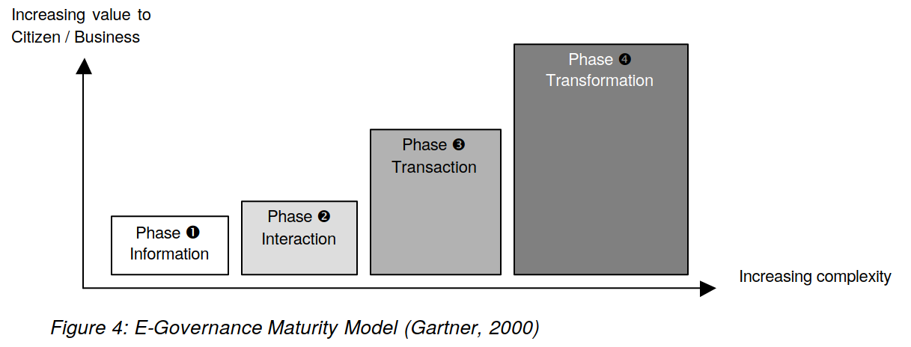

**Phase 1 : Information**

In the first phase e-governance means being present on the web, providing the external public (G2C and G2B) with relevant information. The format of the first government websites is similar to that of a brochure or leaflet. The value to the public is that government information is publicly accessible; processes are described and thus become more transparent, which improves democracy and service. Internally (G2G) the government can also disseminate information with static electronic means, such as the Internet. This phase it is all about information. From a 1-page presence website to a site with all relevant government information available to the public, in order to improve transparency in democracy.

**Phase 2 : Interaction**

In the second phase the interaction between government and the public (G2C and G2B) is stimulated with various applications. People can ask questions via e-mail, use search engines for information and are able to download all sorts of forms and documents. These functionalities save time. In fact the complete intake of (simple) applications can be done online 24/7. Normally this would have only been possible at a counter during opening hours. Internally (G2G) government organizations use Local Area Networks (LAN), intranets and e-mail to communicate and exchange data. The bottom line is that more efficiency and effectiveness is achieved because a large part of the intake process is done online. However, you still have to go to the office to finalize the transaction, by paying a fee, handing over evidence or signing papers. The use of electronic communications tools speed up the internal government processes.

**Phase 3: Transaction**

With phase three the complexity of the technology is increasing, but customer (G2C and G2B) value will also be higher. Complete transactions can be done without going to an office. Examples of online services are filing income tax, filing property tax, extending/renewal of licenses, visa and passports and online voting. Phase three is mainly complex because of security and personalization issues – e.g., digital (electronic) signatures are necessary to enable legal transfer of services. On the business side the government is starting with e-procurement applications. In this phase, internal (G2G) processes have to be redesigned to provide good service. Government needs to create new laws and legislation that will enable paperless transactions with legal certification. The bottom line is that now the complete process is online, including payments, digital signatures etc. This saves time, paper and money.

**Phase 4: Transformation**

The fourth phase is the transformation phase in which all information systems are integrated and the public can get G2C and G2B services at one (virtual) counter. One single point of contact for all services is the ultimate goal.

The complex aspect in reaching this goal is mainly on the internal side, e.g. the necessity to drastically change culture, processes and responsibilities within the government institution (G2G). Government employees in different departments have to work together in a smooth and seamless way. In this phase cost savings, efficiency and customer satisfaction are reaching highest possible levels.

**IMPACT OF TECHNOLOGY**

The use of ICT means in Governance has impact on the following aspects:

**24/7 Service Model**: Systems and processes have to be adapted to a completely new service model. Intake processes are made self-service and even in the middle of the night a citizen should get an immediate (automated) response about the status of the application. Citizen’s expectations towards government’s response times will change because of the new communication medium. E-mail should be seen a new but serious channel besides the traditional channels such as telephone, physical counter, post and fax.

**Need for Content:** Websites consist of content (information). Governments will have to collect (buy), produce and update content daily. In phase 1 content will be static, but in phase 2 content will be changing every day. Content managers in each (large) department are responsible for the information on the website.

**Human Resources:** Effective use of ICTs in an organisation requires training of people. People should feel comfortable with the tools they can use otherwise they will return to their old working patterns and habits. Maintaining technological infrastructure requires IT skilled resources. Governments will have to compete with the private (commercial) sector to recruit the necessary IT skilled people.

**Security:** Just about any computer system is vulnerable to external attacks. As the government moves its core processes (information, communication and transactions) to the Internet it is becoming far more vulnerable. Internet increases the number of entry points exponentially. Protection is possible with anti-virus software, firewall at gateways, encryption technology, and authentic identification tools.

**Privacy:** In phases 3 and 4 governments possess detailed information about citizens and businesses, which is often held in multiple offices on many different computer systems (or still in paper files). The integration of data can result in situations where the privacy of individual citizens is in danger. It is the responsibility of the government to restrict the utilisation of private information, and secure such information from access by unintended parties. Due to public concern regarding privacy several countries have already passed data protection laws.

**IT Department:** With the implementation of e-governance IT is becoming more and more important in government operations. The need for a professional IT department will inevitable increase, not only during implementation, but also for maintenance of software, hardware and infrastructure.

**INDIAN E-GOVERNMENT INITIATIVES**

**1. Custom and Excise**

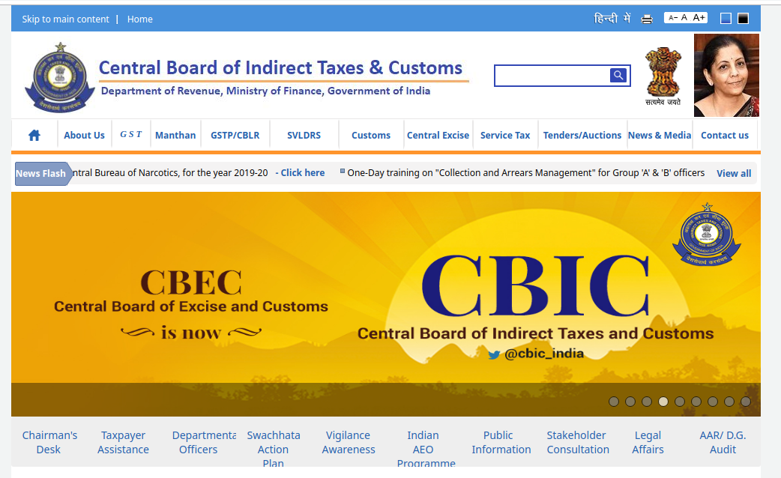

Central Board of Indirect Taxes and Customs (erstwhile Central Board of Excise & Customs) is a part of the Department of Revenue under the Ministry of Finance, Government of India. It deals with the tasks of formulation of policy concerning levy and collection of Customs, Central Excise duties, Central Goods & Services Tax and IGST, prevention of smuggling and administration of matters relating to Customs, Central Excise, Central Goods & Services Tax, IGST and Narcotics to the extent under CBIC's purview. The Board is the administrative authority for its subordinate organizations, including Custom Houses, Central Excise and Central GST Commissionerates and the Central Revenues Control Laboratory.

On the portal 98% of export and 90-95% of import documentation computerized, Electronic filing can be done through ICEGATE at 3 locations (Mumbai, Delhi, Chennai). 80% of Service Tax returns electronically processed

**2. Indian Railway**

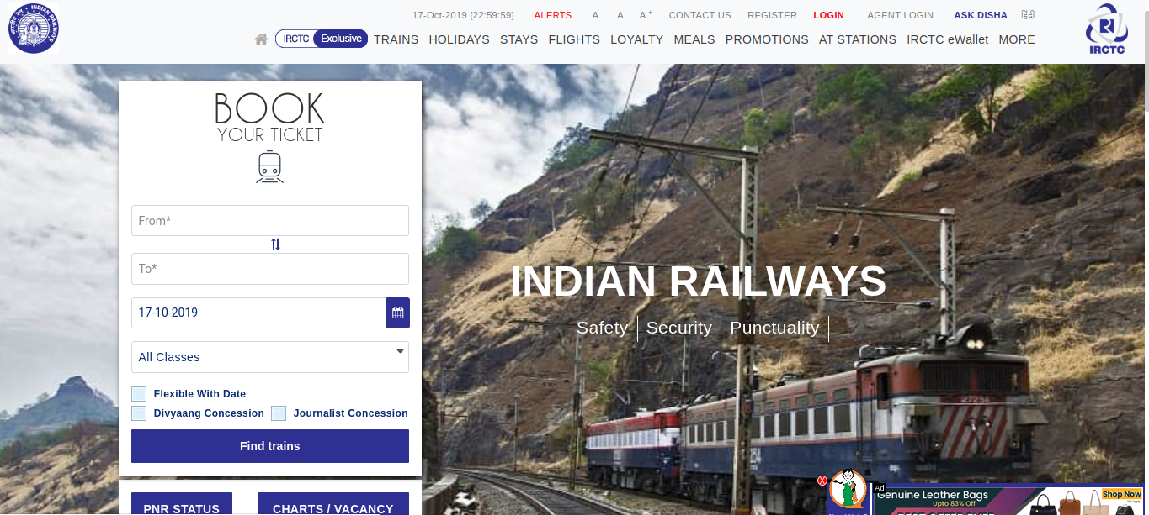

Indian Railway Catering and Tourism Corporation (IRCTC) is a subsidiary of the Indian Railways that handles the catering, tourism and online ticketing operations of the latter, with around 5,50,000 to 6,00,000 bookings everyday. It is the world's second busiest and highest of 15 to 16 Lakhs tickets every day.

After the advent of IRCTC, pantry cars were introduced inside long or medium distance trains which catered to passengers by serving freshly cooked quality food, thus revolutionizing train travel in India. It pioneered internet-based rail ticket booking through its website, as well as from the mobile phones via WiFi, GPRS or SMS. It also provides SMS facility to check PNR status and Live Train Status as well. In addition to e-tickets, Indian Railways Catering and Tourism Corporation also offers I-tickets that are basically like regular tickets except that they are booked online and delivered by post. The tickets PNR status is also made available. Commuters on the suburban rail can also book season tickets through the website. It has also launched a loyalty program called Shubh Yatra for frequent travelers. Through this program, passengers can avail of discounts on all tickets booked round the year by paying an upfront annual fee.

**3. Online Passport and Visa Service**

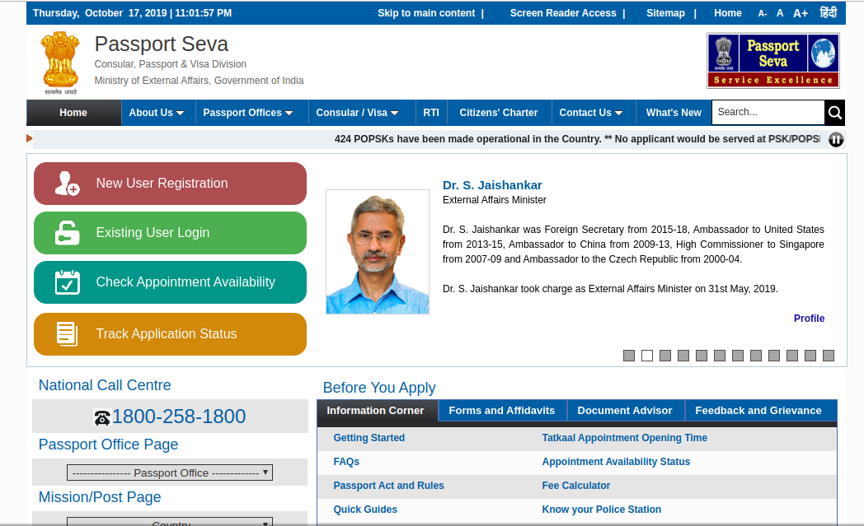

A Passport is an essential travel document for those who are traveling abroad for education, tourism, pilgrimage, medical attendance, business purposes and family visits. During the last few years, the growing economy and spreading globalization have led to an increased demand for Passport and related services. This increasing demand for passports and related services is coming from both large cities and smaller towns, creating a need for wider reach and availability. To augment and improve the delivery of passport services to Indian citizens, the Ministry of External Affairs (MEA) launched the Passport Seva Project (PSP) in May 2010.

The project has been implemented in a Public Private Partnership (PPP) mode with Tata Consultancy Services, selected through a public competitive procurement process. Under this program, the sovereign and fiduciary functions like verification, granting and issuing of passport have been retained by MEA. The ownership and strategic control of the core assets including data/information is with MEA.

Passport Seva enables simple, efficient and transparent processes for delivery of passport and related services. Apart from creating a countrywide networked environment for Government staff, it integrates with the State Police for physical verification of applicant's credentials and with India Post for delivery of passports.

**4. Indian Postal Services**

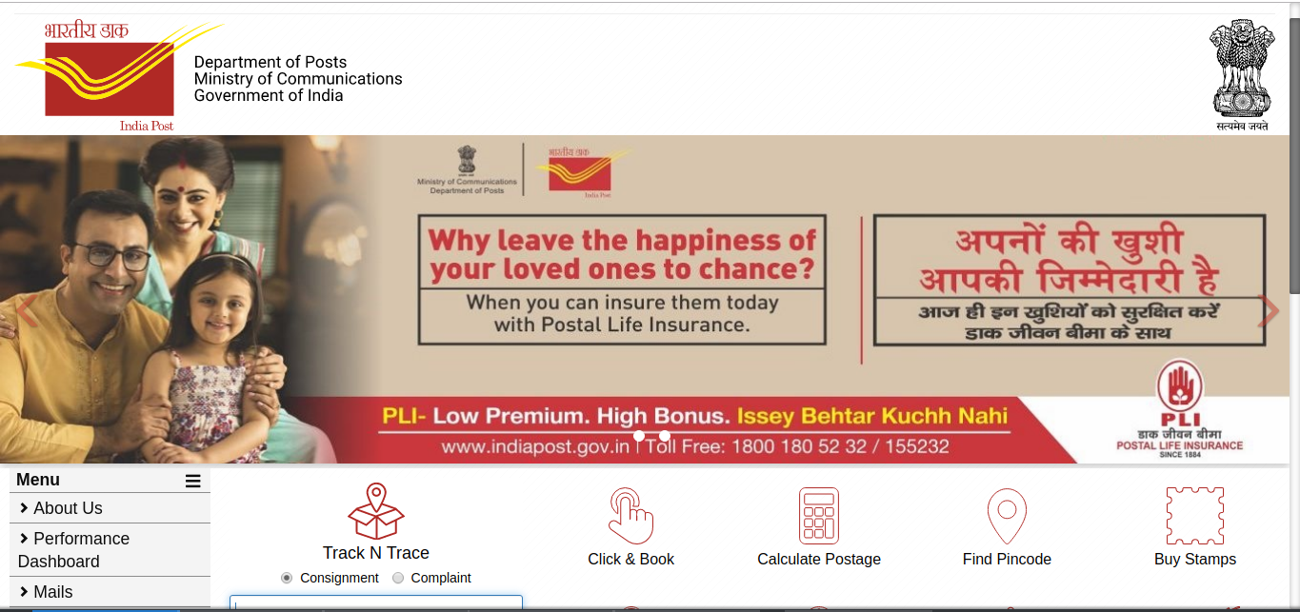

For more than 150 years, the Department of Posts (DoP) has been the backbone of the country’s communication and has played a crucial role in the country’s social economic development. It touches the lives of Indian citizens in many ways: delivering mails, accepting deposits under Small Savings Schemes, providing life insurance cover under Postal Life Insurance (PLI) and Rural Postal Life Insurance (RPLI) and providing retail services like bill collection, sale of forms, etc. The DoP also acts as an agent for Government of India in discharging other services for citizens such as Mahatma Gandhi National Rural Employment Guarantee Scheme (MGNREGS) wage disbursement and old age pension payments. With 1, 55,531 Post Offices, the DoP has the most widely distributed postal network in the world.

On this service provies direct e-credit of Monthly Income Scheme returns into the investors accounts, dematerialization of Savings Certificate (NSC) and Vikas Patras (KVP), offering full portability, tracking of posts and parcels, payments of PLI premium etc.

**5. E-Mitra (Rajasthan)**

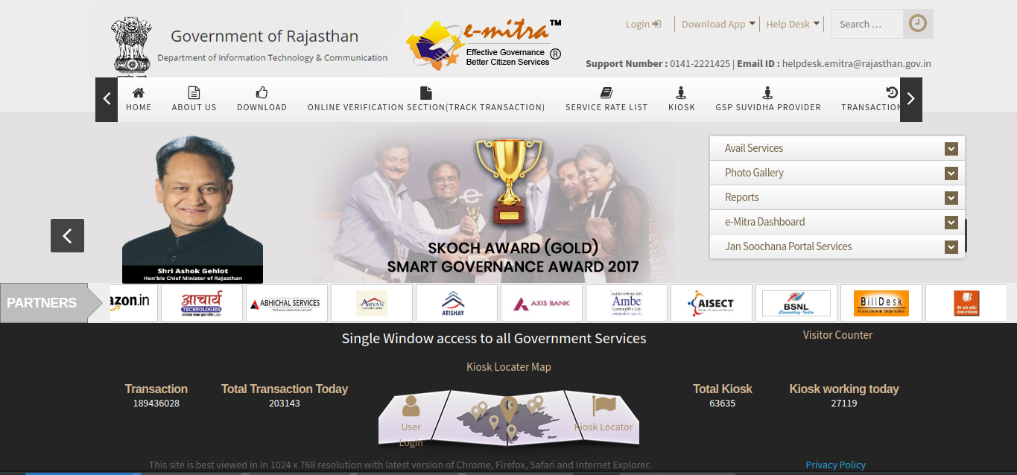

Committed to quick and convenient delivery of citizen services, Government of Rajasthan set up the eMitra platform of eGovernance way back in the year 2004. Currently, over 250 G2C and B2C services are being provided through this platform across all rural & urban areas in 33 districts of the State. And new services are being added to its fold regularly. The eMitra service delivery points – centers & kiosks – are run on Public-Private Partnership model.

**Its primary objectives are** :

Provide a wide range of services of various government & private organisations in a citizen-friendly manner under one roof, so that citizens can overcome the inconvenience faced in moving around various offices. Empower women by providing them business opportunities. Generate employment opportunities for people till the grassroot level.

**Its positive outcomes are:**

Reduced footfall in government offices, with service delivery closer-to-home.

Service delivery on FIFO (first-in-firrst-out) basis.

Easy record keeping/online document management system.

Time-bound delivery of services.

Reduced time for availing services, hence more time for other activities.

Real-time, transparent online systems for better visibility to all.

Anytime-Anywhere-Service (different platforms available like web, mobile, kiosk) that reduces cost of travel and saves time.

**6. Boomi (Karnatka Govt.)**

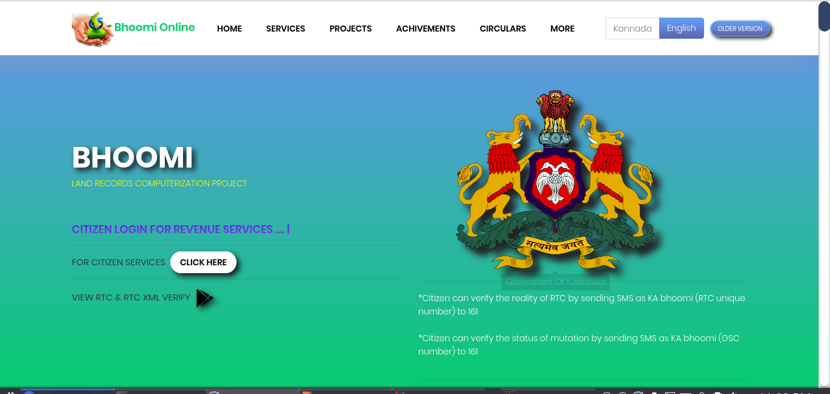

A flagship project of Karnataka State Government, is a Land Records management system. The project was inaugurated in the year 2000. Under this project, all the manual RTCs which prevailed at the time of data entry were digitized and made available to the citizen through Kiosk Centres. All the ownership or any other changes in the RTCs are carried out through mutation as per KLR Act using the Land Records database. Bhoomi back offices have been set up at all taluks of the state. In each of these centres LR Kiosk & Application Kiosk have also been setup.

It provides computerized records of Right Tenancy & Corps (RTC), This project has benefited 20 million rural land records covering 6.7 million farmers.

**CHALLENGES FOR DEVELOPMENT**

In this section challenges of e-governance for developing countries are investigated. Four SWOT analyses are presented, with a focus on the following aspects of e-governance:

•Political

•Social

•Economic

•Technological

**SWOT-Analyses of e-governance**

The SWOTs are kept at a high level. Going into detail would be a problem because situations vary for each country, for each moment and for each e-governance solution.

**Political Aspects**

Political aspects related to e-governance are e.g. the formulated strategy and policy, laws and legislation, leadership, decision making processes, funding issues, international affairs, political stability.

|  |  |  |  |
| --- | --- | --- | --- |
| Political aspects– Implementation and maintaining of e-governance solutions | | | |
| Strengths | Weaknesses | Opportunities | Threats |
| Combination with democratisation reforms  Internet as pull factor  Modern image | BudgetCyber laws not availableNo problem owner within government  No expertise about technologySlow decision making processHierarchy in organisations  Short term approach due to electionsIntegration and reform | Raise external fundingShow competitive edge  Transparency causes natural change of processes  Reinvent government | BureaucracyPiracy, misuse CorruptionMaintaining disorder, no transparencyPolitical instability  Resistance |

**Social Aspects**

Examples of some of the social aspects related to e-governance are people, (level of) education, employment, income, digital divide, rural areas vs. cities, rich vs. poor, literacy, IT skills.

|  |  |  |  |
| --- | --- | --- | --- |
| Social aspects– Implementation and maintaining e-governance solutions | | | |
| Strengths | Weaknesses | Opportunities | Threats |
| People eager to learn IT skills  Skilled people possible export product | Basic education poor: trainers needed  No IT literacy  Low literacy  Different languages  Public acceptance of self-service models  Skill shortage: competition with private sector | Education system improve  People learn structural job  Cheap manpower widely available  Promotion of internetBetter healthcare | Brain drain IT skilled people after training  Resistance of people  Digital divide  Privacy |

**Economic Aspects**

Economical aspects related to e-governance are funding, cost-savings, business models, e-Commerce, spin-offs of e-governance.

|  |  |  |  |
| --- | --- | --- | --- |
| Economic– Implementation and maintaining e-governance solutions | | | |
| Strengths | Weaknesses | Opportunities | Threats |
| E-Governance good argument for external funding  Transparency for businesses (procurement) | Investors Budget control | Cost efficiency through e-governance  New business  More efficiency tax revenues | Corruption |

**Technological Aspects**

As discussed in the previous chapter, technology will be a bottleneck for e-governance in developing countries. Technological aspects involve software, hardware, infrastructure, telecom, IT skilled people, maintenance, safety and security issues.

|  |  |  |  |
| --- | --- | --- | --- |
| Technological aspects– Implementation and maintaining e-governance solutions | | | |
| Strengths | Weaknesses | Opportunities | Threats |
| Everything is new: no negative legacyLeapfrogging possible  Internet as driving (pull) factor | Shortage IT skilled people  High cost of internet  Heterogeneous data  Lack of IT standards?  Costs of software licenses | 2nd hand hardware available  Use one standard | Dependency of technology |

**REFERENCES**

1. DAC. (2014). Annual Report: 2014–2015. Government of India: Department of Agriculture and Co-operation.
2. UN (2008) UN E-government survey 2008: From E-government to connected governance, United Nations, New York. Retrieved March 2, 2009, from http://unpan1.un.org/intradoc/groups/
3. public/documents/UN/UNPAN028607.pdf
4. http://emitra.rajasthan.gov.in/content/emitra/en/Aboutus/Aboutemitrabrochure.html
5. Ministry of Information Tech. Indiawww.mit.gov.in
6. Wikipedia.
7. Slide Share.