CSCL1030 CloudOps Tools and Techniques

Applied Laboratory 2

Instructor Name
Joba Hassan

Name: Anant Chauhan

- Making 4 identical AWS EC2

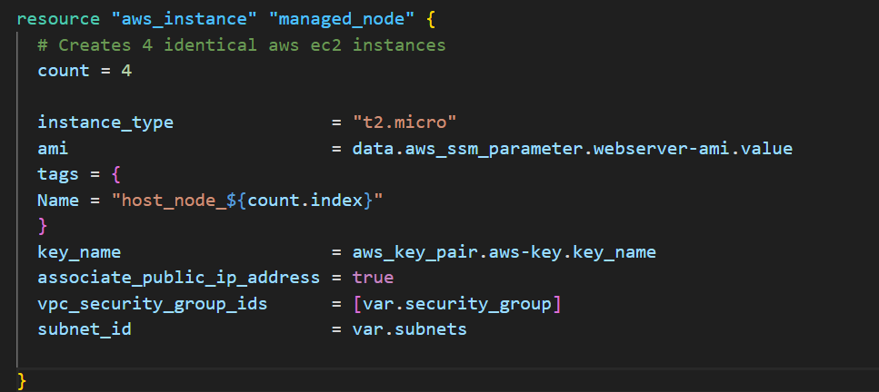
- Control node

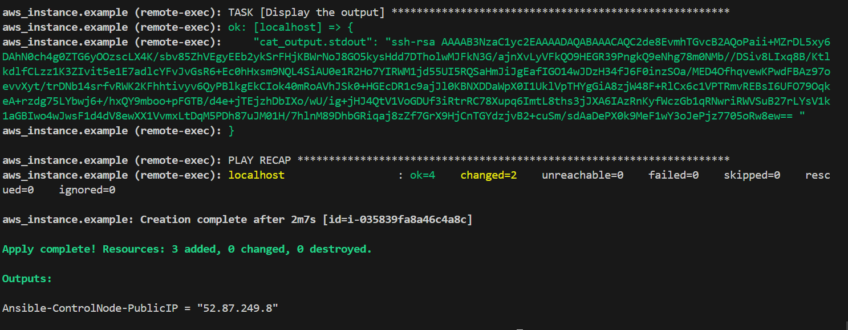
- Managed nodes [including IP addresses for four web servers]
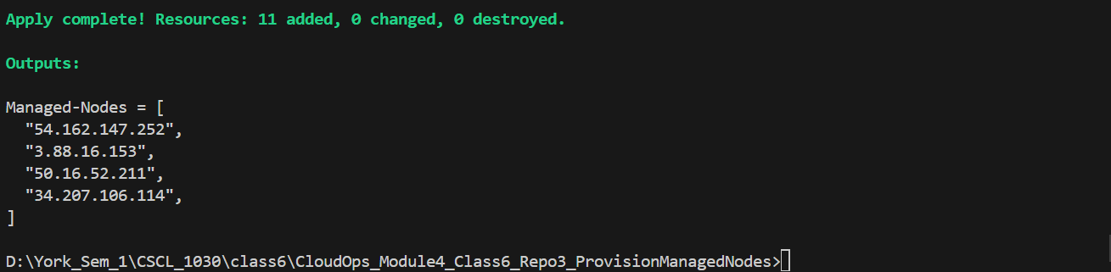

- AWS EC2 list showing all created servers, including public Ips
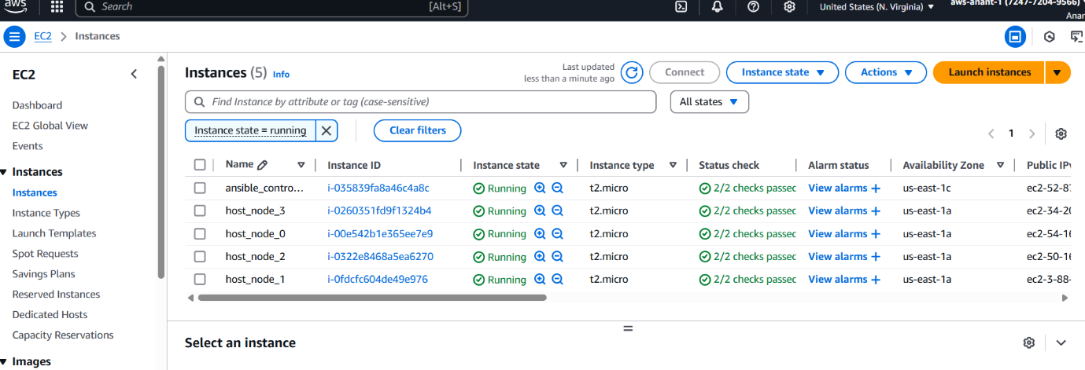

- Hosts.ini
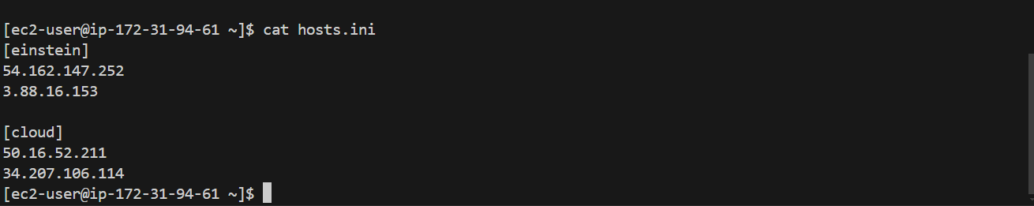

- Output from running ansible-playbook commands for both playbooks.
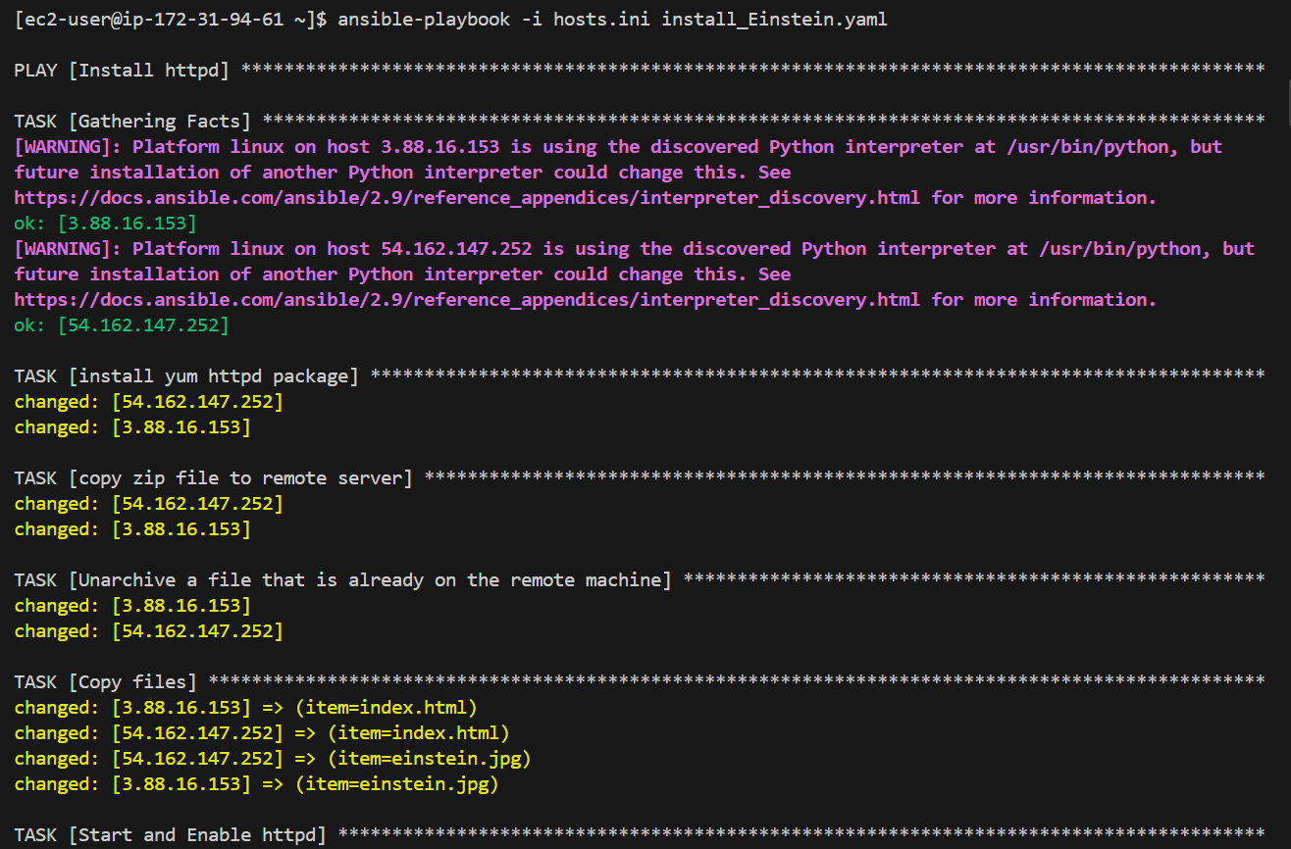

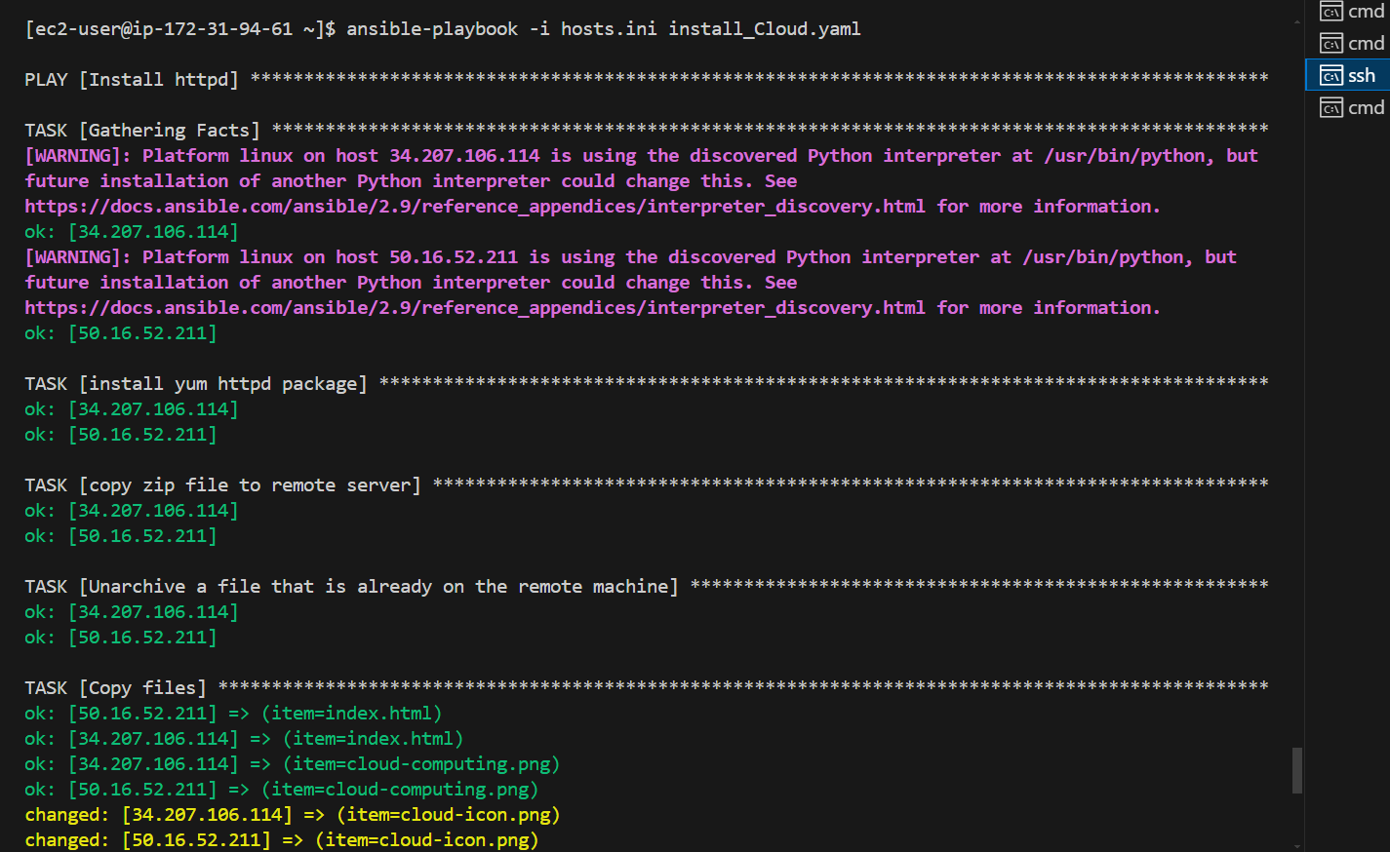

- Screenshot of 4 browser windows, showing URL in the address bar and web page that is being rendered.
