

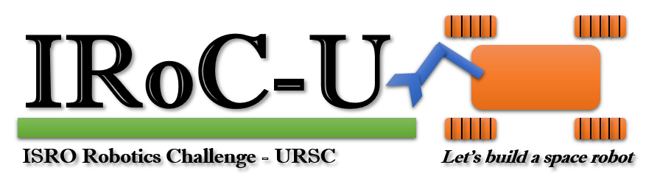

ISRO ROBOTICS CHALLENGE - URSC 2026
FINAL PROJECT REPORT
ASCEND: Autonomous GPS-Denied Micro-UAV and Automated Base Station
LATEST FIELD-ROUND CONFIGURATION
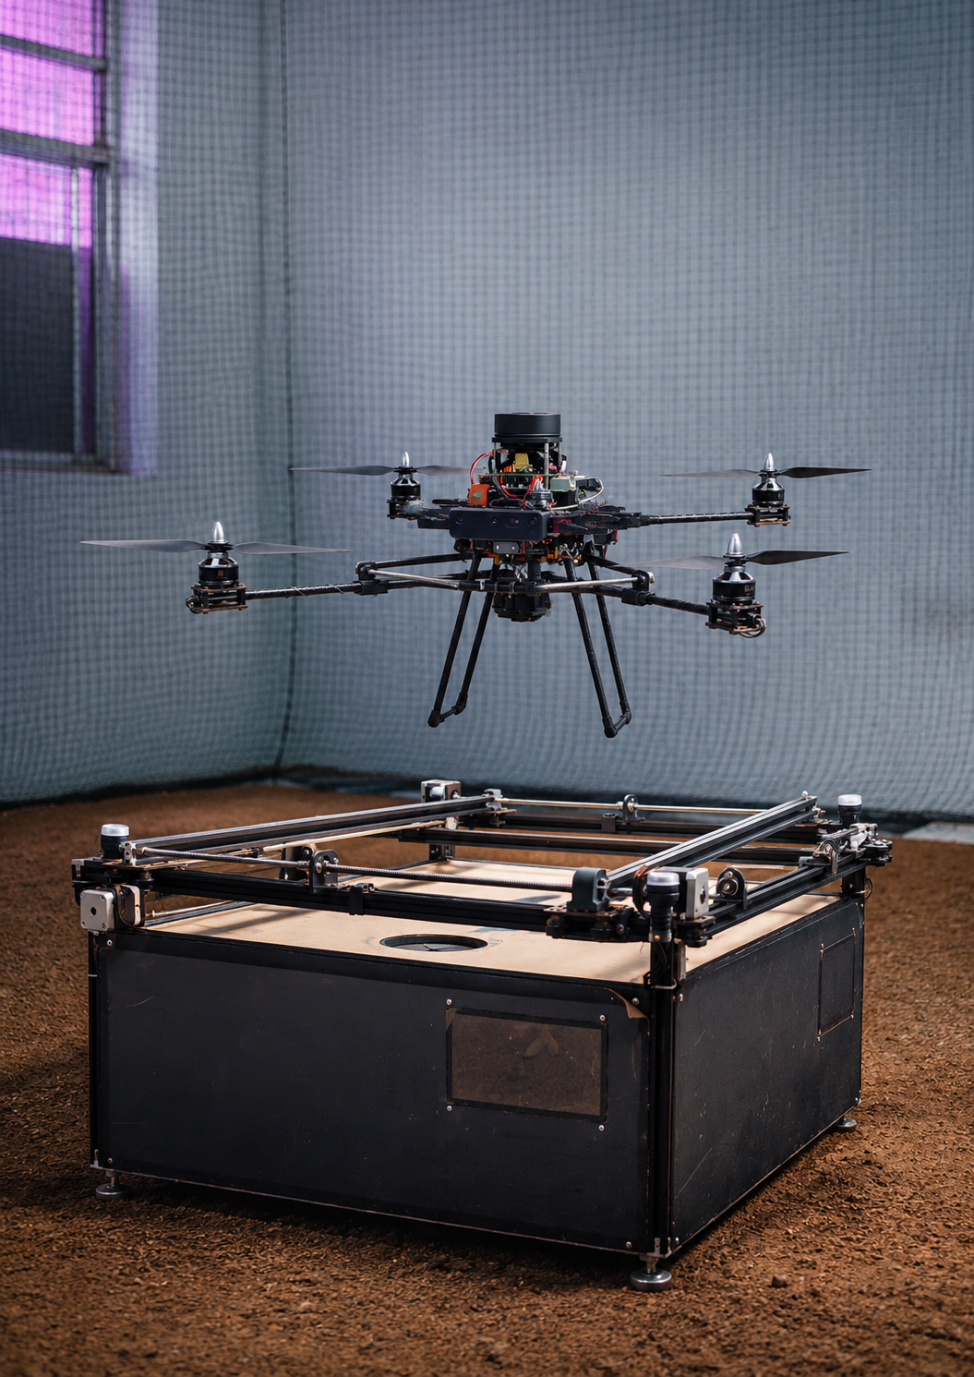
Team Name | IIC_SIT
Team ID | 10144
Institute | Sinhgad Institute of Technology, Lonavala
Document Version | Version 2.0 - Updated Current Configuration
Submission Date | 11 July 2026

Prepared for the IRoC-U 2026 Final Field Round, Bengaluru

Table 1. Document identification
Field | Value
Document title | IRoC-U 2026 Final Project Report - Updated Current Configuration
Project | ASCEND Autonomous GPS-Denied Micro-UAV and Automated Base Station
Team | IIC_SIT
Team ID | 10144
Institute | Sinhgad Institute of Technology, Lonavala
Document owner | Yash Kamble - Team Lead
Faculty guide | Dr. M. S. Chaudhari - Mentor
Classification | Competition submission / controlled project document
Status | Draft prepared for final verification
Table 2. Revision history
Version | Date | Description of change | Prepared by | Approved by
0.1 | [10/01/2026] | Initial architecture and requirement draft | Team IIC_SIT | Dr. M. S. Chaudhari
0.5 | [1/05/2026] | Elimination-round configuration freeze | Team IIC_SIT | Dr. M. S. Chaudhari
1.0 | 11/07/2026 | Initial latest-configuration compilation | Team IIC_SIT | Dr. M. S. Chaudhari
2.0 | 11/07/2026 | Regenerated from current-stack, design/test, mission-outcome and demonstration records | Team IIC_SIT | Dr. M. S. Chaudhari

Configuration Freeze Checklist
Check | Required confirmation
Physical configuration | All hardware listed in Sections 3 and 20 is installed on the final competition vehicle.
Sensor roles | RPLidar, H-Flow, Sony IMX500, Hailo AI HAT+ 2 and any supplementary thermal payload match the installed build.
Mass and dimensions | All values are measured after the final assembly.
Software versions | PX4, OS, MAVSDK/MAVLink, RPLidar driver, Picamera2/IMX500 and mission commit IDs are recorded.
Photographs | Final photos match the configuration described in this report.
Test evidence | Tables and plots use final-build test runs only.
Safety values | Margins, stop distances, speed limits and failsafes are verified.
Final review | No placeholder text or image boxes remain in the submitted PDF.

Source Documents and Configuration Authority
This regenerated report uses a controlled source hierarchy to resolve differences among proposal, pre-field, elimination-round and current-stack documents. The Current Drone Stack Specification is the controlling source for the active aerial baseline; the Design and Test Report is the controlling source for Base Station v6.1; the Mission Outcome and 04 July 2026 Demonstration Reports provide validation evidence; and the Arena and Feature Report defines the implemented offline image-analysis pipeline. Earlier Livox MID360, OAK-D and proposal-stage architectures are treated as historical configurations and are intentionally not presented as the active final baseline in this file.
Authority level | Source record | Use in this report
1 - Current aerial baseline | Current Drone Stack Specification Report | Active Pixhawk/PX4, Raspberry Pi 5, RPLidar, H-Flow, propulsion, frame and battery stack
2 - Current ground baseline | Design and Test Report - Base Station v6.1 | Mechanical centering, iris/actuator, pogo interface, electronics, modes and charging telemetry
3 - Validation evidence | Mission Outcome and IRoC-U 2026 Demonstration Reports | Mission status, attempt history and successful task evidence
4 - Processing implementation | Arena and Feature Report | HD-to-LR transfer, SIFT/KNN/RANSAC target validation and output folders
Historical only | Proposal and earlier pre-field reports | Development traceability; to be added later as a separate previous-configuration section

Declaration and Approval
We hereby declare that this report represents the latest configuration of the ASCEND autonomous drone and automated base station developed by Team IIC_SIT for the IRoC-U 2026 Final Field Round. The configuration, photographs, measurements, software versions and validation results included in the final submitted copy will be checked against the physically assembled system.
The team further declares that all technical claims in the final report will be supported by implementation evidence, measured results, flight logs, photographs or engineering calculations. Any remaining limitation will be identified transparently in the relevant section.
Yash kamble  ____________________________  Team Leader | Mr. Suraj Surve  ____________________________  Industry expert | Dr. M. S. Chaudhari  ____________________________  Faculty coordinator / Dean of R&D

Acknowledgement
Team IIC_SIT expresses sincere gratitude to the ISRO Robotics Challenge - URSC 2026 Organizing Committee for providing the technical challenge and final field-round opportunity. The team acknowledges the support of Sinhgad Institute of Technology, Lonavala, institute management, faculty mentors, laboratory and workshop staff, Project reviewers and every student member who contributed to the mechanical, electronics, autonomy, perception, testing, documentation and logistics activities of ASCEND.

Team Information
Role | Name
Team Lead | Yash Kamble
Team Members | Aniket Raj; Sanskar Herale; Vignarth Mahesh Chitiken; Anant Prafulla Hejib
Mentor | Dr. M. S. Chaudhari
Institute | Sinhgad Institute of Technology, Lonavala

Executive Summary
ASCEND (Autonomous Survey & Computation in GPS-Denied Environments) is an integrated autonomous micro-UAV and automated base-station platform developed by Team IIC_SIT for the IRoC-U 2026 challenge. The current system supports autonomous initialization, takeoff, indoor survey, image capture, coordinate logging, return and landing support, mechanical docking, wired data transfer, post-flight target validation and protected battery charging.
The current aerial baseline is built around a Pixhawk 6C running PX4 and a Raspberry Pi 5 with 16 GB RAM and NVMe storage. PX4 remains the low-level flight authority, while the Raspberry Pi executes the Python mission supervisor through MAVSDK/MAVLink. The active navigation and safety stack uses SLAMTEC RPLidar A1M8 range scans for obstacle , boundary and lane awareness, together with a Holybro H-Flow optical-flow, time-of-flight range and IMU module for near-ground motion and altitude support. A Sony IMX500 Raspberry Pi AI Camera captures high-definition mission imagery, A Waveshare MLX90640 thermal camera is documented as a supplementary payload and must be retained in the final baseline only when physically installed.
The final airframe uses a custom carbon-fibre tube-and-clamp structure, custom PCB integration, T-Motor MN3110 470 KV motors, 14 x 4.7 propellers, a T-Motor F55-series all-in-one ESC and a 4S 2800 mAh lithium-ion battery. The Base Station uses a 20 x 20 mm aluminium-extrusion frame, four NEMA17/T8 lead-screw centering axes, eight Omron limit switches, a linear-actuator and iris mechanism, and separate spring-loaded pogo-pin groups for charging and Ethernet. A Teensy 4.1 performs real-time mechanism and relay control, while a Raspberry Pi 5 with a 7-inch touch display manages the user interface, data transfer and post-flight processing.
Team validation records dated 04 July 2026 document a successful full autonomous mission on the third demonstration attempt after hardware correction and software tuning. The recorded task status includes autonomous takeoff, survey, coordinate determination, landing, charging and data validation. The mission-outcome record further confirms HD image collection, LR image generation, target identification and transfer of mission data to the base station.

List of Tables
The report contains configuration, requirement, interface, safety, test and result tables. Table numbers are included directly above each table for easy editing and cross-reference.

Abbreviations
Abbreviation | Meaning
ASCEND | Autonomous Survey & Computation in GPS-Denied Environments
UAV | Unmanned Aerial Vehicle
GNSS | Global Navigation Satellite System
PX4 | Open-source autopilot flight-control firmware
MAVLink | Micro Air Vehicle communication protocol
MAVSDK | MAVLink Software Development Kit
ESC | Electronic Speed Controller
BMS | Battery Management System
FOV | Field of View
RTL | Return to Launch / Return to Base
V&V | Verification and Validation
HMI | Human-Machine Interface
HUD | Head-Up Display
CG | Centre of Gravity

1. Introduction

1.1 Project Background
Indoor autonomous flight is fundamentally different from conventional outdoor navigation because GNSS position, heading and velocity information may be unavailable or unreliable. The vehicle must therefore estimate its local motion from onboard sensors, maintain stable flight near physical boundaries, plan a path that covers the required area, detect unsafe conditions, capture useful image data and return to a compact base station using only onboard perception and computation.
The ASCEND project combines a GPS-denied micro-UAV with an automated docking and post-flight station. This integrated approach treats the mission as a complete lifecycle rather than only a flight task: the drone must become ready, fly the planned mission, land precisely, establish a reliable mechanical and electrical interface, transfer data, present results and prepare for the next mission.

1.2 Problem Statement
PROBLEM STATEMENT: Engineering problem
Develop an autonomous micro-UAV capable of safe GPS-denied arena coverage, onboard image acquisition, target analysis, return-to-base and precision landing, together with a base station that automatically corrects landing misalignment, protects internal mechanisms, transfers mission data and safely charges the flight battery.

1.3 Project Objectives
- Perform reliable system initialization and pre-flight health checks.
- Achieve controlled autonomous takeoff, hover and local motion without GNSS.
- Generate and execute a systematic coverage path inside a validated safe region.
- Capture high-quality images with sufficient overlap for analysis and map generation.
- Detect obstacles or boundaries and respond using hold, back-off, clip or skip behaviour.
- Return to the stored base reference and complete a camera-guided staged descent.
- Land within the mechanical correction range of the automated base station.
- Center the landed drone, establish pogo-pin contacts, transfer data and enable protected charging.
- Provide live engineering visualization and post-flight target/map outputs.
- Document final configuration, measured performance, limitations and safety measures.

1.4 Scope and Boundaries
Included in this report | Outside the present report scope
Final drone mechanical, propulsion, electrical, avionics and sensor configuration | Manufacturing drawings for commercial components
Mission software, path planning, perception, landing and failsafe architecture | Source-code listing in full
Automated base-station mechanism, charging and data workflow | Certified product-level battery charger compliance testing
Final test plan, measured results and evidence locations | Unverified future hardware concepts
Known limitations and operational controls | Claims not demonstrated on the final build

2. Challenge Understanding and Requirement Analysis

2.1 Mission Lifecycle
1. Power on the drone and base-station subsystems.
2. Validate flight controller, companion computer, cameras, optical flow, range sensing, battery and storage.
3. Stream valid offboard setpoints, arm and take off to the defined mission altitude.
4. Confirm stable local pose before horizontal movement.
5. Generate or certify the safe flyable arena region and execute systematic coverage lanes.
6. Capture images and record target candidates with mission coordinates and timestamps.
7. Return to the base reference using conservative speed and explicit settle windows.
8. Use downward vision for final alignment and staged descent.
9. Confirm touchdown, disarm and transfer control to the base station.
10. Center the drone, open the iris, extend the pogo-pin interface and verify electrical/data connections.
11. Transfer mission data, update the dashboard and enable protected charging.
12. Retract mechanisms, close the iris and return the station to mission-ready state.

2.2 System Requirements
Table 3. Primary system requirements and verification approach
ID | Requirement | Design response | Verification evidence
SYS-01 | Operate without GNSS or external navigation infrastructure | PX4 local control, H-Flow motion/altitude aid, RPLidar arena awareness and onboard mission logic | Indoor flight log and local-state validation
SYS-02 | Stable autonomous takeoff and hover | PX4 closed-loop control with H-Flow support | Altitude/position plot and video
SYS-03 | Systematic arena coverage | Safe-region boustrophedon planner | Planned-versus-flown path and coverage map
SYS-04 | Boundary and obstacle protection | RPLidar sector validation, safe-region margins and hold/back-off/skip logic | Measured stopping/hold test
SYS-05 | Image acquisition and target analysis | Sony IMX500 HD capture, docked transfer and SIFT/KNN/RANSAC or Hailo-assisted analysis | Image dataset and annotated output
SYS-06 | Return to base | Stored local home reference and staged approach | Final return error
SYS-07 | Autonomous landing and docking support | Stored base reference, controlled descent and mechanical centering | Landing/docking evidence and repeated trials
SYS-08 | Automated centering and docking | Four-rod lead-screw mechanism | Correctable offset and centering time
SYS-09 | Safe charging and data transfer | Verified pogo contacts, BMS and Ethernet | Continuity, transfer and charging test
SYS-10 | Traceable mission evidence | Logs, Foxglove topics, images, configuration and mission ID | Complete mission archive

2.3 Success Criteria
Metric | Target / acceptance criterion | Final measured value | Status
Coverage completion | All valid planned lane segments completed or safely classified | 1m | Pass
Obstacle stopping distance | Stop before configured minimum distance | 1m | Pass
Landing error | Within base-station correction envelope | 0.2 m | Pass
Docking success | Verified power/data connection without short or reverse polarity | 100% | Pass
Transfer integrity | Complete verified copy of mission files | 100% | Pass

3. Latest Configuration Snapshot
CONFIGURATION FREEZE: Controlling baseline
This chapter is generated from the team’s Current Drone Stack Specification and Base Station Design and Test Report. OAK-D and Livox hardware belong to prior development configurations and should be added later only in the historical comparison chapter.

3.1 Current Drone Configuration
Table 4. Current autonomous drone subsystem configuration
Subsystem | Current component / implementation | Primary role
Flight controller | Pixhawk 6C running PX4 | Primary stabilization, arming, local control, motor mixing and immediate failsafes
Companion computer | Raspberry Pi 5, 16 GB RAM, 512 GB NVMe | Mission supervisor, sensor processing, image storage, logging and dashboard publication
Primary arena awareness | SLAMTEC RPLidar A1M8, 360-degree 2D scanner | Wall/boundary sectors, lane geometry support and close-range collision checks
Hover and altitude aid | Holybro H-Flow optical flow + ToF rangefinder + IMU | Near-ground motion estimation, hover support and altitude consistency
AI / survey camera | Raspberry Pi AI Camera with Sony IMX500 | HD survey capture, target/landing visual observations and on-sensor AI capability
AI accelerator | Raspberry Pi AI HAT+ 2, Hailo-10H, 40 TOPS INT4 | Accelerated onboard/base-station visual inference
Supplementary thermal payload | Waveshare MLX90640, 32 x 24, 55-degree FOV - verify installed | Surface-temperature scanning and feature-classification support
Mission interface | Python + MAVSDK / MAVLink | Setpoint stream, action commands, telemetry, acknowledgements and state machine
Frame and integration | Custom carbon-fibre frame, 10 mm tubes/clamps and custom PCB | Rigid structure, clean power/wiring integration and repeatable mounting
Propulsion | 4 x T-Motor MN3110 470 KV, 14 x 4.7 propellers, T-Motor F55-series 4-in-1 ESC | Lift, low-speed indoor control and motor power conversion
Flight battery | 4S lithium-ion, 2800 mAh | Main energy source for propulsion and embedded electronics

3.2 Current Base Station Configuration
Table 5. Current automated base-station configuration
Subsystem | Current component / implementation | Primary role
Structural frame | 20 x 20 mm aluminium extrusion, cast corner brackets, glass-acrylic top and black-acrylic sides | Rigid landing bed and protected field enclosure
Active centering | 4 x NEMA17 motors, T8 lead screws (8 mm diameter, 1.25 mm pitch), brass nuts and KP08/KFL08 bearings | Correct residual X/Y landing offset and align pogo contacts
Travel safety | 8 x Omron snap-action limit switches with SW2-to-SW1 homing sequence | Prevent over-travel and establish repeatable home/max positions
Docking interface | Custom spring-loaded pogo matrix with physically separated power and Ethernet groups | Tolerance to leveling error, charging connection and wired mission-data link
Protection mechanism | Linear actuator plus actuated iris; 8-second closing delay after actuator HOME | Protect pogo interface and internal circuitry from dust and rotor downwash
High-level controller | Raspberry Pi 5, 16 GB, 7-inch 1024 x 600 capacitive touch display | HMI, Ethernet payload handling, post-processing and supervision
AI acceleration | Hailo AI HAT+ 2, Hailo-10H, 40 TOPS INT4, 8 GB | Local docking-state and visual-processing acceleration
Real-time controller | Teensy 4.1 | Pulse generation, limit-switch reading, relay control and deterministic sequencing
Motor drivers | 4 x TB6600 microstep drivers | Drive the four NEMA17 centering axes
Electrical safety | Heavy-duty relay, default OFF | Prevent charging until mechanical/electrical validation passes
Operating modes | FULL AUTO; SKIP ETH; SKIP CHG; MECH ONLY | Full mission and isolated field diagnostics

TEST EVIDENCE: Recorded charging telemetry
Base Station v6.1 logs report a stabilized internal supply of 12.29-12.33 V, an initial measured pogo voltage of 12.62 V at approximately 54 s after mating, and progression up to 14.08 V during extended testing. .
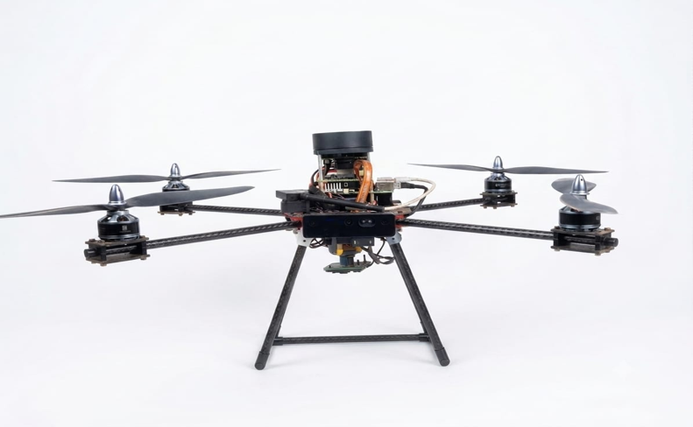Figure 3. Final assembled current autonomous drone

4. Overall System Architecture
ASCEND uses a layered architecture that separates physical flight authority, mission intelligence, perception, safety, docking and post-flight processing. This separation reduces the risk that a high-level software delay directly destabilizes the vehicle and allows each layer to enter a defined safe state when a dependency becomes invalid.
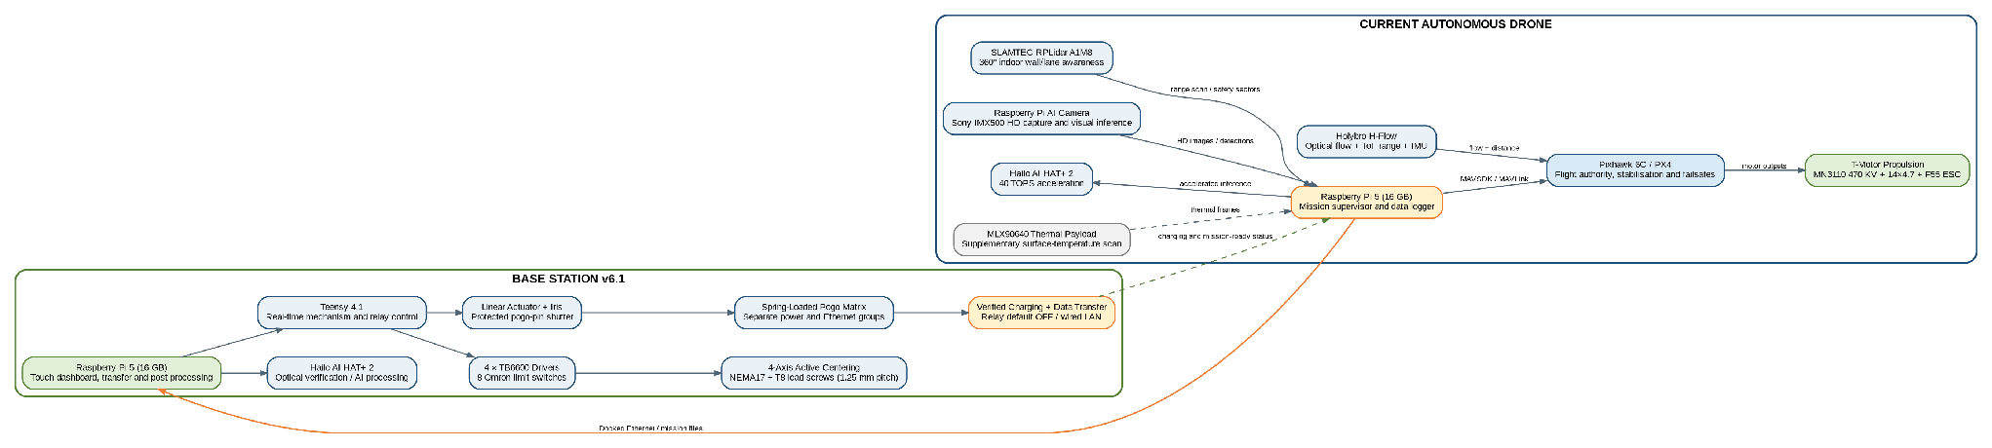
Figure 2. Overall ASCEND drone and automated base-station architecture (Generated for this report)

4.1 Control Hierarchy
- Pixhawk 6C / PX4 is the only authority for low-level attitude, rate, velocity, yaw and motor control.
- Raspberry Pi 5 issues bounded high-level setpoints and supervises mission progress through MAVSDK/MAVLink.
- Perception sensors provide pose, depth, image and range information to health and safety gates before movement is permitted.
- The coverage, return and landing managers generate goals only inside configured safety and validity limits.
- The base station remains electrically isolated from the flight battery until landing, centering and contact validation are complete.

4.2 Functional Interfaces
Table 6. Major subsystem interfaces
Source | Destination | Interface | Information / function
Raspberry Pi 5 | Pixhawk 6C | USB MAVLink | Offboard setpoints, arm/land commands, telemetry and health
RPLidar A1M8 | Raspberry Pi 5 | USB serial | 360-degree scans, arena-wall sectors and collision/boundary ranges
Holybro H-Flow | Pixhawk 6C | CAN BUS | Optical flow and range-assisted stabilization
Sony IMX500 AI Camera | Raspberry Pi 5 | CSI | HD survey images, target frames and visual landing observations
Hailo AI HAT+ 2 | Raspberry Pi 5 | PCIe / HAT interface | Accelerated visual inference and post-processing support
Drone Pi | Base-station Pi | Docked Ethernet | Mission data, checksums, status and results
Base-station Pi | Teensy 4.1 | USB/UART | Mechanism commands, limits, faults and acknowledgements
Charging controller | Flight battery/BMS | Pogo contacts | Protected power and battery-management signals

5. Final Drone Mechanical Design

5.1 Airframe and Structural Design
The final drone uses a carbon-fibre structure selected for high stiffness-to-mass ratio and reduced deformation during rapid motor-load changes. The body incorporates a custom PCB lower plate to reduce point-to-point wiring and improve repeatability. Ten-millimetre carbon-fibre rods form the arms and are retained by custom clamps. Custom 3D-printed landing-gear mounts provide the required ground clearance and docking geometry. M2.5 fasteners with rubber cap nuts are used where appropriate to reduce vibration-induced loosening.
All sensor mounts maintain a known orientation relative to the PX4 body frame. The RPLidar horizontal scan plane is kept clear of arms, propellers, landing gear and wiring; the H-Flow faces downward with an unobstructed floor view; and the Sony IMX500 camera is aligned for survey imaging and visual landing observations. Cable routing is separated from propeller discs and the lower docking interface.
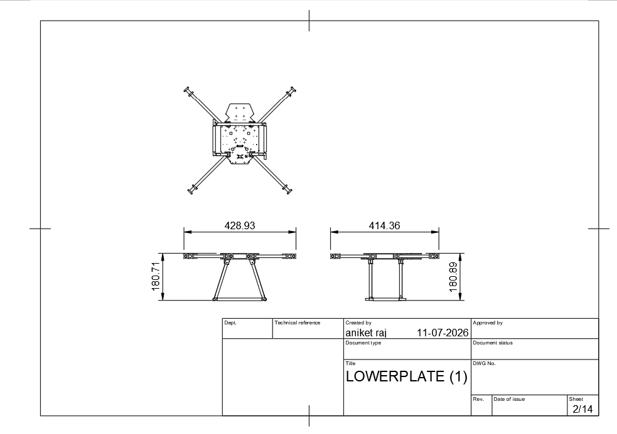
Figure 4. Drone dimensional views and key mounting dimensions

5.2 Final Dimensions and Mass Properties
Table 7. Measured final drone dimensions
Parameter | Symbol | Measured value | Measurement condition
Core frame length | L | 328 mm | Propellers installed / removed:
Core frame width | W | 254 mm | Propellers installed / removed:
Maximum height | H | 180 mm | Landing gear in flight configuration
Motor-to-motor wheelbase | D | 320 mm | Centre-to-centre diagonal / adjacent:
Ground clearance | G | 151 mm | Level surface
Docking contact height | P | 100 mm | From base landing plane
Total takeoff mass | MTOM | 1960 g | Final battery and all sensors installed
Centre-of-gravity offset | CG | -2 mm | Relative to geometric centre
Table 8. Mass breakdown and centre-of-gravity inputs
Item | Quantity | Unit mass | Total mass
Carbon frame and arms | 1 | 125g | 125g
Motors | 4 | 98g | 98g
Propellers | 4 | 114g | 114g
ESC and power PCB | 1 | 17.8g | 17.8g
Pixhawk 6C and power module | 1 | 34.6g | 34.6
Raspberry Pi 5 and storage | 1 | 70g | 70g
Sony IMX500 AI Camera | 1 | 10g | 10g
H-Flow | 1 | 15.2g | 15.2g
Hailo AI HAT+ 2 | 1 | 19g | 19g
RPLidar A1M8 and mount | 1 | 170g | 170g
Battery | 1 | 220g | 220g
Landing gear / docking hardware | 1 set | 40g | 40g

5.3 Landing and Docking Geometry
The landing gear is designed not only for flight touchdown but also for interaction with the base-station centering rods. The final report must state the maximum landing offset and yaw misalignment that can be corrected mechanically without damaging the frame or obstructing the pogo-pin interface. Hard stops and soft-contact surfaces should prevent excessive centering force.

6. Propulsion, Battery and Power Distribution

6.1 Propulsion System
The propulsion system uses four T-Motor Navigator MN3110 470 KV brushless motors paired with 14 x 4.7 nylon propellers and a T-Motor F55-series 4-in-1 electronic speed controller. The motor-propeller combination must provide sufficient thrust margin for stable indoor hover, controlled acceleration and recovery from small disturbances while remaining compatible with the final frame dimensions and battery voltage.
Table 9. Propulsion configuration and verified values
Parameter | Final value | Verification / evidence
Motor model | T-Motor Navigator MN3110 470 KV | Datasheet and installed-part photograph
Motor quantity | 4 | Visual inspection
Propeller | 14 x 4.7 nylon, CW/CCW | Installed part
ESC | T-Motor F55-series 4-in-1 - verify exact label | Installed part / configuration
Battery cell count | 4S lithium-ion | Battery label and charger
Battery capacity | 2800 mAh | Battery label
Battery C-rating | 13c | Battery label
Measured hover throttle | 45% | PX4 log
Maximum measured thrust per motor | 1050g | Thrust test
Total thrust-to-weight ratio | 2:1 | Calculated from final measured mass

6.2 Battery and Flight Endurance
Record endurance using the final payload, propellers, battery and mission software. A single unloaded hover test is not sufficient to represent mission endurance. The final value should include takeoff, coverage movement, return and landing, together with a defined remaining battery reserve.
Test | Initial voltage | Final voltage | Duration | Mission profile | Notes
Battery endurance test 1 | 16.4 | 14.5 | 9m | full mission | Battery heated little bit
Battery endurance test 2 | 16.39 | 14.65 | 8m | Hover | Battery stable
Reported usable endurance |  |  | 8.5 m |  | Mean or conservative minimum

Table 10. Power budget
Load | Supply voltage | Typical current | Peak current | Protection / source
Pixhawk 6C and peripherals | 5V] | 0.5A | 1A | Power module / fuse
Raspberry Pi 5 | 5 V regulated | 2A | 5A | DC-DC converter / current limit
RPLidar A1M8 | 5V | 1A | 2A | Regulated USB/sensor rail
Holybro H-Flow | 5V | 0.3A | 0.5A | Flight-controller port
Hailo AI HAT+ 2 | 5 V / PCIe rail | 1A | 2A | Raspberry Pi HAT supply

7. Avionics and Flight-Control System

7.1 Pixhawk 6C and PX4 Responsibilities
Pixhawk 6C running PX4 is the low-level flight authority. It closes the attitude, angular-rate, velocity and yaw loops; estimates vehicle state using onboard and external sensor inputs; generates motor outputs; manages arming checks; and activates immediate flight failsafes. The companion computer does not directly command motor outputs. It publishes bounded setpoints only while PX4 reports valid local control conditions.
- Attitude and body-rate stabilization.
- Local velocity and position control where estimator validity permits.
- Yaw control and transition settling.
- Motor mixing and ESC output.
- Arming, disarming and landed-state handling.
- Offboard-loss, battery and estimator failsafes.
- Telemetry publication to the companion computer.

7.2 Raspberry Pi 5 Mission Computer
The Raspberry Pi 5 is the mission brain. It runs the Python mission supervisor, sensor interfaces, mission-state logic, coverage planner, boundary/obstacle manager, image-capture manager, target-processing pipeline, return manager, landing manager, base-station transfer client, structured logging and Foxglove publication. The final build should record RAM, storage, operating-system image, cooling hardware and power-converter rating.
Table 11. Companion-computer final software environment
Item | Final version / configuration | Evidence location
Raspberry Pi model | Raspberry Pi 5, 16 GB RAM | System photograph / invoice
Storage | 512 GB NVMe SSD kit | System information
Operating system | Raspberry Pi OS Bookworm Lite | /etc/os-release
Kernel | Linux 6.18 | uname -a
Python | Python 3.14.6 | python3 --version
MAVSDK | v3.17.1 | Package record
MAVLink / pymavlink | 2.0 | Package record
Picamera2 / IMX500 stack | 3 | Package record
Hailo runtime / model | Halio hat +2 40 ai tops | Package/model record
RPLidar / ROS 2 driver | ROS 2 JAZZY | Package/launch record
OpenCV | OpenCV 5.0.0 | Package record

7.3 Control and Perception Architecture
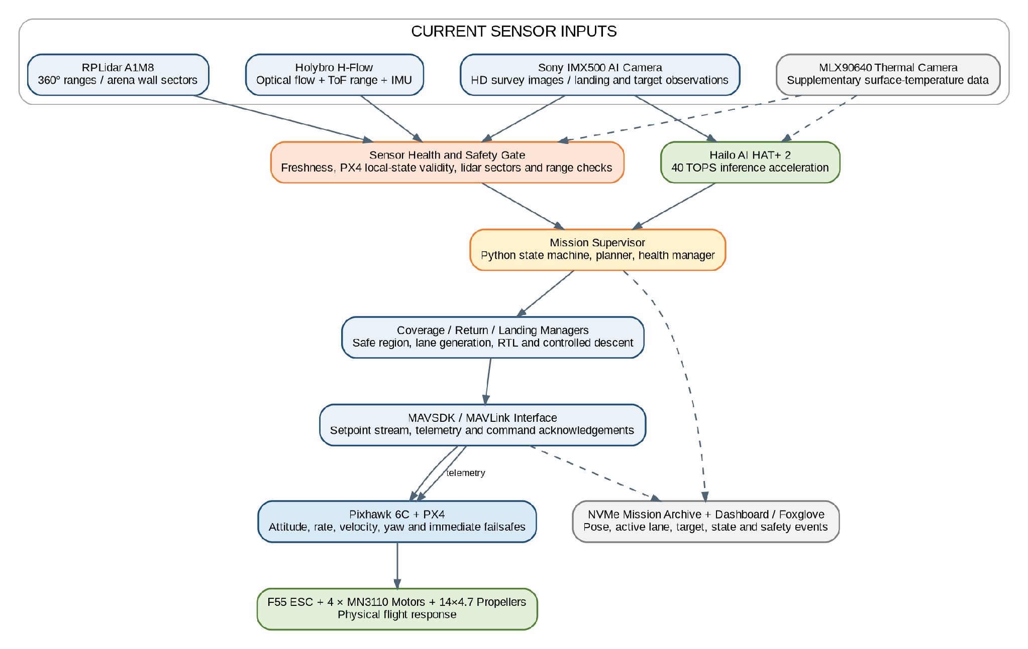
Figure 5. Drone control, perception, mission and logging architecture

7.4 Offboard Handshake and Command Supervision
1. Open the final Pixhawk communication port and wait for a valid heartbeat.
2. Confirm expected vehicle identity, firmware state and local-position health.
3. Start a continuous offboard setpoint stream before requesting offboard mode.
4. Request arm only after sensor, battery, storage and mission conditions pass.
5. Validate mode and arm acknowledgements before takeoff.
6. Monitor heartbeat, telemetry age and setpoint-loop timing throughout the mission.
7. On timeout or rejected command, stop mission progression and invoke the configured hold/land response.

8. GPS-Denied Navigation, Survey Sensing and Perception

8.1 Current Navigation Strategy
The current field stack uses complementary sensors rather than one monolithic localization payload. PX4 on Pixhawk 6C remains responsible for low-level state validity and flight response. Holybro H-Flow supplies downward optical-flow, time-of-flight distance and IMU measurements that support near-ground hover and altitude behaviour. RPLidar A1M8 provides a horizontal 360-degree scan used by the mission supervisor to observe arena walls, derive/certify the safe flyable region, monitor lane transitions and trigger close-range hold or skip behaviour.
The companion computer treats scan freshness, sector validity, H-Flow quality/range and PX4 local-position health as mandatory movement gates. The system does not claim that a 2D RPLidar independently provides full six-degree-of-freedom localization. Instead, range geometry is used for arena-relative planning and safety while PX4/H-Flow maintain flight stability within the tested indoor operating envelope.

8.2 Sensor Roles and Mounting
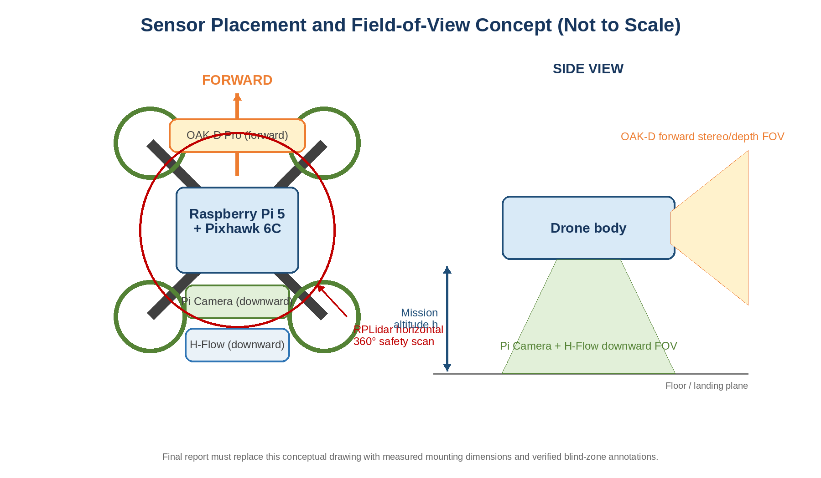
Figure 6. Current sensor placement and field-of-view concept
Table 12. Current sensing and perception specification
Sensor / module | Mounting and orientation | Key output | Current documented setting
SLAMTEC RPLidar A1M8 | Horizontal scan plane clear of arms and wiring | 360-degree polar ranges, wall sectors and collision distance | Nominal 6 m radius, up to 10 Hz -
Holybro H-Flow | Downward, unobstructed floor view | Optical flow, ToF range and IMU data | PAA3905E1 flow, AFBR-S50LV85D ToF, ICM-42688-P IMU
Sony IMX500 Raspberry Pi AI Camera | Survey/landing view fixed to the frame | HD images, target frames and on-sensor neural-network output | Record final resolution, capture interval, exposure and FOV
Hailo AI HAT+ 2 | Mounted with Raspberry Pi 5 | Accelerated inference | Hailo-10H, 40 TOPS INT4;
MLX90640 thermal camera | Supplementary payload - verify installed orientation | 32 x 24 thermal array | 55-degree FOV; record frame rate/calibration if retained

8.3 Sensor Health Gating
Health check | Valid condition | Action when invalid
RPLidar scan freshness | Newest scan age below configured timeout | Hold and reject lane progression; land/return if persistent
RPLidar sector coverage | Required sectors contain sufficient finite samples | Disable movement toward unobserved/unsafe direction
H-Flow quality | Flow quality above threshold with valid ground range | Reduce motion or hold; controlled landing if persistent
PX4 local-position state | Estimator reports valid local control state | Do not enter or continue horizontal offboard movement
IMX500 frame/storage | Fresh frame and successful image write | Retry capture; preserve flight safety even when imaging is unavailable
Hailo inference service | Runtime and model respond within timeout | Continue raw capture; defer target processing or use offline SIFT pipeline
Battery and compute health | Voltage, temperature, storage and process heartbeat valid | Early return, safe land or controlled shutdown

8.4 Calibration and Frame Alignment
Calibration item | Method | Recorded output
RPLidar angular zero | Known wall/target direction and body-frame comparison | Zero-angle offset
RPLidar scale/scan quality | Measured wall distances at multiple ranges | Bias/error and minimum valid sample count
H-Flow orientation | PX4 orientation setting and known floor-motion test | Orientation parameter and axis sign
Range scale | Measured heights above a level floor | Scale/bias and valid altitude band
IMX500 optical centre | Image centre versus mechanical survey/landing reference | Pixel offset and mount angle
Thermal alignment | Co-register thermal and RGB views using a known target | Offset/scale record

8.5 Blind Zones and Operating Envelope
Document every scan occlusion created by the frame, motor supports, landing gear or payload. The current report must state minimum reliable RPLidar range, practical wall-detection range, H-Flow floor-texture and lighting requirements, valid ToF altitude band, IMX500 exposure limits and the safe mission altitude. Safety margins shall be based on the least-observed direction, not only the best sensor sector.

9. Autonomous Mission Software

9.1 Software Module Structure
Module | Responsibility | Critical inputs | Outputs
Mission supervisor | Owns the state machine and transition rules | Health state, operator start/abort | Current state and subsystem commands
PX4 interface | Heartbeat, telemetry, mode/arm commands and setpoint stream | MAVLink connection | Validated flight-control interface
Sensor health manager | Freshness, validity and consistency checks | IMX500/Hailo, H-Flow, RPLidar and PX4 | Health gates and fault codes
Arena manager | Boundary certification and safe flyable polygon | Geometry / range data / configuration | Safe region
Coverage planner | Boustrophedon lane and transition generation | Safe region, FOV, overlap | Ordered segments
Obstacle manager | Close-range collision and boundary supervision | RPLidar sectors and safe-region geometry | Hold/back-off/skip command
Image manager | Capture timing, file naming and metadata | Pose, camera frames, mission state | Stored images and manifest
Target manager | Reference matching / AI inference and annotations | Captured images | Labels, confidence and coordinates
Return manager | Coarse and fine return-to-base sequence | Local pose, base reference | Safe return goals
Landing manager | Target detection, visual servo and descent states | Downward image, altitude, landed state | XY corrections and descent commands
Logger / Foxglove | Structured events, CSV and visualization | All mission modules | Mission evidence and live monitor

9.2 Mission State Machine
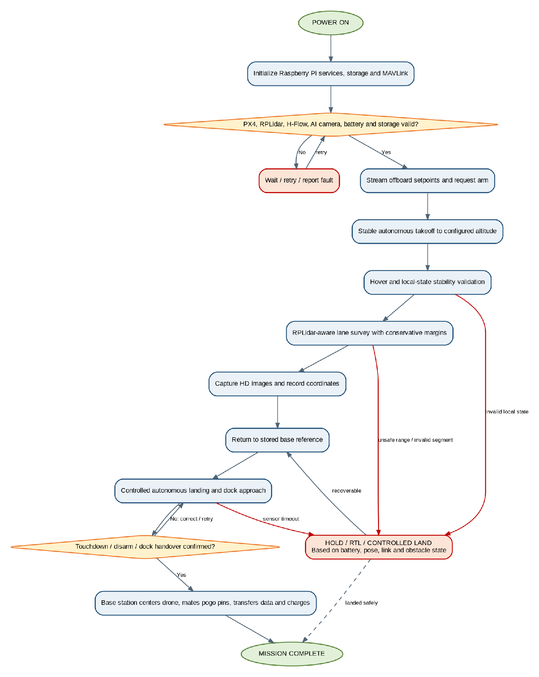
Figure 7. Autonomous mission state machine and principal failsafe transitions

9.3 Pre-Flight Health Checklist
Check | Method | Pass criterion | Logged evidence
Pixhawk heartbeat | MAVLink heartbeat monitor | Expected system detected within timeout | Timestamp and system ID
Vehicle health | PX4 telemetry | Attitude, local position, range/flow and arming state valid | Health snapshot
Battery | PX4 battery telemetry | Above mission-start threshold | Voltage and remaining %
RPLidar A1M8 | Scan/sector monitor | Fresh scan with valid samples in required sectors | Scan age and sector minima
H-Flow | PX4/driver status | Valid quality and range | Quality value
Pi Camera | Test capture | Frame readable and storage write successful | Test filename
Sony IMX500 camera | Test capture | Frame readable and storage write successful | Test filename / timestamp
Storage | Disk-space check | Required free space available | Free-space value
Mission configuration | Schema and range check | No missing or invalid safety parameter | Configuration hash
Base reference | Home/base initialization | Valid local reference stored | Home coordinates

9.4 Mission Configuration File
All mission-critical values should be loaded from a version-controlled configuration file rather than scattered through source code. The supervisor validates type, range and dependencies before enabling arming. The configuration hash is copied into the mission archive so that every flight can be reproduced.
Configuration group | Examples | Validation
Vehicle limits | Maximum XY/Z speed, acceleration, yaw rate | Positive and within tested envelope
Coverage | Altitude, margin, lane spacing, overlap, capture interval | Geometry remains feasible
Collision | Sector angles, stop/skip distance, hold time | Stop distance exceeds worst-case braking need
Landing | Stage heights, tolerances, speed and target timeout | Monotonic descent and bounded corrections
Failsafe | Battery threshold, heartbeat timeout, sensor timeout | Mapped to a defined safe action
Data | Mission path, storage reserve, transfer destination | Writable and sufficient space

9.5 Event Logging and Fault Codes
Every state transition, rejected command, health-gate failure, safety trigger, recovery action and landing/docking milestone is stored with monotonic time, mission time and relevant measurements. Fault codes should be stable across software versions so that flight logs and base-station summaries can be compared reliably.

10. Arena Coverage and Path Planning

10.1 Safe Flyable Region
The arena boundary is converted into a local planar representation. A safety margin is applied inward from every validated wall or boundary to obtain the flyable polygon. The vehicle centre, not the propeller tip, is planned inside this region; therefore the margin must already account for the full vehicle radius, localization error, stopping distance, airflow disturbance and a reserve factor.

10.2 Camera Coverage and Lane Spacing
For a camera with horizontal field of view θ at altitude h above the imaged plane, the ideal ground coverage width W is calculated as:
W = 2 h tan(θ / 2)
The operational lane spacing is smaller than the ideal width to provide image overlap, compensate for roll/pitch, reduce stitching gaps and tolerate local-position error. The final report must use the measured or manufacturer-verified field of view and the actual mission altitude.
Table 13. Coverage geometry calculation
Input / result | Symbol | Final value | Note
Mission altitude above image plane | h | 2m | Use actual floor-to-camera height
Horizontal camera FOV | θ | 79 degrees | Final camera mode
Ideal ground coverage width | W | 6 m | Calculated using formula
Required lateral overlap | O | 20% | Based on stitching tests
Operational lane spacing | S | 0.7 m | S = W x (1 - O) with safety adjustment
Number of valid lanes | N | 3 | Based on safe flyable width

10.3 Coverage Planner Workflow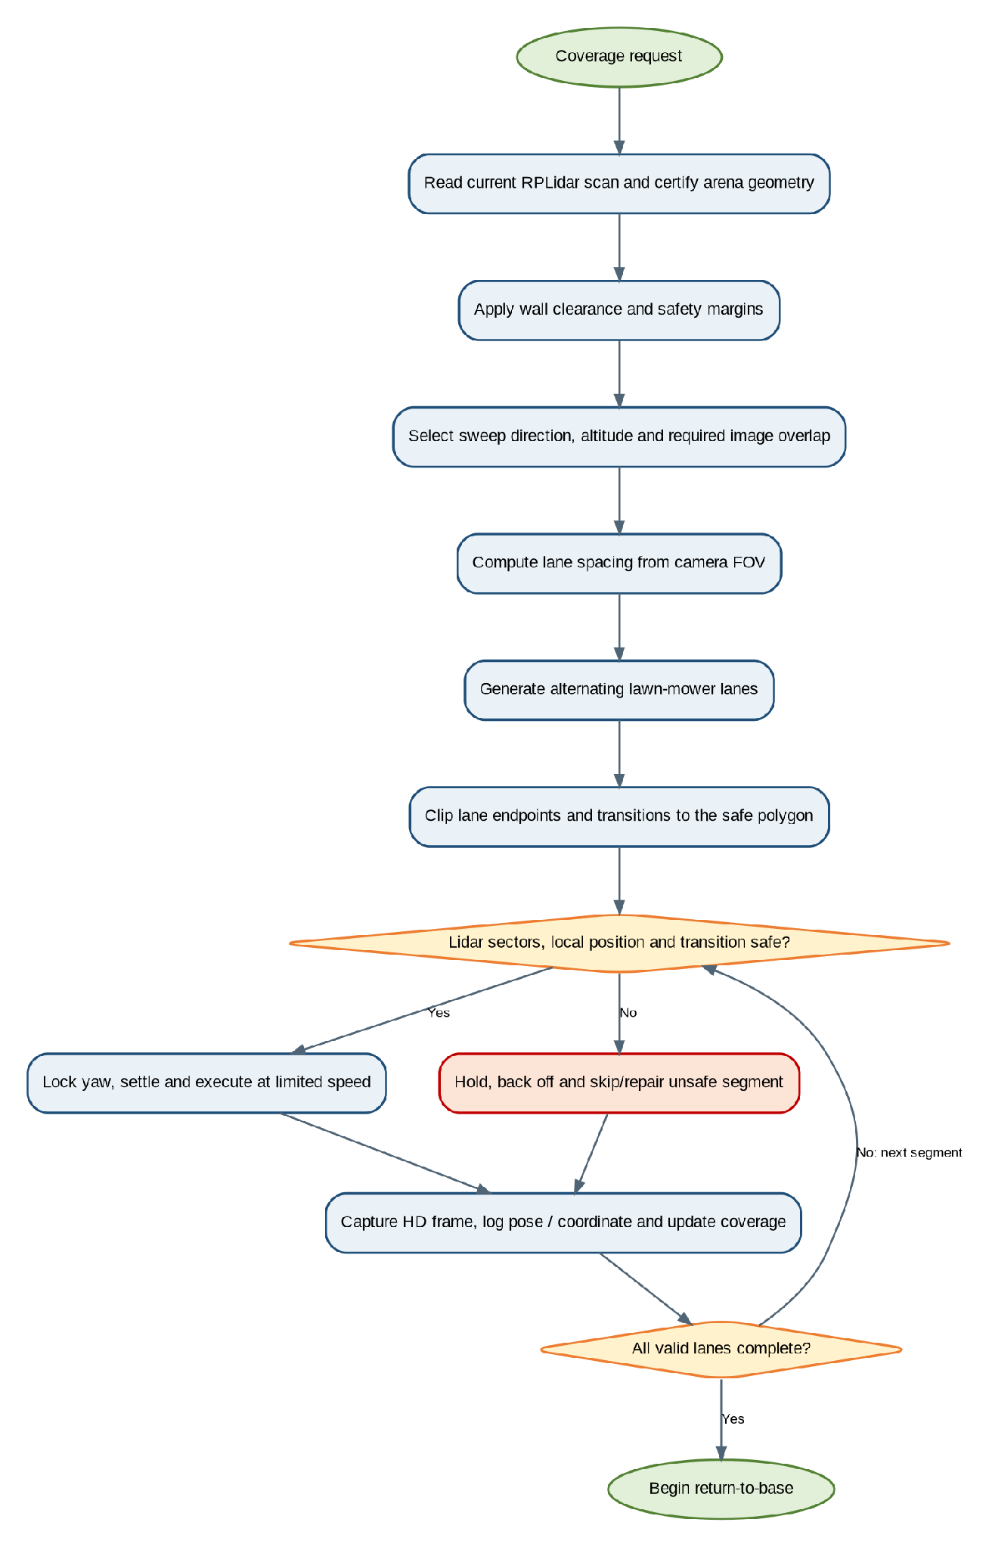
Figure 8. Coverage-lane generation, validation and execution workflow

10.4 Transition and Collision Behaviour
Parameter | Final value | Purpose / rationale
Wall safety margin | 1.5m | Keep vehicle and uncertainty envelope away from boundary
Path-edge clearance | 1 m | Additional clipping distance for planned segments
Lane spacing | 0.7m | Camera overlap and arena coverage
Maximum coverage speed | 0.4 m/s | Limit blur, drift and stopping distance
Maximum transition speed | 0.3 m/s | Conservative cross-lane motion
Forward collision half-angle | 55 degrees | Monitored forward sector
Collision stop distance | 1.3] | Immediate stop/hold threshold
Collision skip distance | 1.2m | Mark segment unsafe and continue safely
Hold duration | 5 s | Allow transient obstacle/noise to clear

11. Image Capture, Target Detection and Map Generation

11.1 HD Image Acquisition
During the survey, the Sony IMX500 camera captures high-definition frames and stores them in the onboard table_map/ directory. Each capture should be linked to mission ID, sequence number, timestamp, local coordinate, active lane and camera settings. The drone is used primarily as a data-acquisition platform during flight so that battery and compute resources are not consumed by unnecessary full-resolution batch processing.
Table 14. Current image-capture configuration record
Parameter | Current / final entry | Evidence
Camera | Raspberry Pi AI Camera, Sony IMX500 | Installed-part photograph
HD source folder | table_map/ | Mission archive
Resolution / exposure | 1080*720 | Camera configuration
Capture trigger | After every 150px of the camera movement | Mission configuration
Filename / metadata | table_map/, scan_*, timestamp and coordinate linkage | Manifest / CSV
Onboard storage | 512 GB NVMe SSD | System record
Raw-data retention | Original HD images retained after transfer | Transfer manifest

11.2 Docked Transfer and LR Conversion
After landing and pogo-pin Ethernet connection, the table_map/ folder is transferred to the base-station server. The LR Converter creates table_map_lr/ by downscaling the HD frames for faster comparison. The original HD dataset remains unchanged for evidence and final visual proof. Pre-seeded target references are stored in reference_targets/. Also with that the Basestation dashboard offers the
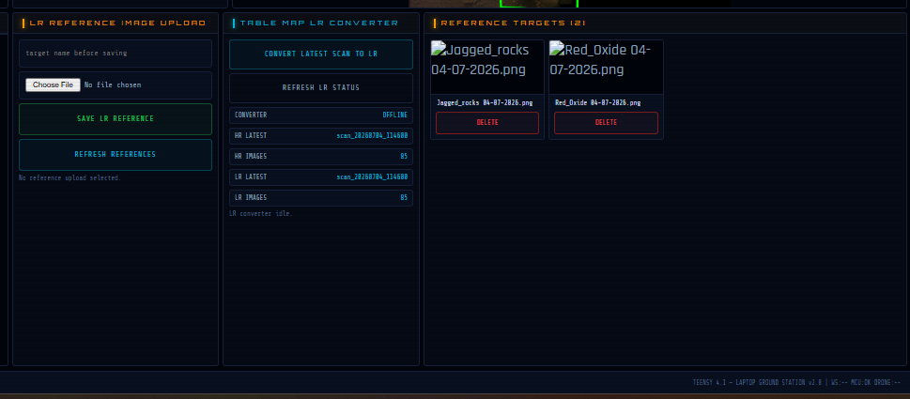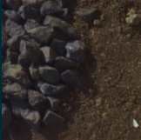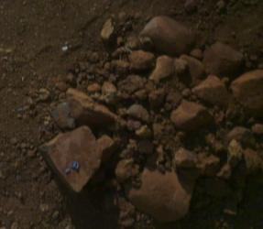

11.3 Implemented Target-Matching Pipeline
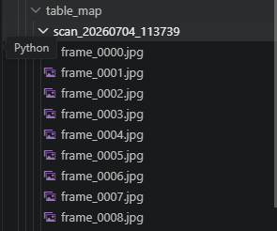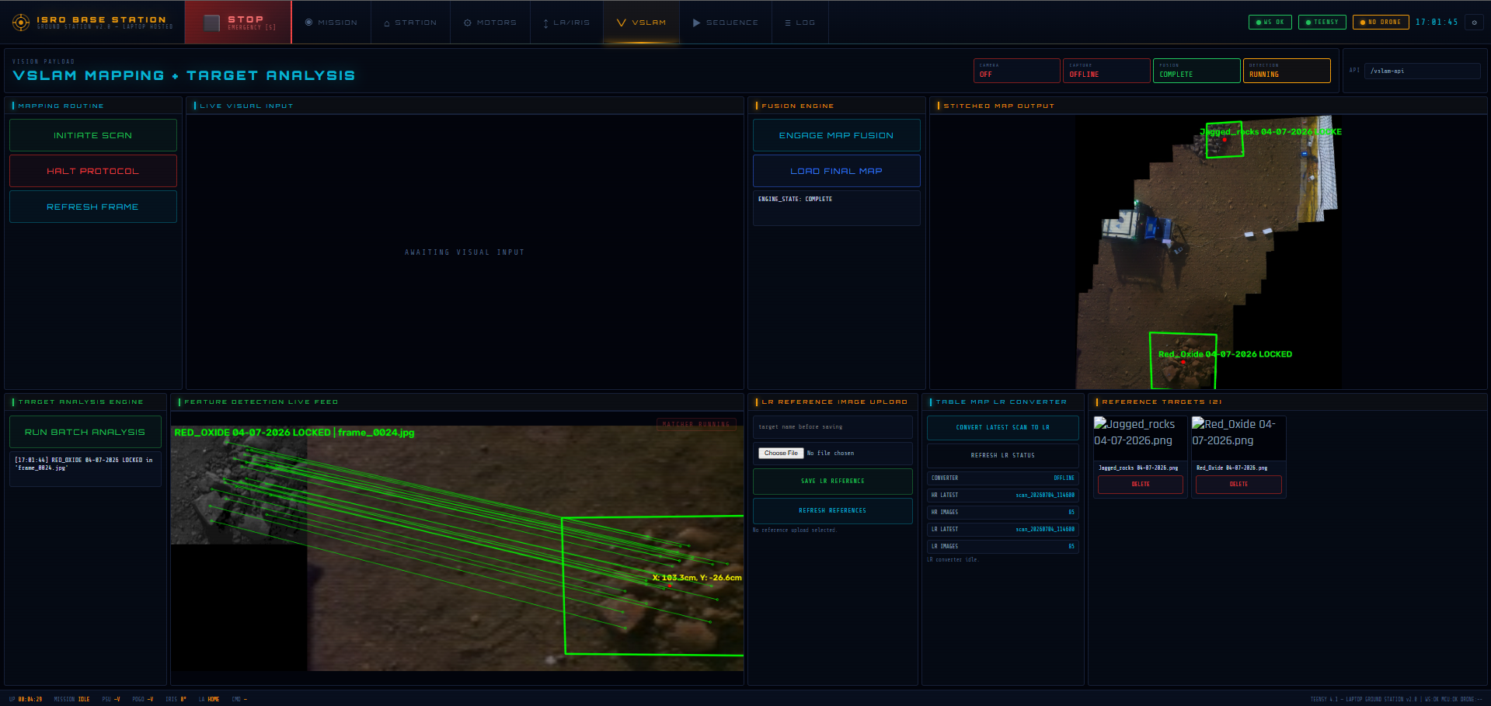
Figure 9. HD capture, docked transfer, LR conversion and SIFT/KNN/RANSAC target-validation pipeline
1. Load each low-resolution survey frame and the corresponding pre-seeded reference image.
2. Extract SIFT keypoints and descriptors, which are robust to scale and orientation changes.
3. Use a brute-force KNN matcher with k=2 and apply Lowe’s ratio test D1 < 0.7 x D2.
4. Require at least 15 good matches before attempting geometric verification.
5. Estimate a homography with RANSAC to reject outliers and project the reference boundary into the survey frame.
6. Reject non-convex or physically implausible projected target regions.
7. For an accepted match, save high-resolution visual proof to analyzed_targets/ and update analysis_feed.jpg, match_timestamps.txt and coordinate.txt.
8. Preserve failed/no-lock frames for audit rather than silently deleting them.
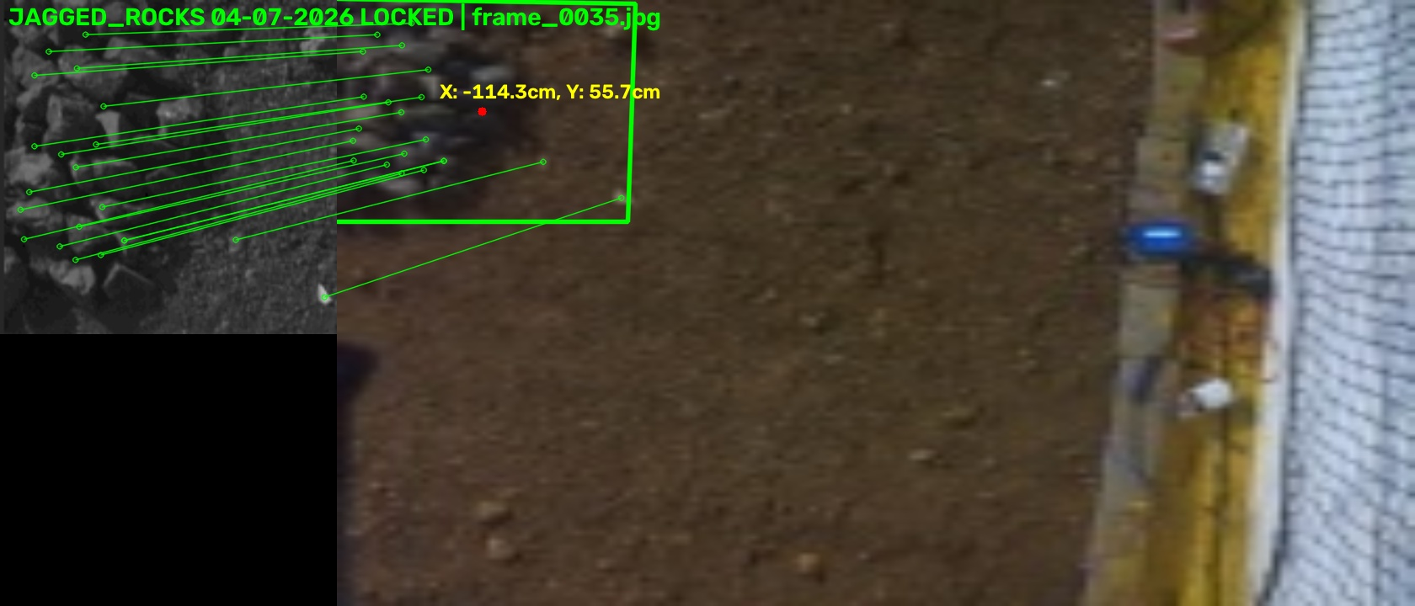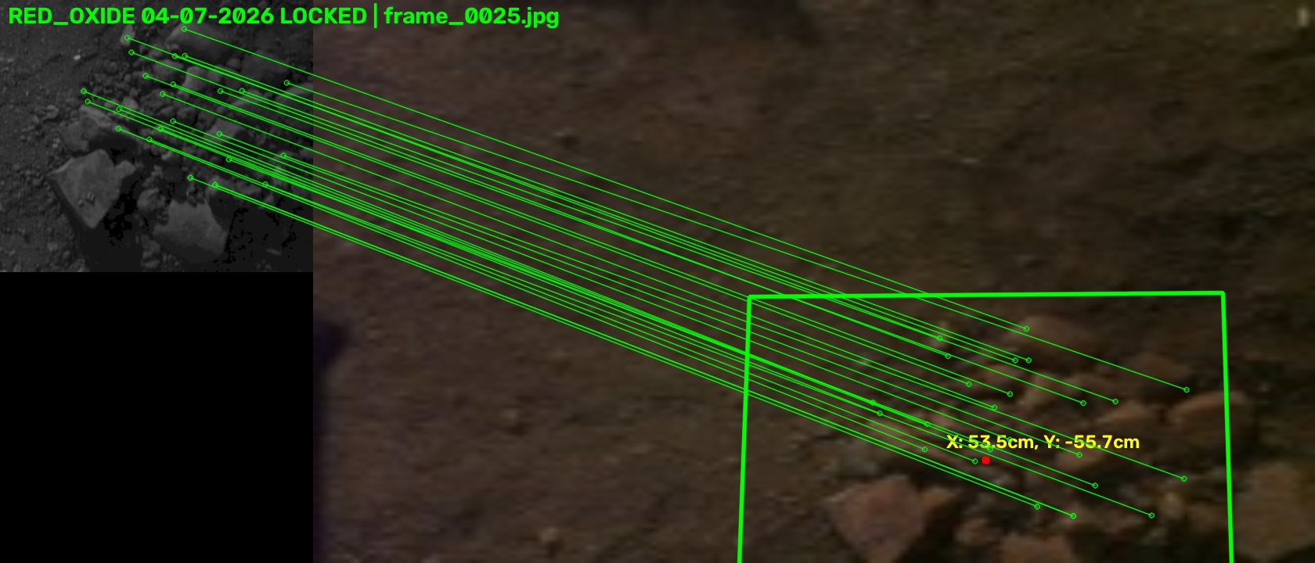
Figure 9. Target detection and annotation evidence

11.4 Arena Test Reference and Target Coordinates
Reference target | Recorded X coordinate | Recorded Y coordinate | Final detected coordinate / error
Ice Patches | 280 | -140 | -
Black Stone | 200 | 160 | 50.56
Red Soil Patches | 280 | 180 | 101.6
The pre-field image-analysis report used a 20 ft x 30 ft red-soil test arena with a 1.5 ft yellow inner boundary and two 400 W focus LED lamps. The base station was treated as the local coordinate origin. Correct the report identity to Team ID 10144 wherever the source pre-field document contains the typographical value 10114.

11.5 Aerial Map / Mosaic Generation
The post-flight workflow may select quality-filtered frames for image stitching and overlay accepted target coordinates on the resulting arena view. State the exact final stitching algorithm, number of frames, overlap, map resolution and any distortion or excluded region. Do not claim full metric mapping unless the output has been calibrated and validated against ground truth.
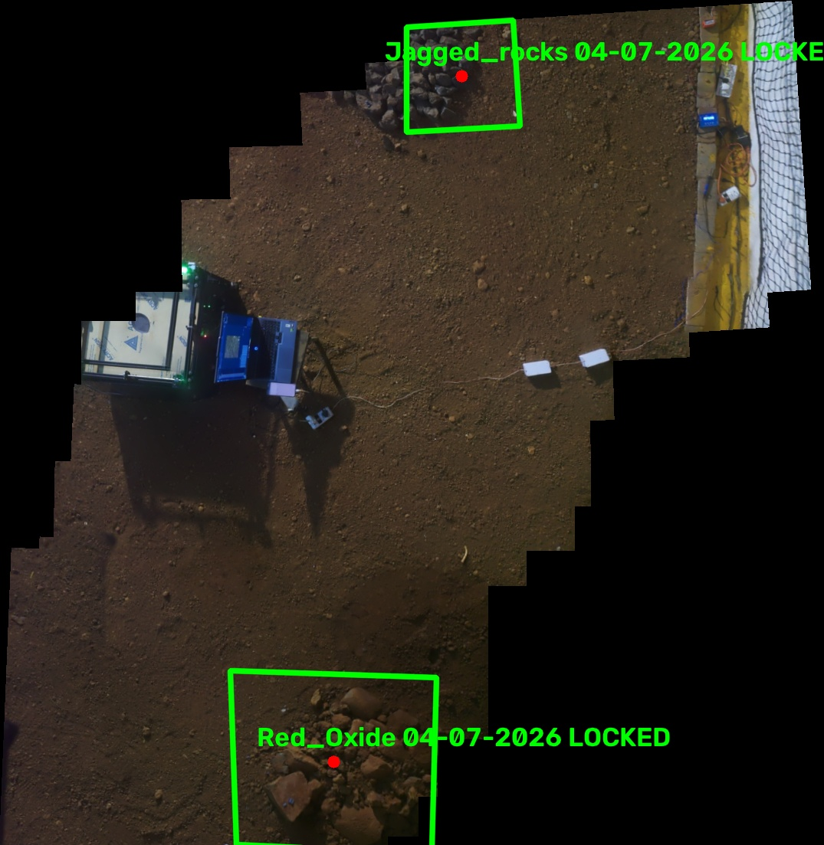
Figure 17. Final stitched arena map with target-coordinate overlay

12. Return-to-Base and Precision Landing

12.1 Return Strategy
The return sequence is separated into a coarse transit and a fine approach. The drone first returns toward the stored base reference at a conservative bounded velocity. Near the station, it reduces speed, holds above the landing region and confirms stable pose before enabling downward-camera guidance. This separation prevents the final visual controller from being activated while the vehicle still carries high horizontal velocity or yaw error.

12.2 Vision-Guided Landing Sequence
1. Arrive at the configured pre-landing altitude above the base reference.
2. Hold position and stabilize yaw.
3. Acquire the landing target or base visual feature with the downward camera.
4. Compute horizontal pixel error and convert it to bounded XY correction.
5. When the error remains inside the coarse tolerance for the settle interval, descend to the next stage.
6. Repeat alignment with reduced correction speed and tighter tolerance.
7. Perform a gentle final descent while monitoring target visibility, range and vertical velocity.
8. Confirm landed state, disarm and notify the base station.
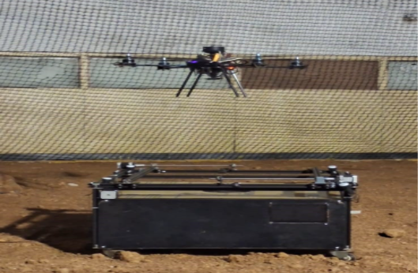
Figure 10. Precision landing image sequence

13. Automated Base Station v6.1

13.1 Functional Overview
Base Station v6.1 is the mechanical, electrical, data and post-processing hub of ASCEND. Its qualification functions are docking compatibility, charging-interface verification and LAN-to-LAN data-transfer verification. The station actively centers the landed drone, exposes and mates the protected pogo-pin interface, establishes Ethernet, enables charging only after validation, and displays mission results on a local touch interface.
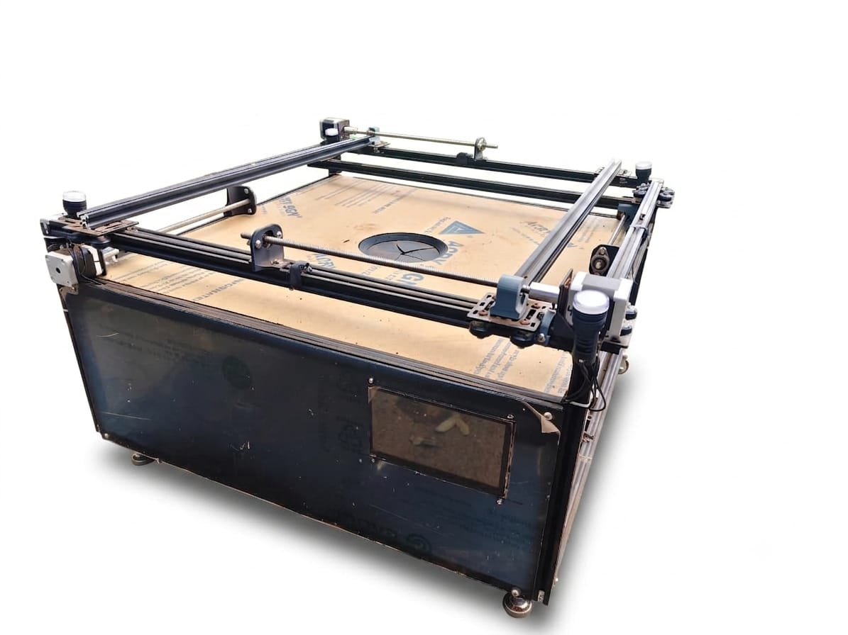
Figure 11. Final assembled Base Station v6.1

13.2 Structure and Four-Axis Centering
The rigid frame uses standard 20 x 20 mm aluminium extrusion profiles, cast 90-degree corner brackets, M5 hardware with nylon-insert lock nuts, a custom Gantry Base 5050, a smooth glass-acrylic landing surface and black-acrylic side panels. Four NEMA17 motors drive T8 threaded lead screws through custom brass nuts. KP08/KFL08 bearings support the free screw ends and reduce whip. Eight Omron snap-action limit switches define home and maximum travel; firmware uses an SW2 maximum-to-SW1 home calibration sequence before automatic centering.
Table 15. Base Station v6.1 mechanical record
Parameter | Documented value / component | Final verification
Frame profile | 20 x 20 mm aluminium extrusion | Measure final outer dimensions
Landing surface | Smooth glass acrylic; black acrylic sides | Photograph and material record
Centering motors | 4 x NEMA17 | Record exact motor and current setting
Lead screws | T8, 8 mm diameter, 1.25 mm pitch | Verify installed lead/pitch
Support bearings | KP08 / KFL08 zinc-alloy pillow/flange bearings | Installed-part check
Travel limits | 8 x Omron snap-action switches | SW1/SW2 mapping and test log
Centering time | 80 s | Mean and maximum from repeated trials

13.3 Iris, Linear Actuator and Pogo Matrix
Spring-loaded pogo connectors are mounted on a custom 3D-printed plate and divided into high-current power pins and isolated Ethernet/data pins. Compliance in the pins absorbs minor leveling errors and maintains contact. The protective shutter uses a linear actuator and iris. After the docking cycle, the actuator retracts to HOME and firmware applies an approximately 8-second delay before the iris closes over the contacts to protect them from dust and rotor downwash.
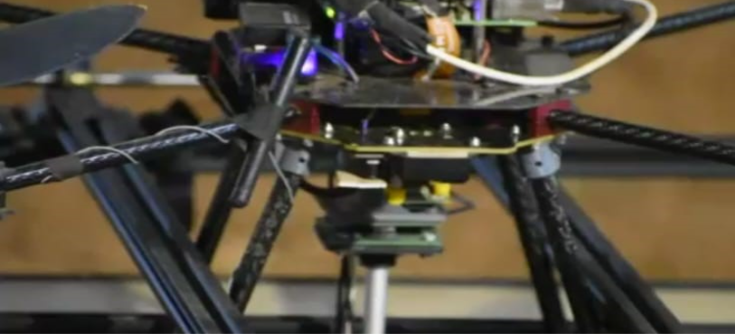
Figure 13. Pogo-pin power/Ethernet matrix and iris-actuator section

13.4 Electronics and Control Modes
Module / mode | Implementation | Function
High-level controller | Raspberry Pi 5, 16 GB | Touch HMI, Ethernet payloads, mission archive and post-processing
Display | 7-inch IPS LCD, 1024 x 600, capacitive HDMI | Local mission status, control and result visualization
AI accelerator | Hailo AI HAT+ 2, Hailo-10H, 40 TOPS INT4, 8 GB | Local visual verification/inference
Real-time controller | Teensy 4.1 | TB6600 pulses, limit inputs and relay sequencing
Relay policy | Default OFF | No charging until all required conditions pass
FULL AUTO | Center -> open LA/iris -> mate pogo -> Ethernet -> charge | Complete docking lifecycle
SKIP ETH | Mechanical + charging path only | Field charging diagnostic
SKIP CHG | Mechanical + Ethernet only | Data-transfer diagnostic
MECH ONLY | Motors + LA + iris, no electrical routing | Safe mechanical diagnostic

13.5 Automated Base-Station Flow
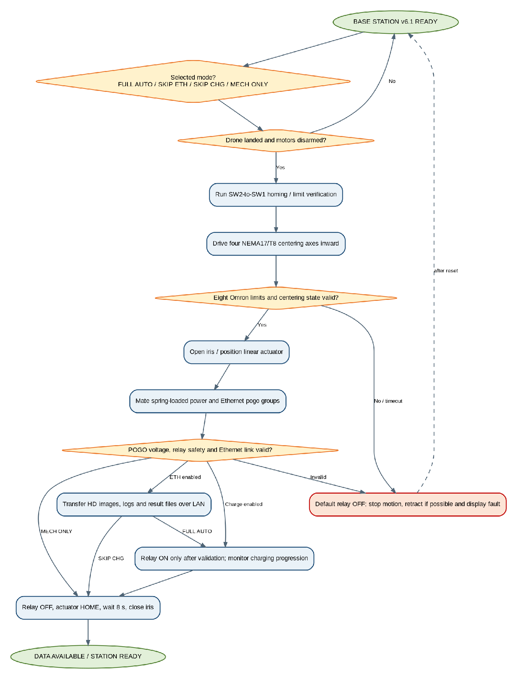
Figure 12. Base Station v6.1 centering, contact, Ethernet and charging sequence
LOG EVIDENCE: Charging evidence to preserve
Documented v6.1 logs show PSU = 12.29-12.33 V, initial POGO = 12.62 V near t = 54 s, and progression to POGO = 14.08 V. Attach the complete official log, initial/final battery percentage and elapsed charge time in the final evidence package.

14. Communication, Data Management and Dashboard

14.1 Communication and Data Flow
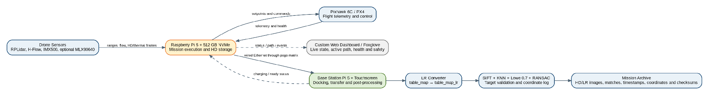
Figure 14. Flight telemetry, mission data, docking transfer and post-flight dashboard flow

14.2 Mission Archive Structure
mission_YYYYMMDD_HHMMSS/
├── configuration/
│ ├── mission_config.yaml
│ ├── px4_parameters.params
│ └── software_versions.txt
├── images/original/
├── images/annotated/
├── maps/
├── logs/
│ ├── events.log
│ ├── mission.csv
│ ├── px4.ulg
│ └── sensor_health.csv
├── detections/targets.json
├── transfer_manifest.sha256
└── summary.txt

14.3 Data Integrity and Transfer
- Create a manifest containing file path, size and checksum before transfer.
- Copy data over docked Ethernet to a mission-specific directory on the base station.
- Verify file count, size and checksum after transfer.
- Retry failed files without deleting the onboard source copy.
- Mark transfer complete only after verification succeeds.
- Preserve raw images and flight logs even when post-processing fails.

14.4 Engineering Visualization
Foxglove is used as an engineering monitoring and validation interface rather than as the flight-control authority. Recommended live topics include drone pose, arena boundary, planned coverage path, active segment, current target, obstacle distances, mission state, battery, sensor health and safety events. The base-station dashboard displays post-flight originals, annotated detections, stitched map, coordinates, transfer state and charging state.
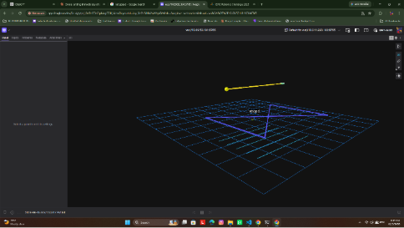
Figure 16. Foxglove live mission-monitoring screenshot
15. Safety, Reliability and Failsafe Design

15.1 Layered Safety Architecture
Safety layer | Implementation | Failure contained
Mechanical | Rigid frame, locked fasteners, propeller clearance, soft centering contacts and hard stops | Structural looseness, contact damage and mechanism over-travel
Flight controller | PX4 attitude/rate control, estimator monitoring, arming checks and offboard/battery failsafes | Immediate loss of stable control or command stream
Mission software | State-transition guards, bounded speeds, settle windows and timeout handling | Unsafe sequence progression
Perception | RPLidar sectors, H-Flow validity, IMX500 capture health and PX4 local-state checks | Boundary/obstacle approach and stale sensor use
Planning | Safe polygon, lane clipping, transition validation and skip logic | Commands outside the flyable region
Electrical | Regulation, fuse/current limits, BMS, polarity/contact verification | Overcurrent, reverse polarity and unsafe charging
Operational | Pre-flight checklist, controlled test envelope, emergency stop and trained operator | Residual integration risk

15.2 Flight Failsafe Matrix
Table 17. Fault detection and autonomous response
Fault | Detection condition | Immediate response | Final response
Low battery | Remaining capacity or voltage below configured threshold | Stop new coverage segments | Return and land / controlled land
MAVLink heartbeat loss | No heartbeat within timeout | PX4 offboard failsafe / hold | Land according to PX4 configuration
Setpoint-loop overrun | Command stream age exceeds limit | Stop mission progression | Recover stream or land
Invalid local position | PX4 estimator flag invalid | Hold / reject horizontal command | Controlled land if persistent
RPLidar failure | Scan/sector timeout | Hold and stop new horizontal movement | Return/land using H-Flow/PX4 safe mode if validated
H-Flow invalid | Quality/range below threshold | Reduce speed / hold | Land if stable local control is unavailable
RPLidar obstacle | Required sectors below stop distance | Stop and hold/back off | Skip segment or return
Landing target lost | No valid target beyond timeout | Stop descent and hold | Reacquire, climb slightly or controlled land
Excessive tilt/velocity | PX4 telemetry exceeds limit | Reject new motion command | Hold/land
Software exception | Supervisor catches fatal error | Send safe hold/land request | Persist logs and terminate safely

15.3 Base-Station Safety Matrix
Hazard | Prevention / detection | Safe response
Centering while motors active | Require landed and disarmed confirmation plus delay | Do not move rods; display fault
Rod over-travel | Limit switches, step count and timeout | Stop motor and release if safe
Iris obstruction | Servo current/time monitoring and position check | Stop and reverse / flag fault
Pogo-pin misalignment | Centering confirmation and contact-state validation | Retract actuator; retry or require operator
Reverse polarity / short | Polarity, continuity and current checks before enable | Keep charger isolated
Over-temperature / over-current | BMS and charger protection | Disable charging and log fault
Incomplete data transfer | Checksum and file-manifest verification | Retry; preserve onboard data
Unexpected drone movement | Interlock on landed state and emergency stop | Retract/stop all mechanisms
16. System Integration and Build Process

16.1 Mechanical Integration
- Confirm frame symmetry and motor alignment before sensor calibration.
- Mount the flight controller near the CG with the configured PX4 orientation.
- Rigidly mount the RPLidar and record its angular zero and scan-plane occlusions.
- Keep H-Flow and downward camera fields of view free from landing gear and wiring.
- Check the RPLidar scan plane for arm, propeller and cable occlusions.
- Secure connectors with strain relief while allowing service access.
- Balance battery and payload placement to minimize CG offset.
- Check landing-gear compatibility with centering rods and pogo-pin position.

16.2 Electrical Integration
- Use appropriately rated conductors and connectors for propulsion and charging currents.
- Separate high-current motor wiring from camera and communication paths where possible.
- Use a regulated supply sized for Raspberry Pi 5 peak current and connected peripherals.
- Provide a common and controlled grounding strategy.
- Add fusing/current limiting and verify no supply exceeds sensor or flight-controller ratings.
- Perform continuity and polarity tests before connecting the battery.
- Log the final connector pinout and cable labels in Appendix C.

16.3 Software Startup Sequence
1. Boot the Raspberry Pi 5 and mount the mission storage.
2. Start the process supervisor and create the mission log directory.
3. Initialize the Pixhawk link and verify heartbeat.
4. Initialize RPLidar scan, H-Flow status, Sony IMX500 capture, Hailo runtime and optional thermal stream.
5. Start Foxglove/telemetry publication.
6. Run pre-flight health and configuration checks.
7. Wait for the authorized mission-start command.
8. Stream safe initial setpoints and proceed through the mission state machine.

17. Testing and Validation

17.1 Verification Philosophy
Validation is performed progressively from component checks to subsystem tests and finally full mission runs. A full mission is attempted only after the required lower-level tests pass on the same hardware and software configuration. Every test record should include date, build version, battery, environment, operator, expected result, measured result, log location and pass/fail decision.

17.3 Flight-Test Conditions
Variable | Test condition / value
Arena size | 30 length x 25 width x 15 height
Boundary material | Net
Floor surface | Red soil
Lighting | 400W Flood lights
Mission altitude | 2m
Base-station location | centre
Vehicle mass | 1960g
Battery | 4s 2800mah 13c lithium ion

18. Results and Discussion

18.1 Demonstrated Mission Outcome
Task reference | Recorded status | Documented outcome
10.5.1 Autonomous Take-Off | Successful | Stable autonomous lift-off demonstrated
10.5.2 Autonomous Survey | Successful | Survey coverage completed
10.5.3 Coordinate Determination | Successful | Target coordinates recorded during mission
10.5.4 Autonomous Landing | Successful | Controlled autonomous landing demonstrated
10.5.5 Autonomous Charging | Successful | Docking and charging performed
10.5.6 Autonomous Data Validation | Successful | Data validation completed after mission
The Mission Outcome Report separately records HD image collection, LR image generation, target identification, and transfer of captured images and mission data to the base station. Insert the corresponding links, screenshots and logs into the image boxes and evidence appendix of the final submitted copy.

18.3 Coverage and Imaging Results
Metric | Final result | Interpretation
Safe flyable area | 42 m² | After wall/safety margin
Number of planned lanes | 3 | Final mission configuration
Number of executed lanes | 3 | Include clipped/skipped segments
Lane spacing | 0.7 | Based on FOV and overlap
Estimated coverage completeness | 85 % | Method must be stated
Images captured | 75 | Original images
Mosaic resolution | 5 cm /px | Post-flight output
Target detections | Enter correct | Final algorithm

18.4 Landing and Docking Results

Figure 20. Landing accuracy and successful docking result

18.5 Base-Station Performance
Metric | Measured result | Acceptance / discussion
Centering time | 80s | From valid landed state to centered position
Maximum corrected offset | 40mm | X/Y and yaw test envelope
Iris opening/closing time | 5s | No obstruction or timeout
Pogo connection attempts | 3 | Mean / maximum retries
Ethernet link rate | 100mbps | Negotiated link and actual transfer rate
Mission dataset size | 350MB | Representative mission
Verified transfer time | 7.5s | Checksum complete
Charging current | 2 A | Within BMS/charger limit
Charging-state verification | 13.5 | Voltage, current and temperature behaviour

19. Engineering Challenges and Resolutions
This section records the most important technical issues encountered during development and the changes that produced the latest configuration. It demonstrates engineering learning without presenting earlier prototype limitations as current final-build behaviour.
Table 21. Engineering issue-resolution record
Issue | Observed effect | Root cause / investigation | Final modification
Takeoff drift | Lateral movement immediately after liftoff | CG, optical-flow quality, estimator readiness and thrust transient investigated | Rebalanced payload, verified flow/range, staged climb and pose gate
Unsafe lane transition | Transition approached wall or generated invalid next lane | Path endpoint too close to boundary and transition not independently clipped | Clip all segments/transitions to safe polygon; yaw lock; reduced transition speed
Yaw transient | Initial movement direction inconsistent with planned lane | Yaw reference/settle timing and frame convention checked | Explicit yaw command, tolerance and settle window before translation
Close-range collision response | Single threshold insufficient for all directions/noise | Sensor blind zones and isolated range values analyzed | Sector validation, minimum-sector count, hold/back-off and skip logic
Precision landing variation | Landing error changed with lighting/altitude | Exposure, target scale and aggressive correction near ground | Staged descent, dead zone, speed reduction and target-loss recovery
Docking contact reliability | Intermittent power/data contact | Landing offset, pin compression and actuator alignment | Mechanical centering, spring-loaded pins, contact verification and retry

19.1 Development-to-Final Configuration Traceability
The elimination-round configuration and prior prototype architecture will be added later as a separate historical configuration chapter or appendix. When added, each difference should be described using “previous configuration → reason for change → final configuration → evidence of improvement.” The latest configuration in Sections 3 and 20 remains the controlling baseline for final-field documentation.

20. Final Frozen Current Configuration

20.1 Current Drone Baseline
Table 22. Current drone hardware and software baseline
Category | Frozen current baseline | Verification still required
Frame | Custom carbon-fibre frame; 10 mm OD x 8 mm ID tubes; carbon sheet/PCB integration | Final overall dimensions and takeoff mass
Core footprint | Approximately 328 mm x 254 mm from design record | Measure final assembly including landing gear
Motors | 4 x T-Motor Navigator MN3110 470 KV | Serial/part-label photograph
Propellers | 14 x 4.7 nylon, CW/CCW | Exact manufacturer/model
ESC | T-Motor F55-series 4-in-1 | Resolve F55 II Pro vs F55A PRO III from physical label
Battery | 4S lithium-ion, 2800 mAh | Exact pack model, mass and usable endurance
Flight controller | Pixhawk 6C, PX4 | Firmware version and parameter hash
Companion computer | Raspberry Pi 5, 16 GB, 512 GB NVMe, Raspberry Pi OS Bookworm Lite | OS image, kernel and cooling hardware
Primary arena awareness | SLAMTEC RPLidar A1M8 | Driver version, scan rate and valid range
Hover/altitude support | Holybro H-Flow optical flow + ToF + IMU | PX4 orientation and quality/range thresholds
Survey / AI camera | Sony IMX500 Raspberry Pi AI Camera | Final mode, exposure and capture trigger
AI accelerator | Hailo AI HAT+ 2, 40 TOPS | Runtime and deployed model
Thermal payload | MLX90640 32 x 24, 55-degree FOV - supplementary | Confirm physical installation or remove
Mission software | Python + MAVSDK / MAVLink | Release/commit and startup script
Engineering visualization | Custom web dashboard and/or Foxglove | Version, ports and final layout
Autonomy mode | No GNSS; onboard mission logic with RPLidar/H-Flow/PX4 local control | Official final-mission evidence ID

20.2 Base Station v6.1 Baseline
Table 23. Current base-station hardware and software baseline
Category | Frozen current baseline | Verification still required
Frame | 20 x 20 mm extrusion, cast brackets, glass-acrylic top, black-acrylic sides | Final outer dimensions and mass
Centering | 4 x NEMA17, 4 x TB6600, T8 8 mm/1.25 mm screws, brass nuts, KP08/KFL08 bearings | Driver current, travel and correction envelope
Limits | 8 x Omron snap-action switches; SW2 max to SW1 home sequence | Switch map and fault-injection result
Iris / actuator | Linear actuator and protective iris with ~8 s delayed close after HOME | Exact actuator/servo model and timing
Pogo interface | Spring-loaded separated power and Ethernet groups | Pin model, current rating and final pinout
Low-level control | Teensy 4.1 | Firmware version/commit
High-level control | Raspberry Pi 5, 16 GB | OS/software release
Display | 7-inch 1024 x 600 capacitive HDMI touch display | Installed model
AI accelerator | Hailo AI HAT+ 2, Hailo-10H, 40 TOPS INT4, 8 GB | Runtime/model release
Charging safety | Heavy relay default OFF; enable after validation | Charger/BMS model, limits and percentage-rise test
Data transfer | Wired LAN-to-LAN Ethernet through pogo matrix | Negotiated rate, checksum method and transfer result
Modes | FULL AUTO, SKIP ETH, SKIP CHG, MECH ONLY | Final operator procedure and UI screenshot

21. Limitations and Risk Mitigation
Table 24. Known limitations and operational mitigations
Limitation / dependency | Potential effect | Mitigation in final system | Residual risk
RPLidar is a horizontal 2D scanner and does not observe all vertical/overhead hazards | Unseen obstacle or incomplete geometry | Known test arena, conservative altitude, scan-plane audit and safety observer | Low
Optical flow depends on visible floor texture and valid range | Hover drift or invalid local velocity | Floor validation, quality threshold and pose monitoring | Low
RPLidar returns can degrade on dark, transparent or angled surfaces | Missed/unstable boundary range | Minimum valid sectors, conservative wall margin, hold/skip logic and controlled tests | Med
IMX500 images depend on lighting, exposure and motion blur | Reduced target/mosaic confidence | Controlled capture timing, lighting check, raw-image retention and offline validation | High
Battery endurance limits mission time and retries | Low reserve during return/landing | Conservative start threshold, in-mission battery monitoring and early return | Low
Docking corrects only a finite landing offset | Contact may fail after large landing error | Visual landing tolerance, centering envelope and operator recovery | Low
Pogo interface exposed to dust/misalignment | Intermittent charging/data contact | Protective iris, spring pins, centering and contact verification | Low
Companion-computer software may stop unexpectedly | Loss of mission setpoints | PX4 offboard failsafe, supervisor, logs and controlled landing | Low

21.1 Operational Risk Controls
- Use a written pre-flight and base-station checklist for every official attempt.
- Perform hardware inspection after transport and before connecting the flight battery.
- Confirm final parameter file and mission software commit before flight.
- Use an authorized emergency-control method and trained safety operator.
- Do not bypass failed health checks solely to start a mission.
- Preserve all logs after any abnormal event before restarting the system.
- Keep charging disabled until docking-contact validation succeeds.

22. Conclusion and Future Improvements

22.1 Conclusion
The regenerated latest-configuration report defines ASCEND as a practical RPLidar-based indoor autonomous drone and Base Station v6.1. The drone combines Pixhawk 6C/PX4 flight authority, Raspberry Pi 5 mission supervision, RPLidar arena awareness, Holybro H-Flow hover and altitude support, Sony IMX500 HD acquisition, Hailo acceleration, custom carbon-fibre/PCB integration and a T-Motor propulsion system. The base station adds active four-axis centering, protected spring-loaded power/Ethernet contacts, deterministic Teensy control, a touch HMI, post-flight processing and guarded charging.
The documented mission workflow spans takeoff, survey, coordinate determination, image capture, return/landing support, docking, HD-to-LR conversion, SIFT/KNN/RANSAC target validation, data transfer and charging. Team records show that the full autonomous task sequence was completed on the third demonstration attempt on 04 July 2026 after correcting earlier hardware and software issues. The report preserves this evidence while leaving quantitative performance fields open for the final measured values and official logs.
All older Livox MID360, OAK-D and proposal-stage concepts are intentionally excluded from the controlling baseline. They can be added later as a separate previous-configuration comparison without creating ambiguity in the final-field submission.

22.2 Future Improvements
- Fuse RPLidar geometry, H-Flow quality and PX4 local-state confidence with a single online consistency score.
- Add vertical or depth redundancy for hazards outside the horizontal scan plane.
- Automate IMX500 exposure selection and image-quality rejection for variable lighting.
- Improve lane replanning around partially observed boundaries and blocked transitions.
- Quantify landing/docking correction envelopes and pogo-pin contact reliability over larger repeated datasets.
- Generate automated mission summaries, plots and checksum reports immediately after docking.
- Reduce airframe mass and validate thermal/power margins under sustained Hailo processing.

References
[1] ISRO Robotics Challenge - URSC 2026, Final Field Round communication and submission requirements, July 2026.
[2] Team IIC_SIT, “Current Drone Stack Specification Report,” Team 10144, July 2026.
[3] Team IIC_SIT, “Design and Test Report - Base Station v6.1 and ASCEND Pilot,” Team 10144, 2026.
[4] Team IIC_SIT, “Mission Outcome Report,” Team 10144, July 2026.
[5] Team IIC_SIT, “IRoC-U 2026 Evaluation / Demonstration Report,” 04 July 2026.
[6] Team IIC_SIT, “Arena and Feature Report - Target Recognition & Logging Architecture,” June 2026.
[7] PX4 Autopilot and MAVSDK documentation used for the final installed release.
[8] Holybro H-Flow, SLAMTEC RPLidar A1M8, Raspberry Pi IMX500 AI Camera and Hailo AI HAT+ 2 documentation.
[9] T-Motor MN3110, F55-series ESC and 14 x 4.7 propeller documentation.
[10] Teensy 4.1, TB6600, NEMA17, T8 lead-screw, limit-switch, charger/BMS and pogo-pin datasheets used in the installed Base Station v6.1.

Appendix A - Complete Bill of Materials
No. | Component | Manufacturer / model | Qty. | Unit mass | Purpose | Final status
1 | Carbon-fibre frame/tubes/sheet | 10 mm OD x 8 mm ID tubes; 300 x 100 x 1 mm sheet / custom PCB | 1 set | 250g | Airframe and integration | Installed
2 | Motors | T-Motor Navigator MN3110 470 KV | 4 | 98g | Propulsion | Installed
3 | Propellers | 14 x 4.7 nylon CW/CCW | 4 + spares | 114g | Propulsion | Installed
4 | ESC | T-Motor F55-series 4-in-1 - verify exact model | 1 | 17.8g | Motor control | Installed
5 | Flight controller | Pixhawk 6C | 1 | 34.6g | PX4 flight control | Installed
6 | Companion computer | Raspberry Pi 5, 16 GB + 512 GB NVMe | 1 | 70g | Mission computing/storage | Installed
7 | Primary range sensor | SLAMTEC RPLidar A1M8 | 1 | 170g | Arena/boundary awareness | Installed
8 | Optical flow/range | Holybro H-Flow | 1 | 15.2g | Hover and altitude aid | Installed
9 | AI survey camera | Raspberry Pi AI Camera, Sony IMX500 | 1 | 10g | HD capture / visual inference | Installed
10 | AI accelerator | Hailo AI HAT+ 2, 40 TOPS | 1 | 19g | Inference acceleration | Installed
11 | Thermal camera | Waveshare MLX90640 32 x 24 | 1 | 10g | Supplementary thermal scan | Verify installed
12 | Battery | 4S Li-ion 2800 mAh | 1 + spares | 220g | Flight power | Installed
13 | Power modules | MINI560 5V/5A; 200W 20A buck; Pixhawk power module | 1 each | 50g | Regulation and telemetry | Installed

Appendix B - Critical PX4 and Mission Parameters
Parameter / software setting | Final value | Purpose | Verification
PX4 version | v1.18 | Autopilot baseline | Firmware screen/log
Airframe configuration | QuadCopter | Mixer and dynamics | PX4 setup
Estimator configuration | Flow / CTRL_FLow | GPS-denied local state | Parameter export
Offboard-loss action | Hold / time out land | Safe response to Pi/setpoint loss | Failsafe test
Battery low/critical action | 15% RTL | Reserve for return/landing | Battery test
Takeoff altitude | 2.5 m | Mission operating height | Flight test
Takeoff vertical speed | 0.20 m/s | Controlled climb | Flight log
Coverage speed | 0.3 m/s | Imaging/safety trade-off | Flight log
Transition speed | 0.3 m/s | Safe lane change | Flight log
Wall safety margin | 1.5 m | Boundary clearance | Path plot
Lane spacing | 0.7 m | Coverage overlap | Calculation/test
Collision stop distance | 1.3 m | Immediate obstacle response | Obstacle test
Collision hold duration | 5 s | Transient/noise handling | Obstacle test
Landing coarse/fine tolerances | 0.30 | Precision landing | Landing trials
Sensor timeouts | 10s Land | Health gating | Fault-injection test

Appendix C - Electrical Pinout and Interface Record
Connector / pin | Source | Destination | Signal / voltage | Wire colour
XT60 | Flight battery | ESC / power module | Signal / Power | Black
Cable | Regulator | Raspberry Pi 5 | 5 V / GND | Black
Cable | Raspberry Pi | Pixhawk | USB/UART MAVLink | Black
USB | RPLidar A1M8 | Raspberry Pi | USB serial | Black
SLIT pcie | Sony IMX500 camera | Raspberry Pi | CSI | Golden copper
PCIE | Hailo AI HAT+ 2 | Raspberry Pi | PCIe/HAT | Golden Copper
Can bus | H-Flow | Pixhawk | Cable | Red/black
Pogo + | Base charger | Drone battery/BMS | Positive | Black
Pogo - | Base charger | Drone battery/BMS | Negative | Black]
Pogo BMS | Base controller | Drone BMS | [Signal] | Black
Pogo Ethernet | Base Pi | Drone Pi | Ethernet pairs | Black

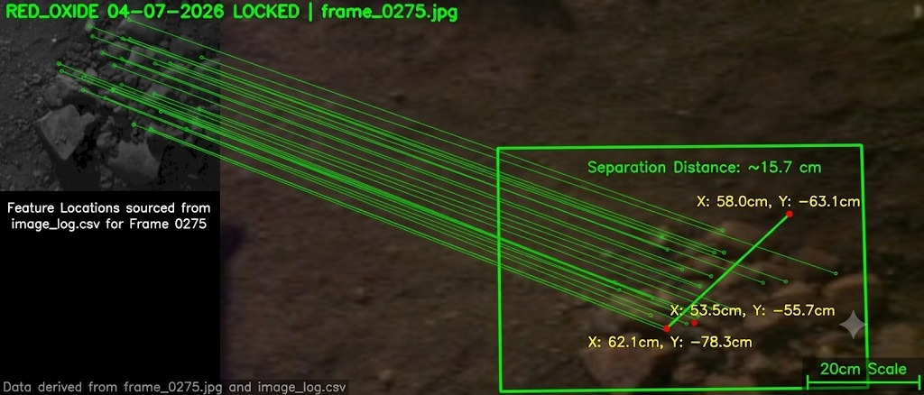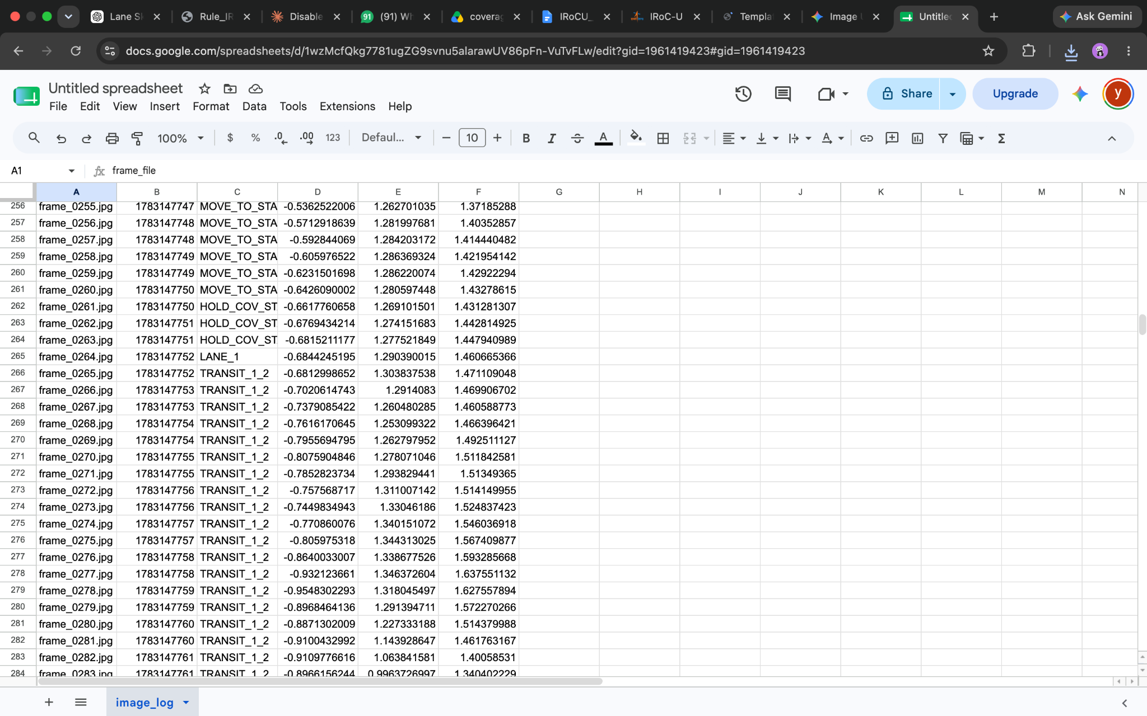

Figure 21. Additional final-mission photographic evidence

